# Android 文件操作

<http://www.open-open.com/lib/view/open1330957864280.html>

<http://blog.csdn.net/ztp800201/article/details/7322110>

<http://blog.csdn.net/fenghome/article/details/5668598>

<http://wenku.baidu.com/view/4b9867db7f1922791688e880.html>

获取资源文件夹下的XML:

<http://blog.csdn.net/freestyleboy21/article/details/7008228>

# android全局异常处理

<http://www.cnblogs.com/liangyang/articles/2335891.html>

# android生命周期

# android XML序列化和反序列化

<http://blog.csdn.net/chenzheng_java/article/details/6220258>

<http://www.360doc.com/content/12/0119/12/8134611_180331882.shtml>

<http://developer.android.com/reference/java/io/Serializable.html>

<http://tdq222.iteye.com/blog/702114>

<http://blog.csdn.net/shichexixi/article/details/5985683>

# IDEA 发布android APP

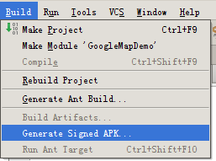

# 跳转到GPS设置页面



# GPS

<http://blog.csdn.net/swqqcs/article/details/7245696>

# 使用GoogleMapService获取地理位置信息

地图纠偏: <http://xxy12300.blog.163.com/blog/static/26343458201161474540724/>

<http://ditujiupian.com/Map/ReadMe.html>

# Google Account

<https://developers.google.com/google-apps/tasks/oauth-and-tasks-on-android?hl=zh-CN>

<https://developers.google.com/accounts/docs/OAuth2ForDevices?hl=zh-CN>