An Economic Life in Vain

Ulrich Blum and Leonard Dudley

Abstract:
After an initial period of fast expansion, East Germany’s economy has been virtually stagnating for now at least eight years. We relate the present development to the long-term economic development of Germany since the beginning of the 19th century. We produce annual time series for Germany incl. West Germany and, separately, for East Germany after WWI. We explain the present stalemate by the lost economic years of the GDR, i.e. the true economic starting point of East German economic recovery is 1948.

Zusammenfassung:
Nach einer ersten Periode der Expansion stagniert die ostdeutsche Wirtschaft nach nunmehr über acht Jahren. Wir beziehen die aktuellen Probleme des Aufschwungs Ost auf die langfristige Entwicklung der deutschen Wirtschaft seit Beginn des 19.Jahrhunderts. Wir berechnen jährliche Zeitreihen für Gesamtdeutschland sowie für West- und Ostdeutschland getrennt. Die aktuell unbefriedigende Lage erklären wir in den wirtschaftlich verlorenen Jahren der DDR, so daß der tatsächlich Bezugspunkt für den Aufschwung Ostdeutschlands wohl im Jahr 1948 zu suchen ist.

Key words:
East Germany, income, time series, incremental output capital ratio. Richtungskoeffizient

JEL-Codes: N1, O1
In the mid-1990s, after several years of rapid expansion following reunification, East Germany’s economy entered a period of stagnation. Here we set these recent developments in the context of the long-term growth of the German economy. We produce annual time series for Germany including West Germany from the beginning of the 19th century and, separately, for East Germany after World War II. We explain the present stagnation by developments during the lost economic years of the GDR. In effect, the true economic starting point for an understanding of German’s current economic difficulties is not 1990 but 1948.

1. The Stagnating Twin: the German Economic Divide

When on November 9th, 1989, the Iron Curtain melted away and the path to Unification was paved within less than a year, everybody foresaw a second “Wirtschaftswunder” in the New Provinces of Germany, especially its southern parts that had been the industrial core land of Central Germany between the wars. But today, 15 years and some 1000 b € of transfers to the East later, things often look more bleak than shining. Although some areas have progressed, in general, since 2000, per-capita income in the East has stagnated at about 60% of the level of the West. Without transfer payments, nearly one fifth of the East-German workforce would instantaneously lose its jobs and per-capita incomes would shrink even further.

What has happened? Did East Germany not qualify in the 1980s as the eighth largest economy in the world? Was its initial growth after Unification not impressive? We argue that the proper starting point to monitor the recovery of the East German economy is not 1989 but the late forties or early fifties. The impressive economic development of East Germany after the War was halted because of an adverse institutional system (Blum, Dudley 1999, 2000) that forced the region back to economic levels of the fifties.

In our paper we will first model the long-term development of German income using Maddison’s series for the German Reich and West Germany, extended to 2005 (Maddison 1995). We then compute the market values of East Germany’s income of 1946 and 1991. Finally, we estimate the missing data between 1946 and 1991 for East Germany.

2. Income of the German Reich and West Germany
The series produced by Maddison (1995) show per-capita incomes of Germany (German Reich until end of WW II; afterwards West Germany) between 1820 and 1994 in Geary-Khamis-values of 1990. In the study, this special type of purchasing power was used to ensure the international comparability of national-accounts data. For our purpose, this property is not required; however, it is the best continuous series that is publicly available on which to base our analysis.

We added the values of West Germany for the years 1991 to 2005 by using, for 1991 to 1994, the ratios between national per-capita incomes of West Germany (1995 €) and the Geary-Khamis series (1990 $); the average was 0,796 with which we deflated the official series.

Figure 1:
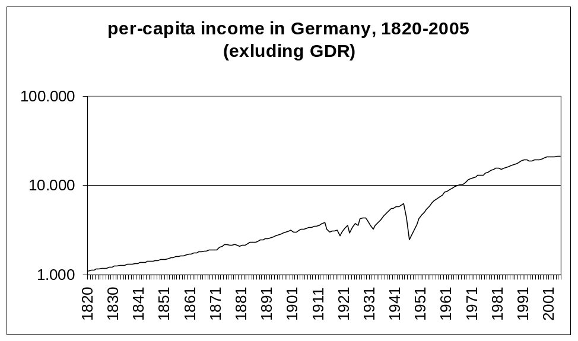

We clearly see the impact of World War I, the Great Depression, the collapse of the Third Reich and the accelerated growth immediately following this period. Note that since the data are in per-capita terms, the changes in population and territory after each war need not be taken into account.

3. Income in East Germany

3.1 General Framework
In calculating East Germany per-capital income prior to 1990, one faces three major problems. First, from 1948 onwards, the economy of East Germany was increasingly restricted from access to free world markets and redirected to the Comecon. Only internal German trade, subsidized by a huge swap agreement, remained as an important export window to the West, especially from the sixties onwards. Second, the composition of goods reflected this change. As a consequence, an internal and an external purchasing power of the East German Mark must be distinguished. However, the unavailability of international goods and also of those goods produced by East Germany for exports to generate foreign cash that lead to huge forced savings must somehow be accounted for. Finally, the quality of goods did not improve as it did in the West; often, it deteriorated over time. Thus, output data are exaggerated. this phenomenon was addressed in the nineties, by the US Senate with a view on the adaptation of pensions to inflation. As the Boskin-commission (Boskin et al. 1998) found out, the Consumer Price Index overstated US inflation by some 1.1 percent per year because it did not account for quality improvements.

3.1 Correction for a Relative Decline in the Quality of Goods
In a previous paper Blum and Dudley (1999) have addressed the problem of quality changes in the East German economy vis-à-vis the West German economy. A problem similar to that mentioned above arises once output growth in planned economies is compared with that in Western countries. To the extent that quality improvements and new products did not occur in East Germany but did occur in the West -- and presumably were under-reported, for the reasons mentioned above -- traditional growth rate comparisons will provide an overly favorable image of the planned economy.

Let Y represent the value of East-German aggregate production at world prices and V represent the volume of output measured by official statistics. If the data can be assumed to be free of deliberate manipulation, then any significant discrepancy in the growth rates of the two measures must be due to changes in the quality of output, q.
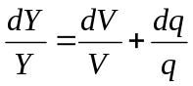 (3.1)
The difficulty in applying equation (3.1) to estimate economic growth in East Germany is that q is not directly observable.

How might the quality of aggregate output in a non-market economy be measured? The success of a dynamic system may be evaluated by its ability to reproduce itself over time. If the quality of its current output falls, then each additional unit of that output that is put aside to be invested will generate less and less future production. For example, new generations of machine tools, though just as costly to build as earlier models, may have an ever-smaller productivity. Accordingly, quality may be measured by a comparison of the incremental output-capital ratio in the planned economy to that of a benchmark measure in a market economy, indicated by asterisks:
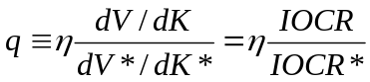, (3.2)
where is a constant and K is the reported capital stock. Then the rate of change in the quality index is:
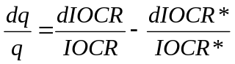 (3.3)
Substituting from (3.3) into (3.1), we have:
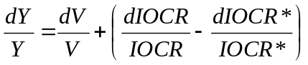 (3.4)
A quadratic trend was fitted to the East and West-German incremental output-capital ratios from 1951 to 1988; Table 1 gives the results. The ratio of the fitted values is shown in Figure 2. After remaining relatively stable in the 1950s and 1960s, this measure of quality fell sharply in the 1970s and 1980s. By 1988, the fitted ratio was 43 percent of its value in 1951. Here, then, is one possible explanation of why actual per-capita income in East Germany at the moment of reunification turned out to be only about one-half the official level.

Table 1:
Quadratic Trend of Incremental Output-Capital Ratio, IOCR,
for East and West Germany, 1951-1988 (Blum, Dudley 1999)
 | East Germany | West Germany
constant | 2.0286 | 0.9714
 | (0.1195) | (0.1325)
t | -0.1137 | -0.0627
 | (0.0141) | (0.0157)
t² | 0.0019 | 0.0014
 | (0.0004) | (0.0004)
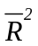 | 0.8048 | 0.3131
number of observations | 38 | 38
standard errors in parenthesis.

Applying these quality estimates to the East-German total social product series with the help of equation (3.1), we obtained a corrected set of annual output growth rates (G-CORR) in Figure 2. A comparison of this series with the official data (G-EAST) reveals that this correction has virtually no effect for the period prior to 1969, which continues to show rapid growth. However, from 1969 to 1988, the revised estimates indicate that total real output actually fell -- by 0.4 percent per year on average -- despite high levels of investment and an increasingly skilled labor force

Figure 2:
Growth in East Germany
(left scale: level of IOCR; right scale: growth rates)
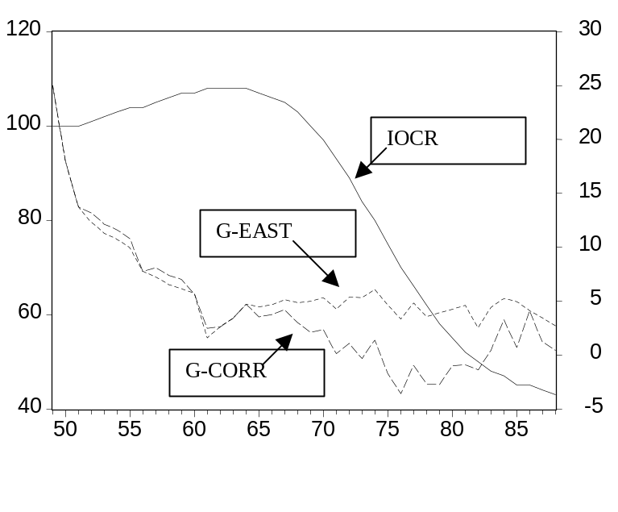

3.2 The Loss of Foreign Exchange Position
To compensate its firms for their export earnings from the West, the East-German regime applied a shadow exchange rate that differed from the official exchange rate of one (East) Mark for one DM. After remaining relatively stable since the mid-1950s, this “commercial exchange rate” was repeatedly devalued after 1968, reaching a 1987 level that was only 45 percent of its 1968 value (Schalk, König 1988). This implied not only a loss of competitiveness but also that consumers increasingly lost access to desired products. Figure 3 shows the RiKo and the ICOR (the inverse of the IOCR). Clearly, the RiKo shows a more radical loss of competitiveness than the ICOR.

Figure 3:
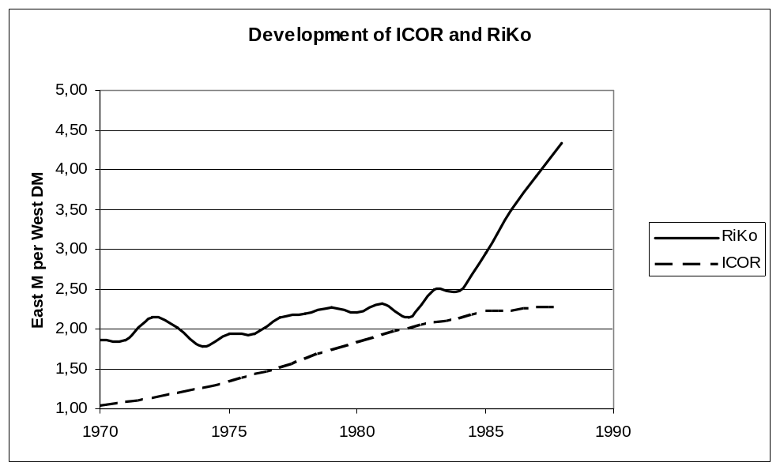

3.3 Revised East German Income Data, 1946 - 2005
We started with data from East German national accounts for 1948 to 1988; income data is given in 1985 prices by East German national statistics. To adapt East German data to that of the West and translate it to the Geary-Khamis Dollar standard (GK$) given in 1990 prices, we proceeded as follows:
- East German per-capita income, calculated as “produced national income”, was 1.653 M in 1950. Following the material product system, services and government are not included. they make up roughly 50% of West German GDP. Furthermore, depreciation and indirect taxes, which make up some 25 % of GDP, are not included. Correcting for these shortcomings, the East German value has to be multiplied by 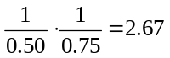 to obtain a rough equivalent of the West German value.
- In a second step, the conversion ratio between the GK$ and the DM or the Euro (€) respectively have to be established. This was based on West German income data. 1950 GDP for West Germany was 353.6 billion DM, for 1960 731.7 billion DM in prices of 1980; in prices of 1990, GDP for 1960 was 1,000 billion DM. This translates into a value of 1950 GDP in 1990 prices of 483.3 billion DM. We obtain, given a population of 49.99 million people, a per capita income of 9,667 DM or 4,882 Euro (DM / € conversion rate of 1.96).
- Given the GK$-value of 4,281 $ for West Germany from Maddison (1995) in 1950, we obtain a scaling factor of 0.878; the scaling factor obtained comparing GK$-values of West Germany for the 1991-1994 period was 0.796. We produced a linearly smoothed series for 1950 to 1988 for adapting East German income in Euro to GK-Dollars.

Example: Given a per-capita income of 1,656 M in 1950 and of 14,533 in 1985, the 1950 and 1985 GK$ value for East Germany is computed as follows:
1950: 1.977 = 1,653 * 2.67 * 0.878 /1.96.
1985: 15,913 = 14,522 * 2.67 * 0.804 / 1.96

In a second step, two possible corrections were applied:
- The series was deflated using the IOCR vector, which implies that an internal evaluation of production is performed. This generated, for 1985, a corrected per-capita income of 7,161 GK-Dollar.
- The series was deflated using the RiKo vector, which implies that an external evaluation of production is performed. This generated, for 1985, a corrected per-capita income of 5,376 GK-Dollar.
- In a final step, both corrections were applied simultaneously and retained for the final analysis. This generated, for 1985, a corrected per-capita income of 6,269 GK-Dollars.

The second correction is more radical then the first because it neglects the effect of local production and local pricing, i.e. purchasing power.

Figure 4:
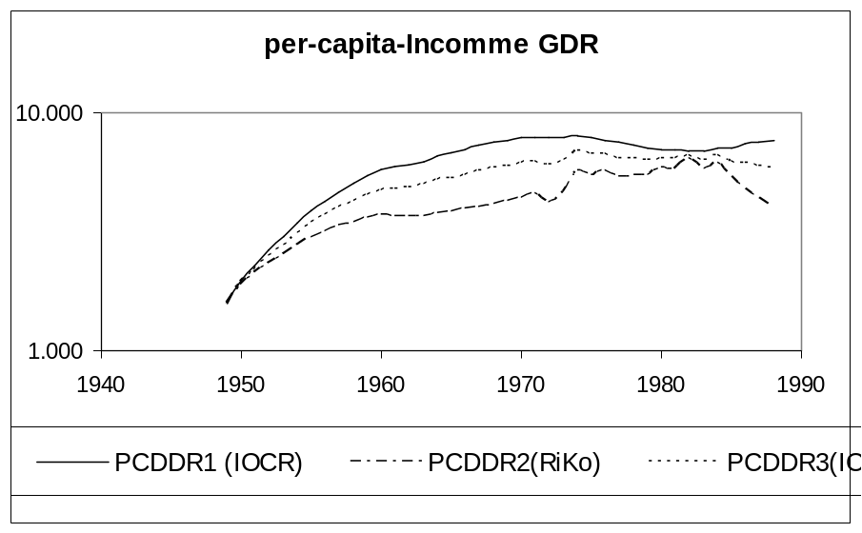

4. The Consolidated Picture
Figure 5 puts the puzzles together. We note that average per-capita income of East Germany hardly exceeded that of the thirties. We know that the Central German Industrial District was among the richest regions of Germany, about 50% above the Reich’s average (### 19##). East Germany, where about 50% of the territory was in this area, has never been able to match this level.
Figure 5:
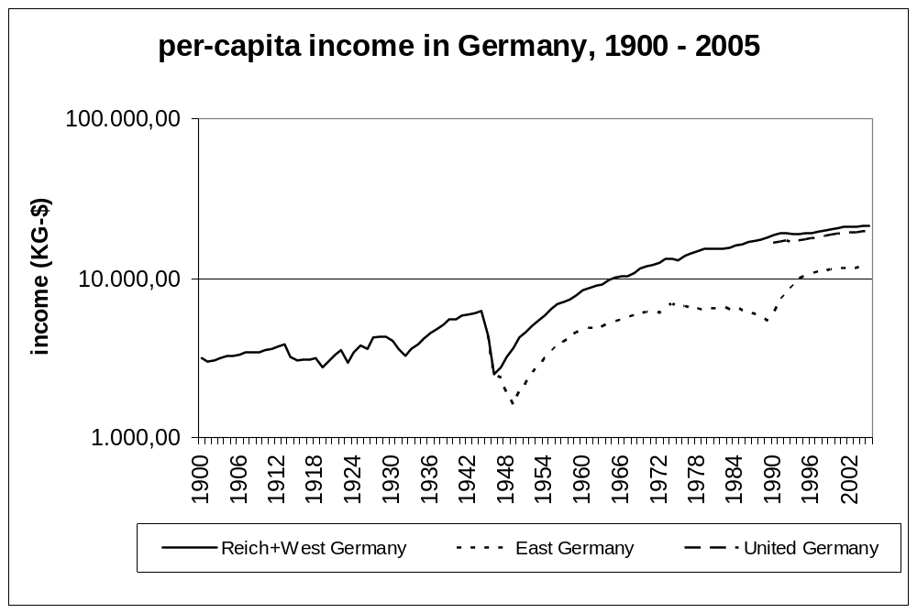

Literature

Blum, U.; Dudley, L.; 1999; The Two Germanies: Information Technology and Economic Divergence, 1949-1989, Journal of Institutional and Theoretical Economics Vol. 155, No. 4, 710-737.
Blum, U.; Dudley, L.; 2000; Blood, Sweat, Tears: Rise and Decline of the East German Economy, 1949 – 1988, Zeitschrift für Nationalökonomie und Statistik – Journal of Economics and Statistics, Vol. 220/4, 438-452.
Boskin, M.J.; Dulberger, E.R.; Gordon, R.H.; Groliches, Z.;. Jorgenson, D. W.; 1998; Consumer Prices, the Consumer Price Index, and the Cost of Living, Journal of Economic Perspectives, 12, 3-26.
Maddison, A., 1995, Monitoring the World Economy, OECD, Paris.
Schalk A.; König, H.; 1988; Zur Entwicklung des Kurses der Mark der DDR zu kapitalistischen Währungen seit 1949, mimeo., German Democratic Republic.
Schwarzer, O., 1990, Die räumliche Ordnung der Wirtschaft in Deutschland um 1910, Steiner, Stuttgart.
Schalck-Golodkowski, A., 2000, Deutsch-deutsche Erinnerungen rororo, Reinbek bei Hamburg.
Statistisches Bundeamt (###), Statistical Yearbook for Germany, Wiesbaden
Staatliche Zentralverwaltung für Statistik (Hrsg.), 1989, Statistisches Jahrbuch der DDR 1989.
Strauß, F.-J, 1989, Die Erinnerungen, Siedler, Berlin

All values are taken from the Statistical Yearbooks of Germany (##)

