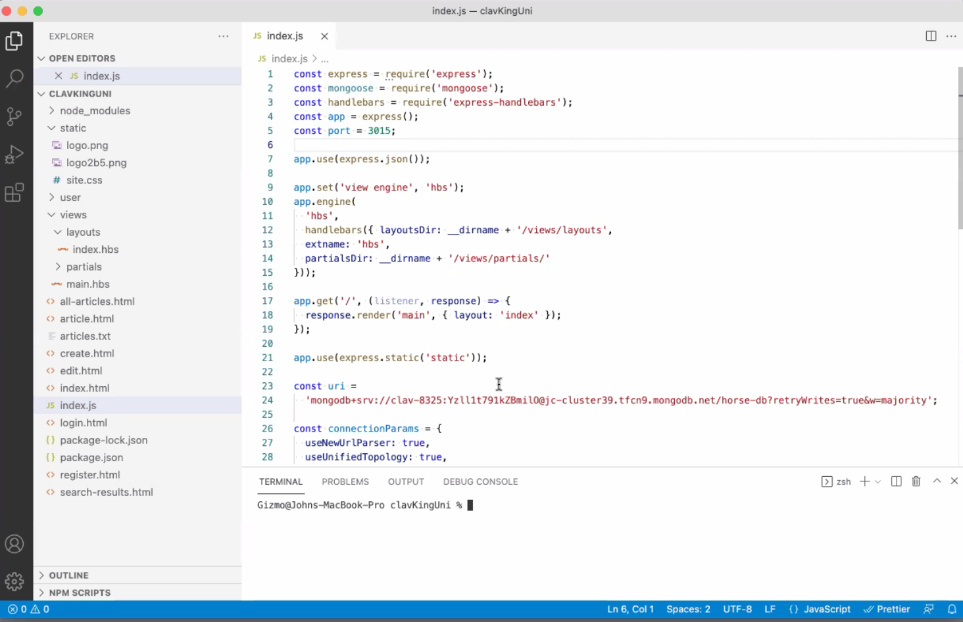
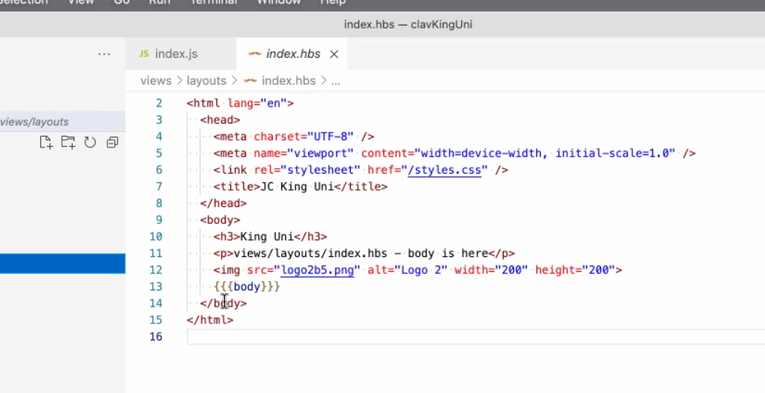

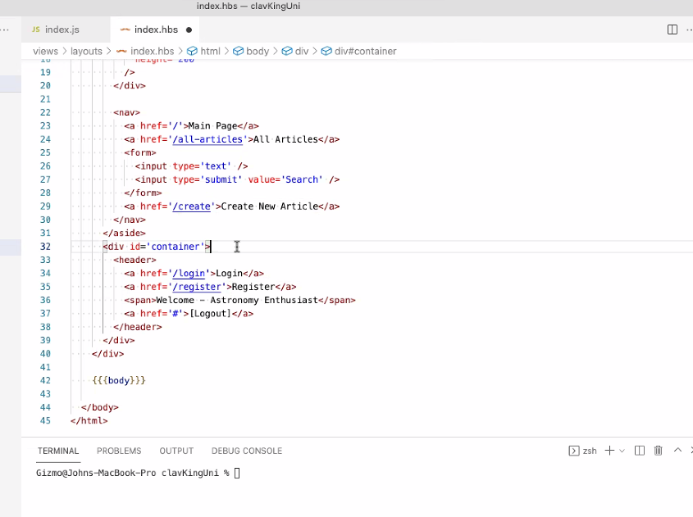
Hi Patrick, it's not explicitly said in the vid tutorial instructions, but it makes sense that if you delete a course, it should be removed from all enrolled users collection of courses. I thought removing it from the Course collection would update the users end since we connected them in the schema build, but that's not the case. Do we have to manually update each enrolled user by filtering out the removed course and saving or is there a better way to do this? Would populating user courses give you only courses that currently exist in the Course collection?
From Patrick Galloway to Everyone: 08:21 PM
you will need to delete the course from the user side too. you wont get the course after its been deleted, but the lookup can cause an error
From Jenna Hee to Everyone: 08:27 PM
Ok. I got the manual way working. I was having trouble updating the user courses to the populated list but I might have just had something wrong with the ordering.
From Patrick Galloway to Everyone: 08:29 PM
so when you go to delete the course populate the users then delete the course id from their array (you can use the .filter method to do this

