Handlebars templates:
home home();

display404 display404();
eventsHolder – commented out for now eventsHolder(); handlebars not working
orgEvent – orgEvent – button click gives console.log
editEvent editEvent(); event listener on button post to console.log
ownerEvent ownerEvent();
joinEvent joinEvent – needs event listener on Join Button
loginForm loginForm() button event listner performs console.log
signupForm – signupForm() button event listener performs console.log
displayProfile – displayProfile() displays page but userId and userURL do not populate

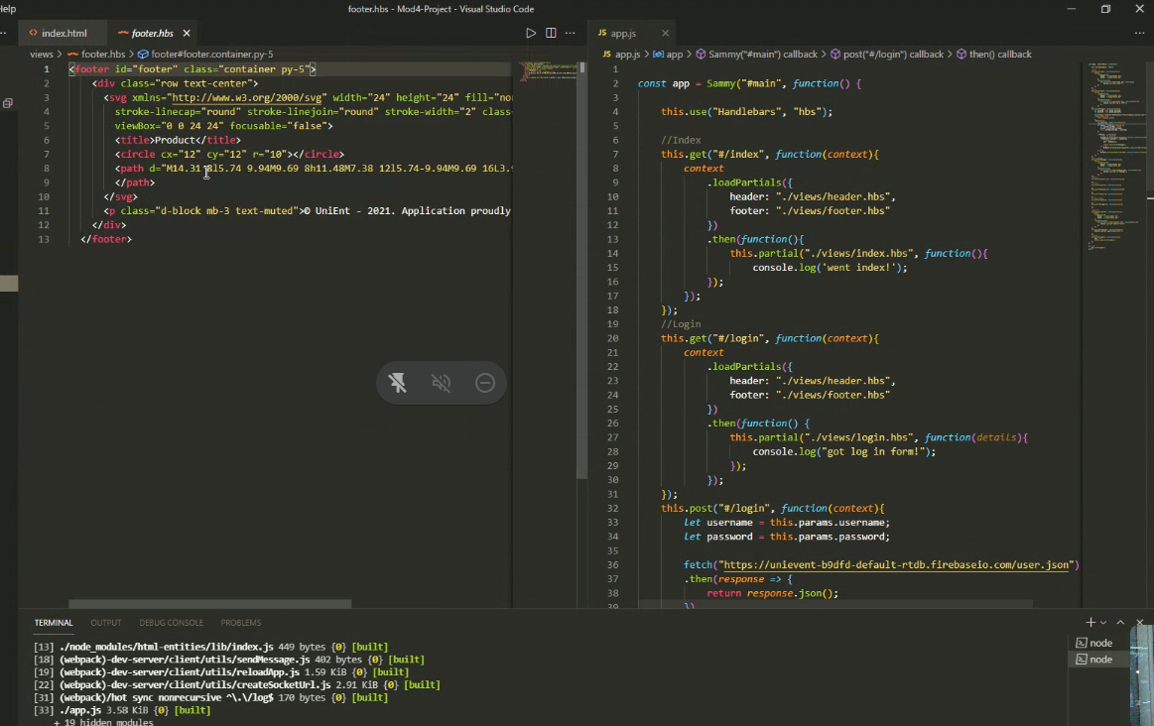

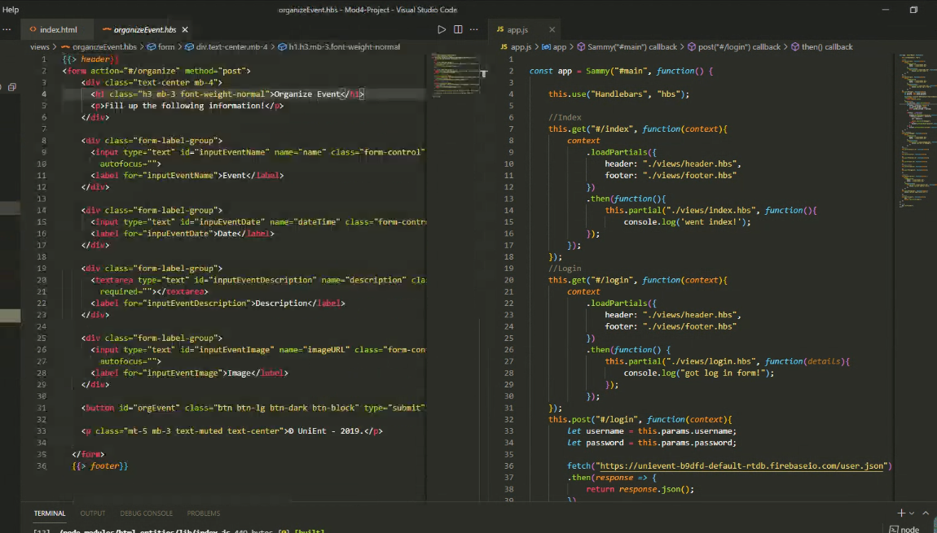

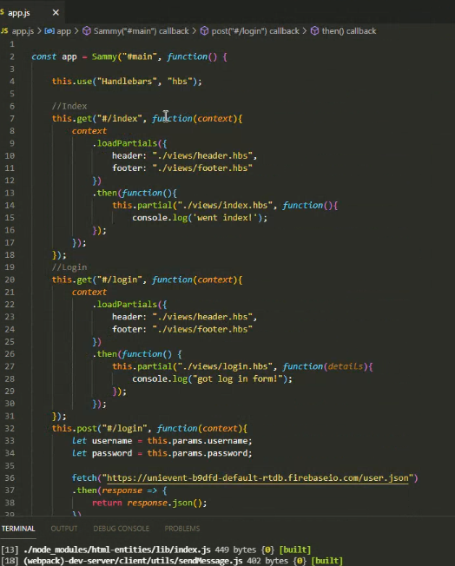

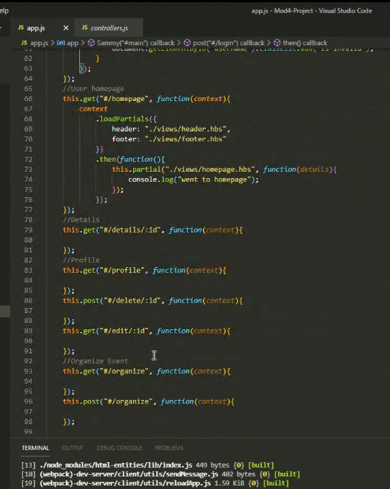

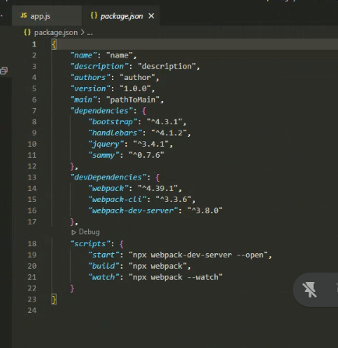

npm i -y

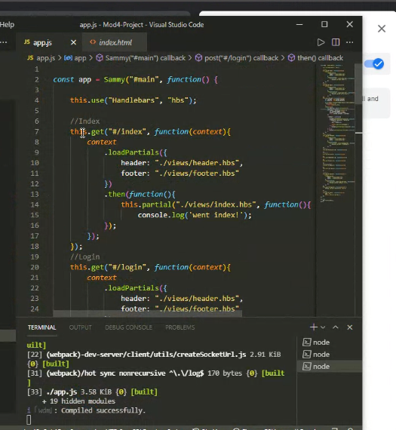
npm start

1:35 loading in dummy data and templating handlebars

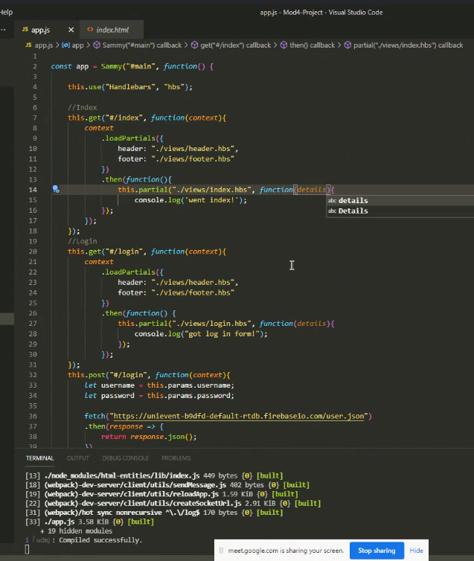

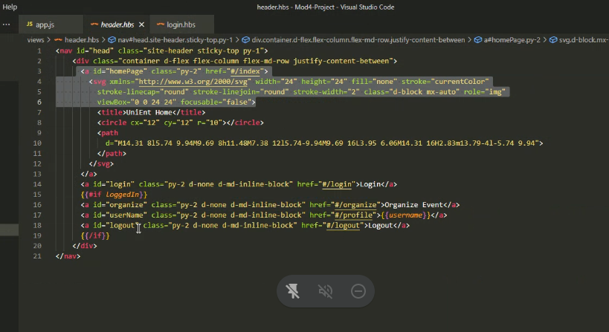

Header at 1:58

https://events-473a6-default-rtdb.firebaseio.com/.json
{
"events": {
"1": {
"dateTime": "09-30-2021 7:00pm",
"description": "Come celebrate the graduation of the class of 2021",
"imageURL": "https://italianallegria.com/wp-content/uploads/2019/02/graduation-3649717_1920.jpg",
"name": "Graduation Party",
"organizer": "user1",
"peopleInterestedIn": 0
},
"2": {
"dateTime": "10-15-2021 8:00pm",
"description": "Greatest girls band of the 60's and 70's",
"imageURL": "https://bloximages.chicago2.vip.townnews.com/qctimes.com/content/tncms/assets/v3/editorial/2/82/282c704f-a025-5e0b-a09b-5c5d4c42b172/58629d654b0f1.image.jpg",
"name": "Cuties Concert",
"organizer": "user3",
"peopleInterested": 0
},
"3": {
"dateTime": "10-27-2021 7:30pm",
"description": "It's a surprise! Come celebrate with us and surprise our birthday girl!",
"imageURL": "https://img.chewy.com/is/image/catalog/139519_MAIN._AC_SL1500_V1540401494_.jpg",
"name": "Birthday Party",
"organizer": "user1",
"peopleInterested": 0
},
"-Mjf0LUAPI6q60HTKK0Y": {
"dateTime": "09-29-2021 7:00pm",
"description": "Graduation class of 2021",
"imageURL": "https://italianallegria.com/wp-content/uploads/2019/02/graduation-3649717_1920.jpg",
"name": "High School Party",
"organizer": "user12",
"peopleInterestedIn": 0
}
},
"users": {
"-MjeyuE2Q-J3iy7XZDrx": {
"loggedin": false,
"orgOf": {
"-Mjf0LUAPI6q60HTKK0Y": "High School Party"
},
"password": "pass12",
"userid": "user12"
},
"-Mjez8RzyEHoGZ8bgPSL": {
"loggedin": "true",
"password": "pass13",
"userid": "user13"
}
}
}

https://www.pixelstalk.net/wp-content/uploads/2016/04/Happy-Birthday-Wallpapers-HD-Images-Pictures.jpg

<a href="#/catalog/:{{teamId}}">Go To Team</a>

-MkVJUxPdO04Jsy8h6gr

MkZGxltTfmDe5i3g1Lf

user1 pass1
user2 pass2

"scripts": {
"start": "npx webpack-dev-server --open",
"build": "npx webpack",
"watch": "npx webpack --watch"
}

{
"events": {
"1": {
"dateTime": "09-30-2021 7:00pm",
"description": "Come celebrate the graduation of the class of 2021",
"imageURL": "https://italianallegria.com/wp-content/uploads/2019/02/graduation-3649717_1920.jpg",
"name": "Graduation Party",
"organizer": "user12",
"peopleInterestedIn": 5
},
"-Mjf0LUAPI6q60HTKK0Y": {
"dateTime": "09-29-2021 7:00pm",
"description": "Graduation class of 2021",
"imageURL": "https://italianallegria.com/wp-content/uploads/2019/02/graduation-3649717_1920.jpg",
"name": "High School Party",
"organizer": "user12",
"peopleInterestedIn": 4
},
"-MkTMr7J4Gis3tKxDCfX": {
"dateTime": "10-27-2021",
"description": "fdghkk.jhybo87yt ot7 u 6tv5r5rcv5r6",
"imageURL": "https://www.pixelstalk.net/wp-content/uploads/2016/04/Happy-Birthday-Wallpapers-HD-Images-Pictures.jpg",
"name": "Test 111",
"organizer": "user12",
"peopleInterestedIn": 1
},
"-MkUxaxb4m9H8sOOindU": {
"dateTime": "10-27-2021",
"description": "Greatest girls band of the 60's and 70's",
"imageURL": "https://bloximages.chicago2.vip.townnews.com/qctimes.com/content/tncms/assets/v3/editorial/2/82/282c704f-a025-5e0b-a09b-5c5d4c42b172/58629d654b0f1.image.jpg",
"name": "Cuties Concert Duex!!",
"organizer": "jm1",
"peopleInterestedIn": 0
},
"-MkUy72rm6HwQEGknY0L": {
"dateTime": "10-27-2021 8:00 pm",
"description": "It's a surprise! Come celebrate with us and surprise our birthday girl!",
"imageURL": "https://img.chewy.com/is/image/catalog/139519_MAIN._AC_SL1500_V1540401494_.jpg",
"name": "Birthday Party",
"organizer": "jm1",
"peopleInterestedIn": 0
},
"-MkVCG00qo8ue0HsBPEn": {
"dateTime": "10-28-2021 10:12pm",
"description": "new description from jm at 10:12 pm",
"imageURL": "https://weneedfun.com/wp-content/uploads/2016/01/Blue-Flower-13.jpg",
"name": "Test 10:12",
"organizer": "jm1",
"peopleInterestedIn": 11
},
"-MkVJUxPdO04Jsy8h6gr": {
"dateTime": "10-30-2021",
"description": "This is the new description",
"imageURL": "https://italianallegria.com/wp-content/uploads/2019/02/graduation-3649717_1920.jpg",
"name": "Graduation",
"organizer": "jm1",
"peopleInterestedIn": 0
},
"-MkXqzPerZeEUe157k0b": {
"dateTime": "09-30-2021",
"description": "Come celebrate the graduation of the class of 2021",
"imageURL": "https://clipartart.com/images/school-graduation-clipart-7.png",
"name": "Graduation",
"organizer": "user12",
"peopleInterestedIn": 0
},
"-MkZL7xglZ14mNq0dMTS": {
"dateTime": "10-28-2021 8pm",
"description": "new description from jm\r\noriginal id: -MkVCG00qo8ue0HsBPEn\r\n\r\nadded time",
"imageURL": "https://weneedfun.com/wp-content/uploads/2016/01/Blue-Flower-13.jpg",
"name": "Test",
"organizer": "jm1",
"peopleInterestedIn": 0
},
"-MkZvZfFz-Pi2BYcVw9u": {
"dateTime": "10-28-2021 8pm",
"description": "this is a new event",
"imageURL": "./images/user.png",
"name": "Event 9:50 pm",
"organizer": "jm1",
"peopleInterestedIn": 0
}
},
"users": {
"-Mjez8RzyEHoGZ8bgPSL": {
"loggedin": "true",
"password": "pass13",
"userid": "user13"
},
"-MkTi36a5h5_iSkyLKkr": {
"loggedin": "true",
"password": "jm1",
"userid": "jm1"
},
"-MkXcZi5ftXh0PxCG_O1": {
"loggedin": "true",
"password": "user12",
"userid": "user12"
}
}
}
// context.pageUsername = pageUsername;
// context.loadPartials({
// headerIn: "./views/headerIn.hbs",
// footer: "./views/footer.hbs",
// })
// .then(function () {
// this.partial("./views/four04.hbs", function (details){

// });
// });





