Using Large Language Models to Automatically Generate Assertions in Selenium Tests

Objective
The goal of this assignment is to explore the use of Large Language Models (LLMs) to automatically generate assertions in Selenium WebDriver test scripts where they are missing.
Students will design an experiment to evaluate the effectiveness of an LLM in producing meaningful, executable, and correct assertions under different prompting conditions. The goal of the experiment is to analyses how the quality of the generated assertions varies depending on the contextual information made available to the model.
The LLM to be used will be unique for all groups and will be established by the instructor.

Applications
- As a first case study, the experiments must be carried out on the Spring Petclinic web application, a widely used reference app for testing. This will allow students to become familiar with the experimental procedure using an already known application. The test suite will be made available on Aulaweb, and you will have to use that one.

- As a second case study, students will work on an additional open-source web application assigned by the instructor. The test suite assigned to the different groups will be one of those available in the BEWT repository: https://github.com/OlianasD/BEWT.A table will be made available on Aulaweb indicating, for each group, the application to be considered.

Before starting the experiment, after installing the applications, run the test suite several times to verify that all test cases pass and that there are no flakiness issues. If any flakiness problems occur, try to fix them by adding appropriate Thread.sleep statements. Also pay attention to the fact that running a test suite multiple times may change the state of the application, for example by adding a user. This may cause some tests to fail if the application is not restored to a clean initial state. Therefore, before running the experiment, make sure that the application is in a clean initial state. The Petclinic test suite provided on AulaWeb is designed to test Petclinic running locally. If you are using the Dockerized version instead, please modify it accordingly. Also, make sure to customize the POM files as needed.

Prompting Strategy and Treatments
The experiments must be performed in a zero-shot setting, meaning that the model will receive only the instruction and the available context, without worked-out examples of how assertions should be generated. The purpose is to evaluate how well the model can understand the Selenium test context and generate meaningful assertions without additional examples.
For each application, students must consider the following three treatments:
- Without comments: each test (deprived of the original assertion) contains no explicit comments describing the assertion to be generated. The process will consist of two main steps. First, the assertions will be removed from the original test, which will then serve as the gold standard for the evaluation (see below). Second, in place of each removed assertion, a placeholder comment will be inserted to explicitly indicate where the LLM is expected to generate the missing assertion. Specifically, the following comment will be added: // Insert here a JUnit 5 assertion that correctly reflects the purpose of the test.

- With comments: each test (deprived of the original assertion) contains a natural language comment indicating what the assertion should check within the page. These comments may be generated previously and automatically using an LLM by analyzing the assertion to be described., but they must be manually validated before being used in the experiment. The natural language comment describing the assertion must be placed immediately before the placeholder comment: // Insert here a JUnit 5 assertion that correctly reflects the purpose of the test that substitutes the assertion.

- With comments plus web pages: each test (deprived of the original assertion) contains a natural-language comment indicating what the assertion should check on the page. In addition to the commented tests, the corresponding HTML pages observed before the assertion point will also be provided to the LLM. The web page must contain only the HTML and therefore must be cleaned of any JavaScript and CSS. These pages can be recorded in advance by executing the tests with suitable Selenium commands able to get the HTML and then included in the prompt given to the LLM

Experimental Procedure
- Download from Aulaweb the Selenium test scripts for Petclinic.
- Prepare the three treatment versions described above: without comments, with comments, and with comments plus web pages.
- Compare results across treatments following the steps 2, 3 and 4 explained below.
- Fill in the given excel file available on Aulaweb.
- For the second application, use the application assigned to your group in the table published on Aulaweb.
- Prepare the same three treatment versions as done for PetClinic.
- Compare results across treatments following the steps 2, 3 and 4 explained below.
- Fill in the given excel file available on Aulaweb.

Prompt Engineering to generate assertions
- Use the LLM established by the instructor.
- Experiment with zero-shot prompts to guide the model in generating assertions.
- In the version without comments, ask the LLM to substitute the placeholder // Insert here a JUnit 5 assertion that correctly reflects the purpose of the test with a JUnit 5 assertion.
- In the version with comments, ask the LLM to generate the assertion immediately after the comment, previously generated that explain in natural language the original assertion, substituting the placeholder // Insert here a JUnit 5 assertion that correctly reflects the purpose of the test.
- In the version with comments plus web pages, the prompt will include both the tests with comments and, as additional context, the HTML pages visited by the test case before the assertion point.

LLM Model
The model to be used for the experiment is Gemma-4-31B-it, an instruction-tuned model from Google DeepMind’s Gemma family. It is a 31B-parameter model designed to follow natural-language prompts and suitable for tasks involving reasoning, text understanding, and code generation. For this reason, it is appropriate for our task, where the model must generate missing JUnit 5/Selenium assertions from a test case, optionally supported by assertion-guiding comments and cleaned HTML context. The model is available through Google AI Studio and should be used via API rather than running it locally. This simplifies the setup and ensures that all groups interact with the same model under comparable conditions.

Example of Prompt
You are given a Selenium JUnit 5 test where the original assertion has been removed.
Generate only the missing JUnit 5 assertion at the placeholder position.
Do not modify the rest of the test.
Do not add explanations.
The assertion must be executable and consistent with the purpose of the test.
[Test code here]
[Optional: cleaned HTML pages visited before the assertion point here]

Execution and Functional Evaluation
- Run the three versions of the test suites corresponding to the three treatments (remember to first run the complete experiment on PetClinic, and only afterwards on the application assigned to you).
- Record the functional outcome of each generated assertion. In particular, each generated assertion must first be classified according to its execution outcome as passed, when the test executes successfully with the generated assertion; failed, when the generated assertion is executed but the test fails; or run time error, when the generated assertion causes an execution exception. For example, in Selenium tests, an assertion should be classified as run time error if it triggers a NoSuchElementException because the generated locator refers to an element that is not present in the page. Finally, not compiling when the test cannot be compiled.
- Compare results across treatments filling in the given excel file available on Aulaweb.

Qualitative Error Analysis
In addition to the functional evaluation, each generated assertion must be manually classified into one of the following categories:
Category | Meaning
Correct | The assertion is equivalent to the gold-standard/reference assertion.
Over-assertive | The assertion checks more than necessary and may fail because of irrelevant or unstable details.
Under-assertive | The assertion checks less than necessary and may pass even when the page behavior is wrong.
Wrong assertion | The assertion checks the wrong element or the wrong condition (it does not check the intended testing objective).
Not executable | The assertion does not compile or cannot be executed.

This qualitative analysis is fundamental to understand why one treatment works better than another. Passing tests alone are not sufficient: an assertion may pass because it is too weak, while a failing assertion may fail because it is too strong or because it checks irrelevant implementation details.

Examples: Under-assertive and Over-assertive
To evaluate the generated assertions, it is important to distinguish between under-assertive and over-assertive assertions.
An under-assertive assertion checks something related to the expected behavior, but it is weaker than the reference assertion. In other words, it may pass even when the test does not fully verify the intended behavior.
For example, the reference assertion checks whether the expected last name appears in a specific element of the page:
// Reference assertion
WebElement firstResult = driver.findElement(
By.xpath("/html[1]/body[1]/div[1]/div[1]/table[1]/tbody[1]/tr[1]/td[1]/b[1]")
);
assertTrue(firstResult.getText().contains("Franklin"));
);

The generated assertion only checks whether the last name appears somewhere in the page source:
// Generated assertion
assertTrue(
driver.getPageSource().contains("Franklin"),
"Owner with last name 'Franklin' should be present"
);
This is under-assertive because the assertion is too weak: the last name could appear anywhere on the page, not necessarily in the expected result position.

An over-assertive assertion checks the expected behavior, but it also adds extra constraints that were not required by the reference assertion. This makes the test more restrictive than necessary and may cause it to fail even when the application behaves correctly.
For example, the reference assertion directly searches for the bold element containing the expected owner name:
// Reference assertion
WebElement ownerElement = driver.findElement(
By.xpath("//b[contains(text(),'George Franklin')]")
);
assertEquals("George Franklin", ownerElement.getText());
The generated assertion first restricts the search to the first table with class table, and only then looks for a bold element:
// Generated assertion
WebElement ownerNameElement = driver.findElement(
By.xpath("//table[contains(@class,'table')][1]//b")
);
String actualOwnerName = ownerNameElement.getText();
assertEquals(
"George Franklin",
actualOwnerName,
"Expected owner name to be '" + owner + "' but was: " + actualOwnerName
);
This is over-assertive because it introduces an additional structural constraint: the owner name must appear inside the first table with class table. This constraint is not present in the reference assertion.

In summary:
Under-assertive means: the generated assertion checks too little.
Over-assertive means: the generated assertion checks too much.

Experiment Execution Modes
The experiment can be carried out with different degrees of automation.
Students may use simple scripts that call the selected LLM while keeping several steps manual, such as, e.g., manually removing the original assertions that will constitute the gold standard and fill in the Excel file..
Alternatively, students may implement a more agentic system, especially those who attended the Advanced Secure Software Engineering course, to automate almost all phases of the experiment. However, the validation of the generated comments and the qualitative classification of the generated assertions as Correct, Over-assertive, Under-assertive, Wrong assertion, or Not executable must always be performed manually.

Deliverables
- A written report containing briefly:
- Experimental setup, assigned application, and LLM used.
- The prompts used and the rationale behind them.
- A clear description of the various steps performed, such as how the comments related to the assertions were validated, how the web pages were produced, how they were cleaned of JavaScript and CSS, and how they were provided to the LLM.
- Problems, difficulties, anomalies encountered, and choices made while executing the task.
- A summary of the results of test execution, including the number of assertions generated and pass/fail/not executable/working rates. That is, a table similar to this one, accompanied by charts that visually show the percentages.
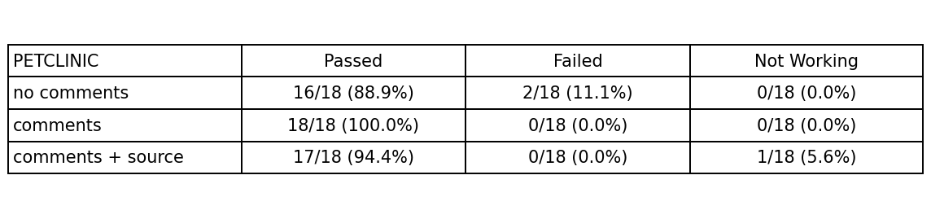
- A summary of the qualitative classification of each generated assertion according to the categories above. That is, a table similar to this one, accompanied by charts that visually show the percentages.

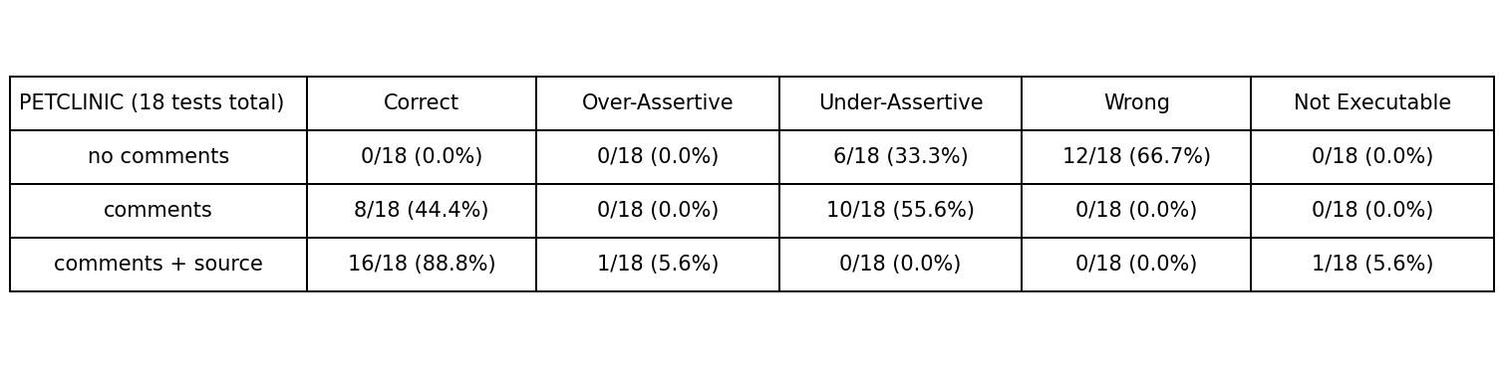
- An Excel file summarizing the obtained results. A template will be provided on Aulaweb and must be used for the submission.

Expected Learning Outcomes
- Understand the role of assertions in automated testing.
- Gain experience with Selenium test development and execution.
- Learn how to design and conduct experiments with LLM-based tools.
- Understand the concept of zero-shot prompting and its implications for evaluating LLM capabilities.
- Develop critical skills in analyzing the effectiveness of LLM-based code generation.
- Assess how results vary across different applications, prompts, and treatments.

