1)Take a picture/screenshot of your white board, post it notes, Google doc, or whatever you use for initial brainstorming.

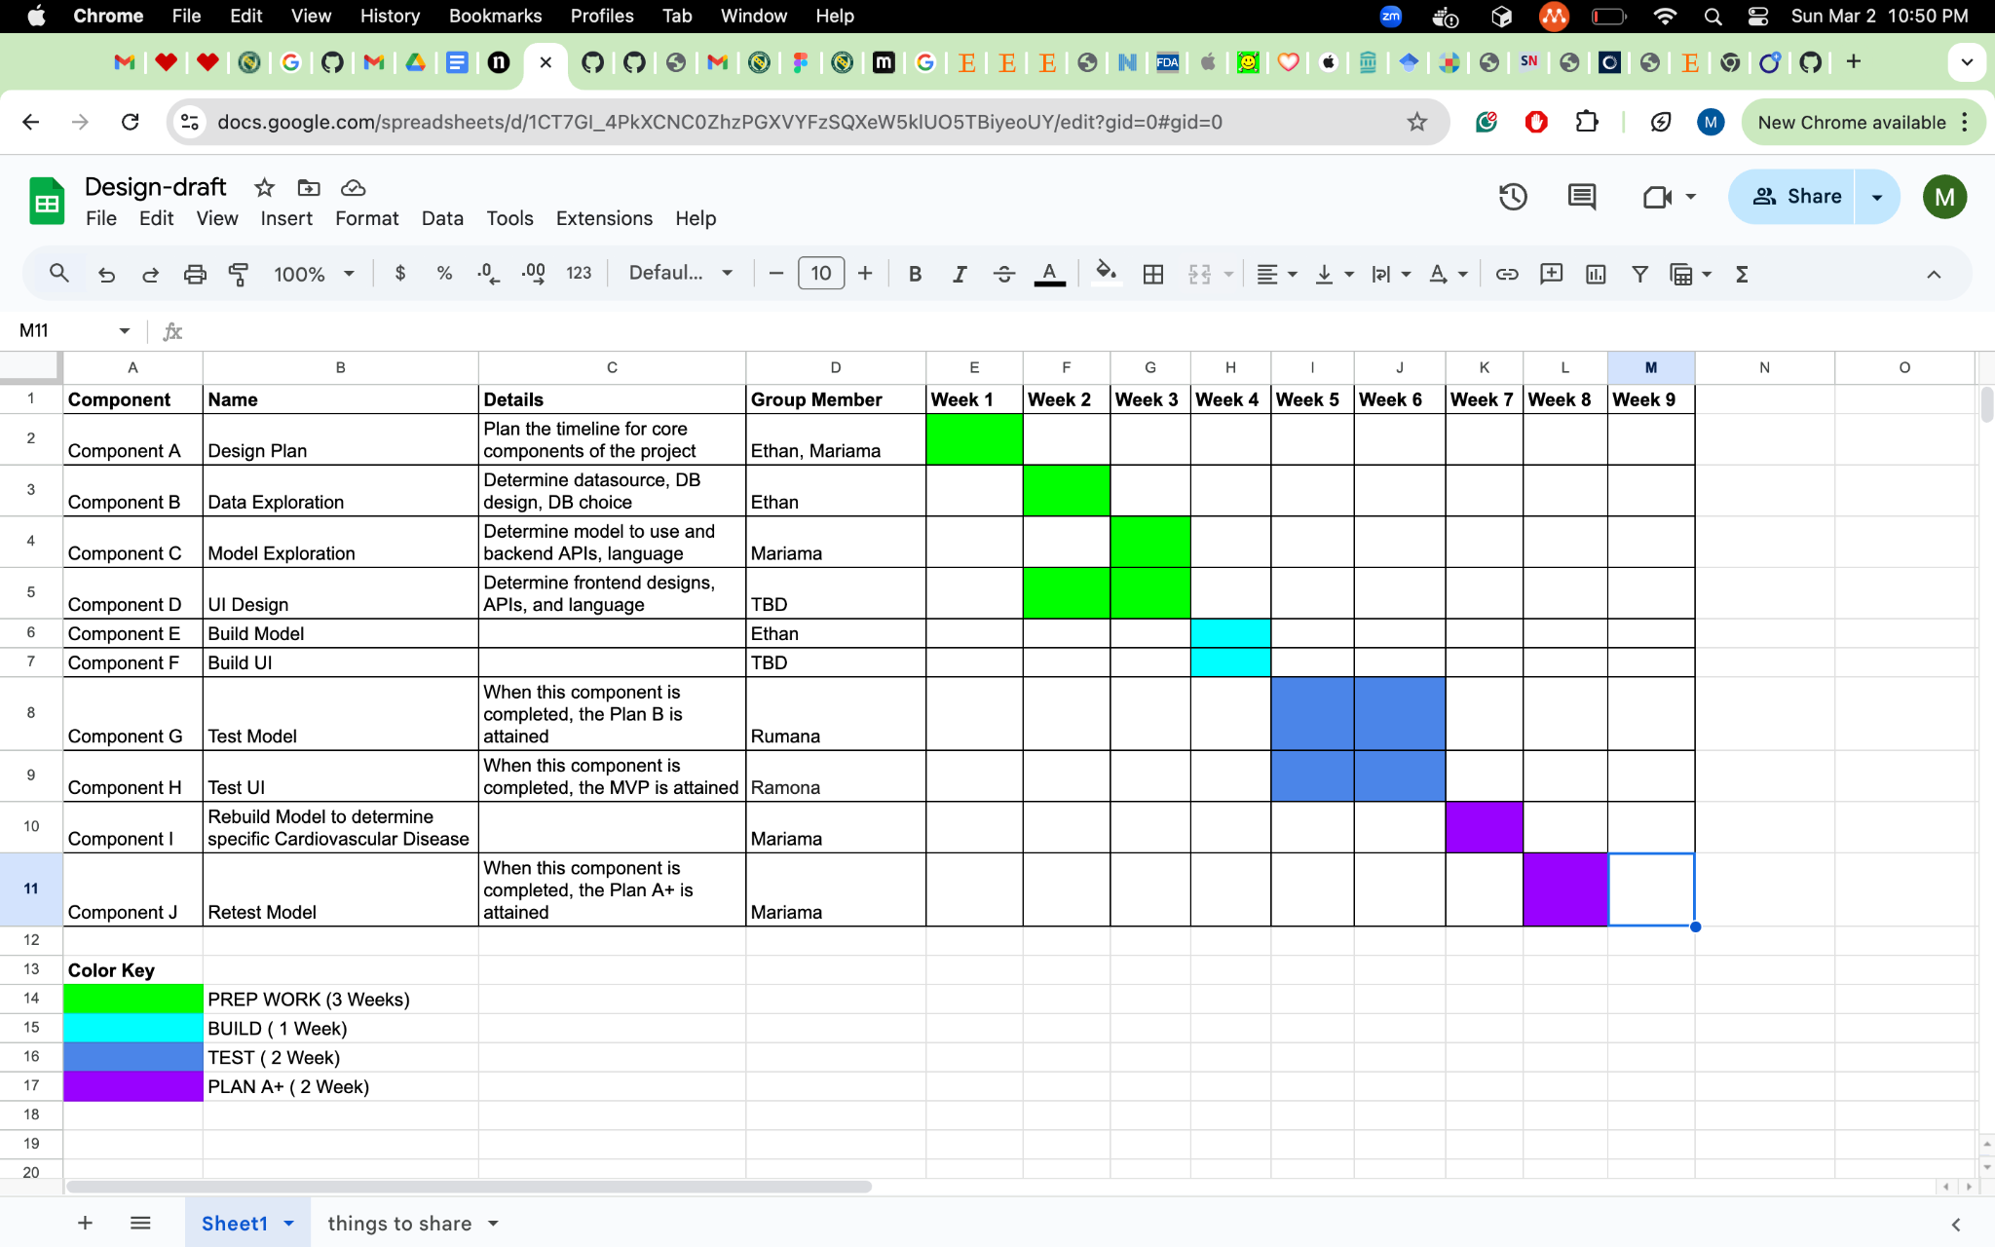

2) Tell me what GANTT chart tracking software you've chose to use (Excel, Google sheets, dotProject, etc.)

*Google sheets*

3) Submit a PDF version of your initial schedule with half week intervals. It should show the critical path, dependencies among subtasks, who will do what, etc.

*It has been submitted*

4) Propose a plan for updating the GANTT chart each week. Will you meet to update it collectively? Will you identify one person who will be in charge of actually updating the GANTT chart and exporting a PDF version along with some high level notes about how it has changed (more subtasks added, some subtasks completed, critical path slipping, new estimates)?

*We will meet on Tuesdays and Saturdays to update it together. We will then submit the pdfs.*

5) Describe your anticipated/target MVP as well as at least one "Plan B" MVP for if the schedule is slipping and a "Plan A+" if things are going really well.

*MVP: A web application that* ***predicts the presence*** *of cardiovascular diseases*

*Plan B:* ***Just a model*** *that predicts the presence of cardiovascular diseases*

*Plant A+: A web application that* ***predicts the type*** *of cardiovascular diseases present*

6) What is on the critical path in your GANTT chart towards your MVP?

*Data Exploration -> Build Model -> Test Model*

7) Identify a list of key risks to the success of your project. Make a plan for resolving the risks as early as is possible.

1. *Datasource: Some components of the project depend on the datasource eg. model generation. The quicker we determine the datasource, the better. We plan to flush out the datasource in the second week of the project.*
2. *Model generation: As the model determines the success of the project (the higher accuracy the better), we plan to start this at the beginning of the project.*
3. *Working Together as Group Work: Like every other group, we might face issues like time conflicts. We have decided to meet on Tuesdays and Saturdays to ensure everyone is on the same page.*