How users are intended to use this product. The user is very specific, someone interested in calculating the various environmental affects of the CMP Slurry manufacturing process.

The full system isn't completed yet, but if it was the user would be able to use the data collected by Clarkson faculty member to get valuable information on processes. This includes process time, energy consumption, waste, quality of product, yield, and emission level. This would also later include something about the "impact assessment", which calculated all the things above and see which process is good.

This leads us the the second part of what the system should be able to do. After the user input, they will be able to compare it to other processes with that was completed.

Additionally, the user can also include data's of their own to the website.

This will all be possible when the full system is completed.

In the Demo version of the site now:

Opening the site

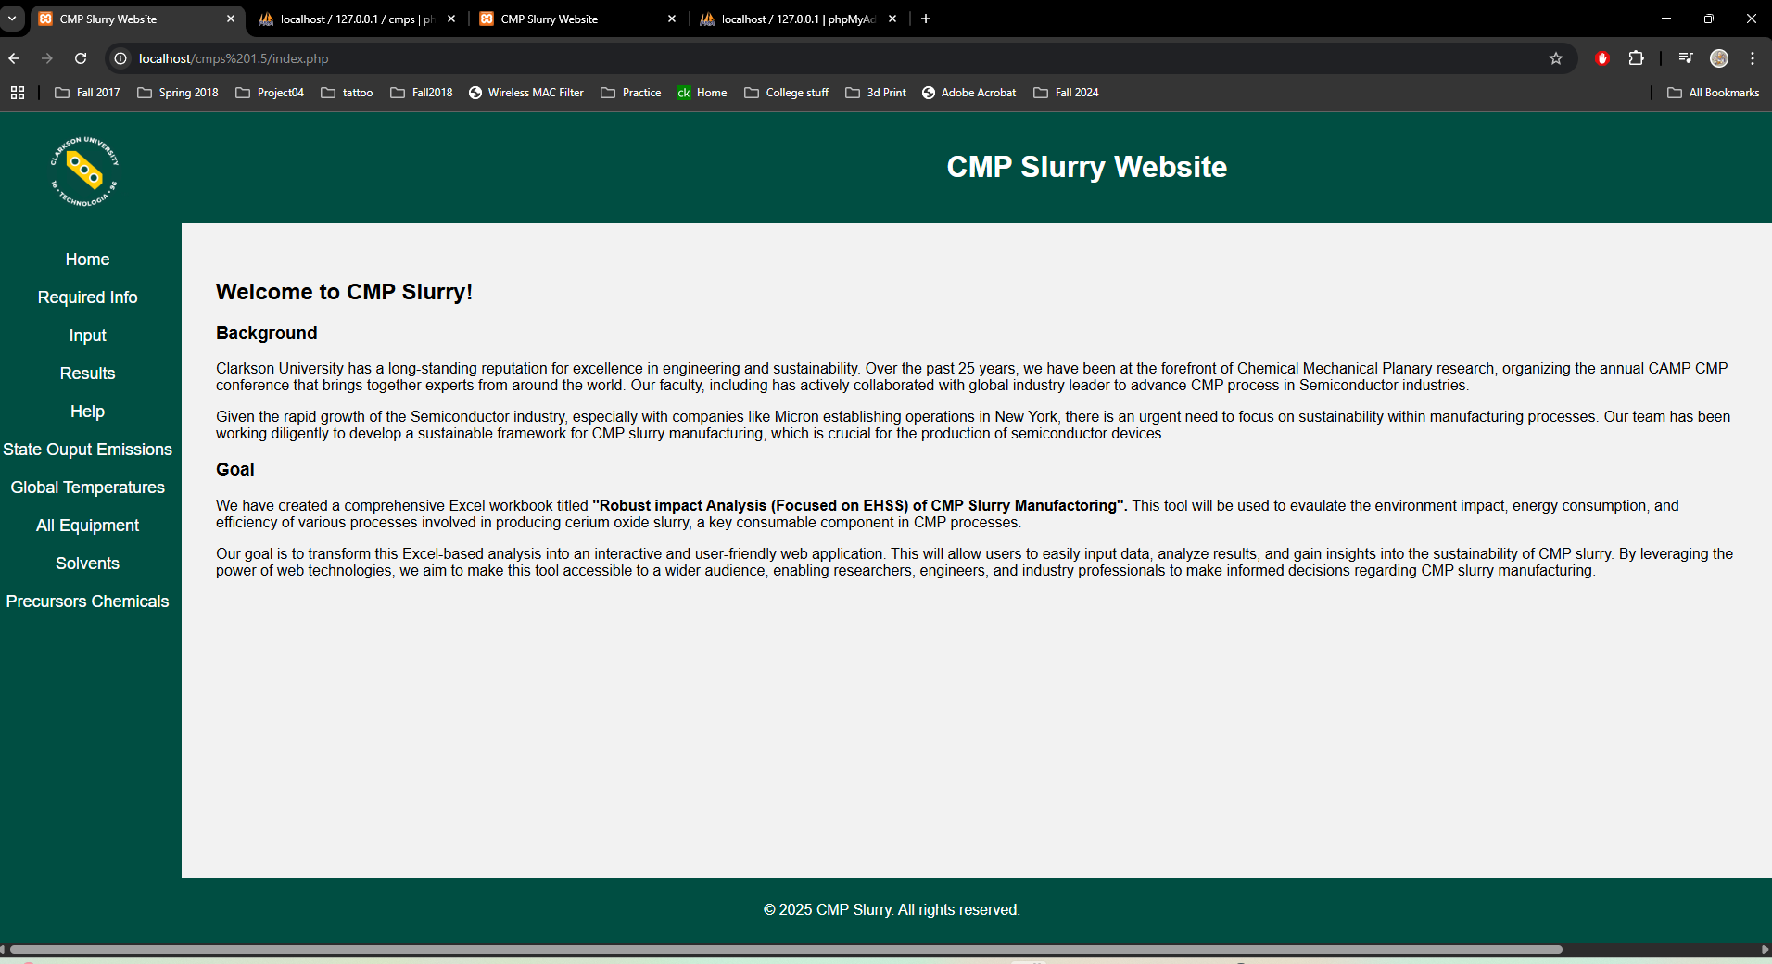

Selectable tabs

Tab Home:

Displays the goal of the project and background



Tab Required Infor:

Tells the user what information is required for each task and is nicely highlighted.

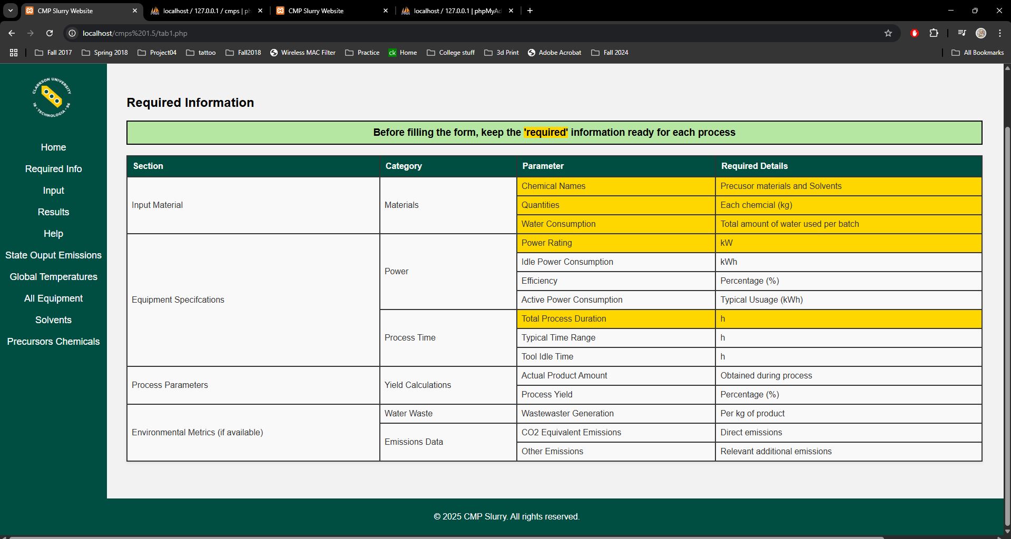

Tab Input:

Though button 'Add process' doesn't save the results of the process, Button 'Calculate' functions

When pressed with inputs:

-Idle Electricity Consumption(kWh)

-Active Electricity Consumption(kWh)

-Heating/Cooling Energy(kWh)

-Total Energy Consumption(kWh)

-Water used for reaction

-cleaning/Washing Particle

-Tool Washing

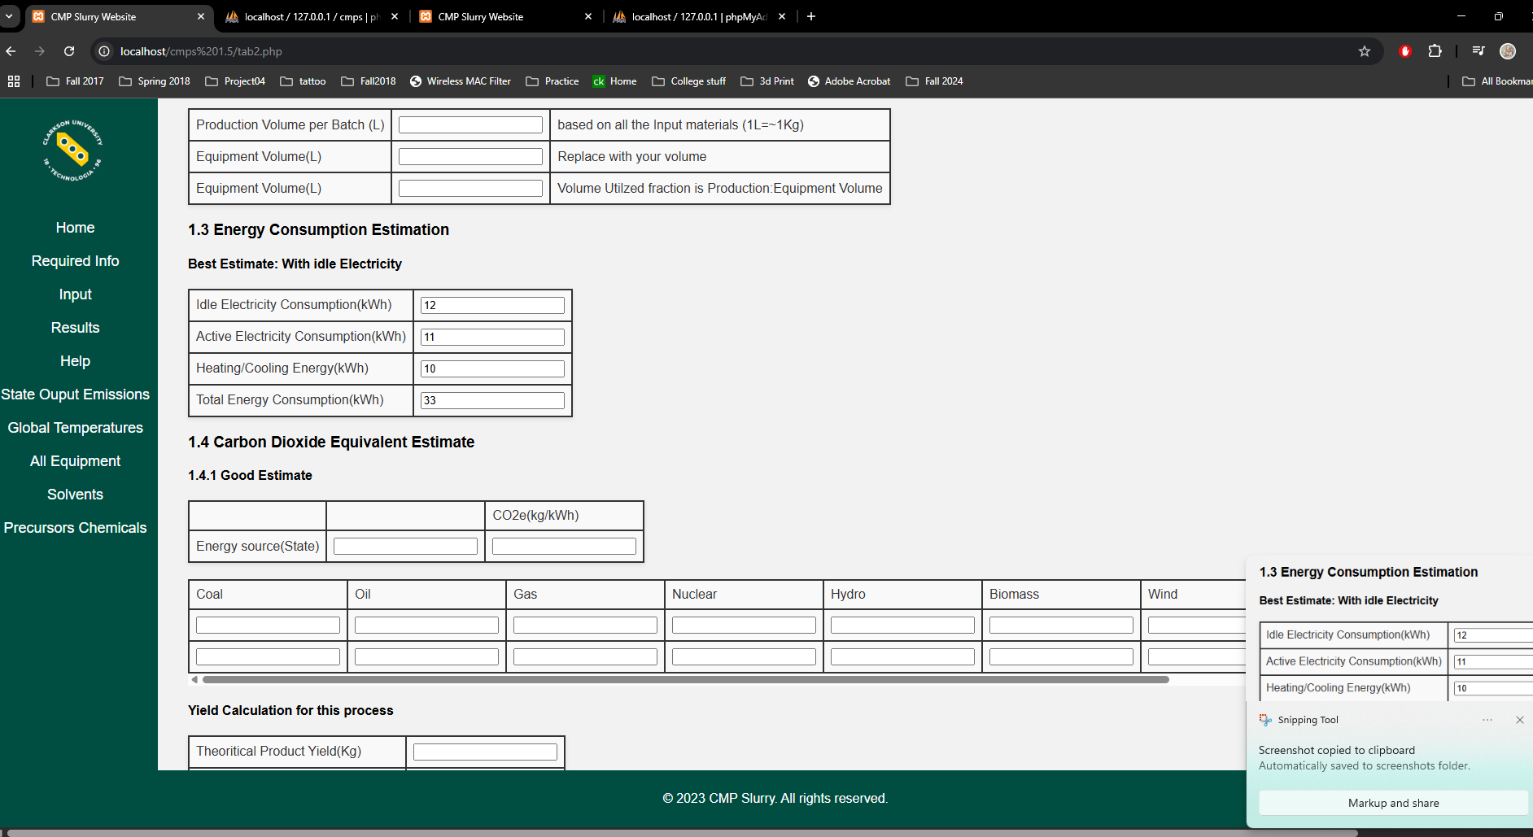

Example of required fields and input

Will display the calculation results for Impact Assessment fields and Energy Consumption Calculations

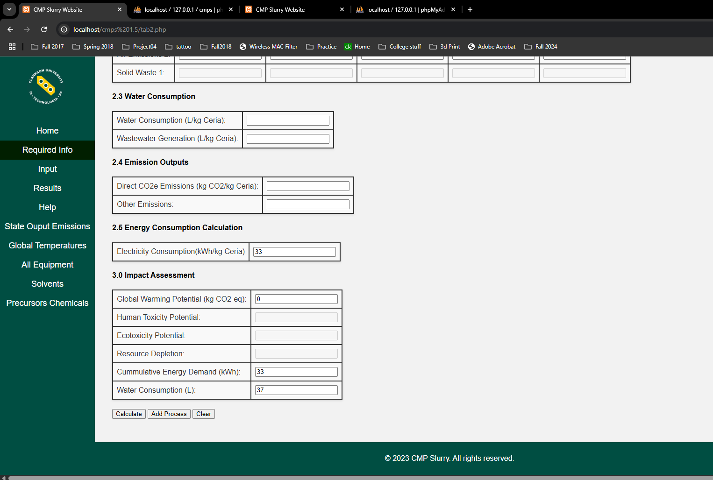

\*currently no error handling of incorrect input

Button 'Clear' Clears form

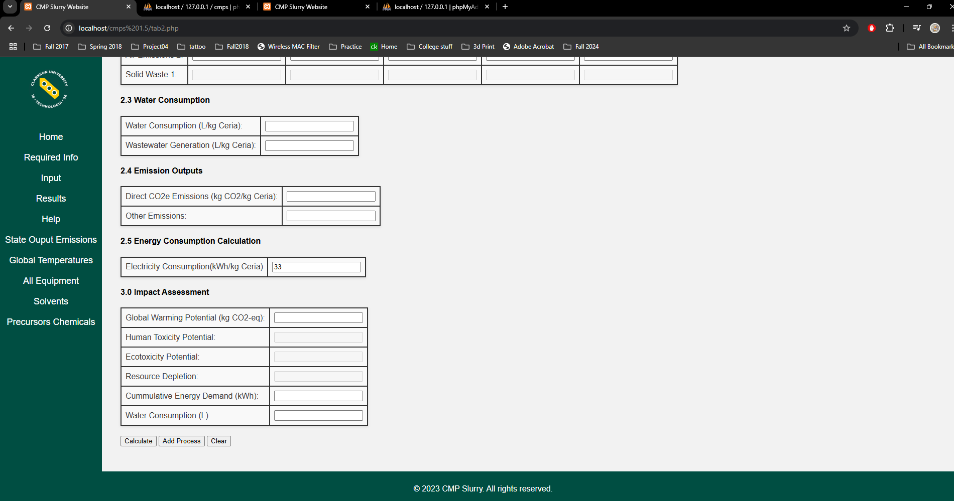

Cleared fields

Tab Results:

Displays dummy results to show what saved results would look like and what informatin would be saved

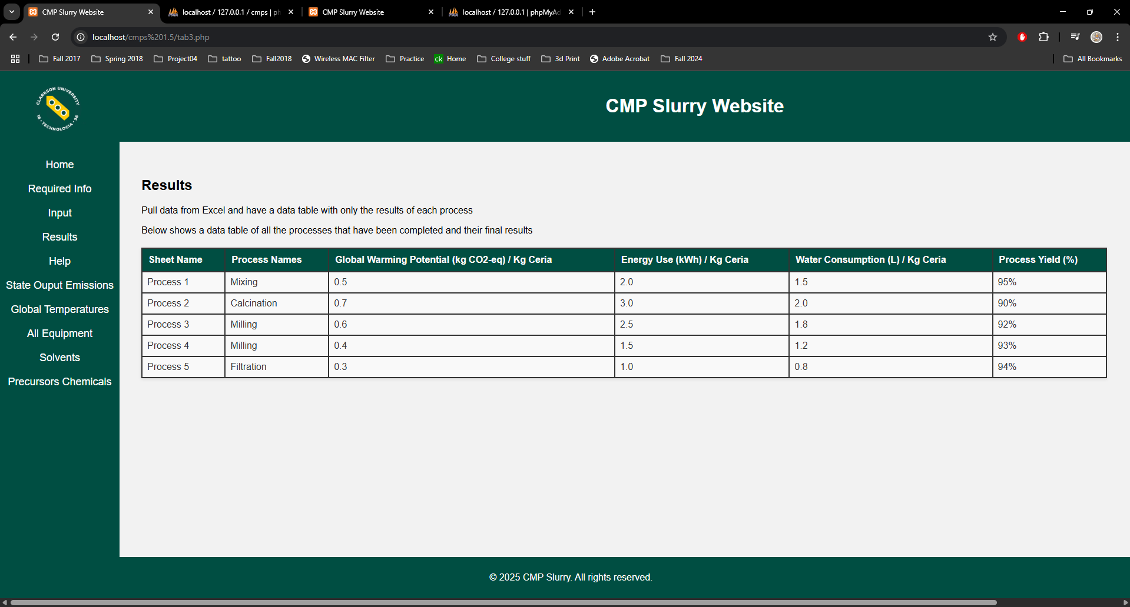

Tab Help:

Not implemented

Tab State Output Emissions:

Not implemented

Tab Global Temperatures:

The clients wanted a graph of the global temperatures so it's displayed on this tab

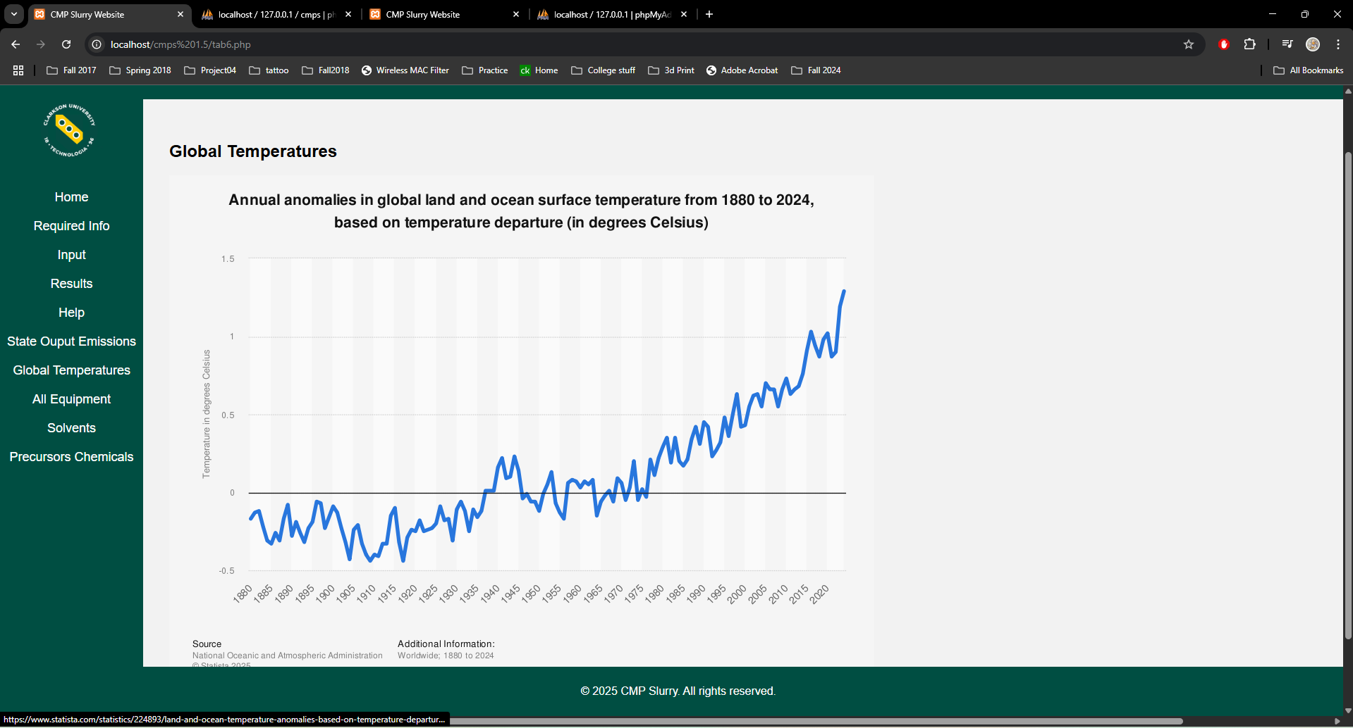

Tab All equipment:

Displays all available equipment for a process and it's related stats.

This table can only be updated through the phpMyAdmin tab through updating the table with sql or it's GUI

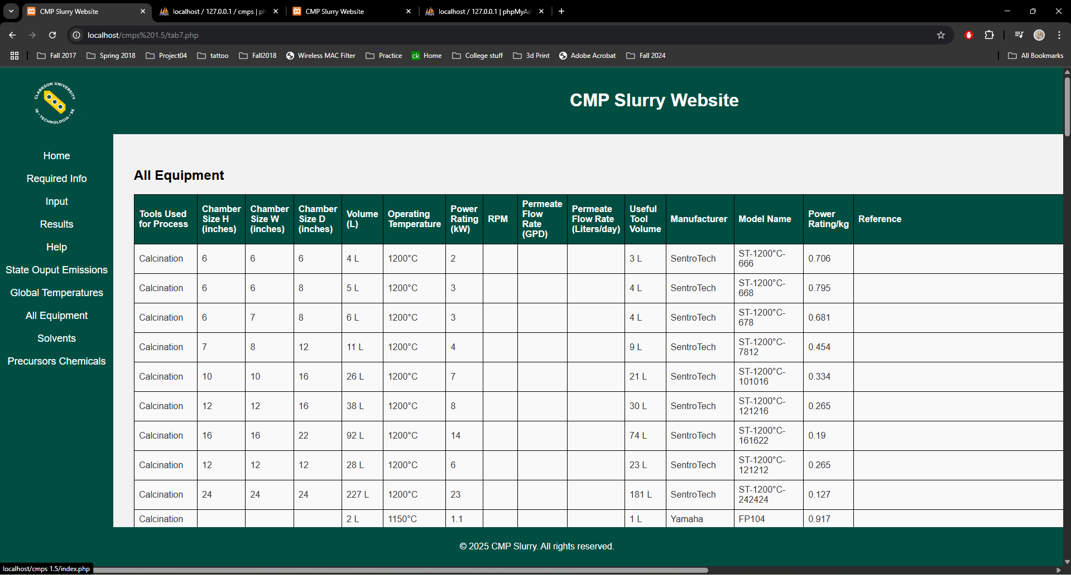

Tab Solvents:

Displays an up to date table of available solvents.

This can be added to with the "Add New Solvent" and filling in the required inputs.

When an solvent is added the display will refresh to reflect the update.

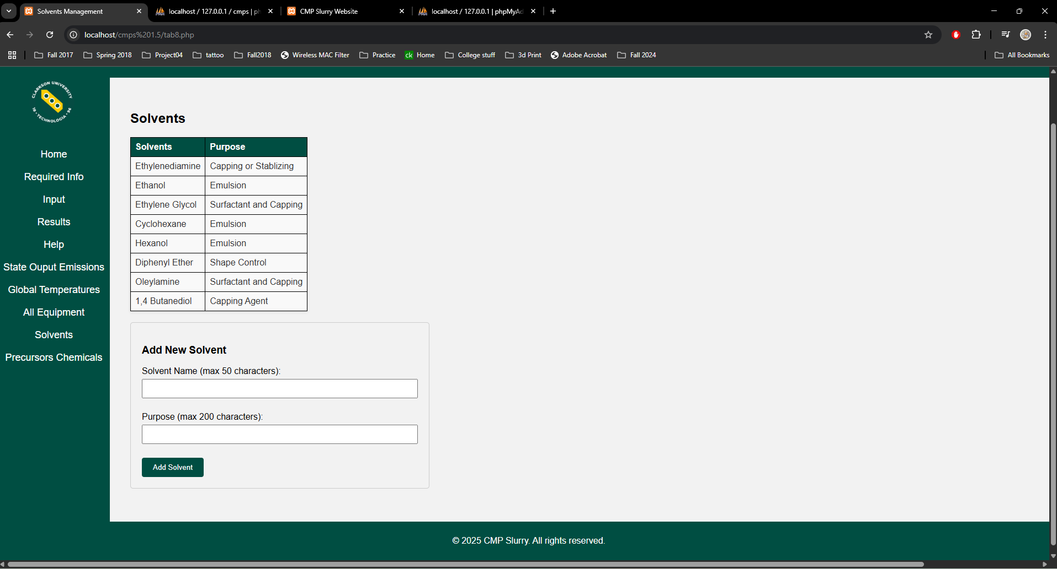

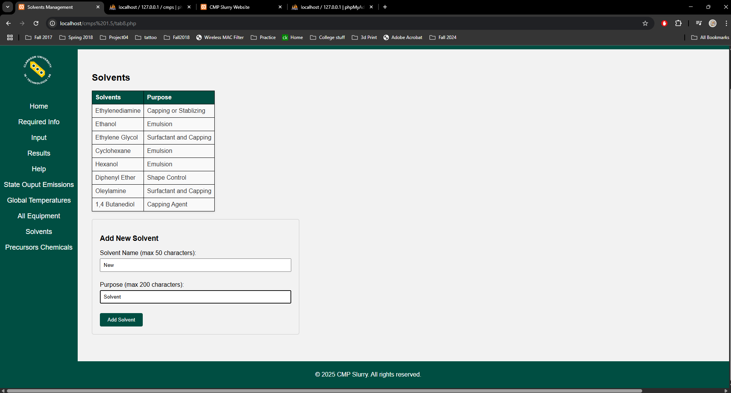

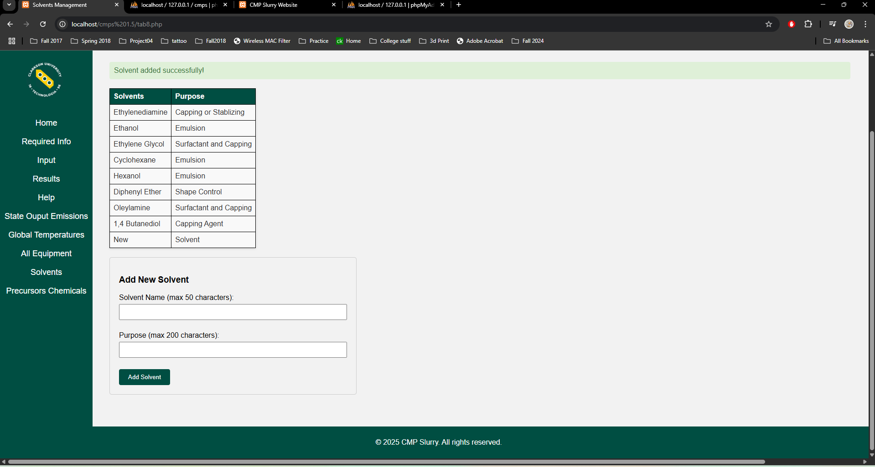

\*in an actual implementatin this would be behind an admin account so not anyone could add to the database\*

Tab Precursors Chemicals:

Not implemented