Table of contents

Introduction

Background
- Data Programming paradigm
- Labelling functions
- Transformation functions
- Slice-aware functions
- Archetypal data programming workflow diagram

Related Work
- Use cases of data programming

Data Exploration:
- Dataset description of US Airline Tweet Sentiment dataset and BBC News Dataset
- Class distributions
- Frequency distributions of tweet length and article length
- Frequency distribution of top 50 tokens using TFIDF
- Clustering analysis

Methodology:
- Labelling function workflow
- Transformation function workflow

Experimental Setup:

LABELLING FUNCTION EXPERIMENTS
1.0 Data
Train / Dev / Test splits
1.1 Effect of different labelling functions on label model accuracy
1.2. Performance of classification models trained on weakly supervised data and gold label data

TRANSFORMATION FUNCTION EXPERIMENTS
2.0 Data
Train / Dev / Test splits
Dataset size
2.1 Effect of different augmentation techniques on weak classifier accuracy

Results and discussion

Conclusion and future work

INTRODUCTION

Supervised learning has given us state-of-the-art results on many machine learning tasks, from sentiment analysis, text categorization, image classification to question and answering. However, supervised learning needs data to be labelled by human annotators, a task which is time consuming and laborious. To alleviate this bottleneck, researchers have developed techniques to programmatically build training datasets, techniques that bypass the need for annotators and save time. Collectively, these techniques are grouped under the term 'Data Programming'.

In this project, we investigate to what extent data programming techniques are able to replace hand-crafted, "gold" labels for supervised learning. We take two datasets, the Twitter US Airline Sentiment dataset, and the BBC News dataset, which from several linguistic aspects are different from each other. We then separately apply two data programming techniques on each dataset - labelling functions and transformation functions - to obtain a weakly labeled datasets. The resulting weakly labeled datasets are then used to train a Logistic Regression model and a Distilbert Transformer model. From our experiments, we find that:

1. Building a high quality weakly labeled dataset involves iteratively fine-tuning and re-evaluating the design and combinations of labelling functions

2. Models trained with weak labels lag behind models trained with gold labels by 15.44 +- (4.36) accuracy points for the US Airline Sentiment Dataset and 13.02 +-(1.58) accuracy points for the BBC News dataset

3. Data augmentation did not lead to weakly supervised models improving their accuracy scores.

We conclude that data programming is a viable approach to building training datasets in the absence of human annotators. However, the accuracy of models trained on datasets generated by data programming depends on whether a developer is able to construct labelling functions of high quality. In addition, transformation functions are an effective way of increasing the size of a dataset. Still, developers should be aware that augmentation may not necessarily lead to an increase in model accuracy.

DATA EXPLORATION

Dataset Description

Twitter US Airline Sentiment Dataset

This dataset consists of 14873 tweets scraped on February 2015 from Twitter. Each row in the dataset is a tweet, and each tweet is classified as having positive, negative or neutral sentiment. Altogether, every row in the dataset contains 15 columns:
tweet_id (int64) | Unique ID of tweet
airline_sentiment (str) | Sentiment of tweet  (Positive / Negative / Neutral)
airline_sentiment_  confidence (float64) | Confidence score of tweet’s sentiment
negative_reason (str) | For negative tweets, the reason behind the negative sentiment
negativereason  confidence (float64) | Confidence score of reason behind negative tweet
airline (str) | Name of the US Airline. eg. Delta
airline_sentiment_  gold (str) | Airline sentiment gold label (14600 nan values)
name (str) | User name of tweeter
negativereason_  gold (str) | Gold reason for negative tweet (14608 nan values)
retweet_count (int64) | Number of times original tweet was retweeted
text (str) | Text of the tweet
tweet_coord (obj) | Geo-coordinates of tweet location
tweet_created (obj) | Timestamp when tweet was created (YYYY:M:D H:M:S timezone-offset)
tweet_location (str) | Location where tweet originated (user-declared)
user_timezone (obj) | Timezone of user eg. Eastern Time (US & Canada)
BBC News Dataset

This dataset consists of 2225 articles dated between 2004-2005. They were taken from the BBC news website and fall into 5 categories (business, entertainment, politics, sport and tech)

Category (str) | Class label of the article (business / entertainment / politics / sport / tech
Text (str) | Text of the article

Class distributions

Table 1: Class distribution of tweet sentiment in Twitter US Airline Sentiment Dataset is imbalanced in favour of negative tweets
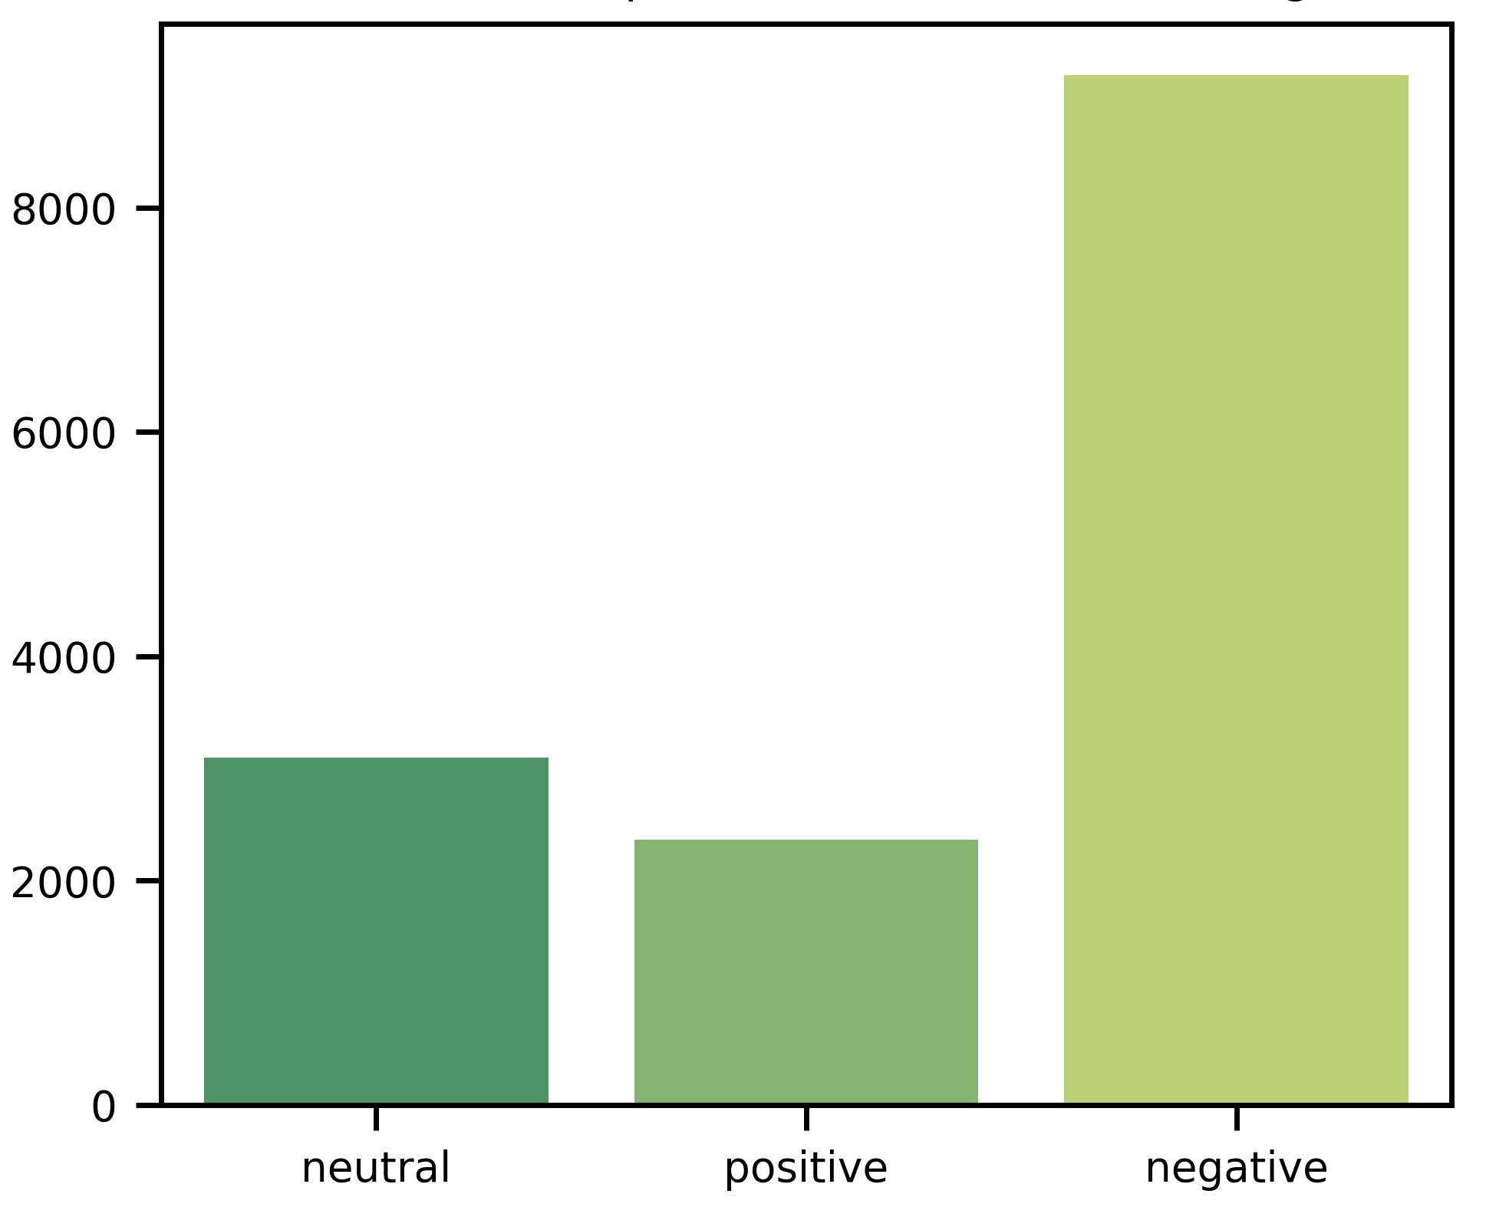
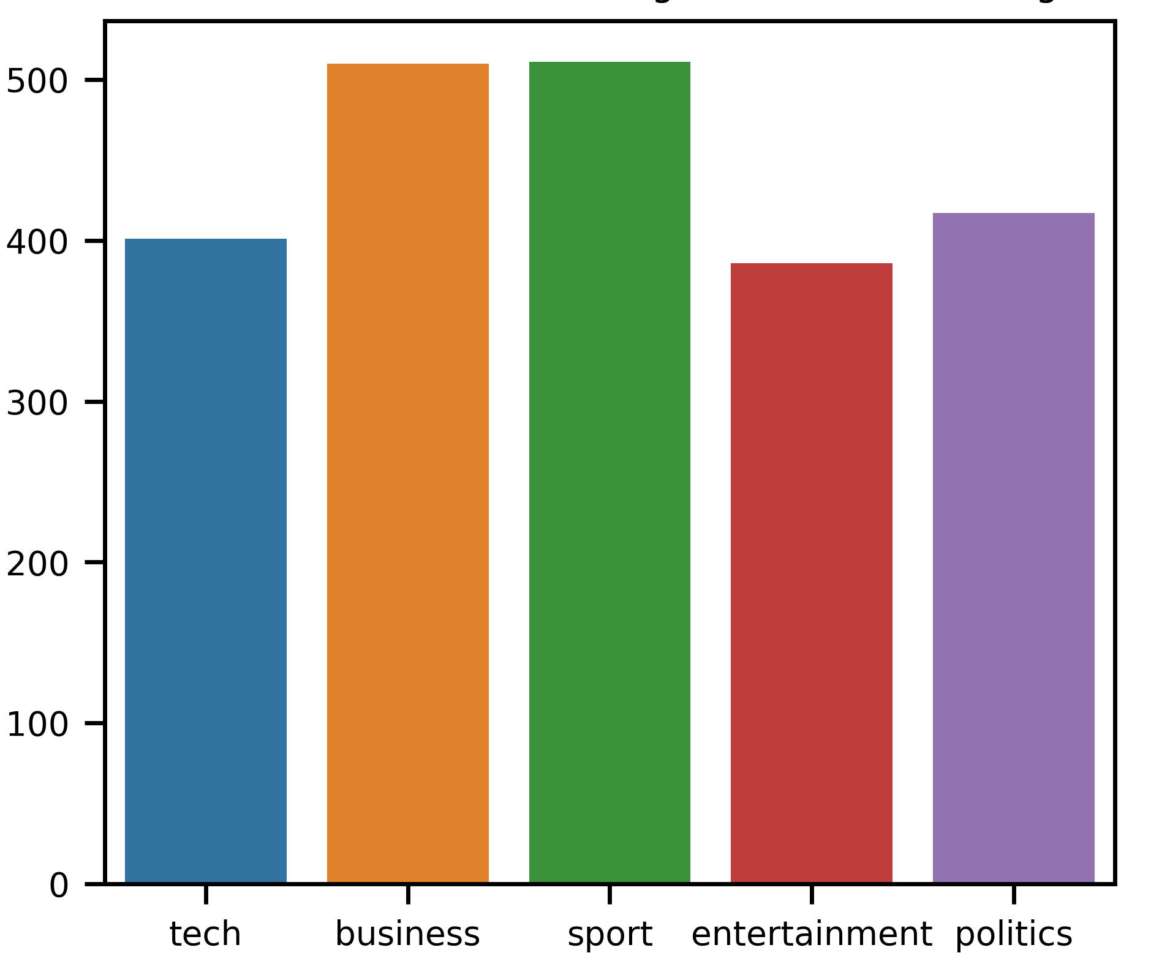
Table 2: Class distribution of article categories in BBC News dataset is fairly balanced

. ‘Papers with Code - Sentiment Analysis’. Accessed 1 November 2020. https://paperswithcode.com/task/sentiment-analysis.
. Papers with Code - AG News Benchmark (Text Classification)’. Accessed 1 November 2020. https://paperswithcode.com/sota/text-classification-on-ag-news.
. Papers with Code - ImageNet Benchmark (Image Classification)’. Accessed 1 November 2020. https://paperswithcode.com/sota/image-classification-on-imagenet.
. ‘The Stanford Question Answering Dataset’. Accessed 1 November 2020. https://rajpurkar.github.io/SQuAD-explorer/.
. Ehrenberg, Henry R., Jaeho Shin, Alexander J. Ratner, Jason A. Fries, and Christopher Ré. ‘Data Programming with DDLite: Putting Humans in a Different Part of the Loop’. In Proceedings of the Workshop on Human-In-the-Loop Data Analytics - HILDA ’16, 1–6. San Francisco, California: ACM Press, 2016. https://doi.org/10.1145/2939502.2939515.
. Ratner, Alexander, Stephen H. Bach, Henry Ehrenberg, Jason Fries, Sen Wu, and Christopher Ré. ‘Snorkel: Rapid Training Data Creation with Weak Supervision’. Proceedings of the VLDB Endowment 11, no. 3 (November 2017): 269–82. https://doi.org/10.14778/3157794.3157797.
. Twitter US Airline Sentiment | Kaggle’. Accessed 1 November 2020. https://www.kaggle.com/crowdflower/twitter-airline-sentiment.
. Insight - BBC Datasets’. Accessed 1 November 2020. http://mlg.ucd.ie/datasets/bbc.html.
. ‘Snorkel Labeling Package — Snorkel 0.9.6 Documentation’. Accessed 1 November 2020. https://snorkel.readthedocs.io/en/v0.9.6/packages/labeling.html.
. ‘Snorkel Augmentation Package — Snorkel 0.9.6 Documentation’. Accessed 1 November 2020. https://snorkel.readthedocs.io/en/v0.9.6/packages/augmentation.html.
Twitter US Airline Sentiment | Kaggle’. Accessed 1 November 2020. https://www.kaggle.com/crowdflower/twitter-airline-sentiment.
nsight - BBC Datasets’. Accessed 1 November 2020. http://mlg.ucd.ie/datasets/bbc.html.

