Aug 20, 2026

Nike Messaging (Client Required Template)
Invited Richard Bryan Del Rosario Jennifer Collado Laxmi Narayana Rhaldin Rueda David Paulo Truelen Shanelyn Eranista Jeanne Paulo De Jesus Neil Allen Senar Jade Frances Arrisga
Attachments Nike Messaging (Client Required Template) Notes - Nike Messaging (Client Required Template)
Meeting records Transcript

Summary
Migration strategy discussions addressed technical Excel to Google Sheets conversion challenges and validated architectural requirements.
Conversion and Architecture Challenges
Analysis of existing Excel workbooks revealed significant compatibility risks due to complex formula structures and existing data errors. Team members highlighted that manual daily file creation currently hinders operational reporting efficiency.
Migration Strategy Consensus
The team reached a consensus to implement a hybrid solution featuring an automated data uploader and native Google Sheets calculation logic. This approach ensures robust data handling and meets critical operational reporting requirements.
Validation and Project Timeline
Validation plans focus on comparing legacy Excel output against new Google Sheets builds to ensure metric consistency. The project will prioritize one messaging queue with finalization scheduled for the upcoming week.

Decisions
Aligned
- Hybrid migration solution adopted The team selected the hybrid migration solution, which involves developing an automated uploader for raw data ingestion combined with rebuilding calculations natively in Google Sheets.
- Hourly data ingestion override policy The raw data ingestion process is set to override existing data on an hourly basis rather than appending.
- Migration validation strategy defined The migration validation scope will prioritize key operational metrics while strictly separating existing Excel workbook errors from errors introduced by the migration pipeline.
- Automated project data architecture established The project architecture is set to utilize automated data ingestion, native Google Sheet calculations, and Excel for final output validation.
- Project delivery and validation timeline set The project delivery is scheduled for the 27th, with the subsequent validation phase to occur on the 28th.

Next steps
- [Jeanne Paulo De Jesus] Develop uploader: Construct an automated ingestion process for raw source files into the new Google Sheets system.
- [Jeanne Paulo De Jesus] Rebuild reporting: Program the calculation and reporting logic natively within the target spreadsheet environment.
- [Jade Frances Arrisga] Validate output: Perform a final business validation of the migrated reporting results against the original Excel template data.
- [Neil Allen Senar] Create Group: Create a group for team coordination.
- [Jeanne Paulo De Jesus] Finalize Notes: Finalize the meeting notes.
- [Jeanne Paulo De Jesus] Deliver Project: Complete the project delivery by the 27th.
- [David Paulo Truelen] Validate Delivery: Validate the delivery on Friday.
- [Jade Frances Arrisga] Follow Up: Ask for updates on Monday.

Details
Did the screenshots in this section make your notes better or worse?
- Identification of Excel Compatibility Issues: The team initiated a discussion regarding significant compatibility challenges when converting their current Excel-based reporting files into Google Sheets, specifically noting that conditional formatting, pivot tables, and specific formulas break during the conversion process. David Paulo Truelen demonstrated the current file structure, which relies on Microsoft 365 Excel, highlighting that the manual conversion process undermines the visibility and functionality required for operational reporting (00:00:20) (00:05:14).
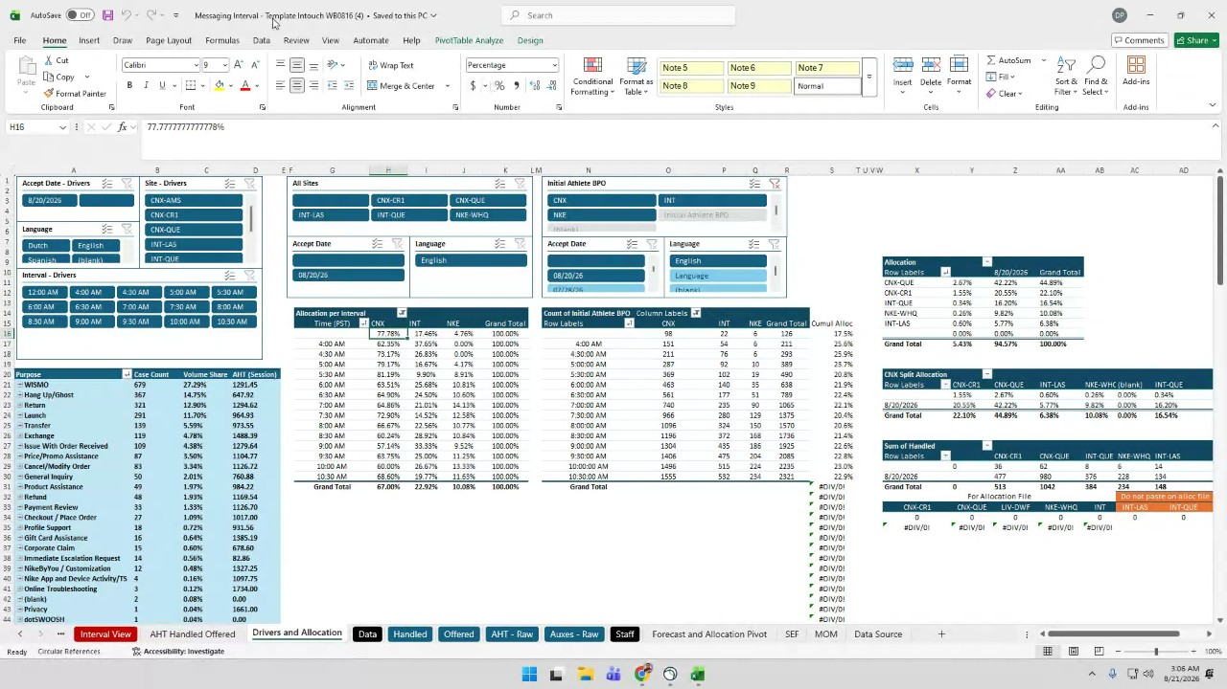
- Exploratory Data Analysis Findings: Jeanne Paulo De Jesus conducted an exploratory data analysis on the current workbook, revealing a highly complex structure comprising approximately 272,000 formula cells and over 1,200 pivot data formulas. These findings indicate a significant risk during migration, as the existing Excel architecture is deeply integrated with native calculator features that do not directly translate to Google Sheets functionality (00:25:53).
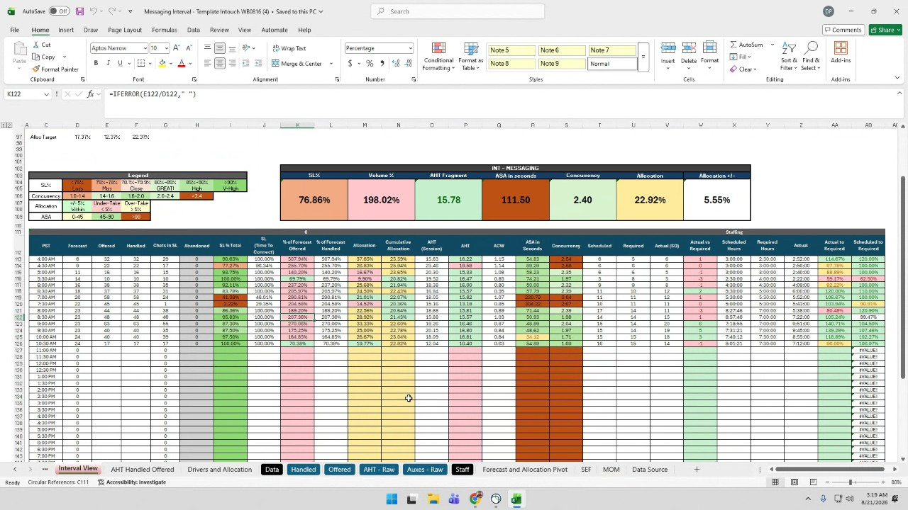
- Current Operational Workflow: The team described their current workflow, which involves extracting data from Salesforce and client tools in CSV or XLS formats (00:09:46). Real-time analysts (RTAs) then manually dump this data into established templates, refresh multiple pivot tables, and generate internal and operational interval views (00:12:56) (00:22:23).
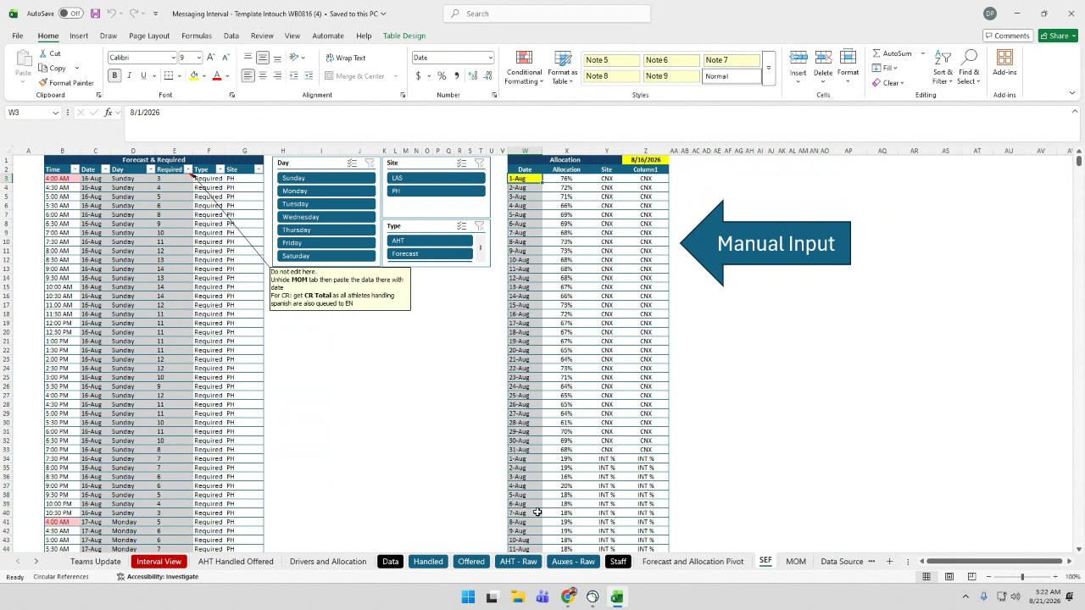
- Reporting and Template Management: Currently, the team creates a new Excel file every day to manage their data, which creates versioning and tracking inefficiencies. Jade Frances Arrisga expressed a strong preference for shifting to a weekly template model to streamline updates and historical tracking, acknowledging that the current daily file creation is cumbersome (00:14:37).
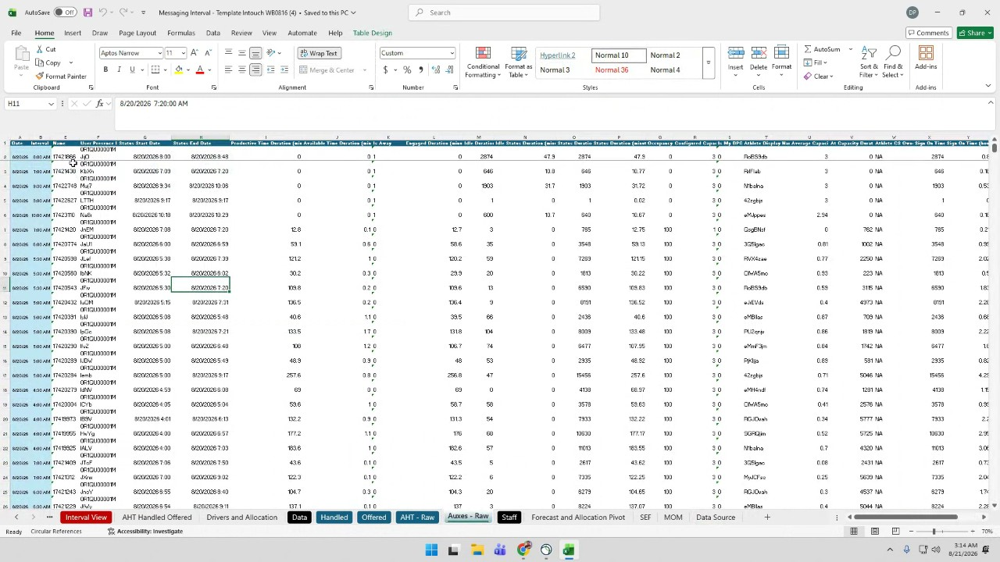
- Pre-existing Data Errors: Jeanne Paulo De Jesus identified that the current Excel source files already contain approximately 5,000 rows of errors, including NA, value, division by zero, and reference errors. It was decided that these existing errors must be categorized and tracked separately from any new errors introduced during the migration to Google Sheets to avoid confusion regarding the integrity of the transition (00:27:38).
- Definition of Operational Requirements: The team clarified that all current tabs, including those for handled data, offered data, staffing, and forecast allocation, are operationally required for the RTAs (00:32:18). The team confirmed that they must continue providing these metrics, specifically service level, handle time, and staffing percentages, to operations without interruption (00:29:59) (00:49:53).
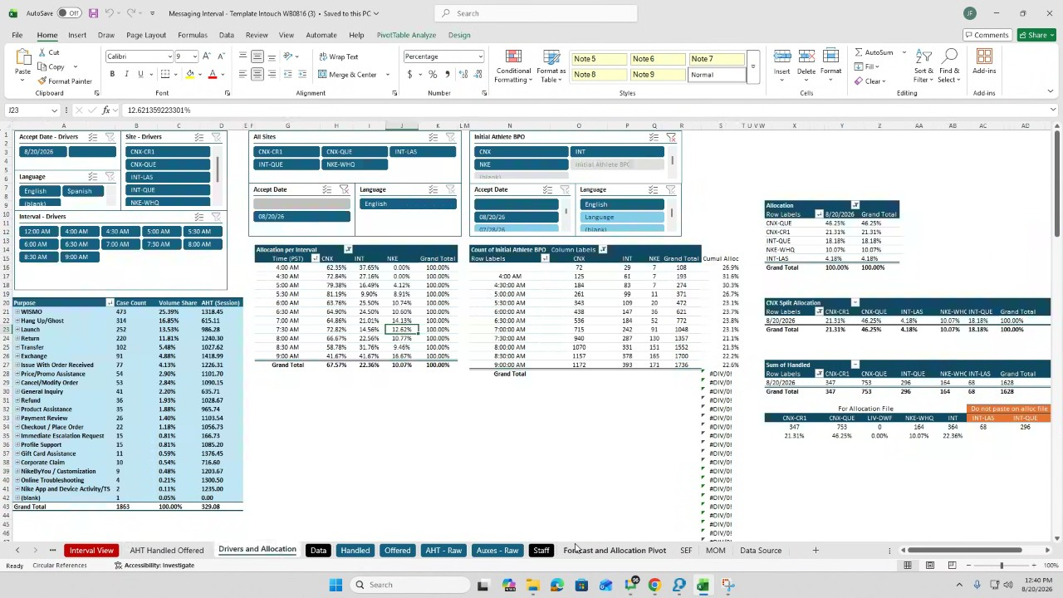
- Selection of Migration Strategy: Jeanne Paulo De Jesus presented two options for the migration: a native Google Sheets template or a hybrid solution featuring an automated uploader and a native Google Sheets calculation layer. The group reached a consensus to pursue the hybrid solution, as it provides a more robust framework for automating raw file ingestion while rebuilding calculation logic natively within Google Sheets (00:41:49).
- Data Upload and Update Frequency: The team confirmed that data uploads need to occur on an hourly basis to meet operational requirements. The proposed uploader will handle the raw data, with the understanding that the process will involve overriding the previous data in the same cells each hour rather than appending rows (00:47:03).
- Validation and Baseline Comparison: Jeanne Paulo De Jesus outlined the validation plan, which involves comparing the output of the legacy Excel templates against the new Google Sheets build. This validation will focus on ensuring that critical metrics, such as handle time, abandonment rates, and staffing percentages, remain consistent between both platforms to verify the accuracy of the migration (00:48:24).
- Technical Capacity and Project Scope: The team confirmed that the migration project is currently scoped to cover only one messaging queue (00:55:56). Regarding volume constraints, the team noted that daily row counts for metrics like handled and offered data range between 3,000 and 7,000, which falls well within the Google Sheets limit of 10 million cells (00:53:59).
- Recording and Team Coordination: David Paulo Truelen and Jeanne Paulo De Jesus discussed the process for recording team coordinates, noting the need for a step-by-step approach per tab to maintain clarity for a 40-minute recording. Jade Frances Arrisga noted that they would compile errors from the run. Neil Allen Senar proposed creating a group in Google Drive to facilitate this coordination (00:57:35).
- Current Workflow and Architecture: Jeanne Paulo De Jesus reviewed the current workflow, which involves sourcing data from Salesforce and pasting it into an Excel template. The reporting cycle for the template is weekly, while the data freshness is maintained on an hourly basis. Jeanne Paulo De Jesus described the final architecture as moving toward automated ingestion with native Google Sheet calculations, with an Excel output used as the control for validation (01:00:06).
- Validation Protocol: Jeanne Paulo De Jesus and David Paulo Truelen clarified that David Paulo Truelen is responsible for validating the output upon delivery. They confirmed that any existing errors from the Excel files are to be explicitly excluded from the validation process (01:00:06).
- Project Timeline: The team discussed the schedule for the upcoming deliverables. Jeanne Paulo De Jesus proposed delivering the work by the 27th, with validation scheduled for the 28th. Jade Frances Arrisga confirmed they were comfortable with this plan, and the team agreed to wait until Friday to finalize the items (01:01:55).

