TD 01
A prendre en compte : j’ai reussi à créer un codespaces qu’au bout d’un certain temps. Je n’ai pas pu faire certaines questions du TD 1 qui nécéssitent un terminal codespaces.
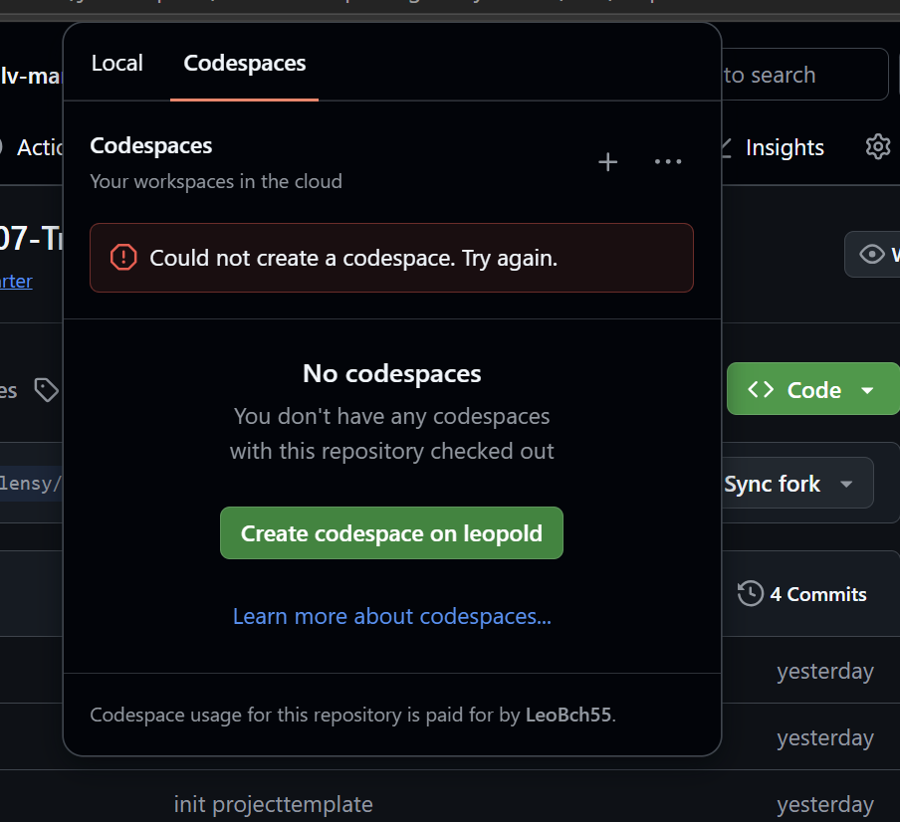
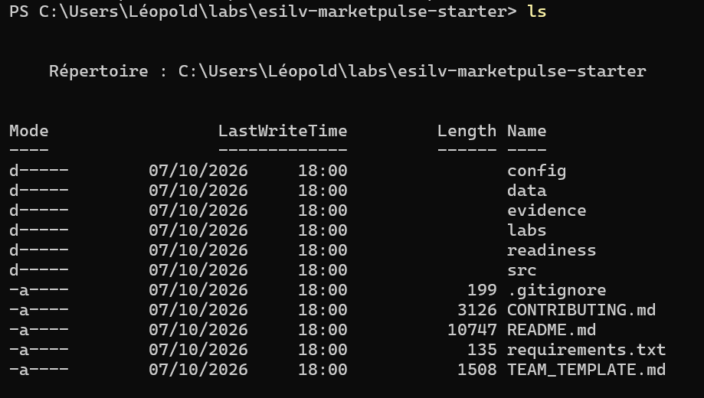
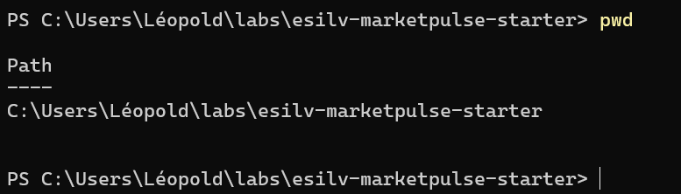

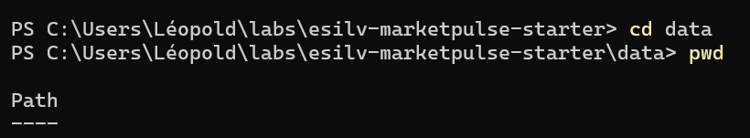
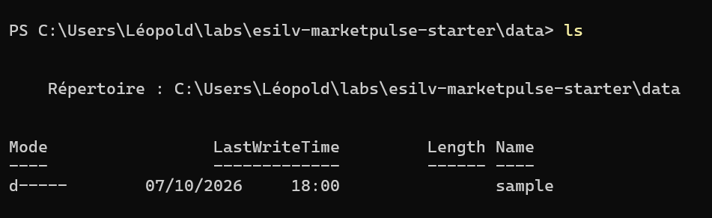
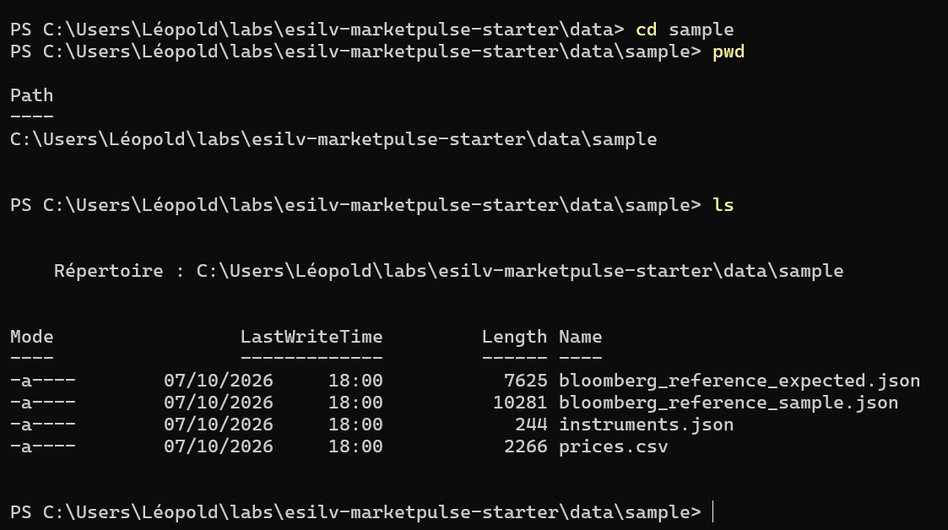
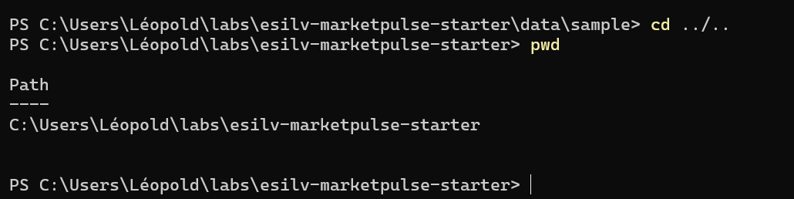
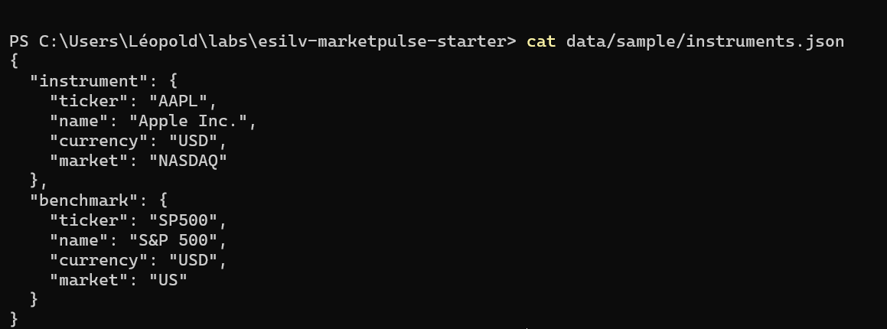
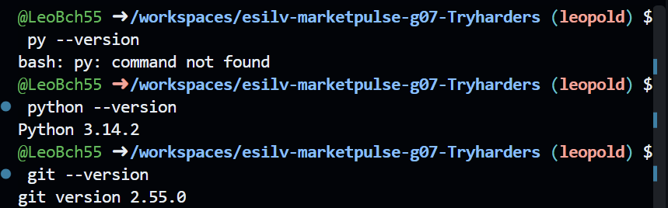
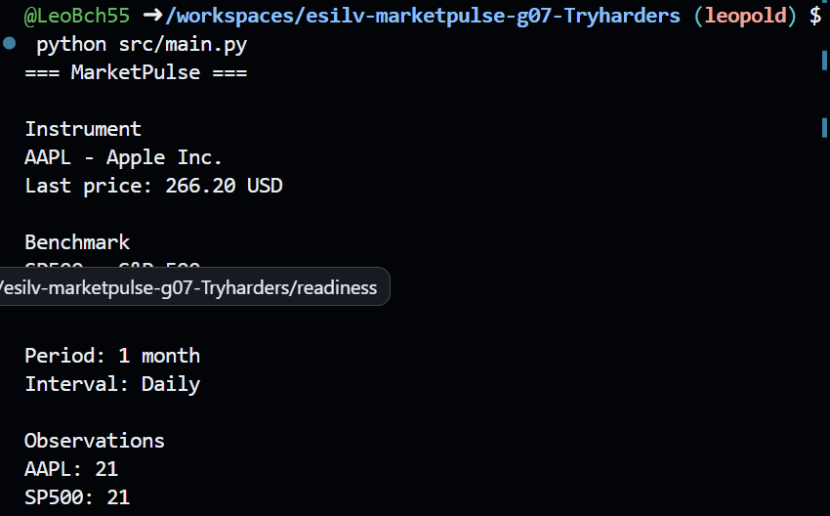
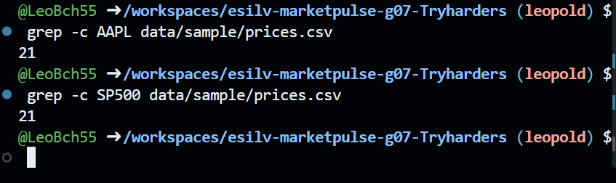
@LeoBch55 ➜ /workspaces/esilv-marketpulse-g07-Tryharders (leopold) $ find . -type f
./README.md
./readiness/01_R8_1_STUDENT_BOOTSTRAP_AND_CLONE_VALIDATION.md
./evidence/README.md
./requirements.txt
./TEAM_TEMPLATE.md
./src/main.py
./labs/README.md
./labs/TD02_PYTHON_CSV_JSON.md
./labs/TD01_BOOTSTRAP_LINUX.md
./labs/TD03_GIT_LOCAL_WORKFLOW.md
./data/sample/bloomberg_reference_sample.json
./data/sample/prices.csv
./data/sample/bloomberg_reference_expected.json
./data/sample/instruments.json
./CONTRIBUTING.md
./config/settings.yml
./.gitignore
./.git/description
./.git/packed-refs
./.git/index
./.git/hooks/pre-push
./.git/hooks/push-to-checkout.sample
./.git/hooks/sendemail-validate.sample
./.git/hooks/commit-msg.sample
./.git/hooks/post-update.sample
./.git/hooks/fsmonitor-watchman.sample
./.git/hooks/pre-rebase.sample
./.git/hooks/pre-merge-commit.sample
./.git/hooks/pre-receive.sample
./.git/hooks/applypatch-msg.sample
./.git/hooks/post-commit
./.git/hooks/update.sample
./.git/hooks/post-merge
./.git/hooks/pre-applypatch.sample
./.git/hooks/prepare-commit-msg.sample
./.git/hooks/pre-push.sample
./.git/hooks/post-checkout
./.git/hooks/pre-commit.sample
./.git/objects/c8/c87121f923cfe2d787cfe73f4192577c78c963
./.git/objects/24/bf1511c729955b9ec77031deaca07df2e94339
./.git/objects/pack/pack-59f585c7d8aef33ba720cc149ad081cb28716546.pack
./.git/objects/pack/pack-59f585c7d8aef33ba720cc149ad081cb28716546.idx
./.git/objects/pack/pack-59f585c7d8aef33ba720cc149ad081cb28716546.rev
./.git/objects/98/1664e87aeb82033350e6d1c05f68bd5b59570c
./.git/objects/ba/5c9f4940c5f6dd78f9788f0116e2966297e1dd
./.git/objects/e9/258d3bd7d56371d6ae268e8efe26eaa1445e3c
./.git/objects/e6/9de29bb2d1d6434b8b29ae775ad8c2e48c5391
./.git/objects/cf/babe4596e3db8e3c7b5d801deb509af6c0ebd6
./.git/objects/20/b940264b0b1ccc06bf2b2017beefb76fde5d24
./.git/objects/75/ae0acf22f112d779d278d29d8daebd21808a78
./.git/objects/9f/d6c8a18fbc6b648d35f9e70483bc03043d16e8
./.git/objects/bf/b94a6112ada1f2183bdfbc499cf0769a7d3933
./.git/config
./.git/refs/heads/leopold
./.git/refs/remotes/origin/main
./.git/refs/remotes/origin/branchemaelys
./.git/refs/remotes/origin/esther
./.git/refs/remotes/origin/HEAD
./.git/refs/remotes/origin/jeanne
./.git/HEAD
./.git/logs/refs/heads/leopold
./.git/logs/refs/remotes/origin/main
./.git/logs/refs/remotes/origin/branchemaelys
./.git/logs/refs/remotes/origin/esther
./.git/logs/refs/remotes/origin/HEAD
./.git/logs/refs/remotes/origin/jeanne
./.git/logs/HEAD
./.git/info/exclude
./.git/FETCH_HEAD

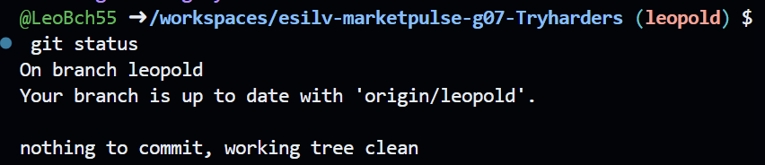
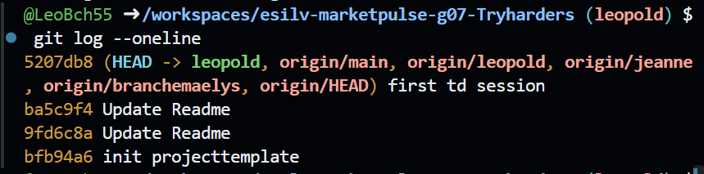

TD 02

