**DATE: 2/13/2013  
T0: MARK KOCHANSKI  
FROM: ANTHONY HOPKINS  
SUBJECT: TEAM IOBYTES STATUS REPORT: 2/6-2/13**

**PROJECT STATUS SUMMARY** Percent Complete: 28%

We held a PM meeting and basically discussed who each group is waiting on and what we need from that group in order to progress with our work. We are all coming up with more questions for the next survey and will hopefully be able to continue receiving strong input from the audience. Because the 4 individual teams (iOS, websites, database, and project design) are planning on bringing and posting all of our artifacts online and in class in order to show each other how much we have progressed. My team has been editing one another’s artifacts and are beginning to get an idea of what the design of the website should look like.

**WORK PLANNED FOR LAST WEEK**

* Set up GitHub to create online information and file sharing forum for teams
* Design 6 pages for the website
* Have portfolio of artifacts with final designs of the 6 web pages

**WORK COMPLETED LAST WEEK**

* Design 6 pages for the website (we actually designed more than 6)
* Set up GitHub to create online information and file sharing forum for teams

**WORK PLANNED FOR NEXT WEEK**

* Complete portfolio with all web pages
* Adjust website design based off the results of the survey
* Come up with new questions for the next survey
* Have portfolio of artifacts with final designs of the 6 web pages

**ARTIFACTS**

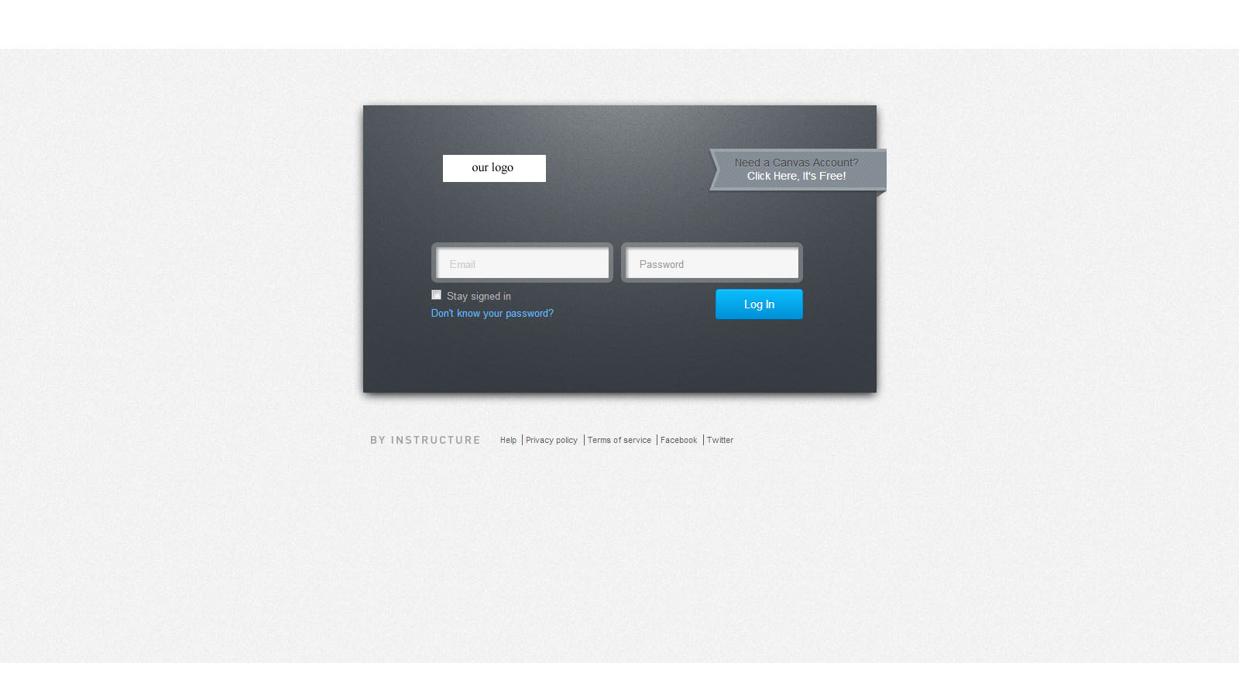Above is the log in page; this page will look the same for the students and the professors.

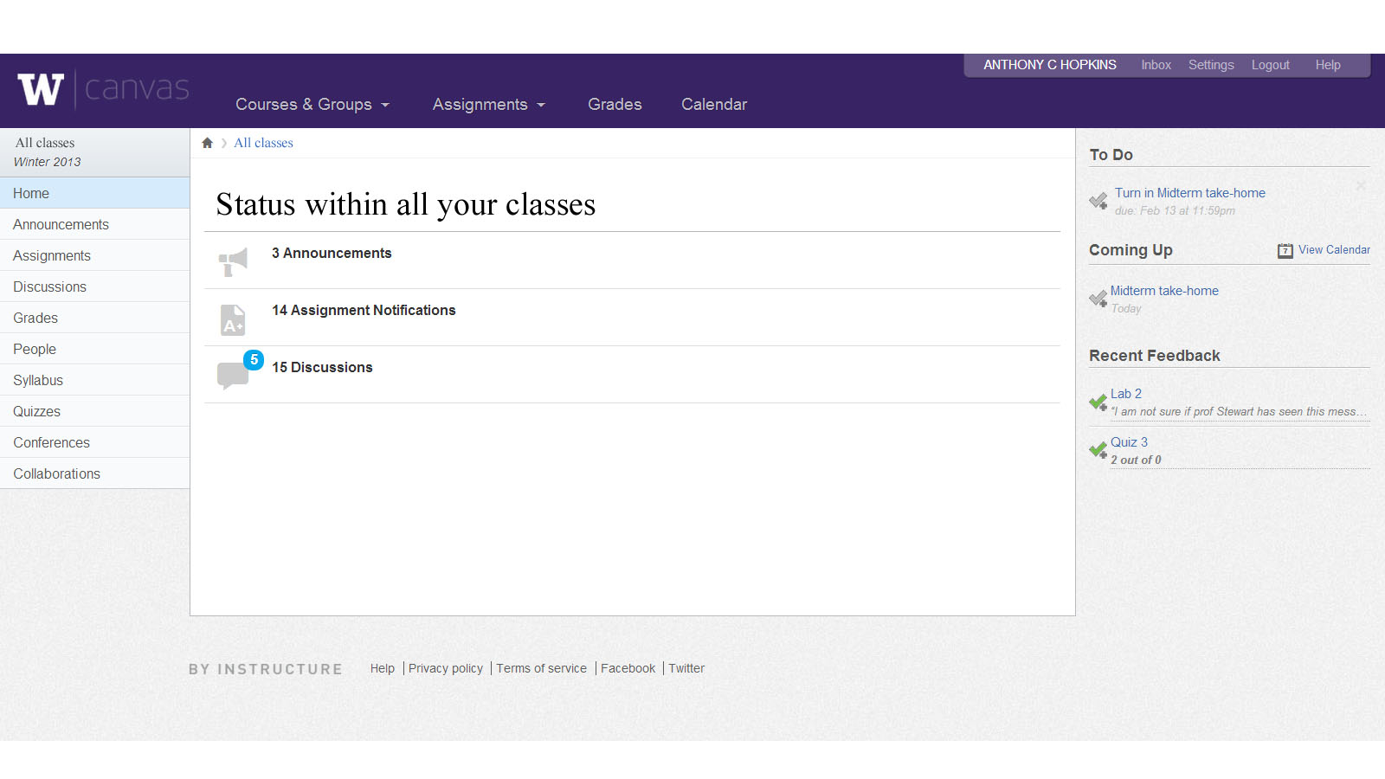

This is a rough draft of the student home page. More editing is to be done on this piece. The instructor’s page will look very similar to students page, but will not carry all the features that are on the right side of the picture (“To Do…Coming Up… Recent Feedback”).

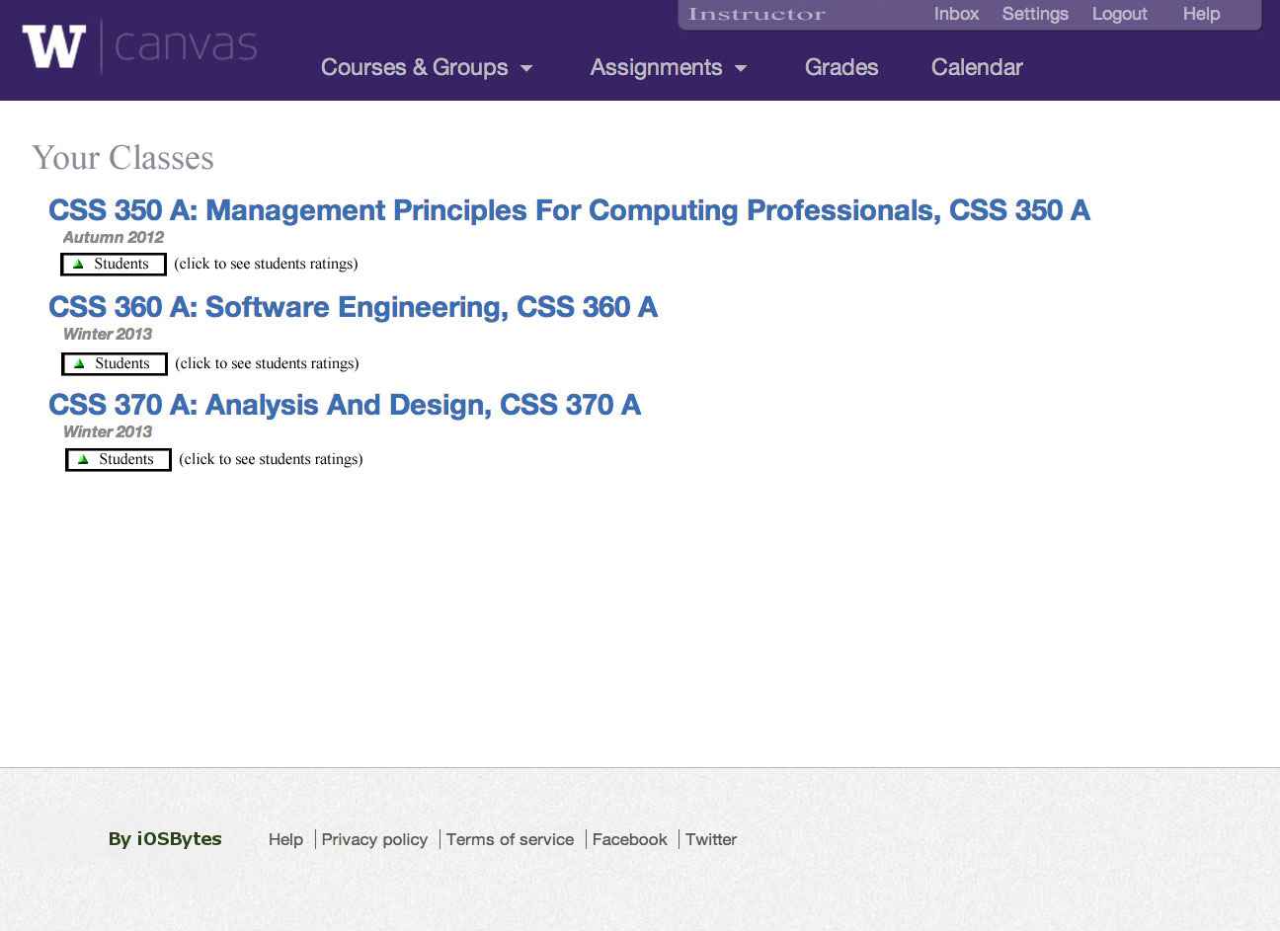

This is the page is what will come up if the instructor clicks on the student button on the screen. By clicking on the green arrow next to “student” in the box, the instructor will be taken to a page where all the students in the class are listed along with their ratings and comments from other students.

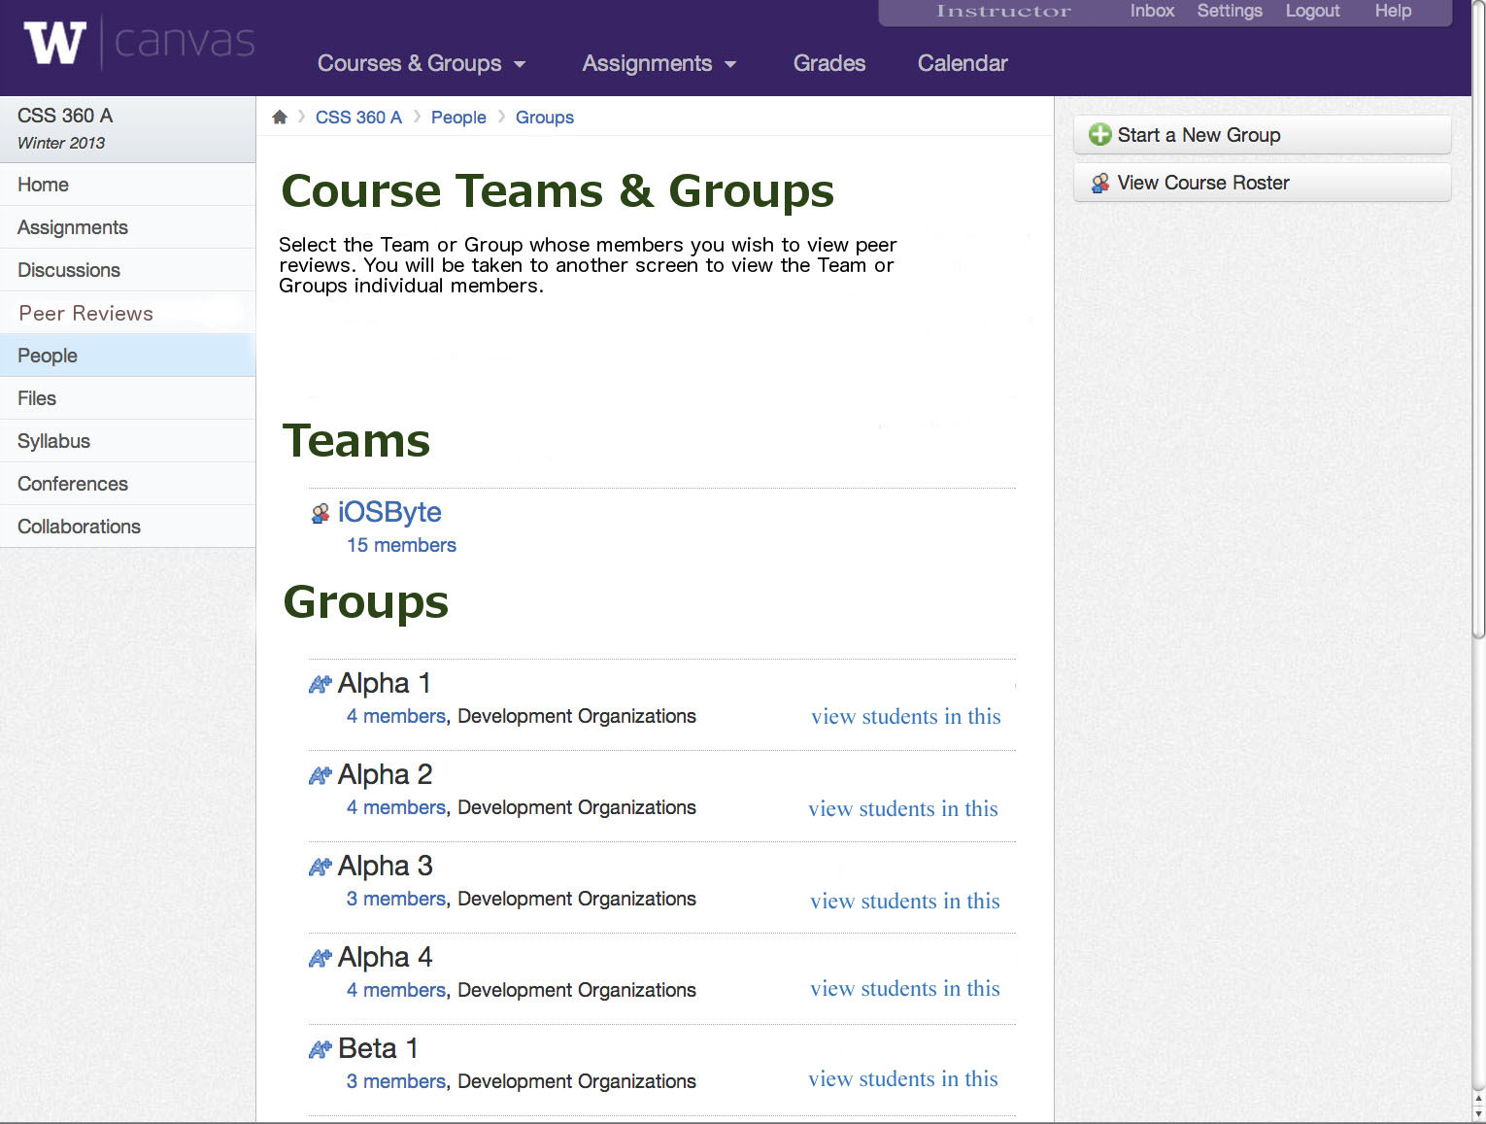

This is a rough draft of what the instructor would see if he/she separated their class into groups. The instructor can click on the amount of members under each group and it will take the instructor to a page where their ratings and comments are visible.

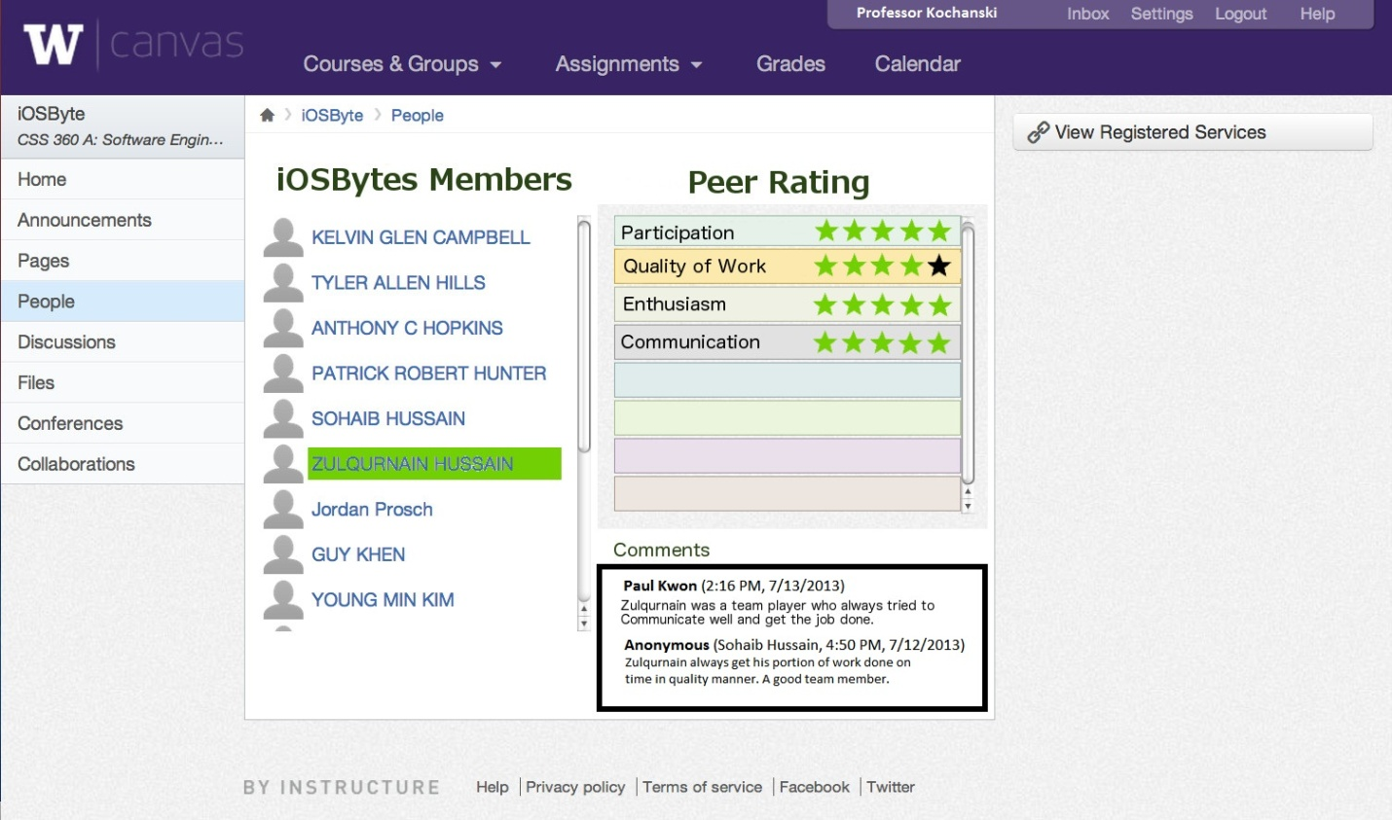

This is a rough draft of what the instructor would see after clicking on the students. When a student is selected their ratings and comments from other students then become visible.

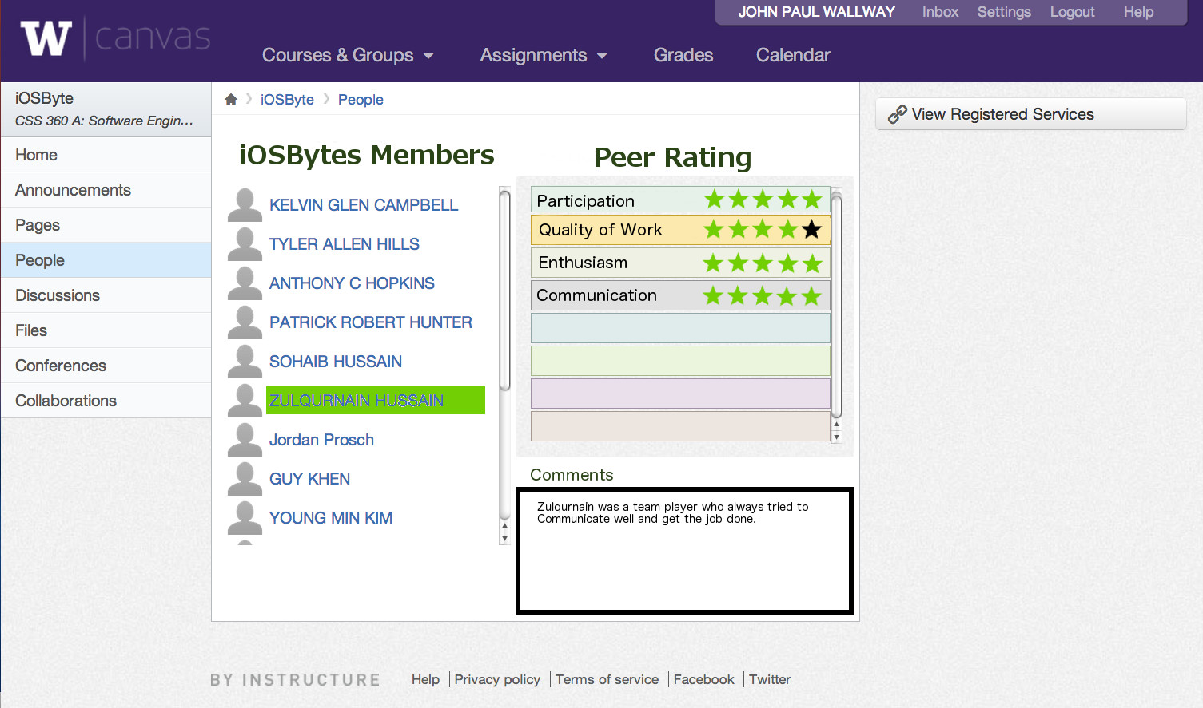

This is a rough draft of what the students would see after clicking on the students. When a student is selected their ratings and comments from other students then become visible.

**FIRST DESIGN(S) OF WEB PAGES   
(These pages have either been edited or removed from project)**

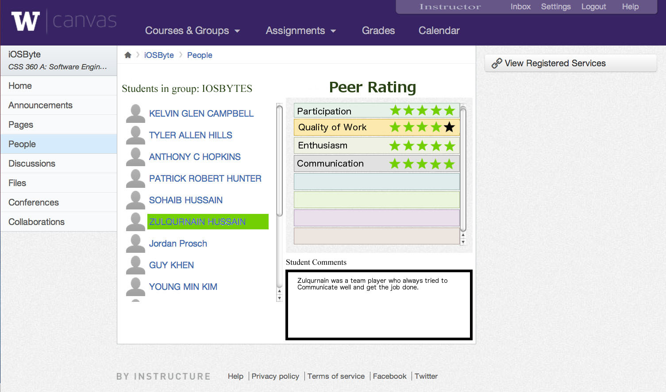

Above is the first version of what the student ratings would look like from the instructors account.  
  


The picture above is a rough draft version of our logo. Once our team comes to a conclusion on what we want the final version to look like, it will replace the University of Washington’s logo as well as Canvas’s.

**IMMEDIATE TASKS**

|  |  |  |  |  |  |
| --- | --- | --- | --- | --- | --- |
| Tasks | Planned | Forcasted | Actual | Status | Cost |
| Complete portfolio | (2/10/13) | (2/20/13) | (2/20/13) | Begun | 5 hours |
| Adjust website design based off the results of the survey | (2/10/13) | (2/20/13) | (2/20/13) | Begun | 1 hour |
| Come up with new questions for next survey | (2/10/13) | (2/20/13) | (2/20/13) | Begun | 1 hour |