Documentation

1. Architecture

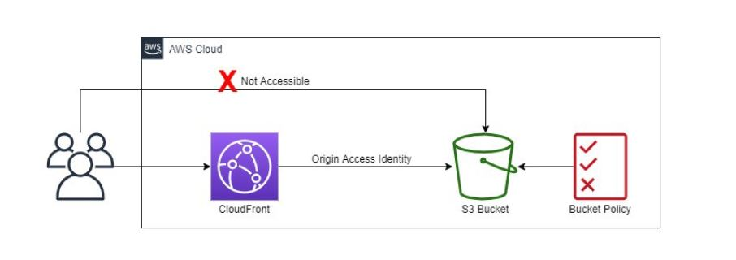

1. Steps used

Follow images from 1 to 11 using the title as instruction