Project three: Azubi Nebula

Table of Contents

Introduction

1. Overview
2. Architecture
3. Technologies required
4. How to make it work

Conclusion

Demo

Introduction

As the culmination of our training approaches, we find ourselves tasked with applying and mastering various services through the implementation of real-world projects. In this endeavor, our focus turns to Project 3, centered around the creation of a student dashboard. This undertaking serves not only as a practical application of our acquired skills but also as a testament to our collective ability to design and deliver effective web solutions. In the following pages, we present the approach of solution crafted by me.

1. Overview

Nebula is a student dashboard application that seeks innovative solutions for seamless, dynamic information handling.

We are called to conceive and to build a solution using modern technologies to meet the expectations.

Let’s embark into this thrilling journey, utilizing technologies to manage student’s data

1. Architecture

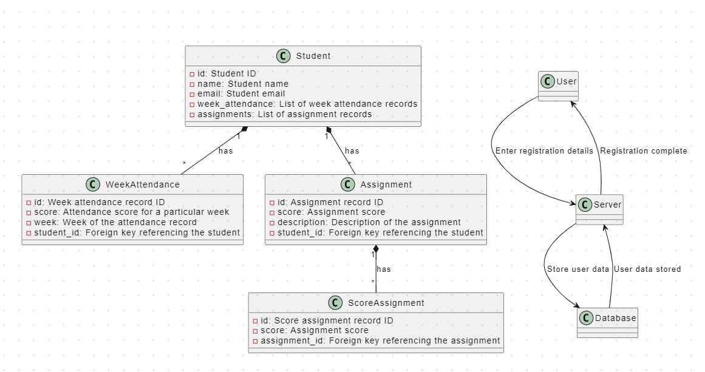

1. Technologies used

In our technological framework, Nebula leverages the robust python, incorporating several of its key services:

* Flask
* Sqlite3
* Docker (to implement)
* AWS EC2 (to implement)

The app itself required the use of component or programming language like

* html
* CSS
* bootstrap5
* Git, GitHub
* and more like JavaScript, jQuery

1. How to make it work

To operationalize our solution effectively, follow these straightforward steps to deploy and manage the infrastructure using Terraform:

* Download the source code:

You can download the zip file or git pull it to your local repository

* Make sure you have flask installed

You can run the command: pip install flak

* Run the python code:

You can use the command python app.py while you are in the root folder of the project

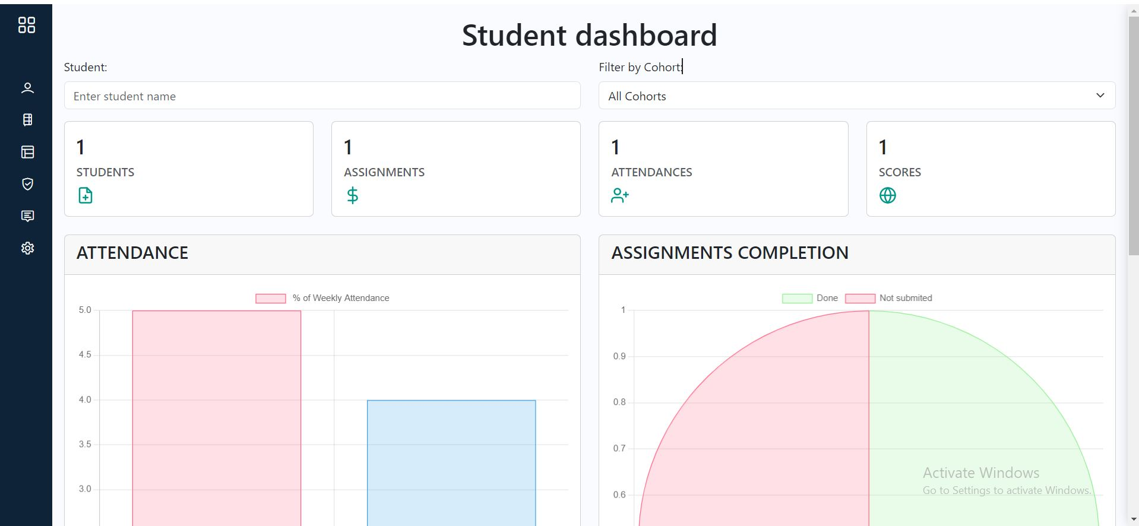

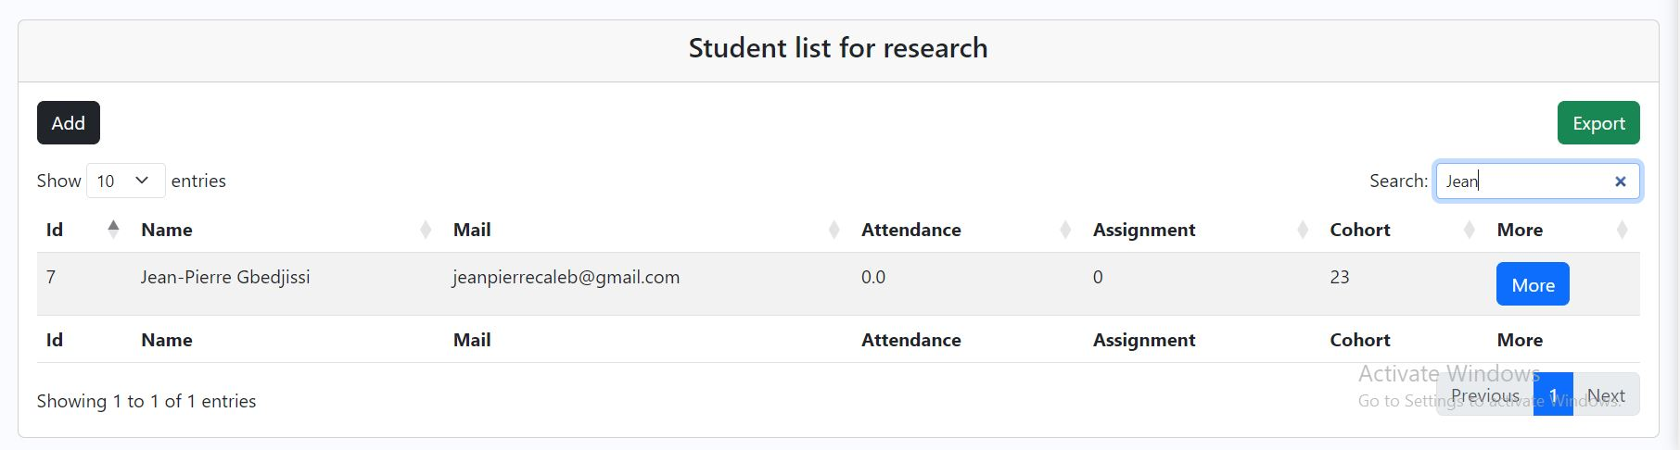

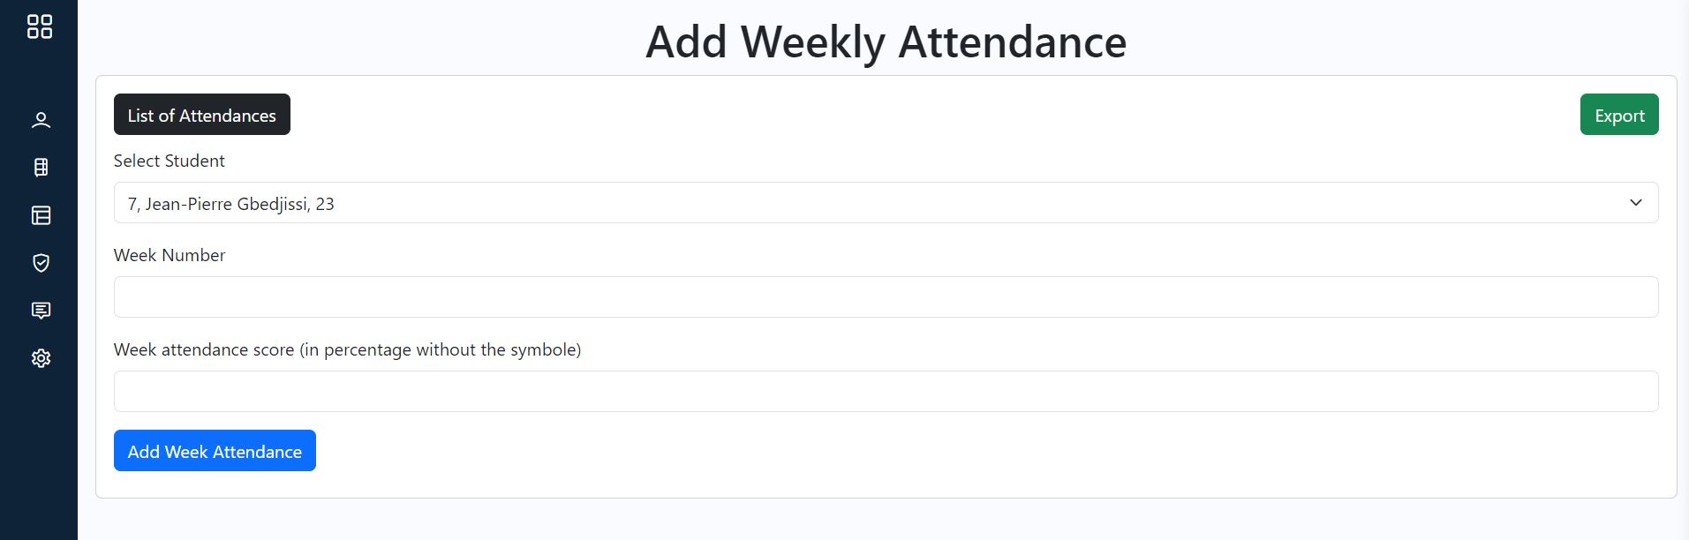

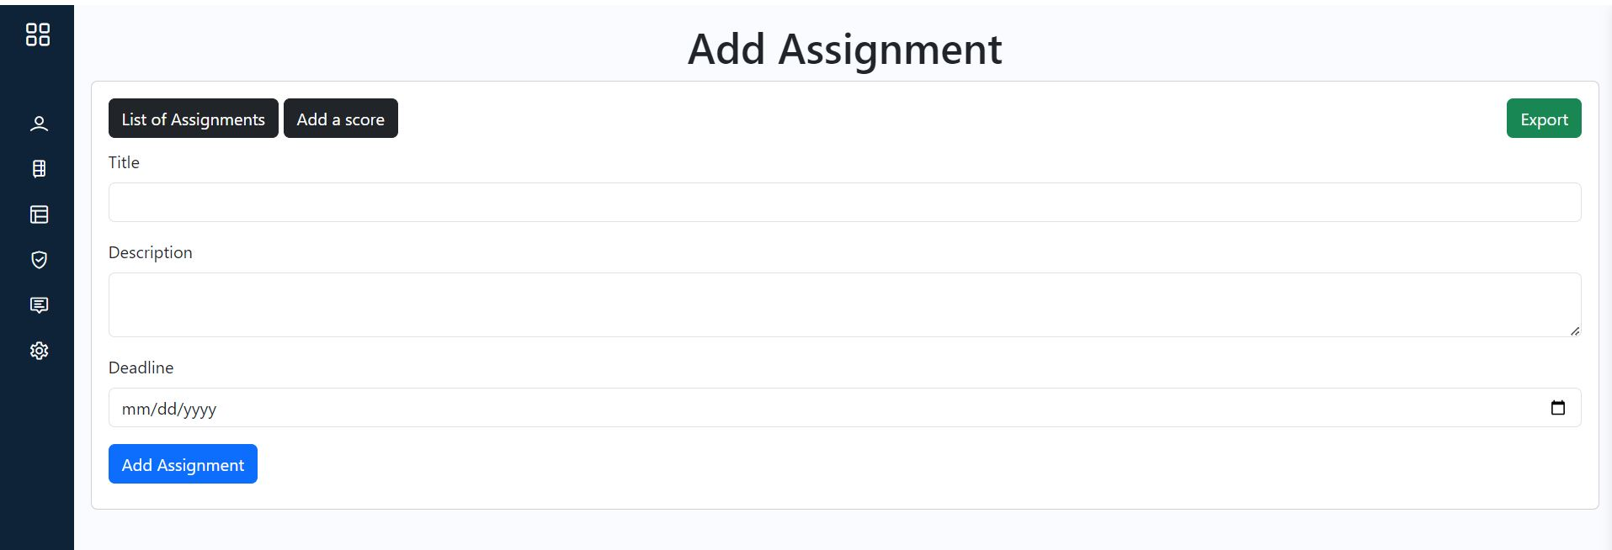

Conclusion

In conclusion, our Nebula Platform represents an approach of solution for student data. We actually hold on to the languages we met during our training and experiences.

While our current solution represents an attempt towards delivering seamless and dynamic student data administration, we acknowledge then that it is not yet perfect. As we navigate the exciting realm of web platform, we recognize the importance of continuous improvement. The journey to perfection is an ongoing process, and we are committed to refining our platform to better meet the evolving needs and expectations of our users.

Demo

Follow the how to use point and the images