4.Enable OLAP operations (drill-down, roll-up, slicing, dicing)
- Drill-down (Year → Month → Day)
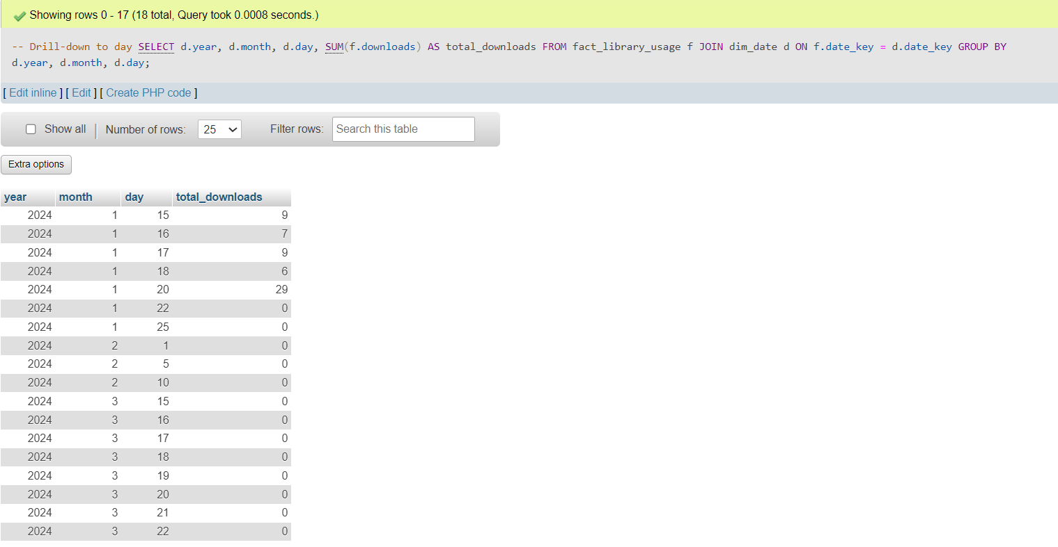
- Roll-up (Day → Month → Year)
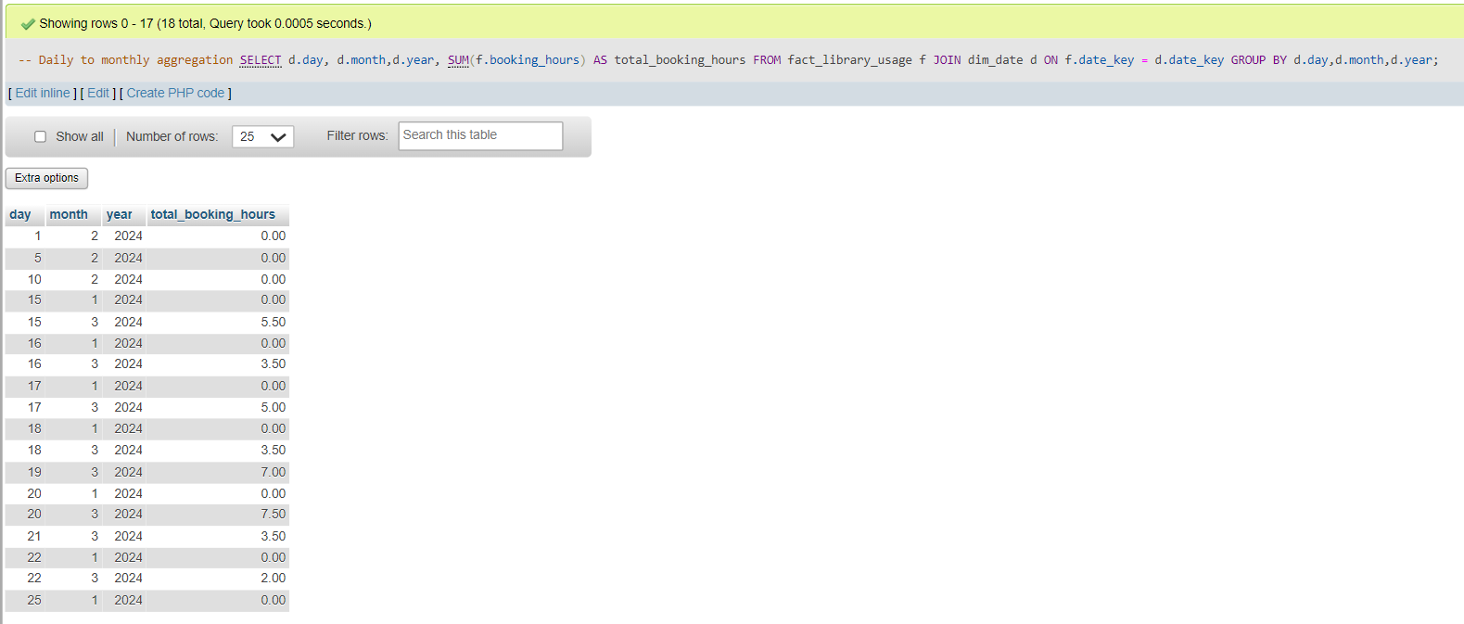
- Slicing (subset on one dimension)
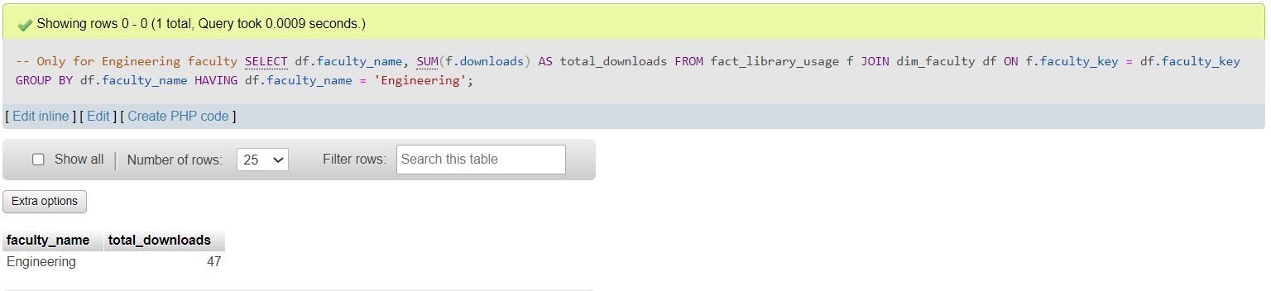

- Dicing (subset on multiple dimensions)
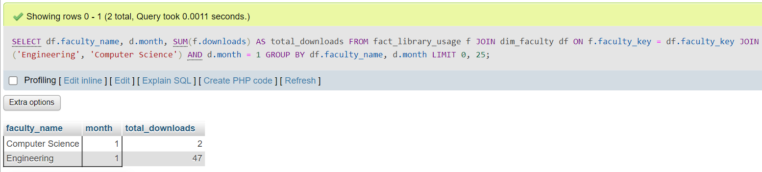

Snowflake schema diagram
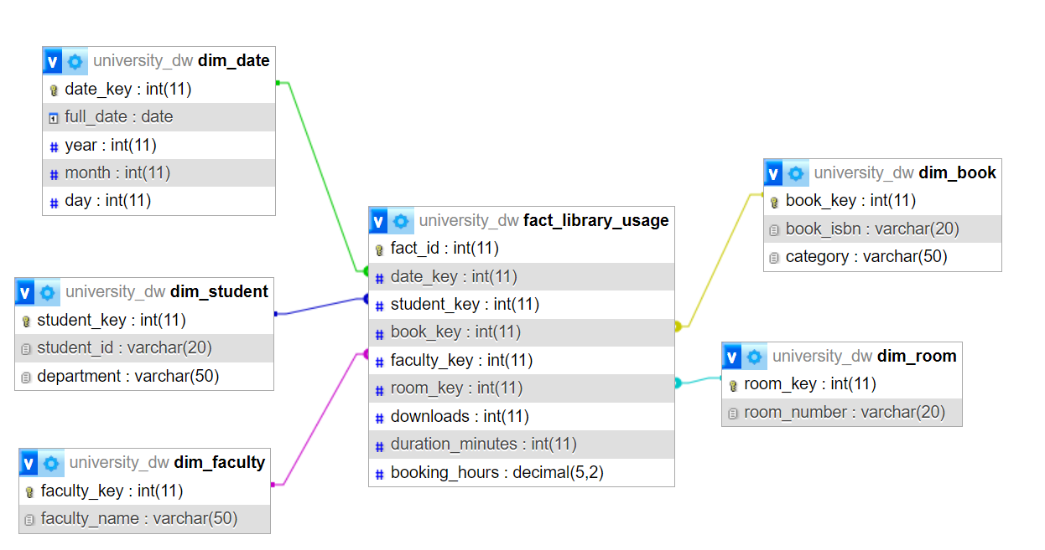
Pivot views on faculties
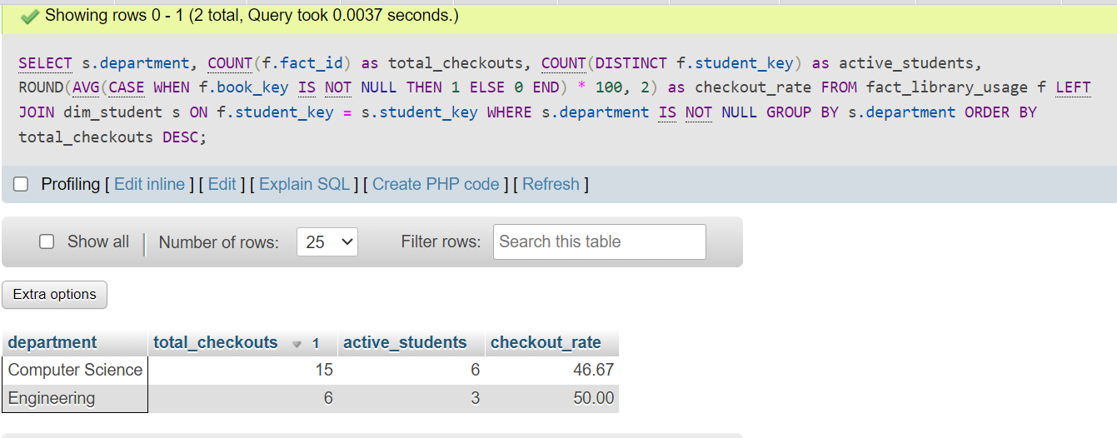
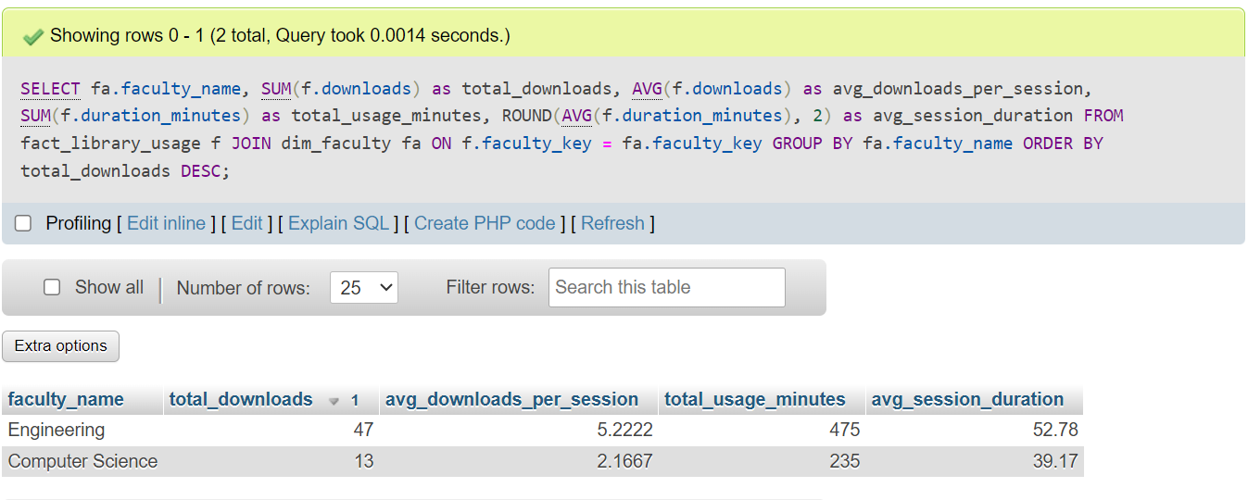

Users
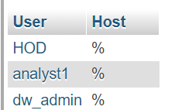
ERD
