A Prototype Spill Monitoring Framework Combining Visual Detection and a Conservation Regularized Neural Field
Development and preliminary evaluation

Abstract
This study presents a prototype spill-monitoring framework that combines single-class visual spill detection, image-based fluid classification, and a conservation-regularized neural field within a web interface for still images and video. The detector was trained and evaluated on a project image dataset divided into 1,799 training, 495 validation, and 270 test images. Its saved test metrics were 0.991 precision, 0.992 recall, 0.992 F1, 0.994 mAP@0.50, and 0.838 mAP@0.50:0.95. A separate 294-image wet-surface audit recorded at least one false detection in 72 images (24.5%), showing that the high internal test scores do not by themselves establish robust field performance. The neural field was trained on numerically generated thin-film trajectories rather than observed spill events. On held-out simulated trajectories, its saved pointwise predictions had an overall thickness RMSE of 5.63 × 10⁻⁵ m; on foreground points above the simulation visibility threshold, RMSE was 1.29 × 10⁻⁴ m. The final model used data-fit, geometric, and volume-conservation losses; no PDE residual was included. In a single illustrative photograph, the detector’s maximum score was 0.040, below the interface threshold. The work therefore supports a modular decision-support prototype, while field validation, camera calibration, and operational threshold selection remain necessary.
Keywords: oil spill detection; computer vision; object detection; fluid classification; mass conservation; neural surrogate; environmental monitoring

1 Introduction
Timely identification of oil on water can support environmental monitoring and response, but visible appearance varies with lighting, water state, camera view, and spill composition. Recent work has used optical satellite imagery and drone-captured RGB data for spill mapping, while also documenting the difficulty of separating oil from water and other visually similar surfaces [1,2]. These findings motivate systems that expose detections for human review and evaluate false alarms on wet or reflective backgrounds, rather than reporting only aggregate accuracy.
This work develops a modular prototype for image and video monitoring. A YOLOv8 detector proposes spill regions; a separate LightGBM model classifies each detected crop into one of four fluid categories; and a neural field trained with geometric and mass-conservation penalties supplies a learned volume-consistency signal for tracked regions. The software presents boxes, confidence values, track status, and environmental inputs in a browser interface. The framework is intended to support operator review, not to make autonomous incident declarations.
The contribution is an integration and preliminary evaluation of these components, together with an explicit account of their current validation limits. The neural field is trained on numerical simulations, not controlled visual spill events. Although physics-informed learning can incorporate physical relationships through residual or conservation-based terms [3,4], the final neural-field checkpoint described here has no PDE-residual loss. We therefore describe it as conservation-regularized and distinguish simulation performance from field performance.

2 Materials and methods

2.1 System architecture
The application is implemented as a Flask service with a browser dashboard. It accepts still images and video files and includes interfaces for webcam and RTSP sources. For each frame, the detector returns a spill bounding box and confidence score. The detected crop is passed to the fluid classifier, whose outputs are combined with a greedy IoU tracker. Track histories are evaluated by a trajectory module that queries the learned neural field over a 40 × 40 spatial grid and compares predicted volume with the track baseline. The current software requires multiple detections to establish a baseline and accumulate temporal evidence before returning a track status. A still image can receive a detection and fluid label, but it cannot satisfy the trajectory check.
The dashboard accepts a detector path through configuration. Its current fallback checkpoint is spill_best.pt; the detector metrics reported in this manuscript apply specifically to best_spill_detector.pt and should not be attributed to the dashboard’s fallback configuration.
The detector has one object class, “spill.” Fluid classes are assigned by a separate LightGBM model: water, light hydrocarbon, heavy oil, or drilling mud. The classifier extracts 37 features from a normalized detection crop, including RGB/HSV statistics, a specular-highlight proxy, GLCM texture, local binary patterns, heuristic geometry, and three environmental variables (wind speed, current velocity, and temperature). Default environmental values are substituted when field measurements are absent. No independent held-out fluid-crop evaluation was performed in this study; classifier labels are therefore provisional.

2.2 Visual detector data and training
The detector dataset uses a single spill class and contains 2,564 images across its training, validation, and test partitions. The YOLOv8n model was initialized from pretrained YOLOv8n weights and trained for up to 100 epochs at 640-pixel image size, with batch size 16, seed 42, early stopping patience 20, and the project’s configured colour and geometric augmentations. The split counts and training settings are summarized in Table 1. Reported metrics were read from the project’s saved test-evaluation output.
Partition or setting | Value
Training images | 1,799
Validation images | 495
Test images | 270
Detector | YOLOv8n; one class: spill
Training schedule | Up to 100 epochs; 640-pixel images; batch size 16; seed 42

Table 1. Detector data partitions and principal training settings.
The inference interface currently uses a confidence threshold of 0.4. Threshold selection was not calibrated against a deployment-specific cost function. A single user-supplied Louisiana spill photograph was also examined as an illustrative probe, separate from the saved test metrics. The detector returned a maximum score of 0.040 when queried at a diagnostic confidence floor of 0.001, so the application displayed no box at its operational threshold. Dataset membership for this image has not been established; this observation is not a formal external test result.

2.3 Conservation-regularized neural field
Synthetic trajectories were generated using a conservative semi-implicit finite-volume solution of the gravity-driven thin-film model:
∂h/∂t + ∇·q = 0, q = −(ρ g h³ / 3μ) ∇h
The numerical domain was 1 × 1 m on a 40 × 40 grid with 61 output times over 0–300 s. Thirty trajectories were generated with varied initial Gaussian spill geometry, density, viscosity, and thickness. Trajectories, rather than individual points, were assigned to the train, validation, and test partitions: 21, 4, and 5 trajectories, respectively. These are simulated conditions and parameter ranges, not measurements from spill incidents.
The final neural field is a fully connected network with 16 normalized inputs, five hidden layers of 96 tanh units, and a non-negative thickness output. It was trained for 100 epochs with a supervised thickness-data loss and additional geometric, per-state mass, and trajectory-level conservation losses. The configured final geometry and mass weights were 0.3 each, and the conservation weight was 0.01 with warm-up. The PDE-residual weight was zero. The saved training history reached its minimum validation RMSE of 3.14 × 10⁻⁵ m at epoch 35; the final recorded epoch had validation RMSE 4.27 × 10⁻⁵ m. The checkpoint is selected using validation performance.
During application inference, the track validator computes the model-predicted volume for the baseline and subsequent observed bounding-box geometries. It flags large relative drift as a screening signal. Pixel-to-metre conversion, assumed initial thickness, and fluid properties are not calibrated to a deployment camera or measured incident; consequently, the volume-drift status is not a direct measurement of physical spill volume or a validated pass/fail determination.

2.4 Evaluation measures
Detector performance is summarized using precision, recall, F1, mAP@0.50, and mAP@0.50:0.95 from the saved held-out test evaluation. A separate audit counted wet-surface negative images with at least one false detection. Neural-field thickness error is reported as RMSE and MAE over saved test predictions, both across all spatial points and on foreground points defined by the simulation threshold h > 10⁻⁵ m. Because most grid points are background, the foreground metrics are included to avoid relying on an aggregate dominated by near-zero targets.

3 Results

3.1 Detector evaluation
For best_spill_detector.pt, the project’s saved evaluation on its 270-image held-out test partition reported precision 0.9913, recall 0.9919, F1 0.9916, mAP@0.50 0.9944, and mAP@0.50:0.95 0.8380 (Table 2). These are internal dataset results. In the separate wet-surface negative audit, 72 of 294 images produced at least one false detection, corresponding to an image-level false-positive rate of 24.5%. The internal test metrics and wet-surface audit measure different conditions and do not establish field readiness. The threshold-dependent precision–recall behavior and normalized classification outcomes are shown in Figures 1 and 2. The wet-surface audit response across confidence thresholds is shown in Figure 3.
Metric | Saved result
Precision | 0.9913
Recall | 0.9919
F1 score | 0.9916
mAP@0.50 | 0.9944
mAP@0.50:0.95 | 0.8380
Wet-surface negative images with ≥1 false detection | 72 / 294 (24.5%)

Table 2. Saved internal detector metrics and the separate wet-surface false-positive audit.
In the illustrative Louisiana photograph, the selected detector’s maximum confidence was 0.040 at a diagnostic floor of 0.001. This is below the dashboard’s 0.4 display threshold. The single-image observation is a useful warning about confidence calibration and domain transfer, but it does not provide a statistically sufficient estimate of external performance.
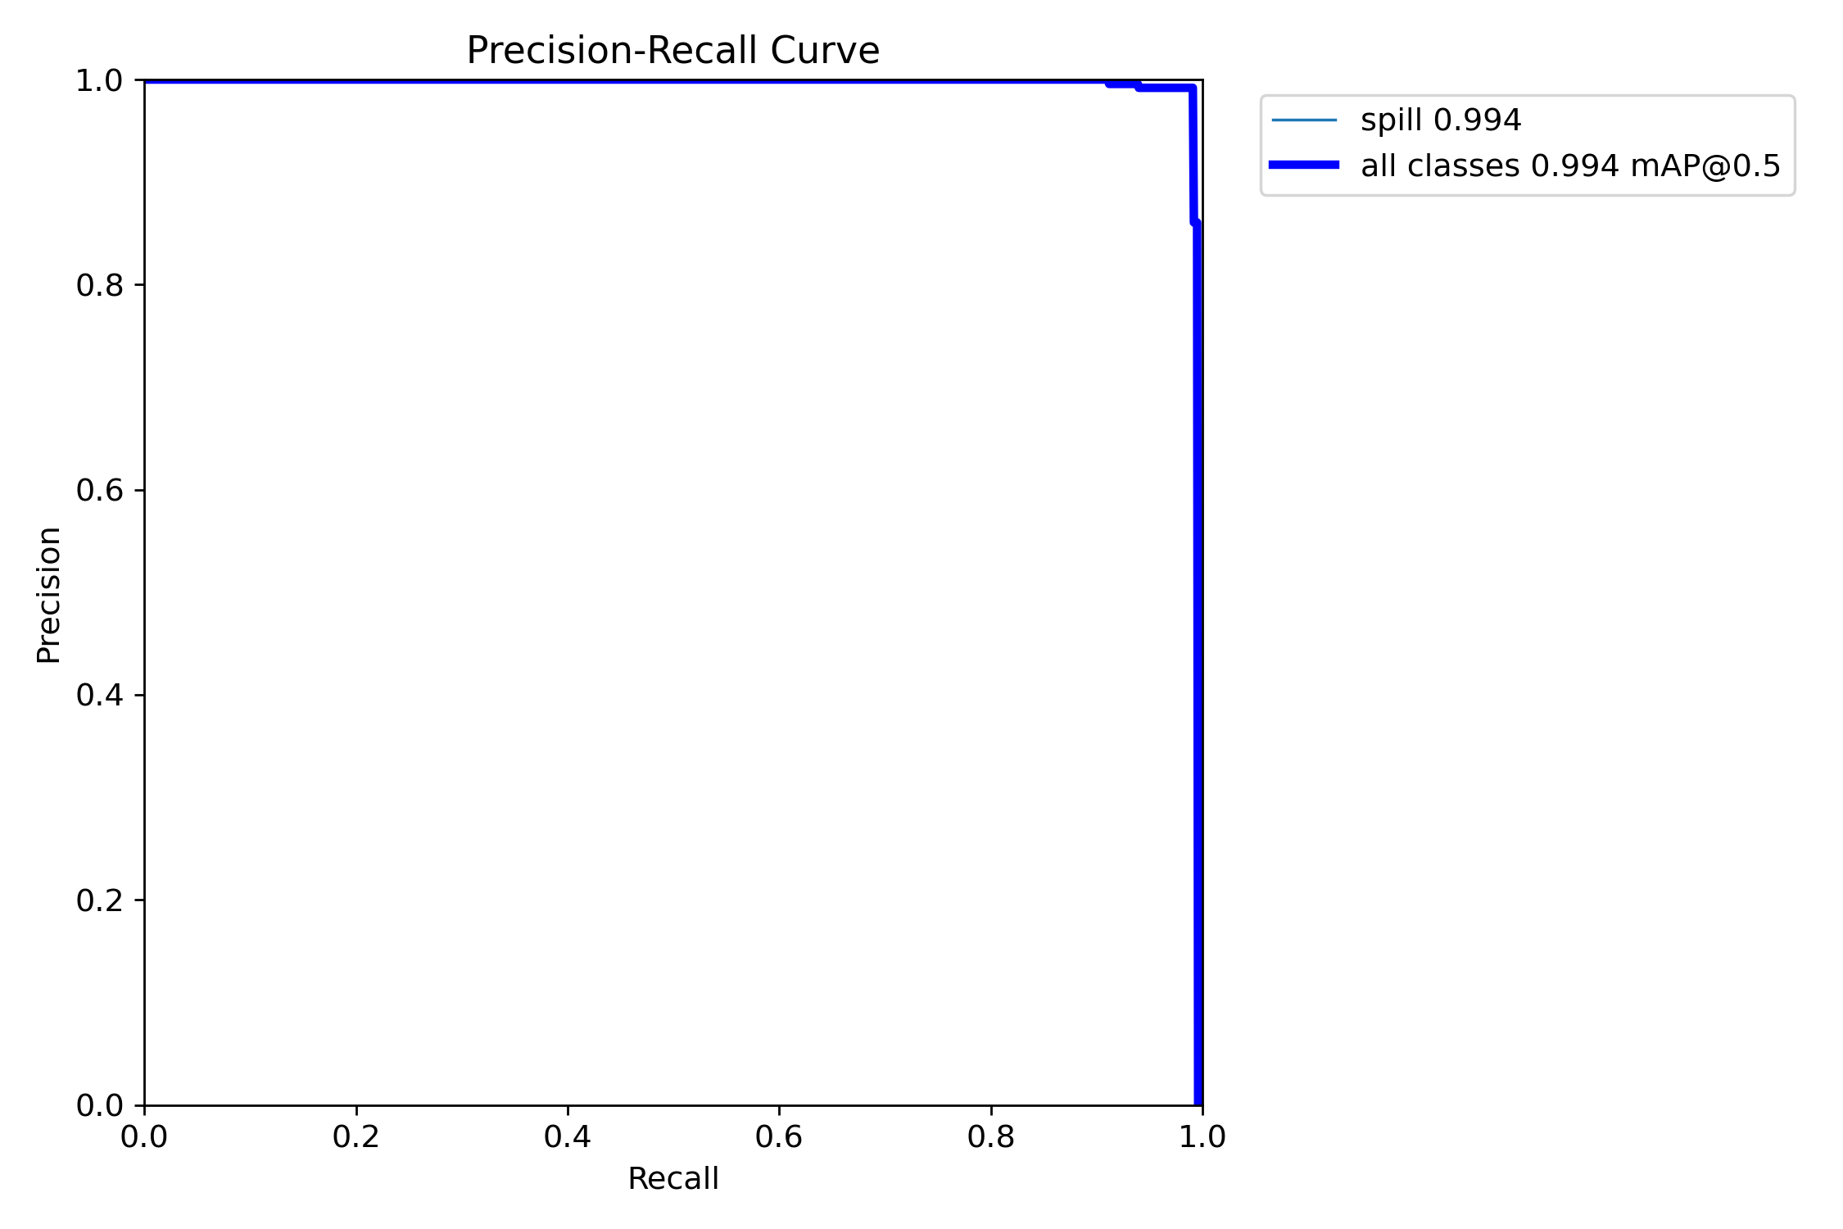
Figure 1. Precision–recall curve for spill detection on the held-out internal test partition.
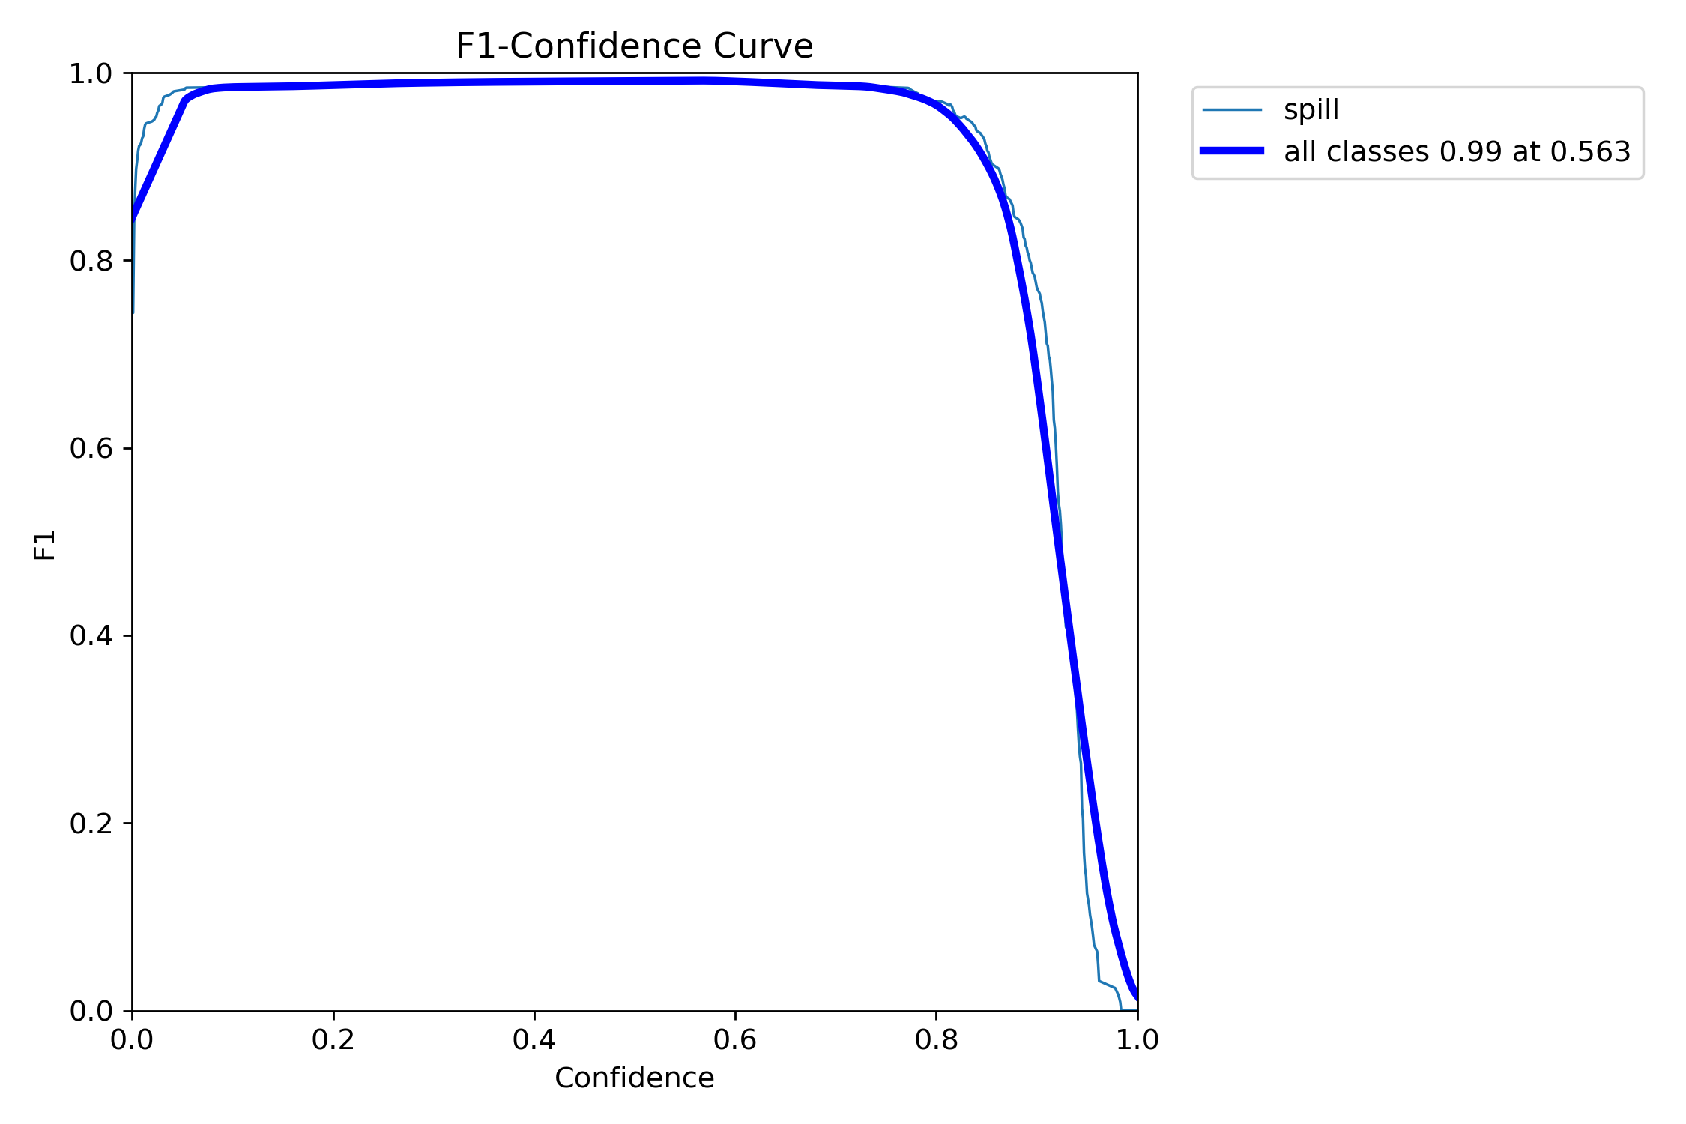
Figure 2. F1 score across confidence thresholds in the saved held-out detector evaluation.
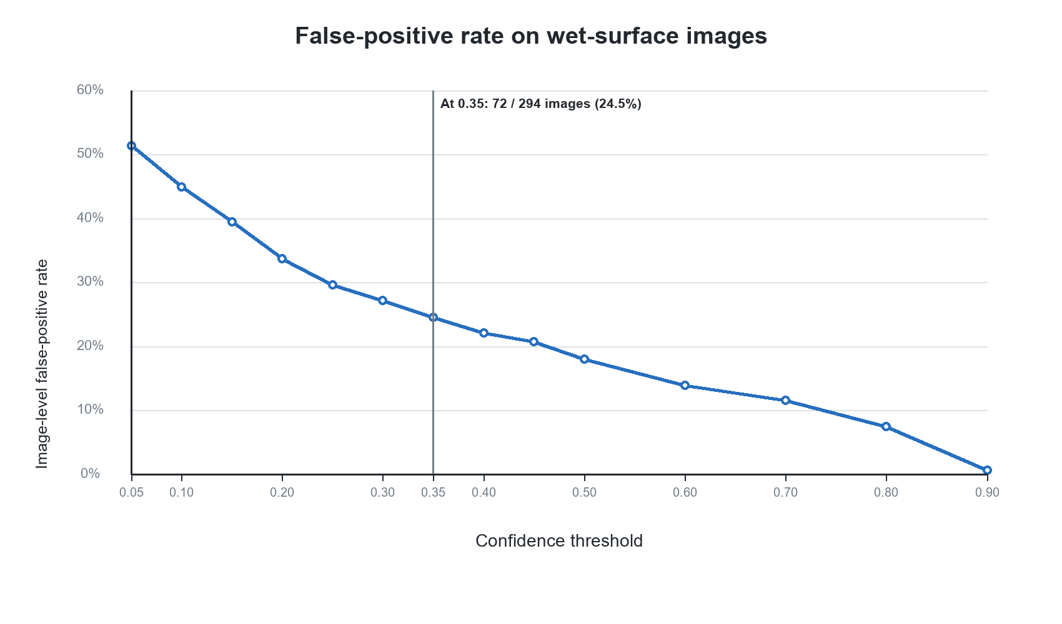
Figure 3. Image-level false-positive rate across confidence thresholds in the separate wet-surface negative audit.

3.2 Neural-field evaluation
The saved held-out prediction file contains 488,000 point predictions from five simulated test trajectories. Overall thickness RMSE was 5.63 × 10⁻⁵ m and MAE was 1.84 × 10⁻⁵ m. For the 92,390 foreground points with reference thickness greater than 10⁻⁵ m, RMSE was 1.29 × 10⁻⁴ m and MAE was 9.56 × 10⁻⁵ m. These results quantify approximation of the simulation-generated field; they do not measure performance on observed oil thickness or camera imagery. The training trajectory and held-out foreground predictions are shown in Figures 4 and 5.
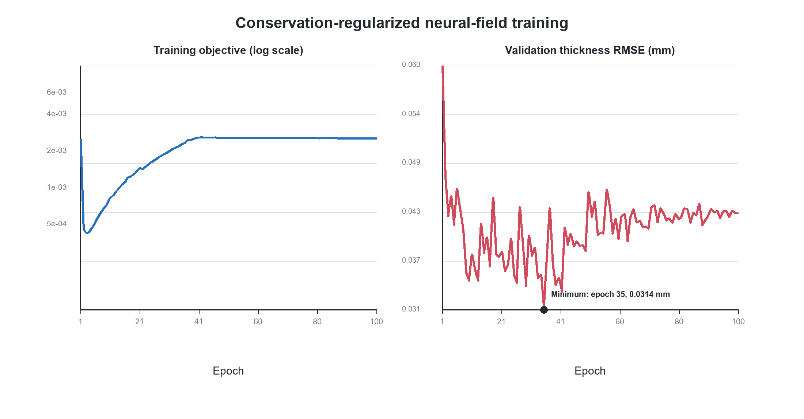
Figure 4. Training objective and validation thickness RMSE for the conservation-regularized neural field; the minimum validation RMSE occurred at epoch 35.
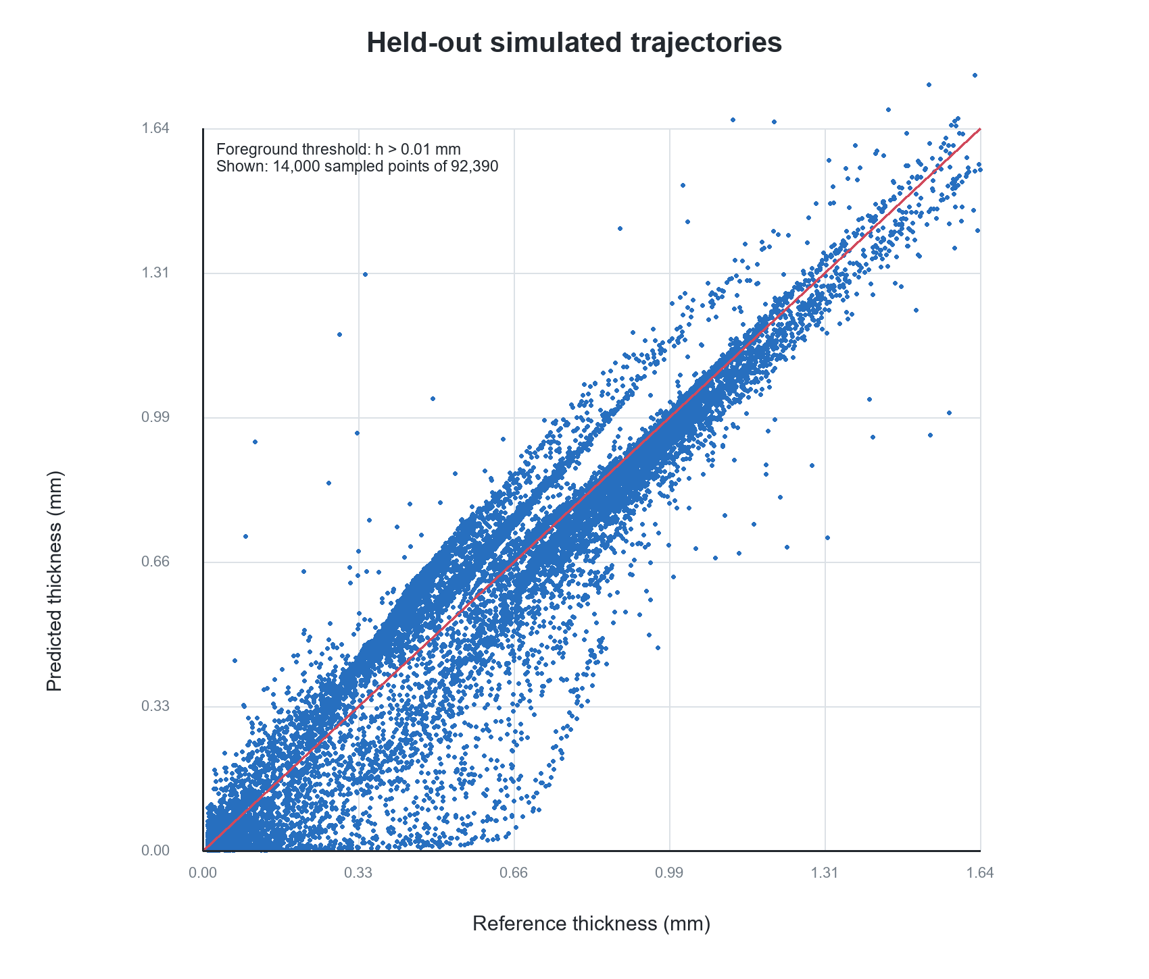
Figure 5. Predicted against reference thickness for a reproducible sample of foreground points from five held-out simulated trajectories. The dashed line denotes equality.
Evaluation subset | Points | RMSE (m) | MAE (m)
All test grid points | 488,000 | 5.63 × 10⁻⁵ | 1.84 × 10⁻⁵
Foreground (h > 10⁻⁵ m) | 92,390 | 1.29 × 10⁻⁴ | 9.56 × 10⁻⁵

Table 3. Neural-field pointwise errors on five held-out simulated trajectories.

3.3 Integrated software prototype
The software combines still-image analysis with annotated video frames, fluid-class estimates, and multi-frame tracks. The interface exposes environmental inputs and reports trajectory status only after accumulating detections. The implementation is functional as a demonstration framework, but no measured end-to-end latency, sustained-stream reliability, or field-operator evaluation is available in the project records reviewed for this manuscript.

4 Discussion
The results support a limited conclusion: the project has a working modular prototype and strong detector metrics on its internal image test partition, while the detector’s wet-surface audit and low score on a single illustrative image expose unresolved generalization and threshold-calibration issues. Optical spill monitoring is known to face ambiguity between oil, water, glint, and other surface patterns [1,2]. The current audit gives a concrete reason to prioritize negative examples and independent camera or incident splits before presenting the detector as operationally reliable.
The neural field contributes a separate simulation-based component. Its training incorporates geometric and mass-conservation constraints, a form of physics-based regularization used in surrogate modeling [4]. However, the checkpoint reported here does not minimize a PDE residual and receives no measured trajectories. It should therefore be described as a conservation-regularized surrogate, not as a model that has experimentally validated spill dynamics. Its trajectory drift score is best treated as an exploratory consistency indicator until the camera mapping, thickness assumptions, fluid properties, and decision thresholds are calibrated and independently evaluated.
The separation of detection from fluid classification is useful for modular development: a detector can propose a candidate without needing to determine the fluid class, and a separate module can provide a provisional class estimate. However, no independent classification report or held-out fluid-crop evaluation was located. The application should therefore display classifier confidence and retain an unknown or review state when evidence is weak. It should not infer fluid identity as a confirmed fact from the current prototype.
For environmental monitoring services, the system is most defensibly framed at this stage as an operator-facing screening prototype. The next evaluation should use annotated image sequences from independent sources, include wet-surface and non-spill negatives, report performance by source and viewing condition, calibrate thresholds on validation data, and assess the integrated pipeline without using test images for tuning. A separate study is needed to validate the fluid classifier and the conservation surrogate against documented physical measurements or independently generated solver cases.

5 Limitations
- No controlled visual spill events or field measurements are represented in the current project results. The neural-field training and test sets are numerical simulations.
- Detector scores come from an internal split whose source independence and deployment representativeness require further documentation. The wet-surface audit has image-level false positives and is not a complete operational benchmark.
- The single Louisiana-image probe is not a formal external test and its membership in the detector dataset has not been verified.
- The fluid-classifier artifact lacks a located independent test report; environmental values may be imputed defaults rather than sensor readings.
- Camera scale, thickness initialization, and fluid-property inputs in the conservation interface are placeholders. They do not support calibrated physical measurements.
- The final conservation model has no PDE-residual term. Its conservation-related output is not a direct PDE residual and its video trajectory status has not been field validated.
- No controlled study of computational latency, operator usability, or continuous deployment reliability has been completed.

6 Conclusion
A prototype spill-monitoring framework has been assembled from a YOLOv8 visual detector, a LightGBM fluid classifier, a conservation-regularized neural field trained on simulated spill trajectories, and a web-based image/video interface. Internal detector metrics are high, but a wet-surface audit and a low-confidence result on one illustrative spill image show that those metrics alone are insufficient to establish field reliability. The neural field approximates synthetic thickness data with measurable error but has not been validated against physical incidents, and its final training did not include a PDE residual. The appropriate next step is independent, annotated image/video evaluation and calibration of the detection, classification, and trajectory modules before making operational performance claims.

References
Sun Z, Yang Q, Yan N, Chen S, Zhu J, Zhao J, Sun S. Utilizing deep learning algorithms for automated oil spill detection in medium resolution optical imagery. Marine Pollution Bulletin. 2024;206:116777. https://doi.org/10.1016/j.marpolbul.2024.116777.
De Kerf T, Sels S, Samsonova S, Vanlanduit S. A dataset of drone-captured, segmented images for oil spill detection in port environments. Scientific Data. 2024;11:1180. https://doi.org/10.1038/s41597-024-03993-8.
Raissi M, Perdikaris P, Karniadakis GE. Physics-informed neural networks: a deep learning framework for solving forward and inverse problems involving nonlinear partial differential equations. Journal of Computational Physics. 2019;378:686–707. https://doi.org/10.1016/j.jcp.2018.10.045.
Donnelly J, Daneshkhah A, Abolfathi S. Physics-informed neural networks as surrogate models of hydrodynamic simulators. Science of the Total Environment. 2024;912:168814. https://doi.org/10.1016/j.scitotenv.2023.168814.
Jocher G, Chaurasia A, Qiu J. Ultralytics YOLOv8. Version 8.0.0 [software]. 2023. https://github.com/ultralytics/ultralytics.

