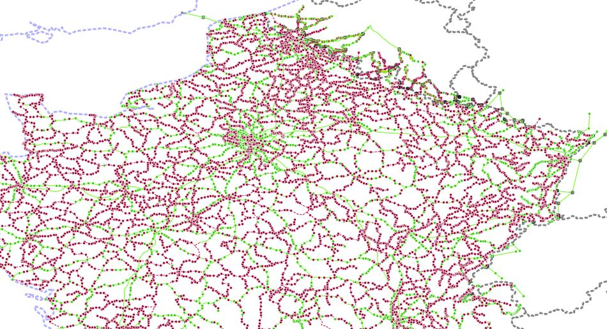
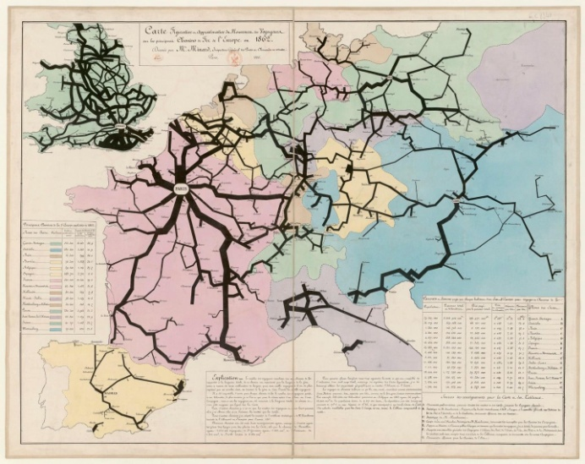
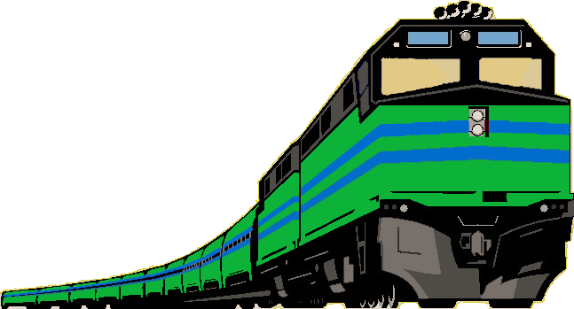
West Europe – digital
A century of railways in
version
... towards a green new rail
1925
2025

WAGONRAIL-Century: a “Time Machine” project
Transport is currently the fastest growing share of CO2 emissions. The share of “cleaner” transport (maritime and rail) has been declining for at least five decades.
Dealing with this degradation requires studying long-term trends, based on a reliable and exhaustive documentation of the networks, over a sufficient period of time and on a spatial scale that is both large and locally precise. Transport has an end-to-end action: high-speed lines, local lines and “last mile” services weigh equally in a complex overall balance sheet. The European Transport White Paper [2011] calls for more documented retrospective work.

The ambition of this “Time Machine” project is both historical and forward-looking, both local and transnational.

The century-long scale looks relevant to cover a variety of major events. The West Europe spatial scale looks relevant to account for political or cultural approaches from different institutions and interests.

The objective of the project is to carry out exhaustive geocoding of European railway networks, as they have existed for the last hundred years, and to code and run simulation tools.

Geocoding past infrastructures goes beyond simple heritage digitizing. The exploitation of the "digital twin" of our Planet is underway in Europe (Destination Earth-ESA), in the USA (Earth System Digital Twins-NASA) and large private groups (Facebook, IBM, etc.) are betting on the market of "metaverse", whose vertiginous growth is not limited to video games.

The postulate of the project is that the digital twin must know the past of its “real” sister.

The development of this project is based on a series of specific tasks:
• Collect current data in each country, then aim for completeness in the census of localities and industrial sites formerly reached by rail. With emphasis on border rail crossings and their evolution over the century;
• Collect data on the life cycle of lines and equipments, for later diachronic studies;
• Develop data quality control tools (checks of structural, temporal, spatial constraints);
• Develop graph traversal tools (shortest path) to allow computing of coverage density, population served, energy consumption, CO2 simulators, etc.
• Build the most relevant data structure to serve information for graph analysis, plane geometry (areas and distances), etc., in inter-operation with studies using socio-economic data.

The progressive enrichment of the data and their structure will allow both to develop new tools and to extend the coverage and density of the network.

Rail, “one of the most sustainable, innovative and safest transport modes we have”, yet has been largely weakened for more than half a century, including in the last decade. Its rehabilitation motivates the attention paid to the production of quality data in precision, completeness and ease of use, which may help any researcher to address historical, political, economic, social questions, with quantitative data. This should help any citizen as well, to learn about the evolution of rail and to "play" with a simulator, indeed virtual, but not imaginary, since all components have existed at some time in the contemporary history.

Time Machine: https://www.timemachine.eu
Project WAGONRAIL-Century (West-european Archive of Geocoded Observations of the Network of Rail-Accessible Industries and Localities, over a Century).

As said in the motto of the European Year of Rail (2021)

