CAR-T response in DLBCL is shaped by the immune tumor microenvironment: integrative transcriptomic evidence

Jean Silva de Souza Resende^{1,2,3}, Igor Samesima Giner^{1,2}, Maria Gabriela Custódio Figueiredo¹, Mariana Martins Paraízo¹, Enzo Lalli⁴, Mauro Antônio Alves Castro³, Bonald Cavalcante de Figueiredo^{1,2}*

1 Instituto de Pesquisa Pelé Pequeno Príncipe, Curitiba, PR 80250-060, Brazil
2 Faculdades Pequeno Príncipe, Curitiba, PR, 80230-020, Brazil.
3 Bioinformatics and Systems Biology Laboratory, Federal University of Paraná, Curitiba, PR 81520-260, Brazil
4 Institut de Pharmacologie Moléculaire et Cellulaire CNRS UMR7275, Inserm U1323, Université Côte d’Azur, 06560 Valbonne, France

*Corresponding Authors:
bonald.figueiredo@professor.fpp.edu.br (B.C.F.); mauro.castro@ufpr.br (M.A.A.C)

Abstract

Background: Anti-CD19 CAR T-cell therapy (Axi-cel) has transformed the treatment landscape for relapsed or refractory diffuse large B-cell lymphoma (DLBCL). However, a substantial proportion of patients fail to achieve durable responses. Although target antigen escape is well-described, therapeutic failure frequently occurs in tumors retaining positive CD19 expression. This study aimed to investigate the intrinsic and microenvironmental transcriptomic determinants of resistance to Axi-cel.
Methods: We performed an integrative analysis of targeted gene expression data from tumor microenvironment panels generated in the pivotal ZUMA-1 and ZUMA-7 clinical trial cohorts. Potential evasion mechanisms were investigated through differential gene expression, pathway enrichment analysis, and survival analyses. The treatment-context specificity and independence of the candidate signature were further evaluated across the axi-cel treatment cohorts, the ZUMA-7 standard-of-care salvage chemotherapy arm from ZUMA-7, and an independent first-line chemoimmunotherapy cohort from TCGA-DLBC.
Results: Transcriptomic mapping revealed that baseline T-cell exhaustion signatures and global HLA downregulation fail to independently stratify response to Axi-cel. Therapeutic sensitivity was associated with preservation of B-cell lineage phenotypic integrity (CD19, MS4A1, TNFRSF17) and transcriptional competence (IRF8). Conversely, early CAR T-cell escape was associated with tumor dedifferentiation, epithelial-mesenchymal-like tissue-remodeling programs, altered cellular adhesion involving CDH2 and NCAM1, and immune-excluding chemotaxis associated with CCL20. Cross-cohort evaluation indicated that most markers comprising this risk profile were associated predominantly with failure in the cellular immunotherapy setting. WNT11 was an exception, emerging as a broader adverse prognostic marker of intrinsic tumor aggressiveness. Cellular deconvolution further showed that the estimated bulk abundance of infiltrating immune and stromal populations did not independently stratify clinical outcomes.
Conclusions: Early resistance to Axi-cel in DLBCL may reflect malignant-clone phenotypic plasticity, loss of lymphoid identity, and aberrant tissue-remodeling programs rather than classical immune deprivation alone. Characterization of these candidate evasion pathways provides a framework for further biomarker validation and identifies potential biological targets for combination strategies designed to overcome resistance to CAR T-cell therapy.

What is already known on this topic
Although anti-CD19 CAR T-cell therapy (Axi-cel) is highly effective for relapsed/refractory DLBCL, many patients experience therapeutic failure without losing CD19 expression

What this study adds
This study reveals that early Axi-cel resistance is not primarily driven by classical baseline immune deprivation, but rather by the malignant clone's phenotypic plasticity, characterized by the loss of B-cell lineage identity and the activation of aggressive tissue remodeling and epithelial-mesenchymal transition-like (EMT-like) programs.

How this study might affect research, practice or policy
These findings provide an orthogonally validated transcriptomic framework for pre-treatment risk stratification and identify EMT-like and Wnt signaling as rational targets for novel combination therapies or the engineering of next-generation CAR T-cells.

Introduction

Diffuse large B-cell lymphoma (DLBCL) is the most common aggressive non-Hodgkin lymphoma in adults and is characterized by substantial biological and clinical heterogeneity. Despite major advances with first-line rituximab-based chemoimmunotherapy (R-CHOP), approximately 30–40% of patients develop relapsed or refractory (r/r) disease, which has historically been associated with a dismal prognosis and limited treatment options (1,2). Following failure of first-line therapy, CD19-directed chimeric antigen receptor (CAR) T-cell therapies, including axicabtagene ciloleucel (axi-cel), have transformed the therapeutic landscape by inducing durable remissions in a subset of patients (3,4).
However, a substantial proportion of patients treated with axi-cel either fail to achieve a sustained complete response or experience early relapse. Although antigen escape through loss or reduced expression of CD19 has been described, disease progression frequently occurs despite preserved target expression, indicating that resistance is often mediated by mechanisms beyond antigen loss (5,6). These observations support a model in which axi-cel resistance arises from a complex interplay between tumor-intrinsic biological programs and the surrounding tumor microenvironment (TME).
In conventional tumor immunology, immune evasion is frequently attributed to pre-existing T-cell exhaustion and impaired antigen-presentation machinery, including downregulation of human leukocyte antigen (HLA) molecules. Although pathways such as PD-1/PD-L1 signaling may contribute to adaptive resistance after CAR T-cell infusion, baseline global exhaustion signatures have not consistently stratified treatment responses independently (7–9). Similarly, while immunosuppressive cellular populations have been associated with impaired CAR T-cell expansion and activity, quantitative estimates of immune and stromal infiltration alone do not fully account for the marked variability in clinical outcomes (REF?). This discrepancy suggests that the functional state and phenotypic plasticity of malignant B cells may constitute more consequential barriers to CAR T-cell activity than the abundance of inhibitory cell populations alone.
Effective antitumor immunity also depends on the coordinated activation of inflammatory pathways. Acute activation of interferon (IFN) enhances target vulnerability, whereas an inability to mount an effective baseline inflammatory program, or its chronic dysregulation, can limit CAR T-cell engagement (10,11). In parallel, specific chemokine networks, including the CCL20–CCR6 axis, have been implicated in immune exclusion and the establishment of an immunologically anergic microenvironment (12). Beyond classical immune signaling, emerging paradigms highlight the role of tumor dedifferentiation and aggressive tissue remodeling. Programs analogous to epithelial-mesenchymal transition-like (EMT-like) and alterations in cellular adhesion confer physical and biological protection against effector immune cell infiltration and cytotoxicity, representing a largely unexplored frontier in cellular immunotherapy resistance (13–15).
Conversely, preservation of mature B-cell lineage identity may favor therapeutic sensitivity. Sustained expression of canonical B-cell markers, including CD19 and MS4A1, together with lineage-defining transcriptional regulators such as IRF8, may maintain a differentiated cellular state that is more permissive to immune recognition and elimination (16,17). Thus, the balance between B-cell lineage integrity and the acquisition of dedifferentiated, inflammatory, or tissue-remodeling phenotypes may critically influence the response to CD19-directed CAR T-cell therapy.
To decode this multidimensional evasion network, the present study aimed to investigate the molecular determinants of Axi-cel response by integrating transcriptomic data from the pivotal ZUMA-1 and ZUMA-7 clinical trials. Rather than focusing exclusively on bulk immune infiltration, we systematically evaluated baseline B-cell lineage integrity, canonical exhaustion markers, and the HLA complex. Through this approach, we identified distinct biological pathways of intrinsic resistance, ranging from immune silencing to aggressive tissue remodeling, and established an orthogonally validated transcriptomic signature that provides a mechanistic framework to predict CAR T-cell failure and guide future therapeutic strategies.

2. Materials and methods

2.1 Study Design and Clinical Cohorts

This retrospective translational study analyzed transcriptomic and clinical data from patients with relapsed or refractory (r/r) diffuse large B-cell lymphoma (DLBCL) treated with the axicabtagene ciloleucel (Axi-cel) anti-CD19 CAR T-cell therapy. Data were derived from the pivotal ZUMA-1 (NCT02348216, https://clinicaltrials.gov/study/NCT02348216; third-line setting) and ZUMA-7 (NCT03391466, https://clinicaltrials.gov/study/NCT03391466; second-line setting) clinical trials. The TCGA-DLBC cohort (https://portal.gdc.cancer.gov/projects/TCGA-DLBC; N = 47; CAR-T naive) was incorporated as a reference control representing conventional chemoimmunotherapy.
Within the ZUMA-1 cohort, we evaluated baseline (pre-lymphodepletion) profiles (N = 29; 20 Complete Response [CR] vs. 9 Non-CR) alongside paired longitudinal dynamics (post-infusion vs. baseline) in a subset of patients (N = 8, all achieving CR). For the ZUMA-7 study, baseline evaluations were conducted in the experimental Axi-cel arm (N = 134; 58 Sustained Response, 70 Failure, 6 unclassified) and the standard-of-care (SOC) salvage chemotherapy control arm (N = 122; 18 Sustained Response, 80 Failure, 24 unavailable) to model Event-Free Survival (EFS). Well-established clinical prognostic factors, namely baseline tumor burden (Sum of Product Diameters, SPD) and molecular subtype (Cell of Origin, COO), were extracted as clinical covariates for multivariable adjustments.

2.2 Transcriptomic Data Acquisition and Processing

Preprocessed gene expression matrices derived from custom microarray platforms were retrieved from the Gene Expression Omnibus (GEO) repository under accession numbers GSE197977 (ZUMA-1 cohort, https://www.ncbi.nlm.nih.gov/geo/query/acc.cgi?acc=GSE197977; 74 samples, 724 genes) and GSE248835 (ZUMA-7 cohort, https://www.ncbi.nlm.nih.gov/geo/query/acc.cgi?acc=GSE248835; 256 samples, 817 transcripts and functional signatures). For clinical response stratification within the ZUMA-7 cohort, patients were categorized into "Sustained" and "Failure" groups, which correspond directly to the "Ongoing" and "Others" clinical outcomes, respectively, as originally defined by Locke et al. (2024). To establish the reference control cohort, RNA sequencing data (RNA-seq, quantified as Transcripts Per Million [TPM]) for the TCGA-DLBC cohort were systematically obtained from the Genomic Data Commons (GDC) portal.
To enable analytical integration across distinct transcriptomic technologies, clinical metadata and feature identifiers were harmonized through unified mapping to official Gene Symbol nomenclature. To mitigate platform-dependent scaling biases, stabilize intrinsic variance, and ensure direct cross-cohort statistical comparability across all three datasets, all absolute expression profiles underwent Log2 transformation prior to inferential and survival modeling.

2.3 Tumor Microenvironment Deconvolution and B-Cell Lineage Integrity

The architecture of the tumor microenvironment (TME) was deconvoluted using the Microenvironment Cell Populations-counter algorithm (MCP-counter; MCPcounter R package v1.2.0) (19), quantifying the absolute abundance of eight immune and two stromal populations. To investigate therapeutic target preservation and tumor phenotypic integrity, variations in B-cell lineage abundance and its canonical markers across baseline clinical outcomes were statistically evaluated using the Mann-Whitney U test. Complementarily, longitudinal remodeling of the tumor ecosystem under CAR T-cell selective pressure (intra-patient post-infusion vs. baseline) was mapped using the Wilcoxon signed-rank test for paired samples.

2.4 Transcriptomic Mapping of Immune Evasion

To delineate the immunosuppressive architecture and tumor escape potential, transcriptomic profiles associated with T-cell exhaustion and the integrity of the antigen presentation machinery (HLA) were investigated. Aiming for a granular and functional phenotypic assessment, the HLA complex was stratified a priori into four biological axes: classical Class I molecules, the intracellular processing machinery, Class II molecules, and non-classical inhibitory Class I molecules. To identify latent biological clusters, Log2-transformed counts were scaled into Z-scores and subjected to unsupervised hierarchical clustering (Euclidean distance and Ward's linkage method; stats R package v4.6.1) , followed by visualization using multidimensional heatmaps (ComplexHeatmap v2.28.0) (20) . Finally, direct clinico-genomic integration was performed by pairing the uncovered evasion profiles with clinical efficacy annotations (Response, EFS), molecular subtype (COO), and continuous tumor burden (SPD).

2.5 Global Transcriptomic Mapping and Pathway Enrichment

To map the global transcriptomic perturbations underlying primary resistance to Axi-cel, baseline differential expression analysis (DEA) was conducted using the limma R package (v3.68.4) (21), adopting an exploratory heuristic threshold (nominal p < 0.05, | Log2 | > 0.5) for the initial prospection of signatures. Aiming to translate isolated transcripts into functional programs and capture biological heterogeneity at the individual patient level, Single-Sample Gene Set Enrichment Analysis (ssGSEA; GSVA v2.6.5) (22) was employed. This approach quantified the activation intensity (Mean Normalized Enrichment Score, Mean NES) of eight ontological macrocategories from the MSigDB Hallmark collection (23). Complementarily, to identify the core mechanistic axes driving therapeutic failure at the population level, classical GSEA (fgsea v1.38.0) (24) was performed based on the continuous statistical ranking derived from limma (adjusted p < 0.05).

2.6 Prognostic Modeling and Tumor Microenvironment Dynamic

To determine the clinical impact of transcriptomic signatures on therapeutic efficacy, Event-Free Survival (EFS) within the ZUMA-7 cohort was modeled using Kaplan-Meier estimates and the log-rank test (survival R package v3.8.6, survminer v0.5.2) (25,26). Patient stratification was strictly based on the intra-cohort median expression, ensuring a standardized analytical threshold and mitigating cutpoint optimization biases (cutpoint overfitting). Aiming to validate the independent prognostic value of the signatures and isolate their effect from well-established clinical confounders, multivariable Cox proportional hazards regression models were constructed to derive Hazard Ratios (HR) adjusted for baseline tumor burden (Sum of Product Diameters, SPD) and molecular subtype (Cell of Origin, COO). Finally, to elucidate the functional dynamics within the tumor ecosystem, the network of interactions between candidate biomarkers and the absolute abundance of immune and stromal populations (estimated via MCP-counter) was mapped using Spearman's rank correlation (stats v4.6.1).

2.7 Validation of Therapeutic Specificity

To conclusively discriminate strict predictive value (specific to cellular immunotherapy) from mere general prognostic impact (inherent to baseline DLBCL aggressiveness), the therapeutic specificity of the biomarkers was assessed through orthogonal validation across three independent clinical scenarios. Maintaining standardized stratification by median expression, the genomic impact was modeled on Event-Free Survival (EFS) in the experimental arm (ZUMA-7 Axi-cel) and directly contrasted with two conventional therapy groups: EFS in the control arm (ZUMA-7 SOC; salvage setting) and Overall Survival (OS) in the TCGA-DLBC cohort (R-CHOP; first-line setting). Under this rigorous design, the retention of statistical significance (p < 0.05) exclusively within the Axi-cel cohort classified the transcript as a genuine predictor of specific anti-CD19 CAR T-cell evasion, thereby ruling out markers of non-specific tumor aggressiveness.

2.8 Analytical Integration and Cross-Validation with Pivotal Literature

To contextualize the biological originality and translational robustness of our findings, the predictive value of the biomarker panel was subjected to systematic cross-validation against the genomic data reported in the original publications of the ZUMA-1 and ZUMA-7 trials. The predictive profile of each transcript was methodologically categorized based on its direct concordance with the literature, structuring the validation framework into three comparative scenarios: (I) Broad Concordance, encompassing biomarkers whose predictive effects were simultaneously confirmed by the original findings of both cohorts; (II) Cohort-Specific Concordance, including transcripts primarily supported by only one of the trials (ZUMA-1 or ZUMA-7), reflecting biological nuances potentially associated with the line of therapy; and (III) Emerging Significance/Novelty, grouping biological targets characterized in the original literature as inconclusive, non-specific, or not reported (NR), but which acquired autonomous and validated predictive significance in the current study through multivariable Cox modeling for EFS.

2.9 Biological Integration and Representation of the Mechanistic Model

To synthesize the complexity of the tumor ecosystem and provide a unified translational interpretation of the findings, a conceptual mechanistic model was developed. This model resulted from the topological integration of the study's three core analytical frameworks: (I) the directionality of enriched functional pathways (GSEA/ssGSEA); (II) the architecture and composition of the cellular microenvironment (MCP-counter); and (III) the validated predictive impact on clinical survival (Cox and Kaplan-Meier modeling across the ZUMA-1, ZUMA-7, and TCGA cohorts). The integrative diagram -phenotypically dichotomized into axes of immune resistance/evasion and programs of sensitivity/target preservation under CAR T-cell selective pressure - was compiled and illustrated using the BioRender platform (https://biorender.com).

2.10 Statistical Analysis and Data Visualization

All analytical processing and statistical modeling were executed within the R computational environment (version 4.6.1). The distribution of continuous variables between independent groups was evaluated using the non-parametric Mann-Whitney U test, whereas the Wilcoxon signed-rank test was applied for intra-patient paired longitudinal measurements (27,28). Bivariate associations, such as the covariance between gene expression and immune populations, were quantified using Spearman's rank correlation coefficient.
Statistical significance for survival probability estimates (Kaplan-Meier) was assessed via the log-rank test. Multivariable Cox proportional hazards regression was employed to derive Hazard Ratios (HR) and their respective 95% confidence intervals (95% CI), with the mathematical validity of the models confirmed through the analysis of Schoenfeld residuals, ensuring adherence to the proportional hazards assumption.
To mitigate the inflation of false positives (Type I error) inherent to genomic multiple testing scenarios (DEA and GSEA), nominal p-values were systematically adjusted using the Benjamini-Hochberg method, thereby controlling the False Discovery Rate (FDR) (29). A two-tailed statistical significance threshold of p < 0.05 was adopted a priori across all inferential analyses. The visualization of high-dimensional complex data was orchestrated primarily utilizing the ggplot2 (v4.0.3) (30), ComplexHeatmap (v2.28.0) (31), and survminer (v0.5.2) (26) R packages.

3. Results

3.1 B-Cell Lineage Integrity, Not Just Isolated CD19 Expression, Dictates Response to Axi-cel

Clinical evaluation of the therapeutic target is frequently reduced to the isolated presence of the CD19 gene. However, our data reveal that high CD19 expression alone does not guarantee Axi-cel efficacy; rather, it is essential to evaluate the global phenotypic integrity of the B-cell lineage. Within the Axi-cel cohort of the ZUMA-7 study, patients who achieved a sustained clinical response exhibited a consistent trend toward higher baseline expression across the entire panel of B-cell lineage markers (CD19, MS4A1/CD20, TNFRSF17) compared to those who experienced therapeutic failure (Figure 1A). This profile indicates that CAR T-cell sensitivity relies on the preservation of the broader B-cell transcriptional program within the tumor, rather than merely the isolated abundance of CD19.
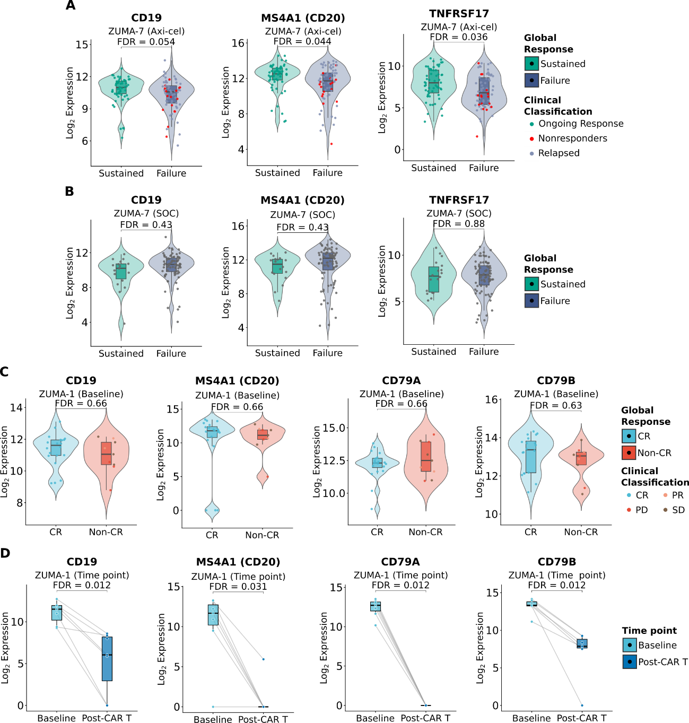
Figure 1. Baseline availability and longitudinal assessment of canonical B-cell lineage markers demonstrate the efficacy of Axi-cel. (A) Pre-infusion (baseline) mRNA expression levels (Log₂) of canonical B-cell lineage markers (CD19, MS4A1/CD20, and TNFRSF17) - corresponding to the panel established in the pivotal ZUMA-7 study (18) - assessed in the Axi-cel-treated cohort. Patients are stratified by durable clinical outcome (sustained response versus failure). (B) Baseline expression of the same pivotal gene panel from the ZUMA-7 study in the standard-of-care (SOC) control arm. (C) Baseline expression of B-cell-specific markers (CD19, MS4A1, CD79A, CD79B) defined in the pivotal ZUMA-1 study (32), assessed in the ZUMA-1 cohort and stratified by clinical response (CR versus Non-CR). (D) Paired longitudinal analysis comparing target gene expression between baseline (pre-infusion) and post-CAR-T biopsies in patients from the ZUMA-1 study. Comparisons were performed using the Wilcoxon rank-sum test (A-C) and the Wilcoxon signed-rank test (D), with the Benjamini-Hochberg False Discovery Rate (FDR) correction applied specifically to the pivotal gene panels evaluated. Boxplots overlaid on violin plots indicate the median and interquartile range. Overlaid scatter points are color-coded according to granular clinical classifications.

This association was mechanistically specific to cellular therapy; no significant discrepancies in B-cell lineage markers were observed within the standard-of-care (SOC) chemotherapy arm of the ZUMA-7 study (Figure 1B) or at baseline in the ZUMA-1 cohort (Figure 1C). Finally, paired longitudinal analysis in ZUMA-1 confirmed the on-target pharmacodynamic impact of the CAR T-cell therapy, revealing a profound and statistically significant depletion of all B-cell markers following infusion (Figure 1D). This transcriptional eradication was further validated by cellular deconvolution of the tumor microenvironment (Supplementary Figure S1), confirming the clearance of the malignant clone and the anticipated B-cell aplasia. Taken together, these findings demonstrate that baseline B-cell lineage identity may serve as a crucial prerequisite for the optimal engagement and therapeutic success of Axi-cel.

3.2 T-Cell Exhaustion and HLA Downregulation Are Not the Primary Determinants of Axi-cel Resistance

In classical tumor immunology, immune evasion is frequently orchestrated by the induction of T-cell exhaustion within the microenvironment or by the suppression of the human leukocyte antigen (HLA) presentation machinery. However, our multidimensional transcriptomic mapping revealed that these canonical axes do not primarily dictate therapeutic failure to Axi-cel. Expression profiling of T-cell exhaustion signatures (Figure 2) failed to reveal the formation of biological clusters capable of segregating patients with sustained responses from those experiencing therapeutic failure. This lack of phenotypic modulation demonstrated no statistically significant discrepancies in these immune inhibitors based on clinical outcomes (Supplementary Table S1; all FDR > 0.05). This non-discriminatory pattern remained consistent across the baseline cohorts of both the ZUMA-7 and ZUMA-1 studies. Furthermore, the temporal assessment of these signatures (post-CAR T-cell infusion) in the ZUMA-1 cohort did not evidence consistent longitudinal fluctuations that could account for immune escape.
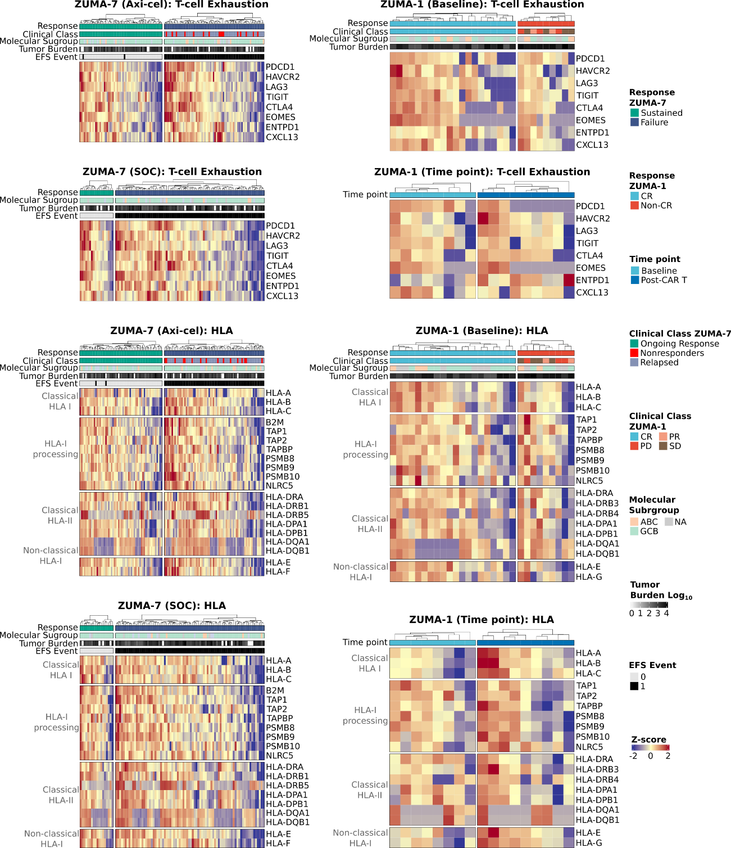
Figure 2. Transcriptional profile of immune evasion mechanisms: T-cell exhaustion in the microenvironment and regulation of the antigen presentation machinery (HLA). Normalized gene expression profiles (Z-score) mapping the immunosuppressive architecture in the ZUMA-7 and ZUMA-1 cohorts. The first four heatmaps show the expression of T-cell exhaustion genes. The baseline profile is stratified by clinical outcome (Sustained Response vs. Failure/CR vs. Non-CR) in the ZUMA-7 Axi-cel, ZUMA-7 Standard of Care (SOC), and ZUMA-1 (Baseline) cohorts, whereas the ZUMA-1 (Time point) section presents longitudinal changes in these immunosuppressive markers from the pre-infusion assessment (Baseline) to one week after CAR-T infusion (Post-CAR-T). The other four heatmaps relate to the HLA machinery: an assessment of the functional integrity of antigen presentation, biologically subdivided into four axes: classical Class I molecules, the intracellular processing complex, classical Class II molecules, and non-classical inhibitory Class I molecules. Samples (columns) are hierarchically clustered within each clinical response stratum. Top annotations provide individualized clinical context for each patient: Overall Response, detailed Clinical Classification, Molecular Subgroup/Cell of Origin, Tumor Burden (mapped on a continuous logarithmic grayscale), and occurrence of EFS (event-free survival) events. Expression divergence is mapped on a Z-score scale, where intense blue represents underexpression (-2) and dark red represents overexpression (+2) relative to the cohort mean.

Similarly, the functional and structural assessment of the HLA complex integrity demonstrated intra-cohort heterogeneity. Unsupervised hierarchical clustering, even when integrated with strongly weighted clinical covariates such as baseline tumor burden (SPD) and cell of origin (COO), confirmed the absence of an HLA downregulation profile univocally or predominantly associated with CAR-T resistance. This observation was further supported by continuous statistical analysis, which confirmed the lack of significant transcriptional downregulation across the intracellular processing complex, as well as the classical and non-classical presentation molecules (Supplementary Table S1).
Our findings suggest that, due to the synthetic nature of its antigen recognition, anti-CD19 CAR T-cell efficacy operates with remarkable independence from traditional HLA restriction pathways and the degree of pre-existing immune exhaustion, highlighting the critical need to investigate alternative mechanisms of intrinsic tumor resistance.

3.3 Global Transcriptomic Mapping Reveals Divergent Pathways of Intrinsic and Acquired Resistance to CAR T-Cell Therapy

To decode resistance mechanisms beyond classical immune escape, we conducted a differential gene expression analysis (volcano plots, Figure 3A) integrated with pathway enrichment analysis (GSEA/ssGSEA). The biological architecture of therapeutic failure revealed divergent profiles depending on the treatment line evaluated.
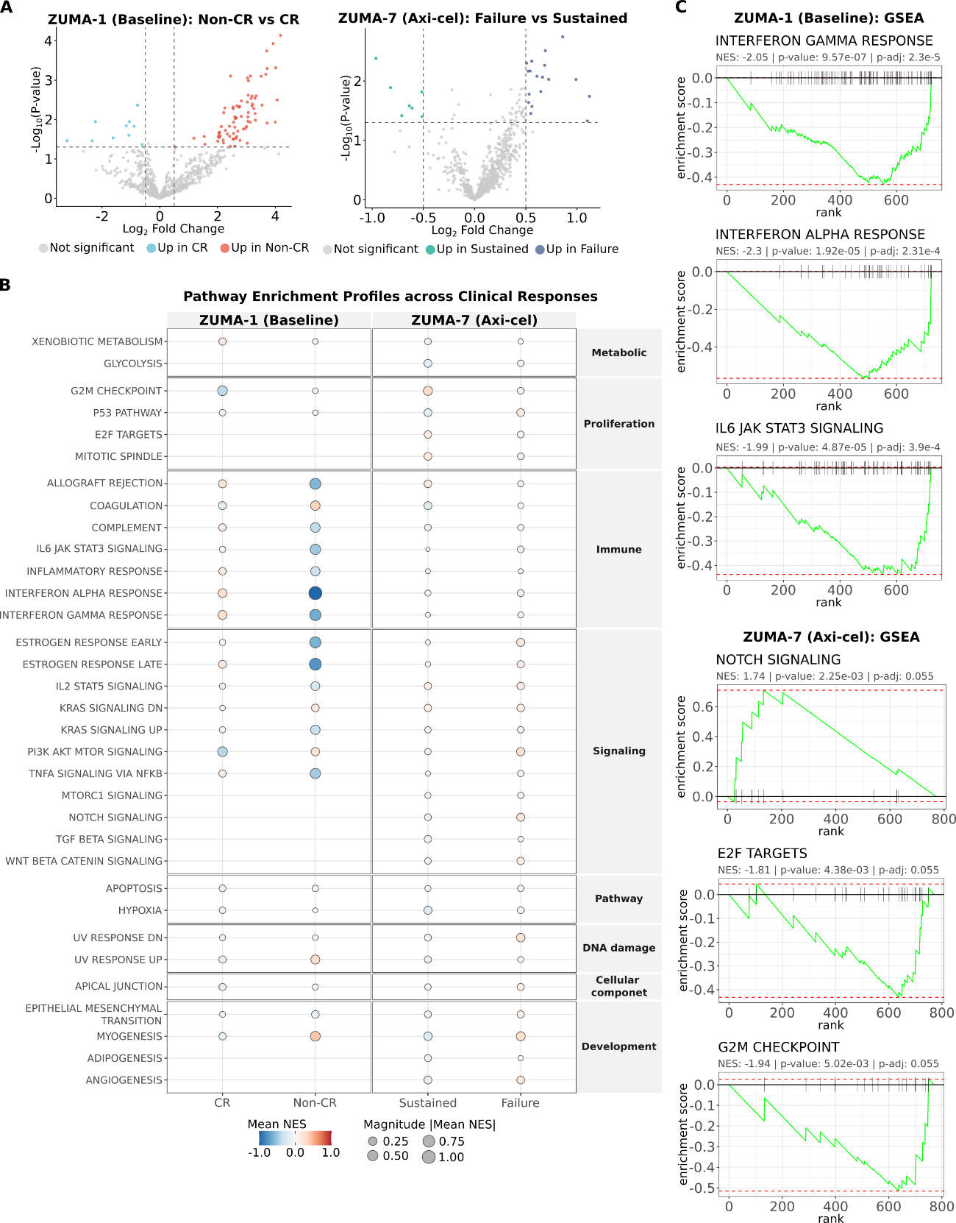
Figure 3. Global gene expression and functional pathways associated with Axi-cel treatment failure. (A) Volcano plots showing differential gene expression analysis (DEA) prior to infusion, comparing clinical response groups in the ZUMA-1 (left; Non-CR vs. CR) and ZUMA-7 (right; Failure vs. Sustained) cohorts. Significance is highlighted based on an exploratory threshold of unadjusted p-value < 0.05 and absolute log2 fold change > 0.5 (dashed lines). (B) Pathway enrichment profiles assessed via single-sample GSEA (ssGSEA). MSigDB Hallmark gene sets were grouped into eight functional categories (y-axis). Circle color indicates the Mean Normalized Enrichment Score (Mean NES), reflecting pathway hyperactivation (red) or suppression (blue) in each clinical group. Circle size is proportional to the absolute magnitude of enrichment (Mean NES), representing the intensity of biological activity. (C) Representative enrichment plots from classical GSEA, detailing key pathways driving resistance in each cohort. In the ZUMA-1 cohort, marked suppression of interferon (alpha and gamma) signaling and inflammatory signaling is observed in patients who did not achieve complete remission (Non-CR). In the ZUMA-7 cohort, alterations in intrinsic signaling (Notch) and cell cycle proliferation programs (E2F targets, G2M checkpoint) appear enriched in patients from the Failure group.

In the later-line cohort (ZUMA-1 baseline), the failure to achieve complete remission (Non-CR) may have been driven by an intrinsically "cold" or anergic microenvironment. A marked transcriptional suppression of Interferon signaling pathways (alpha and gamma) and the global inflammatory response was observed (Figures 3B and 3C). Differential gene expression analysis confirmed this phenotype, demonstrating that complete responders (CR) exhibited an upregulation of canonical interferon-stimulated genes (STAT1, MX1, IFI27), whereas the Non-CR group was enriched for alternative chemotactic markers (CCL20) and MAGE/KIR family genes (Supplementary Table S2).
In contrast, within the earlier-line cohort (ZUMA-7 baseline), therapeutic failure was not governed by immune deprivation, but rather by intrinsic tumor dedifferentiation and unrestrained proliferation. The group experiencing treatment failure displayed marked hyperactivation of cell cycle programs (E2F targets, G2/M checkpoint) and embryonic developmental pathways (Notch signaling) (Figures 3B, 3C; Supplementary Table S3). Consistently, differential expression highlighted the upregulation of markers associated with tissue remodeling and aggressive cellular adhesion (MET, EPCAM, NCAM1) in patients who failed therapy, as opposed to the preservation of mature B-cell lineage markers (CD19, MS4A1) in the sustained response group (Supplementary Table S2). Global analysis of tumor microenvironment (TME) modules (IO360 platform) confirmed that absolute stromal and myeloid cell populations did not differ significantly between clinical outcomes following FDR adjustment (Supplementary Table S4), reiterating the central role of intrinsic tumor aggressiveness in early-line escape.
Finally, to map the dynamics of acquired resistance, we evaluated paired longitudinal biopsies from the ZUMA-1 study (Supplementary Figure S2A). Alongside the anticipated clearance of B-cell antigens, the residual post-infusion microenvironment was dominated by the induction of tissue damage repair pathways, including IL-6/JAK/STAT3 signaling, the Complement cascade, Coagulation, and Epithelial-Mesenchymal Transition (EMT-like) programs (Supplementary Figure S2B). This profile reflects the local inflammatory "storm" induced by CAR T-cell cytotoxicity, which appears to foster a wound-healing and tissue remodeling niche conducive to eventual tumor escape.

3.4 Independent Prognostic Impact and Microenvironment Dynamics of Resistance Signatures

To establish the translational clinical utility of the previously identified transcriptomic differences, we evaluated their direct impact on Event-Free Survival (EFS). Kaplan-Meier survival estimates confirmed that dichotomization of the expression of these transcripts successfully stratified patient clinical outcomes (Figure 4A).
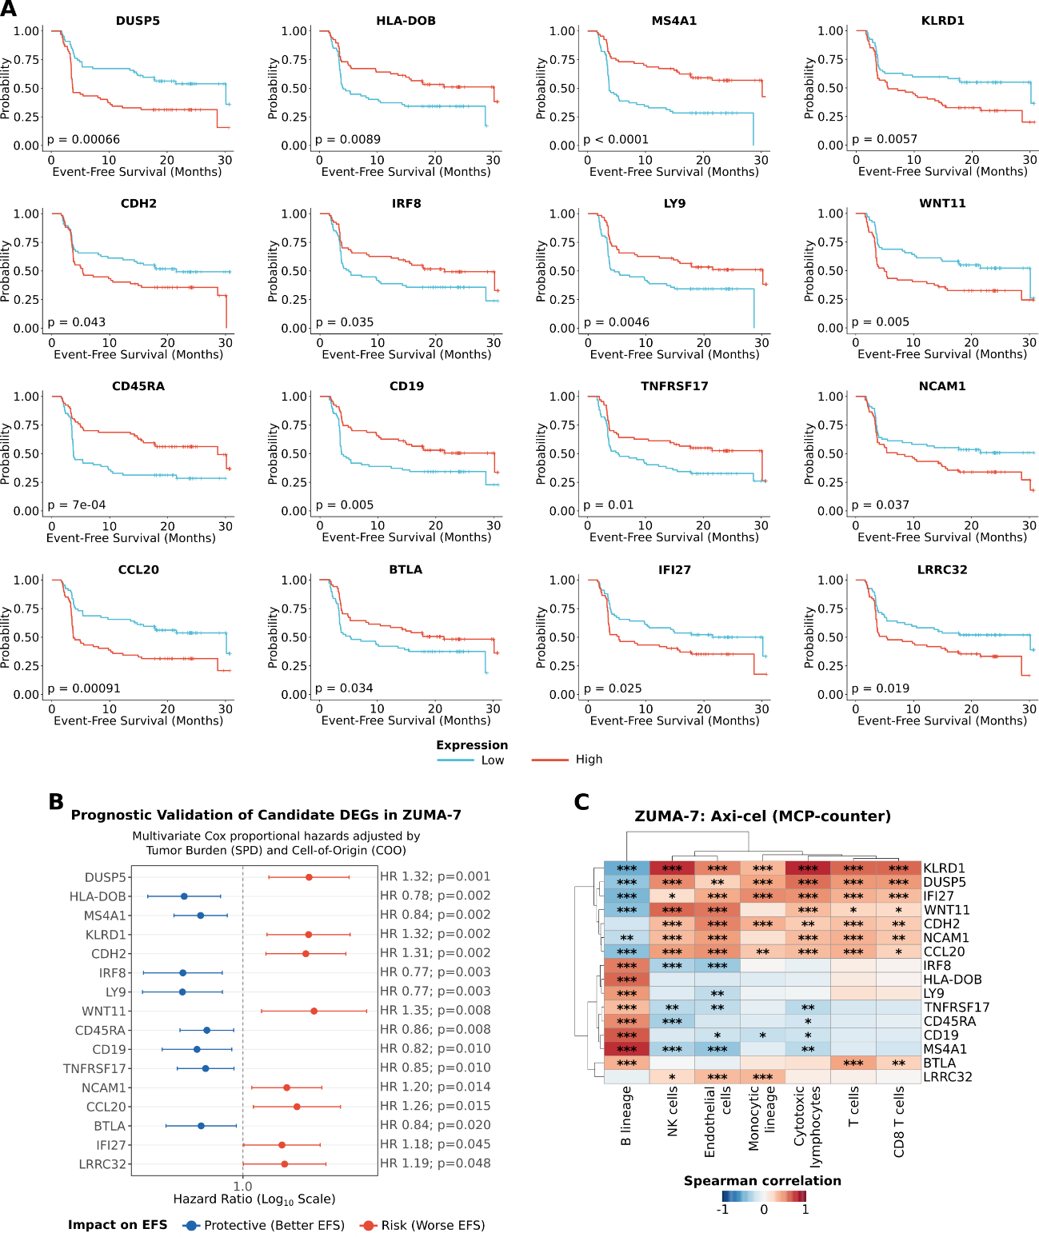
Figure 4. Prognostic assessment and microenvironment independence of transcriptional signatures in the ZUMA-7 cohort. (A) Kaplan-Meier estimates for Event-Free Survival (EFS), stratifying patients according to the expression (High in red vs. Low in blue) of potential biomarkers. Statistical significance was assessed using the log-rank test. (B) Multivariate Cox proportional hazards analysis validating the independent prognostic impact of target genes on EFS, following clinical adjustment for baseline tumor burden (SPD) and lymphoma subtype (Cell of Origin, COO). Hazard Ratios greater than 1 (red) indicate genes associated with a worse clinical outcome, whereas values ​​less than 1 (blue) denote a protective biological effect. (C) Spearman correlation matrix mapping interactions within the tumor ecosystem between candidate gene expression and the absolute abundance of immune and stromal populations, estimated using the MCP-counter algorithm. Statistical significance (p < 0.05; ** p < 0.01; *** p < 0.001) represents the strength of the association between potential marker genes and the estimated cell types.

Specifically, the preservation of B-cell lineage identity and antigen presentation machinery (CD19, MS4A1, TNFRSF17, HLA-DOB), along with mature lymphoid markers (IRF8, BTLA, LY9), emerged as powerful independent protective factors (HR ranging from 0.77 to 0.86; all p < 0.05), dictating prolonged clinical benefit with Axi-cel. In contrast, transcripts associated with alternative chemotaxis (CCL20; HR = 1.26), dysregulated signaling (DUSP5, WNT11), and markers of tissue remodeling and cellular adhesion (CDH2, NCAM1, LRRC32) were validated as intrinsic and independent risk factors (HR > 1; p < 0.05), driving early therapeutic failure regardless of tumor volume and lymphoma subtype.
Finally, to decode the cellular origin and crosstalk of these prognostic signatures within the tumor ecosystem, we conducted a Spearman correlation analysis pairing gene expression with the absolute abundance of immune and stromal populations (estimated using the MCP-counter algorithm) (Figure 4C). This topological mapping elucidated which genes were primarily derived from the intrinsic malignant clone versus those mediated by the recruitment of adjacent stromal or myeloid compartments, consolidating the cellular architecture of CAR-T resistance.
To substantiate the premise that resistance is primarily driven by intrinsic tumor biology and its functional programs (rather than the physical exclusion of immune cells), we evaluated the global microenvironmental composition. Cellular deconvolution (MCP-counter) demonstrated that the absolute abundance of baseline infiltrating immune and stromal populations was unable to stratify clinical response to Axi-cel in both the ZUMA-7 and ZUMA-1 cohorts (Supplementary Figure S3; all adjusted p-values non-significant). This lack of segregation by bulk population estimates reinforces the finding that it is the functional state - specifically the transcriptional phenotype of aggressive adhesion and tissue remodeling - rather than the quantitative count of infiltrating cells, that dictates therapeutic success or failure.

3.5 Orthogonal Validation Confirms the Predictive Specificity of the Signature for CAR T-Cell Therapy

To conclusively determine whether the identified biomarkers represent evasion mechanisms specific to cellular immunotherapy (predictive value) or merely reflect the intrinsic, generic aggressiveness of DLBCL (general prognostic value), we conducted a cross-orthogonal validation. The survival impact of each of the 16 candidate transcripts was contrasted in parallel across three distinct clinical scenarios: the experimental arm (ZUMA-7 Axi-cel; cellular therapy), the active control arm (ZUMA-7 SOC; salvage chemotherapy), and an independent first-line cohort (TCGA-DLBC; R-CHOP chemoimmunotherapy) (Figure 5).
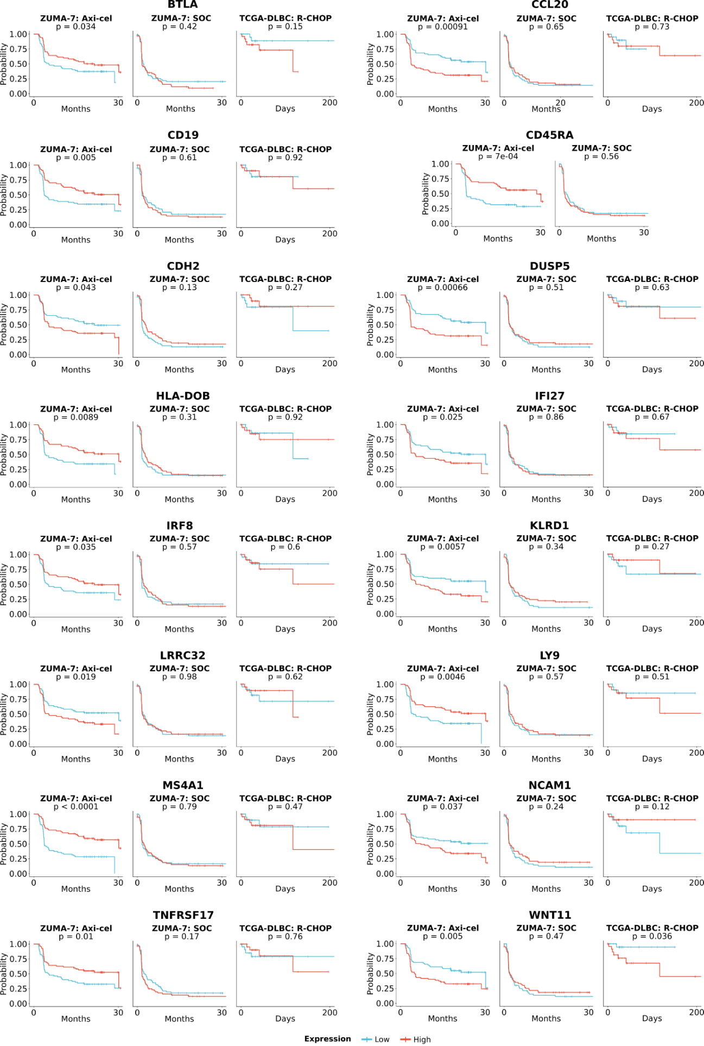
Figure 5. Clinical orthogonal validation of the genomic signature as a specific predictive biomarker for CAR T-cell therapy. Kaplan-Meier survival curves for the 16 identified candidate genes, evaluating the impact of their baseline expression across three distinct clinical scenarios of diffuse large B-cell lymphoma (DLBCL). For each gene, the panels display, from left to right: (1) ZUMA-7 Axi-cel: Event-Free Survival (EFS) in patients treated with anti-CD19 CAR T-cell therapy; (2) ZUMA-7 SOC: EFS in the randomized control arm treated with standard-of-care (SOC) salvage chemotherapy; and (3) TCGA-DLBC: Overall Survival (OS) in first-line patients treated with R-CHOP chemoimmunotherapy. Patients were strictly stratified into high-expression (High, red line) and low-expression (Low, blue line) groups based on the intra-cohort median expression threshold for each transcript. Follow-up time (x-axis) is presented in months for the ZUMA-7 study and in days for the TCGA cohort. Statistical significance was determined using the log-rank test. The retention of statistical significance (p < 0.05) exclusively in the Axi-cel arm - while absent in the SOC and TCGA-DLBC arms for most targets - validates the signature's predictive nature regarding resistance mechanisms specific to cellular immunotherapy. The WNT11 gene serves as a notable exception, demonstrating pan-prognostic value indicating intrinsic tumor aggressiveness independent of the therapeutic modality.

Kaplan-Meier survival analyses revealed that 15 of the 16 genes in the panel retained statistical significance for survival stratification strictly confined to the Axi-cel arm. This lack of impact under the pressure of conventional treatments indicates that these transcriptomic perturbations may orchestrate a genuine evasion program highly specific to anti-CD19 CAR T-cell biology. The sole exception within this panel was the WNT11 gene. The hyperactivation of this transcript was associated with consistently inferior clinical outcomes in TCGA-DLBC. This finding suggests that WNT11 may act as a pan-prognostic marker of failure, reflecting a state of profound cellular dedifferentiation and baseline lymphoma aggressiveness that confers cross-resistance to both chemotherapy and cellular immunotherapy.

3.6 Analytical Integration and Biological Originality: Cross-Validation with Pivotal Trials

To contextualize the translational robustness and, above all, the biological originality of our discoveries, we conducted a systematic cross-validation of the 16 predictive biomarker panel against the original transcriptomic findings reported in the pivotal ZUMA-1 (32) and ZUMA-7 (18) studies. The comparative results, outlined across three concordance scenarios, are summarized in Table 1.

Table 1. Comparative analysis of the 16 potential baseline transcriptomic biomarkers identified in the ZUMA-1 and ZUMA-7 pivotal studies for Axi-cel CAR-T therapy.
Category / Primary Function | Gene / Marker | ZUMA-1 Study Findings† | Did we confirm in ZUMA-1? | ZUMA-7 Study Findings‡ | Did we confirm in ZUMA-7? | Conclusion††
Cohort Specifications and Technical Differences: ZUMA-1 represents heavily pre-treated (3rd-line) r/r DLBCL analyzed using a 724-gene panel (GSE197977), whereas ZUMA-7 represents 2nd-line r/r DLBCL analyzed using the expanded IO360 platform comprising 817 transcripts and signatures (GSE248835). Biological differences regarding the line of treatment and technical variations in the gene panels account for the distinct transcriptomic profiles observed between the cohorts.
Lineage B /  Target Preservation | CD19 | Post-treatment: Significant reduction in CR¹.  Baseline: Similar expression between responders and non-responders. | Yes | Clinical Association: High gene expression (for the gene and protein in CD19) correlates with better EFS and sustained response.  Context: B-cell signature. | Yes | Supported by the two studies
 | MS4A1 (CD20)
 | TNFRSF17 (BCMA)
 | LY9 (CD229)
 | IRF8
Antigen Presentation | HLA-DOB | Post-treatment: Reduction in post-infusion TME in CR².  Baseline: Lower expression in future responders³. | No | Context: Cluster 4 (Lymphoid). Individually associated with continuous response (PCA analysis). | Yes | Supported by ZUMA-7. ZUMA-1 did not show the same profile; this may be an effect of the lines of treatment, given that ZUMA-7 involves second-line treatment while ZUMA-1 involves third-line treatment.
Hostile Microenvironment / Resistance | CCL20 | Baseline: Significantly higher expression in Non-Responders⁴. | Yes | Context: Myeloid inflammatory signature; SII (Stromal and Immunosuppressive Index). Associated with worse EFS and lower DOR. | Yes | Supported by the two studies
 | LRRC32 | Not prominently mentioned. | Not reported | Context: Stromal signature; SII (Stromal and Immunosuppressive Index). Associated with worse EFS and shorter DOR. | Yes | Supported by ZUMA-7 but not highlighted by ZUMA-1; however, this gene was not found in the list of genes analyzed in ZUMA-1.
 | *NCAM1 (CD56) | Post-treatment: Trend towards reduction in non-responders⁵. | Inconclusivo | Context: "NK CD56dim" signature associated with lower DOR. | Yes  (indirectly) | Identified as a potential baseline risk factor with significance in EFS and Cox analyses. This result aligns with the findings from ZUMA-7.
Immune Activation and Dysfunction | *BTLA | Post-treatment: Significant reduction in CR⁶.  Baseline: Similar expression between responders and non-responders. | Inconclusive | Context: Frequently associated with T-cell regulation; supports an "immunologically hot" tumor. | Inconclusive | It has been proposed as a potential baseline protective factor, showing significance in EFS and Cox analyses. Although the ZUMA-1 trial demonstrated that CAR-T therapy reduces the expression of this gene in patients achieving a complete response, there was no difference in baseline levels between responders and non-responders; the ZUMA-7 trial, meanwhile, did not directly address this.
 | *KLRD1 (CD94) | Post-treatment: Significant increase in OR⁷. Interestingly, the increase was more detectable in Non-CR. | Inconclusive | Context: Cluster 4 (Cytotoxic). Signature associated with SOC, but not significantly with axi-cel. | Inconclusive | Presented as a potential baseline risk factor with significance regarding EFS and Cox. While ZUMA-1 shows a significant increase in objective response following CAR-T treatment - and a trend toward an increase in non-CR cases - this is not observed at baseline; conversely, ZUMA-7 shows significant results regarding SOC.
 | *IFI27 | Post-treatment: Significantly upregulated in CR and Non-CR⁸.  Context: TME activation marker post-CAR T. | Not specific | Context: Cluster 3 ("IFN downstream" genes). Associated with resistance environments. | Inconclusive | Presented as a potential baseline risk factor, reinforced by the ZUMA-7 finding, albeit indirectly.
"Stem-like" CAR-T | CD45RA | Baseline (PTPRC/CD45): General trend of higher expression in responders⁹. RA isoform not detailed. | Inconclusive | CAR-T product (CCR7+CD45RA+): Strongest predictors of prolonged survival, overcoming an unfavorable TME. | Yes | Presented as a potential baseline protective factor, confirmed by findings from ZUMA-7, and supported by the trend of higher expression in responders.
Intrinsic Resistance | * DUSP5 | Not specifically mentioned (generic families cited). | Not reported | Not detailed individually. | Not reported | Presented as a potential risk factor with significance for EFS and Cox.
 | * CDH2
 | WNT11 |  |  | Individually associated with the continuous response. | No | By evaluating the gene itself - rather than just Cluster 1, as ZUMA-7 did - we found an association with a possible risk factor.
Notes: † The quantitative/descriptive associations and trends for the ZUMA-1 study are detailed numerically in the statistical notes below. ‡ The associations in the ZUMA-7 study refer to global gene clusters (e.g., Cluster 1, signature B) or composite algorithmic indices (e.g., SII) correlated with clinical outcomes in the Axi-cel arm. †† The associations and predictive insights derived from the current work were based on the categorization into risk factors (adjusted Hazard Ratio > 1) and protective factors (adjusted Hazard Ratio < 1), validated through predictive independence testing utilizing multivariable Cox proportional hazards models adjusted for clinical covariates (baseline tumor burden [SPD] and molecular subtype [COO]). * Denotes novel findings from this study that were not explicitly highlighted as independent predictors in the original articles.
1 - Post-treatment reduction in CR: CD19 (Log2FC: -4.75; P=1.89E-06); MS4A1 (Log2FC: -9.02; P=6.02E-07); TNFRSF17 (Log2FC: -7.53; P=3.54E-08); IRF8 (Log2FC: -1.41; P=4.91E-06); LY9 (Log2FC: -2.75; P=0.036).
2 - HLA-DOB: Significant reduction in the TME post-infusion in CR (Log2FC: -3.00; P=0.004).
3 - HLA-DOB (Baseline): Lower expression in responders (Log2FC: -2.47; P=0.011).
4 - CCL20 (Baseline): Identified as a marker of worse clinical outcome (Log2FC: -3.61; P=0.013).
5 - NCAM1 (Post-treatment): Trend towards reduction in Non-CR (Log2FC: -4.00; P=0.120).
6 - BTLA: Significant post-infusion reduction in CR (Log2FC: -3.67; P=0.003).
7 - KLRD1 (Post-treatment): Significant increase in OR (Log2FC: 2.31; P=0.015). Numerically greater increase in Non-CR (P=0.027) vs. CR (P=0.095).
8 - IFI27 (Post-treatment): Upregulated in CR (Log2FC: 1.88; P=3.60E-05) and Non-CR (Log2FC: 2.73; P=0.002).
9 - PTPRC/CD45 (Baseline): Overall trend P=0.070.
Abbreviations: CAR: Chimeric Antigen Receptor; CR: Complete Response; DOR: Duration of Response; EFS: Event-Free Survival; FC: Fold Change; IFN: Interferon; MCP-counter: Microenvironment Cell Populations Counter; NK: Natural Killer; OR: Objective Response; PCA: Principal Component Analysis; SOC: Standard of Care; TME: Tumor Microenvironment; SII: Stromal and Immunosuppressive Index.
The first scenario, Broad Concordance, validated our analytical workflow by mirroring the established literature. The retention of B-cell lineage identity (CD19, MS4A1, TNFRSF17) and antigen presentation markers consensually emerged as a crucial protective factor across all analyses. Similarly, inflammatory signatures and specific profiles (Cohort-Specific Concordance) tended to align with the original descriptive findings of their respective cohorts, confirming the intrinsic consistency of the primary data.
The most notable finding of this integration, however, lay in the contribution of Novel Biological Discoveries. Several genes identified in our study as powerful intrinsic risk factors for CAR T-cell failure - most notably DUSP5, WNT11, CDH2, NCAM1, and LRRC32 - were not reported or failed to gain prominence as independent predictors in the original publications. While the pivotal trials frequently based their conclusions on univariate analyses, composite indices (e.g., Stromal and Immunosuppressive Index), or global clusters, our multivariable modeling made it possible to isolate the direct transcriptional impact of these targets. Thus, our model indicates that genetic programs associated with tissue remodeling, aggressive cellular adhesion, and epithelial-mesenchymal transition (EMT-like) may serve as latent and independent determinants of early resistance to Axi-cel, adding an unprecedented mechanistic layer to the understanding of therapeutic failure.

3.7 Integrated Mechanistic Model of CAR T-Cell Response Dynamics

To consolidate the complexity of the transcriptomic and clinical interactions uncovered in this study, we developed an integrative mechanistic model of the response dynamics to Axi-cel (Figure 6).
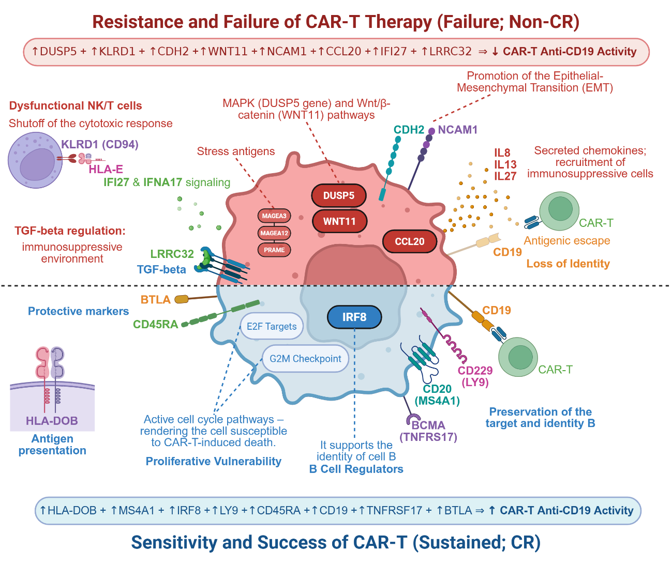
Figure 6. Integrated mechanistic model of transcriptional signatures determining sensitivity and resistance to anti-CD19 CAR T-cell therapy. A comprehensive synthesis of the biological landscape and tumor-microenvironment interactions derived from the orthogonal cross-analyses of the ZUMA-1 and ZUMA-7 cohorts. The Top Panel (Red – Therapeutic Failure/Evasion) illustrates the intrinsic resistance mechanisms orchestrated by the enrichment of risk markers (e.g., tissue remodeling, aggressive cellular adhesion, and dedifferentiation programs), culminating in impaired anti-CD19 CAR T-cell efficacy and early relapse. The Bottom Panel (Blue – Therapeutic Success/Sensitivity) delineates the cellular and microenvironmental state associated with durable clinical responses, strictly governed by the robust baseline expression of protective biomarkers (e.g., canonical B-cell lineage preservation and antigen presentation integrity).
Within the therapeutic failure axis (top panel), the model illustrates how tumor dedifferentiation - orchestrated by the loss of B-cell identity, cell cycle hyperactivation, and tissue remodeling programs (EMT-like and CDH2/NCAM1-mediated adhesion) - fosters a phenotype of intrinsic resistance, ultimately culminating in evasion from CAR T-cell recognition and clearance. Conversely, within the clinical success axis (bottom panel), the model highlights the state of therapeutic sensitivity dictated by the robust preservation of the canonical B-cell lineage (CD19, MS4A1), the integrity of antigen presentation (HLA-DOB), and a permissive microenvironment.
Collectively, this visual representation synthesizes the transition from a dogma primarily focused on immune exhaustion (classical for immune checkpoint inhibitors) toward a novel paradigm centered on the intrinsic biology of the malignant clone and its capacity for phenotypic adaptation under the selective pressure of cellular immunotherapy.

4. Discussion

The findings of this study position resistance to anti-CD19 CAR T-cell therapy (Axi-cel) in diffuse large B-cell lymphoma (DLBCL) as a multifactorial process in which baseline CD19 antigen availability alone possesses limited predictive value. Although CD19 loss is widely described as a classic relapse mechanism, it occurs in only a minority of cases, and disease progression frequently emerges in tumors that retain detectable target expression (5,6). Consistent with this premise, our data demonstrate that Axi-cel efficacy relies fundamentally on the overall preservation of B-cell lineage identity (CD19, MS4A1, TNFRSF17). This aligns with emerging paradigms indicating that malignant dedifferentiation and lineage plasticity serve as potent, antigen-independent mechanisms of immune evasion (33,34). These observations support a model in which CD19 expression is necessary but not sufficient, indicating that tumors retaining a differentiated and mature lymphoid program remain significantly more susceptible to CAR T-cell-mediated cytotoxicity, whereas phenotypic dedifferentiation renders the malignant clone refractory to immune clearance (35).
One of the most prominent findings within these cohorts lies in the refutation that pre-existing T-cell exhaustion and the downregulation of the HLA machinery act as the primary determinants of baseline resistance to Axi-cel. In classical tumor immunology, PD-1/PD-L1 signaling and HLA loss dictate therapeutic failure to immune checkpoint inhibitors. However, our transcriptomic mapping demonstrated that these baseline exhaustion signatures fail to independently stratify clinical response. This observation does not preclude the biological role of immune checkpoints; rather, it aligns with recent clinical evidence suggesting that pathways such as PD-1 operate in a dynamic, post-infusional manner, intrinsically affecting the CAR T-cell itself instead of being reflected in the global baseline tumor transcriptome (7–9,36,37). Furthermore, the independence of Axi-cel from the HLA complex reiterates that the synthetic design of the receptor effectively bypasses traditional antigen presentation pathways, thereby redirecting the focus of resistance toward alternative barriers within the tumor microenvironment (38).
Upon investigating the architecture of this intrinsic resistance, we revealed that evasion mechanisms diverge significantly depending on the line of therapy. In later-line settings involving extensively pretreated patients (ZUMA-1), therapeutic failure was characterized by an intrinsically anergic or "silenced" microenvironment, governed by the coordinated suppression of interferon (IFN-alpha and IFN-gamma) signaling (39). Although chronic IFN signaling can induce adaptive resistance (10), our data do not support a model of excessive inflammation. Instead, they point to an inability to mount an effective baseline inflammatory program, coupled with immune exclusion mediated by alternative chemotactic axes, such as the hyperactivation of CCL20 (12,40).
In stark contrast, in earlier lines of treatment (ZUMA-7), resistance was not mediated by immune deprivation, but rather by profound tumor dedifferentiation, cell cycle activation, and aggressive tissue remodeling programs. The independent validation of transcripts associated with epithelial-mesenchymal transition (EMT-like) and cellular adhesion - namely CDH2 and NCAM1 - as risk factors (HR > 1) represents an unprecedented translational discovery in this context. It is well established that phenotypic plasticity and tissue remodeling confer both physical and biological protection against the infiltration and cytotoxicity of effector immune cells (13,14). Notably, the WNT11 gene emerged not only as a predictor of CAR T-cell failure but also as a transversal pan-prognostic marker, indicating an intrinsic tumor hyper aggressiveness that confers cross-resistance to both conventional chemotherapy and cellular immunotherapy (15).
As a counterpoint to this evasion network, we identified a protective ecosystem defined by IRF8, HLA-DOB, LY9, and BTLA. IRF8, in particular, acts as a master regulator that links B-cell differentiation to immune competence, polarizing myeloid cells and sustaining interferon responsiveness (16,41). Interestingly, although BTLA is classically considered an inhibitory receptor, its association with improved outcomes corroborates studies linking it to less differentiated, memory-like cellular states, which exhibit greater proliferative potential and persistence in adoptive cell therapies (42,43). Such findings refine the concept of a "hot" tumor in the CAR T-cell era: what determines therapeutic success is not the bulk volume of the pre-existing immune infiltrate (as demonstrated by our cellular deconvolution analysis), but rather the functional and structural competence of this signaling.
In summary, the results synthesized by our integrative mechanistic model (Figure 6) provide a valuable contribution to better understanding the complexity of Axi-cel failure. CAR T-cell resistance in DLBCL does not stem simply from host T-cell "exhaustion", but results from latent biological determinants of the malignant clone - which sheds its canonical lymphoid identity and adopts aberrant phenotypes of adhesion, dedifferentiation, and localized immune silencing. From a translational perspective, patients whose baseline transcriptomic profile expresses this high-risk signature (enriched for EMT-like, WNT11, CDH2, and CCL20) may not derive primary benefit from Axi-cel monotherapy, necessitating the rational design of combination strategies (such as Wnt pathway blockers, chemotaxis inhibitors, or stromal niche modulation) and next-generation CAR T-cells armored against this hostile microenvironment.
Despite the translational contributions and methodological rigor of this study, certain limitations must be acknowledged. First, the reliance on targeted gene expression panels (such as the IO360 platform), while highly sensitive for tumor-immune profiling, restricts the analysis to a pre-selected repertoire of transcripts, precluding the discovery of novel biological pathways beyond this scope. Furthermore, this approach captures an averaged expression profile across the bulk tumor tissue, potentially obscuring intratumoral heterogeneity within rare cellular subclones or cell-to-cell interactions at single-cell resolution. Second, as this investigation represents a secondary analysis of pivotal clinical trial cohorts, prospective validation in independent real-world patient series remains essential to establish the routine clinical utility of this biomarker panel. Finally, although we demonstrated the independent prognostic impact of novel risk targets further mechanistic in vitro and in vivo functional studies are required to elucidate the precise molecular pathways through which tissue remodeling and phenotypic plasticity impair CAR T-cell cytotoxicity. Future perspectives should leverage single-cell and spatial transcriptomics to decipher the microenvironmental topography of immune evasion, alongside preclinical trials evaluating combination strategies designed to neutralize these intrinsic resistance programs.

Conclusion

Collectively, this study provides a valuable addition to understanding the mechanisms of resistance to anti-CD19 CAR T-cell therapy (Axi-cel) in diffuse large B-cell lymphoma (DLBCL). Our findings indicate that therapeutic failure is not primarily dictated by the isolated loss of the CD19 antigen or pre-existing immune exhaustion within the tumor microenvironment. Instead, sensitivity to Axi-cel relies on the overall preservation of B-cell lineage phenotypic integrity (CD19, MS4A1, TNFRSF17) and the functional competence of immune signaling (IRF8, HLA-DOB, BTLA). Conversely, early therapeutic escape is driven by intrinsic biological determinants of the malignant clone, including the loss of lymphoid differentiation, the activation of tissue remodeling and epithelial-mesenchymal transition programs (EMT-like; mediated by CDH2 and NCAM1), immune-excluding chemotaxis (CCL20), and a baseline hyperaggressive state (WNT11).
Orthogonal validation confirmed that this transcriptomic signature possesses strict predictive specificity for cellular immunotherapy, distinguishing it from agnostic resistance markers to conventional chemotherapy. From a translational perspective, characterizing these evasion axes helps to better understand the heterogeneity of CAR T-cell response, establishing a rational foundation for pre-treatment risk stratification and providing promising biological targets for the development of combination strategies as well as the design of next-generation CAR T-cells engineered to overcome the refractory tumor microenvironment.

Contributors:

Funding:

Data availability statement

The transcriptomic datasets analyzed in this study are publicly available. The ZUMA-1 and ZUMA-7 cohort data can be found in the Gene Expression Omnibus (GEO) repository under accession numbers GSE197977 and GSE248835, respectively. The TCGA-DLBC cohort data are available through the Genomic Data Commons (GDC) portal. To ensure full transparency and methodological reproducibility, all custom analytical code, R scripts, and computational pipelines developed for this manuscript have been deposited and are freely accessible in the GitHub repository at: https://github.com/jeanssresende/DLBCL-CD19-Analysis.

Ethics statements

Acknowledgements

Reference

1. Crump M, Neelapu SS, Farooq U, Van Den Neste E, Kuruvilla J, Westin J, et al. Outcomes in refractory diffuse large B-cell lymphoma: results from the international SCHOLAR-1 study. Blood. 19 de outubro de 2017;130(16):1800–8. doi:10.1182/blood-2017-03-769620
2. Sehn LH, Salles G. Diffuse Large B-Cell Lymphoma. N Engl J Med. 4 de março de 2021;384(9):842–58. doi:10.1056/NEJMra2027612 PubMed PMID: 33657296; PubMed Central PMCID: PMC8377611.
3. Locke FL, Miklos DB, Jacobson CA, Perales MA, Kersten MJ, Oluwole OO, et al. Axicabtagene Ciloleucel as Second-Line Therapy for Large B-Cell Lymphoma. N Engl J Med. 16 de fevereiro de 2022;386(7):640–54. doi:10.1056/NEJMoa2116133
4. Neelapu SS, Locke FL, Bartlett NL, Lekakis LJ, Miklos DB, Jacobson CA, et al. Axicabtagene Ciloleucel CAR T-Cell Therapy in Refractory Large B-Cell Lymphoma. N Engl J Med. 28 de dezembro de 2017;377(26):2531–44. doi:10.1056/NEJMoa1707447
5. Jain M, Ziccheddu B, Coughlin C, Faramand R, Griswold A, Reid K, et al. 675 Genomic drivers of large B-cell lymphoma resistance to CD19 CAR-T therapy. J Immunother Cancer. 10 de novembro de 2021;9(Suppl 2). doi:10.1136/jitc-2021-SITC2021.675 PubMed PMID: 10.1136/jitc-2021-SITC2021.675.
6. Majzner RG, Rietberg SP, Labanieh L, Sotillo E, Weber EW, Lynn RC, et al. Low CD19 Antigen Density Diminishes Efficacy of CD19 CAR T Cells and Can be Overcome By Rational Redesign of CAR Signaling Domains. Blood. 29 de novembro de 2018;132(Supplement 1):963. doi:10.1182/blood-2018-99-115558
7. Chong EA, Melenhorst JJ, Lacey SF, Ambrose DE, Gonzalez V, Levine BL, et al. PD-1 blockade modulates chimeric antigen receptor (CAR)–modified T cells: refueling the CAR. Blood. 23 de fevereiro de 2017;129(8):1039–41. doi:10.1182/blood-2016-09-738245
8. Hill JA, Li D, Hay KA, Green ML, Cherian S, Chen X, et al. Infectious complications of CD19-targeted chimeric antigen receptor–modified T-cell immunotherapy. Blood. 4 de janeiro de 2018;131(1):121–30. doi:10.1182/blood-2017-07-793760
9. Chong EA, Alanio C, Svoboda J, Nasta SD, Landsburg DJ, Lacey SF, et al. Pembrolizumab for B-cell lymphomas relapsing after or refractory to CD19-directed CAR T-cell therapy. Blood. 17 de fevereiro de 2022;139(7):1026–38. doi:10.1182/blood.2021012634
10. Benci JL, Xu B, Qiu Y, Wu TJ, Dada H, Twyman-Saint Victor C, et al. Tumor Interferon Signaling Regulates a Multigenic Resistance Program to Immune Checkpoint Blockade. Cell. dezembro de 2016;167(6):1540-1554.e12. doi:10.1016/j.cell.2016.11.022
11. Sharma P, Goswami S, Raychaudhuri D, Siddiqui BA, Singh P, Nagarajan A, et al. Immune checkpoint therapy—current perspectives and future directions. Cell. abril de 2023;186(8):1652–69. doi:10.1016/j.cell.2023.03.006
12. Karin M, Clevers H. Reparative inflammation takes charge of tissue regeneration. Nature. janeiro de 2016;529(7586):307–15. doi:10.1038/nature17039
13. Chaffer CL, Weinberg RA. A Perspective on Cancer Cell Metastasis. Science. 25 de março de 2011;331(6024):1559–64. doi:10.1126/science.1203543
14. Terry S, Savagner P, Ortiz‐Cuaran S, Mahjoubi L, Saintigny P, Thiery J, et al. New insights into the role of EMT in tumor immune escape. Mol Oncol. julho de 2017;11(7):824–46. doi:10.1002/1878-0261.12093
15. Galluzzi L, Chan TA, Kroemer G, Wolchok JD, López-Soto A. The hallmarks of successful anticancer immunotherapy. Sci Transl Med. 19 de setembro de 2018;10(459):eaat7807. doi:10.1126/scitranslmed.aat7807
16. Alspach E, Lussier DM, Miceli AP, Kizhvatov I, DuPage M, Luoma AM, et al. MHC-II neoantigens shape tumor immunity and response to immunotherapy. Nature. outubro de 2019;574(7780):696–701. doi:10.1038/s41586-019-1671-8 PubMed PMID: 31645760; PubMed Central PMCID: PMC6858572.
17. Shipp MA, Ross KN, Tamayo P, Weng AP, Kutok JL, Aguiar RCT, et al. Diffuse large B-cell lymphoma outcome prediction by gene-expression profiling and supervised machine learning. Nat Med. janeiro de 2002;8(1):68–74. doi:10.1038/nm0102-68
18. Locke FL, Filosto S, Chou J, Vardhanabhuti S, Perbost R, Dreger P, et al. Impact of tumor microenvironment on efficacy of anti-CD19 CAR T cell therapy or chemotherapy and transplant in large B cell lymphoma. Nat Med. fevereiro de 2024;30(2):507–18. doi:10.1038/s41591-023-02754-1
19. Becht E, Giraldo NA, Lacroix L, Buttard B, Elarouci N, Petitprez F, et al. Estimating the population abundance of tissue-infiltrating immune and stromal cell populations using gene expression. Genome Biol. dezembro de 2016;17(1):218. doi:10.1186/s13059-016-1070-5
20. Gu Z, Eils R, Schlesner M. Complex heatmaps reveal patterns and correlations in multidimensional genomic data. Bioinformatics. 15 de setembro de 2016;32(18):2847–9. doi:10.1093/bioinformatics/btw313
21. Ritchie ME, Phipson B, Wu D, Hu Y, Law CW, Shi W, et al. limma powers differential expression analyses for RNA-sequencing and microarray studies. Nucleic Acids Res. 20 de abril de 2015;43(7):e47–e47. doi:10.1093/nar/gkv007
22. Hänzelmann S, Castelo R, Guinney J. GSVA: gene set variation analysis for microarray and RNA-Seq data. BMC Bioinformatics. dezembro de 2013;14(1):7. doi:10.1186/1471-2105-14-7
23. Dharmesh D. Bhuva <bhuva.d@wehi.edu.au> [aut, cre] (<https://orcid.org/0000-0002-6398-9157>), Gordon K. Smyth [aut] (<https://orcid.org/0000-0001-9221-2892>), Alexandra Garnham [aut] (<https://orcid.org/0000-0002-8312-8450>). msigdb [Internet]. Bioconductor; [citado 1º de agosto de 2026]. Disponível em: https://bioconductor.org/packages/msigdb doi:10.18129/B9.BIOC.MSIGDB
24. Korotkevich G, Sukhov V, Budin N, Shpak B, Artyomov MN, Sergushichev A. Fast gene set enrichment analysis [Internet]. Bioinformatics; 2016 [citado 1º de agosto de 2026]. Disponível em: http://biorxiv.org/lookup/doi/10.1101/060012 doi:10.1101/060012
25. Therneau TM. survival: Survival Analysis [Internet]. 2001 [citado 1º de agosto de 2026]. p. 3.8-9. Disponível em: https://CRAN.R-project.org/package=survival doi:10.32614/CRAN.package.survival
26. Kassambara A, Kosinski M, Biecek P. survminer: Drawing Survival Curves using “ggplot2” [Internet]. 2016 [citado 1º de agosto de 2026]. p. 0.5.2. Disponível em: https://CRAN.R-project.org/package=survminer doi:10.32614/CRAN.package.survminer
27. Wilcoxon F. Individual Comparisons by Ranking Methods. Biom Bull. dezembro de 1945;1(6):80. doi:10.2307/3001968
28. Mann HB, Whitney DR. On a Test of Whether one of Two Random Variables is Stochastically Larger than the Other. Ann Math Stat. março de 1947;18(1):50–60. doi:10.1214/aoms/1177730491
29. Benjamini Y, Hochberg Y. Controlling the False Discovery Rate: A Practical and Powerful Approach to Multiple Testing. J R Stat Soc Ser B Stat Methodol. 1º de janeiro de 1995;57(1):289–300. doi:10.1111/j.2517-6161.1995.tb02031.x
30. Wickham H. Data Analysis. Em: ggplot2 [Internet]. Cham: Springer International Publishing; 2016 [citado 1º de agosto de 2026]. p. 189–201. (Use R!). Disponível em: http://link.springer.com/10.1007/978-3-319-24277-4_9 doi:10.1007/978-3-319-24277-4_9
31. Zuguang Gu. ComplexHeatmap [Internet]. Bioconductor; 2017 [citado 1º de agosto de 2026]. Disponível em: https://bioconductor.org/packages/ComplexHeatmap doi:10.18129/B9.BIOC.COMPLEXHEATMAP
32. Scholler N, Perbost R, Locke FL, Jain MD, Turcan S, Danan C, et al. Tumor immune contexture is a determinant of anti-CD19 CAR T cell efficacy in large B cell lymphoma. Nat Med. setembro de 2022;28(9):1872–82. doi:10.1038/s41591-022-01916-x
33. Beltran H, Hruszkewycz A, Scher HI, Hildesheim J, Isaacs J, Yu EY, et al. The Role of Lineage Plasticity in Prostate Cancer Therapy Resistance. Clin Cancer Res. 1º de dezembro de 2019;25(23):6916–24. doi:10.1158/1078-0432.CCR-19-1423
34. Dufva O, Pölönen P, Brück O, Keränen MAI, Klievink J, Mehtonen J, et al. Immunogenomic Landscape of Hematological Malignancies. Cancer Cell. setembro de 2020;38(3):380-399.e13. doi:10.1016/j.ccell.2020.06.002
35. Chapuy B, Stewart C, Dunford AJ, Kim J, Kamburov A, Redd RA, et al. Molecular subtypes of diffuse large B cell lymphoma are associated with distinct pathogenic mechanisms and outcomes. Nat Med. maio de 2018;24(5):679–90. doi:10.1038/s41591-018-0016-8
36. Cherkassky L, Morello A, Villena-Vargas J, Feng Y, Dimitrov DS, Jones DR, et al. Human CAR T cells with cell-intrinsic PD-1 checkpoint blockade resist tumor-mediated inhibition. J Clin Invest. 25 de julho de 2016;126(8):3130–44. doi:10.1172/JCI83092
37. Larson RC, Maus MV. Recent advances and discoveries in the mechanisms and functions of CAR T cells. Nat Rev Cancer. março de 2021;21(3):145–61. doi:10.1038/s41568-020-00323-z
38. Majzner RG, Mackall CL. Clinical lessons learned from the first leg of the CAR T cell journey. Nat Med. setembro de 2019;25(9):1341–55. doi:10.1038/s41591-019-0564-6
39. Ayers M, Lunceford J, Nebozhyn M, Murphy E, Loboda A, Kaufman DR, et al. IFN-γ–related mRNA profile predicts clinical response to PD-1 blockade. J Clin Invest. 26 de junho de 2017;127(8):2930–40. doi:10.1172/JCI91190
40. Karin N, Wildbaum G. The Role of Chemokines in Shaping the Balance Between CD4+ T Cell Subsets and Its Therapeutic Implications in Autoimmune and Cancer Diseases. Front Immunol. 30 de novembro de 2015;6. doi:10.3389/fimmu.2015.00609
41. Tamura T, Yanai H, Savitsky D, Taniguchi T. The IRF Family Transcription Factors in Immunity and Oncogenesis. Annu Rev Immunol. 1º de abril de 2008;26(1):535–84. doi:10.1146/annurev.immunol.26.021607.090400
42. Ritthipichai K, Haymaker CL, Martinez M, Aschenbrenner A, Yi X, Zhang M, et al. Multifaceted Role of BTLA in the Control of CD8+ T-cell Fate after Antigen Encounter. Clin Cancer Res. 12 de outubro de 2017;23(20):6151–64. doi:10.1158/1078-0432.CCR-16-1217
43. Haymaker C, Wu RC, Bernatchez C, Radvanyi LG. PD-1 and BTLA and CD8⁺ T-cell “exhaustion” in cancer: “Exercising” an alternative viewpoint. OncoImmunology. agosto de 2012;1(5):735–8. doi:10.4161/onci.20823

Supplementary Material

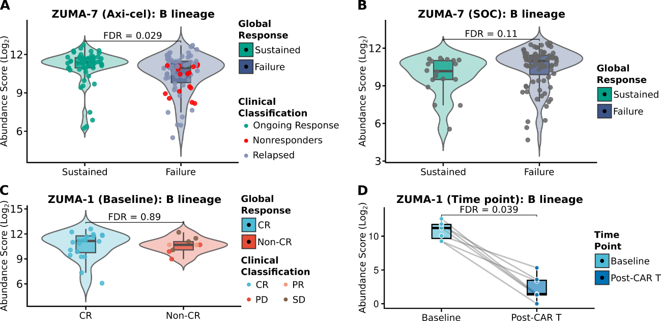
Supplementary Figure 1. B-cell lineage abundance determined by deconvolution. (A) B-cell lineage abundance at baseline (pre-infusion) in the Axi-cel-treated cohort from the ZUMA-7 study, computationally estimated using the MCP-counter (Microenvironment Cell Populations-counter) algorithm. (B) B-cell lineage abundance in the standard-of-care (SOC) control arm of the ZUMA-7 study. (C) Baseline B-cell lineage abundance in the ZUMA-1 study cohort, comprising previously treated patients, stratified by clinical response (CR vs. Non-CR). (D) Paired longitudinal analysis comparing B-cell lineage abundance between pre-infusion (baseline) and post-CAR-T treatment biopsies in patients from the ZUMA-1 study. Cell abundance scores are presented on a Log2 scale. Statistical differences were assessed using the Wilcoxon rank-sum test (A-C) and the Wilcoxon signed-rank test for paired samples (D), with Benjamini-Hochberg correction for False Discovery Rate (FDR). Boxplots overlaid on violin plots indicate the median and interquartile range. Overlaid scatter points represent individual patients, color-coded according to granular clinical classifications.

Supplementary Table 1. Statistical summary of the transcriptional profile for T-cell exhaustion and the antigen presentation (HLA) machinery. Statistical comparisons of the expression levels of key T-cell exhaustion markers and HLA machinery genes across the evaluated clinical cohorts. Details include the context of the empirical analysis (Cohort), the biological category and specific transcriptional target (Gene group and feature), as well as the clinical or temporal strata compared (group_1 and group_2). Comparisons assess durable clinical response (Sustained vs. Failure in ZUMA-7; CR vs. Non-CR in ZUMA-1) or longitudinal intra-patient evolution (Baseline vs. Post-CAR T). Nominal p-values (p_value) were derived using non-parametric statistical testing (the Wilcoxon rank-sum/Mann-Whitney U test for independent groups, or the Wilcoxon signed-rank test for paired longitudinal samples). To ensure statistical rigor and preserve biological power, adjusted p-values (padj_BH and label_padj) reflect the False Discovery Rate (FDR) correction via the Benjamini-Hochberg method, applied strictly and independently within each mechanistic panel (T-cell exhaustion and HLA).

Cohort | Gene group | feature | group_1 | group_2 | p_value | padj_BH | label_padj
ZUMA-7 (Axi-cel) | T-cell Exhaustion | PDCD1 | Sustained | Failure | 0.2719692403 | 0.9866334126 | FDR = 0.99
 |  | HAVCR2 | Sustained | Failure | 0.9408566095 | 0.9866334126 | FDR = 0.99
 |  | LAG3 | Sustained | Failure | 0.8688339197 | 0.9866334126 | FDR = 0.99
 |  | TIGIT | Sustained | Failure | 0.9866334126 | 0.9866334126 | FDR = 0.99
 |  | CTLA4 | Sustained | Failure | 0.5673178455 | 0.9866334126 | FDR = 0.99
 |  | EOMES | Sustained | Failure | 0.8537887177 | 0.9866334126 | FDR = 0.99
 |  | ENTPD1 | Sustained | Failure | 0.5935402521 | 0.9866334126 | FDR = 0.99
 |  | CXCL13 | Sustained | Failure | 0.6510243896 | 0.9866334126 | FDR = 0.99
 |  | CTLA4.IO360 | Sustained | Failure | 0.5150549128 | 0.9866334126 | FDR = 0.99
 |  | PD-L1.IO360 | Sustained | Failure | 0.9427607212 | 0.9866334126 | FDR = 0.99
 |  | PD-L2.IO360 | Sustained | Failure | 0.2556070809 | 0.9866334126 | FDR = 0.99
 |  | TIGIT.IO360 | Sustained | Failure | 0.8895972964 | 0.9866334126 | FDR = 0.99
 |  | Treg.IO360 | Sustained | Failure | 0.4654097293 | 0.9866334126 | FDR = 0.99
 |  | Exhausted CD8.IO360 | Sustained | Failure | 0.8631859034 | 0.9866334126 | FDR = 0.99
ZUMA-7 (SOC) | T-cell Exhaustion | PDCD1 | Sustained | Failure | 0.3063178545 | 0.6126357091 | FDR = 0.61
 |  | HAVCR2 | Sustained | Failure | 0.1563394684 | 0.6126357091 | FDR = 0.61
 |  | LAG3 | Sustained | Failure | 0.2384186045 | 0.6126357091 | FDR = 0.61
 |  | TIGIT | Sustained | Failure | 0.656339371 | 0.7239191114 | FDR = 0.72
 |  | CTLA4 | Sustained | Failure | 0.6763501953 | 0.7239191114 | FDR = 0.72
 |  | EOMES | Sustained | Failure | 0.1849245518 | 0.6126357091 | FDR = 0.61
 |  | ENTPD1 | Sustained | Failure | 0.7239191114 | 0.7239191114 | FDR = 0.72
 |  | CXCL13 | Sustained | Failure | 0.5000949844 | 0.7239191114 | FDR = 0.72
ZUMA-1 (Baseline) | T-cell Exhaustion | PDCD1 | CR | Non-CR | 0.9890860763 | 0.9890860763 | FDR = 0.99
 |  | HAVCR2 | CR | Non-CR | 0.08540005721 | 0.5984377774 | FDR = 0.6
 |  | LAG3 | CR | Non-CR | 0.4488283331 | 0.5984377774 | FDR = 0.6
 |  | TIGIT | CR | Non-CR | 0.3208014374 | 0.5984377774 | FDR = 0.6
 |  | CTLA4 | CR | Non-CR | 0.2094087821 | 0.5984377774 | FDR = 0.6
 |  | EOMES | CR | Non-CR | 0.4277861069 | 0.5984377774 | FDR = 0.6
 |  | ENTPD1 | CR | Non-CR | 0.2735956697 | 0.5984377774 | FDR = 0.6
 |  | CXCL13 | CR | Non-CR | 0.6586315234 | 0.752721741 | FDR = 0.75
ZUMA-1(Time point) | T-cell Exhaustion | PDCD1 | Baseline | Post-CAR T | 0.0625 | 0.2291666667 | FDR = 0.23
 |  | HAVCR2 | Baseline | Post-CAR T | 0.49609375 | 0.65234375 | FDR = 0.65
 |  | LAG3 | Baseline | Post-CAR T | 0.328125 | 0.525 | FDR = 0.52
 |  | TIGIT | Baseline | Post-CAR T | 0.2734375 | 0.525 | FDR = 0.52
 |  | CTLA4 | Baseline | Post-CAR T | 0.65234375 | 0.65234375 | FDR = 0.65
 |  | EOMES | Baseline | Post-CAR T | 0.609375 | 0.65234375 | FDR = 0.65
 |  | ENTPD1 | Baseline | Post-CAR T | 0.00390625 | 0.03125 | FDR = 0.031
 |  | CXCL13 | Baseline | Post-CAR T | 0.0859375 | 0.2291666667 | FDR = 0.23
ZUMA-7 (Axi-cel) | HLA | HLA-A | Ongoing | Failure | 0.1558275284 | 0.8542864847 | FDR = 0.85
 |  | HLA-B | Ongoing | Failure | 0.4537893506 | 0.8542864847 | FDR = 0.85
 |  | HLA-C | Ongoing | Failure | 0.9637300661 | 0.9637300661 | FDR = 0.96
 |  | B2M | Ongoing | Failure | 0.6407148636 | 0.8542864847 | FDR = 0.85
 |  | TAP1 | Ongoing | Failure | 0.3068034716 | 0.8542864847 | FDR = 0.85
 |  | TAP2 | Ongoing | Failure | 0.3469206171 | 0.8542864847 | FDR = 0.85
 |  | TAPBP | Ongoing | Failure | 0.5869328169 | 0.8542864847 | FDR = 0.85
 |  | PSMB8 | Ongoing | Failure | 0.9142337549 | 0.9637300661 | FDR = 0.96
 |  | PSMB9 | Ongoing | Failure | 0.5290570863 | 0.8542864847 | FDR = 0.85
 |  | PSMB10 | Ongoing | Failure | 0.6035147298 | 0.8542864847 | FDR = 0.85
 |  | NLRC5 | Ongoing | Failure | 0.5640794632 | 0.8542864847 | FDR = 0.85
 |  | HLA-DRA | Ongoing | Failure | 0.8015823694 | 0.9637300661 | FDR = 0.96
 |  | HLA-DRB1 | Ongoing | Failure | 0.4771962257 | 0.8542864847 | FDR = 0.85
 |  | HLA-DRB5 | Ongoing | Failure | 0.3022943929 | 0.8542864847 | FDR = 0.85
 |  | HLA-DPA1 | Ongoing | Failure | 0.6407148636 | 0.8542864847 | FDR = 0.85
 |  | HLA-DPB1 | Ongoing | Failure | 0.5290570863 | 0.8542864847 | FDR = 0.85
 |  | HLA-DQA1 | Ongoing | Failure | 0.9256335295 | 0.9637300661 | FDR = 0.96
 |  | HLA-DQB1 | Ongoing | Failure | 0.5608500093 | 0.8542864847 | FDR = 0.85
 |  | HLA-E | Ongoing | Failure | 0.6135638729 | 0.8542864847 | FDR = 0.85
 |  | HLA-F | Ongoing | Failure | 0.9599152389 | 0.9637300661 | FDR = 0.96
ZUMA-7 (SOC) | HLA | HLA-A | Ongoing | Failure | 0.1536763213 | 0.6147052853 | FDR = 0.61
 |  | HLA-B | Ongoing | Failure | 0.1199195598 | 0.6147052853 | FDR = 0.61
 |  | HLA-C | Ongoing | Failure | 0.333079009 | 0.6516399752 | FDR = 0.65
 |  | B2M | Ongoing | Failure | 0.1536763213 | 0.6147052853 | FDR = 0.61
 |  | TAP1 | Ongoing | Failure | 0.1243516212 | 0.6147052853 | FDR = 0.61
 |  | TAP2 | Ongoing | Failure | 0.1266150558 | 0.6147052853 | FDR = 0.61
 |  | TAPBP | Ongoing | Failure | 0.3909839851 | 0.6516399752 | FDR = 0.65
 |  | PSMB8 | Ongoing | Failure | 0.7033887869 | 0.8273888855 | FDR = 0.83
 |  | PSMB9 | Ongoing | Failure | 0.6041998353 | 0.8273888855 | FDR = 0.83
 |  | PSMB10 | Ongoing | Failure | 0.6696536082 | 0.8273888855 | FDR = 0.83
 |  | NLRC5 | Ongoing | Failure | 0.5000949844 | 0.7693768991 | FDR = 0.77
 |  | HLA-DRA | Ongoing | Failure | 0.3909839851 | 0.6516399752 | FDR = 0.65
 |  | HLA-DRB1 | Ongoing | Failure | 0.2649679363 | 0.6516399752 | FDR = 0.65
 |  | HLA-DRB5 | Ongoing | Failure | 0.2276352435 | 0.6503864101 | FDR = 0.65
 |  | HLA-DPA1 | Ongoing | Failure | 0.9086958139 | 0.9086958139 | FDR = 0.91
 |  | HLA-DPB1 | Ongoing | Failure | 0.7102091039 | 0.8273888855 | FDR = 0.83
 |  | HLA-DQA1 | Ongoing | Failure | 0.744649997 | 0.8273888855 | FDR = 0.83
 |  | HLA-DQB1 | Ongoing | Failure | 0.8079050805 | 0.8504264005 | FDR = 0.85
 |  | HLA-E | Ongoing | Failure | 0.347009064 | 0.6516399752 | FDR = 0.65
 |  | HLA-F | Ongoing | Failure | 0.2172040643 | 0.6503864101 | FDR = 0.65
ZUMA-1 (Baseline) | HLA | HLA-A | CR | Non-CR | 0.3901535746 | 0.7913846074 | FDR = 0.79
 |  | HLA-B | CR | Non-CR | 0.1988162762 | 0.7555018495 | FDR = 0.76
 |  | HLA-C | CR | Non-CR | 0.6940491792 | 0.9068378648 | FDR = 0.91
 |  | TAP1 | CR | Non-CR | 0.5624921805 | 0.9068378648 | FDR = 0.91
 |  | TAP2 | CR | Non-CR | 0.1673796468 | 0.7555018495 | FDR = 0.76
 |  | TAPBP | CR | Non-CR | 0.3171323429 | 0.7913846074 | FDR = 0.79
 |  | PSMB8 | CR | Non-CR | 0.7636529388 | 0.9068378648 | FDR = 0.91
 |  | PSMB9 | CR | Non-CR | 0.9815559753 | 0.9815559753 | FDR = 0.98
 |  | PSMB10 | CR | Non-CR | 0.7285843592 | 0.9068378648 | FDR = 0.91
 |  | NLRC5 | CR | Non-CR | 0.4165182144 | 0.7913846074 | FDR = 0.79
 |  | HLA-DRA | CR | Non-CR | 0.8714316169 | 0.9198444845 | FDR = 0.92
 |  | HLA-DRB3 | CR | Non-CR | 0.4165182144 | 0.7913846074 | FDR = 0.79
 |  | HLA-DRB4 | CR | Non-CR | 0.5859048498 | 0.9068378648 | FDR = 0.91
 |  | HLA-DPA1 | CR | Non-CR | 0.8714316169 | 0.9198444845 | FDR = 0.92
 |  | HLA-DPB1 | CR | Non-CR | 0.7636529388 | 0.9068378648 | FDR = 0.91
 |  | HLA-DQA1 | CR | Non-CR | 0.1013197697 | 0.6783170519 | FDR = 0.68
 |  | HLA-DQB1 | CR | Non-CR | 0.1071026924 | 0.6783170519 | FDR = 0.68
 |  | HLA-E | CR | Non-CR | 0.1047164729 | 0.6783170519 | FDR = 0.68
 |  | HLA-G | CR | Non-CR | 0.4165182144 | 0.7913846074 | FDR = 0.79
ZUMA-1(Time point) | HLA | HLA-A | Baseline | Post-CAR T | 0.203125 | 0.4288194444 | FDR = 0.43
 |  | HLA-B | Baseline | Post-CAR T | 0.0546875 | 0.3463541667 | FDR = 0.35
 |  | HLA-C | Baseline | Post-CAR T | 0.01953125 | 0.259765625 | FDR = 0.26
 |  | TAP1 | Baseline | Post-CAR T | 0.49609375 | 0.7916666667 | FDR = 0.79
 |  | TAP2 | Baseline | Post-CAR T | 0.359375 | 0.6828125 | FDR = 0.68
 |  | TAPBP | Baseline | Post-CAR T | 0.91015625 | 1 | FDR = 1
 |  | PSMB8 | Baseline | Post-CAR T | 0.5703125 | 0.8263020833 | FDR = 0.83
 |  | PSMB9 | Baseline | Post-CAR T | 1 | 1 | FDR = 1
 |  | PSMB10 | Baseline | Post-CAR T | 0.91015625 | 1 | FDR = 1
 |  | NLRC5 | Baseline | Post-CAR T | 0.1640625 | 0.4288194444 | FDR = 0.43
 |  | HLA-DRA | Baseline | Post-CAR T | 0.02734375 | 0.259765625 | FDR = 0.26
 |  | HLA-DRB3 | Baseline | Post-CAR T | 0.65234375 | 0.8263020833 | FDR = 0.83
 |  | HLA-DRB4 | Baseline | Post-CAR T | 0.1875 | 0.4288194444 | FDR = 0.43
 |  | HLA-DPA1 | Baseline | Post-CAR T | 0.1640625 | 0.4288194444 | FDR = 0.43
 |  | HLA-DPB1 | Baseline | Post-CAR T | 0.65234375 | 0.8263020833 | FDR = 0.83
 |  | HLA-DQA1 | Baseline | Post-CAR T | 0.5 | 0.7916666667 | FDR = 0.79
 |  | HLA-DQB1 | Baseline | Post-CAR T | 1 | 1 | FDR = 1
 |  | HLA-E | Baseline | Post-CAR T | 0.09765625 | 0.4288194444 | FDR = 0.43
 |  | HLA-G | Baseline | Post-CAR T | 0.1640625 | 0.4288194444 | FDR = 0.43

Supplementary Table 2. Differential gene expression (DEG) analysis associated with clinical outcomes and longitudinal cellular evolution in the ZUMA-1 and ZUMA-7 cohorts. For each assessed transcript, the magnitude of biological change is reported as the Log2 Fold Change (logFC), alongside its mean expression across all contrast samples (AveExpr). Statistical inferences for each group comparison (contrast and comparison) are derived from empirical Bayes moderated t-statistics (t) and the log-odds of differential expression (B). Statistical significance is denoted by the nominal p-value (P.Value) and the adjusted p-value (adj.P.Val) rigorously corrected for multiple comparisons using the Benjamini-Hochberg False Discovery Rate (FDR) control method. The definitive biological direction of transcriptional enrichment for each gene is explicitly summarized (direction_RawP).

Feature | logFC | AveExpr | t | P.Value | adj.P.Val | B | comparison | direction_RawP
CCL20 | 4.18 | 2.36 | 4.62 | 0.000072 | 0.042 | 1.61 | Non-CR vs CR | Up in Non-CR
KIR_Activating_Subgroup_2 | 3.93 | 1.97 | 4.45 | 0.000117 | 0.042 | 1.19 | Non-CR vs CR | Up in Non-CR
MAGEA12 | 3.70 | 2.07 | 4.29 | 0.000180 | 0.043 | 0.81 | Non-CR vs CR | Up in Non-CR
MAGEA3 | 4.01 | 2.45 | 3.93 | 0.000483 | 0.063 | -0.07 | Non-CR vs CR | Up in Non-CR
IL13 | 3.72 | 2.72 | 3.91 | 0.000504 | 0.063 | -0.11 | Non-CR vs CR | Up in Non-CR
KIR3DL3 | 3.67 | 2.39 | 3.79 | 0.000704 | 0.063 | -0.40 | Non-CR vs CR | Up in Non-CR
MASP1 | 2.45 | 0.97 | 3.75 | 0.000780 | 0.063 | -0.49 | Non-CR vs CR | Up in Non-CR
CCL16 | 3.14 | 1.51 | 3.75 | 0.000783 | 0.063 | -0.49 | Non-CR vs CR | Up in Non-CR
IL27 | 3.51 | 1.84 | 3.75 | 0.000793 | 0.063 | -0.50 | Non-CR vs CR | Up in Non-CR
CCL15 | 3.04 | 1.46 | 3.71 | 0.000874 | 0.063 | -0.59 | Non-CR vs CR | Up in Non-CR
CCR3 | 3.07 | 1.50 | 3.65 | 0.001031 | 0.068 | -0.74 | Non-CR vs CR | Up in Non-CR
F12 | 3.06 | 2.17 | 3.33 | 0.002402 | 0.127 | -1.48 | Non-CR vs CR | Up in Non-CR
SPANXB1 | 3.34 | 2.06 | 3.31 | 0.002504 | 0.127 | -1.52 | Non-CR vs CR | Up in Non-CR
PRM1 | 3.19 | 1.95 | 3.31 | 0.002521 | 0.127 | -1.52 | Non-CR vs CR | Up in Non-CR
C8G | 3.29 | 2.96 | 3.26 | 0.002871 | 0.127 | -1.64 | Non-CR vs CR | Up in Non-CR
IFNA17 | 3.16 | 1.80 | 3.25 | 0.002898 | 0.127 | -1.64 | Non-CR vs CR | Up in Non-CR
PRAME | 4.06 | 3.81 | 3.22 | 0.003161 | 0.127 | -1.72 | Non-CR vs CR | Up in Non-CR
SPACA3 | 2.83 | 1.63 | 3.19 | 0.003362 | 0.127 | -1.77 | Non-CR vs CR | Up in Non-CR
CCL1 | 3.03 | 1.80 | 3.17 | 0.003580 | 0.127 | -1.83 | Non-CR vs CR | Up in Non-CR
MPPED1 | 3.21 | 2.08 | 3.12 | 0.004042 | 0.127 | -1.93 | Non-CR vs CR | Up in Non-CR
FEZ1 | 3.54 | 5.42 | 3.10 | 0.004276 | 0.127 | -1.98 | Non-CR vs CR | Up in Non-CR
MASP2 | 3.20 | 2.77 | 3.08 | 0.004463 | 0.127 | -2.02 | Non-CR vs CR | Up in Non-CR
TSLP | 2.68 | 1.61 | 3.08 | 0.004465 | 0.127 | -2.02 | Non-CR vs CR | Up in Non-CR
IL25 | 2.77 | 1.81 | 3.07 | 0.004655 | 0.127 | -2.06 | Non-CR vs CR | Up in Non-CR
FUT5 | 2.54 | 1.28 | 3.06 | 0.004786 | 0.127 | -2.08 | Non-CR vs CR | Up in Non-CR
CD207 | 2.74 | 1.77 | 3.05 | 0.004819 | 0.127 | -2.09 | Non-CR vs CR | Up in Non-CR
IL3 | 2.25 | 0.94 | 3.03 | 0.005057 | 0.127 | -2.13 | Non-CR vs CR | Up in Non-CR
CTCFL | 3.26 | 2.44 | 3.02 | 0.005234 | 0.127 | -2.16 | Non-CR vs CR | Up in Non-CR
PTGDR2 | 2.54 | 1.31 | 3.02 | 0.005262 | 0.127 | -2.16 | Non-CR vs CR | Up in Non-CR
OSM | 3.07 | 2.72 | 2.92 | 0.006636 | 0.151 | -2.37 | Non-CR vs CR | Up in Non-CR
C8B | 2.21 | 1.16 | 2.92 | 0.006680 | 0.151 | -2.37 | Non-CR vs CR | Up in Non-CR
S100A7 | 3.30 | 2.81 | 2.90 | 0.007042 | 0.155 | -2.42 | Non-CR vs CR | Up in Non-CR
CLU | 2.82 | 1.98 | 2.83 | 0.008299 | 0.172 | -2.56 | Non-CR vs CR | Up in Non-CR
IFNB1 | 2.60 | 1.53 | 2.83 | 0.008458 | 0.172 | -2.58 | Non-CR vs CR | Up in Non-CR
ULBP2 | 3.05 | 2.85 | 2.82 | 0.008571 | 0.172 | -2.59 | Non-CR vs CR | Up in Non-CR
SH2D1B | 2.65 | 1.87 | 2.80 | 0.009075 | 0.178 | -2.64 | Non-CR vs CR | Up in Non-CR
RAG1 | 2.62 | 1.69 | 2.78 | 0.009468 | 0.180 | -2.67 | Non-CR vs CR | Up in Non-CR
IL8 | 3.31 | 3.78 | 2.74 | 0.010362 | 0.188 | -2.75 | Non-CR vs CR | Up in Non-CR
IGLL1 | 3.05 | 2.27 | 2.72 | 0.011037 | 0.188 | -2.80 | Non-CR vs CR | Up in Non-CR
IL24 | 2.56 | 1.97 | 2.69 | 0.011617 | 0.188 | -2.85 | Non-CR vs CR | Up in Non-CR
CT45A1 | 4.00 | 3.90 | 2.69 | 0.011623 | 0.188 | -2.85 | Non-CR vs CR | Up in Non-CR
EPCAM | 3.13 | 4.12 | 2.69 | 0.011697 | 0.188 | -2.85 | Non-CR vs CR | Up in Non-CR
MAGEB2 | 3.72 | 4.14 | 2.67 | 0.012247 | 0.193 | -2.89 | Non-CR vs CR | Up in Non-CR
IL5RA | 2.41 | 1.67 | 2.59 | 0.014747 | 0.214 | -3.05 | Non-CR vs CR | Up in Non-CR
FLT3 | 3.00 | 3.36 | 2.59 | 0.014998 | 0.214 | -3.07 | Non-CR vs CR | Up in Non-CR
C8A | 2.13 | 1.36 | 2.58 | 0.015070 | 0.214 | -3.07 | Non-CR vs CR | Up in Non-CR
BID | 2.60 | 4.37 | 2.57 | 0.015514 | 0.216 | -3.10 | Non-CR vs CR | Up in Non-CR
KIR3DL2 | 2.97 | 3.00 | 2.54 | 0.016748 | 0.229 | -3.16 | Non-CR vs CR | Up in Non-CR
IFNA7 | 2.90 | 2.18 | 2.52 | 0.017408 | 0.233 | -3.19 | Non-CR vs CR | Up in Non-CR
CASP10 | 2.27 | 1.48 | 2.49 | 0.018813 | 0.248 | -3.26 | Non-CR vs CR | Up in Non-CR
IL26 | 2.70 | 2.76 | 2.47 | 0.019776 | 0.256 | -3.30 | Non-CR vs CR | Up in Non-CR
IFNA2 | 2.06 | 1.14 | 2.44 | 0.021014 | 0.264 | -3.35 | Non-CR vs CR | Up in Non-CR
GATA3 | 2.06 | 1.37 | 2.44 | 0.021117 | 0.264 | -3.36 | Non-CR vs CR | Up in Non-CR
TNFRSF12A | 2.56 | 4.40 | 2.41 | 0.022384 | 0.275 | -3.41 | Non-CR vs CR | Up in Non-CR
IL17F | 2.06 | 1.15 | 2.40 | 0.022922 | 0.276 | -3.43 | Non-CR vs CR | Up in Non-CR
SPINK5 | 2.34 | 2.15 | 2.40 | 0.023273 | 0.276 | -3.44 | Non-CR vs CR | Up in Non-CR
LBP | 2.10 | 1.56 | 2.34 | 0.026269 | 0.293 | -3.54 | Non-CR vs CR | Up in Non-CR
IL1RAPL2 | 2.42 | 2.29 | 2.33 | 0.026805 | 0.293 | -3.56 | Non-CR vs CR | Up in Non-CR
FOXJ1 | 1.54 | 0.48 | 2.33 | 0.026860 | 0.293 | -3.56 | Non-CR vs CR | Up in Non-CR
CTAGE1 | 2.03 | 1.16 | 2.33 | 0.026897 | 0.293 | -3.56 | Non-CR vs CR | Up in Non-CR
ROPN1 | 2.66 | 2.33 | 2.33 | 0.027077 | 0.293 | -3.57 | Non-CR vs CR | Up in Non-CR
IL1RL1 | 2.05 | 1.54 | 2.30 | 0.028540 | 0.304 | -3.61 | Non-CR vs CR | Up in Non-CR
REN | 1.18 | 0.37 | 2.29 | 0.029764 | 0.304 | -3.64 | Non-CR vs CR | Up in Non-CR
CCL26 | 2.65 | 3.35 | 2.28 | 0.029854 | 0.304 | -3.65 | Non-CR vs CR | Up in Non-CR
XCR1 | 2.57 | 3.03 | 2.27 | 0.030876 | 0.310 | -3.68 | Non-CR vs CR | Up in Non-CR
CXCL5 | 2.53 | 1.91 | 2.26 | 0.031581 | 0.313 | -3.69 | Non-CR vs CR | Up in Non-CR
CREBBP | 2.20 | 5.04 | 2.24 | 0.033161 | 0.324 | -3.73 | Non-CR vs CR | Up in Non-CR
ITGA2B | 2.78 | 3.03 | 2.23 | 0.033807 | 0.326 | -3.75 | Non-CR vs CR | Up in Non-CR
KIR3DL1 | 2.01 | 1.34 | 2.21 | 0.035380 | 0.328 | -3.79 | Non-CR vs CR | Up in Non-CR
ARG2 | 2.20 | 2.92 | 2.16 | 0.039041 | 0.358 | -3.87 | Non-CR vs CR | Up in Non-CR
SLC11A1 | 3.03 | 4.80 | 2.15 | 0.039609 | 0.358 | -3.88 | Non-CR vs CR | Up in Non-CR
SYCP1 | 1.56 | 0.97 | 2.12 | 0.042437 | 0.375 | -3.94 | Non-CR vs CR | Up in Non-CR
IFNL2 | 2.60 | 3.10 | 2.07 | 0.047217 | 0.407 | -4.03 | Non-CR vs CR | Up in Non-CR
AIRE | 2.45 | 2.90 | 2.06 | 0.048027 | 0.409 | -4.04 | Non-CR vs CR | Up in Non-CR
MIF | 0.53 | 11.94 | 2.05 | 0.049601 | 0.418 | -4.07 | Non-CR vs CR | Up in Non-CR
PLA2G6 | -0.77 | 8.04 | -3.10 | 0.004286 | 0.127 | -1.99 | Non-CR vs CR | Up in CR
MX1 | -2.23 | 9.11 | -2.71 | 0.011293 | 0.188 | -2.82 | Non-CR vs CR | Up in CR
IL4R | -1.05 | 9.90 | -2.70 | 0.011356 | 0.188 | -2.83 | Non-CR vs CR | Up in CR
IFI27 | -1.16 | 9.22 | -2.60 | 0.014474 | 0.214 | -3.04 | Non-CR vs CR | Up in CR
TNFSF12 | -0.89 | 8.27 | -2.59 | 0.014712 | 0.214 | -3.05 | Non-CR vs CR | Up in CR
STAT1 | -1.07 | 10.59 | -2.36 | 0.025074 | 0.293 | -3.50 | Non-CR vs CR | Up in CR
ITGA4 | -1.62 | 8.51 | -2.29 | 0.029284 | 0.304 | -3.63 | Non-CR vs CR | Up in CR
CD96 | -3.21 | 5.90 | -2.22 | 0.034600 | 0.327 | -3.77 | Non-CR vs CR | Up in CR
MRC1 | -2.34 | 6.26 | -2.22 | 0.034729 | 0.327 | -3.77 | Non-CR vs CR | Up in CR
PECAM1 | -0.61 | 9.48 | -2.11 | 0.043542 | 0.380 | -3.96 | Non-CR vs CR | Up in CR
MET | 0.86 | 6.25 | 3.19 | 0.001802 | 0.600 | -3.43 | Failure vs Sustained | Up in Failure
KLRD1 | 0.69 | 5.50 | 3.01 | 0.003097 | 0.600 | -3.56 | Failure vs Sustained | Up in Failure
TNFRSF25 | 0.56 | 6.38 | 2.88 | 0.004636 | 0.600 | -3.66 | Failure vs Sustained | Up in Failure
PDGFA | 0.51 | 5.59 | 2.85 | 0.005013 | 0.600 | -3.68 | Failure vs Sustained | Up in Failure
DUSP5 | 0.68 | 7.76 | 2.83 | 0.005450 | 0.600 | -3.70 | Failure vs Sustained | Up in Failure
RORC | 0.54 | 3.15 | 2.75 | 0.006811 | 0.600 | -3.75 | Failure vs Sustained | Up in Failure
WNT11 | 0.52 | 3.79 | 2.75 | 0.006825 | 0.600 | -3.75 | Failure vs Sustained | Up in Failure
CDH2 | 0.61 | 5.63 | 2.68 | 0.008348 | 0.600 | -3.80 | Failure vs Sustained | Up in Failure
NCAM1 | 0.66 | 4.10 | 2.67 | 0.008631 | 0.600 | -3.81 | Failure vs Sustained | Up in Failure
EPCAM | 0.72 | 4.85 | 2.64 | 0.009373 | 0.600 | -3.83 | Failure vs Sustained | Up in Failure
C7 | 0.99 | 6.64 | 2.64 | 0.009416 | 0.600 | -3.83 | Failure vs Sustained | Up in Failure
MAML3 | 0.65 | 7.28 | 2.46 | 0.015074 | 0.600 | -3.94 | Failure vs Sustained | Up in Failure
NGFR | 0.53 | 5.41 | 2.43 | 0.016638 | 0.600 | -3.97 | Failure vs Sustained | Up in Failure
CCL21 | 1.12 | 7.74 | 2.39 | 0.018100 | 0.605 | -3.99 | Failure vs Sustained | Up in Failure
LRRC32 | 0.53 | 6.99 | 2.30 | 0.022944 | 0.626 | -4.04 | Failure vs Sustained | Up in Failure
CPA3 | 0.56 | 4.70 | 2.24 | 0.026873 | 0.626 | -4.08 | Failure vs Sustained | Up in Failure
KLRB1 | 0.55 | 5.89 | 2.13 | 0.035207 | 0.626 | -4.14 | Failure vs Sustained | Up in Failure
SERPINA9 | 1.10 | 7.25 | 2.01 | 0.047013 | 0.626 | -4.21 | Failure vs Sustained | Up in Failure
TNFRSF17 | -0.96 | 7.41 | -2.92 | 0.004151 | 0.600 | -3.63 | Failure vs Sustained | Up in Sustained
MS4A1 | -0.82 | 11.72 | -2.52 | 0.012911 | 0.600 | -3.91 | Failure vs Sustained | Up in Sustained
IRF8 | -0.52 | 10.56 | -2.46 | 0.015308 | 0.600 | -3.95 | Failure vs Sustained | Up in Sustained
BTLA | -0.64 | 5.86 | -2.25 | 0.026220 | 0.626 | -4.08 | Failure vs Sustained | Up in Sustained
HLA-DOB | -0.61 | 8.56 | -2.21 | 0.028533 | 0.626 | -4.10 | Failure vs Sustained | Up in Sustained
CD45RA | -0.71 | 9.77 | -2.09 | 0.038299 | 0.626 | -4.16 | Failure vs Sustained | Up in Sustained
CD19 | -0.51 | 10.47 | -2.08 | 0.039593 | 0.626 | -4.17 | Failure vs Sustained | Up in Sustained
IFITM2 | 1.33 | 11.06 | 5.65 | 0.000313 | 0.038 | 0.72 | Post vs Baseline | Up in Post
IGF1R | 1.98 | 8.72 | 5.44 | 0.000410 | 0.042 | 0.46 | Post vs Baseline | Up in Post
NT5E | 1.89 | 7.46 | 5.10 | 0.000644 | 0.043 | 0.03 | Post vs Baseline | Up in Post
ENTPD1 | 0.86 | 8.73 | 4.84 | 0.000922 | 0.043 | -0.31 | Post vs Baseline | Up in Post
LTBR | 1.91 | 8.62 | 4.57 | 0.001336 | 0.047 | -0.67 | Post vs Baseline | Up in Post
CXCL12 | 3.35 | 11.04 | 4.50 | 0.001488 | 0.047 | -0.77 | Post vs Baseline | Up in Post
PDGFRB | 2.69 | 10.30 | 4.33 | 0.001892 | 0.055 | -1.01 | Post vs Baseline | Up in Post
MSR1 | 3.10 | 8.19 | 4.23 | 0.002182 | 0.056 | -1.14 | Post vs Baseline | Up in Post
APP | 2.39 | 10.26 | 4.18 | 0.002384 | 0.058 | -1.23 | Post vs Baseline | Up in Post
FOS | 3.43 | 8.37 | 4.05 | 0.002879 | 0.065 | -1.41 | Post vs Baseline | Up in Post
LRP1 | 2.10 | 10.11 | 3.88 | 0.003739 | 0.076 | -1.67 | Post vs Baseline | Up in Post
FCGR2A | 2.45 | 9.97 | 3.83 | 0.004015 | 0.076 | -1.74 | Post vs Baseline | Up in Post
ANXA1 | 2.10 | 10.93 | 3.83 | 0.004031 | 0.076 | -1.74 | Post vs Baseline | Up in Post
MAPK3 | 0.95 | 9.41 | 3.82 | 0.004068 | 0.076 | -1.75 | Post vs Baseline | Up in Post
LAMP2 | 1.29 | 10.19 | 3.75 | 0.004541 | 0.082 | -1.86 | Post vs Baseline | Up in Post
TNFRSF1A | 1.46 | 9.90 | 3.72 | 0.004746 | 0.084 | -1.90 | Post vs Baseline | Up in Post
COL3A1 | 2.78 | 13.38 | 3.71 | 0.004850 | 0.084 | -1.92 | Post vs Baseline | Up in Post
THBS1 | 2.20 | 9.76 | 3.54 | 0.006321 | 0.094 | -2.18 | Post vs Baseline | Up in Post
PECAM1 | 1.96 | 10.75 | 3.53 | 0.006360 | 0.094 | -2.18 | Post vs Baseline | Up in Post
C4B | 1.82 | 9.57 | 3.51 | 0.006652 | 0.096 | -2.23 | Post vs Baseline | Up in Post
CD59 | 1.56 | 11.42 | 3.43 | 0.007451 | 0.100 | -2.34 | Post vs Baseline | Up in Post
TXNIP | 1.58 | 12.28 | 3.41 | 0.007735 | 0.100 | -2.37 | Post vs Baseline | Up in Post
C7 | 4.28 | 8.29 | 3.40 | 0.007840 | 0.100 | -2.39 | Post vs Baseline | Up in Post
CD63 | 1.86 | 13.03 | 3.35 | 0.008442 | 0.100 | -2.46 | Post vs Baseline | Up in Post
ENG | 1.83 | 9.59 | 3.32 | 0.008921 | 0.100 | -2.51 | Post vs Baseline | Up in Post
NRP1 | 3.82 | 9.36 | 3.31 | 0.009061 | 0.100 | -2.53 | Post vs Baseline | Up in Post
CFI | 2.86 | 6.40 | 3.31 | 0.009078 | 0.100 | -2.53 | Post vs Baseline | Up in Post
A2M | 2.41 | 11.50 | 3.31 | 0.009113 | 0.100 | -2.53 | Post vs Baseline | Up in Post
PNMA1 | 1.01 | 8.07 | 3.27 | 0.009687 | 0.100 | -2.59 | Post vs Baseline | Up in Post
NOD1 | 0.88 | 8.05 | 3.25 | 0.009952 | 0.100 | -2.62 | Post vs Baseline | Up in Post
BCL2L1 | 1.00 | 10.41 | 3.25 | 0.009952 | 0.100 | -2.62 | Post vs Baseline | Up in Post
CCL14 | 3.83 | 8.27 | 3.21 | 0.010600 | 0.102 | -2.68 | Post vs Baseline | Up in Post
TNFSF12 | 1.28 | 9.53 | 3.20 | 0.010723 | 0.102 | -2.69 | Post vs Baseline | Up in Post
ATG7 | 0.94 | 10.07 | 3.19 | 0.010998 | 0.102 | -2.72 | Post vs Baseline | Up in Post
FCGR3A | 1.93 | 9.93 | 3.18 | 0.011241 | 0.103 | -2.74 | Post vs Baseline | Up in Post
C1S | 2.21 | 10.01 | 3.17 | 0.011415 | 0.103 | -2.75 | Post vs Baseline | Up in Post
C1R | 2.51 | 11.23 | 3.14 | 0.011850 | 0.106 | -2.79 | Post vs Baseline | Up in Post
IL1R1 | 3.35 | 7.46 | 3.13 | 0.012080 | 0.107 | -2.81 | Post vs Baseline | Up in Post
RUNX1 | 0.93 | 9.58 | 3.11 | 0.012509 | 0.108 | -2.84 | Post vs Baseline | Up in Post
PDGFC | 2.68 | 7.38 | 3.11 | 0.012571 | 0.108 | -2.85 | Post vs Baseline | Up in Post
F13A1 | 3.00 | 8.97 | 2.96 | 0.015804 | 0.124 | -3.07 | Post vs Baseline | Up in Post
IFI27 | 1.71 | 10.71 | 2.92 | 0.016915 | 0.129 | -3.13 | Post vs Baseline | Up in Post
CD36 | 3.27 | 9.14 | 2.87 | 0.018577 | 0.133 | -3.22 | Post vs Baseline | Up in Post
CXCL16 | 1.57 | 8.24 | 2.84 | 0.019388 | 0.135 | -3.26 | Post vs Baseline | Up in Post
SERPING1 | 2.55 | 11.85 | 2.83 | 0.019704 | 0.135 | -3.28 | Post vs Baseline | Up in Post
IL6ST | 1.19 | 10.95 | 2.82 | 0.019939 | 0.135 | -3.29 | Post vs Baseline | Up in Post
CDH5 | 2.72 | 7.62 | 2.81 | 0.020266 | 0.135 | -3.31 | Post vs Baseline | Up in Post
ITGA5 | 2.70 | 8.53 | 2.79 | 0.021010 | 0.138 | -3.34 | Post vs Baseline | Up in Post
IL11RA | 2.23 | 5.93 | 2.78 | 0.021396 | 0.140 | -3.36 | Post vs Baseline | Up in Post
ITGA6 | 2.80 | 7.30 | 2.77 | 0.021836 | 0.140 | -3.38 | Post vs Baseline | Up in Post
TLR2 | 1.04 | 9.06 | 2.71 | 0.024048 | 0.153 | -3.47 | Post vs Baseline | Up in Post
CD163 | 3.39 | 9.68 | 2.70 | 0.024446 | 0.153 | -3.48 | Post vs Baseline | Up in Post
TNFSF10 | 1.11 | 10.23 | 2.69 | 0.024576 | 0.153 | -3.49 | Post vs Baseline | Up in Post
LILRB2 | 1.17 | 8.03 | 2.69 | 0.024943 | 0.153 | -3.50 | Post vs Baseline | Up in Post
CEBPB | 1.20 | 9.69 | 2.68 | 0.025162 | 0.153 | -3.51 | Post vs Baseline | Up in Post
MERTK | 2.91 | 8.17 | 2.66 | 0.026123 | 0.157 | -3.55 | Post vs Baseline | Up in Post
C3AR1 | 2.82 | 8.21 | 2.65 | 0.026414 | 0.157 | -3.56 | Post vs Baseline | Up in Post
HLA-C | 1.05 | 12.81 | 2.64 | 0.026671 | 0.157 | -3.57 | Post vs Baseline | Up in Post
CFB | 2.50 | 6.50 | 2.64 | 0.026913 | 0.157 | -3.58 | Post vs Baseline | Up in Post
CD14 | 1.80 | 10.27 | 2.62 | 0.027765 | 0.158 | -3.61 | Post vs Baseline | Up in Post
ITGB1 | 1.25 | 11.70 | 2.61 | 0.028006 | 0.158 | -3.61 | Post vs Baseline | Up in Post
C2 | 1.85 | 9.08 | 2.60 | 0.028545 | 0.158 | -3.63 | Post vs Baseline | Up in Post
CD34 | 2.46 | 5.73 | 2.60 | 0.028561 | 0.158 | -3.63 | Post vs Baseline | Up in Post
PSEN1 | 0.59 | 9.25 | 2.60 | 0.028907 | 0.158 | -3.64 | Post vs Baseline | Up in Post
CDKN1A | 1.02 | 8.42 | 2.59 | 0.029110 | 0.158 | -3.65 | Post vs Baseline | Up in Post
MRC1 | 3.46 | 8.59 | 2.58 | 0.029558 | 0.159 | -3.67 | Post vs Baseline | Up in Post
CD46 | 0.64 | 10.88 | 2.58 | 0.029765 | 0.159 | -3.67 | Post vs Baseline | Up in Post
CD99 | 1.06 | 11.95 | 2.58 | 0.029835 | 0.159 | -3.67 | Post vs Baseline | Up in Post
JAK2 | 0.88 | 10.27 | 2.57 | 0.030025 | 0.159 | -3.68 | Post vs Baseline | Up in Post
MAPK8 | 0.55 | 7.91 | 2.57 | 0.030229 | 0.159 | -3.69 | Post vs Baseline | Up in Post
MAF | 1.52 | 8.91 | 2.55 | 0.031098 | 0.161 | -3.71 | Post vs Baseline | Up in Post
ITGA1 | 2.95 | 8.22 | 2.55 | 0.031148 | 0.161 | -3.72 | Post vs Baseline | Up in Post
SIGLEC1 | 3.04 | 9.07 | 2.52 | 0.032983 | 0.164 | -3.77 | Post vs Baseline | Up in Post
LY96 | 1.16 | 9.18 | 2.51 | 0.033145 | 0.164 | -3.77 | Post vs Baseline | Up in Post
LGALS3 | 1.74 | 10.60 | 2.51 | 0.033264 | 0.164 | -3.78 | Post vs Baseline | Up in Post
C1QB | 2.64 | 11.60 | 2.50 | 0.033637 | 0.164 | -3.79 | Post vs Baseline | Up in Post
IFNL1 | 1.71 | 8.21 | 2.50 | 0.034033 | 0.164 | -3.80 | Post vs Baseline | Up in Post
CCR1 | 2.71 | 5.86 | 2.49 | 0.034252 | 0.164 | -3.81 | Post vs Baseline | Up in Post
VEGFA | 0.72 | 8.10 | 2.47 | 0.035288 | 0.167 | -3.83 | Post vs Baseline | Up in Post
MAP3K5 | 0.82 | 9.62 | 2.42 | 0.038274 | 0.179 | -3.91 | Post vs Baseline | Up in Post
C3 | 3.09 | 8.31 | 2.41 | 0.039052 | 0.180 | -3.93 | Post vs Baseline | Up in Post
CSF3R | 2.60 | 8.00 | 2.41 | 0.039323 | 0.180 | -3.94 | Post vs Baseline | Up in Post
IL17RA | 0.86 | 8.77 | 2.38 | 0.040956 | 0.182 | -3.97 | Post vs Baseline | Up in Post
FCER1G | 1.47 | 10.86 | 2.35 | 0.043163 | 0.187 | -4.02 | Post vs Baseline | Up in Post
UBC | 0.71 | 14.25 | 2.34 | 0.043713 | 0.187 | -4.04 | Post vs Baseline | Up in Post
TICAM2 | 0.75 | 8.00 | 2.33 | 0.044546 | 0.190 | -4.05 | Post vs Baseline | Up in Post
CD79A | -11.31 | 6.47 | -6.96 | 0.000065 | 0.031 | 2.17 | Post vs Baseline | Up in Baseline
TNFRSF17 | -7.85 | 3.85 | -6.58 | 0.000100 | 0.031 | 1.78 | Post vs Baseline | Up in Baseline
POU2AF1 | -8.81 | 5.15 | -6.38 | 0.000127 | 0.031 | 1.56 | Post vs Baseline | Up in Baseline
TNFRSF13C | -9.19 | 5.45 | -5.75 | 0.000274 | 0.038 | 0.84 | Post vs Baseline | Up in Baseline
CD83 | -2.71 | 9.86 | -5.71 | 0.000290 | 0.038 | 0.79 | Post vs Baseline | Up in Baseline
ST6GAL1 | -1.49 | 10.30 | -5.01 | 0.000730 | 0.043 | -0.09 | Post vs Baseline | Up in Baseline
PAX5 | -8.88 | 6.22 | -4.93 | 0.000808 | 0.043 | -0.18 | Post vs Baseline | Up in Baseline
IRF8 | -1.34 | 9.99 | -4.91 | 0.000834 | 0.043 | -0.21 | Post vs Baseline | Up in Baseline
CD27 | -1.56 | 9.98 | -4.86 | 0.000887 | 0.043 | -0.27 | Post vs Baseline | Up in Baseline
PRKCE | -4.90 | 3.85 | -4.84 | 0.000918 | 0.043 | -0.31 | Post vs Baseline | Up in Baseline
IL12A | -3.29 | 2.08 | -4.80 | 0.000975 | 0.043 | -0.37 | Post vs Baseline | Up in Baseline
CCL22 | -5.34 | 2.50 | -4.77 | 0.001010 | 0.043 | -0.40 | Post vs Baseline | Up in Baseline
TLR9 | -6.42 | 3.71 | -4.77 | 0.001017 | 0.043 | -0.41 | Post vs Baseline | Up in Baseline
AICDA | -5.92 | 3.45 | -4.70 | 0.001108 | 0.045 | -0.49 | Post vs Baseline | Up in Baseline
CXCR5 | -7.55 | 4.51 | -4.60 | 0.001277 | 0.047 | -0.63 | Post vs Baseline | Up in Baseline
MS4A1 | -7.78 | 4.51 | -4.54 | 0.001399 | 0.047 | -0.71 | Post vs Baseline | Up in Baseline
BLK | -6.86 | 4.14 | -4.53 | 0.001417 | 0.047 | -0.73 | Post vs Baseline | Up in Baseline
C1QBP | -0.99 | 9.84 | -4.44 | 0.001623 | 0.049 | -0.86 | Post vs Baseline | Up in Baseline
LAMP3 | -5.06 | 3.16 | -4.29 | 0.002027 | 0.055 | -1.07 | Post vs Baseline | Up in Baseline
CD79B | -5.47 | 10.56 | -4.28 | 0.002056 | 0.055 | -1.09 | Post vs Baseline | Up in Baseline
CD19 | -5.01 | 8.52 | -4.21 | 0.002267 | 0.057 | -1.18 | Post vs Baseline | Up in Baseline
MAP4K2 | -1.06 | 8.88 | -4.05 | 0.002876 | 0.065 | -1.41 | Post vs Baseline | Up in Baseline
PBK | -5.50 | 4.95 | -3.97 | 0.003266 | 0.072 | -1.54 | Post vs Baseline | Up in Baseline
LILRA4 | -3.57 | 1.63 | -3.92 | 0.003479 | 0.074 | -1.60 | Post vs Baseline | Up in Baseline
BLNK | -5.38 | 5.78 | -3.83 | 0.003991 | 0.076 | -1.73 | Post vs Baseline | Up in Baseline
BTLA | -5.25 | 5.49 | -3.61 | 0.005683 | 0.093 | -2.07 | Post vs Baseline | Up in Baseline
ETS1 | -0.75 | 11.22 | -3.60 | 0.005758 | 0.093 | -2.09 | Post vs Baseline | Up in Baseline
TP53 | -0.89 | 9.63 | -3.59 | 0.005796 | 0.093 | -2.09 | Post vs Baseline | Up in Baseline
CD1A | -3.34 | 1.64 | -3.57 | 0.006032 | 0.094 | -2.13 | Post vs Baseline | Up in Baseline
IL22RA1 | -3.72 | 1.82 | -3.53 | 0.006361 | 0.094 | -2.18 | Post vs Baseline | Up in Baseline
SH2B2 | -5.67 | 6.19 | -3.50 | 0.006743 | 0.096 | -2.24 | Post vs Baseline | Up in Baseline
BCL2 | -2.54 | 10.32 | -3.45 | 0.007311 | 0.100 | -2.32 | Post vs Baseline | Up in Baseline
TTK | -4.52 | 5.30 | -3.43 | 0.007489 | 0.100 | -2.34 | Post vs Baseline | Up in Baseline
REL | -1.04 | 9.18 | -3.37 | 0.008197 | 0.100 | -2.43 | Post vs Baseline | Up in Baseline
CD22 | -6.63 | 7.84 | -3.36 | 0.008314 | 0.100 | -2.44 | Post vs Baseline | Up in Baseline
CARD9 | -3.79 | 4.23 | -3.28 | 0.009481 | 0.100 | -2.57 | Post vs Baseline | Up in Baseline
SYT17 | -3.10 | 2.15 | -3.28 | 0.009527 | 0.100 | -2.58 | Post vs Baseline | Up in Baseline
RPS6 | -1.14 | 14.60 | -3.27 | 0.009716 | 0.100 | -2.60 | Post vs Baseline | Up in Baseline
CR2 | -4.96 | 5.51 | -3.25 | 0.009968 | 0.100 | -2.62 | Post vs Baseline | Up in Baseline
ANP32B | -0.74 | 11.00 | -3.25 | 0.009978 | 0.100 | -2.62 | Post vs Baseline | Up in Baseline
CDK1 | -5.48 | 6.46 | -3.24 | 0.010106 | 0.100 | -2.63 | Post vs Baseline | Up in Baseline
INPP5D | -1.11 | 10.19 | -3.23 | 0.010226 | 0.100 | -2.65 | Post vs Baseline | Up in Baseline
MAGEB2 | -3.51 | 1.72 | -3.23 | 0.010249 | 0.100 | -2.65 | Post vs Baseline | Up in Baseline
CREBBP | -3.29 | 3.76 | -3.19 | 0.010956 | 0.102 | -2.71 | Post vs Baseline | Up in Baseline
CD3EAP | -4.48 | 5.36 | -3.09 | 0.012988 | 0.110 | -2.88 | Post vs Baseline | Up in Baseline
CLEC6A | -2.67 | 1.21 | -3.08 | 0.013022 | 0.110 | -2.88 | Post vs Baseline | Up in Baseline
MASP2 | -2.61 | 1.18 | -3.07 | 0.013377 | 0.111 | -2.91 | Post vs Baseline | Up in Baseline
HLA-DOB | -4.12 | 7.73 | -3.06 | 0.013581 | 0.111 | -2.92 | Post vs Baseline | Up in Baseline
CD1E | -2.80 | 1.26 | -3.06 | 0.013652 | 0.111 | -2.92 | Post vs Baseline | Up in Baseline
TRAF2 | -0.61 | 9.10 | -3.04 | 0.013971 | 0.112 | -2.95 | Post vs Baseline | Up in Baseline
IFNL2 | -2.84 | 1.29 | -2.99 | 0.015206 | 0.121 | -3.03 | Post vs Baseline | Up in Baseline
HAMP | -3.54 | 2.71 | -2.94 | 0.016385 | 0.127 | -3.10 | Post vs Baseline | Up in Baseline
TLR7 | -3.21 | 3.88 | -2.94 | 0.016506 | 0.127 | -3.11 | Post vs Baseline | Up in Baseline
CCL11 | -3.13 | 2.41 | -2.92 | 0.017106 | 0.129 | -3.14 | Post vs Baseline | Up in Baseline
CCR4 | -3.98 | 2.45 | -2.90 | 0.017476 | 0.130 | -3.16 | Post vs Baseline | Up in Baseline
ILF3 | -0.58 | 11.44 | -2.89 | 0.017863 | 0.132 | -3.18 | Post vs Baseline | Up in Baseline
CD70 | -4.18 | 4.55 | -2.88 | 0.018289 | 0.133 | -3.21 | Post vs Baseline | Up in Baseline
IL21R | -4.16 | 6.22 | -2.87 | 0.018391 | 0.133 | -3.21 | Post vs Baseline | Up in Baseline
ULBP2 | -2.57 | 1.26 | -2.85 | 0.019185 | 0.135 | -3.25 | Post vs Baseline | Up in Baseline
ADA | -0.89 | 9.35 | -2.83 | 0.019741 | 0.135 | -3.28 | Post vs Baseline | Up in Baseline
LY9 | -4.43 | 6.76 | -2.82 | 0.020115 | 0.135 | -3.30 | Post vs Baseline | Up in Baseline
C8G | -2.73 | 1.34 | -2.81 | 0.020327 | 0.135 | -3.31 | Post vs Baseline | Up in Baseline
NFATC1 | -0.77 | 8.47 | -2.77 | 0.021582 | 0.140 | -3.37 | Post vs Baseline | Up in Baseline
TFRC | -0.86 | 9.94 | -2.68 | 0.025138 | 0.153 | -3.51 | Post vs Baseline | Up in Baseline
IL1B | -3.21 | 2.77 | -2.64 | 0.026898 | 0.157 | -3.58 | Post vs Baseline | Up in Baseline
IKBKE | -0.84 | 9.39 | -2.63 | 0.027146 | 0.157 | -3.58 | Post vs Baseline | Up in Baseline
MIF | -0.84 | 11.30 | -2.60 | 0.028851 | 0.158 | -3.64 | Post vs Baseline | Up in Baseline
HLA-DRA | -0.79 | 14.26 | -2.59 | 0.029069 | 0.158 | -3.65 | Post vs Baseline | Up in Baseline
CCR7 | -4.20 | 3.28 | -2.52 | 0.032619 | 0.164 | -3.76 | Post vs Baseline | Up in Baseline
BIRC5 | -4.39 | 6.96 | -2.52 | 0.032910 | 0.164 | -3.77 | Post vs Baseline | Up in Baseline
RUNX3 | -0.72 | 9.10 | -2.51 | 0.033065 | 0.164 | -3.77 | Post vs Baseline | Up in Baseline
PDCD1 | -4.01 | 4.46 | -2.50 | 0.033596 | 0.164 | -3.79 | Post vs Baseline | Up in Baseline
CAMP | -2.54 | 2.95 | -2.49 | 0.034145 | 0.164 | -3.80 | Post vs Baseline | Up in Baseline
HLA-DMB | -0.63 | 11.20 | -2.49 | 0.034636 | 0.165 | -3.82 | Post vs Baseline | Up in Baseline
BID | -2.99 | 2.71 | -2.44 | 0.037199 | 0.175 | -3.88 | Post vs Baseline | Up in Baseline
SLAMF1 | -4.76 | 4.14 | -2.41 | 0.039392 | 0.180 | -3.94 | Post vs Baseline | Up in Baseline
CD40 | -2.11 | 9.67 | -2.40 | 0.039797 | 0.180 | -3.95 | Post vs Baseline | Up in Baseline
IGLL1 | -1.87 | 0.82 | -2.40 | 0.039861 | 0.180 | -3.95 | Post vs Baseline | Up in Baseline
KIR3DL2 | -2.25 | 0.99 | -2.40 | 0.039922 | 0.180 | -3.95 | Post vs Baseline | Up in Baseline
MEF2C | -0.99 | 9.82 | -2.39 | 0.040252 | 0.180 | -3.96 | Post vs Baseline | Up in Baseline
CXCL6 | -2.09 | 0.92 | -2.38 | 0.041356 | 0.183 | -3.98 | Post vs Baseline | Up in Baseline
LCP1 | -1.19 | 12.11 | -2.37 | 0.041677 | 0.183 | -3.99 | Post vs Baseline | Up in Baseline
IL23A | -2.93 | 2.54 | -2.37 | 0.042089 | 0.184 | -4.00 | Post vs Baseline | Up in Baseline
IL17RB | -3.64 | 2.52 | -2.35 | 0.043296 | 0.187 | -4.03 | Post vs Baseline | Up in Baseline
CARD11 | -1.80 | 8.04 | -2.33 | 0.044827 | 0.190 | -4.06 | Post vs Baseline | Up in Baseline
CD53 | -0.99 | 11.81 | -2.31 | 0.046343 | 0.195 | -4.09 | Post vs Baseline | Up in Baseline
IL4R | -0.72 | 10.06 | -2.29 | 0.047382 | 0.197 | -4.11 | Post vs Baseline | Up in Baseline
RELB | -1.70 | 7.70 | -2.29 | 0.047453 | 0.197 | -4.11 | Post vs Baseline | Up in Baseline
CYFIP2 | -2.50 | 9.32 | -2.29 | 0.047872 | 0.198 | -4.12 | Post vs Baseline | Up in Baseline
CD80 | -3.86 | 5.11 | -2.28 | 0.048264 | 0.199 | -4.13 | Post vs Baseline | Up in Baseline
ICAM3 | -0.82 | 10.13 | -2.26 | 0.049775 | 0.204 | -4.16 | Post vs Baseline | Up in Baseline

Supplementary Table 3. Gene Set Enrichment Analysis (GSEA) of Hallmark biological pathways across the ZUMA-1 and ZUMA-7 cohorts. Systemic assessment of functional pathways was performed using the Hallmark collection from the Molecular Signatures Database (MSigDB), mapping globally dysregulated transcriptional programs according to baseline clinical outcomes (ZUMA-1 and ZUMA-7) and longitudinal intra-patient treatment dynamics (ZUMA-1 Time Point). For each evaluated biological pathway, the absolute Enrichment Score (ES) and the Normalized Enrichment Score (NES) are presented, reflecting the magnitude and direction of the transcriptional shift for a given clinical phenotype. The statistical significance of the directional enrichment is quantified by the empirical nominal p-value (pval), accompanied by the computational log error estimate (log2err) and the adjusted p-value (padj) via False Discovery Rate (FDR) control using the Benjamini-Hochberg method. The comprehensiveness of each active gene network is indicated by the number of detected transcripts (size), stratified by the corresponding source cohort (Cohort).

pathway | pval | padj | log2err | ES | NES | size | Cohort
HALLMARK_INTERFERON_GAMMA_RESPONSE | 0.000001 | 0.000023 | 0.64 | -0.43 | -2.05 | 81 | ZUMA-1 (Baseline)
HALLMARK_INTERFERON_ALPHA_RESPONSE | 0.000019 | 0.000231 | 0.58 | -0.57 | -2.30 | 34 | ZUMA-1 (Baseline)
HALLMARK_IL6_JAK_STAT3_SIGNALING | 0.000049 | 0.000390 | 0.56 | -0.44 | -1.99 | 57 | ZUMA-1 (Baseline)
HALLMARK_ESTROGEN_RESPONSE_LATE | 0.012167 | 0.073000 | 0.38 | -0.54 | -1.71 | 16 | ZUMA-1 (Baseline)
HALLMARK_ALLOGRAFT_REJECTION | 0.033654 | 0.161541 | 0.32 | -0.24 | -1.25 | 117 | ZUMA-1 (Baseline)
HALLMARK_ESTROGEN_RESPONSE_EARLY | 0.059449 | 0.237794 | 0.32 | -0.56 | -1.60 | 10 | ZUMA-1 (Baseline)
HALLMARK_PI3K_AKT_MTOR_SIGNALING | 0.154229 | 0.497502 | 0.26 | -0.35 | -1.22 | 21 | ZUMA-1 (Baseline)
HALLMARK_COMPLEMENT | 0.165834 | 0.497502 | 0.25 | -0.25 | -1.14 | 55 | ZUMA-1 (Baseline)
HALLMARK_COAGULATION | 0.252941 | 0.674510 | 0.09 | 0.38 | 1.16 | 35 | ZUMA-1 (Baseline)
HALLMARK_APOPTOSIS | 0.399314 | 0.915343 | 0.06 | 0.34 | 1.07 | 41 | ZUMA-1 (Baseline)
HALLMARK_G2M_CHECKPOINT | 0.419532 | 0.915343 | 0.07 | 0.45 | 1.04 | 10 | ZUMA-1 (Baseline)
HALLMARK_UV_RESPONSE_DN | 0.459821 | 0.917647 | 0.14 | -0.32 | -0.99 | 15 | ZUMA-1 (Baseline)
HALLMARK_XENOBIOTIC_METABOLISM | 0.526786 | 0.917647 | 0.13 | -0.31 | -0.97 | 15 | ZUMA-1 (Baseline)
HALLMARK_UV_RESPONSE_UP | 0.609475 | 0.917647 | 0.05 | 0.34 | 0.90 | 17 | ZUMA-1 (Baseline)
HALLMARK_APICAL_JUNCTION | 0.613260 | 0.917647 | 0.13 | -0.24 | -0.91 | 27 | ZUMA-1 (Baseline)
HALLMARK_P53_PATHWAY | 0.622549 | 0.917647 | 0.12 | -0.25 | -0.89 | 22 | ZUMA-1 (Baseline)
HALLMARK_KRAS_SIGNALING_UP | 0.650000 | 0.917647 | 0.16 | -0.21 | -0.91 | 45 | ZUMA-1 (Baseline)
HALLMARK_EPITHELIAL_MESENCHYMAL_TRANSITION | 0.796407 | 1.000000 | 0.03 | 0.26 | 0.77 | 30 | ZUMA-1 (Baseline)
HALLMARK_MYOGENESIS | 0.914698 | 1.000000 | 0.03 | 0.26 | 0.65 | 13 | ZUMA-1 (Baseline)
HALLMARK_KRAS_SIGNALING_DN | 0.929239 | 1.000000 | 0.03 | 0.26 | 0.62 | 12 | ZUMA-1 (Baseline)
HALLMARK_HYPOXIA | 1.000000 | 1.000000 | 0.02 | 0.16 | 0.40 | 14 | ZUMA-1 (Baseline)
HALLMARK_IL2_STAT5_SIGNALING | 1.000000 | 1.000000 | 0.02 | 0.14 | 0.45 | 56 | ZUMA-1 (Baseline)
HALLMARK_INFLAMMATORY_RESPONSE | 1.000000 | 1.000000 | 0.18 | -0.12 | -0.56 | 85 | ZUMA-1 (Baseline)
HALLMARK_TNFA_SIGNALING_VIA_NFKB | 1.000000 | 1.000000 | 0.01 | 0.15 | 0.48 | 59 | ZUMA-1 (Baseline)
HALLMARK_NOTCH_SIGNALING | 0.002245 | 0.055251 | 0.43 | 0.71 | 1.74 | 11 | ZUMA-7 (Axi-cel)
HALLMARK_E2F_TARGETS | 0.004378 | 0.055251 | 0.41 | -0.43 | -1.81 | 26 | ZUMA-7 (Axi-cel)
HALLMARK_G2M_CHECKPOINT | 0.005023 | 0.055251 | 0.41 | -0.51 | -1.94 | 18 | ZUMA-7 (Axi-cel)
HALLMARK_MYOGENESIS | 0.013761 | 0.113530 | 0.38 | 0.62 | 1.56 | 12 | ZUMA-7 (Axi-cel)
HALLMARK_WNT_BETA_CATENIN_SIGNALING | 0.035067 | 0.193942 | 0.27 | 0.55 | 1.49 | 15 | ZUMA-7 (Axi-cel)
HALLMARK_KRAS_SIGNALING_DN | 0.039663 | 0.193942 | 0.25 | 0.54 | 1.48 | 16 | ZUMA-7 (Axi-cel)
HALLMARK_EPITHELIAL_MESENCHYMAL_TRANSITION | 0.041139 | 0.193942 | 0.23 | 0.42 | 1.43 | 52 | ZUMA-7 (Axi-cel)
HALLMARK_ANGIOGENESIS | 0.053528 | 0.220803 | 0.21 | 0.55 | 1.46 | 14 | ZUMA-7 (Axi-cel)
HALLMARK_UV_RESPONSE_DN | 0.121319 | 0.390931 | 0.14 | 0.48 | 1.34 | 19 | ZUMA-7 (Axi-cel)
HALLMARK_P53_PATHWAY | 0.132517 | 0.390931 | 0.12 | 0.42 | 1.30 | 29 | ZUMA-7 (Axi-cel)
HALLMARK_GLYCOLYSIS | 0.133333 | 0.390931 | 0.13 | 0.43 | 1.30 | 26 | ZUMA-7 (Axi-cel)
HALLMARK_MITOTIC_SPINDLE | 0.142157 | 0.390931 | 0.27 | -0.41 | -1.31 | 11 | ZUMA-7 (Axi-cel)
HALLMARK_PI3K_AKT_MTOR_SIGNALING | 0.260000 | 0.660000 | 0.09 | 0.41 | 1.17 | 22 | ZUMA-7 (Axi-cel)
HALLMARK_TNFA_SIGNALING_VIA_NFKB | 0.338809 | 0.798621 | 0.07 | 0.31 | 1.08 | 72 | ZUMA-7 (Axi-cel)
HALLMARK_ALLOGRAFT_REJECTION | 0.389936 | 0.857859 | 0.20 | -0.19 | -1.11 | 110 | ZUMA-7 (Axi-cel)
HALLMARK_ESTROGEN_RESPONSE_LATE | 0.505882 | 0.884434 | 0.05 | 0.34 | 0.99 | 22 | ZUMA-7 (Axi-cel)
HALLMARK_HYPOXIA | 0.523861 | 0.884434 | 0.05 | 0.30 | 0.97 | 37 | ZUMA-7 (Axi-cel)
HALLMARK_KRAS_SIGNALING_UP | 0.526030 | 0.884434 | 0.05 | 0.30 | 0.97 | 38 | ZUMA-7 (Axi-cel)
HALLMARK_UV_RESPONSE_UP | 0.534911 | 0.884434 | 0.05 | 0.34 | 0.97 | 20 | ZUMA-7 (Axi-cel)
HALLMARK_COAGULATION | 0.540636 | 0.884434 | 0.05 | 0.34 | 0.97 | 19 | ZUMA-7 (Axi-cel)
HALLMARK_APICAL_JUNCTION | 0.567778 | 0.884434 | 0.04 | 0.31 | 0.94 | 31 | ZUMA-7 (Axi-cel)
HALLMARK_ESTROGEN_RESPONSE_EARLY | 0.589623 | 0.884434 | 0.05 | 0.34 | 0.93 | 17 | ZUMA-7 (Axi-cel)
HALLMARK_INFLAMMATORY_RESPONSE | 0.685773 | 0.983935 | 0.03 | 0.25 | 0.90 | 80 | ZUMA-7 (Axi-cel)
HALLMARK_XENOBIOTIC_METABOLISM | 0.777123 | 0.997955 | 0.03 | 0.28 | 0.77 | 17 | ZUMA-7 (Axi-cel)
HALLMARK_TGF_BETA_SIGNALING | 0.825871 | 0.997955 | 0.10 | -0.25 | -0.76 | 10 | ZUMA-7 (Axi-cel)
HALLMARK_ADIPOGENESIS | 0.882206 | 0.997955 | 0.03 | 0.27 | 0.67 | 11 | ZUMA-7 (Axi-cel)
HALLMARK_INTERFERON_ALPHA_RESPONSE | 0.915767 | 0.997955 | 0.02 | 0.21 | 0.69 | 42 | ZUMA-7 (Axi-cel)
HALLMARK_COMPLEMENT | 0.916304 | 0.997955 | 0.02 | 0.21 | 0.66 | 36 | ZUMA-7 (Axi-cel)
HALLMARK_IL6_JAK_STAT3_SIGNALING | 0.922175 | 0.997955 | 0.02 | 0.21 | 0.69 | 47 | ZUMA-7 (Axi-cel)
HALLMARK_IL2_STAT5_SIGNALING | 0.925577 | 0.997955 | 0.02 | 0.20 | 0.69 | 56 | ZUMA-7 (Axi-cel)
HALLMARK_MTORC1_SIGNALING | 0.967105 | 0.997955 | 0.11 | -0.16 | -0.62 | 22 | ZUMA-7 (Axi-cel)
HALLMARK_APOPTOSIS | 0.978378 | 0.997955 | 0.01 | 0.17 | 0.56 | 43 | ZUMA-7 (Axi-cel)
HALLMARK_INTERFERON_GAMMA_RESPONSE | 0.997955 | 0.997955 | 0.01 | 0.14 | 0.50 | 86 | ZUMA-7 (Axi-cel)
HALLMARK_COMPLEMENT | 0.000007 | 0.000164 | 0.61 | 0.53 | 2.18 | 55 | ZUMA-1 (Time point)
HALLMARK_EPITHELIAL_MESENCHYMAL_TRANSITION | 0.000069 | 0.000826 | 0.54 | 0.60 | 2.17 | 30 | ZUMA-1 (Time point)
HALLMARK_COAGULATION | 0.000203 | 0.001624 | 0.52 | 0.54 | 2.01 | 35 | ZUMA-1 (Time point)
HALLMARK_IL6_JAK_STAT3_SIGNALING | 0.003999 | 0.023996 | 0.41 | 0.41 | 1.70 | 57 | ZUMA-1 (Time point)
HALLMARK_MYOGENESIS | 0.014536 | 0.065522 | 0.38 | 0.61 | 1.71 | 13 | ZUMA-1 (Time point)
HALLMARK_UV_RESPONSE_DN | 0.020246 | 0.065522 | 0.35 | 0.56 | 1.62 | 15 | ZUMA-1 (Time point)
HALLMARK_APOPTOSIS | 0.020734 | 0.065522 | 0.35 | 0.39 | 1.51 | 41 | ZUMA-1 (Time point)
HALLMARK_INTERFERON_GAMMA_RESPONSE | 0.021841 | 0.065522 | 0.35 | 0.32 | 1.40 | 81 | ZUMA-1 (Time point)
HALLMARK_ESTROGEN_RESPONSE_EARLY | 0.041899 | 0.111261 | 0.32 | 0.58 | 1.50 | 10 | ZUMA-1 (Time point)
HALLMARK_KRAS_SIGNALING_DN | 0.046359 | 0.111261 | 0.32 | -0.59 | -1.53 | 12 | ZUMA-1 (Time point)
HALLMARK_ALLOGRAFT_REJECTION | 0.059843 | 0.130565 | 0.23 | -0.30 | -1.31 | 117 | ZUMA-1 (Time point)
HALLMARK_G2M_CHECKPOINT | 0.107345 | 0.214689 | 0.19 | -0.56 | -1.40 | 10 | ZUMA-1 (Time point)
HALLMARK_XENOBIOTIC_METABOLISM | 0.172185 | 0.317881 | 0.16 | 0.43 | 1.25 | 15 | ZUMA-1 (Time point)
HALLMARK_INTERFERON_ALPHA_RESPONSE | 0.210773 | 0.345890 | 0.15 | 0.32 | 1.18 | 34 | ZUMA-1 (Time point)
HALLMARK_KRAS_SIGNALING_UP | 0.227273 | 0.345890 | 0.15 | 0.29 | 1.15 | 45 | ZUMA-1 (Time point)
HALLMARK_ESTROGEN_RESPONSE_LATE | 0.230594 | 0.345890 | 0.14 | 0.40 | 1.17 | 16 | ZUMA-1 (Time point)
HALLMARK_APICAL_JUNCTION | 0.407925 | 0.559748 | 0.10 | 0.29 | 1.02 | 27 | ZUMA-1 (Time point)
HALLMARK_P53_PATHWAY | 0.419811 | 0.559748 | 0.10 | 0.32 | 1.03 | 22 | ZUMA-1 (Time point)
HALLMARK_PI3K_AKT_MTOR_SIGNALING | 0.608200 | 0.768253 | 0.08 | 0.27 | 0.90 | 21 | ZUMA-1 (Time point)
HALLMARK_HYPOXIA | 0.665428 | 0.798513 | 0.06 | -0.30 | -0.82 | 14 | ZUMA-1 (Time point)
HALLMARK_UV_RESPONSE_UP | 0.731207 | 0.799514 | 0.07 | 0.28 | 0.83 | 17 | ZUMA-1 (Time point)
HALLMARK_IL2_STAT5_SIGNALING | 0.732888 | 0.799514 | 0.05 | -0.22 | -0.85 | 56 | ZUMA-1 (Time point)
HALLMARK_INFLAMMATORY_RESPONSE | 0.783715 | 0.817790 | 0.07 | 0.19 | 0.85 | 85 | ZUMA-1 (Time point)
HALLMARK_TNFA_SIGNALING_VIA_NFKB | 0.915702 | 0.915702 | 0.04 | -0.19 | -0.74 | 59 | ZUMA-1 (Time point)

Supplementary Table 4. Differential expression analysis of global spatial tumor microenvironment signatures (IO 360 platform) in the ZUMA-7 cohort. The analyzed variables (Feature) correspond to robust algorithmic scores derived from the NanoString Tumor Signaling 360 platform (identified by the .IO360 suffix). These scores encompass broad macro-environmental biological modules, including myeloid inflammation, cell proliferation, hypoxia signaling, and global quantification of immune populations. The table details the magnitude of the enrichment difference (Log2 Fold Change, logFC), the cohort mean expression (AveExpr), the empirical moderated t-statistic (t), and the differential log-odds (B). Significance was evaluated via the nominal p-value (P.Value) and subsequently corrected for multiple testing scenarios using the Benjamini-Hochberg FDR method (adj.P.Val).

Feature | logFC | AveExpr | t | P.Value | adj.P.Val | B | comparison | direction_RawP
B Cells.IO360 | -0.41 | 8.60 | -2.22 | 0.028 | 0.601 | -3.77 | Failure vs Sustained | Not significant
Myeloid Inflammation.IO360 | 0.26 | 2.61 | 1.68 | 0.095 | 0.601 | -4.25 | Failure vs Sustained | Not significant
NOS2.IO360 | 0.22 | 1.47 | 1.64 | 0.104 | 0.601 | -4.28 | Failure vs Sustained | Not significant
Endothelial Cells.IO360 | 0.20 | 3.51 | 1.57 | 0.119 | 0.601 | -4.33 | Failure vs Sustained | Not significant
MAGEs.IO360 | 0.10 | 0.60 | 1.48 | 0.141 | 0.601 | -4.40 | Failure vs Sustained | Not significant
NK Cells.IO360 | 0.27 | 4.70 | 1.47 | 0.144 | 0.601 | -4.41 | Failure vs Sustained | Not significant
Apoptosis.IO360 | 0.09 | 4.61 | 1.46 | 0.147 | 0.601 | -4.41 | Failure vs Sustained | Not significant
CD8 T Cells.IO360 | 0.37 | 5.18 | 1.45 | 0.151 | 0.601 | -4.42 | Failure vs Sustained | Not significant
APM Loss.IO360 | -0.08 | 1.50 | -1.44 | 0.152 | 0.601 | -4.43 | Failure vs Sustained | Not significant
Cytotoxic Cells.IO360 | 0.31 | 5.95 | 1.44 | 0.153 | 0.601 | -4.43 | Failure vs Sustained | Not significant
NK CD56dim.IO360 | 0.23 | 4.49 | 1.41 | 0.161 | 0.601 | -4.45 | Failure vs Sustained | Not significant
PD-1.IO360 | 0.34 | 5.74 | 1.39 | 0.167 | 0.601 | -4.46 | Failure vs Sustained | Not significant
Mast Cells.IO360 | 0.24 | 1.94 | 1.38 | 0.169 | 0.601 | -4.46 | Failure vs Sustained | Not significant
DC.IO360 | 0.22 | 4.38 | 1.36 | 0.175 | 0.601 | -4.48 | Failure vs Sustained | Not significant
Glycolytic Activity.IO360 | 0.07 | 4.99 | 1.32 | 0.188 | 0.601 | -4.50 | Failure vs Sustained | Not significant
T Cells.IO360 | 0.32 | 5.96 | 1.16 | 0.248 | 0.688 | -4.60 | Failure vs Sustained | Not significant
IFN Downstream.IO360 | 0.15 | 5.00 | 1.15 | 0.254 | 0.688 | -4.61 | Failure vs Sustained | Not significant
PD-L2.IO360 | -0.23 | 5.73 | -1.12 | 0.266 | 0.688 | -4.62 | Failure vs Sustained | Not significant
Proliferation.IO360 | -0.13 | 6.52 | -1.10 | 0.272 | 0.688 | -4.63 | Failure vs Sustained | Not significant
Lymphoid.IO360 | 0.19 | 6.24 | 1.07 | 0.288 | 0.691 | -4.65 | Failure vs Sustained | Not significant
TH1 Cells.IO360 | 0.20 | 4.63 | 0.97 | 0.332 | 0.733 | -4.69 | Failure vs Sustained | Not significant
Cytotoxicity.IO360 | 0.25 | 6.13 | 0.97 | 0.336 | 0.733 | -4.70 | Failure vs Sustained | Not significant
IDO1.IO360 | 0.27 | 4.72 | 0.85 | 0.394 | 0.790 | -4.74 | Failure vs Sustained | Not significant
TGF-Beta.IO360 | 0.09 | 5.13 | 0.81 | 0.419 | 0.790 | -4.76 | Failure vs Sustained | Not significant
Inflammatory Chemokines.IO360 | 0.14 | 4.55 | 0.80 | 0.424 | 0.790 | -4.77 | Failure vs Sustained | Not significant
Treg.IO360 | 0.19 | 5.46 | 0.72 | 0.475 | 0.790 | -4.80 | Failure vs Sustained | Not significant
Exhausted CD8.IO360 | 0.15 | 6.28 | 0.68 | 0.500 | 0.790 | -4.81 | Failure vs Sustained | Not significant
JAKSTAT Loss.IO360 | 0.09 | 1.50 | 0.68 | 0.500 | 0.790 | -4.81 | Failure vs Sustained | Not significant
Stroma.IO360 | 0.12 | 4.28 | 0.68 | 0.500 | 0.790 | -4.81 | Failure vs Sustained | Not significant
Hypoxia.IO360 | 0.06 | 4.02 | 0.66 | 0.508 | 0.790 | -4.81 | Failure vs Sustained | Not significant
CTLA4.IO360 | 0.21 | 6.22 | 0.66 | 0.510 | 0.790 | -4.81 | Failure vs Sustained | Not significant
APM.IO360 | -0.08 | 5.80 | -0.62 | 0.539 | 0.803 | -4.83 | Failure vs Sustained | Not significant
IL10.IO360 | 0.16 | 6.66 | 0.60 | 0.552 | 0.803 | -4.83 | Failure vs Sustained | Not significant
Immunoproteasome.IO360 | -0.07 | 5.99 | -0.56 | 0.579 | 0.817 | -4.84 | Failure vs Sustained | Not significant
Hypermutation.IO360 | 0.04 | 1.01 | 0.47 | 0.641 | 0.853 | -4.87 | Failure vs Sustained | Not significant
B7-H3.IO360 | 0.07 | 2.83 | 0.46 | 0.643 | 0.853 | -4.87 | Failure vs Sustained | Not significant
MMR Loss.IO360 | 0.02 | 1.35 | 0.42 | 0.676 | 0.853 | -4.88 | Failure vs Sustained | Not significant
PD-L1.IO360 | 0.10 | 5.52 | 0.38 | 0.703 | 0.853 | -4.88 | Failure vs Sustained | Not significant
TIS.IO360 | 0.09 | 7.85 | 0.37 | 0.714 | 0.853 | -4.89 | Failure vs Sustained | Not significant
Myeloid.IO360 | 0.06 | 4.89 | 0.35 | 0.728 | 0.853 | -4.89 | Failure vs Sustained | Not significant
CD45.IO360 | 0.04 | 7.65 | 0.35 | 0.729 | 0.853 | -4.89 | Failure vs Sustained | Not significant
Neutrophils.IO360 | 0.07 | 4.04 | 0.30 | 0.765 | 0.874 | -4.90 | Failure vs Sustained | Not significant
IFN Gamma.IO360 | 0.07 | 6.21 | 0.23 | 0.819 | 0.915 | -4.91 | Failure vs Sustained | Not significant
TIGIT.IO360 | 0.05 | 6.75 | 0.16 | 0.870 | 0.949 | -4.91 | Failure vs Sustained | Not significant
MSI Predictor.IO360 | 0.00 | 0.22 | -0.10 | 0.923 | 0.985 | -4.92 | Failure vs Sustained | Not significant
Macrophages.IO360 | 0.00 | 5.68 | 0.03 | 0.979 | 0.990 | -4.92 | Failure vs Sustained | Not significant
MHC2.IO360 | 0.00 | 6.37 | 0.03 | 0.980 | 0.990 | -4.92 | Failure vs Sustained | Not significant
ARG1.IO360 | 0.00 | 1.72 | -0.01 | 0.990 | 0.990 | -4.92 | Failure vs Sustained | Not significant

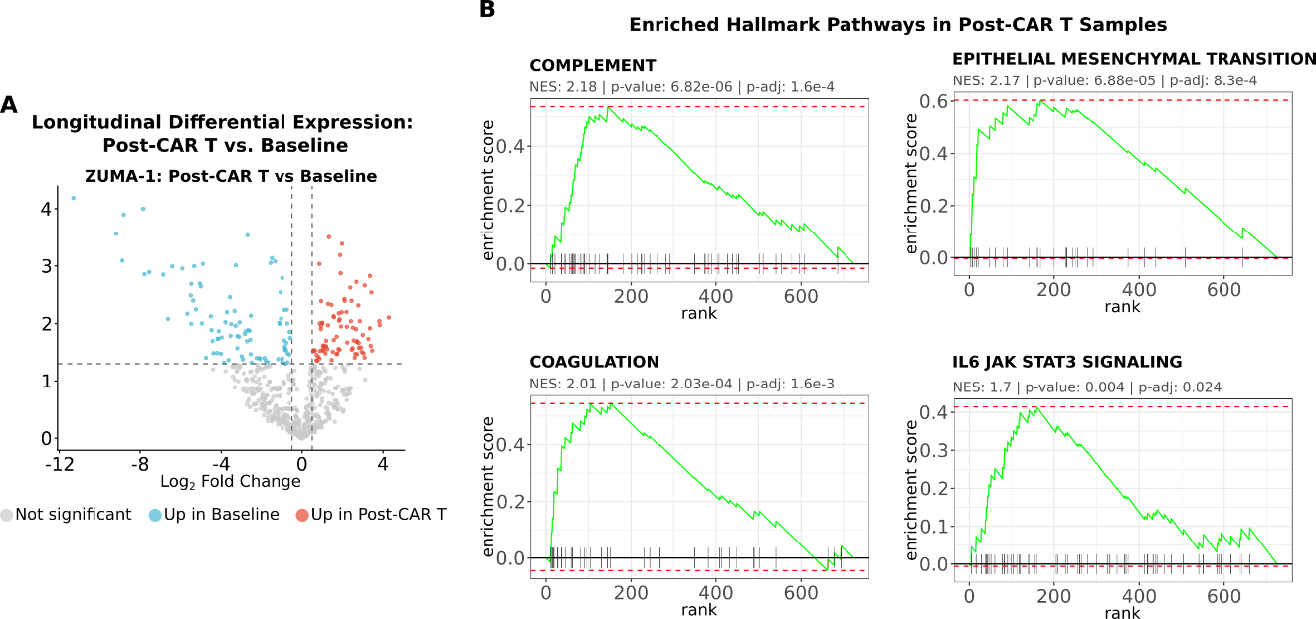
Supplementary Figure 2. Longitudinal transcriptomic evolution and mechanisms of acquired resistance following Axi-cel therapy in the ZUMA-1 study. (A) Volcano plot illustrating the paired analysis of differential gene expression between post-CAR T and baseline samples. Significance is highlighted based on an unadjusted p-value < 0.05 and an absolute log2 fold change > 0.5 (dashed lines). Genes with increased expression following CAR T infusion are represented in red, while those with reduced expression are shown in blue. (B) Standard Gene Set Enrichment Analysis (GSEA) plots for key MSigDB Hallmark pathways with significantly increased expression in post-CAR T samples. The residual tumor microenvironment demonstrates marked induction of inflammatory signaling (IL6/JAK/STAT3, Complement, Coagulation) and tissue remodeling programs (Epithelial-Mesenchymal Transition).

Supplementary Table 5. Prognostic evaluation of differentially expressed genes (DEGs) identified as candidate predictive biomarkers. Survival analyses were employed to determine the clinical impact of candidate genes on event-free survival (EFS) in patients undergoing anti-CD19 CAR T-cell therapy. For each DEG derived from baseline and paired longitudinal time points in the ZUMA-1 study, as well as the Axi-cel arm of the ZUMA-7 study, the table details the statistical significance derived from the log-rank test of Kaplan-Meier estimates (KM_PValue) alongside the initial univariate Cox proportional hazards regression metrics (UniCox_PValue and UniCox_HR). For biomarkers subjected to independent validation, multivariable Cox model metrics are presented, encompassing the Hazard Ratio adjusted for clinical covariates (MultiCox_HR), the corresponding 95% confidence intervals (CI_lower and CI_upper), and the final adjusted statistical significance (MultiCox_PValue).
Gene | KM_PValue | UniCox_PValue | UniCox_HR | MultiCox_HR | CI_lower | CI_upper | MultiCox_PValue
CCL20 | 0.00091 | 0.00485 | 1.27 | 1.26 | 1.05 | 1.51 | 0.01496
MAGEA12 | 0.47997 | 0.58232 | 1.06 | NA | NA | NA | NA
TSLP | 0.28853 | 0.15390 | 1.15 | NA | NA | NA | NA
ULBP2 | 0.38568 | 0.68895 | 0.95 | NA | NA | NA | NA
MX1 | 0.47882 | 0.57439 | 1.05 | NA | NA | NA | NA
IL24 | 0.11270 | 0.06224 | 1.18 | NA | NA | NA | NA
EPCAM | 0.59865 | 0.00397 | 1.23 | NA | NA | NA | NA
MAGEB2 | 0.77230 | 0.10200 | 1.12 | NA | NA | NA | NA
IFI27 | 0.02493 | 0.04114 | 1.16 | 1.18 | 1.00 | 1.39 | 0.04482
TNFSF12 | 0.68831 | 0.87945 | 0.98 | NA | NA | NA | NA
BID | 0.20709 | 0.30244 | 0.85 | NA | NA | NA | NA
KIR3DL2 | 0.02436 | 0.15274 | 1.15 | NA | NA | NA | NA
STAT1 | 0.65511 | 0.29277 | 1.10 | NA | NA | NA | NA
ITGA4 | 0.35843 | 0.46730 | 0.92 | NA | NA | NA | NA
REN | 0.35221 | 0.50761 | 1.08 | NA | NA | NA | NA
CXCL5 | 0.24931 | 0.65532 | 1.03 | NA | NA | NA | NA
CD96 | 0.48458 | 0.93065 | 1.01 | NA | NA | NA | NA
MRC1 | 0.14201 | 0.08238 | 1.14 | NA | NA | NA | NA
KIR3DL1 | 0.04642 | 0.49332 | 1.07 | NA | NA | NA | NA
ARG2 | 0.85037 | 0.69425 | 1.04 | NA | NA | NA | NA
SLC11A1 | 0.29915 | 0.56660 | 1.03 | NA | NA | NA | NA
PECAM1 | 0.45692 | 0.40132 | 1.14 | NA | NA | NA | NA
MET | 0.06352 | 0.00614 | 1.19 | NA | NA | NA | NA
KLRD1 | 0.00570 | 0.00244 | 1.29 | 1.32 | 1.11 | 1.58 | 0.00196
TNFRSF17 | 0.00996 | 0.01211 | 0.86 | 0.85 | 0.76 | 0.96 | 0.00981
TNFRSF25 | 0.15106 | 0.01161 | 1.30 | NA | NA | NA | NA
PDGFA | 0.37157 | 0.01717 | 1.30 | NA | NA | NA | NA
DUSP5 | 0.00066 | 0.00023 | 1.34 | 1.32 | 1.12 | 1.57 | 0.00125
RORC | 0.01961 | 0.02424 | 1.23 | 1.18 | 0.98 | 1.43 | 0.08610
WNT11 | 0.00503 | 0.00330 | 1.35 | 1.35 | 1.08 | 1.69 | 0.00796
CDH2 | 0.04343 | 0.03465 | 1.18 | 1.31 | 1.10 | 1.55 | 0.00201
NCAM1 | 0.03716 | 0.04494 | 1.16 | 1.20 | 1.04 | 1.40 | 0.01411
C7 | 0.13568 | 0.03962 | 1.11 | NA | NA | NA | NA
MS4A1 | 0.00004 | 0.00202 | 0.85 | 0.84 | 0.75 | 0.94 | 0.00184
MAML3 | 0.21919 | 0.16372 | 1.11 | NA | NA | NA | NA
IRF8 | 0.03477 | 0.00485 | 0.80 | 0.77 | 0.66 | 0.92 | 0.00277
NGFR | 0.03081 | 0.06120 | 1.18 | NA | NA | NA | NA
CCL21 | 0.01852 | 0.07513 | 1.07 | NA | NA | NA | NA
LRRC32 | 0.01921 | 0.03816 | 1.18 | 1.19 | 1.00 | 1.42 | 0.04773
BTLA | 0.03422 | 0.00723 | 0.82 | 0.84 | 0.72 | 0.97 | 0.02014
CPA3 | 0.34323 | 0.05450 | 1.16 | NA | NA | NA | NA
HLA-DOB | 0.00889 | 0.00086 | 0.80 | 0.78 | 0.67 | 0.91 | 0.00157
KLRB1 | 0.13620 | 0.10368 | 1.13 | NA | NA | NA | NA
CD45RA | 0.00070 | 0.00566 | 0.87 | 0.86 | 0.77 | 0.96 | 0.00848
CD19 | 0.00504 | 0.00358 | 0.81 | 0.82 | 0.71 | 0.95 | 0.00967
SERPINA9 | 0.19621 | 0.13526 | 1.06 | NA | NA | NA | NA
CD79A | 0.10195 | 0.12966 | 0.90 | NA | NA | NA | NA
IFITM2 | 0.51611 | 0.54919 | 1.07 | NA | NA | NA | NA
NT5E | 0.50391 | 0.06367 | 1.24 | NA | NA | NA | NA
CD27 | 0.74414 | 0.90604 | 1.01 | NA | NA | NA | NA
ENTPD1 | 0.66712 | 0.32534 | 1.10 | NA | NA | NA | NA
CCL22 | 0.60760 | 0.33385 | 0.95 | NA | NA | NA | NA
TLR9 | 0.38770 | 0.47536 | 0.93 | NA | NA | NA | NA
BLK | 0.02549 | 0.08670 | 0.88 | NA | NA | NA | NA
CXCL12 | 0.56383 | 0.72606 | 1.02 | NA | NA | NA | NA
PDGFRB | 0.51691 | 0.51492 | 1.08 | NA | NA | NA | NA
CD79B | 0.15105 | 0.08106 | 0.89 | NA | NA | NA | NA
FCGR2A | 0.11972 | 0.20935 | 1.12 | NA | NA | NA | NA
TNFRSF1A | 0.05409 | 0.15810 | 1.19 | NA | NA | NA | NA
TP53 | 0.80061 | 0.59213 | 1.07 | NA | NA | NA | NA
THBS1 | 0.16934 | 0.23912 | 1.09 | NA | NA | NA | NA
IL22RA1 | 0.96566 | 0.89076 | 1.01 | NA | NA | NA | NA
BCL2 | 0.34958 | 0.40376 | 1.06 | NA | NA | NA | NA
A2M | 0.31734 | 0.37281 | 1.12 | NA | NA | NA | NA
BCL2L1 | 0.22112 | 0.69931 | 1.04 | NA | NA | NA | NA
CCL14 | 0.06137 | 0.21015 | 1.09 | NA | NA | NA | NA
TLR7 | 0.67673 | 0.85313 | 1.02 | NA | NA | NA | NA
CCR4 | 0.98847 | 0.92009 | 1.01 | NA | NA | NA | NA
CD70 | 0.40434 | 0.60433 | 0.97 | NA | NA | NA | NA
IL21R | 0.93967 | 0.95245 | 1.00 | NA | NA | NA | NA
CD36 | 0.14995 | 0.54001 | 1.05 | NA | NA | NA | NA
CXCL16 | 0.04747 | 0.35989 | 1.09 | NA | NA | NA | NA
LY9 | 0.00461 | 0.00189 | 0.78 | 0.77 | 0.65 | 0.92 | 0.00299
CDH5 | 0.62149 | 0.22066 | 1.17 | NA | NA | NA | NA
IL11RA | 0.90697 | 0.48834 | 1.09 | NA | NA | NA | NA
ITGA6 | 0.84593 | 0.28034 | 1.14 | NA | NA | NA | NA
TLR2 | 0.69916 | 0.68649 | 1.04 | NA | NA | NA | NA
CD163 | 0.31903 | 0.35274 | 1.06 | NA | NA | NA | NA
TNFSF10 | 0.13848 | 0.21047 | 1.17 | NA | NA | NA | NA
LILRB2 | 0.69236 | 0.13924 | 1.14 | NA | NA | NA | NA
CEBPB | 0.47624 | 0.35292 | 1.11 | NA | NA | NA | NA
HLA-C | 0.76721 | 0.41673 | 1.09 | NA | NA | NA | NA
IL1B | 0.37299 | 0.08342 | 1.14 | NA | NA | NA | NA
CD14 | 0.88068 | 0.71456 | 1.03 | NA | NA | NA | NA
C2 | 0.42783 | 0.16951 | 1.12 | NA | NA | NA | NA
HLA-DRA | 0.84127 | 0.99096 | 1.00 | NA | NA | NA | NA
CDKN1A | 0.04585 | 0.01046 | 1.35 | 1.27 | 0.99 | 1.64 | 0.05798
JAK2 | 0.59609 | 0.98154 | 1.00 | NA | NA | NA | NA
ITGA1 | 0.47401 | 0.07056 | 1.21 | NA | NA | NA | NA
BIRC5 | 0.58607 | 0.97957 | 1.00 | NA | NA | NA | NA
SIGLEC1 | 0.13588 | 0.04490 | 1.16 | NA | NA | NA | NA
RUNX3 | 0.32771 | 0.67956 | 1.06 | NA | NA | NA | NA
LY96 | 0.54552 | 0.61905 | 1.08 | NA | NA | NA | NA
PDCD1 | 0.83149 | 0.34649 | 1.08 | NA | NA | NA | NA
C1QB | 0.18935 | 0.10524 | 1.11 | NA | NA | NA | NA
HLA-DMB | 0.04290 | 0.41686 | 0.91 | NA | NA | NA | NA
VEGFA | 0.95190 | 0.38683 | 1.10 | NA | NA | NA | NA
MAP3K5 | 0.47069 | 0.16744 | 1.19 | NA | NA | NA | NA
CSF3R | 0.24168 | 0.58051 | 1.04 | NA | NA | NA | NA
CD40 | 0.70164 | 0.98615 | 1.00 | NA | NA | NA | NA
CXCL6 | 0.87766 | 0.40798 | 1.06 | NA | NA | NA | NA
RELB | 0.34828 | 0.61775 | 1.07 | NA | NA | NA | NA
CD80 | 0.24806 | 0.22903 | 1.11 | NA | NA | NA | NA
ICAM3 | 0.22338 | 0.51338 | 0.93 | NA | NA | NA | NA

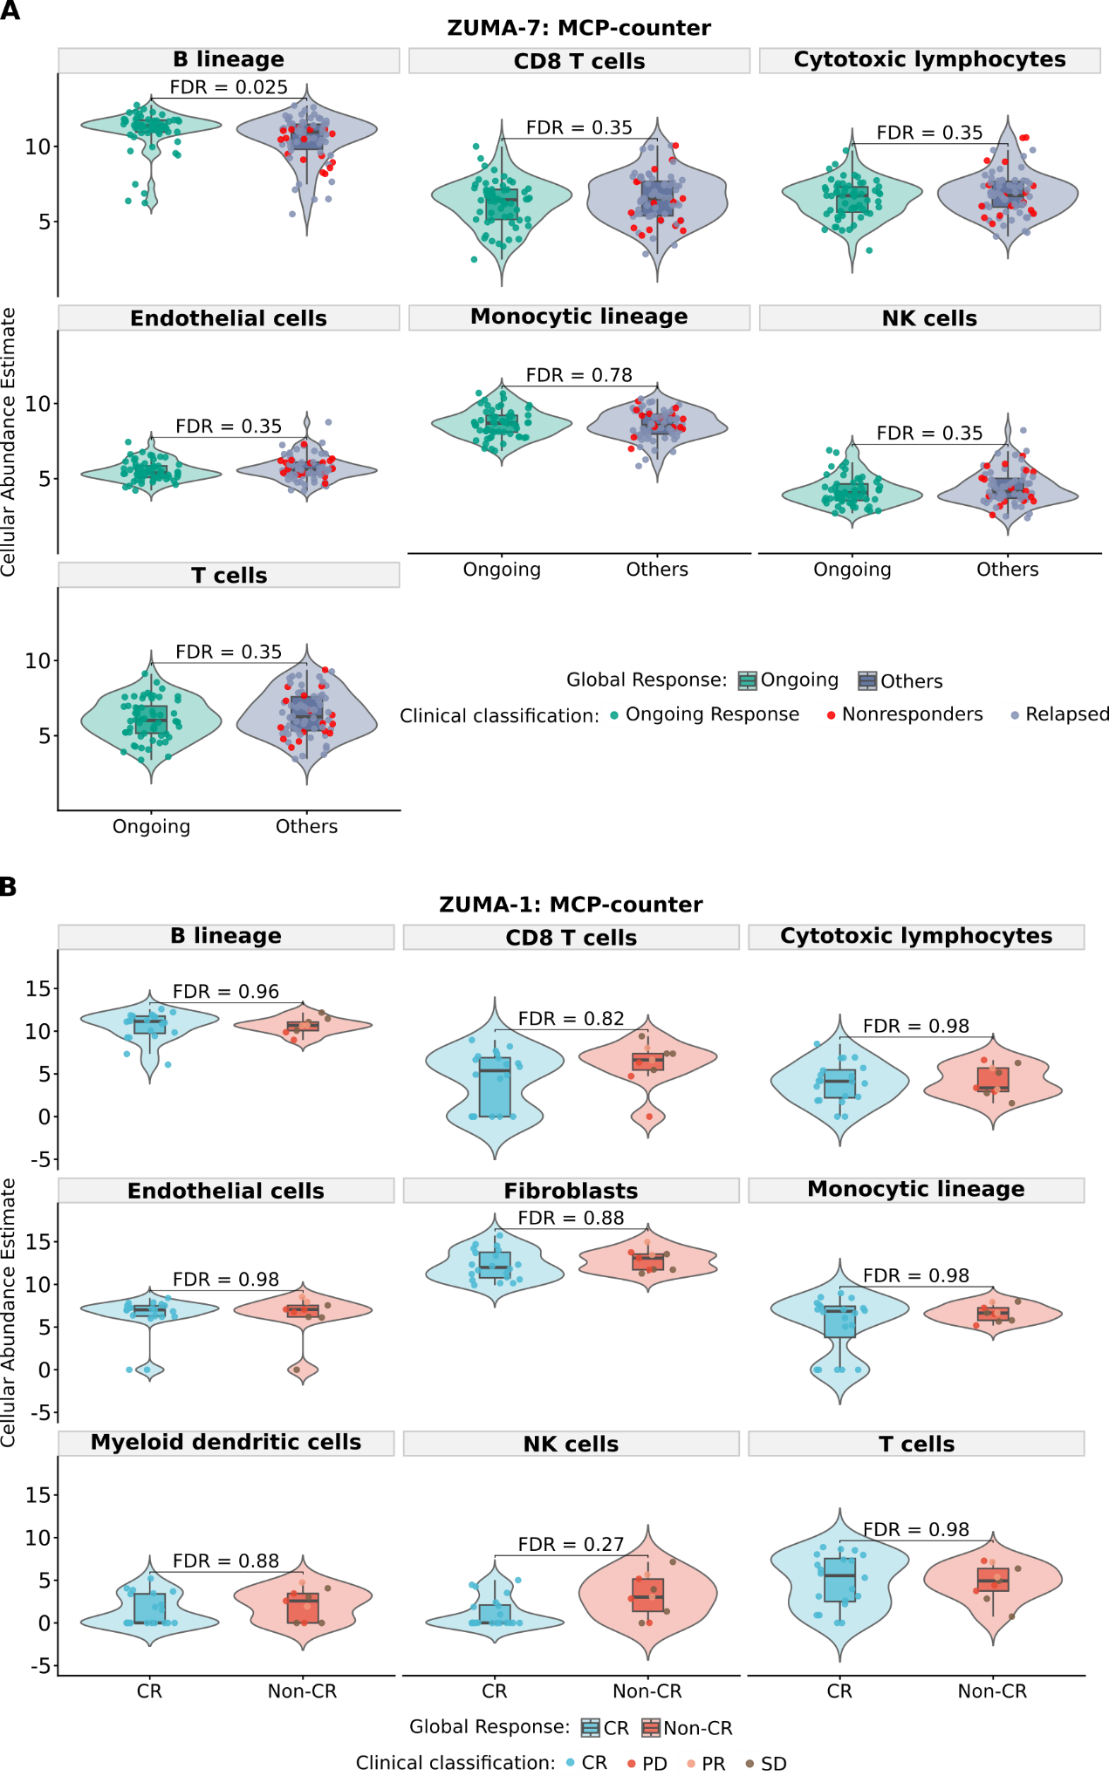
Supplementary Figure 3. Baseline tumor microenvironment cellular composition does not stratify response to Axi-cel in the ZUMA-7 and ZUMA-1 cohorts. Violin plots representing the estimated abundance of cell populations, stratified by overall clinical response (Sustained vs. Failure for ZUMA-7; CR vs. Non-CR for ZUMA-1). (A) Cellular deconvolution estimated by MCP-counter in ZUMA-7 (Axi-cel). (B) Cellular deconvolution estimated by MCP-counter in ZUMA-1 (Baseline). Individual patient data points are overlaid and color-coded according to their specific clinical classification. Statistical comparisons between response groups were performed using the Wilcoxon rank-sum test with Benjamini-Hochberg (FDR) correction.

