Article
CAR-T response in DLBCL is shaped by the immune tumor microenvironment: integrative transcriptomic evidence
Jean Silva de Souza Resende ^{1,2,3}, Igor Samesima Giner ^{1,2}, Maria Gabriela Custódio Figueiredo ¹, Mariana Martins Paraízo ¹, Enzo Lalli ⁴, Mauro Antônio Alves Castro ³ and Bonald Cavalcante de Figueiredo ^{1,2}*
Academic Editor: Firstname Lastname
Received: date
Revised: date
Accepted: date
Published: date
Copyright: © 2026 by the authors. Submitted for possible open access publication under the terms and conditions of the Creative Commons Attribution (CC BY) license.
¹ Oncology Division, Instituto de Pesquisa e Faculdades Pelé Pequeno Príncipe, Curitiba, PR, 80250-060, Brazil
² Faculdades Pequeno Príncipe, Curitiba, PR, 80230-020, Brazil
³ Bioinformatics and Systems Biology Laboratory, Federal University of Paraná, Curitiba, PR, 81531-980, Brazil
⁴ Institut de Pharmacologie Moléculaire et Cellulaire CNRS UMR7275, Inserm U1323,
Université Côte d’Azur, 06560 Valbonne, France
* Correspondence: bonald.figueiredo@professor.fpp.edu.br (B.C.F.)
Abstract
Background/Objectives: Anti-CD19 CAR T-cell therapy (axi-cel) has transformed relapsed/refractory diffuse large B-cell lymphoma (DLBCL) treatment. However, since therapeutic failure frequently occurs in tumors retaining CD19 expression, this study aimed to investigate the intrinsic and microenvironmental transcriptomic determinants of resistance to axi-cel beyond classical antigen escape. Methods: We performed an integrative analysis of baseline targeted transcriptomic data from the pivotal ZUMA-1 and ZUMA-7 clinical trials using differential gene expression and survival analyses. To determine treatment-context specificity, the candidate evasion signatures were systematically cross-evaluated against the ZUMA-7 standard-of-care salvage chemotherapy arm and an independent first-line cohort (TCGA-DLBC). Results: Baseline T-cell exhaustion signatures and global HLA downregulation did not independently stratify axi-cel response. Instead, therapeutic sensitivity was associated with preserved B-cell lineage phenotypic integrity (CD19, MS4A1, TNFRSF17) and transcriptional competence (IRF8). Conversely, early CAR T-cell escape correlated with tumor dedifferentiation, EMT-like tissue-remodeling programs, altered cellular adhesion (CDH2, NCAM1), and immune-excluding chemotaxis (CCL20). Cross-cohort evaluation confirmed most risk markers were predominantly associated with cellular immunotherapy failure, whereas WNT11 emerged as a pan-prognostic marker of broad tumor aggressiveness. Finally, bulk abundance of infiltrating immune and stromal populations did not independently predict clinical outcomes. Conclusions: Early resistance to axi-cel in DLBCL reflects malignant-clone phenotypic plasticity, loss of lymphoid identity, and aberrant tissue remodeling rather than classical immune deprivation alone. These candidate pathways provide a framework for further biomarker validation and identify biological targets for rational combination strategies.
Keywords: diffuse large B-cell lymphoma; CAR T-cell therapy; axi-cel; transcriptomics; tumor microenvironment; treatment resistance; phenotypic plasticity; biomarkers

1. Introduction

Diffuse large B-cell lymphoma (DLBCL) is the most common aggressive non-Hodgkin lymphoma in adults and is characterized by substantial biological and clinical heterogeneity. Despite major advances with first-line rituximab-based chemoimmunotherapy (R-CHOP), approximately 30-40% of patients develop relapsed or refractory (r/r) disease, which has historically been associated with a dismal prognosis and limited treatment options [1,2]. Following failure of first-line therapy, CD19-directed chimeric antigen receptor (CAR) T-cell therapies, including axicabtagene ciloleucel (axi-cel), have transformed the therapeutic landscape by inducing durable remissions in a subset of patients [3,4].
However, a substantial proportion of patients treated with axi-cel either fail to achieve a sustained complete response or experience early relapse. Although antigen escape through loss or reduced expression of CD19 has been described, disease progression frequently occurs despite preserved target expression, indicating that resistance is often mediated by mechanisms beyond antigen loss [5,6]. These observations support a model in which axi-cel resistance arises from a complex interplay between tumor-intrinsic biological programs and the surrounding tumor microenvironment (TME).
In conventional tumor immunology, immune evasion is frequently attributed to pre-existing T-cell exhaustion and impaired antigen-presentation machinery, including downregulation of human leukocyte antigen (HLA) molecules. Although pathways such as PD-1/PD-L1 signaling may contribute to adaptive resistance after CAR T-cell infusion, baseline global exhaustion signatures have not consistently stratified treatment responses independently [7–9]. Similarly, while immunosuppressive cellular populations have been associated with impaired CAR T-cell expansion and activity, quantitative estimates of immune and stromal infiltration alone do not fully account for the marked variability in clinical outcomes [10,11]. This discrepancy suggests that the functional state and phenotypic plasticity of malignant B cells may constitute more consequential barriers to CAR T-cell activity than the abundance of inhibitory cell populations alone.
Effective antitumor immunity also depends on the coordinated activation of inflammatory pathways. Acute activation of interferon (IFN) enhances target vulnerability, whereas an inability to mount an effective baseline inflammatory program, or its chronic dysregulation, can limit CAR T-cell engagement [12,13]. In parallel, specific chemokine networks, including the CCL20-CCR6 axis, have been implicated in immune exclusion and the establishment of an immunologically anergic microenvironment [14]. Beyond classical immune signaling, emerging paradigms highlight the role of tumor dedifferentiation and aggressive tissue remodeling. Programs analogous to epithelial-mesenchymal transition-like (EMT-like) and alterations in cellular adhesion confer physical and biological protection against effector immune cell infiltration and cytotoxicity, representing a largely unexplored frontier in cellular immunotherapy resistance [15–17].
Conversely, preservation of mature B-cell lineage identity may favor therapeutic sensitivity. Sustained expression of canonical B-cell markers, including CD19 and MS4A1, together with lineage-defining transcriptional regulators such as IRF8, may maintain a differentiated cellular state that is more permissive to immune recognition and elimination [18,19]. Thus, the balance between B-cell lineage integrity and the acquisition of dedifferentiated, inflammatory, or tissue-remodeling phenotypes may critically influence the response to CD19-directed CAR T-cell therapy.
To decode this multidimensional evasion network, the present study aimed to investigate the molecular determinants of axi-cel response by integrating transcriptomic data from the pivotal ZUMA-1 and ZUMA-7 clinical trials. Rather than focusing exclusively on bulk immune infiltration, we systematically evaluated baseline B-cell lineage integrity, canonical exhaustion markers, and the HLA complex. Through this approach, we identified distinct biological pathways of intrinsic resistance, ranging from immune silencing to aggressive tissue remodeling, and established an orthogonally validated transcriptomic signature that provides a mechanistic framework to predict CAR T-cell failure and guide future therapeutic strategies.

2. Materials and Methods

2.1. Study Design and Clinical Cohorts
This retrospective translational study analyzed transcriptomic and clinical data from patients with relapsed or refractory (r/r) DLBCL treated with the axicabtagene ciloleucel (axi-cel) anti-CD19 CAR T-cell therapy. Data were derived from the pivotal ZUMA-1 (NCT02348216, https://clinicaltrials.gov/study/NCT02348216; third-line setting) and ZUMA-7 (NCT03391466, https://clinicaltrials.gov/study/NCT03391466; second-line setting) clinical trials. The TCGA-DLBC cohort (https://portal.gdc.cancer.gov/projects/TCGA-DLBC; N = 47; CAR-T naive) was incorporated as a reference control representing conventional chemoimmunotherapy.
Within the ZUMA-1 cohort, we evaluated baseline (pre-lymphodepletion) profiles (N = 29; 20 Complete Response [CR] vs. 9 Non-CR) alongside paired longitudinal dynamics (post-infusion vs. baseline) in a subset of patients (N = 8, all achieving CR). For the ZUMA-7 study, baseline evaluations were conducted in the experimental axi-cel arm (N = 134; 58 Sustained Response, 70 Failure, 6 unclassified) and the standard-of-care (SOC) salvage chemotherapy control arm (N = 122; 18 Sustained Response, 80 Failure, 24 unavailable) to model Event-Free Survival (EFS). Well-established clinical prognostic factors, namely baseline tumor burden (Sum of Product Diameters, SPD) and molecular subtype (Cell of Origin, COO), were extracted as clinical covariates for multivariable adjustments.

2.2 Transcriptomic Data Acquisition and Processing
Preprocessed gene expression matrices derived from custom microarray platforms were retrieved from the Gene Expression Omnibus (GEO) repository under accession numbers GSE197977 (ZUMA-1 cohort, https://www.ncbi.nlm.nih.gov/geo/query/acc.cgi?acc=GSE197977; 74 samples, 724 genes) and GSE248835 (ZUMA-7 cohort, https://www.ncbi.nlm.nih.gov/geo/query/acc.cgi?acc=GSE248835; 256 samples, 817 transcripts and functional signatures). For clinical response stratification within the ZUMA-7 cohort, patients were categorized into "Sustained" and "Failure" groups, which correspond directly to the "Ongoing" and "Others" clinical outcomes, respectively, as originally defined by Locke et al. (2024). To establish the reference control cohort, RNA sequencing data (RNA-seq, quantified as Transcripts Per Million [TPM]) for the TCGA-DLBC cohort were systematically obtained from the Genomic Data Commons (GDC) portal.
To enable analytical integration across distinct transcriptomic technologies, clinical metadata and feature identifiers were harmonized through unified mapping to official Gene Symbol nomenclature. To mitigate platform-dependent scaling biases, stabilize intrinsic variance, and ensure direct cross-cohort statistical comparability across all three datasets, all absolute expression profiles underwent Log2 transformation prior to inferential and survival modeling.

2.3 Tumor Microenvironment Deconvolution and B-Cell Lineage Integrity
The architecture of the tumor microenvironment (TME) was deconvoluted using the Microenvironment Cell Populations-counter algorithm (MCP-counter; MCPcounter R package v1.2.0) [20], estimating the abundance scores of eight immune and two stromal populations. To investigate therapeutic target preservation and tumor phenotypic integrity, variations in B-cell lineage abundance and its canonical markers across baseline clinical outcomes were statistically evaluated using the Mann-Whitney U test. Complementarily, longitudinal remodeling of the tumor ecosystem under CAR T-cell selective pressure (intra-patient post-infusion vs. baseline) was mapped using the Wilcoxon signed-rank test for paired samples.

2.4 Transcriptomic Mapping of Immune Evasion
To delineate the immunosuppressive architecture and tumor escape potential, transcriptomic profiles associated with T-cell exhaustion and the integrity of the antigen presentation machinery (HLA) were investigated. Aiming for a granular and functional phenotypic assessment, the HLA complex was stratified a priori into four biological axes: classical Class I molecules, the intracellular processing machinery, Class II molecules, and non-classical inhibitory Class I molecules. To identify latent biological clusters, Log2-transformed counts were scaled into Z-scores and subjected to unsupervised hierarchical clustering (Euclidean distance and Ward's linkage method; stats R package v4.6.1) , followed by visualization using multidimensional heatmaps (ComplexHeatmap v2.28.0) [21]. Finally, direct clinico-genomic integration was performed by pairing the uncovered evasion profiles with clinical efficacy annotations (Response, EFS), molecular subtype (COO), and continuous tumor burden (SPD).

2.5 Global Transcriptomic Mapping and Pathway Enrichment
To map the global transcriptomic perturbations underlying primary resistance to axi-cel, baseline differential expression analysis (DEA) was conducted using the limma R package (v3.68.4) [22], adopting an exploratory heuristic threshold (nominal p < 0.05, | Log2 | > 0.5) for the initial prospection of signatures. Aiming to translate isolated transcripts into functional programs and capture biological heterogeneity at the individual patient level, Single-Sample Gene Set Enrichment Analysis (ssGSEA; GSVA v2.6.5) [23] was employed. This approach quantified the activation intensity (Mean Normalized Enrichment Score, Mean NES) of eight ontological macrocategories from the MSigDB Hallmark collection [24]. Complementarily, to identify the core mechanistic axes driving therapeutic failure at the population level, classical GSEA (fgsea v1.38.0) [25] was performed based on the continuous statistical ranking derived from limma (adjusted p < 0.05).

2.6 Prognostic Modeling and Tumor Microenvironment Dynamic
To determine the clinical impact of transcriptomic signatures on therapeutic efficacy, EFS within the ZUMA-7 cohort was modeled using Kaplan-Meier estimates and the log-rank test (survival R package v3.8.6, survminer v0.5.2) [26,27]. Patient stratification was strictly based on the intra-cohort median expression, ensuring a standardized analytical threshold and mitigating cutpoint optimization biases (cutpoint overfitting). Aiming to validate the independent prognostic value of the signatures and isolate their effect from well-established clinical confounders, multivariable Cox proportional hazards regression models were constructed to derive Hazard Ratios (HR) adjusted for baseline tumor burden (Sum of Product Diameters, SPD) and molecular subtype (Cell of Origin, COO). Finally, to elucidate the functional dynamics within the tumor ecosystem, the network of interactions between candidate biomarkers and the absolute abundance of immune and stromal populations (estimated via MCP-counter) was mapped using Spearman's rank correlation (stats v4.6.1).

2.7 Validation of Therapeutic Specificity

To conclusively discriminate strict predictive value (specific to cellular immunotherapy) from mere general prognostic impact (inherent to baseline DLBCL aggressiveness), the therapeutic specificity of the biomarkers was assessed through orthogonal validation across three independent clinical scenarios. Maintaining standardized stratification by median expression, the genomic impact was modeled on EFS in the experimental arm (ZUMA-7 axi-cel) and directly contrasted with two conventional therapy groups: EFS in the control arm (ZUMA-7 SOC; salvage setting) and Overall Survival (OS) in the TCGA-DLBC cohort (R-CHOP; first-line setting). Under this rigorous design, the retention of statistical significance (p < 0.05) exclusively within the axi-cel cohort classified the transcript as a genuine predictor of specific anti-CD19 CAR T-cell evasion, thereby ruling out markers of non-specific tumor aggressiveness.

2.8 Analytical Integration and Cross-Validation with Pivotal Literature
To contextualize the biological originality and translational robustness of our findings, the predictive value of the biomarker panel was subjected to systematic cross-validation against the genomic data reported in the original publications of the ZUMA-1 and ZUMA-7 trials. The predictive profile of each transcript was methodologically categorized based on its direct concordance with the literature, structuring the validation framework into three comparative scenarios: (I) Broad Concordance, encompassing biomarkers whose predictive effects were simultaneously confirmed by the original findings of both cohorts; (II) Cohort-Specific Concordance, including transcripts primarily supported by only one of the trials (ZUMA-1 or ZUMA-7), reflecting biological nuances potentially associated with the line of therapy; and (III) Emerging Significance/Novelty, grouping biological targets characterized in the original literature as inconclusive, non-specific, or not reported (NR), but which acquired autonomous and validated predictive significance in the current study through multivariable Cox modeling for EFS.

2.9 Biological Integration and Representation of the Mechanistic Model
To synthesize the complexity of the tumor ecosystem and provide a unified translational interpretation of the findings, a conceptual mechanistic model was developed. This model resulted from the topological integration of the study's three core analytical frameworks: (I) the directionality of enriched functional pathways (GSEA/ssGSEA); (II) the architecture and composition of the cellular microenvironment (MCP-counter); and (III) the validated predictive impact on clinical survival (Cox and Kaplan-Meier modeling across the ZUMA-1, ZUMA-7, and TCGA cohorts). The integrative diagram -phenotypically dichotomized into axes of immune resistance/evasion and programs of sensitivity/target preservation under CAR T-cell selective pressure - was compiled and illustrated using the BioRender platform (https://biorender.com).

2.10 Statistical Analysis and Data Visualization
All analytical processing and statistical modeling were executed within the R computational environment (version 4.6.1). The distribution of continuous variables between independent groups was evaluated using the non-parametric Mann-Whitney U test, whereas the Wilcoxon signed-rank test was applied for intra-patient paired longitudinal measurements [28,29]. Bivariate associations, such as the covariance between gene expression and immune populations, were quantified using Spearman's rank correlation coefficient.
Statistical significance for survival probability estimates (Kaplan-Meier) was assessed via the log-rank test. Multivariable Cox proportional hazards regression was employed to derive Hazard Ratios (HR) and their respective 95% confidence intervals (95% CI), with the mathematical validity of the models confirmed through the analysis of Schoenfeld residuals, ensuring adherence to the proportional hazards assumption.
To mitigate the inflation of false positives (Type I error) inherent to genomic multiple testing scenarios (DEA and GSEA), nominal p-values were systematically adjusted using the Benjamini-Hochberg method, thereby controlling the False Discovery Rate (FDR) [30]. A two-tailed statistical significance threshold of p < 0.05 was adopted a priori across all inferential analyses. The visualization of high-dimensional complex data was orchestrated primarily utilizing the ggplot2 (v4.0.3) [31], ComplexHeatmap (v2.28.0) [32], and survminer (v0.5.2) [27] R packages.

3. Results

3.1 B-Cell Lineage Integrity, Not Just Isolated CD19 Expression, Dictates Response to axi-cel
Clinical evaluation of the therapeutic target is frequently reduced to the isolated presence of the CD19 gene. However, our data reveal that high CD19 expression alone does not guarantee axi-cel efficacy; rather, it is essential to evaluate the global phenotypic integrity of the B-cell lineage. Within the axi-cel cohort of the ZUMA-7 study, patients who achieved a sustained clinical response exhibited a consistent trend toward higher baseline expression across the entire panel of B-cell lineage markers (CD19, MS4A1/CD20, TNFRSF17) compared to those who experienced therapeutic failure (Figure 1A). This profile indicates that CAR T-cell sensitivity relies on the preservation of the broader B-cell transcriptional program within the tumor, rather than merely the isolated abundance of CD19.

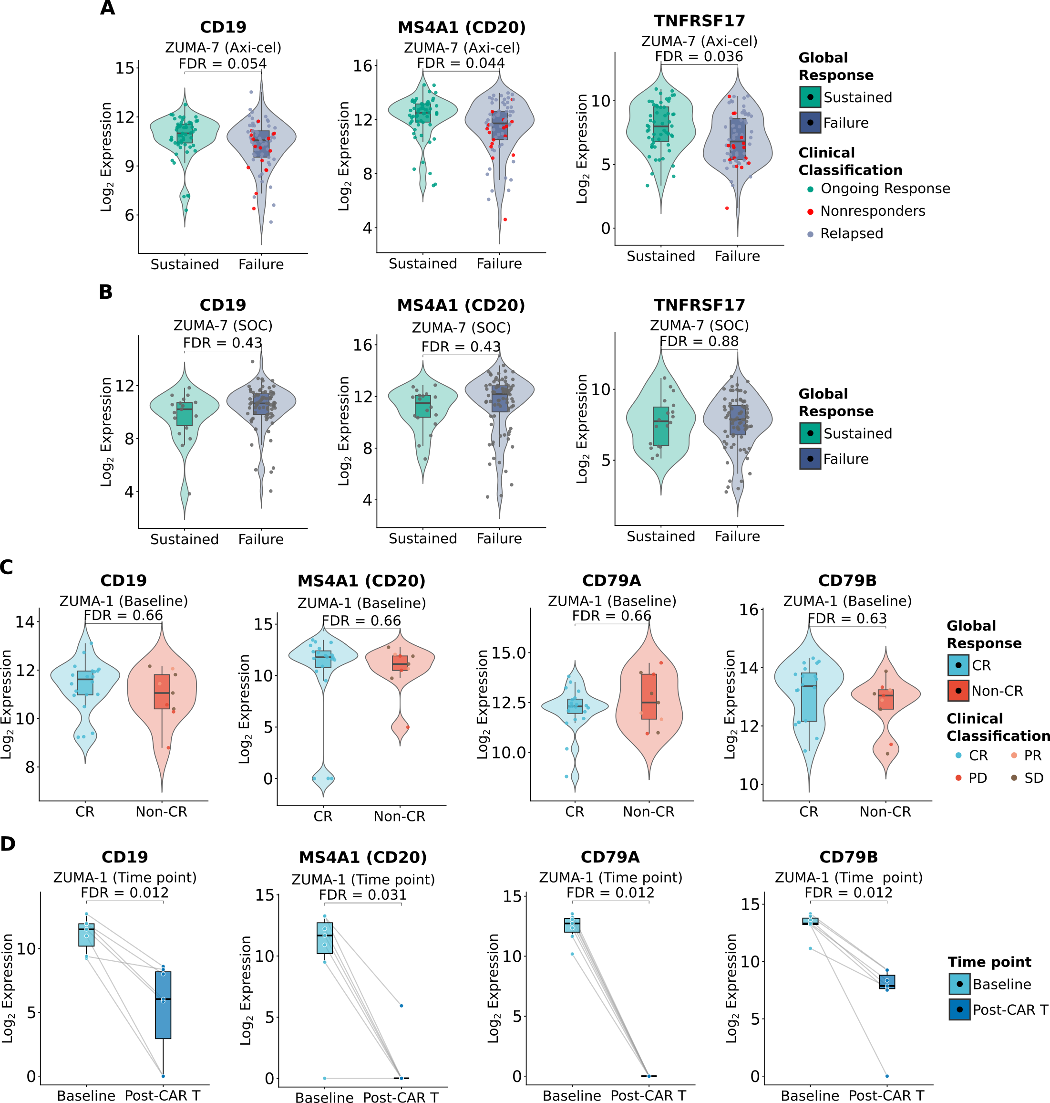
Figure 1. Baseline availability and longitudinal assessment of canonical B-cell lineage markers demonstrate the efficacy of axi-cel. (A) Pre-infusion (baseline) mRNA expression levels (Log2) of canonical B-cell lineage markers (CD19, MS4A1/CD20, and TNFRSF17), corresponding to the panel established in the pivotal ZUMA-7 study [33], assessed in the axi-cel-treated cohort. Patients are stratified by durable clinical outcome (sustained response versus failure). (B) Baseline expression of the same pivotal gene panel from the ZUMA-7 study in the standard-of-care (SOC) control arm. (C) Baseline expression of B-cell-specific markers (CD19, MS4A1, CD79A, CD79B) defined in the pivotal ZUMA-1 study [34], assessed in the ZUMA-1 cohort and stratified by clinical response (CR versus Non-CR). (d) Paired longitudinal analysis comparing target gene expression between baseline (pre-infusion) and post-CAR-T biopsies in patients from the ZUMA-1 study. Comparisons were performed using the Wilcoxon rank-sum test (A-C) and the Wilcoxon signed-rank test (D), with the Benjamini-Hochberg False Discovery Rate (FDR) correction applied specifically to the pivotal gene panels evaluated. Boxplots overlaid on violin plots indicate the median and interquartile range. Overlaid scatter points are color-coded according to granular clinical classifications.
This association was mechanistically specific to cellular therapy; no significant discrepancies in B-cell lineage markers were observed within the standard-of-care (SOC) chemotherapy arm of the ZUMA-7 study (Figure 1b) or at baseline in the ZUMA-1 cohort (Figure 1C). Finally, paired longitudinal analysis in ZUMA-1 confirmed the on-target pharmacodynamic impact of the CAR T-cell therapy, revealing a profound and statistically significant depletion of all B-cell markers following infusion (Figure 1D). This transcriptional eradication was further validated by cellular deconvolution of the tumor microenvironment (Supplementary Figure S1), confirming the clearance of the malignant clone and the anticipated B-cell aplasia. Taken together, these findings demonstrate that baseline B-cell lineage identity may serve as a crucial prerequisite for the optimal engagement and therapeutic success of axi-cel.

3.2 T-Cell Exhaustion and HLA Downregulation Are Not the Primary Determinants of axi-cel Resistance
In classical tumor immunology, immune evasion is frequently orchestrated by the induction of T-cell exhaustion within the microenvironment or by the suppression of the human leukocyte antigen (HLA) presentation machinery. However, our multidimensional transcriptomic mapping revealed that these canonical axes do not primarily dictate therapeutic failure to axi-cel. Expression profiling of T-cell exhaustion signatures (Figure 2) failed to reveal the formation of biological clusters capable of segregating patients with sustained responses from those experiencing therapeutic failure. This lack of phenotypic modulation demonstrated no statistically significant discrepancies in these immune inhibitors based on clinical outcomes (Supplementary Table S1; all FDR > 0.05). This non-discriminatory pattern remained consistent across the baseline cohorts of both the ZUMA-7 and ZUMA-1 studies. Furthermore, the temporal assessment of these signatures (post-CAR T-cell infusion) in the ZUMA-1 cohort did not evidence consistent longitudinal fluctuations that could account for immune escape.

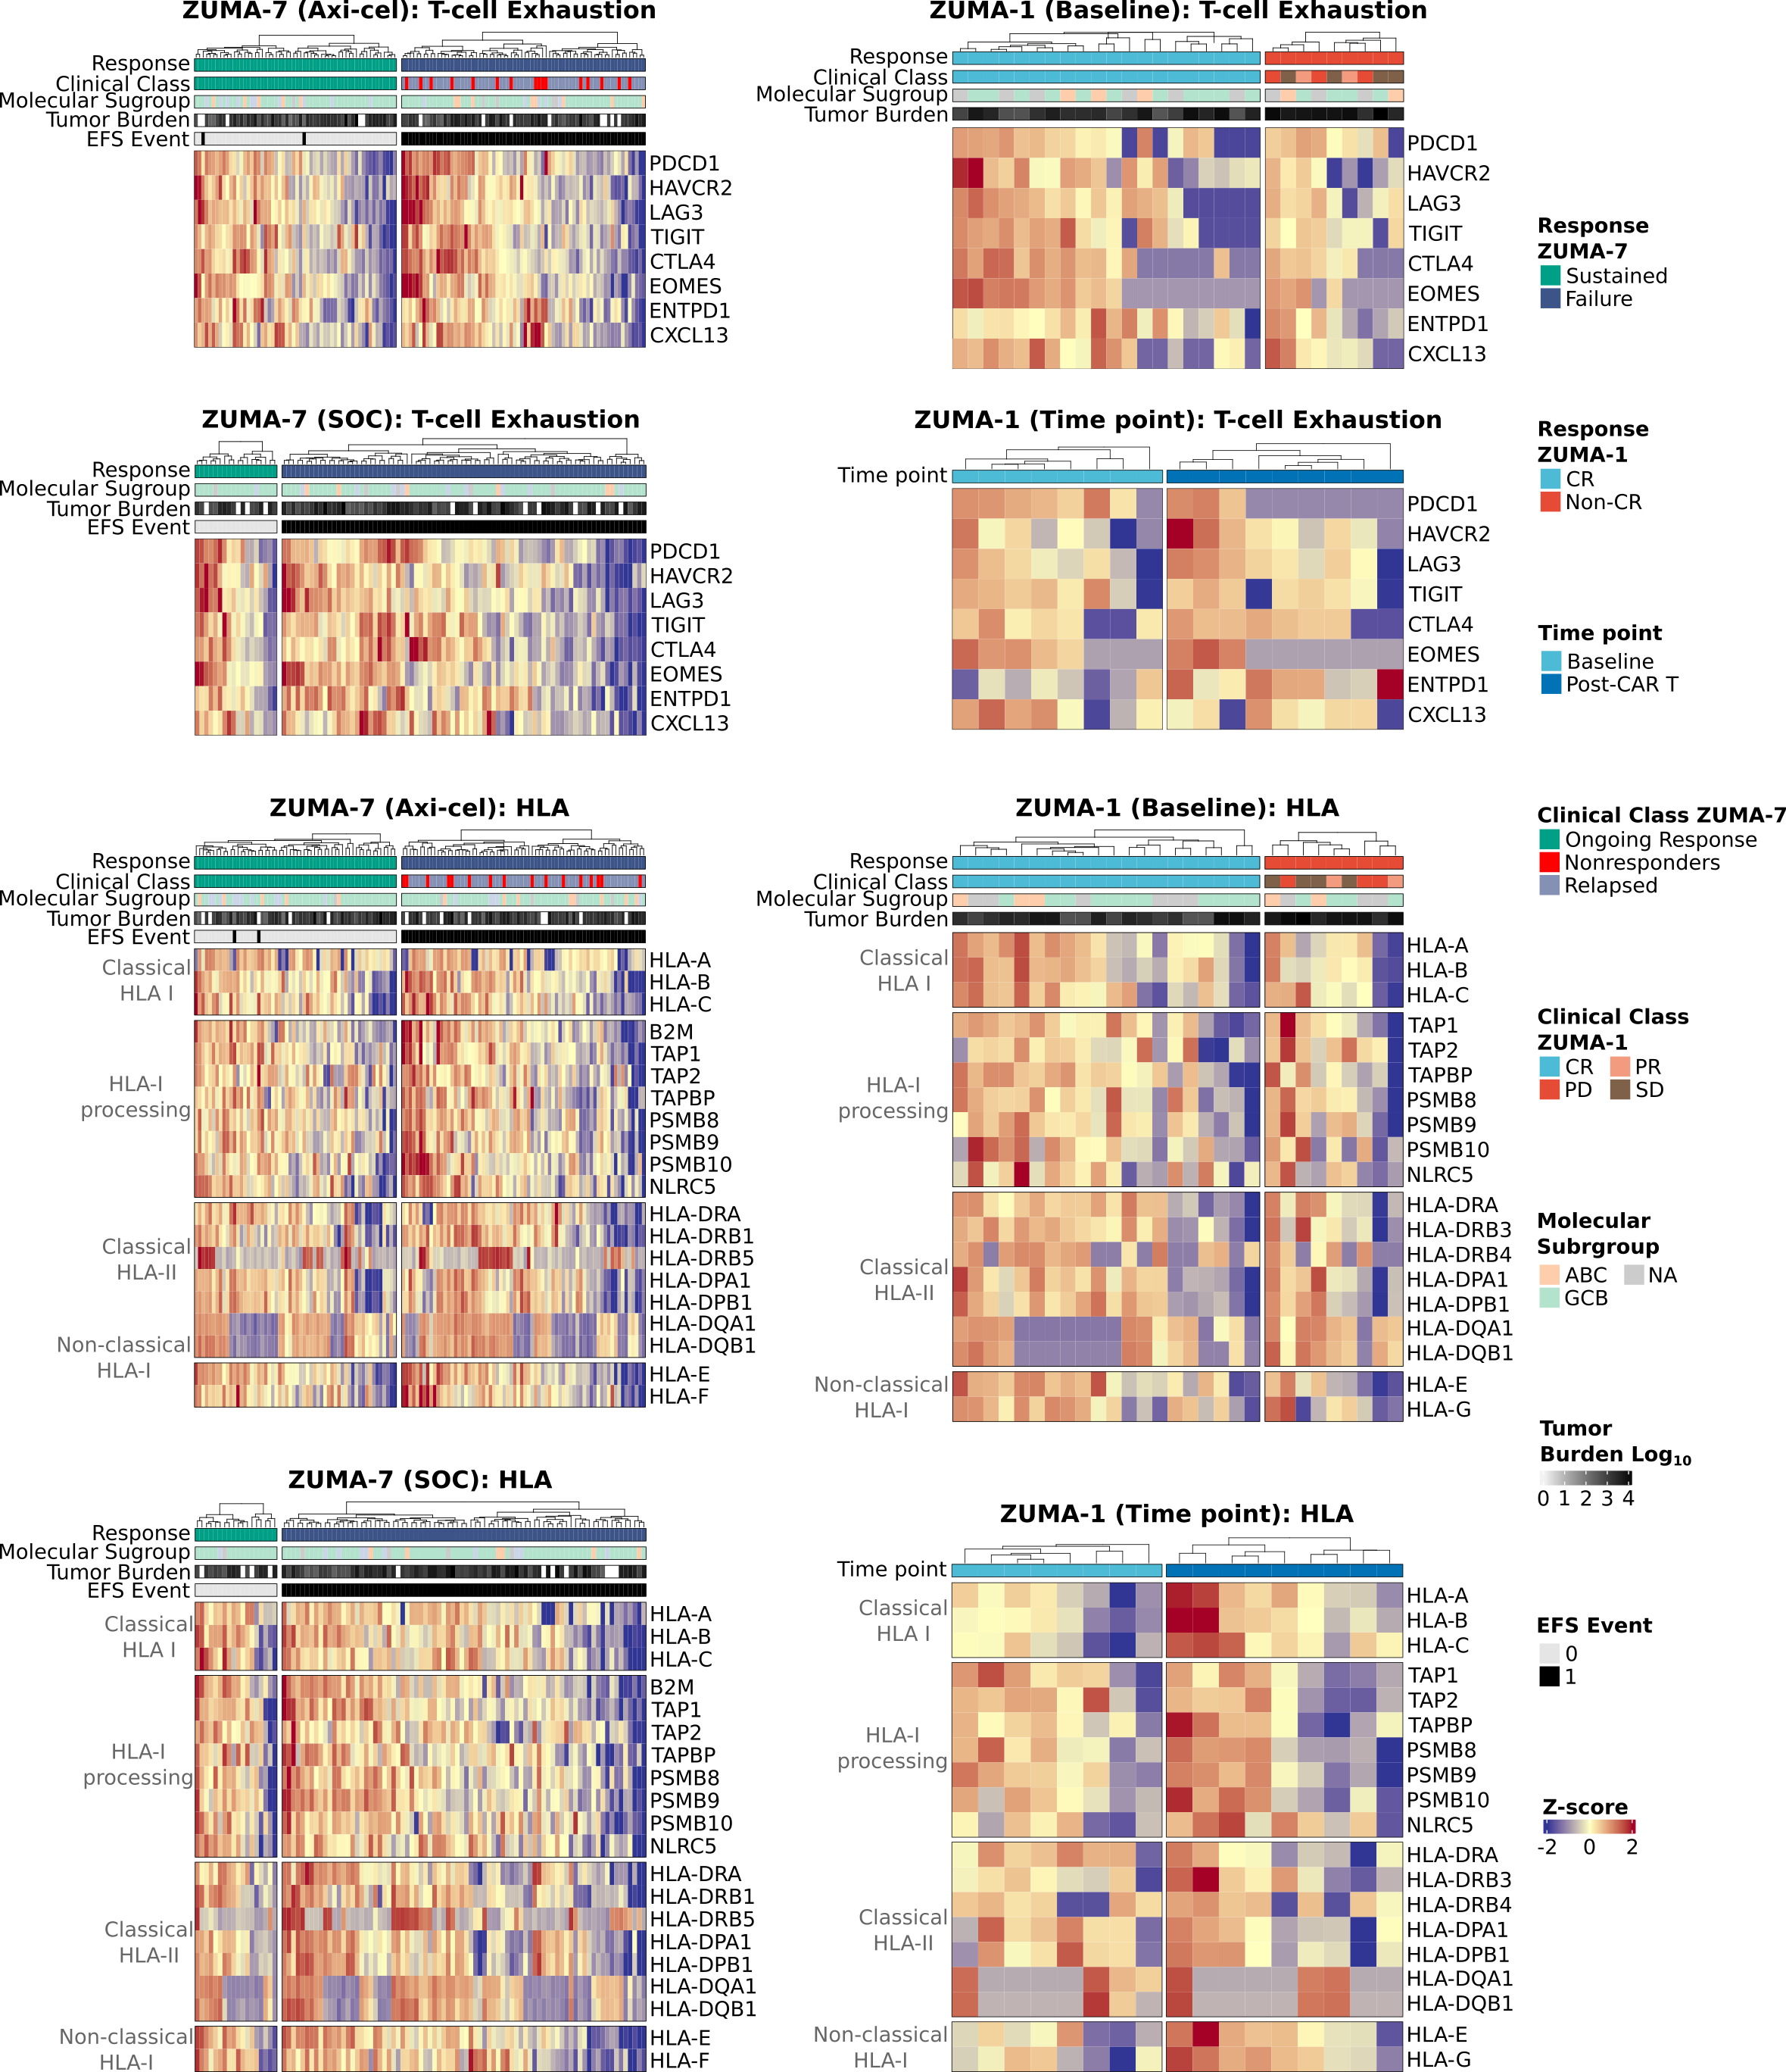

Figure 2. Transcriptional profile of immune evasion mechanisms: T-cell exhaustion in the microenvironment and regulation of the antigen presentation machinery (HLA). Normalized gene expression profiles (Z-score) mapping the immunosuppressive architecture in the ZUMA-7 and ZUMA-1 cohorts. The first four heatmaps show the expression of T-cell exhaustion genes. The baseline profile is stratified by clinical outcome (Sustained Response vs. Failure/CR vs. Non-CR) in the ZUMA-7 axi-cel, ZUMA-7 Standard of Care (SOC), and ZUMA-1 (Baseline) cohorts, whereas the ZUMA-1 (Time point) section presents longitudinal changes in these immunosuppressive markers from the pre-infusion assessment (Baseline) to one week after CAR-T infusion (Post-CAR-T). The other four heatmaps relate to the HLA machinery: an assessment of the functional integrity of antigen presentation, biologically subdivided into four axes: classical Class I molecules, the intracellular processing complex, classical Class II molecules, and non-classical inhibitory Class I molecules. Samples (columns) are hierarchically clustered within each clinical response stratum. Top annotations provide individualized clinical context for each patient: Overall Response, detailed Clinical Classification, Molecular Subgroup/Cell of Origin, Tumor Burden (mapped on a continuous logarithmic grayscale), and occurrence of EFS events. Expression divergence is mapped on a Z-score scale, where intense blue represents underexpression (-2) and dark red represents overexpression (+2) relative to the cohort mean.
Similarly, the functional and structural assessment of the HLA complex integrity demonstrated intra-cohort heterogeneity. Unsupervised hierarchical clustering, even when integrated with strongly weighted clinical covariates such as baseline tumor burden (SPD) and cell of origin (COO), confirmed the absence of an HLA downregulation profile univocally or predominantly associated with CAR-T resistance. This observation was further supported by continuous statistical analysis, which confirmed the lack of significant transcriptional downregulation across the intracellular processing complex, as well as the classical and non-classical presentation molecules (Supplementary Table S1).
Our findings suggest that, due to the synthetic nature of its antigen recognition, anti-CD19 CAR T-cell efficacy operates with remarkable independence from traditional HLA restriction pathways and the degree of pre-existing immune exhaustion, highlighting the critical need to investigate alternative mechanisms of intrinsic tumor resistance.

3.3 Global Transcriptomic Mapping Reveals Divergent Pathways of Resistance to CAR T-Cell Therapy
To decode resistance mechanisms beyond classical immune escape, we conducted a differential gene expression analysis (volcano plots, Figure 3A) integrated with pathway enrichment analysis (GSEA/ssGSEA). The biological architecture of therapeutic failure revealed divergent profiles depending on the treatment line evaluated.

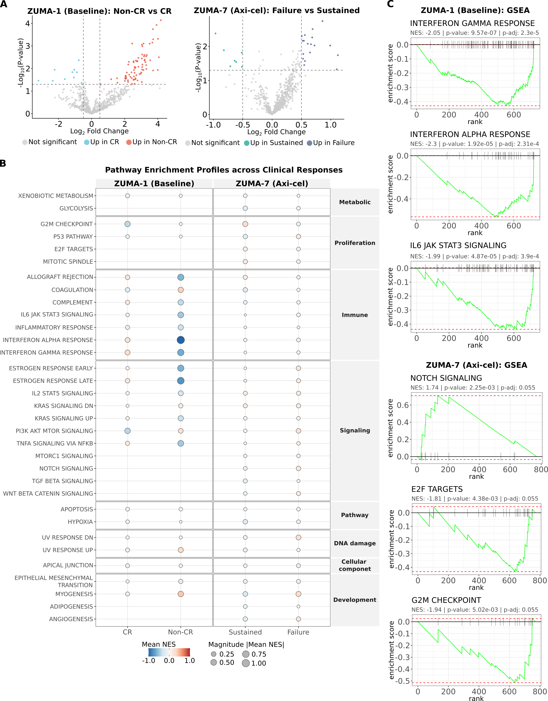
Figure 3. Global gene expression and functional pathways associated with axi-cel treatment failure. (A) Volcano plots showing differential gene expression analysis (DEA) prior to infusion, comparing clinical response groups in the ZUMA-1 (left; Non-CR vs. CR) and ZUMA-7 (right; Failure vs. Sustained) cohorts. Significance is highlighted based on an exploratory threshold of unadjusted p-value < 0.05 and absolute log2 fold change > 0.5 (dashed lines). (B) Pathway enrichment profiles assessed via single-sample GSEA (ssGSEA). MSigDB Hallmark gene sets were grouped into eight functional categories (y-axis). Circle color indicates the Mean Normalized Enrichment Score (Mean NES), reflecting pathway hyperactivation (red) or suppression (blue) in each clinical group. Circle size is proportional to the absolute magnitude of enrichment (Mean NES), representing the intensity of biological activity. (C) Representative enrichment plots from classical GSEA, detailing key pathways driving resistance in each cohort. In the ZUMA-1 cohort, marked suppression of interferon (alpha and gamma) signaling and inflammatory signaling is observed in patients who did not achieve complete remission (Non-CR). In the ZUMA-7 cohort, alterations in intrinsic signaling (Notch) and cell cycle proliferation programs (E2F targets, G2M checkpoint) appear enriched in patients from the Failure group.
In the later-line cohort (ZUMA-1 baseline), the failure to achieve complete remission (Non-CR) may have been driven by an intrinsically "cold" or anergic microenvironment. A marked transcriptional suppression of Interferon signaling pathways (alpha and gamma) and the global inflammatory response was observed (Figures 3B and 3C). Differential gene expression analysis confirmed this phenotype, demonstrating that complete responders (CR) exhibited an upregulation of canonical interferon-stimulated genes (STAT1, MX1, IFI27), whereas the Non-CR group was enriched for alternative chemotactic markers (CCL20) and MAGE/KIR family genes (Supplementary Table S2).
In contrast, within the earlier-line cohort (ZUMA-7 baseline), therapeutic failure was not governed by immune deprivation, but rather by intrinsic tumor dedifferentiation and unrestrained proliferation. The group experiencing treatment failure displayed marked hyperactivation of cell cycle programs (E2F targets, G2/M checkpoint) and embryonic developmental pathways (Notch signaling) (Figures 3b, 3c; Supplementary Table S3). Consistently, differential expression highlighted the upregulation of markers associated with tissue remodeling and cellular adhesion (MET, EPCAM, NCAM1) in patients who failed therapy, as opposed to the preservation of mature B-cell lineage markers (CD19, MS4A1) in the sustained response group (Supplementary Table S2). Global analysis of TME modules (IO360 platform) confirmed that absolute stromal and myeloid cell populations did not differ significantly between clinical outcomes following FDR adjustment (Supplementary Table S4), reiterating the central role of intrinsic tumor aggressiveness in early-line escape.
Finally, to map the dynamics of acquired resistance, we evaluated paired longitudinal biopsies from the ZUMA-1 study (Supplementary Figure S2a). Alongside the anticipated clearance of B-cell antigens, the residual post-infusion microenvironment was dominated by the induction of tissue damage repair pathways, including IL-6/JAK/STAT3 signaling, the Complement cascade, Coagulation, and EMT-like programs (Supplementary Figure S2b). This profile reflects the local inflammatory "storm" induced by CAR T-cell cytotoxicity, which appears to foster a wound-healing and tissue remodeling niche conducive to eventual tumor escape.

3.4 Independent Prognostic Impact and Microenvironment Dynamics of Resistance Signatures
To establish the translational clinical utility of the previously identified transcriptomic differences, we evaluated their direct impact on EFS. Kaplan-Meier survival estimates confirmed that dichotomization of the expression of these transcripts successfully stratified patient clinical outcomes (Figure 4a).

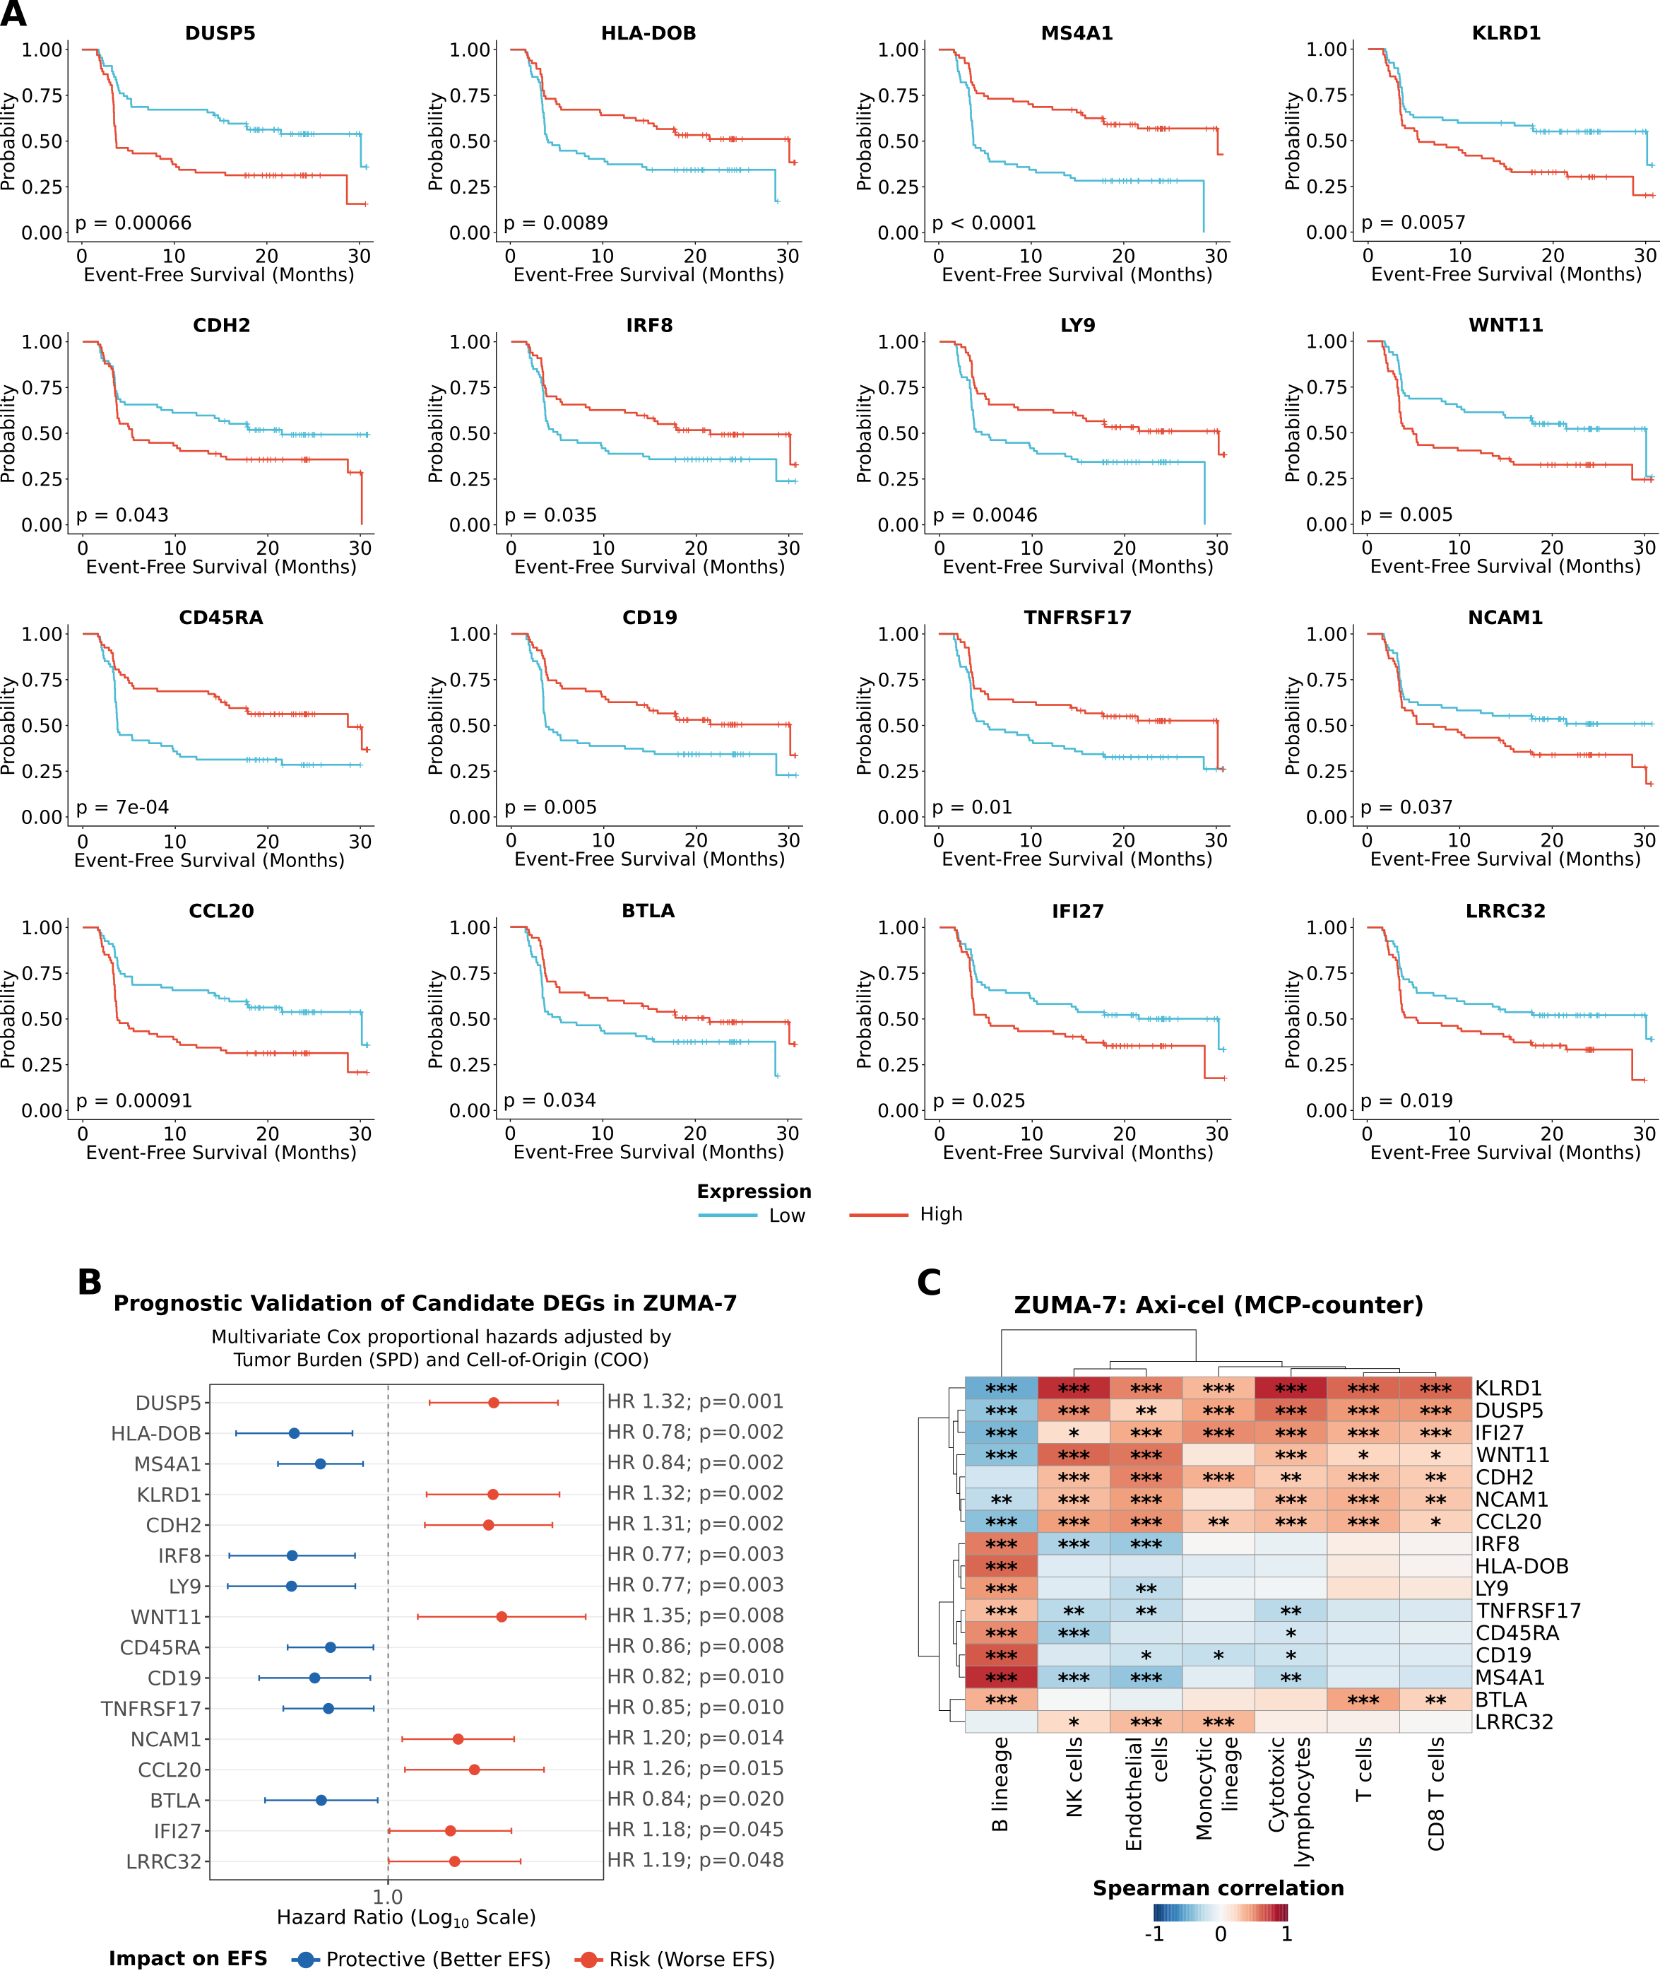

Figure 4. Prognostic assessment and microenvironment independence of transcriptional signatures in the ZUMA-7 cohort. (A) Kaplan-Meier estimates for EFS, stratifying patients according to the expression (High in red vs. Low in blue) of potential biomarkers. Statistical significance was assessed using the log-rank test. (B) Multivariate Cox proportional hazards analysis validating the independent prognostic impact of target genes on EFS, following clinical adjustment for baseline tumor burden (SPD) and lymphoma subtype (Cell of Origin, COO). Hazard Ratios greater than 1 (red) indicate genes associated with a worse clinical outcome, whereas values less than 1 (blue) denote a protective biological effect. (C) Spearman correlation matrix mapping interactions within the tumor ecosystem between candidate gene expression and the absolute abundance of immune and stromal populations, estimated using the MCP-counter algorithm. Statistical significance (p < 0.05; ** p < 0.01; *** p < 0.001) represents the strength of the association between potential marker genes and the estimated cell types.
Specifically, the preservation of B-cell lineage identity and antigen presentation machinery (CD19, MS4A1, TNFRSF17, HLA-DOB), along with mature lymphoid markers (IRF8, BTLA, LY9), emerged as powerful independent protective factors (HR ranging from 0.77 to 0.86; all p < 0.05), dictating prolonged clinical benefit with axi-cel. In contrast, transcripts associated with alternative chemotaxis (CCL20; HR = 1.26), dysregulated signaling (DUSP5, WNT11), and markers of tissue remodeling and cellular adhesion (CDH2, NCAM1, LRRC32) were validated as intrinsic and independent risk factors (HR > 1; p < 0.05), driving early therapeutic failure regardless of tumor volume and lymphoma subtype.
Finally, to decode the cellular origin and crosstalk of these prognostic signatures within the tumor ecosystem, we conducted a Spearman correlation analysis pairing gene expression with the absolute abundance of immune and stromal populations (estimated using the MCP-counter algorithm) (Figure 4C). This topological mapping elucidated which genes were primarily derived from the intrinsic malignant clone versus those mediated by the recruitment of adjacent stromal or myeloid compartments, consolidating the cellular architecture of CAR-T resistance.
To substantiate the premise that resistance is primarily driven by intrinsic tumor biology and its functional programs (rather than the physical exclusion of immune cells), we evaluated the global microenvironmental composition. Cellular deconvolution (MCP-counter) demonstrated that the absolute abundance of baseline infiltrating immune and stromal populations was unable to stratify clinical response to axi-cel in both the ZUMA-7 and ZUMA-1 cohorts (Supplementary Figure S3; all adjusted p-values non-significant). This lack of segregation by bulk population estimates reinforces the finding that it is the functional state - specifically the transcriptional phenotype of aggressive adhesion and tissue remodeling - rather than the quantitative count of infiltrating cells, that dictates therapeutic success or failure.

3.5 Orthogonal Validation Confirms the Predictive Specificity of the Signature for CAR T-Cell Therapy
To conclusively determine whether the identified biomarkers represent evasion mechanisms specific to cellular immunotherapy (predictive value) or merely reflect the intrinsic, generic aggressiveness of DLBCL (general prognostic value), we conducted a cross-orthogonal validation. The survival impact of each of the 16 candidate transcripts was contrasted in parallel across three distinct clinical scenarios: the experimental arm (ZUMA-7 axi-cel; cellular therapy), the active control arm (ZUMA-7 SOC; salvage chemotherapy), and an independent first-line cohort (TCGA-DLBC; R-CHOP) (Figure 5).

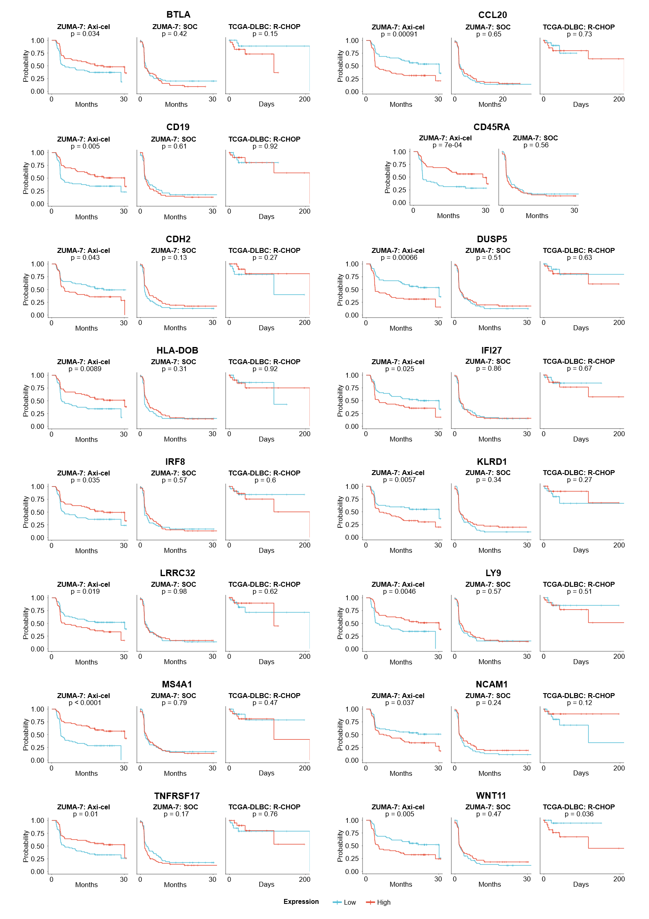
Figure 5. Clinical orthogonal validation of the genomic signature as a specific predictive biomarker for CAR T-cell therapy. Kaplan-Meier survival curves for the 16 identified candidate genes, evaluating the impact of their baseline expression across three distinct clinical scenarios of DLBCL. For each gene, the panels display, from left to right: (1) ZUMA-7 axi-cel: EFS in patients treated with anti-CD19 CAR T-cell therapy; (2) ZUMA-7 SOC: EFS in the randomized control arm treated with standard-of-care (SOC) salvage chemotherapy; and (3) TCGA-DLBC: Overall Survival in first-line patients treated with R-CHOP. Patients were strictly stratified into high-expression (High, red line) and low-expression (Low, blue line) groups based on the intra-cohort median expression threshold for each transcript. Follow-up time (x-axis) is presented in months for the ZUMA-7 study and in days for the TCGA cohort. Statistical significance was determined using the log-rank test. The retention of statistical significance (p < 0.05) exclusively in the axi-cel arm - while absent in the SOC and TCGA-DLBC arms for most targets - validates the signature's predictive nature regarding resistance mechanisms specific to cellular immunotherapy. The WNT11 gene serves as a notable exception, demonstrating pan-prognostic value indicating intrinsic tumor aggressiveness independent of the therapeutic modality.
Kaplan-Meier survival analyses revealed that 15 of the 16 genes in the panel retained statistical significance for survival stratification strictly confined to the axi-cel arm. This lack of impact under the pressure of conventional treatments indicates that these transcriptomic perturbations may orchestrate a genuine evasion program highly specific to anti-CD19 CAR T-cell biology. The sole exception within this panel was the WNT11 gene. The overexpression of this transcript was associated with consistently inferior clinical outcomes in TCGA-DLBC. This finding suggests that WNT11 may act as a pan-prognostic marker of failure, reflecting a state of cellular dedifferentiation and baseline lymphoma aggressiveness that confers cross-resistance to both chemotherapy and cellular immunotherapy.

3.6 Integration of the Current Findings with the Published ZUMA-1 and ZUMA-7 Analyses
To contextualize the findings of the present study, we compared the 16 candidate biomarkers identified in our analyses with the transcriptomic results originally reported for the ZUMA-1 [34] and ZUMA-7 [33] cohorts. Because the present analyses partly reuse these datasets, this comparison was intended to assess concordance with the published biological patterns and identify additional gene-level associations, rather than to provide independent validation. Cohort specifications and technical differences: ZUMA-1 evaluated heavily pre-treated (3rd-line) r/r DLBCL using a 724-gene panel (GSE197977), whereas ZUMA-7 involved 2nd-line r/r DLBCL analyzed via the expanded IO360 platform, which comprises 817 transcripts and signatures (GSE248835). These biological differences in treatment lines, combined with technical variations between the gene platforms, likely account for the distinct transcriptomic profiles observed between the cohorts. The results are summarized in Table 1.
Table 1. Comparison of the 16 candidate baseline transcriptomic biomarkers identified in the present study with findings originally reported for the ZUMA-1 and ZUMA-7 trials.
Biological domain | Marker | Title 3
B-cell lineage / target preservation | CD19 | Directly concordant with ZUMA-7 baseline findings; ZUMA-1 provides post-treatment pharmacodynamic support.
 | MS4A1 (CD20) | Directly concordant with ZUMA-7 baseline findings; ZUMA-1 provides post-treatment B-cell-depletion support.
 | TNFRSF17 (BCMA) | Directly concordant with ZUMA-7 baseline findings; ZUMA-1 provides qualitative post-treatment support.
B-cell lineage / differentiation | LY9 (CD229) | Newly identified gene-level baseline association in the present reanalysis.
 | IRF8 | Newly identified gene-level baseline association (present in ZUMA-1 profiling but not individually highlighted as a predictive marker).
Antigen Presentation / immune competence | HLA-DOB | Newly identified gene-level baseline association.
Adverse microenvironment / Resistance | CCL20 | Newly identified gene-level baseline association with qualitative ZUMA-1 support (not direct replication).
 | LRRC32 | Newly identified gene-level baseline association.
Adhesion /EMT-like remodeling / Intrinsic Resistance | *NCAM1 (CD56) | Newly identified gene-level baseline association; possible contextual relationship to the ZUMA-7 NK CD56dim signature, but not direct concordance.
Immune regulation | BTLA | Newly identified baseline association; ZUMA-1 post-treatment change reflects pharmacodynamics rather than predictive replication.
Cytotoxic-cell-associated marker | *KLRD1 (CD94) | Newly identified baseline association; ZUMA-1 post-treatment findings are not equivalent.
Interferon-responsive state | *IFI27 | Newly identified baseline prognostic association; ZUMA-1 provides only post-treatment interferon-response context.
Immune phenotype | CD45RA | Cohort-specific baseline TME association. Note: Represents a different biological compartment from ZUMA-7, which evaluated CD45RA specifically within the infused CAR-T cell product.
Intrinsic Resistance | *DUSP5 | Newly identified gene-level baseline association.
Adhesion / EMT-like remodeling / Intrinsic Resistance | *CDH2 | Newly identified gene-level baseline associa-tion.
Intrinsic Resistance | WNT11 | Newly identified gene-level baseline association; also potentially pan-prognostic based on independent TCGA cross-cohort analysis.
Notes. Because the present analyses reuse data from ZUMA-1 and ZUMA-7, this comparison does not constitute independent validation. Instead, it distinguishes direct concordance with previously published gene-level findings from contextual support involving composite signatures, different biological compartments, or post-treatment changes, and highlights newly identified associations from the present reanalysis. ZUMA-1 findings referenced here include post-infusion analyses; such post-treatment changes represent pharmacodynamic observations and do not necessarily establish baseline predictive value. Some ZUMA-7 associations were originally reported as gene clusters or cellular signatures rather than as individual gene-level effects.
*Candidate gene-level associations not specifically evaluated or highlighted in the original publications.
Abbreviations: CAR-T: Chimeric Antigen Receptor T-cell; EMT-like: Epithelial-Mesenchymal Transition-like; NK: Natural Killer; TCGA: The Cancer Genome Atlas; TME: Tumor Microenvironment.

Concordance was more variable for immune and microenvironmental markers. CCL20 showed the most consistent adverse association across analyses. In contrast, HLA-DOB displayed different baseline patterns between cohorts, while the findings for BTLA, KLRD1, IFI27, NCAM1, and CD45RA were indirect, time-point dependent, or derived from different biological compartments. These markers should therefore be classified as partially concordant or inconclusive rather than confirmed (Table 1).
DUSP5, CDH2, and LRRC32 were not individually emphasized in the original reports, whereas WNT11 was previously represented within broader transcriptional analyses. Their associations with event-free survival in the current multivariable models extend the original cohort-level observations by identifying candidate gene-level correlates of unfavorable outcome. Collectively, these findings support the hypothesis that cellular plasticity, adhesion, and EMT-like tissue-remodeling programs contribute to axi-cel resistance. Independent cohorts and functional studies are required to determine whether these genes are reproducible predictive biomarkers or causal mediators of therapeutic failure.

3.7 Integrated Model of Transcriptional States Associated with CAR T-Cell Response
To integrate the transcriptomic and clinical associations identified in this study, we developed a conceptual model summarizing the biological states associated with response or resistance to axi-cel (Figure 6).

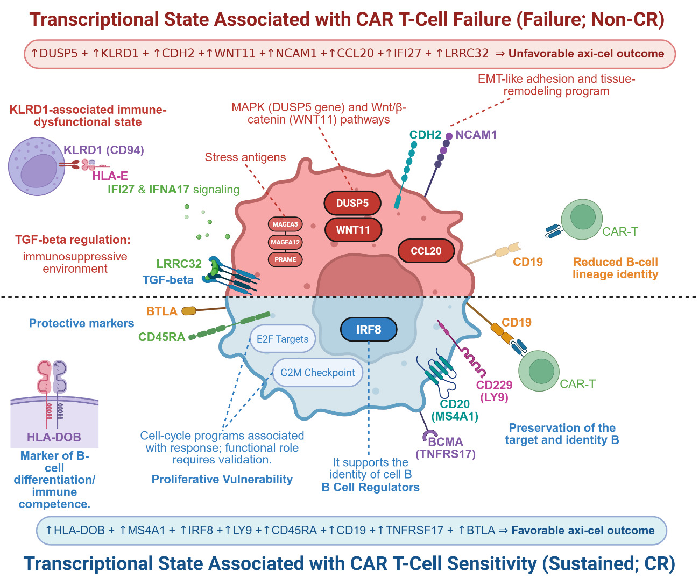
Figure 1. Integrated model of transcriptional states associated with sensitivity and resistance to anti-CD19 CAR T-cell therapy. This model summarizes the tumor-intrinsic and microenvironmental features identified through cross-cohort analyses of the ZUMA-1 and ZUMA-7 datasets. The upper panel (red; therapeutic failure/resistance) depicts an adverse transcriptional state characterized by reduced B-cell lineage identity and increased expression of markers associated with cellular plasticity, aberrant adhesion, tissue remodeling, alternative chemotactic signaling, and immune dysfunction. The lower panel (blue; therapeutic sensitivity) depicts a favorable state associated with preservation of B-cell lineage identity and expression of protective markers linked to lymphoid differentiation and immune competence. Arrows represent proposed biological relationships derived from transcriptomic associations and should not be interpreted as demonstrating direct causal mechanisms. CR, complete response; EMT-like, epithelial–mesenchymal transition-like program. Notes: Conceptual model based on transcriptomic associations; arrows indicate proposed, not experimentally demonstrated, relationships.
Within the therapeutic-failure axis (Figure 6, top panel), reduced B-cell lineage identity occurs alongside adverse transcriptional features involving DUSP5, WNT11, CCL20, CDH2, NCAM1, LRRC32, KLRD1, and IFI27. Collectively, these findings support a candidate resistance state involving tumor-cell plasticity, altered cell–cell and cell–matrix interactions, EMT-like tissue remodeling, alternative chemotactic signaling, and immune dysfunction. These processes may impair tumor susceptibility to CAR T-cell-mediated cytotoxicity, even when CD19 expression remains detectable.
Conversely, the therapeutic-sensitivity axis (Figure 6, lower panel), is characterized by preservation of the mature B-cell program, including CD19, MS4A1, TNFRSF17, and IRF8, together with favorable associations involving LY9, BTLA, CD45RA, and HLA-DOB. Because CAR recognition is HLA-independent, HLA-DOB should be interpreted primarily as a marker of preserved B-cell differentiation or broader immune competence rather than as evidence that conventional antigen presentation is required for axi-cel activity.
Overall, the model shifts the emphasis from isolated CD19 expression and baseline immune exhaustion toward a broader balance between preservation of B-cell lineage identity and acquisition of immune-dysfunctional, plastic, and tissue-remodeling transcriptional states. This framework is hypothesis-generating and highlights candidate pathways for functional and prospective validation.

4. Discussion
This integrative analysis identifies baseline tumor cell state, rather than CD19 expression considered in isolation, as a central correlate of response to axi-cel in DLBCL. Although loss of CD19 is a recognized mechanism of relapse, it accounts for only a subset of treatment failures, and progression frequently occurs in tumors that retain detectable target expression [5,6].
In the ZUMA-7 axi-cel cohort, sustained responders showed a consistent pattern of higher expression across multiple B-cell lineage markers, including CD19, MS4A1, and TNFRSF17. Together with the protective associations of CD19, MS4A1, IRF8, LY9, and TNFRSF17 with event-free survival, these findings suggest that preservation of a broader mature B-cell transcriptional program may facilitate effective CAR T-cell recognition and cytotoxicity. Conversely, reduced lineage integrity may mark a more plastic tumor state that is less susceptible to immune clearance [35–37]. Because not all baseline comparisons reached statistical significance and a similar association was not observed in the ZUMA-1 baseline analysis, B-cell lineage integrity should be regarded as a candidate determinant of sensitivity rather than an established prerequisite for axi-cel efficacy.
Our findings also refine the roles of canonical immune-evasion pathways in CAR T-cell therapy. Baseline transcriptional signatures of T-cell exhaustion and global HLA downregulation did not consistently distinguish responders from non-responders in either ZUMA-1 or ZUMA-7. This result does not imply that immune checkpoints are biologically irrelevant. PD-1/PD-L1 and related pathways may act dynamically after infusion, directly affect the phenotype and persistence of the infused CAR T cells, or be inadequately represented by bulk pretreatment tumor RNA [7–9,38,39]. Similarly, the absence of a global association between HLA machinery and response is biologically compatible with the HLA-independent recognition conferred by the CAR construct [40]. The protective association observed for HLA-DOB should therefore not be interpreted as evidence that conventional antigen presentation is required for axi-cel activity; it may instead reflect preserved B-cell differentiation or a broader immunologically competent tumor state.
The comparison between cohorts further suggests that the biological context of resistance may differ according to treatment setting and prior therapeutic exposure. In the later-line ZUMA-1 cohort, lack of complete response was associated with significant suppression of IFN-alpha, IFN-gamma, and IL-6/JAK/STAT3 programs. This pattern is consistent with an immune-silenced baseline state in which deficient inflammatory signaling may reduce tumor susceptibility to CAR T-cell-mediated killing [41]. This interpretation complements, rather than contradicts, evidence that prolonged IFN signaling can promote adaptive resistance: the timing and duration of pathway activation are likely to determine whether IFN signaling enhances antitumor immunity or contributes to dysfunction [12], The concomitant association of CCL20 with adverse outcome raises the possibility that alternative chemokine programs contribute to an immune-excluding or dysfunctional niche [14,42], although its cellular source and functional role cannot be resolved from bulk transcriptomic data.
In the earlier-line ZUMA-7 cohort, treatment failure was associated with a different transcriptional pattern, characterized by loss of mature B-cell features and enrichment of developmental, adhesion, and tissue-remodeling programs. Notch, E2F-target, and G2/M-checkpoint pathways showed suggestive enrichment, although their false-discovery rates (FDR) marginally exceeded the stringent 0.05 threshold, rendering these specific findings exploratory. The adverse associations of CDH2, NCAM1, LRRC32, DUSP5, CCL20, and WNT11 with event-free survival support a model in which phenotypic plasticity and altered cell-cell or cell-matrix interactions may reduce tumor accessibility or susceptibility to CAR T-cell cytotoxicity [15–17]. Because lymphoma cells lack a baseline epithelial phenotype (e.g., E-cadherin expression and cellular polarity), they cannot undergo a "true" physical Epithelial-to-Mesenchymal Transition, but rather adopt an EMT-like phenotypic plasticity [43]. Notably, WNT11 was the only candidate that also stratified outcome in the independent first-line cohort, suggesting that it may reflect general lymphoma aggressiveness rather than a mechanism restricted to cellular immunotherapy. Recent evidence has linked WNT11 upregulation to specific genetic subsets, such as CD79B-mutated DLBCL, and to the activation of hypoxia-related signaling pathways [44]. Hypoxia is a well-established driver of EMT-like phenotypic plasticity and immune exclusion in the tumor microenvironment. In our cohorts, the adverse prognostic value of WNT11 was maintained across broad clinical settings, suggesting that its overexpression potentially driven by hypoxic adaptation acts as a general mechanism of tissue remodeling and immune evasion, rather than an artifact restricted to a single genetic subtype.
Conversely, IRF8, LY9, BTLA, HLA-DOB, and canonical B-cell markers defined a transcriptional state associated with more favorable outcomes after axi-cel. IRF8 provides a biologically plausible link between maintenance of B-cell identity and immune competence because it regulates lymphoid differentiation and interferon-responsive programs [18,45]. The favorable association of BTLA, despite its conventional classification as an inhibitory receptor, illustrates the limitations of assigning function from a single marker in bulk tissue. BTLA expression may identify a differentiated lymphoid compartment or a less terminally differentiated, memory-like immune state with greater proliferative capacity and persistence [46,47], More broadly, these results suggest that response depends less on the estimated quantity of immune or stromal cells than on the functional state of the malignant and immune compartments. However, the absence of significant differences by MCP-counter or IO360 deconvolution does not exclude contributions from rare populations, spatial organization, or cell-cell interactions that are not captured by bulk estimates.
The cross-cohort analyses strengthen the clinical relevance of the 16-gene panel by showing that most associations observed in the ZUMA-7 axi-cel arm were not reproduced in the ZUMA-7 standard-of-care arm or in TCGA-DLBC. This pattern supports treatment-context specificity and prioritizes the panel for further evaluation as a candidate predictive biomarker. Nevertheless, statistical significance in one treatment group and non-significance in another does not, by itself, demonstrate a differential treatment effect. Formal biomarker-by-treatment interaction testing within the randomized ZUMA-7 population, followed by validation in an independent axi-cel-treated cohort, is needed before predictive specificity can be claimed. The survival analyses should also be interpreted in light of median-based dichotomization, evaluation of multiple candidate genes, and potential model overfitting relative to cohort size.
Several additional limitations warrant consideration. The study is a retrospective secondary analysis of trial datasets with differences in treatment line, prior exposure, sampling schedule, clinical end points, and response definitions, limiting direct biological comparisons between ZUMA-1 and ZUMA-7. The targeted transcriptomic platform restricts discovery to a predefined gene set, while bulk RNA measurements cannot assign transcripts to specific cell types or resolve intratumoral heterogeneity and spatial immune exclusion. Some differential-expression findings were based on exploratory unadjusted thresholds, and several pathway signals did not remain significant after correction for multiple testing. Moreover, transcript abundance does not establish protein expression or functional activity. Prospective validation, formal interaction analyses, and mechanistic experiments are therefore required. Single-cell and spatial transcriptomics, coupled with functional perturbation of candidate pathways such as CCL20-CCR6, WNT signaling, and adhesion/remodeling programs, could clarify whether these signatures are causal mediators of resistance and identify rational combination strategies. Overall, the results support a model in which axi-cel outcome reflects the balance between preserved B-cell lineage identity and the acquisition of immune-silent or plastic tissue-remodeling states, while providing a focused set of hypotheses for biological and clinical validation.

5. Conclusions
Collectively, this study provides a valuable addition to understanding the mechanisms of resistance to anti-CD19 CAR T-cell therapy (axi-cel) in DLBCL. Our findings indicate that therapeutic failure is not primarily dictated by the isolated loss of the CD19 antigen or pre-existing immune exhaustion within the tumor microenvironment. Instead, sensitivity to axi-cel relies on the overall preservation of B-cell lineage phenotypic integrity (CD19, MS4A1, TNFRSF17) and the functional competence of immune signaling (IRF8, HLA-DOB, BTLA). Conversely, early therapeutic escape is driven by intrinsic biological determinants of the malignant clone, including the loss of lymphoid differentiation, the activation of tissue remodeling and epithelial-mesenchymal transition-like programs (EMT-like; mediated by CDH2 and NCAM1), immune-excluding chemotaxis (CCL20), and a baseline hyperaggressive state (WNT11).
Orthogonal validation confirmed that this transcriptomic signature possesses strict predictive specificity for cellular immunotherapy, distinguishing it from agnostic resistance markers to conventional chemotherapy. From a translational perspective, characterizing these evasion axes helps to better understand the heterogeneity of CAR T-cell response, establishing a rational foundation for pre-treatment risk stratification and providing promising biological targets for the development of combination strategies as well as the design of next-generation CAR T-cells engineered to overcome the refractory tumor microenvironment.
Supplementary Materials: The following supporting information can be downloaded at https://www.mdpi.com/article/doi/s1, Figure S1: B-cell lineage abundance determined by deconvolution. (A) B-cell lineage abundance at baseline (pre-infusion) in the axi-cel-treated cohort from the ZUMA-7 study, computationally estimated using the MCP-counter (Microenvironment Cell Populations-counter) algorithm. (B) B-cell lineage abundance in the standard-of-care (SOC) control arm of the ZUMA-7 study. (C) Baseline B-cell lineage abundance in the ZUMA-1 study cohort, comprising previously treated patients, stratified by clinical response (CR vs. Non-CR). (D) Paired longitudinal analysis comparing B-cell lineage abundance between pre-infusion (baseline) and post-CAR-T treatment biopsies in patients from the ZUMA-1 study. Cell abundance scores are presented on a Log2 scale. Statistical differences were assessed using the Wilcoxon rank-sum test (A-C) and the Wilcoxon signed-rank test for paired samples (D), with Benjamini-Hochberg correction for False Discovery Rate (FDR). Boxplots overlaid on violin plots indicate the median and interquartile range. Overlaid scatter points represent individual patients, color-coded according to granular clinical classifications. Table S1: Statistical summary of the transcriptional profile for T-cell exhaustion and the antigen presentation (HLA) machinery. Statistical comparisons of the expression levels of key T-cell exhaustion markers and HLA machinery genes across the evaluated clinical cohorts. Details include the context of the empirical analysis (Cohort), the biological category and specific transcriptional target (Gene group and feature), as well as the clinical or temporal strata compared (group_1 and group_2). Comparisons assess durable clinical response (Sustained vs. Failure in ZUMA-7; CR vs. Non-CR in ZUMA-1) or longitudinal intra-patient evolution (Baseline vs. Post-CAR T). Nominal p-values (p_value) were derived using non-parametric statistical testing (the Wilcoxon rank-sum/Mann-Whitney U test for independent groups, or the Wilcoxon signed-rank test for paired longitudinal samples). To ensure statistical rigor and preserve biological power, adjusted p-values (padj_BH and label_padj) reflect the False Discovery Rate (FDR) correction via the Benjamini-Hochberg method, applied strictly and independently within each mechanistic panel (T-cell exhaustion and HLA). Table S2: Differential gene expression (DEG) analysis associated with clinical outcomes and longitudinal cellular evolution in the ZUMA-1 and ZUMA-7 cohorts. For each assessed transcript, the magnitude of biological change is reported as the Log2 Fold Change (logFC), alongside its mean expression across all contrast samples (AveExpr). Statistical inferences for each group comparison (contrast and comparison) are derived from empirical Bayes moderated t-statistics (t) and the log-odds of differential expression (B). Statistical significance is denoted by the nominal p-value (P.Value) and the adjusted p-value (adj.P.Val) rigorously corrected for multiple comparisons using the Benjamini-Hochberg False Discovery Rate (FDR) control method. The definitive biological direction of transcriptional enrichment for each gene is explicitly summarized (direction_RawP). Table S3: Gene Set Enrichment Analysis (GSEA) of Hallmark biological pathways across the ZUMA-1 and ZUMA-7 cohorts. Systemic assessment of functional pathways was performed using the Hallmark collection from the Molecular Signatures Database (MSigDB), mapping globally dysregulated transcriptional programs according to baseline clinical outcomes (ZUMA-1 and ZUMA-7) and longitudinal intra-patient treatment dynamics (ZUMA-1 Time Point). For each evaluated biological pathway, the absolute Enrichment Score (ES) and the Normalized Enrichment Score (NES) are presented, reflecting the magnitude and direction of the transcriptional shift for a given clinical phenotype. The statistical significance of the directional enrichment is quantified by the empirical nominal p-value (pval), accompanied by the computational log error estimate (log2err) and the adjusted p-value (padj) via False Discovery Rate (FDR) control using the Benjamini-Hochberg method. The comprehensiveness of each active gene network is indicated by the number of detected transcripts (size), stratified by the corresponding source cohort (Cohort). Table S4: Differential expression analysis of global spatial tumor microenvironment signatures (IO 360 platform) in the ZUMA-7 cohort. The analyzed variables (Feature) correspond to robust algorithmic scores derived from the NanoString Tumor Signaling 360 platform (identified by the .IO360 suffix). These scores encompass broad macro-environmental biological modules, including myeloid inflammation, cell proliferation, hypoxia signaling, and global quantification of immune populations. The table details the magnitude of the enrichment difference (Log2 Fold Change, logFC), the cohort mean expression (AveExpr), the empirical moderated t-statistic (t), and the differential log-odds (B). Significance was evaluated via the nominal p-value (P.Value) and subsequently corrected for multiple testing scenarios using the Benjamini-Hochberg FDR method (adj.P.Val). Figure S2: Longitudinal transcriptomic evolution and mechanisms of acquired resistance following axi-cel therapy in the ZUMA-1 study. (A) Volcano plot illustrating the paired analysis of differential gene expression between post-CAR T and baseline samples. Significance is highlighted based on an unadjusted p-value < 0.05 and an absolute log2 fold change > 0.5 (dashed lines). Genes with increased expression following CAR T infusion are represented in red, while those with reduced expression are shown in blue. (B) Standard Gene Set Enrichment Analysis (GSEA) plots for key MSigDB Hallmark pathways with significantly increased expression in post-CAR T samples. The residual tumor microenvironment demonstrates marked induction of inflammatory signaling (IL6/JAK/STAT3, Complement, Coagulation) and tissue remodeling programs (Epithelial-Mesenchymal Transition). Table S5: Prognostic evaluation of differentially expressed genes (DEGs) identified as candidate predictive biomarkers. Survival analyses were employed to determine the clinical impact of candidate genes on EFS in patients undergoing anti-CD19 CAR T-cell therapy. For each DEG derived from baseline and paired longitudinal time points in the ZUMA-1 study, as well as the axi-cel arm of the ZUMA-7 study, the table details the statistical significance derived from the log-rank test of Kaplan-Meier estimates (KM_PValue) alongside the initial univariate Cox proportional hazards regression metrics (UniCox_PValue and UniCox_HR). For biomarkers subjected to independent validation, multivariable Cox model metrics are presented, encompassing the Hazard Ratio adjusted for clinical covariates (MultiCox_HR), the corresponding 95% confidence intervals (CI_lower and CI_upper), and the final adjusted statistical significance (MultiCox_PValue). Figure S3: Baseline tumor microenvironment cellular composition does not stratify response to axi-cel in the ZUMA-7 and ZUMA-1 cohorts. Violin plots representing the estimated abundance of cell populations, stratified by overall clinical response (Sustained vs. Failure for ZUMA-7; CR vs. Non-CR for ZUMA-1). (A) Cellular deconvolution estimated by MCP-counter in ZUMA-7 (axi-cel). (B) Cellular deconvolution estimated by MCP-counter in ZUMA-1 (Baseline). Individual patient data points are overlaid and color-coded according to their specific clinical classification. Statistical comparisons between response groups were performed using the Wilcoxon rank-sum test with Benjamini-Hochberg (FDR) correction.
Author Contributions: Conceptualization, B.C.F., J.S.d.S.R.; methodology, J.S.d.S.R., I.S.G. and M.A.A.C.; formal analysis, J.S.d.S.R. and B.C.F.; data curation, J.S.d.S.R.; writing-original draft preparation, J.S.d.S.R., B.C.F.; writing-review and editing, J.S.d.S.R., I.S.G., M.G.C.F., M.M.P., E.L., M.A.A.C. and B.C.F; visualization, J.S.d.S.R.; supervision, M.A.A.C. and B.C.F.; project administration, B.C.F.; funding acquisition, B.C.F. All authors have read and agreed to the published version of the manuscript.
Funding: Please add: “This research received no external funding” or “This research was funded by NAME OF FUNDER, grant number XXX”. Check carefully that the details given are accurate and use the standard spelling of funding agency names at https://search.crossref.org/funding. Any errors may affect your future funding.
Institutional Review Board Statement: Not applicable. This study involved secondary analyses of publicly available and previously published datasets and did not involve the recruitment of human participants, direct collection of human specimens, animal experimentation, or access to identifiable personal data.
Informed Consent Statement: Not applicable. This study involved secondary analyses of publicly available and previously published datasets and did not include direct recruitment of human participants, collection of human specimens, access to identifiable personal data, or any patient-identifiable information requiring consent for publication.
Data Availability Statement: Publicly available datasets were analyzed in this study. The ZUMA-1 and ZUMA-7 data used in this study are available in the Gene Expression Omnibus under accession numbers GSE197977 and GSE248835, respectively. The TCGA-ACC RNA-seq and clinical data are available via the Genomic Data Commons and UCSC Xena. The generated scripts are available in the GitHub repository at the following link: https://github.com/jeanssresende/DLBCL-CD19-Analysis.
Acknowledgments: Generative AI technology (OpenAI ChatGPT, GPT-5.5) was used to assist with language editing and manuscript organization. All scientific content, data analysis, interpretation and final text were reviewed and approved by the authors.
Conflicts of Interest: The authors declare no conflicts of interest.

Abbreviations
The following abbreviations are used in this manuscript:
DLBCL | Diffuse large B-cell lymphoma
R-CHOP | Rituximab-based chemoimmunotherapy
r/r | Relapsed or refractory
CAR | Chimeric antigen receptor
axi-cel | Axicabtagene ciloleucel
TME | Tumor microenvironment
HLA | Human leukocyte antigen
IFN | Interferon
EMT-like | Epithelial-mesenchymal transition-like
CR | Complete Response
Non-CR | No Complete Response
SOC | Standard-of-care
EFS | Event-Free Survival
SPD | Sum of Product Diameters
COO | Cell of Origin
GEO | Gene Expression Omnibus
TPM | Transcripts Per Million
TCGA | The Cancer Genome Atlas
DLBC | Diffuse Large B-cell Lymphoma
GDC | Genomic Data Commons
MCP-counter | Microenvironment Cell Populations-counter
DEA | Differential expression analysis
ssGSEA | Single-Sample Gene Set Enrichment Analysis
NES | Normalized Enrichment Score
MSigDB | Molecular Signatures Database
GSEA | Gene Set Enrichment Analysis
HR | Hazard Ratios
NR | Not reported
FDR | False Discovery Rate
B-cell | B cell
T-cell | T cell

References
1. Crump, M.; Neelapu, S.S.; Farooq, U.; Van Den Neste, E.; Kuruvilla, J.; Westin, J.; Link, B.K.; Hay, A.; Cerhan, J.R.; Zhu, L.; et al. Outcomes in Refractory Diffuse Large B-Cell Lymphoma: Results from the International SCHOLAR-1 Study. Blood 2017, 130, 1800–1808, doi:10.1182/blood-2017-03-769620.
2. Sehn, L.H.; Salles, G. Diffuse Large B-Cell Lymphoma. N. Engl. J. Med. 2021, 384, 842–858, doi:10.1056/NEJMra2027612.
3. Locke, F.L.; Miklos, D.B.; Jacobson, C.A.; Perales, M.-A.; Kersten, M.-J.; Oluwole, O.O.; Ghobadi, A.; Rapoport, A.P.; McGuirk, J.; Pagel, J.M.; et al. Axicabtagene Ciloleucel as Second-Line Therapy for Large B-Cell Lymphoma. N. Engl. J. Med. 2022, 386, 640–654, doi:10.1056/NEJMoa2116133.
4. Neelapu, S.S.; Locke, F.L.; Bartlett, N.L.; Lekakis, L.J.; Miklos, D.B.; Jacobson, C.A.; Braunschweig, I.; Oluwole, O.O.; Siddiqi, T.; Lin, Y.; et al. Axicabtagene Ciloleucel CAR T-Cell Therapy in Refractory Large B-Cell Lymphoma. N. Engl. J. Med. 2017, 377, 2531–2544, doi:10.1056/NEJMoa1707447.
5. Jain, M.; Ziccheddu, B.; Coughlin, C.; Faramand, R.; Griswold, A.; Reid, K.; Landgren, O.; Locke, F.; Maura, F.; Davila, M.; et al. 675 Genomic Drivers of Large B-Cell Lymphoma Resistance to CD19 CAR-T Therapy. J. Immunother. Cancer 2021, 9, doi:10.1136/jitc-2021-SITC2021.675.
6. Majzner, R.G.; Rietberg, S.P.; Labanieh, L.; Sotillo, E.; Weber, E.W.; Lynn, R.C.; Theruvath, J.L.; Yuan, C.M.; Xu, P.; Nguyen, S.M.; et al. Low CD19 Antigen Density Diminishes Efficacy of CD19 CAR T Cells and Can Be Overcome By Rational Redesign of CAR Signaling Domains. Blood 2018, 132, 963, doi:10.1182/blood-2018-99-115558.
7. Chong, E.A.; Melenhorst, J.J.; Lacey, S.F.; Ambrose, D.E.; Gonzalez, V.; Levine, B.L.; June, C.H.; Schuster, S.J. PD-1 Blockade Modulates Chimeric Antigen Receptor (CAR)–Modified T Cells: Refueling the CAR. Blood 2017, 129, 1039–1041, doi:10.1182/blood-2016-09-738245.
8. Hill, J.A.; Li, D.; Hay, K.A.; Green, M.L.; Cherian, S.; Chen, X.; Riddell, S.R.; Maloney, D.G.; Boeckh, M.; Turtle, C.J. Infectious Complications of CD19-Targeted Chimeric Antigen Receptor–Modified T-Cell Immunotherapy. Blood 2018, 131, 121–130, doi:10.1182/blood-2017-07-793760.
9. Chong, E.A.; Alanio, C.; Svoboda, J.; Nasta, S.D.; Landsburg, D.J.; Lacey, S.F.; Ruella, M.; Bhattacharyya, S.; Wherry, E.J.; Schuster, S.J. Pembrolizumab for B-Cell Lymphomas Relapsing after or Refractory to CD19-Directed CAR T-Cell Therapy. Blood 2022, 139, 1026–1038, doi:10.1182/blood.2021012634.
10. Kotlov, N.; Bagaev, A.; Revuelta, M.V.; Phillip, J.M.; Cacciapuoti, M.T.; Antysheva, Z.; Svekolkin, V.; Tikhonova, E.; Miheecheva, N.; Kuzkina, N.; et al. Clinical and Biological Subtypes of B-Cell Lymphoma Revealed by Microenvironmental Signatures. Cancer Discov. 2021, 11, 1468–1489, doi:10.1158/2159-8290.CD-20-0839.
11. Jain, M.D.; Zhao, H.; Wang, X.; Atkins, R.; Menges, M.; Reid, K.; Spitler, K.; Faramand, R.; Bachmeier, C.; Dean, E.A.; et al. Tumor Interferon Signaling and Suppressive Myeloid Cells Are Associated with CAR T-Cell Failure in Large B-Cell Lymphoma. Blood 2021, 137, 2621–2633, doi:10.1182/blood.2020007445.
12. Benci, J.L.; Xu, B.; Qiu, Y.; Wu, T.J.; Dada, H.; Twyman-Saint Victor, C.; Cucolo, L.; Lee, D.S.M.; Pauken, K.E.; Huang, A.C.; et al. Tumor Interferon Signaling Regulates a Multigenic Resistance Program to Immune Checkpoint Blockade. Cell 2016, 167, 1540-1554.e12, doi:10.1016/j.cell.2016.11.022.
13. Sharma, P.; Goswami, S.; Raychaudhuri, D.; Siddiqui, B.A.; Singh, P.; Nagarajan, A.; Liu, J.; Subudhi, S.K.; Poon, C.; Gant, K.L.; et al. Immune Checkpoint Therapy—Current Perspectives and Future Directions. Cell 2023, 186, 1652–1669, doi:10.1016/j.cell.2023.03.006.
14. Karin, M.; Clevers, H. Reparative Inflammation Takes Charge of Tissue Regeneration. Nature 2016, 529, 307–315, doi:10.1038/nature17039.
15. Chaffer, C.L.; Weinberg, R.A. A Perspective on Cancer Cell Metastasis. Science 2011, 331, 1559–1564, doi:10.1126/science.1203543.
16. Terry, S.; Savagner, P.; Ortiz‐Cuaran, S.; Mahjoubi, L.; Saintigny, P.; Thiery, J.; Chouaib, S. New Insights into the Role of EMT in Tumor Immune Escape. Mol. Oncol. 2017, 11, 824–846, doi:10.1002/1878-0261.12093.
17. Galluzzi, L.; Chan, T.A.; Kroemer, G.; Wolchok, J.D.; López-Soto, A. The Hallmarks of Successful Anticancer Immunotherapy. Sci. Transl. Med. 2018, 10, eaat7807, doi:10.1126/scitranslmed.aat7807.
18. Alspach, E.; Lussier, D.M.; Miceli, A.P.; Kizhvatov, I.; DuPage, M.; Luoma, A.M.; Meng, W.; Lichti, C.F.; Esaulova, E.; Vomund, A.N.; et al. MHC-II Neoantigens Shape Tumor Immunity and Response to Immunotherapy. Nature 2019, 574, 696–701, doi:10.1038/s41586-019-1671-8.
19. Shipp, M.A.; Ross, K.N.; Tamayo, P.; Weng, A.P.; Kutok, J.L.; Aguiar, R.C.T.; Gaasenbeek, M.; Angelo, M.; Reich, M.; Pinkus, G.S.; et al. Diffuse Large B-Cell Lymphoma Outcome Prediction by Gene-Expression Profiling and Supervised Machine Learning. Nat. Med. 2002, 8, 68–74, doi:10.1038/nm0102-68.
20. Becht, E.; Giraldo, N.A.; Lacroix, L.; Buttard, B.; Elarouci, N.; Petitprez, F.; Selves, J.; Laurent-Puig, P.; Sautès-Fridman, C.; Fridman, W.H.; et al. Estimating the Population Abundance of Tissue-Infiltrating Immune and Stromal Cell Populations Using Gene Expression. Genome Biol. 2016, 17, 218, doi:10.1186/s13059-016-1070-5.
21. Gu, Z.; Eils, R.; Schlesner, M. Complex Heatmaps Reveal Patterns and Correlations in Multidimensional Genomic Data. Bioinformatics 2016, 32, 2847–2849, doi:10.1093/bioinformatics/btw313.
22. Ritchie, M.E.; Phipson, B.; Wu, D.; Hu, Y.; Law, C.W.; Shi, W.; Smyth, G.K. Limma Powers Differential Expression Analyses for RNA-Sequencing and Microarray Studies. Nucleic Acids Res. 2015, 43, e47–e47, doi:10.1093/nar/gkv007.
23. Hänzelmann, S.; Castelo, R.; Guinney, J. GSVA: Gene Set Variation Analysis for Microarray and RNA-Seq Data. BMC Bioinformatics 2013, 14, 7, doi:10.1186/1471-2105-14-7.
24. Liberzon, A.; Birger, C.; Thorvaldsdóttir, H.; Ghandi, M.; Mesirov, J.P.; Tamayo, P. The Molecular Signatures Database Hallmark Gene Set Collection. Cell Syst. 2015, 1, 417–425, doi:10.1016/j.cels.2015.12.004.
25. Korotkevich, G.; Sukhov, V.; Budin, N.; Shpak, B.; Artyomov, M.N.; Sergushichev, A. Fast Gene Set Enrichment Analysis 2016.
26. Therneau, T.M. Survival: Survival Analysis 2001, 3.8-9.
27. Kassambara, A.; Kosinski, M.; Biecek, P. Survminer: Drawing Survival Curves Using “Ggplot2” 2016, 0.5.2.
28. Wilcoxon, F. Individual Comparisons by Ranking Methods. Biom. Bull. 1945, 1, 80, doi:10.2307/3001968.
29. Mann, H.B.; Whitney, D.R. On a Test of Whether One of Two Random Variables Is Stochastically Larger than the Other. Ann. Math. Stat. 1947, 18, 50–60, doi:10.1214/aoms/1177730491.
30. Benjamini, Y.; Hochberg, Y. Controlling the False Discovery Rate: A Practical and Powerful Approach to Multiple Testing. J. R. Stat. Soc. Ser. B Stat. Methodol. 1995, 57, 289–300, doi:10.1111/j.2517-6161.1995.tb02031.x.
31. Wickham, H. Data Analysis. In ggplot2; Use R!; Springer International Publishing: Cham, 2016; pp. 189–201 ISBN 978-3-319-24275-0.
32. Zuguang Gu ComplexHeatmap 2017.
33. Locke, F.L.; Filosto, S.; Chou, J.; Vardhanabhuti, S.; Perbost, R.; Dreger, P.; Hill, B.T.; Lee, C.; Zinzani, P.L.; Kröger, N.; et al. Impact of Tumor Microenvironment on Efficacy of Anti-CD19 CAR T Cell Therapy or Chemotherapy and Transplant in Large B Cell Lymphoma. Nat. Med. 2024, 30, 507–518, doi:10.1038/s41591-023-02754-1.
34. Scholler, N.; Perbost, R.; Locke, F.L.; Jain, M.D.; Turcan, S.; Danan, C.; Chang, E.C.; Neelapu, S.S.; Miklos, D.B.; Jacobson, C.A.; et al. Tumor Immune Contexture Is a Determinant of Anti-CD19 CAR T Cell Efficacy in Large B Cell Lymphoma. Nat. Med. 2022, 28, 1872–1882, doi:10.1038/s41591-022-01916-x.
35. Beltran, H.; Hruszkewycz, A.; Scher, H.I.; Hildesheim, J.; Isaacs, J.; Yu, E.Y.; Kelly, K.; Lin, D.; Dicker, A.; Arnold, J.; et al. The Role of Lineage Plasticity in Prostate Cancer Therapy Resistance. Clin. Cancer Res. 2019, 25, 6916–6924, doi:10.1158/1078-0432.CCR-19-1423.
36. Dufva, O.; Pölönen, P.; Brück, O.; Keränen, M.A.I.; Klievink, J.; Mehtonen, J.; Huuhtanen, J.; Kumar, A.; Malani, D.; Siitonen, S.; et al. Immunogenomic Landscape of Hematological Malignancies. Cancer Cell 2020, 38, 380-399.e13, doi:10.1016/j.ccell.2020.06.002.
37. Chapuy, B.; Stewart, C.; Dunford, A.J.; Kim, J.; Kamburov, A.; Redd, R.A.; Lawrence, M.S.; Roemer, M.G.M.; Li, A.J.; Ziepert, M.; et al. Molecular Subtypes of Diffuse Large B Cell Lymphoma Are Associated with Distinct Pathogenic Mechanisms and Outcomes. Nat. Med. 2018, 24, 679–690, doi:10.1038/s41591-018-0016-8.
38. Cherkassky, L.; Morello, A.; Villena-Vargas, J.; Feng, Y.; Dimitrov, D.S.; Jones, D.R.; Sadelain, M.; Adusumilli, P.S. Human CAR T Cells with Cell-Intrinsic PD-1 Checkpoint Blockade Resist Tumor-Mediated Inhibition. J. Clin. Invest. 2016, 126, 3130–3144, doi:10.1172/JCI83092.
39. Larson, R.C.; Maus, M.V. Recent Advances and Discoveries in the Mechanisms and Functions of CAR T Cells. Nat. Rev. Cancer 2021, 21, 145–161, doi:10.1038/s41568-020-00323-z.
40. Majzner, R.G.; Mackall, C.L. Clinical Lessons Learned from the First Leg of the CAR T Cell Journey. Nat. Med. 2019, 25, 1341–1355, doi:10.1038/s41591-019-0564-6.
41. Ayers, M.; Lunceford, J.; Nebozhyn, M.; Murphy, E.; Loboda, A.; Kaufman, D.R.; Albright, A.; Cheng, J.D.; Kang, S.P.; Shankaran, V.; et al. IFN-γ–Related mRNA Profile Predicts Clinical Response to PD-1 Blockade. J. Clin. Invest. 2017, 127, 2930–2940, doi:10.1172/JCI91190.
42. Karin, N.; Wildbaum, G. The Role of Chemokines in Shaping the Balance Between CD4+ T Cell Subsets and Its Therapeutic Implications in Autoimmune and Cancer Diseases. Front. Immunol. 2015, 6, doi:10.3389/fimmu.2015.00609.
43. Yang, J.; Antin, P.; Berx, G.; Blanpain, C.; Brabletz, T.; Bronner, M.; Campbell, K.; Cano, A.; Casanova, J.; Christofori, G.; et al. Guidelines and Definitions for Research on Epithelial–Mesenchymal Transition. Nat. Rev. Mol. Cell Biol. 2020, 21, 341–352, doi:10.1038/s41580-020-0237-9.
44. Grossmann, L.; Jagla, W.; Bettstetter, M.; Bertz, S.; Schwarz-Furlan, S.; Richter, T.; Dechow, T.; Decker, T.; Dreyling, M.; Sotlar, K.; et al. Gene Expression Profiling Provides an Improved Characterization of CD79B-Mutated Diffuse Large B-Cell Lymphomas. J. Pers. Med. 2025, 15, 548, doi:10.3390/jpm15110548.
45. Tamura, T.; Yanai, H.; Savitsky, D.; Taniguchi, T. The IRF Family Transcription Factors in Immunity and Oncogenesis. Annu. Rev. Immunol. 2008, 26, 535–584, doi:10.1146/annurev.immunol.26.021607.090400.
46. Ritthipichai, K.; Haymaker, C.L.; Martinez, M.; Aschenbrenner, A.; Yi, X.; Zhang, M.; Kale, C.; Vence, L.M.; Roszik, J.; Hailemichael, Y.; et al. Multifaceted Role of BTLA in the Control of CD8+ T-Cell Fate after Antigen Encounter. Clin. Cancer Res. 2017, 23, 6151–6164, doi:10.1158/1078-0432.CCR-16-1217.
47. Haymaker, C.L.; Wu, R.C.; Ritthipichai, K.; Bernatchez, C.; Forget, M.-A.; Chen, J.Q.; Liu, H.; Wang, E.; Marincola, F.; Hwu, P.; et al. BTLA Marks a Less-Differentiated Tumor-Infiltrating Lymphocyte Subset in Melanoma with Enhanced Survival Properties. OncoImmunology 2015, 4, e1014246, doi:10.1080/2162402X.2015.1014246.

Disclaimer/Publisher’s Note: The statements, opinions and data contained in all publications are solely those of the individual author(s) and contributor(s) and not of MDPI and/or the editor(s). MDPI and/or the editor(s) disclaim responsibility for any injury to people or property resulting from any ideas, methods, instructions or products referred to in the content.

