Practical exercise : APOL1 – Exercise
Michèle Ramsay

Understanding for APOL1 Renal Risk ‘Genotypes’ are derived

Day 2: KidneyGenAfrica: 1st Training Workshop

Purpose:
- To use raw genotype data to derive APOL1 risk haplotypes and genotypes (G0, G1 and G2; G0/G0, G1/G0, G2/G0, G1/G2, G1/G1 and G2/G2)
- To understand allele and genotype frequencies
- To understand genetic association and causality

Background information:

It is made up of haplotypes that involve 3 different genetic variants. Two single nucleotide variants and one indel.
Each variant is defined by a ‘rs’ number, the nucleotides involved (A/G/C/T) and the amino acid changes (S-serine; G-glycine; I-isoleucine ; M-methionine; N-asparagine; and Y-tyrosine).

Three loci that are each bi-allelic are involved

Locus | Alleles | Genotypes
rs73885319 | A or G | A/A or A/G or G/G
rs60910145 | T or G | T/T or T/G or G/G
rs71785313 | ins or del | ins/ins or ins/del or del/del

Haplotypes (defined by the sequence of alleles at the three loci on a single chromosome):

Haplotype | rs73885319  A/G  S342G | rs60910145  T/G  I384M | rs71785313  TTATAA(ins)/del  N388Y389/del
G0 | A | T | ins
G1 | G | G | ins
G1 | G | T | ins
G1 | A | G | ins
G2 | A | T | del

High Risk Genotypes – as usually referred to in the literature:
G0/G0, G1/G0, G2/G0, G1/G2, G1/G1 and G2/G2

Data as generated in the laboratory (either in a single genotype experiment or an array). The H3Africa array included rs73885319 and rs60910145, but not rs71785313). Therefore if using array data, rs71785313 has to be inferred (imputed) using a statistical probabilistic approach.

Part A: Converting genotype data into APOL1 high risk ‘genotypes’

Individual | rs73885319  A/G | rs60910145  T/G | rs71785313  TTATAA/del
ID 1 | A/A | T/T | ins/ins
ID 2 | A/G | T/T | ins/ins
ID 3 | A/A | A/T | ins/del
ID 4 | A/A | T/T | del/del
ID 5 | A/A | T/G | ins/ins
ID 6 | A/G | T/G | Ins/ins
ID 7 | A/G | T/T | Ins/del
ID 8 | A/G | T/T | Ins/ins

Haplotypes (2 filled in as examples – complete the rest of the table)

Individual | Haplotype 1 | Haplotype 2 | Diplotype | APOL1 risk ‘genotype’
ID 1 | A-T-ins | A-T-ins | A-T-ins/ A-T-ins | G0/G0
ID 2 | A-T-ins | G-T-ins | A-T-ins/ G-T-ins | G0/G1
ID 3
ID 4
ID 5
ID 6
ID 7
ID 8

Questions:
- Could you resolve all the ‘genotypes’ – actually haplotypes?
- What are the allele frequencies for each of the three loci individually?
- What are the APOL1 G0, G1 and G2 frequencies and the diplotype frequencies?

Part B: Effects of APOL1 ‘genotypes’ on phenotype
Examine the following tables and figures and answer questions

Study 1: Brandenburg JT, Govender MA, Winkler CA, Boua PR, Agongo G, Fabian J, Ramsay M. Apolipoprotein L1 High-Risk Genotypes and Albuminuria in Sub-Saharan African Populations. Clin J Am Soc Nephrol. 2022 Jun;17(6):798-808. doi:
10.2215/CJN.14321121. Epub 2022 May 16. PMID: 35577564; PMCID: PMC9269651.

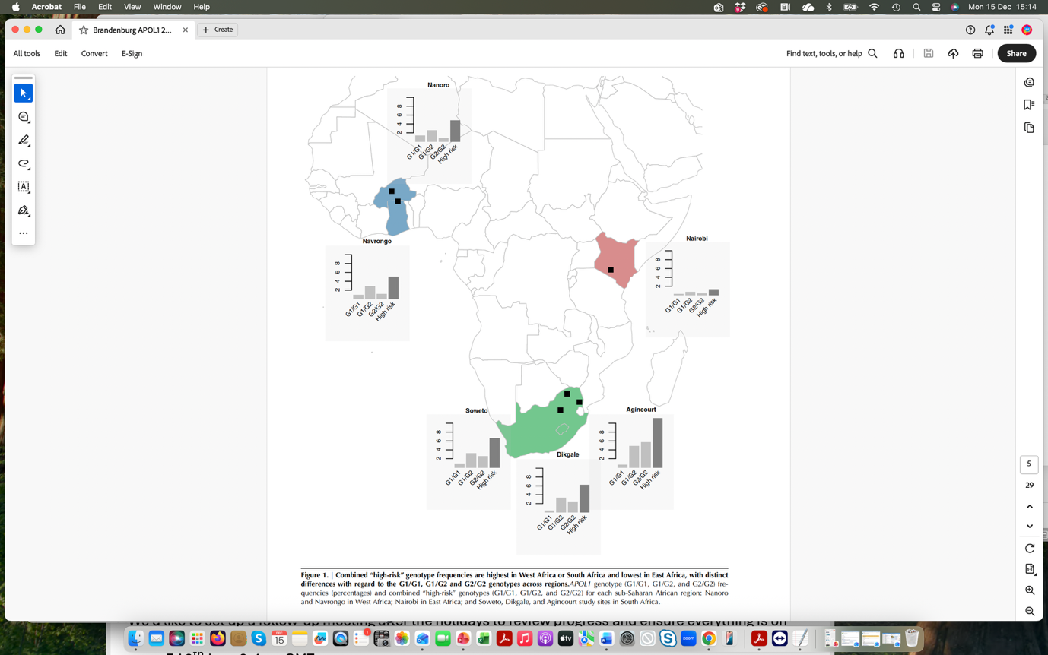

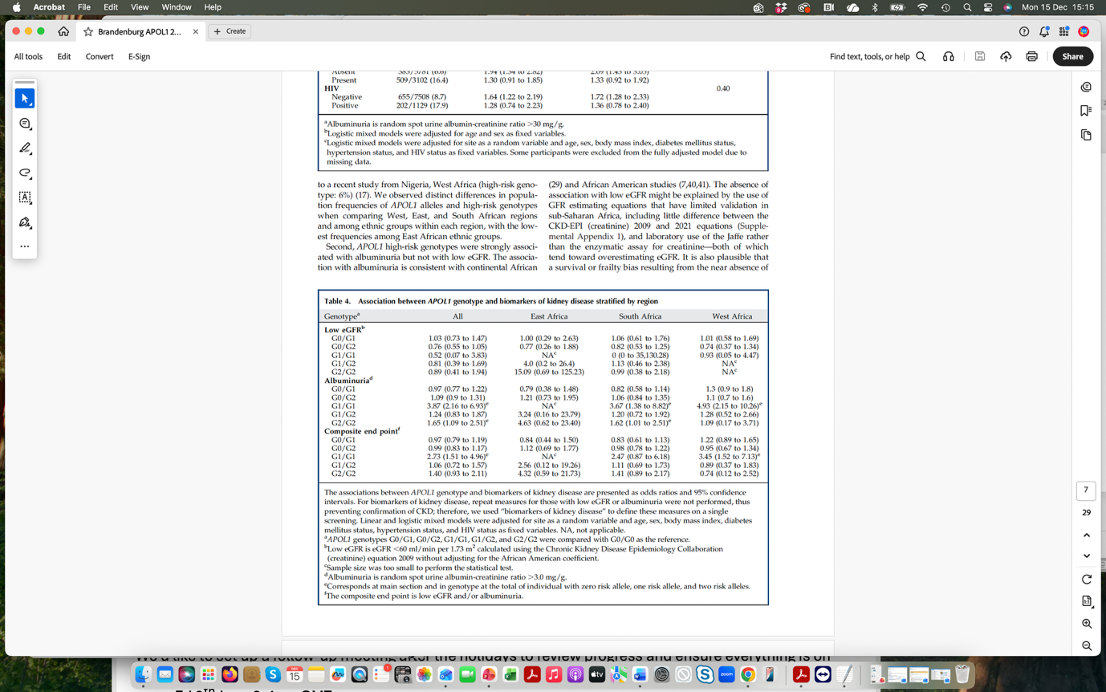

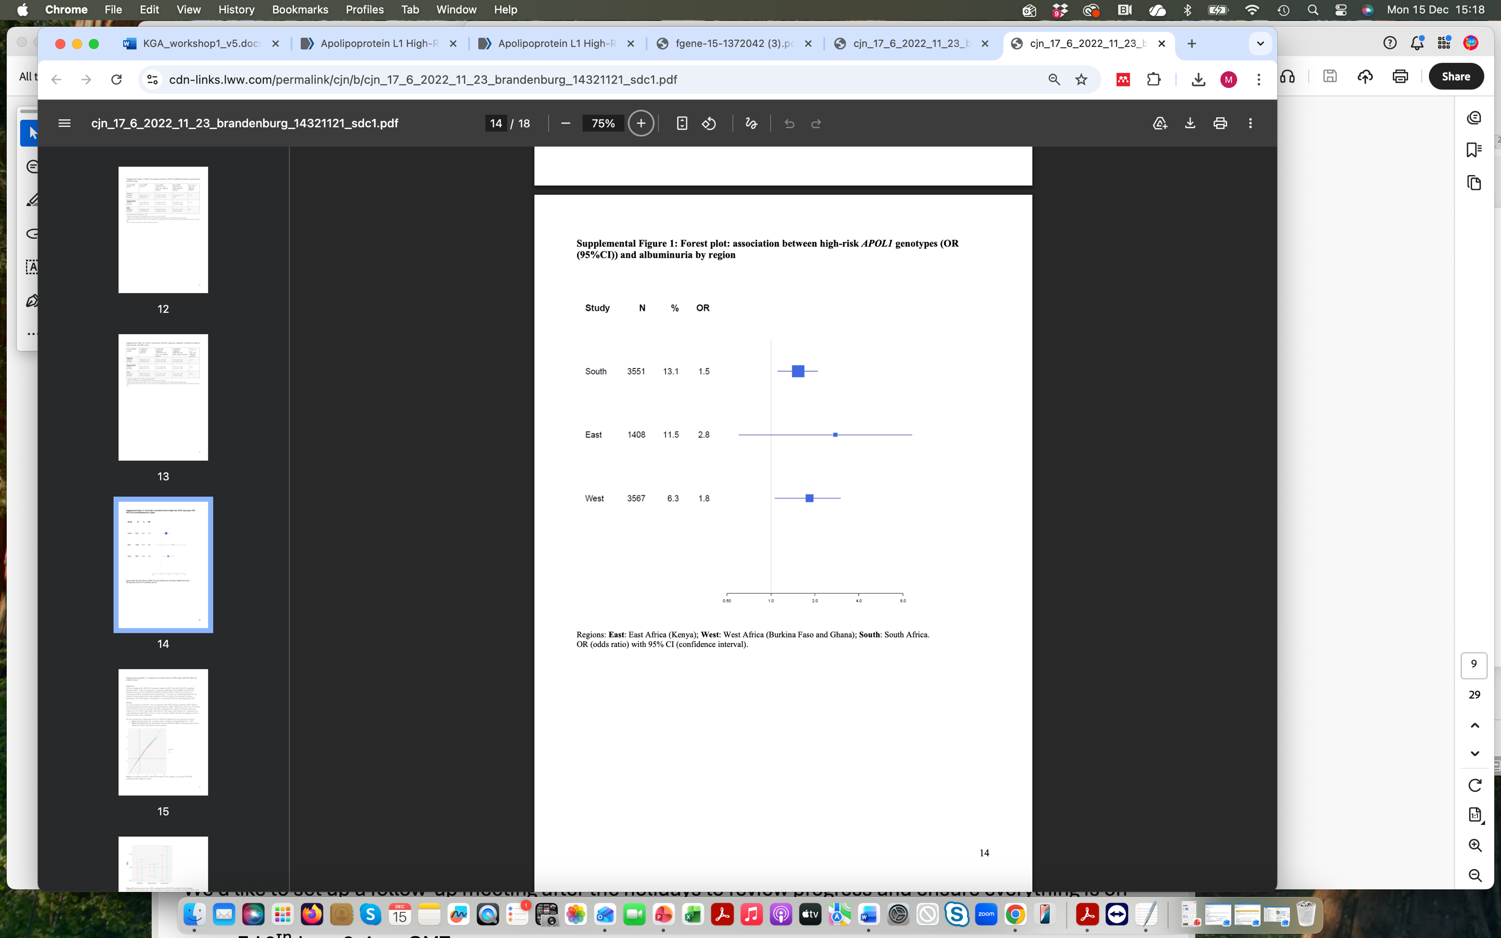

Study 2: Gbadegesin RA, et al. H3Africa Kidney Disease
Research Network. APOL1 Bi- and Monoallelic Variants and Chronic Kidney
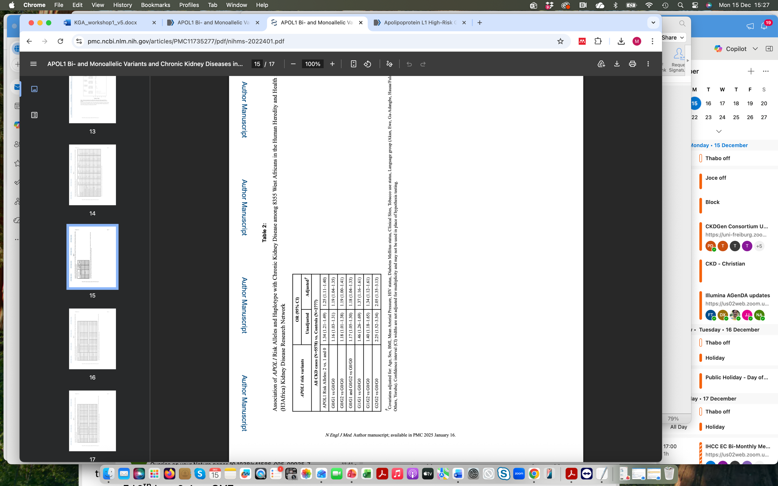
Disease in West Africans. N Engl J Med. 2025 Jan 16;392(3):228-238. doi:
10.1056/NEJMoa2404211. Epub 2024 Oct 26. PMID: 39465900; PMCID: PMC11735277.

Associations of APOL1 Risk Alleles and CKD among 8355 West Africans in the H3Africa Kidney Disease research network (covariates: Age, sex, BMI, MAP, HIV status, diabetes, clinical site, tobacco use and language group)

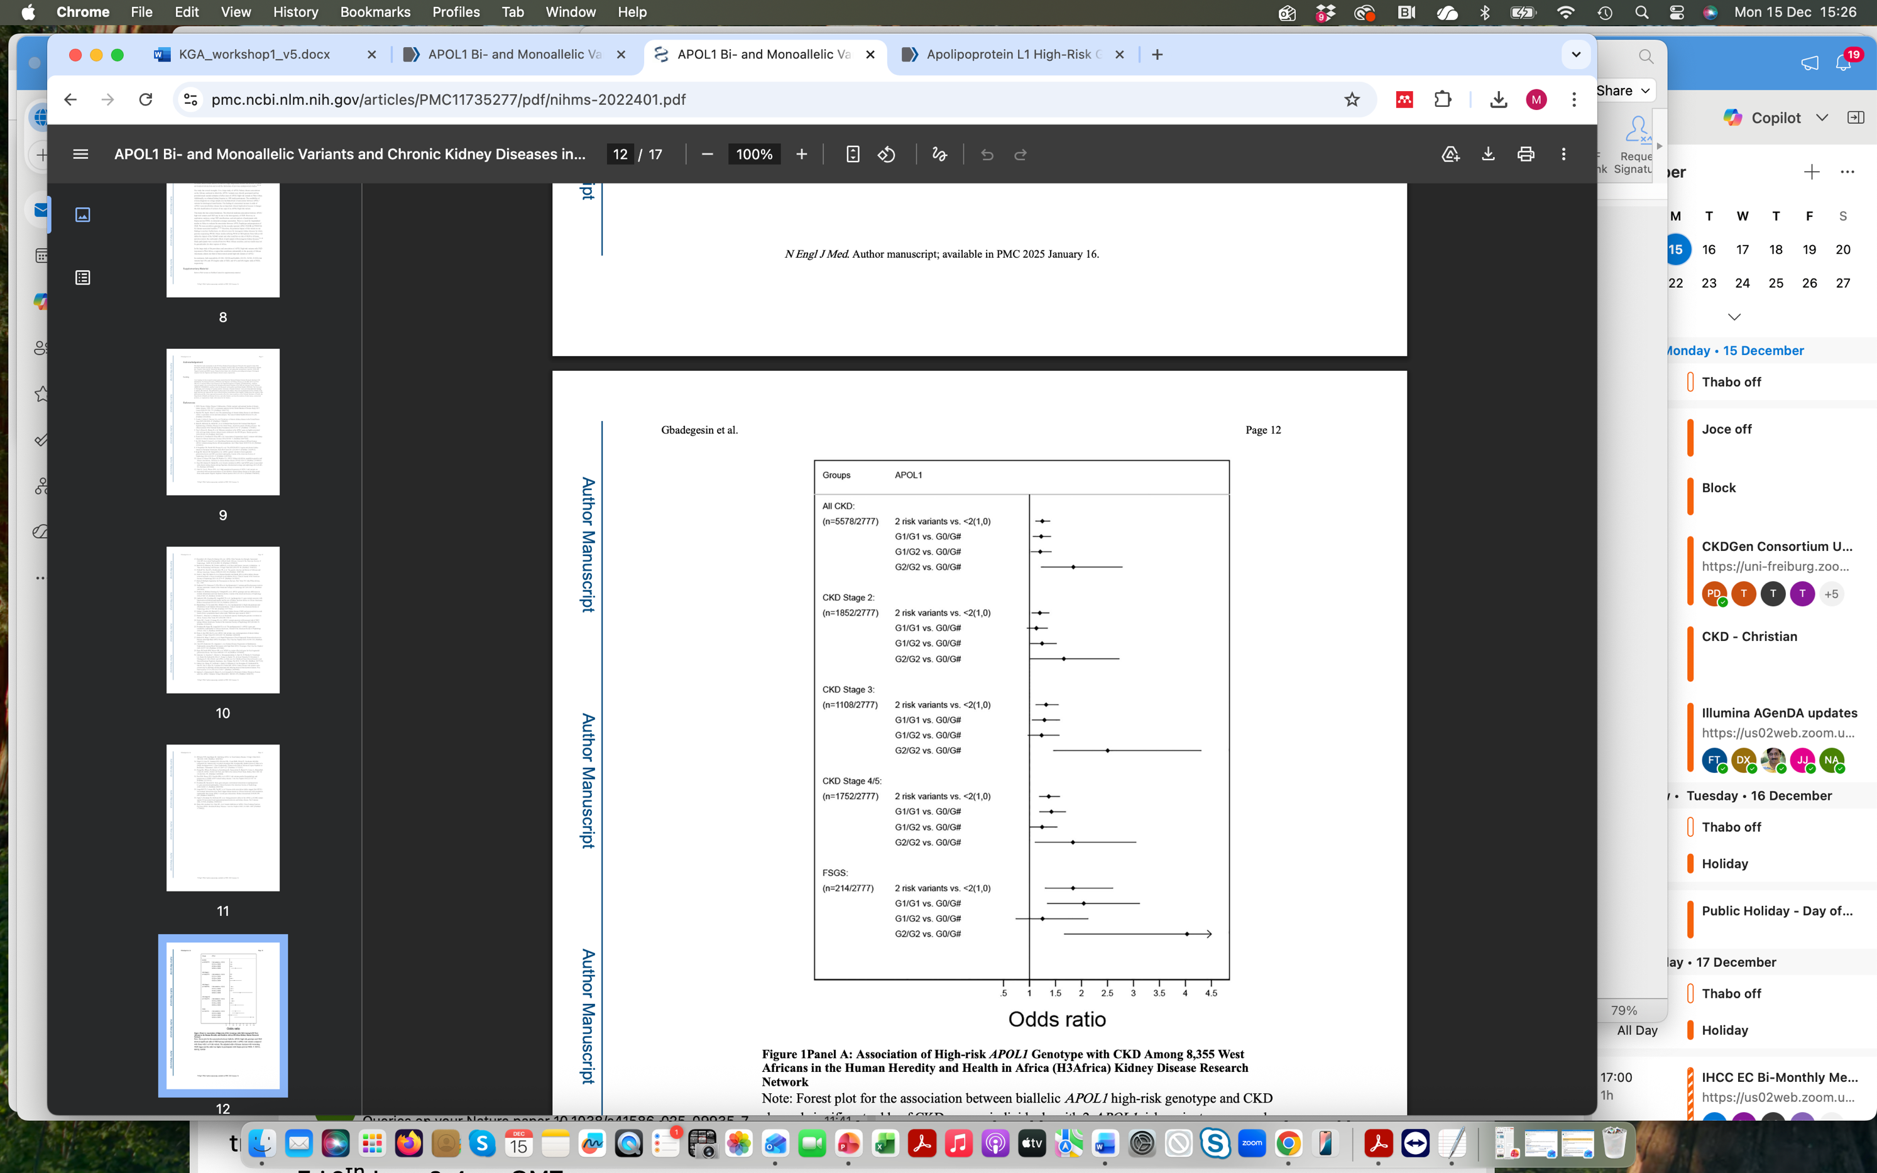

Association of APOL1 high risk genotypes with CKD among 8355 West Africans in the H3Africa Kidney Disease research network

Questions:
- What conclusions can you draw about genotype frequencies in different African populations?
- Are the associations with the genotypes/haplotype or with the alleles?
- Is the APOL1 risk genotype causal of chronic kidney disease? Motivate you response
- Do G1 and G2 contribute equally to the kidney function phenotype?

