Final Project Draft 1

For this project, I downloaded the data from here: https://www.fueleconomy.gov/feg/ws/index.shtml#fuelType1.

This dataset is very large and unruly. I have done quite a bit to wrangle the data in order to create metrics that I believe tell the story that I am trying to tell. I have included the jupyter notebook in raw form and as an html render so that you may see the work on the data. In the file for this submission, I have included a draft of my first interactive visualization (plot 1), as well as the json files for two differently indexed versions of my working dataset. I am using codepen.io to get examples that I am modifying for the visualizations, although I have some ideas about how to extend the functionality of the visualization that I am creating in order to extend the work.

Here is the link to the codepen workspace that I have been modifying. I think there are some settings and packages which I haven’t identified yet which are stopping me from being able to render the work in my own workspace. https://codepen.io/hofmannsven/pen/YzygMqO

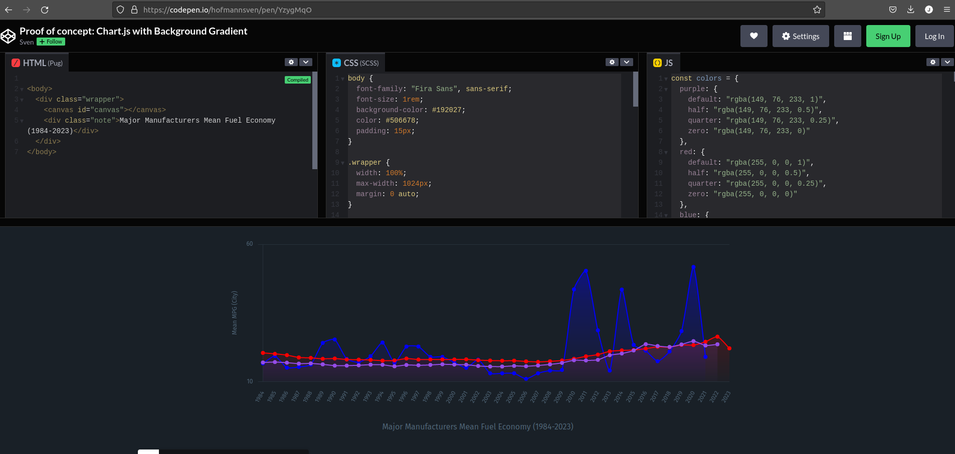
The image above shows the plot that I have made so far. I am hoping to get this plot working outside of the sandbox workspace that I am in.

For other visuals, I will be creating plots that show other facets of the data.

