北京科技大学 计算机与通信工程学院

实 验 报 告

实验名称： 时序逻辑实验

一、实验目的与实验要求
1、实验目的
本实验的目的是学习时序逻辑模块在数字系统中的综合应用与程序编写并且掌握实验平台的外部功能模块在数字系统设计中的应用。学习SRAM的使用，为设计复杂的数字电路，尤其是CPU设计奠定基础。

2、实验要求
- 在实验报告中提交系统级模块图、设计代码、仿真程序（部分模块）、仿真结果截图、实测验证结果照片。
其中，系统级模块设计图要求给出整个系统的数据输出信号，系统内各个子模块的输入输出信号和模块间的连接关系。
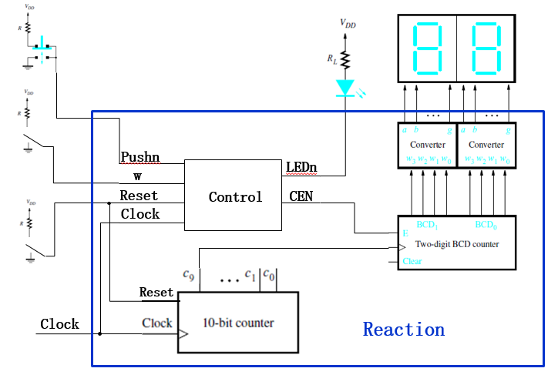
图1：系统级模块设计图

- 提交实验报告和每个实验的完整工程文件。

二、实验设备（环境）及要求
- Xilinx Ego1实验平台。
- OS：Win7 64位
- Software：Vivado15.4开发工具

三、实验内容与步骤
1、实验1
（1）实验内容
在七段数码管上滚动显示学号：按照“4 实验步骤——在七段数码管上滚动显示学号” 完成本实验。以学号40123456为例：
- 首先将学号中的数字被存储在一个32位的寄存器msgArray中；
- 4个数码管始终显示寄存器的低16位数据；
- 用频率为3Hz的时钟控制7段数码循环显示：在时钟的上升沿进行向左循环移动4位，并显示。注意：记得要把msgArray中的内容，即msgArray [3:0]的内容移到了msgArray [31:28]中。
- 复位时，寄存器恢复原始存储状态，7段数码管显示第一组4位字符（寄存器中的低16位），即4012；
下图显示了通过4个数码管滚动显示学号（40123456），初始时刻和经过3个周期以后的效果：
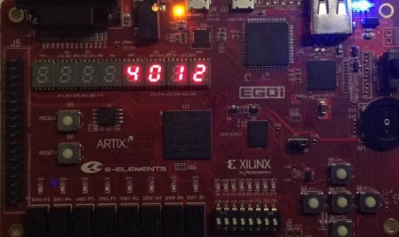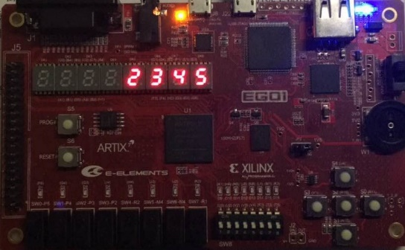
t(0)时刻 t(3)时刻

（2）主要步骤
- 新建工程，完成七段数码管的设计与板级验证
- 滚动七段数码管模块代码如下：
module clkDiv(
input clk100mhz,
output clk190hz,
output clk3hz
);
reg[25:0] count =0;
assign clk190hz = count[18];
assign clk3hz =count[25];
always@(posedge clk100mhz)
count<= count+1;
endmodule

module GPU(
input clk3hz,
input clr,
output [15:0]dataBus
);

reg[31:0] msgArray;
parameter NUMBER = 32'h41524119;
assign dataBus = msgArray[31:16];
always@(posedge clk3hz or posedge clr)
if(!clr)
msgArray<=NUMBER;
else begin
msgArray[3:0]<= msgArray[31:28];
msgArray[31:4]<= msgArray[27:0];
end
endmodule

module segMsg(
input clk190hz,
input [15:0] dataBus,
output reg [3:0] pos,
output reg [7:0] seg
);
reg [1:0] posC;
reg [3:0] dataP;
always @(posedge clk190hz)begin
case(posC)
0:begin
pos <= 4'b0001;
dataP <= dataBus[3:0];
end

1:begin
pos <=4'b0010;
dataP<= dataBus [7:4];
end

2:begin
pos <=4'b0100;
dataP<= dataBus [11:8];
end
3:begin
pos <=4'b1000;
dataP<= dataBus[15:12];
end
endcase
posC=posC + 1;
end
always @(dataP)
case(dataP)
0:seg =8'b0011_1111;
1:seg =8'b0000_0110;
2:seg =8'b0101_1011;
3:seg =8'b0100_1111;
4:seg =8'b0110_0110;
5:seg =8'b0110_1101;
6:seg =8'b0111_1101;
7:seg =8'b0000_0111;
8:seg =8'b0111_1111;
9:seg =8'b0110_1111;
10:seg =8'b0100_0000;
11:seg =8'b0000_0000;
default: seg =8'b0000_1000;
endcase
endmodule

module top(
input clk100mhz,
input clr,
output [3:0] pos,
output [7:0] seg
);
wire clk190hz,clk3hz;
wire [15:0]dataBus;

clkDiv U1(clk100mhz,clk190hz,clk3hz);
GPU U2(clk3hz,clr,dataBus);
segMsg U3(clk190hz,dataBus,pos,seg);

endmodule

`timescale 1ns / 1ps
module GPU_tb();
reg clk;
reg clr;
wire[15:0]dataBus;
initial begin
clk=0;
clr=0;
#100 clr=1;
end
always #5 clk=~clk;
GPU tb1(clk,clr,dataBus);
endmodule

- 管脚约束代码：
set_property IOSTANDARD LVCMOS33 [get_ports {pos[3]}]
set_property IOSTANDARD LVCMOS33 [get_ports {pos[2]}]
set_property IOSTANDARD LVCMOS33 [get_ports {pos[1]}]
set_property IOSTANDARD LVCMOS33 [get_ports {pos[0]}]
set_property IOSTANDARD LVCMOS33 [get_ports {seg[7]}]
set_property IOSTANDARD LVCMOS33 [get_ports {seg[6]}]
set_property IOSTANDARD LVCMOS33 [get_ports {seg[5]}]
set_property IOSTANDARD LVCMOS33 [get_ports {seg[4]}]
set_property IOSTANDARD LVCMOS33 [get_ports {seg[3]}]
set_property IOSTANDARD LVCMOS33 [get_ports {seg[2]}]
set_property IOSTANDARD LVCMOS33 [get_ports {seg[1]}]
set_property IOSTANDARD LVCMOS33 [get_ports {seg[0]}]
set_property PACKAGE_PIN G1 [get_ports {pos[3]}]
set_property PACKAGE_PIN F1 [get_ports {pos[2]}]
set_property PACKAGE_PIN E1 [get_ports {pos[1]}]
set_property PACKAGE_PIN G6 [get_ports {pos[0]}]
set_property PACKAGE_PIN P17 [get_ports clk100mhz]
set_property PACKAGE_PIN P5 [get_ports clr]
set_property IOSTANDARD LVCMOS33 [get_ports clr]
set_property IOSTANDARD LVCMOS33 [get_ports clk100mhz]
set_property PACKAGE_PIN H2 [get_ports {seg[7]}]
set_property PACKAGE_PIN D2 [get_ports {seg[6]}]
set_property PACKAGE_PIN E2 [get_ports {seg[5]}]
set_property PACKAGE_PIN F3 [get_ports {seg[4]}]
set_property PACKAGE_PIN F4 [get_ports {seg[3]}]
set_property PACKAGE_PIN D3 [get_ports {seg[2]}]
set_property PACKAGE_PIN E3 [get_ports {seg[1]}]
set_property PACKAGE_PIN D4 [get_ports {seg[0]}]

- RTL门级结构示意图：
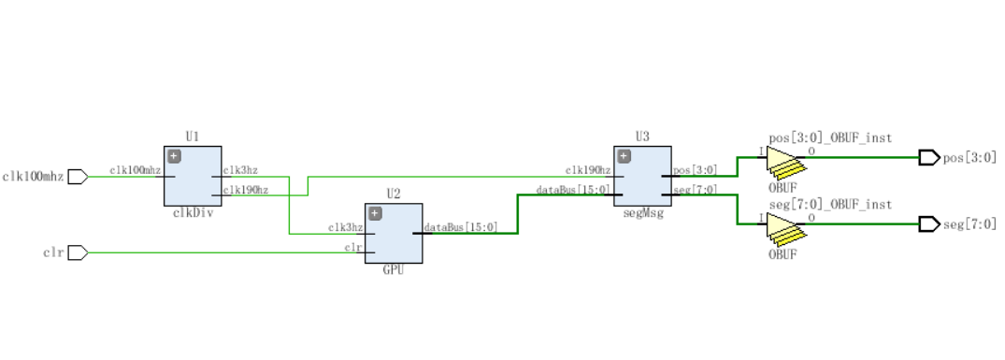
图 2：滚动显示RTL示意图

2、实验2
（1）实验内容
通过按键输入学号，并循环显示：电路功能描述：通过Ego1上的按键输入自己的学号（8位10进制数），并存储在32位的寄存器中；8位10进制数输入完成后，实现类似实验3.1中的滚动显示效果。
除了要求实现上述功能外，还包括如下具体实现上的要求：
- 整个电路具有复位功能；
- 8个数码管中，4个数码管用于输入数据后的循环显示，另外4个用于显示当前正在输入的数据。
- 输入过程可控、实时可视：
  - 用按键或者开关控制输入开始和结束，输入开始后用于循环显示的4个数码管停止循环显示，用于显示输入数据的4个数码管开始显示输入数据；输入结束后用于循环显示的4个数码管开始循环显示输入的学号，用于显示输入数据的4个数码管停止显示输入数据。
  - 用按键切换当前要输入的数据位，切换结果通过用于显示输入数据的4个数码管展示出来，即用户能够通过显示输入数据的4个数码管看出来当前正在输入的是哪一位10进制数。
- 输入数字的时候进行按键消抖（关于按键防抖的原理，请参考本实验手册的“5.1 实验3.2 相关说明”部分）；
- 设计具有开放性，下图仅仅为参考的一种实现效果，不作强求实现一样的效果。
- 数码管、按键、开关的管脚和控制方式等信息请参考本文件“5.1 实验3.2 相关说明”以及”EGo1使用手册.pdf和EGO1电路原理图.pdf”
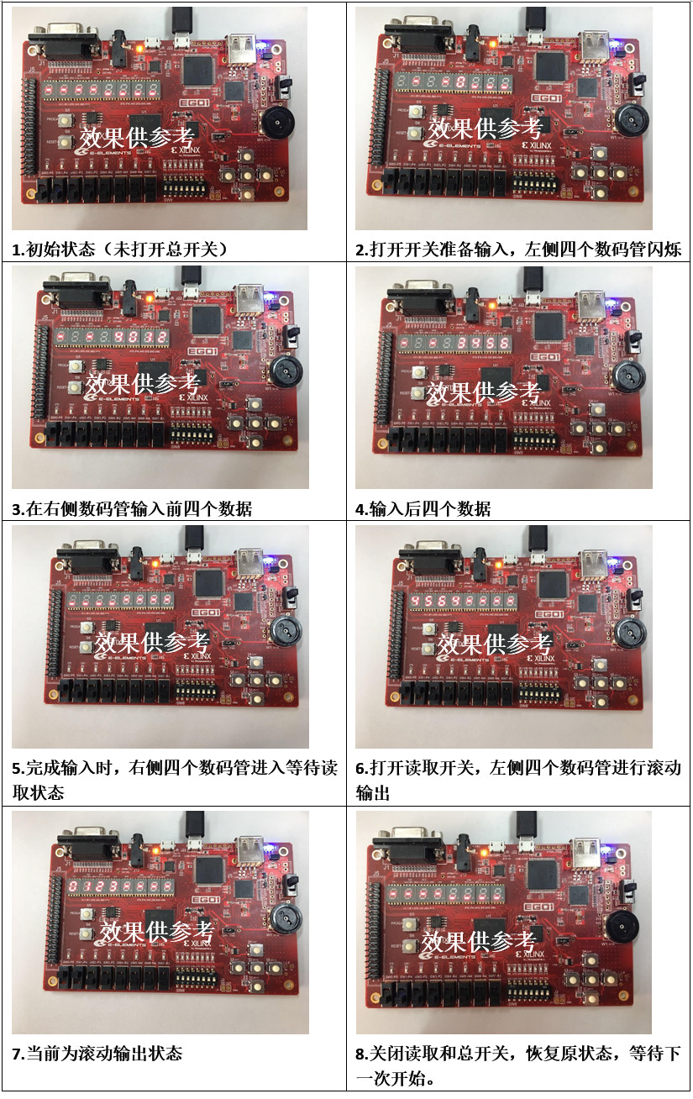
图3： 滚动显示照片

（2）主要步骤
- 确定实验参考图相关知识及确定对应管脚：
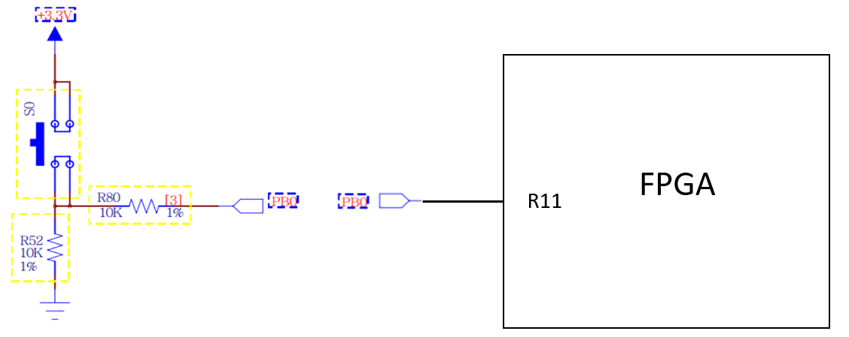
图4： FPGA连接示意图

按键名称 | FPGA管脚
S0 | R11
S1 | R17
S2 | R15
S3 | V1
S4 | U4
图5： 管脚对应表
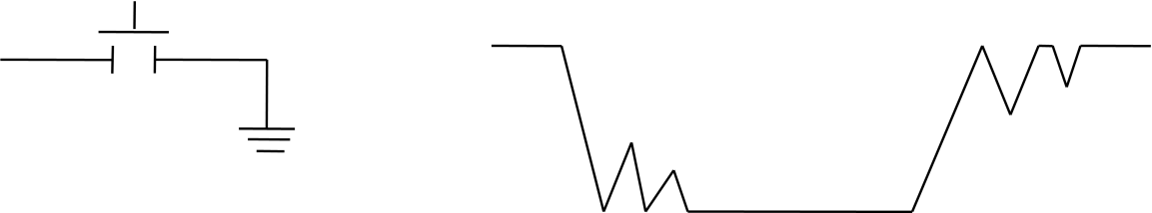
图6： 防抖说明
- 新建工程，catchPress即为输入滚动数码管显示器。
- 模块代码
`timescale 1ns / 1ps

module catchPress(input clk190hz, input press, output signal);
reg delay1, delay2, delay3, delay4, delay5;

always @(posedge clk190hz)
begin
delay5 = delay4;
delay4 = delay3;
delay3 = delay2;
delay2 = delay1;
delay1 = press;
end

assign signal = delay1 & delay2 & delay3 & delay4 & delay5;
endmodule

module clkDiv(input clk100mhz, output clk190hz, output clk3hz);
reg [25:0] cnt = 0;
assign clk190hz = cnt[18];
assign clk3hz = cnt[25];
always @(posedge clk100mhz)
cnt = cnt + 1;
endmodule

`timescale 1ns / 1ps

module dataRead(
input clk190hz,
input rst,
input leftMove,
input rightMove,
input inc,
output [3:0] pos,
output [7:0] seg,
output [31:0] myID,
output [2:0] temp
);

reg [31:0] msgArray = 0;
reg [2:0] cur = 7;
reg [15:0] dataBus;
reg lmv_delay = 0, rmv_delay = 0, inc_delay = 0;

assign myID = msgArray;
assign temp = cur;
always @(posedge clk190hz)
begin
if (!rst) begin
msgArray = 0;
cur = 7;
lmv_delay = 0;
rmv_delay = 0;
inc_delay = 0;
end
else begin
if (leftMove == 1 && lmv_delay == 0) cur = cur + 1;
else if (rightMove == 1 && rmv_delay == 0) cur = cur - 1;
else if (inc == 1 && inc_delay == 0) begin
msgArray = msgArray + (4'b0001 << (4*cur));
if (((msgArray >> (4*cur)) & 4'b1111) == 10)
msgArray = msgArray - (4'b1010 << (4*cur));
end
lmv_delay = leftMove;
rmv_delay = rightMove;
inc_delay = inc;
end

if (cur<4) dataBus = msgArray[15:0];
else dataBus = msgArray[31:16];
end

segMsg2 u(clk190hz, rst, dataBus, cur[1:0], pos, seg);
endmodule
`timescale 1ns / 1ps

module dataShow(
input clk190hz,
input clk3hz,
input rst,
input [31:0] myID,
output [3:0] pos,
output [7:0] seg
);

wire [15:0] dataBus;
GPU u1(clk3hz, rst, myID, dataBus);
segMsg1 u2(clk190hz, rst, dataBus, pos, seg);
endmodule
`timescale 1ns / 1ps

module GPU(input clk3hz, input rst, input [31:0] myID, output [15:0] dataBus);

reg[31:0] msgArray;
assign dataBus = msgArray[31:16];
always @(posedge clk3hz)
begin
if (!rst) msgArray <= myID;
else begin
msgArray[3:0] <= msgArray[31:28];
msgArray[31:4] <= msgArray[27:0];
end
end
endmodule
`timescale 1ns / 1ps

module segMsg1(
input clk190hz,
input rst,
input [15:0] dataBus,
output reg [3:0] pos,
output reg [7:0] seg
);

reg [1:0] posC;
reg [3:0] dataP;

always @(posedge clk190hz)
begin
if (!rst)
begin
pos = 4'b0000;
posC = 0;
end
else begin
case (posC)
0: begin
pos <= 4'b0001;
dataP <= dataBus[3:0];
end
1: begin
pos <= 4'b0010;
dataP <= dataBus[7:4];
end
2: begin
pos <= 4'b0100;
dataP <= dataBus[11:8];
end
3: begin
pos <= 4'b1000;
dataP <= dataBus[15:12];
end
endcase
posC = posC + 1;
end
end

always @(dataP)
case (dataP)
0: seg = 8'b0011_1111;
1: seg = 8'b0000_0110;
2: seg = 8'b0101_1011;
3: seg = 8'b0100_1111;
4: seg = 8'b0110_0110;
5: seg = 8'b0110_1101;
6: seg = 8'b0111_1101;
7: seg = 8'b0000_0111;
8: seg = 8'b0111_1111;
9: seg = 8'b0110_1111;
10:seg = 8'b0100_0000;
11:seg = 8'b0000_0000;
default: seg = 8'b0000_1000;
endcase
endmodule

`timescale 1ns / 1ps

module segMsg2(
input clk190hz,
input rst,
input [15:0] dataBus,
input [1:0] decimalPoint,
output reg [3:0] pos,
output reg [7:0] seg
);

reg [1:0] posC;
reg [3:0] dataP;

always @(posedge clk190hz)
begin
if (!rst)
begin
pos = 4'b0000;
posC = 3;
end
else begin
posC = posC + 1;
case (posC)
0: begin
pos <= 4'b0001;
dataP <= dataBus[3:0];
end
1: begin
pos <= 4'b0010;
dataP <= dataBus[7:4];
end
2: begin
pos <= 4'b0100;
dataP <= dataBus[11:8];
end
3: begin
pos <= 4'b1000;
dataP <= dataBus[15:12];
end
endcase
end
end
always @(posC)
begin
case (dataP)
0: seg = 8'b0011_1111;
1: seg = 8'b0000_0110;
2: seg = 8'b0101_1011;
3: seg = 8'b0100_1111;
4: seg = 8'b0110_0110;
5: seg = 8'b0110_1101;
6: seg = 8'b0111_1101;
7: seg = 8'b0000_0111;
8: seg = 8'b0111_1111;
9: seg = 8'b0110_1111;
10:seg = 8'b0100_0000;
11:seg = 8'b0000_0000;
default: seg = 8'b0000_1000;
endcase

if (posC == decimalPoint) seg = seg | 8'b1000_0000;
end
endmodule
`timescale 1ns / 1ps

module top(
input clk100mhz,
input rst,
input sel,
input left_move,
input right_move,
input increase,
output [3:0] pos1,
output [7:0] seg1,
output [3:0] pos2,
output [7:0] seg2,
output [2:0] temp
);
wire clk190hz, clk3hz;
wire [31:0] myID;
wire [15:0] dataBus;
wire leftMove, rightMove, inc;

clkDiv u1(clk100mhz, clk190hz, clk3hz);
dataShow u2(clk190hz, clk3hz, rst & sel, myID, pos1, seg1);
dataRead u3(clk190hz, rst & (~sel), leftMove, rightMove, inc, pos2, seg2, myID, temp);

catchPress c1(clk190hz, left_move, leftMove);
catchPress c2(clk190hz, right_move, rightMove);
catchPress c3(clk190hz, increase, inc);
endmodule
`timescale 1ns / 1ps

module dataRead_test();
reg clk190hz, rst, leftMove, rightMove, inc;
wire [31:0] myID;
wire [15:0] dataBus;

dataRead u1(clk190hz, rst, leftMove, rightMove, inc, myID, dataBus);

initial begin
clk190hz = 0;
rst = 0;
leftMove = 0;
rightMove = 0;
inc = 0;
#10 rst = 1;
#5 leftMove = 1;
#3 leftMove = 0;
#7 inc = 1;
end

always #5 clk190hz = ~clk190hz;

endmodule
- FPGA板级验证管脚约束文件：
set_property PACKAGE_PIN P17 [get_ports clk100mhz]
set_property PACKAGE_PIN P5 [get_ports rst]
set_property PACKAGE_PIN P4 [get_ports sel]
set_property PACKAGE_PIN R15 [get_ports increase]
set_property PACKAGE_PIN V1 [get_ports left_move]
set_property PACKAGE_PIN R11 [get_ports right_move]
set_property PACKAGE_PIN G1 [get_ports {pos1[3]}]
set_property PACKAGE_PIN F1 [get_ports {pos1[2]}]
set_property PACKAGE_PIN E1 [get_ports {pos1[1]}]
set_property PACKAGE_PIN G6 [get_ports {pos1[0]}]
set_property PACKAGE_PIN H2 [get_ports {seg1[7]}]
set_property PACKAGE_PIN D2 [get_ports {seg1[6]}]
set_property PACKAGE_PIN E2 [get_ports {seg1[5]}]
set_property PACKAGE_PIN F3 [get_ports {seg1[4]}]
set_property PACKAGE_PIN F4 [get_ports {seg1[3]}]
set_property PACKAGE_PIN D3 [get_ports {seg1[2]}]
set_property PACKAGE_PIN E3 [get_ports {seg1[1]}]
set_property PACKAGE_PIN D4 [get_ports {seg1[0]}]
set_property PACKAGE_PIN G2 [get_ports {pos2[3]}]
set_property PACKAGE_PIN C2 [get_ports {pos2[2]}]
set_property PACKAGE_PIN C1 [get_ports {pos2[1]}]
set_property PACKAGE_PIN H1 [get_ports {pos2[0]}]
set_property PACKAGE_PIN D5 [get_ports {seg2[7]}]
set_property PACKAGE_PIN B2 [get_ports {seg2[6]}]
set_property PACKAGE_PIN B3 [get_ports {seg2[5]}]
set_property PACKAGE_PIN A1 [get_ports {seg2[4]}]
set_property PACKAGE_PIN B1 [get_ports {seg2[3]}]
set_property PACKAGE_PIN A3 [get_ports {seg2[2]}]
set_property PACKAGE_PIN A4 [get_ports {seg2[1]}]
set_property PACKAGE_PIN B4 [get_ports {seg2[0]}]
set_property IOSTANDARD LVCMOS33 [get_ports {pos1[3]}]
set_property IOSTANDARD LVCMOS33 [get_ports {pos1[2]}]
set_property IOSTANDARD LVCMOS33 [get_ports {pos1[1]}]
set_property IOSTANDARD LVCMOS33 [get_ports {pos1[0]}]
set_property IOSTANDARD LVCMOS33 [get_ports {pos2[3]}]
set_property IOSTANDARD LVCMOS33 [get_ports {pos2[2]}]
set_property IOSTANDARD LVCMOS33 [get_ports {pos2[1]}]
set_property IOSTANDARD LVCMOS33 [get_ports {pos2[0]}]
set_property IOSTANDARD LVCMOS33 [get_ports {seg1[7]}]
set_property IOSTANDARD LVCMOS33 [get_ports {seg1[6]}]
set_property IOSTANDARD LVCMOS33 [get_ports {seg1[5]}]
set_property IOSTANDARD LVCMOS33 [get_ports {seg1[4]}]
set_property IOSTANDARD LVCMOS33 [get_ports {seg1[3]}]
set_property IOSTANDARD LVCMOS33 [get_ports {seg2[3]}]
set_property IOSTANDARD LVCMOS33 [get_ports {seg2[2]}]
set_property IOSTANDARD LVCMOS33 [get_ports {seg2[1]}]
set_property IOSTANDARD LVCMOS33 [get_ports {seg2[0]}]
set_property IOSTANDARD LVCMOS33 [get_ports clk100mhz]
set_property IOSTANDARD LVCMOS33 [get_ports increase]
set_property IOSTANDARD LVCMOS33 [get_ports left_move]
set_property IOSTANDARD LVCMOS33 [get_ports right_move]
set_property IOSTANDARD LVCMOS33 [get_ports rst]
set_property IOSTANDARD LVCMOS33 [get_ports sel]

set_property PACKAGE_PIN F6 [get_ports temp]
set_property IOSTANDARD LVCMOS33 [get_ports {temp[2]}]
set_property IOSTANDARD LVCMOS33 [get_ports {temp[1]}]
set_property IOSTANDARD LVCMOS33 [get_ports {temp[0]}]

set_property PACKAGE_PIN F6 [get_ports {temp[2]}]
set_property PACKAGE_PIN G4 [get_ports {temp[1]}]
set_property PACKAGE_PIN G3 [get_ports {temp[0]}]

- 滚动数码管RTL门级结构图
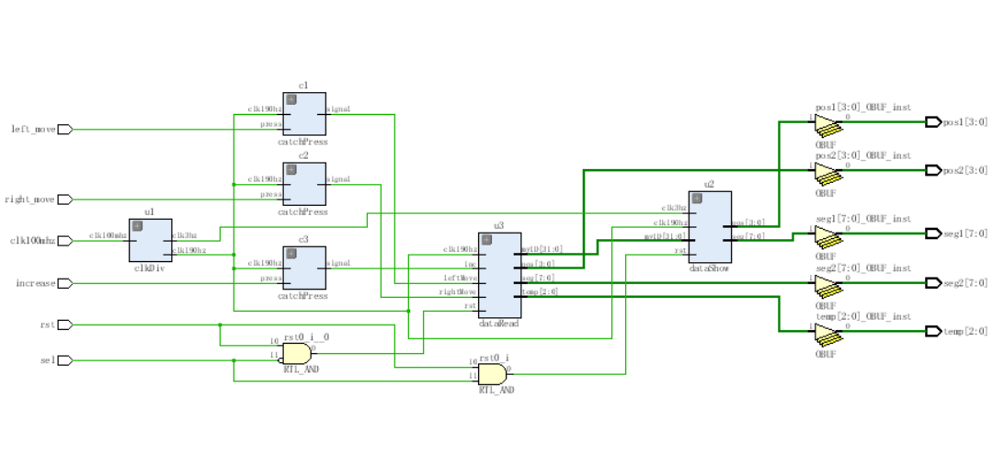
图7： 数码管RTL门级结构图

- 得到板级验证数码管显示情况，见实验结果与分析。

3、实验3
（1）实验内容
SRAM芯片数据存取：在实验3.2的基础上实现将输入的数据存入FPGA的SRAM芯片上，当进行读取时将数据从SRAM芯片中取出来。
（2）主要步骤
- 查询SRAM说明书，理解SRAM相关必备知识。
SRAM静态随机存储器，通常作为CPU的存储器使用。板卡搭载的 IS61WV12816DBLL SRAM 芯片， 总容量 2Mbit。该 SRAM 为异步式 SRAM，最高存取时间可达 8ns。 操控简单，易于读写。
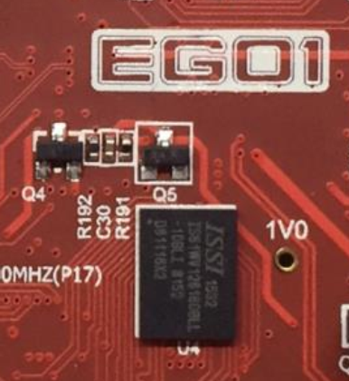
图8： EGO芯片示意图

I/O0-15 | 数据总线
A00-18 | 地址线
OE | 输出使能
CE | 芯片使能
WE | 写使能
UB | 高八位选通
LB | 低八位选通
图9： SRAM管脚配置

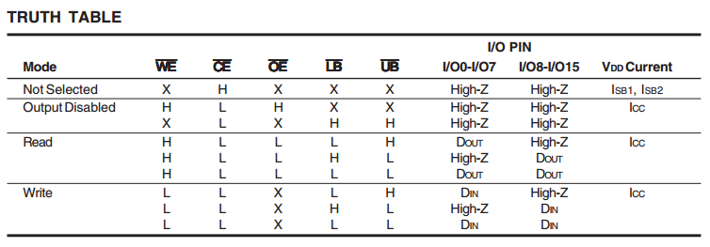
图10：SRAM控制信号真值表

一种SRAM写操作时序如下：
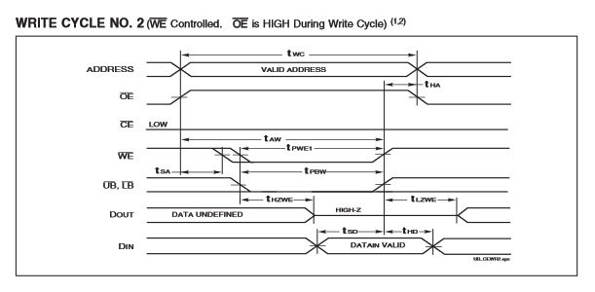
图11：操作时序示意图
- 新建工程，即SRAM写读文件。
- SRAM模块代码如下：
`timescale 1ns / 1ps
module changeAddr(
input clk100mhz,
input changeaddr,
output reg[18:0]addrBus1
);
always@(posedge clk100mhz)begin
if(changeaddr==0) addrBus1 = 19'b100_0000_0000_0000_0000;
else if(changeaddr) addrBus1 = 19'b100_0000_0000_0000_0001;
end
endmodule
`timescale 1ns / 1ps
module clkDiv(
input clk100mhz,
output clk190hz,
output clk6hz,
output clk3hz
);
reg [25:0] count = 0;
assign clk190hz =count[18];
assign clk3hz =count[25];
assign clk6hz =count[24];
always@(posedge clk100mhz)
count <= count + 1;
endmodule
`timescale 1ns / 1ps
module GPU(
input [31:0]number,
input clk3hz,
input clr,
output [15:0]dataBus
);
reg[31:0] msgArray;
assign dataBus = msgArray[31:16];
always @ (posedge clk3hz or posedge clr)
if(!clr )
msgArray <= number;
else begin
msgArray[3:0] <= msgArray[31:28];
msgArray[31:4]<=msgArray[27:0];
end
endmodule
`timescale 1ns / 1ps
module segMsg(
input start,
input clk190hz,
input [15:0] dataBus,
input [15:0] dataBus1,
output reg [3:0] pos,
output reg [3:0] pos1,
output reg [7:0] seg,
output reg [7:0] seg1
);
reg [1:0] posC;
reg [1:0] posC1;
reg [3:0] dataP;
reg [3:0] dataP1;
always @(posedge clk190hz )begin
case(posC1)
0:begin
pos1 <= 4'b0001;
if(start) dataP1 <= dataBus1[3:0];
else dataP1<= 10;
end
1:begin
pos1 <= 4'b0010;
if(start) dataP1 <= dataBus1[7:4];
else dataP1<= 10;
end
2:begin
pos1 <=4'b0100;
if(start) dataP1 <= dataBus1[11:8];
else dataP1<= 10;
end
3:begin
pos1 <= 4'b1000;
if(start) dataP1 <= dataBus1[15:12];
else dataP1<= 10;
end
endcase
posC1 = posC1 + 1;
case(posC)
0:begin
pos <= 4'b0001;
if(start==0) dataP <= dataBus[3:0];
else dataP<= 10;
end
1:begin
pos <= 4'b0010;
if(start==0) dataP <= dataBus[7:4];
else dataP<= 10;
end
2:begin
pos <=4'b0100;
if(start==0) dataP <= dataBus[11:8];
else dataP<= 10;
end
3:begin
pos <= 4'b1000;
if(start==0) dataP <= dataBus[15:12];
else dataP<= 10;
end
endcase
posC = posC + 1;
end
always@(dataP1 or dataP) begin
case(dataP1)
0: seg1 = 8'b0011_1111;
1: seg1 = 8'b0000_0110;
2: seg1 = 8'b0101_1011;
3: seg1 = 8'b0100_1111;
4: seg1 = 8'b0110_0110;
5: seg1 = 8'b0110_1101;
6: seg1 = 8'b0111_1101;
7: seg1 = 8'b0000_0111;
8: seg1 = 8'b0111_1111;
9: seg1 = 8'b0110_1111;
10:seg1 = 8'b0100_0000;
11:seg1 = 8'b0000_0000;
default: seg1 = 8'b0000_1000;
endcase
case(dataP)
0: seg = 8'b0011_1111;
1: seg = 8'b0000_0110;
2: seg = 8'b0101_1011;
3: seg = 8'b0100_1111;
4: seg = 8'b0110_0110;
5: seg = 8'b0110_1101;
6: seg = 8'b0111_1101;
7: seg = 8'b0000_0111;
8: seg = 8'b0111_1111;
9: seg = 8'b0110_1111;
10:seg = 8'b0100_0000;
11:seg = 8'b0000_0000;
default: seg = 8'b0000_1000;
endcase
end
endmodule
`timescale 1ns / 1ps
module sram(
input clk,clr,rEn,
input [31:0] iDataBus,
inout [15:0] dataBus,
output reg[18:0] addrBus,
output ce,ub,lb,
output reg oe,w,
output reg [31:0]oDataBus
);

reg [15:0] tDataBus;
reg [31:0] rDataBus;
reg [3:0] countR ;
reg [3:0] countW ;

assign dataBus = w ? 16'hzzzz : tDataBus;
assign ce = 0;
assign ub = 0;
assign lb = 0;

always @(posedge clk or posedge clr)
if(!clr)begin
countW <= 0;
countR <= 0;
end
else begin
case(countW)
2:begin
w <= 1'b0;
oe <= 1'b1;
tDataBus <= iDataBus[15:0];
addrBus <= 19'd100_000;
end
4:begin
w <= 1'b0;
oe <= 1'b1;
tDataBus <= iDataBus[31:16];
addrBus <= 19'd100_001;
end
default:begin
w <= 1'b1;
oe <= 1'b0;
end
endcase
case(countR)
2:begin
w <= 1'b1;
addrBus<= 19'd100_000;
rDataBus[15:0] <= dataBus;
end
4:begin
w <= 1'b1;
addrBus<= 19'd100_001;
rDataBus[31:16] <= dataBus;
end
8:begin
oDataBus = rDataBus;
end
endcase
if((countW<8)&&(rEn==0))
countW <= countW + 1;
if((countR<12)&&(rEn==1))
countR <= countR + 1;
end
endmodule
`timescale 1ns / 1ps
module sramR(
input clk100mhz,
input w,ce,
input [15:0] dataBus,
output [15:0]LED
);
reg [15:0]data;
always@(posedge clk100mhz)
begin
if(w&&(ce==0))begin
data <= dataBus;
end
end
assign LED=data;
endmodule
`timescale 1ns / 1ps
module sramWR(
input clk100mhz,
input w,ce,changeaddr,
input [15:0]number,
inout [15:0] dataBus,
output reg[15:0]LED,
output oe,lb,ub,
output reg[ 18:0]addrBus
);
reg [15:0] tDataBus;
assign oe=0;assign lb =0;assign ub =0;
assign dataBus = w ? 16'hzzzz : tDataBus;
always@(posedge clk100mhz)begin
if(w==0&&ce==0)begin
tDataBus <= number;
end
else if(w&&(ce==0))begin
LED <= dataBus;
end
case(changeaddr)
1: addrBus= 19'b100_0000_0000_0000_0000;
0: addrBus= 19'b100_0000_0000_0000_0001;
endcase
end
endmodule
`timescale 1ns / 1ps
module xiaodou(
input clk_190Hz,
input btnIn,
output btnOut
);
reg delay1;
reg delay2;
reg delay3;

always @(posedge clk_190Hz)begin
delay3 = delay2;
delay2 = delay1;
delay1 = btnIn;
end
assign btnOut = delay1 & delay2 & delay3;
endmodule
- RTL门级结构图
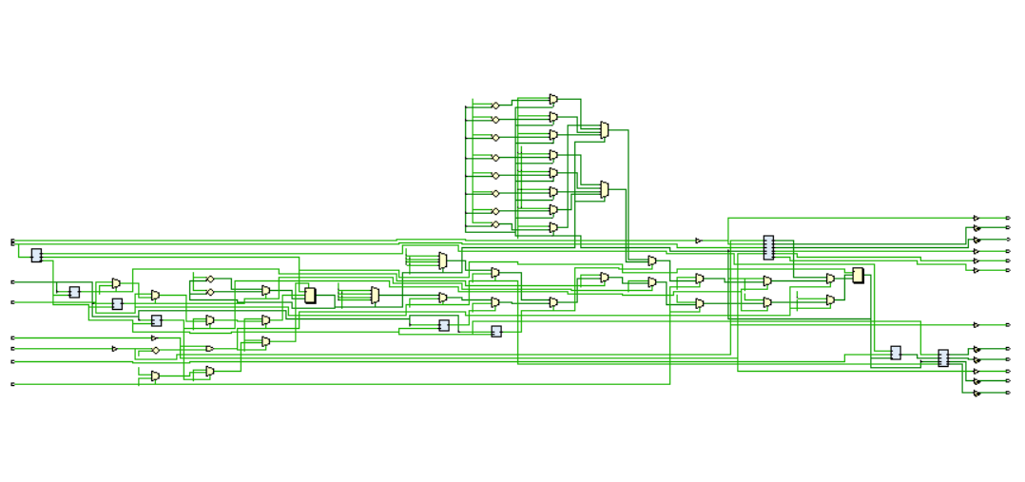
图12： SRAM的RTL门级结构图

- SRAM管脚约束代码
set_property PACKAGE_PIN R15 [get_ports {click[4]}]
set_property PACKAGE_PIN R11 [get_ports {click[3]}]
set_property PACKAGE_PIN V1 [get_ports {click[2]}]
set_property PACKAGE_PIN R17 [get_ports {click[1]}]
set_property PACKAGE_PIN U4 [get_ports {click[0]}]
set_property IOSTANDARD LVCMOS33 [get_ports {click[4]}]
set_property IOSTANDARD LVCMOS33 [get_ports {click[3]}]
set_property IOSTANDARD LVCMOS33 [get_ports {click[2]}]
set_property IOSTANDARD LVCMOS33 [get_ports {click[1]}]
set_property IOSTANDARD LVCMOS33 [get_ports {click[0]}]
set_property IOSTANDARD LVCMOS33 [get_ports {pos[3]}]
set_property IOSTANDARD LVCMOS33 [get_ports {pos[2]}]
set_property IOSTANDARD LVCMOS33 [get_ports {pos[1]}]
set_property IOSTANDARD LVCMOS33 [get_ports {pos[0]}]
set_property IOSTANDARD LVCMOS33 [get_ports {pos1[3]}]
set_property IOSTANDARD LVCMOS33 [get_ports {pos1[2]}]
set_property IOSTANDARD LVCMOS33 [get_ports {pos1[1]}]
set_property IOSTANDARD LVCMOS33 [get_ports {pos1[0]}]
set_property IOSTANDARD LVCMOS33 [get_ports {seg[7]}]
set_property IOSTANDARD LVCMOS33 [get_ports {seg[6]}]
set_property IOSTANDARD LVCMOS33 [get_ports {seg[5]}]
set_property IOSTANDARD LVCMOS33 [get_ports {seg[4]}]
set_property IOSTANDARD LVCMOS33 [get_ports {seg[3]}]
set_property IOSTANDARD LVCMOS33 [get_ports {seg[2]}]
set_property IOSTANDARD LVCMOS33 [get_ports {seg[1]}]
set_property IOSTANDARD LVCMOS33 [get_ports {seg[0]}]
set_property IOSTANDARD LVCMOS33 [get_ports {seg1[7]}]
set_property IOSTANDARD LVCMOS33 [get_ports {seg1[6]}]
set_property IOSTANDARD LVCMOS33 [get_ports {seg1[5]}]
set_property IOSTANDARD LVCMOS33 [get_ports {seg1[4]}]
set_property IOSTANDARD LVCMOS33 [get_ports {seg1[3]}]
set_property IOSTANDARD LVCMOS33 [get_ports {seg1[2]}]
set_property IOSTANDARD LVCMOS33 [get_ports {seg1[1]}]
set_property IOSTANDARD LVCMOS33 [get_ports {seg1[0]}]
set_property IOSTANDARD LVCMOS33 [get_ports clk100mhz]
set_property IOSTANDARD LVCMOS33 [get_ports clr]
set_property IOSTANDARD LVCMOS33 [get_ports res]
set_property IOSTANDARD LVCMOS33 [get_ports start]
set_property PACKAGE_PIN G2 [get_ports {pos[3]}]
set_property PACKAGE_PIN C2 [get_ports {pos[2]}]
set_property PACKAGE_PIN C1 [get_ports {pos[1]}]
set_property PACKAGE_PIN H1 [get_ports {pos[0]}]
set_property PACKAGE_PIN G1 [get_ports {pos1[3]}]
set_property PACKAGE_PIN F1 [get_ports {pos1[2]}]
set_property PACKAGE_PIN E1 [get_ports {pos1[1]}]
set_property PACKAGE_PIN G6 [get_ports {pos1[0]}]
set_property PACKAGE_PIN D5 [get_ports {seg[7]}]
set_property PACKAGE_PIN B3 [get_ports {seg[5]}]
set_property PACKAGE_PIN B1 [get_ports {seg[3]}]
set_property PACKAGE_PIN H2 [get_ports {seg1[7]}]
set_property PACKAGE_PIN B2 [get_ports {seg[6]}]
set_property PACKAGE_PIN A1 [get_ports {seg[4]}]
set_property PACKAGE_PIN A3 [get_ports {seg[2]}]
set_property PACKAGE_PIN A4 [get_ports {seg[1]}]
set_property PACKAGE_PIN B4 [get_ports {seg[0]}]
set_property PACKAGE_PIN D2 [get_ports {seg1[6]}]
set_property PACKAGE_PIN E2 [get_ports {seg1[5]}]
set_property PACKAGE_PIN F3 [get_ports {seg1[4]}]
set_property PACKAGE_PIN F4 [get_ports {seg1[3]}]
set_property PACKAGE_PIN D3 [get_ports {seg1[2]}]
set_property PACKAGE_PIN E3 [get_ports {seg1[1]}]
set_property PACKAGE_PIN D4 [get_ports {seg1[0]}]
set_property PACKAGE_PIN P17 [get_ports clk100mhz]
set_property PACKAGE_PIN P5 [get_ports clr]
set_property PACKAGE_PIN P3 [get_ports res]
set_property PACKAGE_PIN P4 [get_ports start]

set_property IOSTANDARD LVCMOS33 [get_ports {addrBus[18]}]
set_property IOSTANDARD LVCMOS33 [get_ports {addrBus[17]}]
set_property IOSTANDARD LVCMOS33 [get_ports {addrBus[16]}]
set_property IOSTANDARD LVCMOS33 [get_ports {addrBus[15]}]
set_property IOSTANDARD LVCMOS33 [get_ports {addrBus[14]}]
set_property IOSTANDARD LVCMOS33 [get_ports {addrBus[13]}]
set_property IOSTANDARD LVCMOS33 [get_ports {addrBus[12]}]
set_property IOSTANDARD LVCMOS33 [get_ports {addrBus[11]}]
set_property IOSTANDARD LVCMOS33 [get_ports {addrBus[10]}]
set_property IOSTANDARD LVCMOS33 [get_ports {addrBus[9]}]
set_property IOSTANDARD LVCMOS33 [get_ports {addrBus[8]}]
set_property IOSTANDARD LVCMOS33 [get_ports {addrBus[7]}]
set_property IOSTANDARD LVCMOS33 [get_ports {addrBus[6]}]
set_property IOSTANDARD LVCMOS33 [get_ports {addrBus[5]}]
set_property IOSTANDARD LVCMOS33 [get_ports {addrBus[4]}]
set_property IOSTANDARD LVCMOS33 [get_ports {addrBus[3]}]
set_property IOSTANDARD LVCMOS33 [get_ports {addrBus[2]}]
set_property IOSTANDARD LVCMOS33 [get_ports {addrBus[1]}]
set_property IOSTANDARD LVCMOS33 [get_ports {addrBus[0]}]
set_property IOSTANDARD LVCMOS33 [get_ports {dataBus1[15]}]
set_property IOSTANDARD LVCMOS33 [get_ports {dataBus1[14]}]
set_property IOSTANDARD LVCMOS33 [get_ports {dataBus1[13]}]
set_property IOSTANDARD LVCMOS33 [get_ports {dataBus1[12]}]
set_property IOSTANDARD LVCMOS33 [get_ports {dataBus1[11]}]
set_property IOSTANDARD LVCMOS33 [get_ports {dataBus1[10]}]
set_property IOSTANDARD LVCMOS33 [get_ports {dataBus1[9]}]
set_property IOSTANDARD LVCMOS33 [get_ports {dataBus1[8]}]
set_property IOSTANDARD LVCMOS33 [get_ports {dataBus1[7]}]
set_property IOSTANDARD LVCMOS33 [get_ports {dataBus1[6]}]
set_property IOSTANDARD LVCMOS33 [get_ports {dataBus1[5]}]
set_property IOSTANDARD LVCMOS33 [get_ports {dataBus1[4]}]
set_property IOSTANDARD LVCMOS33 [get_ports {dataBus1[3]}]
set_property IOSTANDARD LVCMOS33 [get_ports {dataBus1[2]}]
set_property IOSTANDARD LVCMOS33 [get_ports {dataBus1[1]}]
set_property IOSTANDARD LVCMOS33 [get_ports {dataBus1[0]}]
set_property IOSTANDARD LVCMOS33 [get_ports ce]
set_property IOSTANDARD LVCMOS33 [get_ports control]
set_property IOSTANDARD LVCMOS33 [get_ports clt]
set_property IOSTANDARD LVCMOS33 [get_ports lb]
set_property IOSTANDARD LVCMOS33 [get_ports oe]
set_property PACKAGE_PIN U17 [get_ports {dataBus1[0]}]
set_property PACKAGE_PIN U18 [get_ports {dataBus1[1]}]
set_property PACKAGE_PIN U16 [get_ports {dataBus1[2]}]
set_property PACKAGE_PIN V17 [get_ports {dataBus1[3]}]
set_property PACKAGE_PIN T11 [get_ports {dataBus1[4]}]
set_property PACKAGE_PIN U11 [get_ports {dataBus1[5]}]
set_property PACKAGE_PIN U12 [get_ports {dataBus1[6]}]
set_property PACKAGE_PIN V12 [get_ports {dataBus1[7]}]
set_property PACKAGE_PIN V10 [get_ports {dataBus1[8]}]
set_property PACKAGE_PIN V11 [get_ports {dataBus1[9]}]
set_property PACKAGE_PIN U14 [get_ports {dataBus1[10]}]
set_property PACKAGE_PIN V14 [get_ports {dataBus1[11]}]
set_property PACKAGE_PIN T13 [get_ports {dataBus1[12]}]
set_property PACKAGE_PIN U13 [get_ports {dataBus1[13]}]
set_property PACKAGE_PIN T9 [get_ports {dataBus1[14]}]
set_property PACKAGE_PIN T10 [get_ports {dataBus1[15]}]
set_property PACKAGE_PIN T15 [get_ports {addrBus[0]}]
set_property PACKAGE_PIN T14 [get_ports {addrBus[1]}]
set_property PACKAGE_PIN N16 [get_ports {addrBus[2]}]
set_property PACKAGE_PIN N15 [get_ports {addrBus[3]}]
set_property PACKAGE_PIN M17 [get_ports {addrBus[4]}]
set_property PACKAGE_PIN M16 [get_ports {addrBus[5]}]
set_property PACKAGE_PIN P18 [get_ports {addrBus[6]}]
set_property PACKAGE_PIN N17 [get_ports {addrBus[7]}]
set_property PACKAGE_PIN P14 [get_ports {addrBus[8]}]
set_property PACKAGE_PIN N14 [get_ports {addrBus[9]}]
set_property PACKAGE_PIN T18 [get_ports {addrBus[10]}]
set_property PACKAGE_PIN R18 [get_ports {addrBus[11]}]
set_property PACKAGE_PIN M13 [get_ports {addrBus[12]}]
set_property PACKAGE_PIN R13 [get_ports {addrBus[13]}]
set_property PACKAGE_PIN R12 [get_ports {addrBus[14]}]
set_property PACKAGE_PIN M18 [get_ports {addrBus[15]}]
set_property PACKAGE_PIN L18 [get_ports {addrBus[16]}]
set_property PACKAGE_PIN L16 [get_ports {addrBus[17]}]
set_property PACKAGE_PIN L15 [get_ports {addrBus[18]}]
set_property PACKAGE_PIN V15 [get_ports ce]
set_property PACKAGE_PIN P2 [get_ports clt]
set_property PACKAGE_PIN R2 [get_ports control]
set_property PACKAGE_PIN R10 [get_ports lb]
set_property PACKAGE_PIN T16 [get_ports oe]
set_property PACKAGE_PIN V16 [get_ports w]
set_property PACKAGE_PIN R16 [get_ports ub]
set_property IOSTANDARD LVCMOS33 [get_ports ub]
set_property IOSTANDARD LVCMOS33 [get_ports w]

set_property IOSTANDARD LVCMOS33 [get_ports changeaddr]
set_property PACKAGE_PIN M4 [get_ports changeaddr]

set_property PACKAGE_PIN J3 [get_ports changeaddr1]
set_property IOSTANDARD LVCMOS33 [get_ports changeaddr1]
- FPGA板级验证图像，见实验结果与分析所示
四：实验结果与分析
- 滚动显示数码管顶层模块示意图：
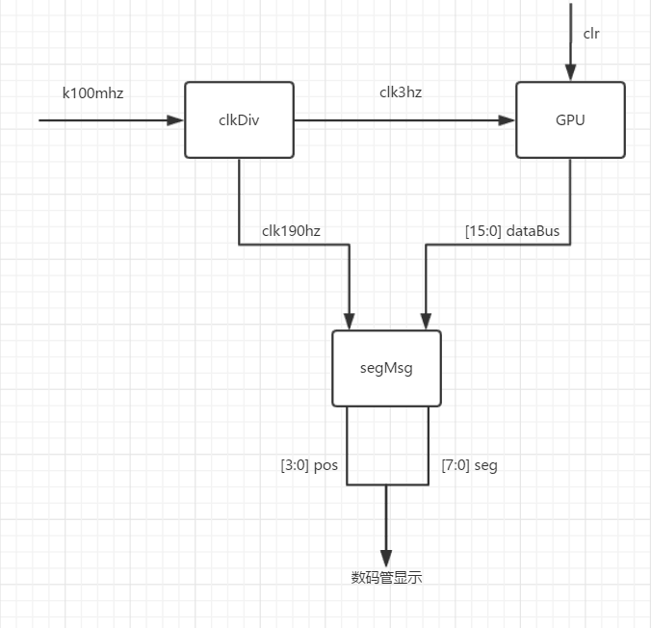
图13 模块框图示意图
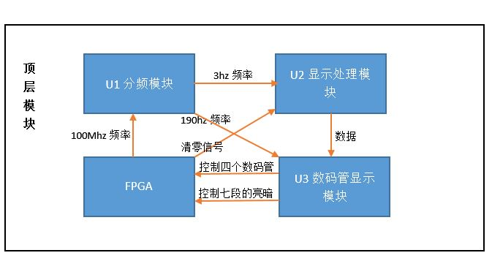
图14：模块示意图
- 板级验证图像
- 实验3.1 FPGA板级验证图像
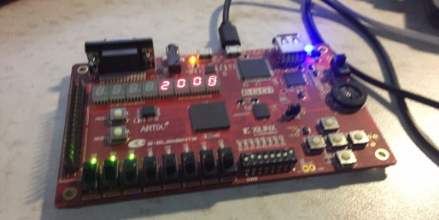
图15： 在七段数码管上滚动显示学号

- 实验3.2FPGA板级验证图像

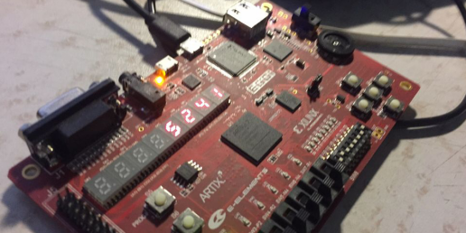
图16： 在七段数码管上滚动显示学号

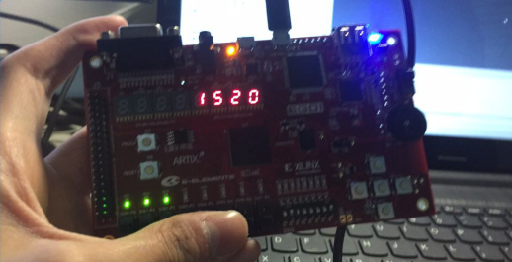
图17： 通过按键输入学号，并循环显示

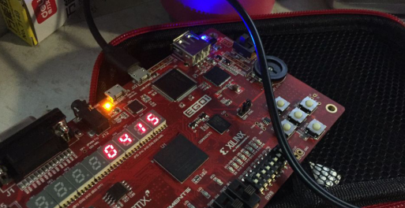
图18： 通过按键输入学号，并循环显示

- 实验3.3 SRAM芯片数据存取示意图情况
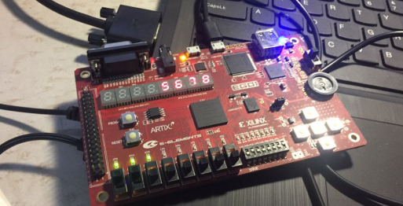
图19： SRAM芯片数据存取

五：结论（讨论）
1、实验结论
电路的输出同时依赖于电路之前的状态和当前输入值的一类常用电路，这种电路称为时序电路。在大部分的情况下，由一个时钟信号控制的时序电路成为同步时序电路，而没有时钟控制信号的时序的电路称为异步时序电路。同步电路易于设计，并且得到广泛的实际应用。但是缺点也是显而易见的，功耗大，时钟是高频率信号，而时钟必须分布到各个触发器，而不管触发器是否要工作，并且，由于最大的时钟频率是由电路中最慢的逻辑路径所决定的，限制了工作的最高频率。但是，相比之下，同步时序电路还是可以获得比异步时序电路更高的工作可靠性和工作速度。
SRAM是静态随机存储器，通常作为CPU的存储器使用。板卡搭载的 IS61WV12816DBLL SRAM 芯片，总容量2Mbit。该 SRAM 为异步式 SRAM，最高存取时间可达 8ns。操控简单，易于读写。RAM (Random Access Memory随机存贮器）是指通过指令可以随机地、个别地对每个存储单元进行访问、访问所需时间基本固定、且与存储单元地址无关的可以读写的存储器。几乎所有的计算机系统和智能电子产品中，都是采用RAM作为主存。
在系统内部，RAM是仅次于CPU的最重要的器件之一。它们之间的关系，就如人的大脑中思维与记忆的关系一样，实际上是密不可分的。但在计算机内部，它们却是完全独立的器件，沿着各自的道路向前发展。在CPU和RAM之间有一条高速数据通道，CPU所要处理的数据和指令必须先放到RAM中等待。而CPU也把大部分正在处理的中间数据暂时放置在RAM中，这就要求RAM和CPU之间的速度保持匹配。
2、讨论
本次试验比较成功，通过本次试验，我掌握了SRAM设计方法与测试方法和FPGA板上数码的设置方法，还掌握了常用中规模集成计数器的逻辑功能和使用方法，在整个大模块框图下，把每个功能划分成不同的小模块，其中，很大一部分都是组合逻辑电路的关键知识的结合实现不同的功能，通过wire进行连接，最终完成了整个系统的设计，使我对数字电路设计有了更加深刻的理解，加深了我对相关数字逻辑理论的认识。
本次实验中，关于分频电路，SRAM设计上都存在另外的设计思路，同时，数字滚动的设计也体现了数字电路设计中的多样性，因此在实际设计中，我们应该努力拓展自己的思路，应用多种角度去思考，以便设计出更加合理高效的电路。

六、教师评审

教师评语 | 实验成绩
签名：

日期：

