# 环节拖拽实现顺序调整、工种拖拽实现流水线调整

<https://segmentfault.com/a/1190000013090341>

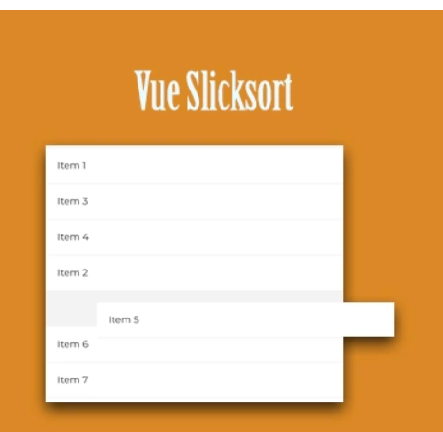

<https://jexordexan.github.io/vue-slicksort/?selectedKind=Vertical%20sorting&selectedStory=Simple%20list&full=0&addons=1&stories=1&panelRight=0&addonPanel=storybook%2Factions%2Factions-panel>

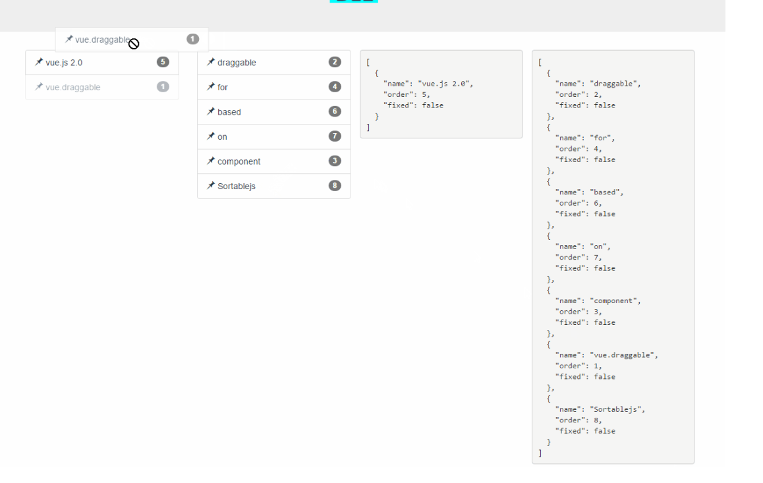

<https://github.com/SortableJS/Vue.Draggable>

# 2 看板插件

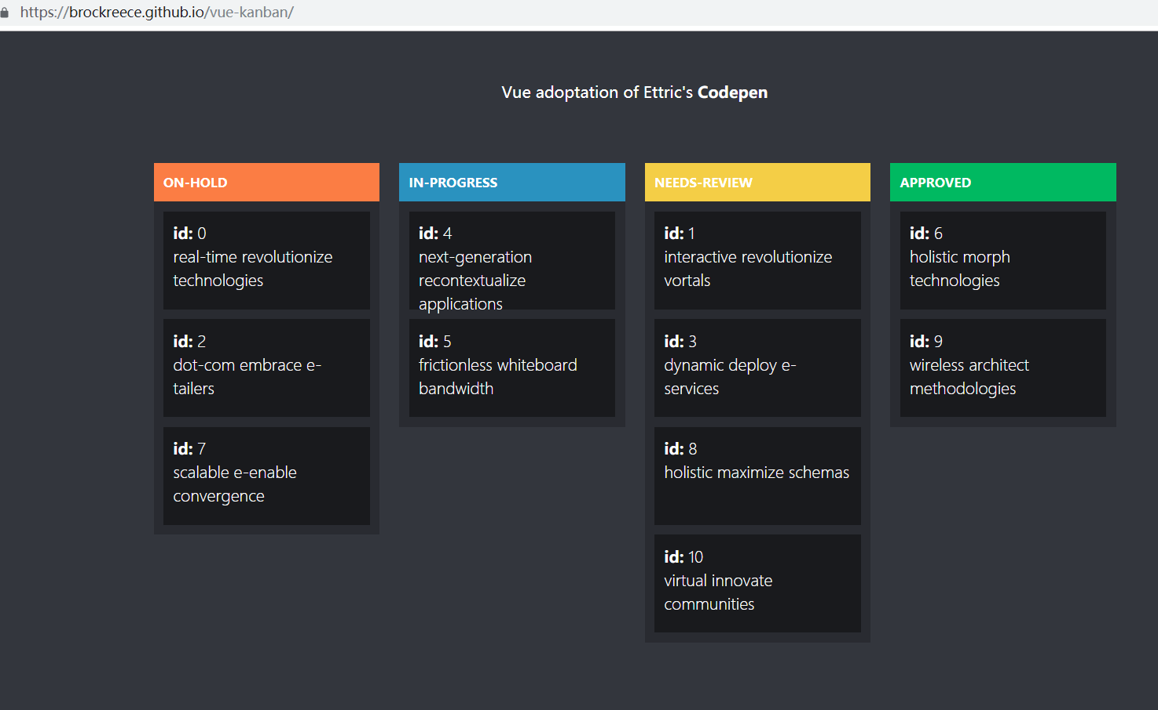

<https://brockreece.github.io/vue-kanban/>