官方网站：<http://www.mathieusavard.info/threesixty/demo.html>

插件优点：

1 可以通过鼠标点击、鼠标移动和自动旋转

2 无css，使用简单

初始化：

<script language="javascript">

$(function() {

//l'array ARR va contenir la liste des images

var arr = [];

//trop lazy pour tout taper...

for (var x=1450; x<= 1480; x++)

arr.push("MAT_" +x + ".jpg");

var arr2 = []

for (var x=1; x<= 25; x++)

arr2.push(x + ".jpg");

//bindons le widget rotate � l'image pic avec la liste d'image arr

$("#mousemove").threesixty({images:arr, method:'mousemove', 'cycle':3, direction:"backward"});

$("#click").threesixty({images:arr2, method:'click', 'cycle':1, 'resetMargin': 10});

$("#img360").threesixty({images:arr2, method:'auto', autoscrollspeed:100});

});

</script>

其中selector为图片id，如html：

<div class="img360_holder">

<img src="../static/img/360pics/RubberBelt 0421.1.png" id="img360" class="img360"/>

<p class="p_title" >

<span class="white_span">欢迎"触摸"</span>

<span class="yellow_span">下一个世界！</span>

</p>

<p class="p_title_2" > Cast II </p>

</div>

# 360 panorama for Jquery

[Back to my personal site and resume](http://www.mathieusavard.info/)

Hi, my name is Mathieu and I do javascript development and jQuery plugins. You are probably reading this page because of your interest in jQuery threesixty. If you'd like to hire me for a private development or to extend this one, feel free to visit [my main site](http://www.mathieusavard.info/) and contact me.

## Demos



Method mouvemove (cycle:3), direction:"backward"

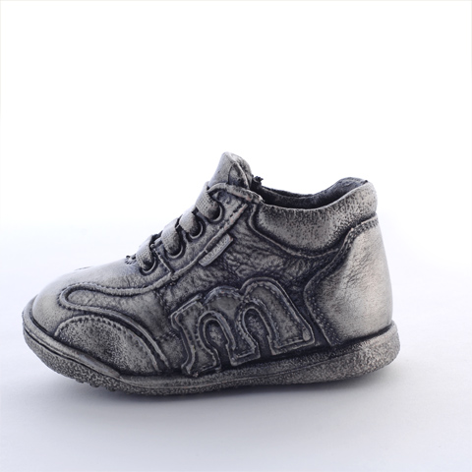

Method click (cycle:1, resetMargin:10)

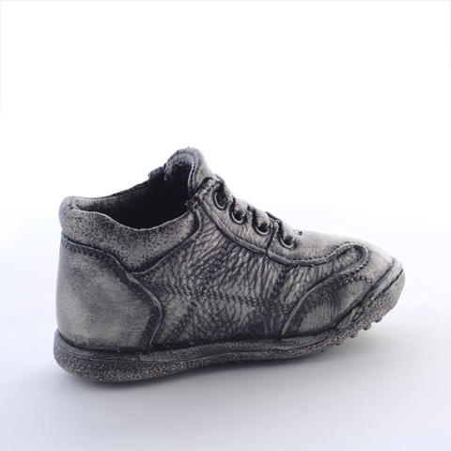

Method auto (autoscrollspeed:100)

## Usage

$("selector").threesixty({images:[array of images], method:'click', direction:'forward', sensibility: 1});

## Features

* method... can be "click", "mousemove" or "auto"
* sensibility to adjust rotation speed
* autoscrollspeed to adjust the speed when method "auto" is selected (lower number gives faster rotation)
* when method is "click" parameter resetMargin indicates a frame thick of n pixels inside the image. Whenever the mouse get into that zone, the action is disabled. This is used to prevent action to occur outside the picture or is the mouse button is released outside of it. 0=infinity=default. (new in 0.3) [thanks to Darrin Brunner for the input]
* parameter direction can be either "forward" or "backward" depending on how your photos were taken and how you want them to appear [Thanks to Pete Baker for the input]
* cycle (see demo) (new in 0.2)
* Preload images
* Display a progress bar expressing loading progress

Releases

* 0.6: Added a method "auto" for making the object simply rotate without user interaction. Tested with jQuery 1.6
* 0.5: complete re-write. No more browser sniffing. Faster performance. A loading progress bar is shown. Now on Github + MIT licensed.
* 0.4: added the direction option.
* 0.3: click method now works then the mouse button is released when mouse cursor is outside the picture. Now runs with jQuery latest (1.3.2). Doesn't require dimension plug-in anymore.
* 0.2.1: mainly a bug fix for click method, has been checked with ie, firefox and safari.

Future features

* Option to zoom into an array of even higher resolution images

Require

* Jquery (tested with 1.3, 1.4, 1.5, 1.6)
* An ordered array of same-size image

[Download](http://www.mathieusavard.info/threesixty/jquery.threesixty.js)

## How-to report an issue

[Please use github issue tracker](http://github.com/matdumsa/jQuery.threesixty/issues)

## Comments

matdumsa _at! mathieusavard dot info

## Donation

Donations are always appreciated, if you would like to request a new feature, please write it in the donation form.

窗体顶端

 https://www.paypal.com/en_US/i/scr/pixel.gif

窗体底端