CHAPTER IV
METHODOLOGY
This chapter presents the methodology used in developing the Smart Water Monitoring Consumption System. Following the sequence of the supplied Chapter 4 reference, it discusses requirements and use cases, system design and user interfaces, the entity relationship diagram, the data dictionary, development and testing, the implementation plan, encountered challenges, and implementation results. All technical statements are based on the implemented Laravel application, ESP32 firmware, database migrations, routes, services, views, and automated tests of the Smart Water project.

4.1 Requirements Analysis and Requirements Documentation
Requirements analysis identified three principal actors: the municipal administrator, the household account holder, and the commissioned smart meter. The administrator manages household records, municipal meters, water-rate configuration, billing statements, leak incidents, notifications, analytics, reports, and audit information. The household user reviews live and historical consumption, estimated billing, leak status, notifications, and account settings. The smart meter measures flow-sensor pulses and submits authenticated interval readings to the server.

4.1.1 Functional Requirements
ID | Requirement | Verified Project Behavior
FR-01 | User and access management | Administrator creates and manages household accounts; public registration is restricted; account status governs access.
FR-02 | Municipal device lifecycle | Register, assign, activate, rotate credentials, reassign, suspend, and decommission meters.
FR-03 | Telemetry ingestion | Accept authenticated interval readings containing a stable reading identifier, flow rate, liters used, meter state, and device diagnostics.
FR-04 | Consumption monitoring | Display live readings, daily/weekly/monthly history, summaries, comparisons, and availability states.
FR-05 | Estimated billing | Apply the latest applicable water rate, fixed charge, subsidy, and billable consumption to estimates and monthly statements.
FR-06 | Leak and threshold detection | Evaluate server-configured thresholds, notify affected users, and support an administrator resolution workflow.
FR-07 | Notifications | Create, read, archive, retry, and remove household or administrative notices according to role and ownership.
FR-08 | Reports and exports | Produce consumption, billing, leak, notification, and operational reports with filtering and export support.
FR-09 | Audit and analytics | Record administrative/security activity and present household- or administrator-scoped analytics.
FR-10 | Account maintenance | Allow authenticated users to update permitted profile fields and change passwords.

4.1.2 Non-Functional Requirements
Quality Attribute | System Response
Security | Laravel Sanctum tokens, role middleware, scoped device credentials, hashed one-time activation codes, token revocation, and audit redaction.
Reliability | Stable reading identifiers prevent double counting; unsent meter intervals are retained in ESP32 Preferences until acknowledged.
Performance | The meter uploads at three-second intervals and the web interface is designed to refresh live information at the same cadence.
Data integrity | Foreign keys, validation, unique identifiers, server-owned household/device associations, precision-preserving numeric fields, and historical charge snapshots.
Usability | Responsive administrator and household workspaces, accessible labels, keyboard-oriented controls, role identification, and light/dark theme support.
Maintainability | Controllers are grouped by feature; models represent domain entities; services isolate billing, analytics, consumption, and audit logic.
Portability | The web application supports SQLite or MySQL, while the field device targets ESP32-S3/M5Stack CoreS3 hardware.

4.1.3 Use-Case Diagram
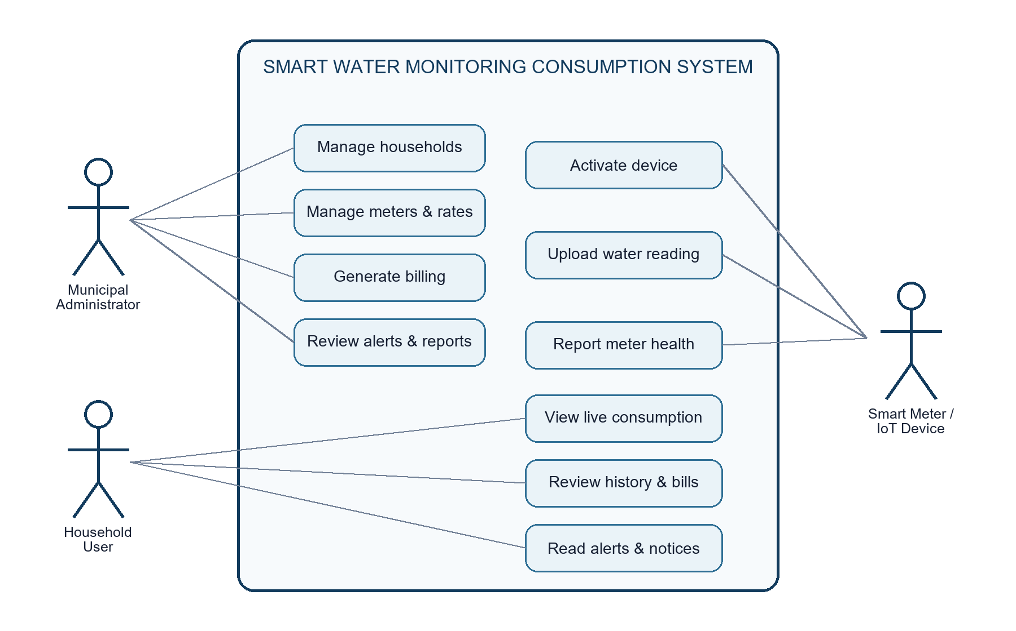
Figure 4.1. Use-case overview of the Smart Water Monitoring Consumption System.

4.1.4 Use-Case Descriptions
The following use-case descriptions adapt the detailed documentation format shown in the reference to the implemented Smart Water actors and workflows. Each specification identifies the responsible actor, scenario, trigger, normal sequence, supporting path, and exceptional conditions.

4.1.4.1 Manage Households
Use Case Name: Manage Households | ID: UC-01 | Importance Level: High
Primary Actor: Municipal Administrator | Use Case Type: Essential
Scenario: The administrator wants to create, review, update, or change the operational status of a household account.
Brief Description: Maintains household identity, service address, contact information, account number, access status, and meter-assignment readiness.
Trigger: The administrator selects Customer Management from the administrative workspace.
Normal Flow of Events:
- The administrator signs in and opens Customer Management.
- The system displays searchable and filterable household records.
- The administrator creates a new household or selects an existing record.
- The administrator enters or updates the permitted household information.
- The system validates required fields, unique account details, role, and status.
- The system saves the household record and logs the administrative activity.
Sub Flows: The administrator may suspend, deactivate, archive, reactivate, or unassign the household meter when authorized.
Alternative/Exceptional Flows: Duplicate emails or account numbers, missing required fields, and unauthorized role changes are rejected with a validation response.
Table 4.1.1 Manage Households

4.1.4.2 Manage Meters and Rates
Use Case Name: Manage Meters and Rates | ID: UC-02 | Importance Level: High
Primary Actor: Municipal Administrator | Use Case Type: Essential
Scenario: The administrator wants to manage municipal smart meters and configure the water rates and monitoring rules applied to households.
Brief Description: Combines meter registration, assignment, maintenance, credential control, and effective-dated water-rate and alert configuration.
Trigger: The administrator opens Device Management or Water Rate Management.
Normal Flow of Events:
- The administrator opens the required meter or rate module.
- The system displays the current devices or active billing configurations.
- For a meter, the administrator registers, assigns, reassigns, suspends, rotates credentials, or decommissions the asset.
- For a rate, the administrator enters the water rate, fixed charge, subsidy, currency, effective date, and alert thresholds.
- The system validates identifiers, household eligibility, numeric ranges, and effective dates.
- The system saves the approved meter or rate configuration and records the activity.
Sub Flows: The administrator may review meter health, calibration dates, activation state, last-seen status, or household-specific rate overrides.
Alternative/Exceptional Flows: Duplicate assets, ineligible household assignments, invalid rates, negative charges, and unauthorized changes are rejected.
Table 4.1.2 Manage Meters and Rates

4.1.4.3 Generate Billing
Use Case Name: Generate Billing | ID: UC-03 | Importance Level: High
Primary Actor: Municipal Administrator | Use Case Type: Essential
Scenario: The administrator wants to generate a monthly billing statement for an eligible household.
Brief Description: Aggregates billable consumption, applies the applicable rate configuration, and preserves a historical charge snapshot.
Trigger: The administrator chooses Generate Statement in Billing Management.
Normal Flow of Events:
- The administrator opens Billing Management.
- The administrator selects the household and billing month.
- The system validates the period, household, billable readings, and applicable rate.
- The billing service totals liters and converts the result to cubic meters.
- The service applies the water rate, fixed charge, subsidy, and opening balance.
- The system stores the statement, charge breakdown, remaining balance, and payment status.
- The administrator reviews the generated billing record.
Sub Flows: Authorized staff may record payments and update the statement status through the implemented billing workflow.
Alternative/Exceptional Flows: Duplicate billing months, missing billable readings, or unavailable rate configurations produce a specific response without creating a misleading statement.
Table 4.1.3 Generate Billing

4.1.4.4 Review Alerts and Reports
Use Case Name: Review Alerts and Reports | ID: UC-04 | Importance Level: High
Primary Actor: Municipal Administrator | Use Case Type: Essential
Scenario: The administrator wants to review leak or consumption alerts and examine municipal operational reports.
Brief Description: Supports alert investigation, incident follow-up, analytics, filtered reports, and supported data exports.
Trigger: The administrator opens Leak Monitoring, Reports, Analytics, or the administrative notification view.
Normal Flow of Events:
- The administrator selects the alert or report module.
- The administrator chooses the affected household, report type, date range, or filter.
- The system validates authorization and input parameters.
- The system retrieves the related readings, alerts, billing information, and operational summaries.
- The administrator reviews the evidence and records follow-up notes when an incident is involved.
- The administrator resolves, marks false, or reopens an alert, or exports a supported report.
Sub Flows: The administrator may review notification delivery state, analytic summaries, and audit context related to an operational event.
Alternative/Exceptional Flows: Invalid ranges, unsupported exports, missing incident identifiers, and unauthorized access return clear validation or access responses.
Table 4.1.4 Review Alerts and Reports

4.1.4.5 View Live Consumption
Use Case Name: View Live Consumption | ID: UC-05 | Importance Level: High
Primary Actor: Household User | Use Case Type: Essential
Scenario: The household user wants to view the latest water consumption and meter state.
Brief Description: Displays the latest owned reading, current flow, interval consumption, estimated billing state, leak state, and meter availability.
Trigger: The household user opens the Dashboard or Live Monitoring page.
Normal Flow of Events:
- The household user signs in.
- The user opens Dashboard or Live Monitoring.
- The browser requests the latest household-scoped readings.
- The server verifies ownership and retrieves the current meter and consumption state.
- The interface displays current flow, liters used, estimated bill, leak status, meter connection, and recent activity.
- The interface refreshes according to the configured near-real-time interval.
Sub Flows: The user may filter recent readings by date or displayed row count.
Alternative/Exceptional Flows: When no active meter or recent reading exists, the interface displays a specific unavailable state rather than misleading zero consumption.
Table 4.1.5 View Live Consumption

4.1.4.6 Review History and Bills
Use Case Name: Review History and Bills | ID: UC-06 | Importance Level: High
Primary Actor: Household User | Use Case Type: Essential
Scenario: The household user wants to review past consumption and current or finalized billing information.
Brief Description: Combines daily, weekly, monthly, or custom consumption history with estimated billing details and monthly statements.
Trigger: The user opens Consumption History or Estimated Billing.
Normal Flow of Events:
- The user selects the consumption-history or billing page.
- For history, the user selects a period or valid custom date range.
- The server retrieves only the household's readings and computes totals, comparisons, and chart data.
- For billing, the server selects the applicable rate and eligible consumption information.
- The interface displays usage summaries, trends, the estimated charge breakdown, and finalized statement history.
- The user reviews the selected history or billing record.
Sub Flows: The household may switch among daily, weekly, and monthly views and inspect individual monthly statements.
Alternative/Exceptional Flows: Invalid ranges are rejected. Missing readings or rate information remain unavailable rather than being interpreted as zero usage or zero charges.
Table 4.1.6 Review History and Bills

4.1.4.7 Read Alerts and Notices
Use Case Name: Read Alerts and Notices | ID: UC-07 | Importance Level: Medium
Primary Actor: Household User | Use Case Type: Essential
Scenario: The household user wants to read leak, consumption, billing, meter, or account notifications.
Brief Description: Presents household-scoped alerts and official notices while preserving the municipality's source and delivery records.
Trigger: The user opens Notifications or selects a recent alert from the household workspace.
Normal Flow of Events:
- The household user signs in and opens Notifications.
- The system retrieves notices owned by the household account.
- The interface displays each notice's type, title, message, date, and read state.
- The user opens a selected alert or notice.
- The system marks the notice as read when applicable.
- The user may remove the notice from the household view.
Sub Flows: Leak-related notices may direct the user to the Leak Detection page for the latest meter signal and response status.
Alternative/Exceptional Flows: A household cannot access another account's notices. User-side removal hides the notice without deleting the municipality's source record.
Table 4.1.7 Read Alerts and Notices

4.1.4.8 Activate Device
Use Case Name: Activate Device | ID: UC-08 | Importance Level: High
Primary Actor: Smart Meter / IoT Device | Use Case Type: Essential
Scenario: A registered M5Stack smart meter wants to exchange its one-time code for a scoped device credential.
Brief Description: Binds the physical hardware to the municipal device record and activates authenticated telemetry access.
Trigger: The technician enters the administrator-issued activation code on the registered device.
Normal Flow of Events:
- The administrator has already registered the meter and issued a short-lived activation code.
- The device submits its UUID, activation code, hardware identity, and firmware version.
- The server verifies that the code is valid, unused, and unexpired.
- The server checks device status and hardware-binding rules.
- The server binds the hardware identity and marks the device active.
- The server issues a scoped device credential.
- The M5Stack stores the credential and becomes ready to upload telemetry.
Sub Flows: An administrator may later rotate the credential or reissue activation after an authorized lifecycle change.
Alternative/Exceptional Flows: Expired, reused, incorrect, or mismatched activation information is rejected and no device credential is issued.
Table 4.1.8 Activate Device

4.1.4.9 Upload Water Reading
Use Case Name: Upload Water Reading | ID: UC-09 | Importance Level: High
Primary Actor: Smart Meter / IoT Device | Use Case Type: Essential
Scenario: An activated smart meter wants to submit a measured water-consumption interval.
Brief Description: Authenticates the device, validates telemetry, stores the reading once, and returns authoritative totals and alert state.
Trigger: The firmware reaches the configured upload interval with a pending measurement.
Normal Flow of Events:
- The sensor counts valid flow pulses during the sampling interval.
- The firmware calculates flow rate and interval liters.
- The device creates a stable reading identifier and stores the pending state.
- The meter submits the reading with its scoped credential.
- The server derives the device and household from the authenticated identity.
- The server validates and stores the reading idempotently.
- The server evaluates thresholds and returns the authoritative total and leak state.
- After acknowledgement, the meter clears the pending interval and advances its sequence.
Sub Flows: The payload may include device name, monitoring state, Wi-Fi strength, and connectivity information.
Alternative/Exceptional Flows: When transmission fails, the pending reading remains available for retry. Duplicate reading identifiers do not double-count consumption.
Table 4.1.9 Upload Water Reading

4.1.4.10 Report Meter Health
Use Case Name: Report Meter Health | ID: UC-10 | Importance Level: Medium
Primary Actor: Smart Meter / IoT Device | Use Case Type: Supporting
Scenario: The smart meter wants to report its connection, firmware, and operational health to the server.
Brief Description: Updates municipal visibility of device connectivity, last-seen activity, telemetry status, firmware version, and relevant diagnostics.
Trigger: The device activates, uploads telemetry, reconnects to the network, or reaches a health-reporting interval.
Normal Flow of Events:
- The M5Stack evaluates its Wi-Fi and server connection state.
- The device prepares its hardware identity, firmware version, monitoring state, signal strength, and health metadata.
- The device submits the health information using its scoped credential.
- The server validates the authenticated device identity.
- The server updates last-seen, last-telemetry, firmware, and operational health fields.
- The administrator workspace displays the latest device status.
Sub Flows: Health information may accompany a water-reading upload to reduce unnecessary network requests.
Alternative/Exceptional Flows: Invalid credentials or mismatched hardware identity are rejected. During network loss, the device retains its state and reports again after reconnection.
Table 4.1.10 Report Meter Health

4.2 System Design, Software, and Processes
The system uses an Internet of Things client-server design. The physical meter performs measurement and short-term persistence, while the Laravel server remains authoritative for identity, ownership, cumulative usage, billing rules, threshold evaluation, and record storage. The browser interfaces consume protected JSON endpoints and present role-specific workspaces.
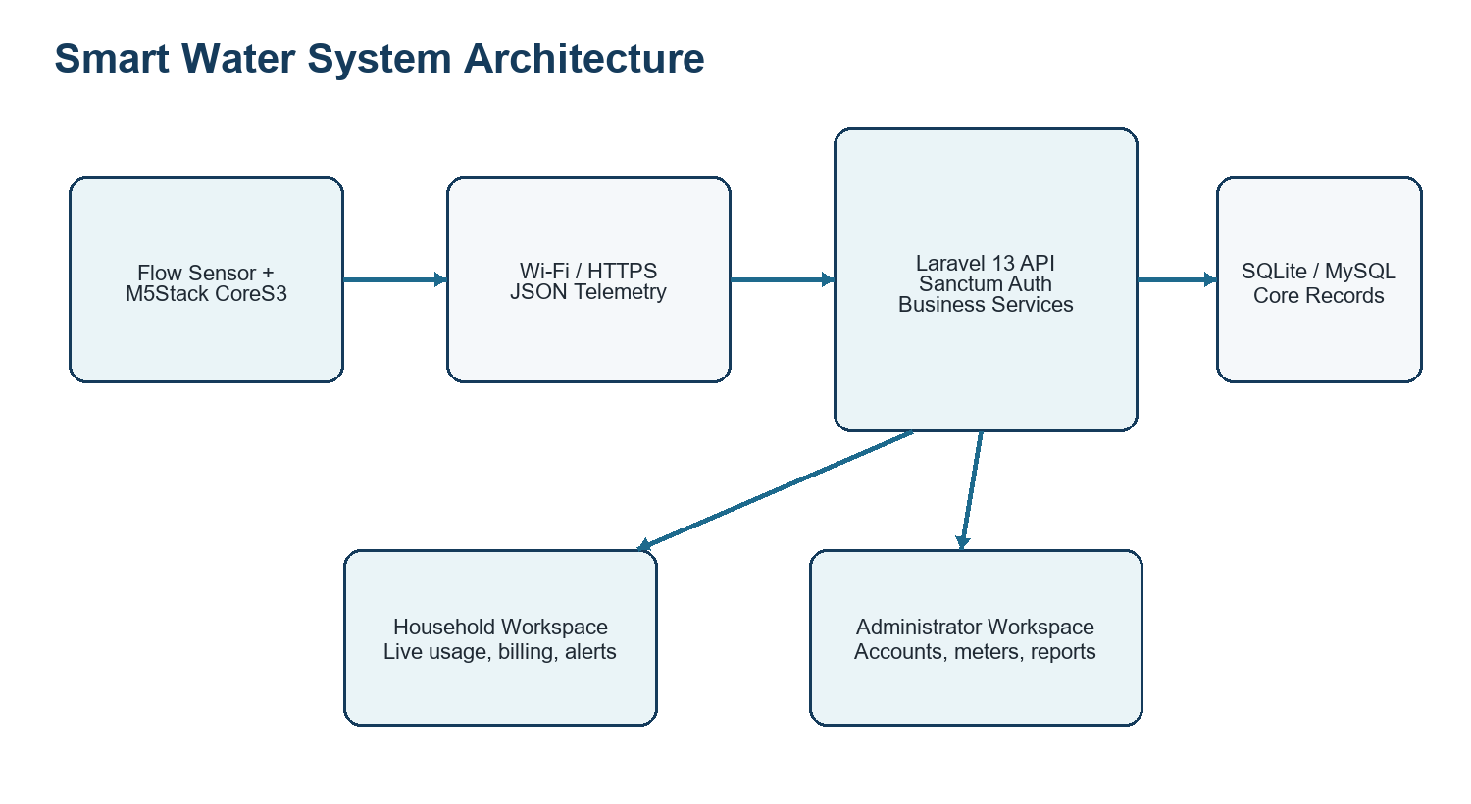
Figure 4.2. Smart Water Monitoring Consumption System architecture.

4.2.1 Telemetry and Billing Process
Commissioning begins in the administrator workspace. The device exchanges its UUID, expiring activation code, hardware ID, and firmware version for a scoped credential. Each reading includes a stable reading_id derived from the registered device identity and local sequence. If transmission fails, the pending interval remains stored in the device. When the API acknowledges the reading, the local sequence advances and the interval accumulator is cleared. The server validates ownership and computes authoritative totals before exposing information to users.
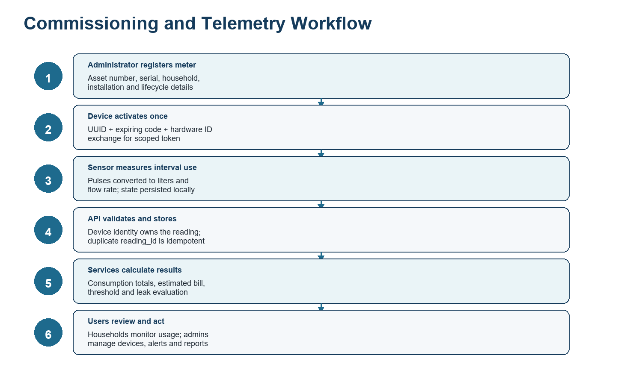
Figure 4.3. Device commissioning, telemetry, calculation, and user-response workflow.

4.2.2 Technology Used
Layer | Technology | Purpose
Backend | PHP 8.3+; Laravel Framework 13.8; Laravel Sanctum 4.0 | Routing, validation, authentication, API controllers, services, reports, and persistence.
Frontend | Blade, JavaScript, Tailwind CSS 4, Vite 8 | Responsive household and administrator workspaces, charts, filters, forms, and live refresh.
Database | SQLite or MySQL | Users, meters, readings, rates, billing statements, notifications, leak alerts, audit logs, sessions, and tokens.
Embedded device | ESP32-S3 / M5Stack CoreS3; M5Unified; Wi-Fi; HTTPClient; Preferences | Pulse measurement, device display, activation, reliable telemetry, and local pending-state storage.
Reporting | Dompdf 3.1.2 and CSV export endpoints | Printable operational reports and downloadable tabular records.
Testing | PHPUnit 12.5.12 through Laravel test runner | Feature verification for access control, telemetry, billing, alerts, analytics, devices, and interfaces.

4.2.3 Output and User Interface Design
The output and user interface design separates household monitoring from municipal administration. Household screens prioritize current flow, consumption history, billing estimates, leak status, notifications, and account settings. Administrator screens prioritize customers, devices, rates, statements, consumption, leak incidents, reports, notifications, analytics, and audit information. The responsive Blade layouts maintain consistent navigation while preserving role-based access boundaries.
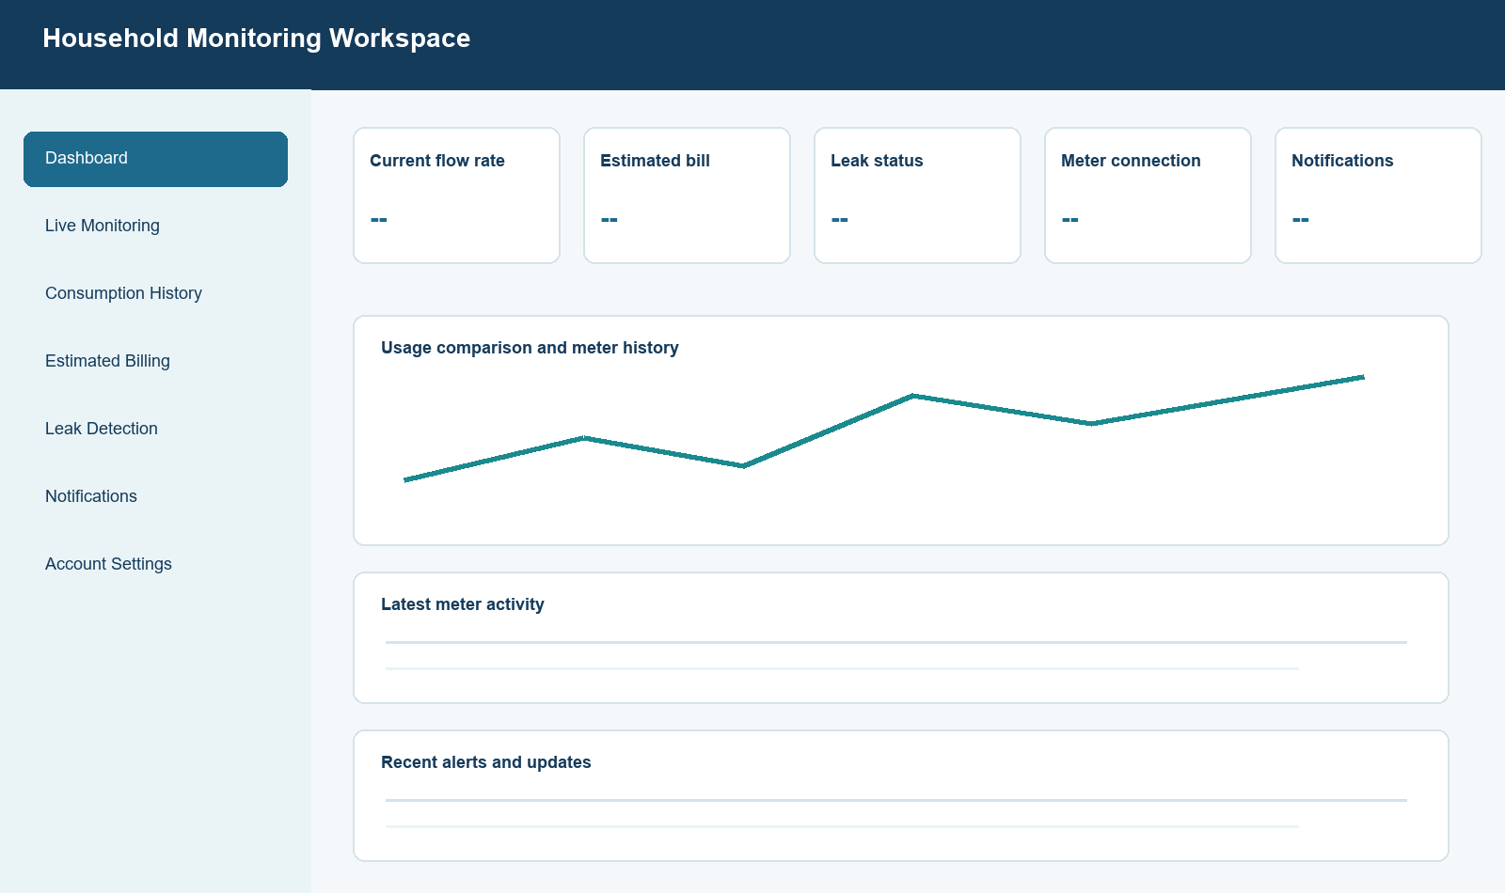
Figure 4.4. Household workspace interface map.
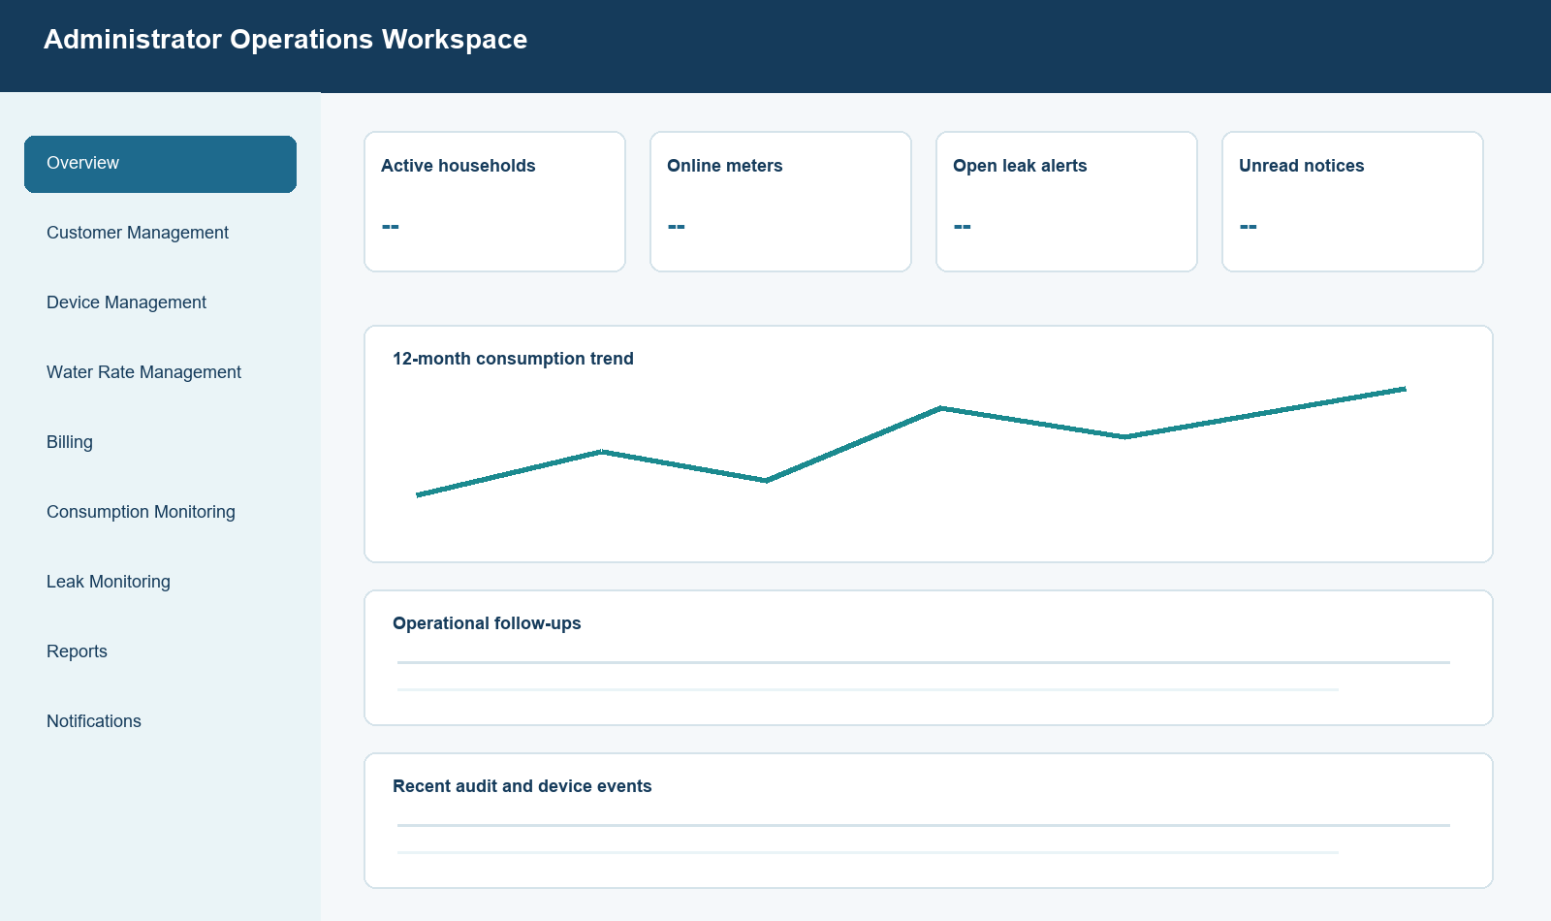
Figure 4.5. Administrator workspace interface map.
User Interface | Primary Outputs | Design Purpose
Household dashboard | Current flow, usage, estimated bill, meter status, leak state, and recent notices | Present essential account information at a glance.
Live monitoring and history | Recent readings, charts, period totals, summaries, and availability states | Support near-real-time review and time-based consumption analysis.
Billing and alerts | Rate breakdown, statements, leak status, thresholds, and notifications | Make charges and exceptional conditions understandable and actionable.
Administrator workspace | Household, meter, rate, billing, consumption, alert, report, and audit records | Centralize municipal operations while maintaining traceability.

4.3 Entity Relationship Diagram
The principal database relationships connect household users to their assigned devices, readings, statements, notifications, and leak incidents. A device may be temporarily unassigned during municipal inventory or maintenance, but an uploaded reading is tied to both the authenticated device and its current household. Billing configuration can be municipal or user-specific, and finalized statements preserve the charge values applied at generation time.
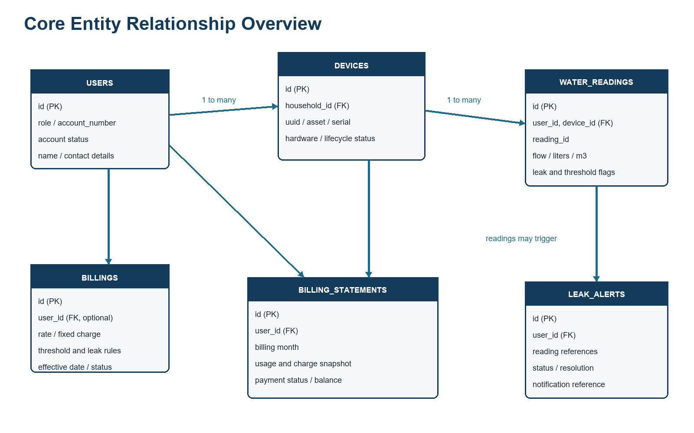
Figure 4.6. Core entity relationship overview (operational fields summarized).

4.4 Data Dictionary
The following data dictionary summarizes the operational tables most directly involved in monitoring, billing, alerting, and administration. Framework-support tables for cache, jobs, sessions, password resets, and personal access tokens remain part of the implementation but are omitted from the main discussion for clarity.

4.4.1 Users Table
The users table stores users data used by the implemented Smart Water application.
Field Name | Data Type | Length | Description
id | BIGINT | 20 | Primary key of the user account.
name | VARCHAR | 255 | Display name of the administrator, household, or device account.
email | VARCHAR | 255 | Unique login or account email address.
role | VARCHAR | 255 | Authorization role: administrator, household user, or device.
account_number | VARCHAR | 255 | Standardized municipal account identifier.
address | VARCHAR | 255 | Required service address for household accounts.
phone | VARCHAR | 255 | Optional contact number.
is_active | BOOLEAN | 1 | Indicates whether the account can remain operational.
email_verified_at | DATETIME | - | Date and time the email was verified.
password | VARCHAR | 255 | Hashed interactive-account password.
remember_token | VARCHAR | 100 | Framework token used for remembered sessions.
created_by_admin | BOOLEAN | 1 | Indicates municipal administrator provisioning.
assigned_user_id | BIGINT | 20 | Household linked to a legacy or supporting device account.
created_by | BIGINT | 20 | Administrator who created the account.
approved_at | DATETIME | - | Date and time the household account was approved.
account_status | VARCHAR | 255 | Lifecycle state such as active, suspended, archived, or deactivated.
created_at | DATETIME | - | Record creation timestamp.
updated_at | DATETIME | - | Record update timestamp.
Table 4.4.1 Database Table of Users

4.4.2 Devices Table
The devices table stores devices data used by the implemented Smart Water application.
Field Name | Data Type | Length | Description
id | BIGINT | 20 | Primary key of the municipal device record.
uuid | VARCHAR | 255 | Unique server-issued device identifier.
asset_number | VARCHAR | 255 | Municipal equipment inventory number.
serial_number | VARCHAR | 255 | Unique manufacturer or field serial number.
name | VARCHAR | 255 | Human-readable meter name.
household_id | BIGINT | 20 | Currently assigned household; nullable while in inventory.
auth_user_id | BIGINT | 20 | Limited authentication identity associated with the device.
hardware_id | VARCHAR | 255 | Bound ESP32 hardware identity.
firmware_version | VARCHAR | 255 | Firmware version reported during activation or telemetry.
status | VARCHAR | 255 | Lifecycle state such as pending, active, suspended, or decommissioned.
maintenance_status | VARCHAR | 255 | Operational or maintenance condition.
installation_address | VARCHAR | 255 | Physical service location of the meter.
installed_at | DATETIME | - | Installation date and time.
last_seen_at | DATETIME | - | Latest successful device contact.
last_telemetry_at | DATETIME | - | Latest accepted telemetry timestamp.
calibrated_at | DATETIME | - | Most recent calibration date.
calibration_due_at | DATETIME | - | Scheduled calibration due date.
token_rotated_at | DATETIME | - | Latest credential rotation timestamp.
revoked_at | DATETIME | - | Credential or device revocation timestamp.
activation_code_hash | VARCHAR | 255 | Hash of the one-time activation code.
activation_expires_at | DATETIME | - | Expiration of the activation code.
activated_at | DATETIME | - | Successful activation timestamp.
notes | TEXT | - | Administrative installation or maintenance notes.
created_at | DATETIME | - | Record creation timestamp.
updated_at | DATETIME | - | Record update timestamp.
Table 4.4.2 Database Table of Devices

4.4.3 Water Readings Table
The water_readings table stores water readings data used by the implemented Smart Water application.
Field Name | Data Type | Length | Description
id | BIGINT | 20 | Primary key of the telemetry record.
user_id | BIGINT | 20 | Household owner of the reading.
device_id | BIGINT | 20 | Authenticated meter that submitted the reading.
reading_id | VARCHAR | 255 | Stable idempotency identifier generated by the device.
flow_rate | DECIMAL | 18,6 | Measured flow rate in liters per minute.
liters_used | DECIMAL | 18,6 | Water volume represented by the interval.
cubic_meter | DECIMAL | 18,6 | Consumption converted to cubic meters.
estimated_bill | DECIMAL | 12,2 | Estimated charge stored with the reading.
rate_per_cubic_meter | DECIMAL | 12,4 | Applicable water rate used for the estimate.
subsidy_deduction | DECIMAL | 12,2 | Subsidy applied to the estimate.
threshold_liters | DECIMAL | 18,6 | Consumption threshold applicable at processing time.
is_threshold_exceeded | BOOLEAN | 1 | Indicates consumption threshold exceedance.
is_possible_leak | BOOLEAN | 1 | Indicates possible leakage under server rules.
leak_detection_status | VARCHAR | 255 | Detailed leak evaluation state.
water_limit_liters | DECIMAL | 18,6 | Configured household water limit snapshot.
monitoring_status | VARCHAR | 255 | Device monitoring state reported with telemetry.
wifi_signal_strength | INTEGER | 11 | Reported Wi-Fi signal strength.
device_connection_status | VARCHAR | 255 | Meter-side connection state.
server_connection_status | VARCHAR | 255 | Latest server acknowledgement state.
device_name | VARCHAR | 255 | Reported or display device name.
device_payload | JSON/TEXT | - | Additional validated device diagnostics.
recorded_at | DATETIME | - | Measurement timestamp supplied or normalized by the server.
created_at | DATETIME | - | Record creation timestamp.
updated_at | DATETIME | - | Record update timestamp.
Table 4.4.3 Database Table of Water Readings

4.4.4 Billing Configurations Table
The billings table stores billing configurations data used by the implemented Smart Water application.
Field Name | Data Type | Length | Description
id | BIGINT | 20 | Primary key of the billing configuration.
user_id | BIGINT | 20 | Household override owner; null indicates municipal default.
water_rate | DECIMAL | 12,4 | Charge per cubic meter.
fixed_monthly_charge | DECIMAL | 12,2 | Fixed recurring monthly charge.
subsidy_deduction | DECIMAL | 12,2 | Configured subsidy deduction.
currency | VARCHAR | 3 | Three-letter billing currency, normally PHP.
effective_date | DATE | - | Date on which the configuration becomes applicable.
threshold_liters | DECIMAL | 18,6 | Consumption alert threshold.
consumption_alert_enabled | BOOLEAN | 1 | Enables consumption threshold notifications.
consumption_alert_unit | VARCHAR | 255 | Unit used by the consumption threshold.
consumption_alert_behavior | VARCHAR | 255 | Audience or handling rule for consumption notices.
leak_alert_enabled | BOOLEAN | 1 | Enables leak alert evaluation.
leak_flow_rate_threshold | DECIMAL | 18,6 | Flow-rate threshold used for possible leak detection.
leak_continuous_duration_minutes | INTEGER | 11 | Required continuous duration before leak handling.
leak_alert_behavior | VARCHAR | 255 | Audience or handling rule for leak notices.
quiet_hours_start | INTEGER | 2 | Starting hour of the configured quiet period.
quiet_hours_end | INTEGER | 2 | Ending hour of the configured quiet period.
is_active | BOOLEAN | 1 | Indicates whether the configuration is applicable.
created_at | DATETIME | - | Record creation timestamp.
updated_at | DATETIME | - | Record update timestamp.
Table 4.4.4 Database Table of Billing Configurations

4.4.5 Billing Statements Table
The billing_statements table stores billing statements data used by the implemented Smart Water application.
Field Name | Data Type | Length | Description
id | BIGINT | 20 | Primary key of the monthly statement.
user_id | BIGINT | 20 | Household billed by the statement.
billing_month | DATE | - | Month represented by the statement.
opening_balance | DECIMAL | 12,2 | Balance carried into the billing period.
total_liters | DECIMAL | 18,6 | Billable water consumption in liters.
total_cubic_meter | DECIMAL | 18,6 | Billable water consumption in cubic meters.
water_rate | DECIMAL | 12,4 | Rate snapshot applied at generation.
fixed_monthly_charge | DECIMAL | 12,2 | Fixed-charge snapshot applied at generation.
subsidy_deduction | DECIMAL | 12,2 | Subsidy snapshot applied at generation.
currency | VARCHAR | 3 | Statement currency.
current_charge | DECIMAL | 12,2 | Charge calculated for the current period.
amount_paid | DECIMAL | 12,2 | Payment recorded against the statement.
remaining_balance | DECIMAL | 12,2 | Outstanding balance after payment.
status | VARCHAR | 255 | Payment state such as unpaid, partial, or paid.
generated_at | DATETIME | - | Date and time the statement was finalized.
paid_at | DATETIME | - | Date and time full payment was recorded.
created_at | DATETIME | - | Record creation timestamp.
updated_at | DATETIME | - | Record update timestamp.
Table 4.4.5 Database Table of Billing Statements

4.4.6 Notifications Table
The notifications table stores notifications data used by the implemented Smart Water application.
Field Name | Data Type | Length | Description
id | BIGINT | 20 | Primary key of the notification.
user_id | BIGINT | 20 | Household recipient; nullable for administrative or batch scope.
water_reading_id | BIGINT | 20 | Related water reading when the notice is telemetry-driven.
type | VARCHAR | 255 | Notification category.
title | VARCHAR | 255 | Short notification heading.
message | TEXT | - | Full notification content.
metadata | JSON/TEXT | - | Structured context used by the interface or workflow.
is_read | BOOLEAN | 1 | Indicates whether the recipient opened the notice.
batch_id | VARCHAR | 255 | Identifier shared by a batch announcement.
delivery_status | VARCHAR | 255 | Delivery lifecycle state.
delivery_error | TEXT | - | Latest delivery failure message when applicable.
scheduled_at | DATETIME | - | Scheduled delivery timestamp.
sent_at | DATETIME | - | Actual delivery or creation timestamp.
archived_at | DATETIME | - | Administrative archive timestamp.
user_deleted_at | DATETIME | - | Household-side removal timestamp without source deletion.
created_at | DATETIME | - | Record creation timestamp.
updated_at | DATETIME | - | Record update timestamp.
Table 4.4.6 Database Table of Notifications

4.4.7 Leak Alerts Table
The leak_alerts table stores leak alerts data used by the implemented Smart Water application.
Field Name | Data Type | Length | Description
id | BIGINT | 20 | Primary key of the leak incident.
user_id | BIGINT | 20 | Affected household.
first_water_reading_id | BIGINT | 20 | First reading associated with the incident.
latest_water_reading_id | BIGINT | 20 | Most recent supporting reading.
notification_id | BIGINT | 20 | Notification associated with the incident.
status | VARCHAR | 255 | Incident state such as detected, acknowledged, resolved, or false alarm.
notes | TEXT | - | Administrative investigation and resolution notes.
detected_at | DATETIME | - | Initial detection timestamp.
last_detected_at | DATETIME | - | Most recent detection timestamp.
notified_at | DATETIME | - | Household notification timestamp.
acknowledged_at | DATETIME | - | Administrative acknowledgement timestamp.
resolved_at | DATETIME | - | Resolution timestamp.
created_at | DATETIME | - | Record creation timestamp.
updated_at | DATETIME | - | Record update timestamp.
Table 4.4.7 Database Table of Leak Alerts

4.4.8 Audit Logs Table
The audit_logs table stores audit logs data used by the implemented Smart Water application.
Field Name | Data Type | Length | Description
id | BIGINT | 20 | Primary key of the audit record.
user_id | BIGINT | 20 | Authenticated actor when available.
action | VARCHAR | 255 | Machine-readable administrative or security action.
auditable_type | VARCHAR | 255 | Type of affected domain record.
auditable_id | BIGINT | 20 | Identifier of the affected domain record.
description | VARCHAR | 255 | Human-readable activity description.
metadata | JSON/TEXT | - | Redacted structured activity context.
outcome | VARCHAR | 255 | Result such as success or failure.
ip_address | VARCHAR | 45 | Request IP address when retained.
user_agent | TEXT | - | Request client or browser description.
request_id | VARCHAR | 255 | Request correlation identifier.
created_at | DATETIME | - | Record creation timestamp.
updated_at | DATETIME | - | Record update timestamp.
Table 4.4.8 Database Table of Audit Logs

4.5 Development and Testing
Development is organized around feature-specific API controllers and domain services. WaterConsumptionService and HouseholdConsumptionService handle aggregation and availability semantics; BillingStatementService preserves monthly charge logic; AnalyticsService produces range-based summaries; and the embedded firmware handles acquisition, display, activation, and delivery reliability. Verification combines automated feature tests with a production frontend build.
Verification | Coverage / Output | Status | Duration | Observation
Laravel automated test suite | 138 tests; 885 assertions | 137 passed; 1 failed | 18.017 seconds | The failing case expected one record but received two in an administrator consumption-history response.
Frontend production build | Vite 8.0.16; 4 modules transformed | Passed | 6.75 seconds | CSS, boot JavaScript, main JavaScript, and manifest were produced successfully.

Current verification status: The project is substantially covered by automated tests, but the suite is not fully green as of 24 August 2026. One consumption-monitoring test must be investigated before claiming complete regression-test acceptance.

4.5.1 Major Test Areas
- Authentication and account restrictions, including blocked, suspended, archived, deleted, and unauthorized users.
- Municipal device registration, activation, hardware binding, credential rotation, reassignment, health, and decommissioning.
- Telemetry validation, device ownership, idempotent reading identifiers, server-authoritative totals, and precision.
- Household live readings, time-zone-aware periods, cumulative-reset handling, missing-data semantics, and billing estimates.
- Water-rate configuration, fixed monthly charges, statement generation, status changes, and historical billing fields.
- Leak alert creation, notification, resolution, false-alarm handling, reopening, and role protection.
- Administrator reporting, analytics, customer management, exports, notification lifecycle, and interface accessibility contracts.

4.6 Implementation Plan
Phase | Owner | Activity | Expected Output
1. Environment preparation | Municipal IT / Developers | Configure PHP, database, application key, mail/queue behavior, timezone, LAN URL, and production assets. | Environment checklist and successful health endpoint.
2. Database deployment | Developers | Back up the target database, run migrations and controlled seeders, and verify indexes and foreign keys. | Current schema and verified baseline records.
3. Administrator setup | System administrator | Create authorized staff accounts, set water rates and alert rules, and verify audit logging. | Operational administrative workspace.
4. Household onboarding | Authorized staff | Create household records with required address, contact details, role, status, and account number. | Active household accounts ready for assignment.
5. Meter commissioning | Technician + Administrator | Register each meter, record asset details, assign household, activate once, and verify last-seen health. | Bound device and successful telemetry.
6. Pilot verification | Project team | Compare measured volume with a calibrated reference, verify network recovery, review alerts, and reconcile billing estimates. | Signed pilot acceptance record.
7. Production rollout | Municipality | Deploy in phases, train staff and households, monitor audit/leak/device dashboards, and maintain backups. | Controlled operational adoption.

4.6.1 Implementation Issues and Challenges
Issue | Effect | Mitigation
Sensor calibration | Pulse-to-liter conversion varies by sensor, pipe conditions, pressure, and installation. | Perform volumetric calibration per installed meter and retain calibration records.
Network interruption | LAN or Wi-Fi loss can delay near-real-time visibility. | Use the firmware pending-reading state, stable IDs, health windows, and field connectivity checks.
Duplicate or noisy pulses | Electrical noise may inflate flow readings. | Use minimum pulse intervals, abnormal-burst rejection, and site validation.
Credential handling | Activation codes or tokens may be exposed during commissioning. | Issue short-lived single-use codes, remove codes after activation, rotate credentials, and restrict administrator access.
Billing configuration | Incorrect effective dates or rate settings can affect estimates and statements. | Require authorized review, retain charge snapshots, and reconcile pilot statements before rollout.
Test-suite regression | One current consumption-history test has a record-count mismatch. | Isolate the query/date fixture, correct the root cause, and rerun the complete suite before acceptance.

4.7 System Implementation and Results
The implemented application provides a complete path from a registered physical meter to role-scoped monitoring and administrative action. The meter reports measured intervals; the API validates device identity; the database preserves raw and derived values; services calculate consumption and estimated billing; and the user interfaces expose monitoring, leak, notification, billing, analytics, and reporting functions. The successful production asset build and 137 passing automated tests demonstrate broad functional coverage, while the remaining failing test identifies a specific acceptance item rather than an undocumented weakness.
Interpretation: The implementation is suitable for continued pilot testing and controlled demonstration. Production acceptance should follow calibration, backup, security, network-recovery, and full regression-test sign-off.

