Methodology
4.1 Requirements Analysis and Requirements Documentation
In describing how the project is designed, the developers used a use-case diagram to explain how the project functions.

Use Case Diagram
Manage Student Information
Manage Roles
Generate Code for Questionnaires

Manage Appointments
Admin
Manage Feedbacks

Manage Forms
Manage Announcements

Set Appointment
Send Feedback

Answer Questionnaires
Student
Send Message

Figure 4.1.1 User Diagram

Use Case Description

Use Case Name:  Manage Roles | ID:1 | Important Level:  High
Primary Actor:  Administrator | Use Case Type: Essential, Detail
Scenario: Admin registers a user then assigned to be and administrator role into the system.
Brief Description: This use case describes how the admin registers a
user then assigned to be an administrator role into the system.
Trigger: The admin registers a user then assigned to be an administrator role into the system.
Normal Flow of Events:
- The admin starts the application and request to log in.
- The admin enters username & password to the system.
- The system navigates to dashboard.
- The admin clicks the user’s sidebar function.
- The admin clicks the Users button.
- The admin registers a user and assign to an administrator role.
- The system ends.
Sub Flows:
Alternative/Exceptional Flows:
Table 4.1.1 Manage Roles

Use Case Name: Manage Student’s  Information | ID:2 | Important Level: High
Primary Actor:  Administrator | Use Case Type: Essential, Detail

Scenario: The admin wants to view or update the user’s information in
the system.
Brief Description: This use case describes how the admin manage the
student’s information in the system.
Trigger: The admin wants to view or update the student’s information.
Normal Flow of Events:
- The admin starts the application and request to log in.
- The admin enters username & password to the system.
- The system navigates to dashboard.
- The admin clicks the student inventory sidebar function.
- The admin can now view and manage the student’s information in the system.
- The system ends.
Sub Flows: View user’s log
Alternative/Exceptional Flows:
Table 4.1.2 Manage Student’s Information.

Use Case Name:  Generate Access Code for Questionnaires | ID: 3 | Important Level:  High
Primary Actor: Administrator | Use Case Type: Essential, Detail
Scenario: The administrator wants to generate an access code for the students to answer a particular.
Brief Description: This use case describes how the administrator can generate an access code for the students to use for them to answer the questionnaire.
Trigger: The Administrator can generate an access code.
Normal Flow of Events:
1. The Administrator starts the application and log in to the system.

- The administrator selects what particular group or student.
- Click the Generate Access Code function to generate an access code.
- The system ends.
Sub Flows:
Alternative/Exceptional Flows:
Table 4.1.3 Generate Access Code for Questionnaires

Use Case Name:  Manage Appointments | ID: 4 | Important Level:  High
Primary Actor: Administrator | Use Case Type: Essential, Detail
Scenario: The administrator wants to approve or cancel an appointment and create one.
Brief Description: This use case describes how the administrator can approve or cancel an appointment and can create an appointment.
Trigger: The Administrator can approve or cancel an appointment and create one.
Normal Flow of Events:
1. The Administrator starts the application and log in to the system.

- The Administrator navigates the sidebar.
- The Administrator clicks the Appointments tab in the sidebar.
- Click the Approve and Cancel an appointment.
- If administrator wants to create an appointment admin, clicks the Create Appointment button.
- Fills up all the fields.
- Clicks submit Appointment
- The system ends.
Sub Flows:
Alternative/Exceptional Flows:
Table 4.1.4 Manage Appointments

Use Case Name:  Manage Feedback | ID: 5 | Important Level:  High
Primary Actor: Administrator | Use Case Type: Essential, Detail
Scenario: The Administrator wants to see feedbacks.
Brief Description: This use case describes how the Administrator can see feedbacks on the services of the Guidance Office
Trigger: The Administrator can see feedbacks.
Normal Flow of Events:
1. The Administrator starts the application and log in to the system.

- The Administrator navigates the sidebar.
- Clicks the feedback tab.
- Feedbacks Appears.
- The system ends.
Sub Flows:
Alternative/Exceptional Flows:
Table 4.1.5 Manage Feedback

Use Case Name:  Manage Forms | ID: 6 | Important Level:  High
Primary Actor: Administrator | Use Case Type: Essential, Detail
Scenario: The can download forms and fills up forms.
Brief Description: This use case describes how the Administrator can manage or download forms and fill them up.
Trigger: The can download forms and fill them up.
Normal Flow of Events:
1. The Administrator starts the application and log in to the system.

- The Administrator navigates on the sidebar.
- Clicks the Forms/ Downloadable forms
- Clicks Download
- Clicks add Form
- Clicks Submit
- The system ends.

Sub Flows:
Alternative/Exceptional Flows:
Table 4.1.6 Manage Forms

Use Case Name:  Manage Announcements | ID: 7 | Important Level:  Medium
Primary Actor: Administrator | Use Case Type: Essential, Detail
Scenario: The Administrator can add Announcements.
Brief Description: This use case describes how the Administrator can add Announcements.
Trigger: The Administrator adds an Announcement.
Normal Flow of Events:
1. The Administrator starts the application and log in to the system.

2. The Administrator navigates on the sidebar.
3. Clicks the Announcement function.
4. Clicks Add Announcement.
5. Fills up the fields.
6. Clicks Submit.
7. The system ends.

Sub Flows:
Alternative/Exceptional Flows:
Table 4.1.7 Manage Announcements

Use Case Name:  Set Appointment | ID: 8 | Important Level:  Medium
Primary Actor: Student | Use Case Type: Essential, Detail
Scenario: The student wants to set an appointment.
Brief Description: This use case describes how the student can set an appointment.
Trigger: The Student can sent an appointment.
Normal Flow of Events:
1. The student starts the application.
- The student navigates the navbar.
- Clicks the Set Appointment function.
- Enters the student ID number and Name.
- Clicks Enter.
- Fills up the fields including the email field.
- Clicks submit.
- Prompts appear that the appointment has been submitted for review or approval.
- Students can receive email stating if the appointment is approved.
- System ends.
Sub Flows:
Alternative/Exceptional Flows:
Table 4.1.8 Set Appointment

Use Case Name:  Send Feedback | ID: 9 | Important Level:  Medium
Primary Actor: Student | Use Case Type: Essential, Detail
Scenario: The student wants to send a feedback.
Brief Description: This use case describes how the student can send a feedback..
Trigger: The Student can send a feedback.
Normal Flow of Events:
1. The student starts the application.

- The student navigates the navbar.
- Clicks the Feedback function.
- Enters the student ID number and Name.
- Clicks Enter.
- Fills up the field.
- Clicks submit.
- Prompts appear that the feedback has been submitted.
- System ends.
Sub Flows:
Alternative/Exceptional Flows:
Table 4.1.9 Send Feedback

Use Case Name:  Answer Questionnaires | ID: 10 | Important Level:  Medium
Primary Actor: Student | Use Case Type: Essential, Detail
Scenario: The student wants to answer a questionnaire.
Brief Description: This use case describes how the student can answer the questionnaire.
Trigger: The Student can answer questionnaire.
Normal Flow of Events:
1. The student starts the application.
- The student navigates the navbar.
- Clicks the Questionnaire function.
- Enters the student ID number and access code.
- Clicks Enter.
- Answers the questionnaire.
- Clicks submit.
- Prompts appear that the questionnaire has been submitted.
- Students can receive email stating if the appointment is approved.
- System ends.
Sub Flows:
Alternative/Exceptional Flows:
Table 4.1.10 Answer Questionnaire

Use Case Name:  Send Messages | ID: 11 | Important Level:  Medium
Primary Actor: Administrator, Student | Use Case Type: Essential, Detail
Scenario: The student and administrator want to send a message.
Brief Description: This use case describes how the student and administrator can send messages.
Trigger: The student and administrator can send a message.
Normal Flow of Events:
1. The Student and Administrator starts the application and log into the system.
- The student and administrator navigate the sidebar.
- Clicks the Chats function.
- Search name of person to chat.
- Put or create a message.
- Clicks send.
- System ends.
Sub Flows:
Alternative/Exceptional Flows:
Table 4.1.11 Send Messages

4.1 Design, Software and Processes
Web Application Developers want to show what to be expected in the system. It is vital or important for the developers to guide them on how they develop the system or web application for them to understand how the system works. It serves as the blue print of the system.

Output and User Interface Design
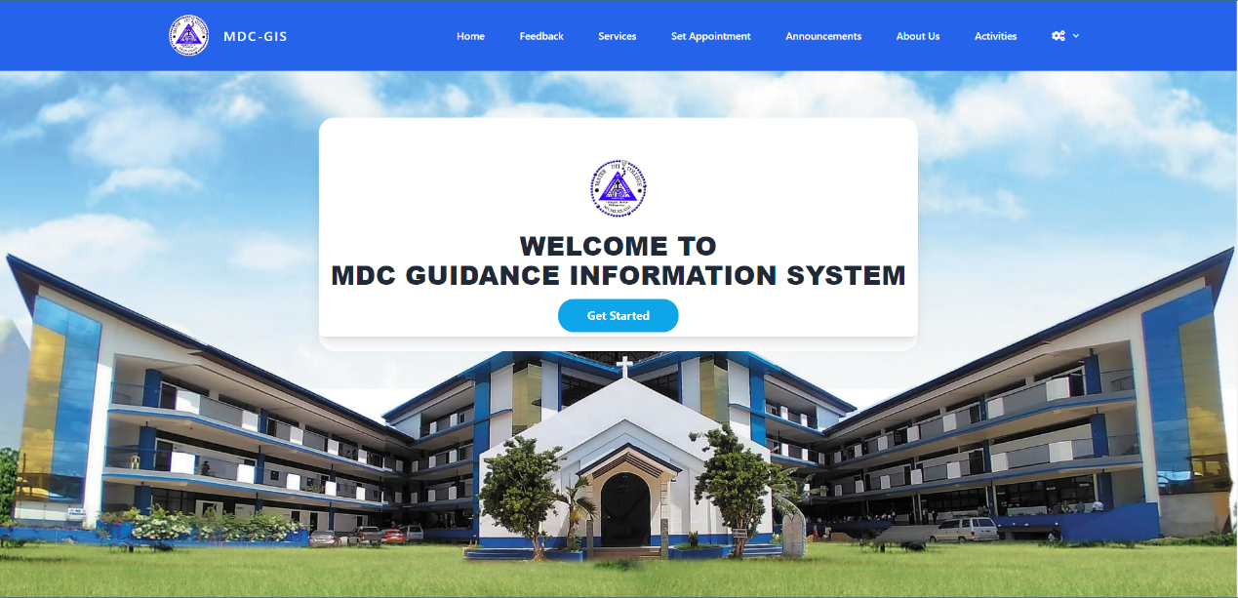

Figure 4.2.1 Home Interface

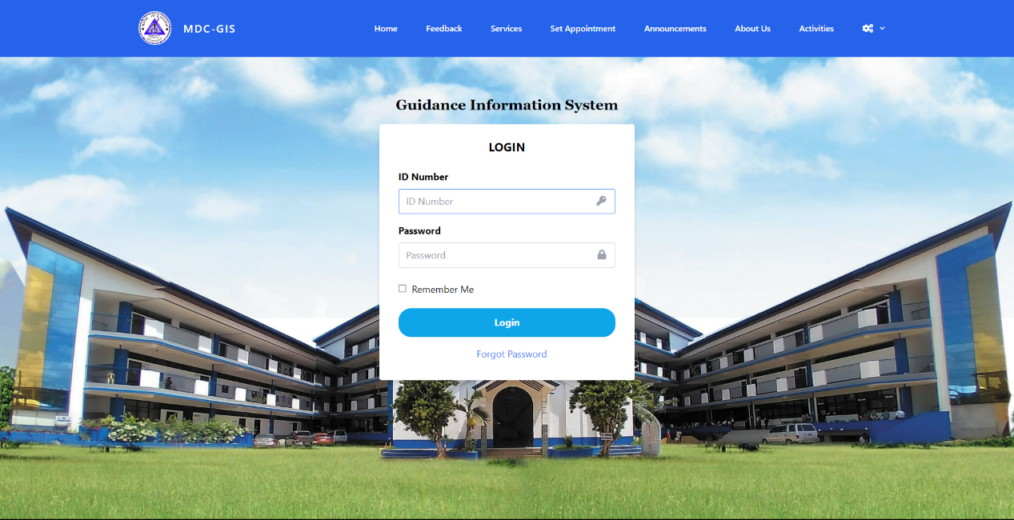

Figure 4.2.2 Log in Interface

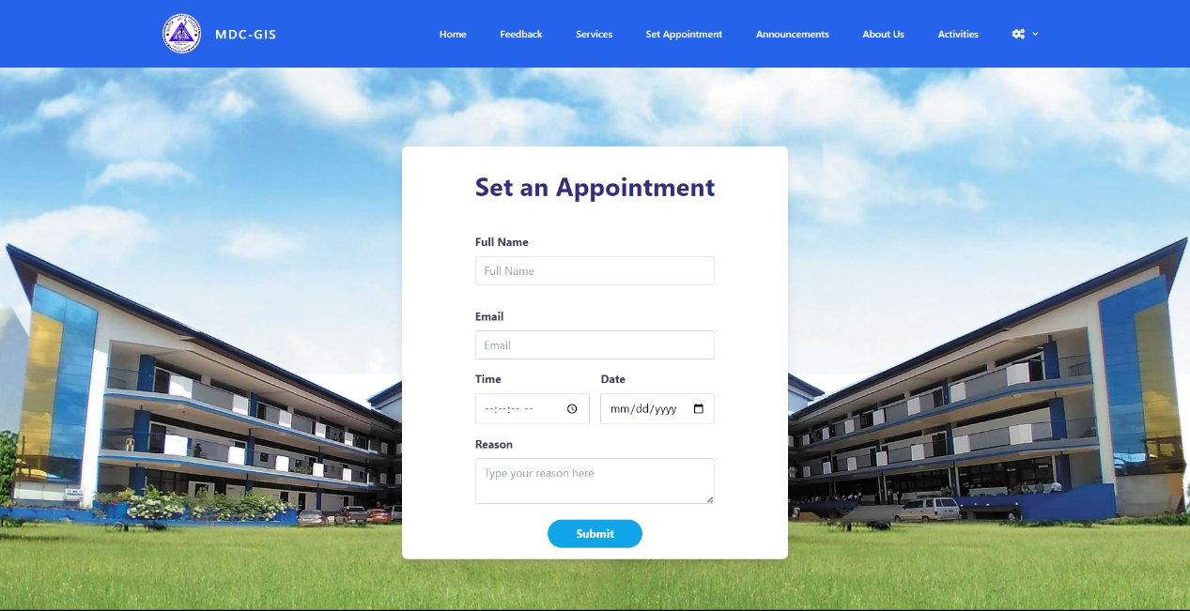

Figure 4.2.3 Log in Interface

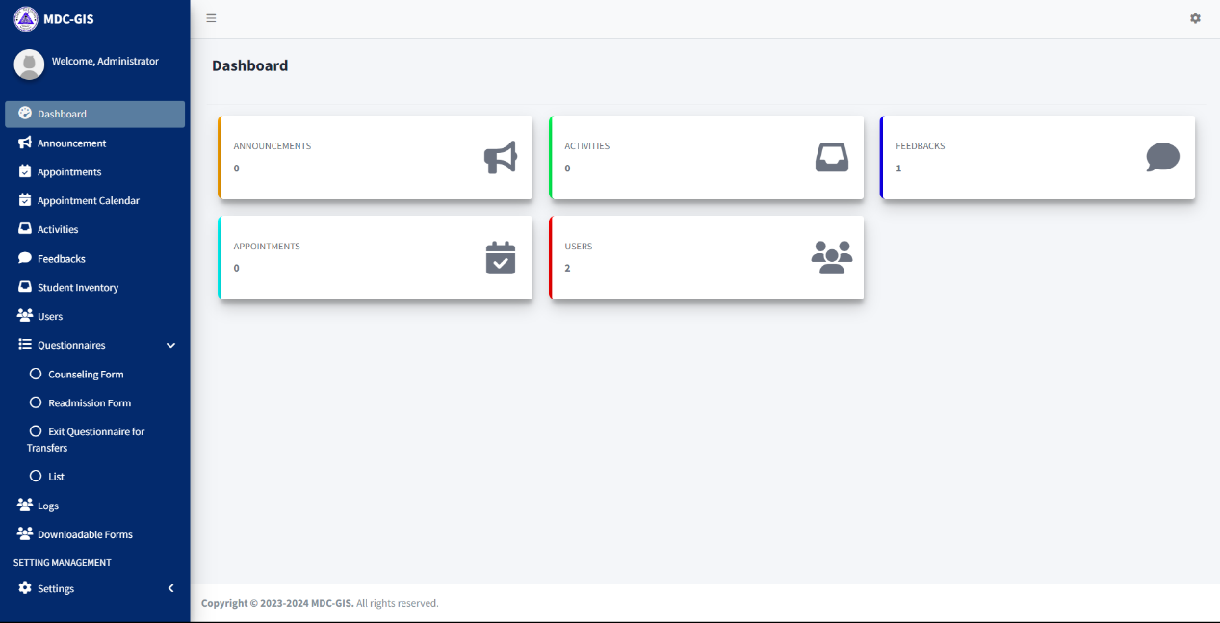

Figure 4.2.4 Admin (Dashboard) Interface

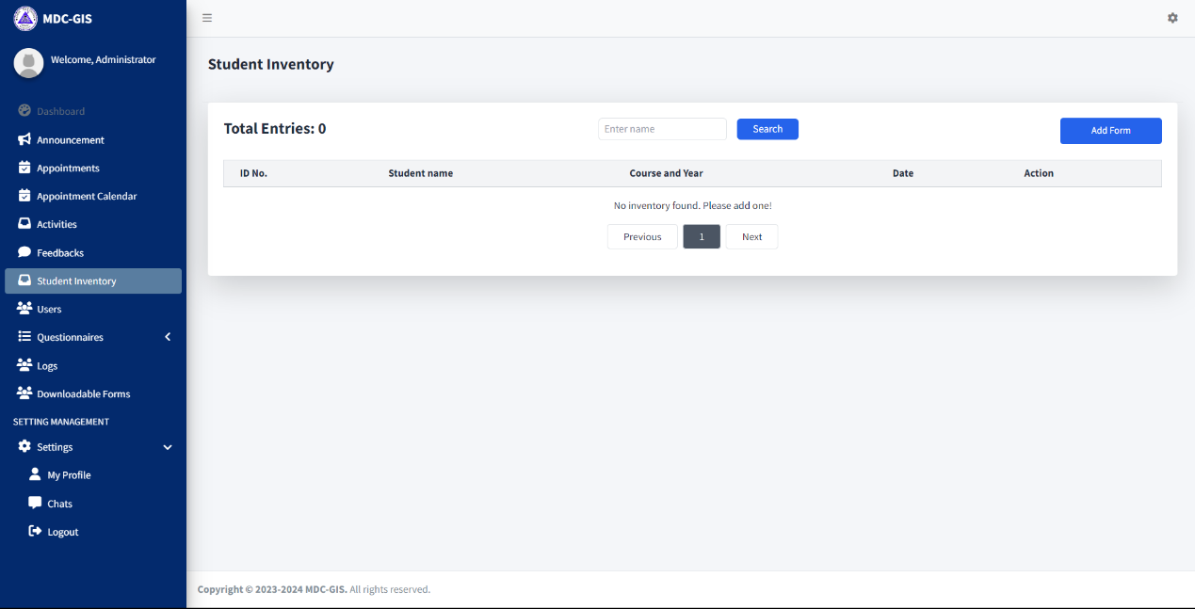
Figure 4.2.1 Student Inventory (Admin) Interface

4.3 Entity Relationship Diagram
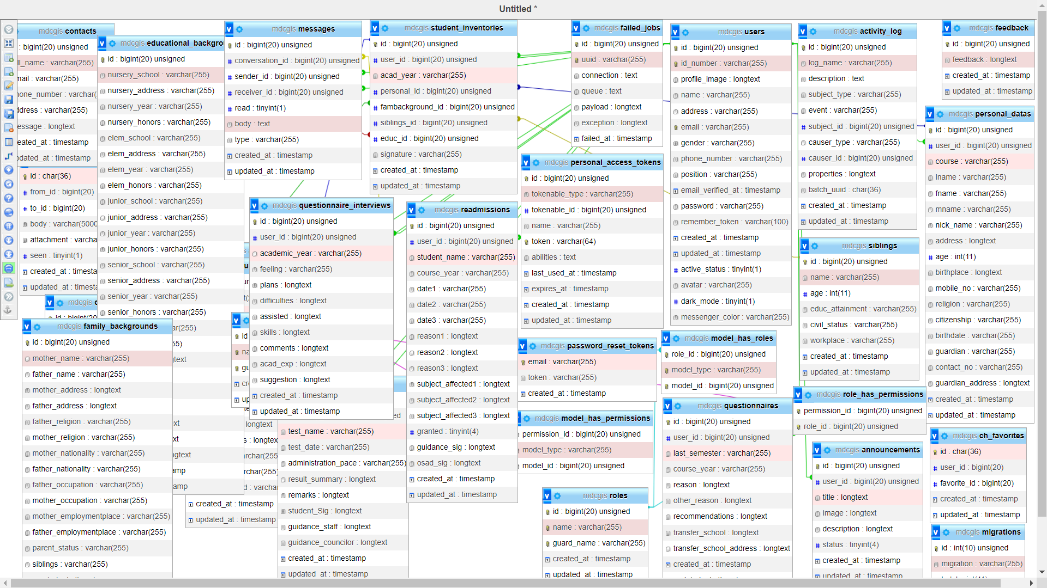
Figure 4.3.1 Home Interface

4.4 Data Dictionary
To further understand the data being saved in the database, the data dictionary will help to show the fields of the tables.

Field Name | Data Type | Length | Description
id | bigInt | 20
Id_number | varchar | 255
Profile_image | longtext
Name | varchar | 255
address | varchar | 255
email | varchar | 255
gender | varchar | 255
Phone_number | varchar | 255
Email_verified_at | timestamp | 255
password | varchar | 255
Remember_token | varchar | 100
Created_at | timestamp
Updated_at | timestamp
Table 4.4.1 Database Table of User

Field Name | Data Type | Length | Description
email | varchar | 255
token | varchar | 255
Created_at | Timestamp
Table 4.4.2 Database Table of Password token

Field Name | Data Type | Length | Description
id | bigint | 20
uuid | varchar | 255
connection | text
queue | text
payload | longtext
exception | longtext
Failed_at | timestamp
Table 4.4.3 Database Table of Failed Jobs

Field Name | Data Type | Length | Description
id | bigint | 20
Tokenable_type | varchar | 255
Tokenable_id | bigint | 20
name | varchar | 255
token | varchar | 64
abilities | text
Last_used_at | timestamp
Expires_at | timestamp
Created_at | timestamp
Updated_at | timestamp
Table 4.4.4 Database Table of Personal Access Tokens

Field Name | Data Type | Length | Description
id | bigint | 20
name | varchar | 255
Guard_name | varchar | 255
Created_at | timestamp
Updated_at | timestamp
Table 4.4.5 Database Table of Permissions

Field Name | Data Type | Length | Description
id | bigint | 20
title | varchar | 255
remarks | longtext
Created_at | timestamp
Updated_at | timestamp
Table 4.4.6 Database Table of announcements

Field Name | Data Type | Length | Description
id | bigint | 20
Full_name | varchar | 255
email | varchar | 255
Phone_number | varchar | 255
address | varchar | 255
message | longtext
Created_at | timestamp
Updated_at | timestamp
Field Name | Data Type | Length | Description
id | bigint | 20
User_id | bigint | 20
fullname | varchar | 255
date | varchar | 255
time | varchar | 255
reason | longtext
status | tinyint | 4
Created_at | timestamp
Updated_at | timestamp
Table 4.4.6 Database Table of Contacts

Table 4.4.7 Database Table of Appointments

Field Name | Data Type | Length | Description
id | bigint | 20
Sender_id | bigint | 20
Reciever_id | bigint | 20
Last_time_message | timestamp
Created_at | timestamp
Updated_at | timestamp
Table 4.4.8 Database Table of Conversation

Field Name | Data Type | Length | Description
id | bigInt | 20
Conversation_id | bigInt | 20
Sender_id | bigInt | 20
Receiver_id | bigInt | 20
read | tinyint | 1
body | text
type | varchar | 255
Created_at | timestamp
Updated_at | timestamp

Table 4.4.9 Database Table of Messages

Field Name | Data Type | Length | Description
id | bigInt | 20
User_id | bigInt | 20
feedback | longtext
Created_at | timestamp
Updated_at | timestamp
Table 4.4.10 Database Table of Feedback

Field Name | Data Type | Length | Description
id | bigInt | 20
User_id | bigInt | 20
title | longtext
image | longtext
description | longtext
status | tinyint | 4
Created_at | timestamp
Updated_at | timestamp
Table 4.4.11 Database Table of Activities

Field Name | Data Type | Length | Description
id | bigInt | 20
User_id | bigInt | 20
reason | longtext
recommendations | longtext
Transfer_school | longtext
Transfer_school_address | longtext
signature | longtext
Created_at | timestamp
Updated_at | timestamp
Table 4.4.12 Database Table of Questionnaires

Field Name | Data Type | Length | Description
id | bigInt | 20
User_id | bigInt | 20
Student_name | varchar | 255
Course_year | varchar | 255
date | varchar | 255
reason | longtext
Subject_affected | longtext
granted | tinyint | 4
Guidance_sig | longtext
osad_sig | longtext
Created_at | timestamp
Updated_at | timestamp
Table 4.4.13 Database Table of Re admissions

Field Name | Data Type | Length | Description
id | bigInt | 20
User_id | bigInt | 20
Student_name | varchar | 255
Course_year | varchar | 255
department | varchar | 255
Contact_num | varchar | 255
Visit_nature | varchar | 255
concern | longtext
Action_taken | longtext
Followup_dates | longtext
counselee | varchar | 255
counselor | varchar | 255
Session_ended | varchar | 255
Created_at | timestamp
Updated_at | timestamp
Table 4.4.14 Database Table of Counseling Forms

Field Name | Data Type | Length | Description
id | bigInt | 20
User_id | bigInt | 20
Academic_year | varchar | 255
feeling | varchar | 255
plans | longtext
difficulties | longtext
assisted | longtext
skills | longtext
comments | longtext
Acad_exp | longtext
suggestion | longtext
Created_at | timestamp
Updated_at | timestamp
Table 4.4.15 Database Table of Questionnaire Interviews

Field Name | Data Type | Length | Description
id | bigInt | 20
User_id | bigInt | 20
course | varchar | 255
lname | varchar | 255
fname | varchar | 255
mname | varchar | 255
Nick_name | varchar | 255
address | longtext
age | int | 11
birthplace | longtext
Mobile_no | varchar | 255
religion | varchar | 255
citizenship | varchar | 255
birthdate | varchar | 255
guardian | varchar | 255
Contact_no | varchar | 255
Guardian_address | longtext
Created_at | timestamp
Updated_at | timestamp
Table 4.4.16 Database Table of Personal Data

Field Name | Data Type | Length | Description
id | bigInt | 20
Mother_name | varchar | 255
Father_name | varchar | 255
Mother_address | longtext
Father_address | longtext
Father_religion | varchar | 255
Mother_religion | varchar | 255
Mother_nationality | varchar | 255
Father_nationality | varchar | 255
Father_occupation | varchar | 255
Mother_occupation | varchar | 255
Mother_employmentplace | varchar | 255
Father_employmentplace | varchar | 255
Parent_status | varchar | 255
siblings | varchar | 255
Created_at | Timestamp
Updated_at | timestamp
Table 4.4.17 Database Table of Family Backgrounds

Field Name | Data Type | Length | Description
d | bigInt | 20
name | varchar | 255
age | int | 11
Educ_attainment | varchar | 255
Civil_status | varchar | 255
workplace | varchar | 255
Created_at | timestamp
Updated_at | timestamp
Table 4.4.18 Database Table of Siblings

Field Name | Data Type | Length | Description
id | bigint | 20
Nursery_school | varchar | 255
Nursery_address | varchar | 255
Nursery_year | varchar | 255
Nursery_honors | varchar | 255
Elem_school | varchar | 255
Elem_address | varchar | 255
Elem_year | varchar | 255
Elem_honors | varchar | 255
Junior_school | varchar | 255
Junior_address | varchar | 255
Junior_year | varchar | 255
Junior_honors | varchar | 255
Senior_school | varchar | 255
Senior_address | varchar | 255
Senior_year | varchar | 255
Senior_honors | varchar | 255
Scholarship | varchar | 255
awards | varchar | 255
organizations | longtext
talents | longtext
athletics | longtext
pasttime | longtext
Fav_subject | longtext
Fav_reason | longtext
Personal_traits | longtext
Created_at | timestamp
Updated-at | timestamp
Table 4.4.19 Database Table of Educational Backgrounds
Field Name | Data Type | Length | Description
id | bigint | 20
User_id | bigint | 20
Acad_year | varchar | 255
Personal_id | bigint | 20
Fambackground_id | bigint | 20
Siblings_id | bigint | 20
Educ_id | bigint | 20
signature | varchar | 255
Created_at | timestamp
Updated_at | timestamp

Table 4.4.19 Database Table of Student Inventories

Field Name | Data Type | Length | Description
id | bigint | 20
Inventory_id | bigint | 20
Test_name | varchar | 255
Test_date | varchar | 255
Administration_pace | varchar | 255
Result_summary | longtext
remarks | longtext
Student_Sig | longtext
Guidance_staff | longtext
Guidance_councilor | longtext
Created_at | timestamp
Updated_at | timestamp
Table 4.4.19 Database Table of For Councilors

4.5 Development and Testing
Maintaining the system's or application's functionality requires constant evaluation and verification. To determine the system's efficacy, the client must first test and assess the system. A system that satisfies or surpasses the expectations of clients results in positive interactions and increased productivity.

4.6 Implementation Plan
The implementation plan's goal is to help the client come up with a method for carrying out the project or how to use is it. Comprehending the impact and significance of the offered measures in augmenting the efficacy and productivity of employees in their job is vital.
Implementation Issues and Challenges
Several complications and issues are being encountered while implementing the system. The challenges a little bit difficult and it is identified and being fixed immediately.

4.7 System Implementation & Results
A well-defined plan is the first step towards a successful implementation. This entails being aware of the actual capabilities of the system and appropriately preparing the project in question. The development tools that will be utilized in the MDC Guidance Information System must be installed before any work can begin. A well-planned and developed system will lead to a successful implementation of the system.

