CAPSTONE PROJECT

SMART WATER CONSUMPTION MONITORING SYSTEM

GROUP 4

MEMBERS
CENITA, ZEUS GYRO M.
JAPAY, JEA MARIE M.
MANGUILIMOTAN, LYKAMAE A.
MASCARIÑAS, JOHN JOSHUA R.

TABLE OF CONTENTS

Chapter Page
- Introduction 1
  - Project Context
  - Purpose and Description 2
  - Objectives 4
  - Scope and Limitations 5
- Review of Related Literature 7
- Technical Background 11
3.1 Architecture Design 11
3.1.1 Smart Water Consumption Monitoring
System Architecture Design 12
3.2 Details of Technology Used 13
IV. Methodology
4.1 Requirements Analysis and Requirements
Documentation 24
4.2 System Design, Software, and Processes 41
4.3 Entity Relationship Diagram 43
4.4 Data Dictionary 45
4.5 Development and Testing 57
4.6 Implementation Plan 58
4.7 System Implementation and Results 59
V. Results and Discussions 60
References

CHAPTER I

Introduction

Project Context
Water is an indispensable household resource because cooking, keeping clean and drinking liquids all require it. However, users of the service may encounter problems in controlling Water closely since older liquid measuring devices are very hard to read. It is a common observation that at home, the only time Water consumption and the fee is known is when the Water usage bill is received. The lack of up-to-date information leads to the delay of people's awareness of the use of the resource.
Without a watching monitoring system, people generally cannot figure Water expenses or identify a leak. Although the Municipality of Calape helps financially to reduce the cost of Water, the process of checking the remaining balance is quite arduous. Water experts point out that residents can not check their monthly Water usage until the bill comes. The cause of such inconvenience is the lack of a way enabling them to get a Water data preview.
Water data kept by the local service workers is their main weapon in the calculation of fees. They can be assisted by a device that will instantly give them information about Water use. The residents and service workers can also benefit from a digital system by which both sides of the business are helped. By collecting Water data, the office ensures that a given Water usage bill is error-free.
The researchers recommend putting smart IoT-based technology to the monitoring of Smart Water Consumption for households as the solution. With a digital flow sensor called YF-S201 coupled with an M5Stack CoreS3 ESP32IoT Development Kit, the system measures the water consumption of the household. Through Wi-Fi wireless transmission, the data is shown in real-time via the internet so that a person can track his/her water usage easily.
Facilitating Water use at the community level and making people cautious is a key aim of IoT-based Smart Water Consumption Monitoring System. The service workers also gain from the IoT-based Smart Water Consumption Monitoring system because besides keeping Water data records, it also offers Water monitoring tools. It has been proposed that this kind of a system encourages the population to change their attitude towards the Water data. When the IoT-based Smart Water Consumption Monitoring System gives the office accurate information, productivity is enhanced.
.

1.2 Purpose and Description
The main contribution of this paper is the IoT-based Smart Water Consumption Monitoring System's design and a detailed explanation of the system. Besides tracking Water consumption at home, the system is an Internet-based Water usage checking service that allows users to be aware of their consumption.
To measure the water consumption in the room, a YF-S201 meter sensor is being used. The heart of the whole device, the M5Stack CoreS3 ESP32 microcontroller, which runs on ESP32 chip, reads, processes and finally shows the real-time Water use data, including, if necessary, a breakdown by water source, etc.
In addition, M5Stack CoreS3 ESP32 features a Wi-Fi module and transmits the data of different users' water usage online continuously without manual interruption. Users can log on to their accounts to check their water use over time, the corresponding cubic meter units, expected water fee, and also view a chart showing consumption pattern over a time span.
The computer program calculates water bills in accordance with the current rate that is put on the platform. It also provides a platform for users with special access rights to set up municipal subsidies or deductions, which makes policy or rate changes possible without software updates.
One of the most interesting aspects is the notification system of the water meter. If usage of water goes beyond the prescribed level or if flow of water is at a level that is highly different from its usual flow, then the users will be notified of this situation through their web application. It aids them to take immediate measures and minimize the usage of water.
In case of a household, users are capable of monitoring their water consumption through the web interface and also sharing details of their consumption records and estimated bills with their local water utility through the web platform.
Finally, this is a water monitoring system that supports IoT technology to help households understand the use of water and therefore encourage saving water.

1.3 Objectives

General Objective
To develop an IoT-based Smart Water Consumption Monitoring System that monitors household water use, transmits data to a web dashboard, and provides real-time consumption data and an estimated bill.

Specific Objectives:
- Measuring water flow through pipelines with the help of a YF-S201 water flow sensor.
- The M5Stack CoreS3 ESP32 IoT Development Kit will be used for gathering, processing and managing the water consumption water.
- Using the M5Stack CoreS3 ESP32 integrated touchscreen display, the users will get to see the status of their water consumption in an updated view continuously.
- Water consumption data will be sent from the device to a web dashboard through Wi-Fi.
- Users will have the ability to get water consumption reports with total water cubic meters used, predicted bills, and other data that are stored in the system.
- Based on the water prices set in the system, the estimated water bill will be produced.
- Any municipal discount or subsidy shall be applied when the remaining balance is calculated.
- The system can be set to alert and notify the users when the actual water usage goes beyond the preset limit or when there is a possible water leakage.
- A system will be created to let users control their water consumption effectively so that even at the moment the bill is ready, they will already have the control of all consumption levels.
- To provide a web platform through which authorized local water utility personnel can review consumption records and estimated monthly bills.

1.4 Scope and Limitations

Scope
This research paper introduces a Smart Water Consumption Monitoring System based on IoT for households. Its main characteristics are enumerated here:
- Household pipelines' water content is measured by the YF-S201 water flow sensor.
- Main processing unit will be M5Stack CoreS3 ESP32 IoT Development Kit.
- Built-in touchscreen display gives the user real-time water consumption data.
- Data goes to the online dashboard via wireless internet connection.
- Consumption, the total volume used, estimated cost, and past consumption data are all things that a user will be able to monitor.
- Estimated bills are calculated using the system by the user's water rate.
- Water subsidy or deduction set by the municipality can be taken into account when computing the final bill.
- Consumption limits or potential leakages detected will send out a notification.
- Utility companies can use local water monitoring tools to view consumption records and estimated bill information.

Limitations
Below are the limitations that must be kept in mind:
- The accuracy of the system is entirely reliant on the correct calibration of YF-S201 water flow sensors.
- Wi-Fi connection must stay stable for the uninterrupted data transmission.
- This research paper has only a limited experimental setup level.
- This system is developed for household purposes only, and thus, it cannot be utilized for large-scale commercial and industrial applications.
- Water utility charges generated according to the system's records cannot correspond to the water utility bills in real life.
- The system has no means by which the system can turn off water automatically. It only notifies and does monitoring functions.
- The system only tracks the water usage level and makes no move in directly regulating water flow in usage.
- Data delays or loss can happen if internet connection is weak or there are network problems.
- The system acts only as a helper in checking water use and it has nothing to do with a water utility's official water metering and billing.
- This monitoring system is only an addition or an assist tool and cannot replace the local water utility company's official water metering and billed process.
Chapter II

Review of Related Literature/Systems
Development and Evaluation of an IoT-Based Home Water Usage Monitoring System Using LoRa and ESP32
Roslan et al. (2025) developed an IoT-based household water monitoring system using ESP32, flow sensors, LoRa, and Google Sheets. The system displays real-time water usage, estimated bills, and possible leak alerts. This study is related to the proposed system because both use IoT devices and flow sensors to monitor household water consumption, detect possible leaks, and provide consumption and billing information.
IoT-Based Smart Water Meter for Domestic Utility
Varghese et al. (2025) developed a Wi-Fi-based smart water meter using ESP32 and water-flow sensors for real-time household monitoring. Users can remotely view consumption data and receive abnormal-usage alerts. This study is relevant because the proposed system also uses ESP32, Wi-Fi, flow sensors, remote monitoring, and notifications.
IoT-Based Smart Water Management, Monitoring and Distribution System for an Apartment
Rapelli et al. (2019) developed an IoT system for monitoring water use and improving water distribution in apartment buildings. It provides consumption data to help reduce water waste. Similarly, the proposed system uses real-time monitoring to support water conservation, while adding household billing estimates and a web-based dashboard.
IoT-Based Water Consumption Monitoring System for Water Management
Clemente, Samaniego, and Cruz (2023) developed a water-monitoring system using flow sensors, Arduino Mega, ESP8266 Wi-Fi, Firebase, and an Android application. It allows users to monitor consumption remotely in real time. This is related to the proposed system because both use IoT communication and flow sensors to provide accessible water-consumption monitoring.

Chapter III

Technical Background
This paper chapter focuses on the Smart Water Consumption Monitoring System and explains in detail the system hardware and software design as well as their working together.
The system is composed of several interconnected components that allow for real-time monitoring of household water consumption. It combines IoT technology with a web application to provide timely monitoring of household water use.

3.1 Architecture Design
The Smart Water Consumption Monitoring System keeps track of water usage at home over a time through Internet of Things and a web-based application.
The M5Stack CoreS3 ESP32 IoT Development Kit serves as the microcontroller and processing unit of the system. The YF-S201 Water Flow Sensor is used to measure how much water is flowing through the household pipeline when the water moves the sensor it creates pulse signals.
In turn, the M5Stack CoreS3 ESP32 receives these signals, then based on this it computes the water-flow rate, total water consumption and the cubic meters used altogether.
The resulting data from the calculations will be the main screen display content on the M5Stack CoreS3 ESP32 built-in touchscreen. In this way householders can keep their eyes on their water consumption through the device itself.
As well as displaying the data, it is transmitted via Wi- fi to the Laravel web application by the M5Stack CoreS3 ESP32 microcontroller.
The Laravel web application deployed on Hostinger Web Hosting processes the incoming data before storing it into the MySQL database of Hostinger's server.
Afterwards, the stored database records are displayed through an interactive web dashboard created with Vue.js. This means the system interface is available through whichever browser you choose that is connected to the internet.
Smart Water Consumption Monitoring System offers two types of user rights access, i.e., Household Users vs Administrators.
On the other hand, Households Users can follow up their water consumption data which includes number of cubic meters consumed billing estimation, record of water used, and receive system alerts through the app immediately.
Administrators have the duty to create and manage user accounts, look after households that have been registered, determine the price of water, make updates to municipality's subsidies or deductions, control notification features, and prepare status reports.
A calculation of bill estimate can be done automatically through the set-up of a water rate by administrators.
Deductions or subsidies of the municipality can similarly be done via the user interface.
Users receive a warning as one of the system's features when such consumption exceeds the preset level or a detection is made of flow of water that might mean a water leakage.

System Flow
It is the flow of the system that is described below:
- Water goes through a mounted YF-S201 flow sensor.
- The sensor generates pulse signals, which then are received by the M5Stack CoreS3 (ESP32-S3) on GPIO2.
- The firmware translates verified pulse counts to flow rate, interval liters, and the overall flow meter total from lifetime use. Each second, it takes a sample.
- CoreS3 shows flow rate, monthly server "Period" total (if available), lifetime "Meter" total, leak status, Wi-Fi, and server status. Users can navigate with touchscreen gestures; touching the middle button will let them to stop/start monitoring.
- A functioning device connects to Laravel, uploads an idempotent interval reading every three seconds over Wi-Fi. Readings are saved locally and can safely be retried if there is a connection failure.
- Laravel confirms the device registration and the household assignment, prohibits multiple readings for the same period, stores the readings, computes the real monthly consumption, checks the thresholds/leaks conditions, and uses the billing rules to determine the amount due if any.
- Household user data gets retrieved by API calls that household dashboards make to secure backend server every three seconds, so that it displays a stream and the history of consumption data.
- Household members can check usage, review estimates/finalized bills, pay slips, alerts, goals, and service requests through the interface.
- Administrators perform several tasks in this system, like household maintenance, meter registration/activation/lifecycle, billing rates, fixed monthly charges, subsidies/deductions, alert settings, financial statements, offline money records, reports, exports, service requests, and logs to be tracked are all managed here.
The proposed system can mainly be applied for household water consumption monitoring.
In addition, the proposed system will give some features that could possibly be helpful for local water services to oversee, on a per household basis, water consumption and estimated bills.

3.2 Details of the Technology Used
M5Stack CoreS3 ESP32 IoT Development Kit
The M5Stack CoreS3 ESP32 IoT Development Kit (M5Stack CoreS3) can be considered as one of the basic components of the Smart Water Consumption Monitoring System. It comes equipped with several features including a dual-core processor, rechargeable battery Wi-Fi and Bluetooth, touchscreen buttons, and of course a processor.
This project uses the Wi-Fi functionality only for the purpose of transmitting water consumption data to the cloud enabling real-time monitoring. The water flow device sends pulse signals to this system YF-S201 Water Flow Sensor and M5Stack CoreS3 ESP32 calculates water usage and then sends data to the web monitoring application via Wi-Fi.
YF-S201 Water Flow Sensor
Water flow measuring is the main function of YF-S201 Water Flow Sensor. A Hall-effect sensor inside a flow sensor will generate pulses with the help of the water moving, which is then used to measure the water speed. These signals will be transmitted via the M5Stack CoreS3 ESP32 module and the computer will then convert these readings into other measures like volume (cubic meters) and the number of gallons/liters, as examples.
Built-in Touchscreen Display
One of the main components of the M5Stack is the touch screen display through which the real-time water consumption of the system is shown locally. This screen serves the user to know, at a glance, the amount of water consumed and the status of the system without checking web dashboard.
Built-in Buttons
There are built-in buttons on the M5Stack CoreS3 ESP32 kit that will help you navigate within the menu and do necessary settings of the system.
Breadboard
A breadboard lets you put together different hardware parts temporarily as you create and test your project.
Jumper Wires
Jumper wires join up different parts of your setup: the M5Stack CoreS3 ESP32, the YF-S201 Water Flow Sensor, and the breadboard.
Water Hose and Pipe Connectors
Using a water hose adapter, PVC connector, and hose clamp will allow you to fix the sensor to the home water pipe.
Power Supply
The system has a battery which can be used to power the M5Stack CoreS3 ESP32.
Software Technologies
Arduino IDE
Arduino IDE helps you develop, compile, and upload a firmware file for the M5Stack CoreS3 ESP32.
Visual Studio Code
Visual Studio Code is the primary software used in the development and maintenance of the source code of the web application.
Laravel Framework
Laravel is an MVC framework which allows you to write code for your web application's backend. It runs different operations on the server like checking if a person is logged in, handling web services, managing subscriptions, sending out alerts, accessing and modifying the database, and other system settings.
Vue.js
Vue.js helps create the system's web dashboard.
Tailwind CSS
Tailwind CSS enables the design and styling of the web dashboard.
MySQL
MySQL together with XAMPP is being utilised for developing, testing, and debugging the local server database system.
MySQL Cloud Database
This system utilises the MySQL cloud-hosted database provided by the selected web hosting provider.
Web Hosting
Hostinger Website Hosting
Through Hostinger, they host the Smart Water Consumption Monitoring System.
Client Devices
Personal Computer
They use a personal computer for programming hardware devices, debugging, creating and/or managing databases, connecting hardware, and testing the entire system during development phases.
Smartphones and Tablets
Smartphones and tablets are devices that a user or a system's admin can use from any place, via a web browser, and still get updates and do things with the system. The dashboard would be one of the ways to do so.

3.3 Feature List
A Smart Meter for the Smart Water Consumption Monitoring System allows individual householders to keep track of water use on an ongoing basis. It also enables water suppliers to manage customers' water use records and handle billing data.
Instant Water Tracking
Measurement of the quantity of water flowing through the household pipeline is carried out by the YF-S201 Water Flow Sensor which is part of the system.
Data collected by the sensor is further interpreted by the M5Stack CoreS3 ESP32 device. The results are displayed on the touch screen of this device.
Users see real-time consumption of water via web app which gets updated wirelessly.
Estimated Billing Computation
Using the household water consumption data already registered, the system calculates the estimated monthly water bill. It converts the overall water consumed in liters to cubes, multiplies by the configured water rate by the administrator, adds fixed charge if any, subtracts municipality subsidy/ deduction that is set as per configuration. An additional condition is that the final estimated amount is no less than zero.
All billing rates, fixed charges, subsidies and deductions can be easily changed by the administrator through dashboard without having to modify program files. In addition, system can generate billing summary and offline payments can also be recorded.
Web-Based Dashboard
You can really take advantage of using a web dashboard. It allows you to view your water usage history, learn how much water you have actually used, get to know your water billing details, see the past records and look at the notifications. You can access it from any device which provides internet connectivity and web browsers.
To send water usage data from M5Stack CoreS3 ESP32 (having Wi-Fi) to a cloud web app you don't need manual interference as it is done automatically.
Backend Laravel processes the data received and stores it in the cloud MySQL database so you and the admins can be informed of the latest happenings as long as you are connected to internet.
In addition to this, the system tracks your water consumption to identify any leaks through patterns that may have emerged over time. In case it identifies an unusual situation, you will receive a notification to let you take immediate action and cut down water loss.
Notification System
It will inform you if your water consumption has surpassed the threshold or if there is a suspected leak. These notifications may be your first indication that something is wrong with water consumption and also help you fix a possible leak quickly.
User Account Management
The administrators can register users, change details, handle accounts, and keep track of household user accounts. This ensures the users' information are correct and that the users with permission are able to the system.
Billing Configuration
Administrators are able to fix the water rate and any municipality subsidy or deduction for billing. Since they are stored in the database, administrators can easily update them if changes to billing policies or assistance programs occur.
Administrators will be given a dashboard in the system where they can water the usage records, manage users, define the billing options, see the logs of sent notifications and prepare reports for helping the water utility offices. At your end, you get to verify your meter readings and your estimated water bills to help you in getting aware of the quantity of water being used and changes therein over time.
User-Friendly Interface
Both on the M5Stack CoreS3 ESP32 touchscreen device and the web dashboard, the system is very straightforward to use. The intention of the system is that everyone, whether a household consumer or administrator, can be effortlessly tracked of their water consumption irrespective of your knowledge level.
The SmartWater Consumption Monitoring System was built following the Prototype Model of the System Development Life Cycle. This methodology enables the researcher to create, develop, test, and fine-tune the system by using and user feedback until such time it fulfills all the necessary demands.
While gathering requirements, the researchers discovered several issues concerning methods of monitoring water usage. For example, they did not have real-time tracking, limited data records, and difficulty assessing the costs before the actual bills showed up. These challenges were taken into consideration when determining the functions and system requirements.
Once the requirements were collected the researchers designed the system's architecture. It features an M5Stack CoreS3 ESP32, a YF-S201 Water Flow Sensor, a web application and a cloud database. They also built the database, created interfaces and defined the workflow of the system at that stage.
Hardware components were physically connected during the prototype phase by placing them on a breadboard using jumper wires, a water hose and pipe fittings. The sensor YF-S201 was plugged into M5Stack CoreS3 ESP32 for tracking water consumption. On the software side it was a mix of technologies: Arduino IDE for programming ESP32 Visual Studio Code for the application, Laravel for backend, Vue.js for frontend and MySQL/XAMPP for a test setup of a database.
After the first prototype came up, the researchers connected the IoT device with their Laravel backend and also to a MySQL database and web dashboard, over Wi-Fi. This system enabled real-time data to be collected and stored, for monitoring and billing.
Modified in a way that allowed checking for the billing calculations as well as test the notifications and making sure that the real-time data is working properly besides adjusting the YF-S201 sensor.
If any problems occurred they had to be remedied through improving the hardware and software of the system, however in the most of the cases, hardware issues were the culprits. The prototype performed just the way the developer had planned to.
The web app that has already been set up to provide access is a tool which can be run in case of any emergency or as means of checking.
The Laravel app and MySQL database were moved out of the localhost development environment (XAMPP is an example of such environment)by means of Hostinger's cloud hosting services.
With the use of those services it became possible to run the system online without being bound to the developer's computer.
Thus the latest prototype enables ordinary consumers of households to have an IoT solution to monitor real-time water consumption.
In addition, the water bureau is provided with functionalities to keep track of usage, billing, and also to create reports.

CHAPTER IV

Methodology

4.1 Requirements Analysis and Requirements Documentation
Requirements analysis revealed that there are three stakeholders involved: the city official, the end-user (a house family), and the smart meter. The first one controls all of the system activities, the second tracks the water usage, and the third device sends the readings to the server in an encrypted way.

Use Case Diagram
Manage households

Manage meters and rates

Generate billing


Record payment and receipt
Alerts reports and action center

Municipal Administrator

Manage service requests

Manage service requests

View live consumption
History bills and receipts
Goals and forecast
Household User
Account access and recovery
Install resilient website

Activate device

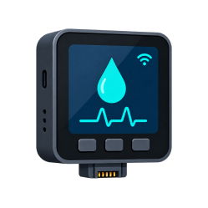
Upload water reading

Smart Meter
IoT Device

Report meter health

Figure 4.1. Use-case overview of the Smart Water Consumption Monitoring System.

Use Case Description
Use Case Name:  Manage Households | ID:1 | Important Level:  High
Primary Actor:  Municipal Administrator | Use Case Type: Essential, Detail
Scenario: The administrator wants to create, review, update, or change the operational status of a household account.
Brief Description: Maintains household identity, service address, contact information, account number, access status, and meter-assignment readiness
Trigger: The administrator selects Customer Management from the administrative workspace.
Normal Flow of Events:
- The administrator signs in and opens Customer Management.
- The system displays searchable and filterable household records.
- The administrator creates a new household or selects an existing record.
- The administrator enters or updates the permitted household information.
- The system validates required fields, unique account details, role, and status.
- The system saves the household record and logs the administrative activity.
Sub Flows:
Alternative/Exceptional Flows:
Table 4.1.1 Manage Households

Use Case Name:  Manage Meters and Rates | ID:2 | Important Level:  High
Primary Actor:  Municipal Administrator | Use Case Type: Essential, Detail
Scenario: The administrator wants to manage municipal smart meters and configure the water rates and monitoring rules applied to households.
Brief Description: Combines meter registration, assignment, maintenance, credential control, and effective-dated water-rate and alert configuration.
Trigger:The administrator opens Device Management or Water Rate Management.
Normal Flow of Events:

- The administrator opens the required meter or rate module.
- The system displays the current devices or active billing configurations.
- For a meter, the administrator registers, assigns, reassigns, suspends, rotates credentials, or decommissions the asset.
- For a rate, the administrator enters the water rate, fixed charge, subsidy, currency, effective date, and alert thresholds.
- The system validates identifiers, household eligibility, numeric ranges, and effective dates.
- The system saves the approved meter or rate configuration and records the activity.
Sub Flows:
Alternative/Exceptional Flows:
Table 4.1.2 Manage Meters and Rates

Use Case Name:  Generate Billing | ID:3 | Important Level:  High
Primary Actor:  Municipal Administrator | Use Case Type: Essential, Detail
Scenario:The administrator wants to generate a monthly billing statement for an eligible household.
Brief Description: Aggregates billable consumption, applies the applicable rate configuration, and preserves a historical charge snapshot.
Trigger: The administrator chooses Generate Statement in Billing Management.
Normal Flow of Events:
- The administrator opens Billing Management.
- The administrator selects the household and billing month.
- The system validates the period, household, billable readings, and applicable rate.
- The billing service totals liters and converts the result to cubic meters.
- The service applies the water rate, fixed charge, subsidy, and opening balance.
- The system stores the statement, charge breakdown, remaining balance, and payment status.
- The administrator reviews the generated billing record.
Sub Flows:
Alternative/Exceptional Flows:
Table 4.1.3 Generate Billing

Use Case Name:  Record Offline Payment and Receipt | ID:4 | Important Level:  High
Primary Actor:  Municipal Administrator | Use Case Type: Essential, Detail
Scenario:Authorized municipal staff want to record an offline payment and issue an official receipt
Brief Description: Records cash, bank-deposit, check, or other offline payments without processing money through the website.
Trigger: The administrator selects Record Payment for an unpaid or partially paid statement.
Normal Flow of Events:
1. The administrator opens the finalized statement.
2. The administrator enters the amount, method, reference, notes, and received date.
3. The system validates the remaining balance and payment details.
4. The payment is stored in the offline-payment ledger.
5. The statement amount paid, remaining balance, and status are recalculated.
6. The system generates a unique receipt number and PDF receipt.
7. The household can download the statement and related receipts.
Sub Flows:
Alternative/Exceptional Flows:
Table 4.1.4 Record Offline Payment and Receipt

Use Case Name:  Review Alerts Reports and Action Center | ID:5 | Important Level:  High
Primary Actor:  Municipal Administrator | Use Case Type: Essential, Detail
Scenario:The administrator wants to investigate alerts and prioritize municipal work requiring attention.
Brief Description: Combines leak follow-up, analytics, reports, exports, failed notices, overdue statements, and the prioritized action center.
Trigger: The administrator opens the Action Center, Leak Monitoring, Reports, Analytics, or Notifications.
Normal Flow of Events:
1. The system combines open requests, overdue statements, leak follow-ups, and failed notices.
2. The administrator selects an item, household, report category, period, or filter.
3. The system validates authorization and input parameters.
4. Related readings, alerts, billing data, notices, and summaries are retrieved.
5. The administrator reviews evidence and records the required follow-up.
6. The administrator resolves, marks false, reopens, retries, archives, or exports the supported record.
Sub Flows:
Alternative/Exceptional Flows:
Table 4.1.5 Review Alerts Reports and Action Center

Use Case Name:  Manage Service Requests | ID:6 | Important Level:  High
Primary Actor:  Household User; Municipal Administrator | Use Case Type: Essential, Detail
Scenario:A household wants to request municipal assistance and staff want to track the response through resolution.
Brief Description: Provides a referenced conversation for billing, leak, meter, account, interruption, and general service concerns.
Trigger: The household opens Service Requests or the administrator opens the municipal request queue.
Normal Flow of Events:
1. The household selects a category and enters the subject and description.
2. The system creates a unique request reference and an open status.
3. The household and authorized staff view the request conversation.
4. The administrator assigns priority, ownership, and status.
5. Either permitted participant adds a message; internal notes remain staff-only.
6. The administrator resolves or reopens the request as needed.
7. Updates are retained and may generate household notifications.
Sub Flows:
Alternative/Exceptional Flows:
Table 4.1.6 Manage Service Requests

Use Case Name:  View Live Consumption | ID:7 | Important Level:  High
Primary Actor:  Household User | Use Case Type: Essential, Detail
Scenario:The household user wants to view the latest water consumption and meter state.
Brief Description: Displays the latest owned reading, current flow, interval consumption, estimated billing state, leak state, and meter availability.
Trigger: The household user opens the Dashboard or Live Monitoring page.
Normal Flow of Events:
- The household user signs in.
- The user opens Dashboard or Live Monitoring.
- The browser requests the latest household-scoped readings.
- The server verifies ownership and retrieves the current meter and consumption state.
- The interface displays current flow, liters used, estimated bill, leak status, meter connection, and recent activity.
- The interface refreshes according to the configured near-real-time interval.
Sub Flows:
Alternative/Exceptional Flows:
Table 4.1.7 View Live Consumption

Use Case Name:  Review History and Bills | ID:8 | Important Level:  High
Primary Actor:  Household User | Use Case Type: Essential, Detail
Scenario:The household user wants to review past consumption and current or finalized billing information..
Brief Description: Combines daily, weekly, monthly, or custom consumption history with estimated billing details and monthly statements.
Trigger: The user opens Consumption History or Estimated Billing
Normal Flow of Events:
1. The user selects the history or billing page.
2. For history, the user selects a period or valid custom date range.
3. The server retrieves only the household's readings and computes totals and chart data.
4. For billing, the server selects the applicable rate and billable interval readings.
5. If the current month is empty, the latest metered month is clearly identified.
6. The interface displays estimates, finalized statements, balances, due dates, and receipts.
7. The user downloads an owned statement or receipt when required.
Sub Flows:
Alternative/Exceptional Flows:
Table 4.1.8 Review History and Bills

Use Case Name:  Set Consumption Goal and Forecast | ID:9 | Important Level:  High
Primary Actor:  Household User | Use Case Type: Essential, Detail
Scenario:The household wants to establish a monthly water-use goal and review projected end-of-month consumption.
Brief Description: Stores one household goal per month and compares actual usage, remaining allowance, progress, and forecast.
Trigger: The user opens Goals and Forecast and saves a target in liters.
Normal Flow of Events:
1. The system loads the household's current-month goal and consumption.
2. The user enters or updates a positive target volume.
3. The system validates and stores the household-scoped goal.
4. Current usage is compared with the target.
5. The service estimates end-of-month consumption from valid readings.
6. The interface displays progress, remaining allowance, and forecast status.
Sub Flows:
Alternative/Exceptional Flows:
Table 4.1.9 Set Consumption Goal and Forecast

Use Case Name:  Manage Notifications and Preferences | ID:10 | Important Level:  High
Primary Actor:  Household User | Use Case Type: Supporting, Detail
Scenario: The household wants to control eligible in-app notices, language, quiet hours, and data-use preferences.
Brief Description: Manages notification categories, read state, quiet hours, English or Filipino labels, and low-bandwidth behavior.
Trigger: The user opens Notifications or Account Settings.
Normal Flow of Events:
1. The system loads household-scoped notices and saved preferences.
2. The user reads, marks, or removes an eligible notice from the personal view.
3. The user selects notification categories and optional quiet hours.
4. The user selects English or Filipino and chooses low-bandwidth mode.
5. The system validates and stores the preferences.
6. The interface immediately applies supported language and data-use changes.
Sub Flows:
Alternative/Exceptional Flows:
Table 4.1.10 Manage Notifications and Preferences

Use Case Name:  Manage Account Access and Recovery | ID:11 | Important Level:  High
Primary Actor:  Household User | Use Case Type: Essential, Detail
Scenario: The household wants to update contact information, change a password, or recover access.
Brief Description: Protects household profile updates and password changes while preserving administrator-controlled account fields.
Trigger: The user opens Account Settings or selects Forgot Password on the login page.
Normal Flow of Events:
1. The authenticated user loads the household profile.
2. The user updates permitted contact details or submits the current and new password.
3. The system validates the request and protects role, status, and account number.
4. For recovery, the user requests a reset link for an eligible approved account.
5. The reset token and replacement password are validated.
6. The profile or password is updated and security activity is recorded.
Sub Flows:
Alternative/Exceptional Flows:
Table 4.1.11 Manage Account Access and Recovery

Use Case Name:  Install and Use Resilient Website | ID:12 | Important Level:  Medium
Primary Actor:  Household User | Use Case Type: Essential, Detail
Scenario: The household wants an installable interface that remains understandable during weak or interrupted connectivity.
Brief Description: Provides the web manifest, service worker, app-shell caching, user-scoped session snapshots, and accessible responsive controls.
Trigger: The user installs the website or revisits it with limited connectivity.
Normal Flow of Events:
1. The browser loads the web manifest and registers the service worker.
2. Static application-shell resources are cached for resilient loading.
3. Authenticated API responses are excluded from service-worker storage.
4. User-scoped dashboard snapshots may be retained only in session storage.
5. The interface reports offline or unavailable live state rather than showing stale data as current.
6. The user reconnects or refreshes to obtain authoritative meter information.
Sub Flows:
Alternative/Exceptional Flows:
Table 4.1.12 Install and Use Resilient Website

Use Case Name:  Activate Device | ID:13 | Important Level:  High
Primary Actor:  Smart Meter / IoT Device | Use Case Type: Essential
Scenario: A registered M5Stack smart meter wants to exchange its one-time code for a scoped device credential.
Brief Description: Binds the physical hardware to the municipal device record and activates authenticated telemetry access.
Trigger: The technician enters the administrator-issued activation code on the registered device.
Normal Flow of Events:
1. The administrator registers the meter and issues a short-lived activation code.
2. The device submits its UUID, activation code, hardware identity, and firmware version.
3. The server verifies that the code is valid, unused, and unexpired.
4. The server checks device status and hardware-binding rules.
5. The hardware identity is bound and the device is marked active.
6. The server issues a scoped credential.
7. The M5Stack stores the credential without printing the token to the serial console.
Sub Flows:
Alternative/Exceptional Flows:
Table 4.1.13 Activate Device

Use Case Name:  Upload Water Reading | ID:14 | Important Level:  High
Primary Actor:  Smart Meter / IoT Device | Use Case Type: Essential
Scenario: An activated smart meter wants to submit a measured water-consumption interval..
Brief Description: Authenticates the device, validates telemetry, stores the reading once, and returns authoritative totals and alert state.
Trigger: The firmware reaches the configured upload interval with a pending measurement.
Normal Flow of Events:
- The sensor counts valid flow pulses during the sampling interval.
- The firmware calculates flow rate and interval liters.
- The device creates a stable reading identifier and stores the pending state.
- The meter submits the reading with its scoped credential.
- The server derives the device and household from the authenticated identity.
- The server validates and stores the reading idempotently.
- The server evaluates thresholds and returns the authoritative total and leak state.
- After acknowledgement, the meter clears the pending interval and advances its sequence.
Sub Flows:
Alternative/Exceptional Flows:
Table 4.1.14 Upload Water Reading

Use Case Name:  Report Meter Health | ID:15 | Important Level:  Medium
Primary Actor:  Smart Meter / IoT Device | Use Case Type: Supporting
Scenario: The smart meter wants to report its connection, firmware, and operational health to the server.
Brief Description: Updates municipal visibility of device connectivity, last-seen activity, telemetry status, firmware version, and relevant diagnostics.
Trigger: The device activates, uploads telemetry, reconnects to the network, or reaches a health-reporting interval.
Normal Flow of Events:
- The M5Stack evaluates its Wi-Fi and server connection state.
- The device prepares its hardware identity, firmware version, monitoring state, signal strength, and health metadata.
- The device submits the health information using its scoped credential.
- The server validates the authenticated device identity.
- The server updates last-seen, last-telemetry, firmware, and operational health fields.
- The administrator workspace displays the latest device status.
Sub Flows:
Alternative/Exceptional Flows:
Table 4.1.15 Report Meter Health

4.2 System Design, Software, and Processes
The whole system is based on client-server architecture typical for the Internet of Things. The meter on the physical side takes measurements and does the data logging for a couple of hours. All the server-side Laravel code is responsible for maintaining and verifying user and data integrity, keeping track of usage history, billing cycles

Output and User Interface Design
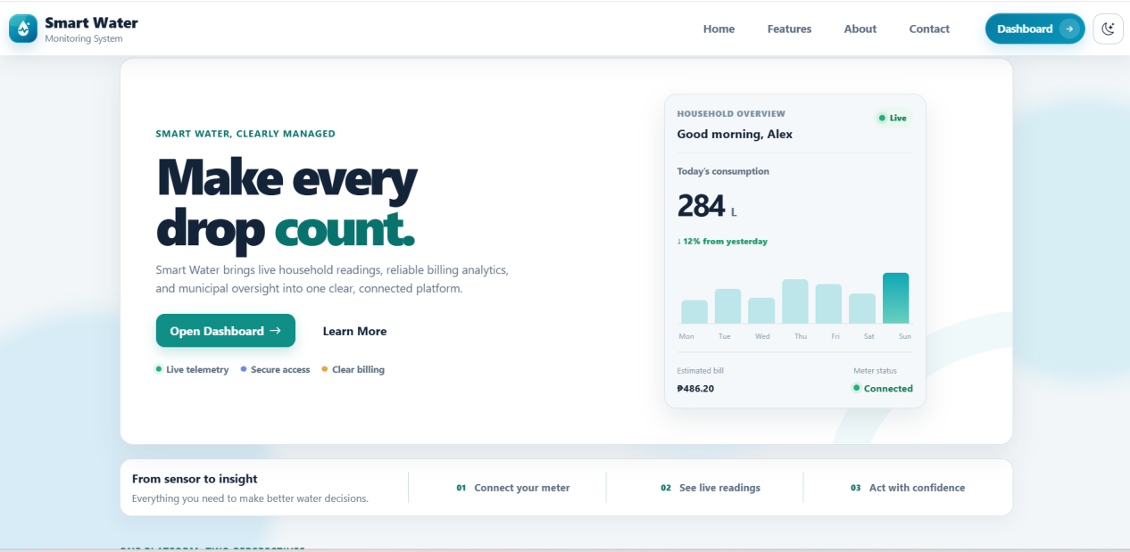
Figure 4.2.1 Home Interface
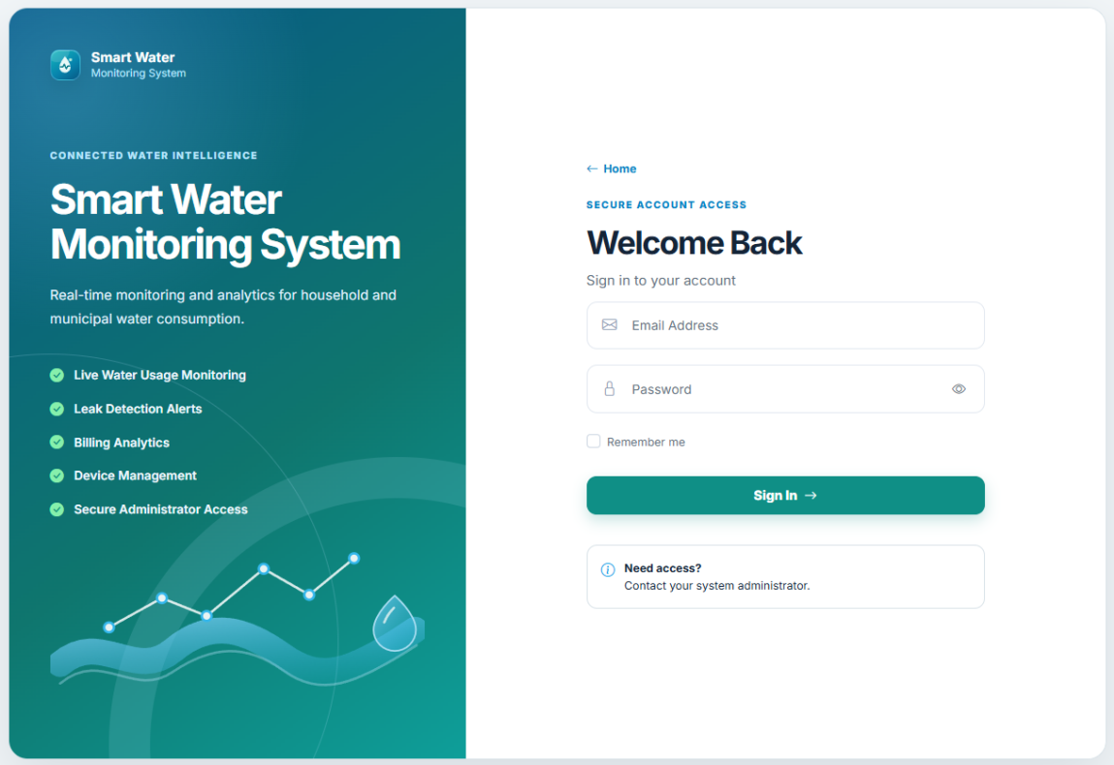

Figure 4.2.2 Log in Interface

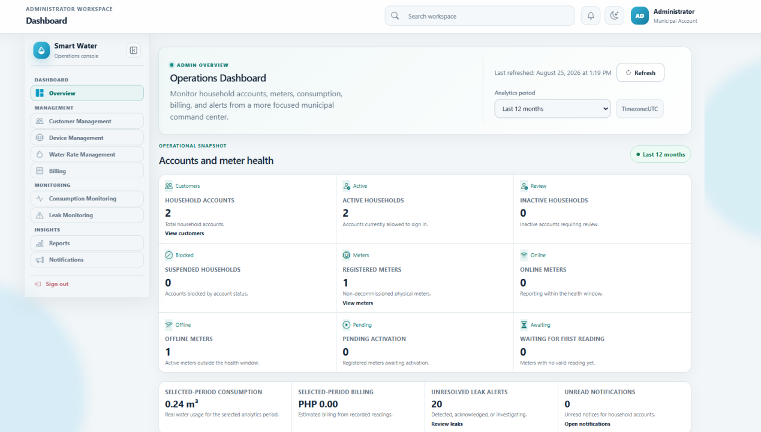
Figure 4.2.3 Admin (Dashboard) Interface

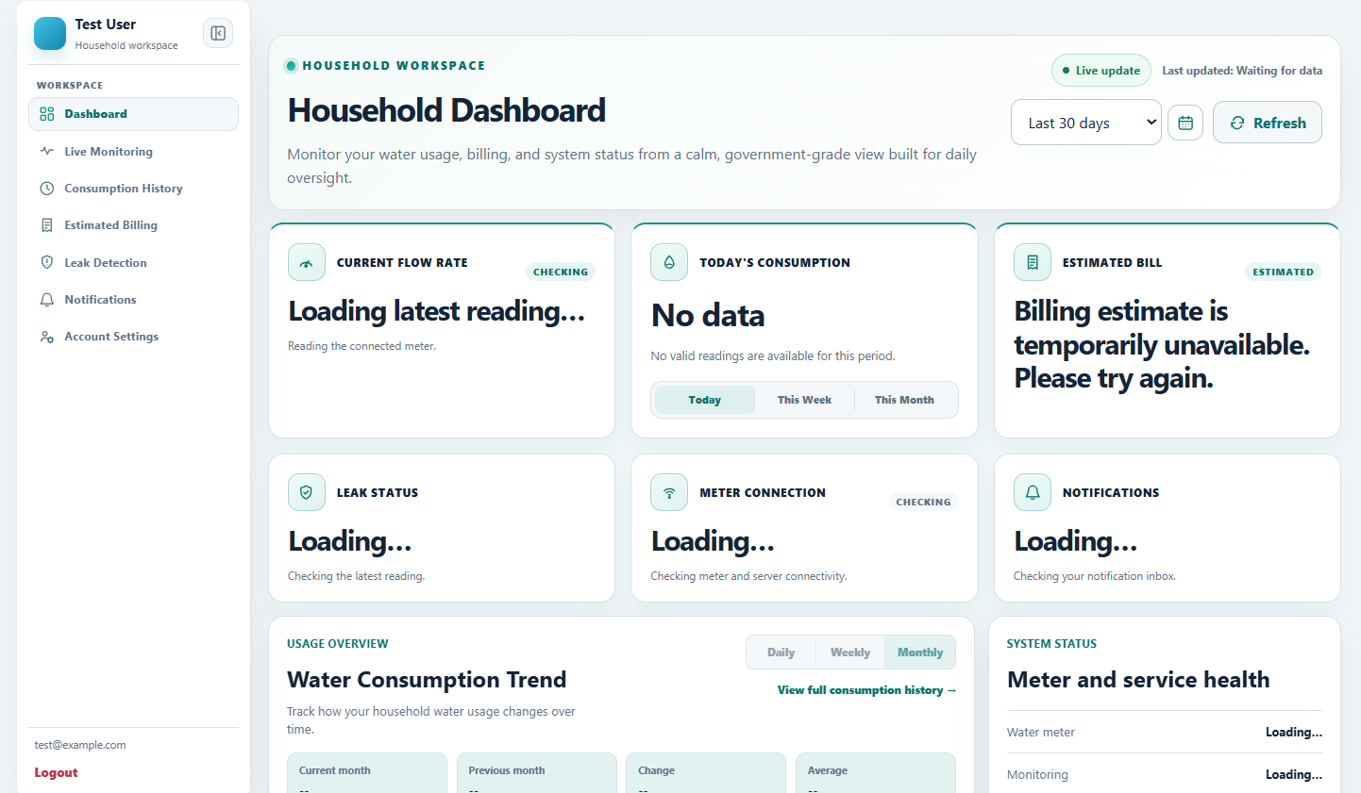
Figure 4.2.4 Household (Dashboard) Interface

4.3 Entity Relationship Diagram
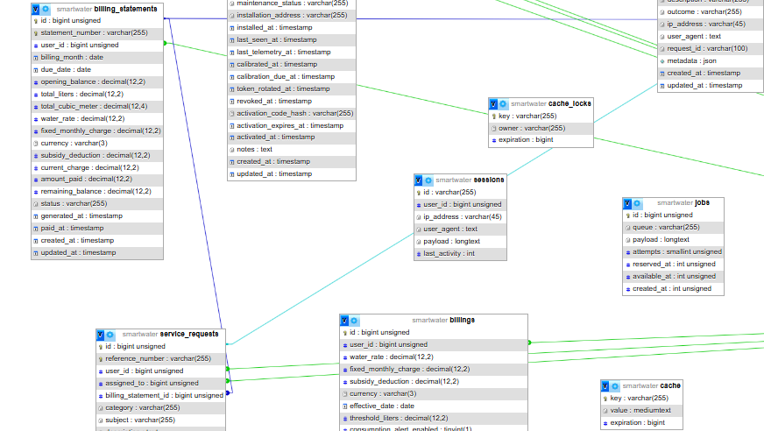
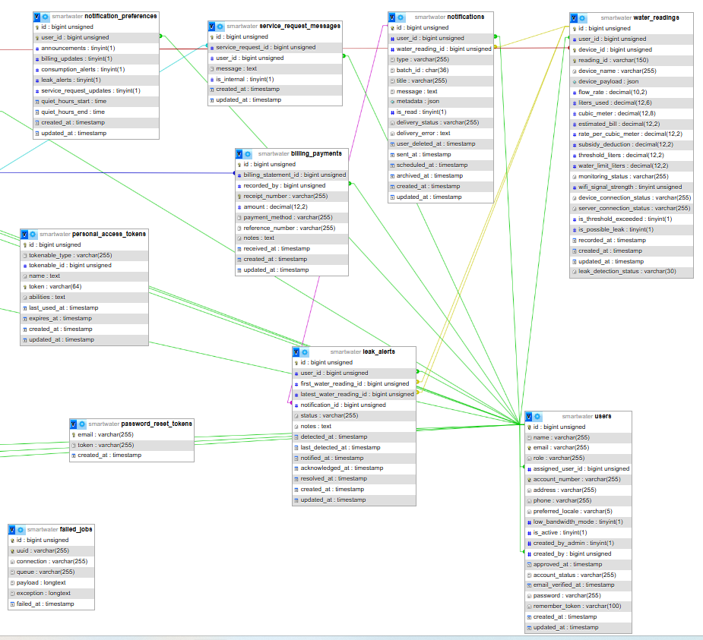

4.4 Data Dictionary
This data dictionary gives a brief overview of operational tables which participate directly in monitoring, billing, alerting, and administration activities. It should be noted that framework-support tables for cache, jobs, sessions, password resets, and personal access tokens will be a part of the implementation but have been excluded from the main discussion to keep things simple and clear.
Field Name | Data Type | Length | Description
id | BIGINT | 20
name | VARCHAR | 255
email | VARCHAR | 255
role | VARCHAR | 255
account_number | VARCHAR | 255
address | VARCHAR | 255
phone | VARCHAR | 255
preferred_locale | VARCHAR | 5
low_bandwidth_mode | BOOLEAN | 1
is_active | BOOLEAN | 1
email_verified_at | DATETIME | -
password | VARCHAR | 255
remember_token | VARCHAR | 100
created_by_admin | BOOLEAN | 1
assigned_user_id | BIGINT | 20
created_by | BIGINT | 20
approved_at | DATETIME | -
account_status | VARCHAR | 255
created_at | DATETIME | -
updated_at | DATETIME | -
Table 4.4.1 Database Table of Users

Field Name | Data Type | Length | Description
id | BIGINT | 20
uuid | VARCHAR | 255
asset_number | VARCHAR | 255
serial_number | VARCHAR | 255
name | VARCHAR | 255
household_id | BIGINT | 20
auth_user_id | BIGINT | 20
hardware_id | VARCHAR | 255
firmware_version | VARCHAR | 255
status | VARCHAR | 255
maintenance_status | VARCHAR | 255
installation_address | VARCHAR | 255
installed_at | DATETIME | -
last_seen_at | DATETIME | -
last_telemetry_at | DATETIME | -
calibrated_at | DATETIME | -
calibration_due_at | DATETIME | -
token_rotated_at | DATETIME | -
revoked_at | DATETIME | -
activation_code_hash | VARCHAR | 255
activation_expires_at | DATETIME | -
activated_at | DATETIME | -
notes | TEXT | -
created_at | DATETIME | -
updated_at | DATETIME | -
Table 4.4.2 Database Table of Devices

Field Name | Data Type | Length | Description
id | BIGINT | 20
user_id | BIGINT | 20
device_id | BIGINT | 20
reading_id | VARCHAR | 255
flow_rate | DECIMAL | 18,6
liters_used | DECIMAL | 18,6
cubic_meter | DECIMAL | 18,6
estimated_bill | DECIMAL | 12,2
rate_per_cubic_meter | DECIMAL | 12,4
subsidy_deduction | DECIMAL | 12,2
threshold_liters | DECIMAL | 18,6
is_threshold_exceeded | BOOLEAN | 1
is_possible_leak | BOOLEAN | 1
leak_detection_status | VARCHAR | 255
water_limit_liters | DECIMAL | 18,6
monitoring_status | VARCHAR | 255
wifi_signal_strength | INTEGER | 11
device_connection_status | VARCHAR | 255
server_connection_status | VARCHAR | 255
device_name | VARCHAR | 255
device_payload | JSON/TEXT | -
recorded_at | DATETIME | -
created_at | DATETIME | -
updated_at | DATETIME | -
Table 4.4.3 Database Table of Water Readings
Field Name | Data Type | Length
id | BIGINT | 20
user_id | BIGINT | 20
water_rate | DECIMAL | 12,4
fixed_monthly_charge | DECIMAL | 12,2
subsidy_deduction | DECIMAL | 12,2
currency | VARCHAR | 3
effective_date | DATE | -
threshold_liters | DECIMAL | 18,6
consumption_alert_enabled | BOOLEAN | 1
consumption_alert_unit | VARCHAR | 255
consumption_alert_behavior | VARCHAR | 255
leak_alert_enabled | BOOLEAN | 1
leak_flow_rate_threshold | DECIMAL | 18,6
leak_continuous_duration_minutes | INTEGER | 11
leak_alert_behavior | VARCHAR | 255
quiet_hours_start | INTEGER | 2
quiet_hours_end | INTEGER | 2
is_active | BOOLEAN | 1
created_at | DATETIME | -
updated_at | DATETIME | -
Table 4.4.4 Database Table of Billing Configurations

Field Name | Data Type | Length | Description
id | BIGINT | 20
user_id | BIGINT | 20
billing_month | DATE | -
opening_balance | DECIMAL | 12,2
total_liters | DECIMAL | 18,6
total_cubic_meter | DECIMAL | 18,6
water_rate | DECIMAL | 12,4
fixed_monthly_charge | DECIMAL | 12,2
subsidy_deduction | DECIMAL | 12,2
currency | VARCHAR | 3
current_charge | DECIMAL | 12,2
amount_paid | DECIMAL | 12,2
remaining_balance | DECIMAL | 12,2
status | VARCHAR | 255
generated_at | DATETIME | -
paid_at | DATETIME | -
created_at | DATETIME | -
updated_at | DATETIME | -
Table 4.4.5 Database Table of Billing Statements

Field Name | Data Type | Length | Description
id | BIGINT | 20
billing_statement_id | BIGINT | 20
recorded_by | BIGINT | 20
receipt_number | VARCHAR | 255
amount | DECIMAL | 12,2
payment_method | VARCHAR | 255
reference_number | VARCHAR | 255
notes | TEXT | -
received_at | DATETIME | -
created_at | DATETIME | -
updated_at | DATETIME | -
Table 4.4.6 Database Table of Billing Payments

Field Name | Data Type | Length | Description
id | BIGINT | 20
user_id | BIGINT | 20
water_reading_id | BIGINT | 20
type | VARCHAR | 255
title | VARCHAR | 255
message | TEXT | -
metadata | JSON/TEXT | -
is_read | BOOLEAN | 1
batch_id | VARCHAR | 255
delivery_status | VARCHAR | 255
delivery_error | TEXT | -
scheduled_at | DATETIME | -
sent_at | DATETIME | -
archived_at | DATETIME | -
user_deleted_at | DATETIME | -
created_at | DATETIME | -
updated_at | DATETIME | -
Table 4.4.7 Database Table of Notifications

Field Name | Data Type | Length | Description
id | BIGINT | 20
user_id | BIGINT | 20
announcements | BOOLEAN | 1
billing_updates | BOOLEAN | 1
consumption_alerts | BOOLEAN | 1
leak_alerts | BOOLEAN | 1
service_request_updates | BOOLEAN | 1
quiet_hours_start | TIME | -
quiet_hours_end | TIME | -
created_at | DATETIME | -
updated_at | DATETIME | -
Table 4.4.8 Database Table of Notifications Preferences
Field Name | Data Type | Length | Description
id | BIGINT | 20
user_id | BIGINT | 20
month | DATE | -
target_liters | DECIMAL | 12,2
created_at | DATETIME | -
updated_at | DATETIME | -
Table 4.4.9 Database Table of Consumption Goals

Field Name | Data Type | Length | Description
id | BIGINT | 20
reference_number | VARCHAR | 255
user_id | BIGINT | 20
assigned_to | BIGINT | 20
billing_statement_id | BIGINT | 20
category | VARCHAR | 255
subject | VARCHAR | 255
description | TEXT | -
priority | VARCHAR | 255
status | VARCHAR | 255
resolved_at | DATETIME | -
created_at | DATETIME | -
updated_at | DATETIME | -
Table 4.4.10 Database Table of Service Requests

Field Name | Data Type | Length | Description
id | BIGINT | 20
service_request_id | BIGINT | 20
user_id | BIGINT | 20
message | TEXT | -
is_internal | BOOLEAN | 1
created_at | DATETIME | -
updated_at | DATETIME | -
Table 4.4.11 Database Table of Service Request Messages

Field Name | Data Type | Length | Description
id | BIGINT | 20
user_id | BIGINT | 20
first_water_reading_id | BIGINT | 20
latest_water_reading_id | BIGINT | 20
notification_id | BIGINT | 20
status | VARCHAR | 255
notes | TEXT | -
detected_at | DATETIME | -
last_detected_at | DATETIME | -
notified_at | DATETIME | -
acknowledged_at | DATETIME | -
resolved_at | DATETIME | -
created_at | DATETIME | -
updated_at | DATETIME | -
Table 4.4.12 Database Table of Leak Alerts

Field Name | Data Type | Length | Description
id | BIGINT | 20
user_id | BIGINT | 20
action | VARCHAR | 255
auditable_type | VARCHAR | 255
auditable_id | BIGINT | 20
description | VARCHAR | 255
metadata | JSON/TEXT | -
outcome | VARCHAR | 255
ip_address | VARCHAR | 45
user_agent | TEXT | -
request_id | VARCHAR | 255
created_at | DATETIME | -
updated_at | DATETIME | -
Table 4.4.13 Database Table of Audit Logs

4.5 Development and Testing
Continuous development and testing were carried out in order to make the Smart Water Monitoring System reliable.
Laravel app, database, M5Stack CoreS3, and YF-S201 water-flow sensor were tested, to confirm correct functioning of the following features: pulse detection, data transmission, billing calculation, alerts and user management.
Once spotted, errors were fixed before the system rolled out.

4.6 Implementation Plan
The plan of action offers a step-by-step guide for the installation and maintenance of the system. It covers activities such as setting up the water-flow sensor and CoreS3, making Wi-Fi connectivity available, the Laravel server and database setup, registration of users and devices, and verifying that users and the administrator can both see the readings correctly displayed on their respective dashboards.
Implementation Issues and Challenges
Several challenges were encountered during the implementation such as incorrect connection of wires, sensor components that were defective, unstable pulse signals, network errors, telemetry responses that were duplicated or malformed, month-boundary billing behavior and possibility of presenting missing data as zero. The problem of hardware was handled by checking the component and wiring, calibration, pulse-noise filtering and repeated volume tests. The software part of the problem was tackled by having stable readings ids, doing matching acknowledgements, keeping retained pending intervals, defining server-based limits and connection status, aggregating current period data, reverting to using the metered-month if latest data is not available, setting up unavailable status, validation, audit logging and automated regression tests.

4.7 System Implementation and Results
The implemented system supports the workflow from measured water flow to household and administrative actions. Before final submission, this section must be supported by documented functional-test results, sensor-calibration results, data-transmission results, billing-validation results, and leak-detection results from the actual prototype.

CHAPTER V

Results and Discussions
Chapter 5 describes the implemented interfaces, the operating methods of the system and the results of a check of the Smart Water Consumption Monitoring system's functionality. A detailed explanation of how the components at household, administrative, and IoT tiers cooperate to capture water-flow pulses will be provided, telemetry transmission, measurement database, consumption calculation, and reporting for monitoring, billing, alerting, and municipal administration.

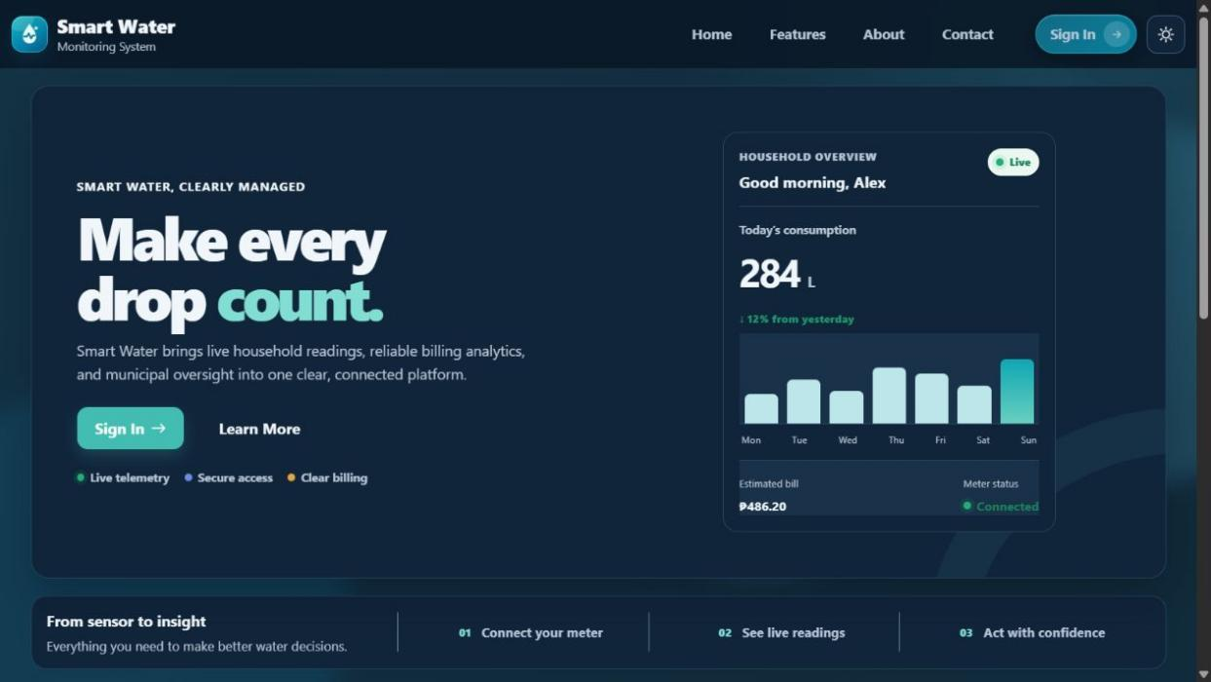
User Guide (Web Application)
Figure 5.1 Landing Page Window

Fig. 5.1 presents the publicly exposed part (home page) of SmartWater. It explains what the service is and leads the users who are entitled to the application to a secure page (application page).
1. The links allow you to go to Home, Features, About, and Contact sections.
2. On the Sign In button is the access after providing the user data (authentication) window.
3. A small switch is the theme control changing the display color mode of the interface between day and night.

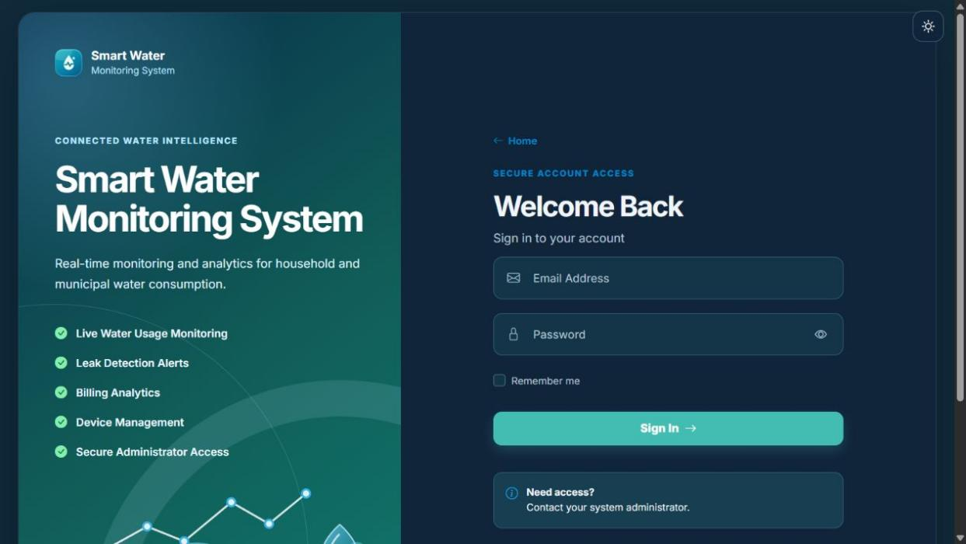
Authentication
Figure 5.2 Log In Page Window

Figure 5.2 displays the household and administrator accounts' login page. Since only authorized staff issue/maintain accounts, the option to sign up publicly is switched off.
1. The login is triggered upon input of the registered mail id with password.
2. The password visibility control helps the user verify the entered password without changing it.
3. Remember Me may retain the authenticated session on the same trusted device.
4. After successful authentication, the system opens the workspace assigned to the user's role.
5. Users who need access are instructed to contact the system administrator.

Household User Guide

Dashboard
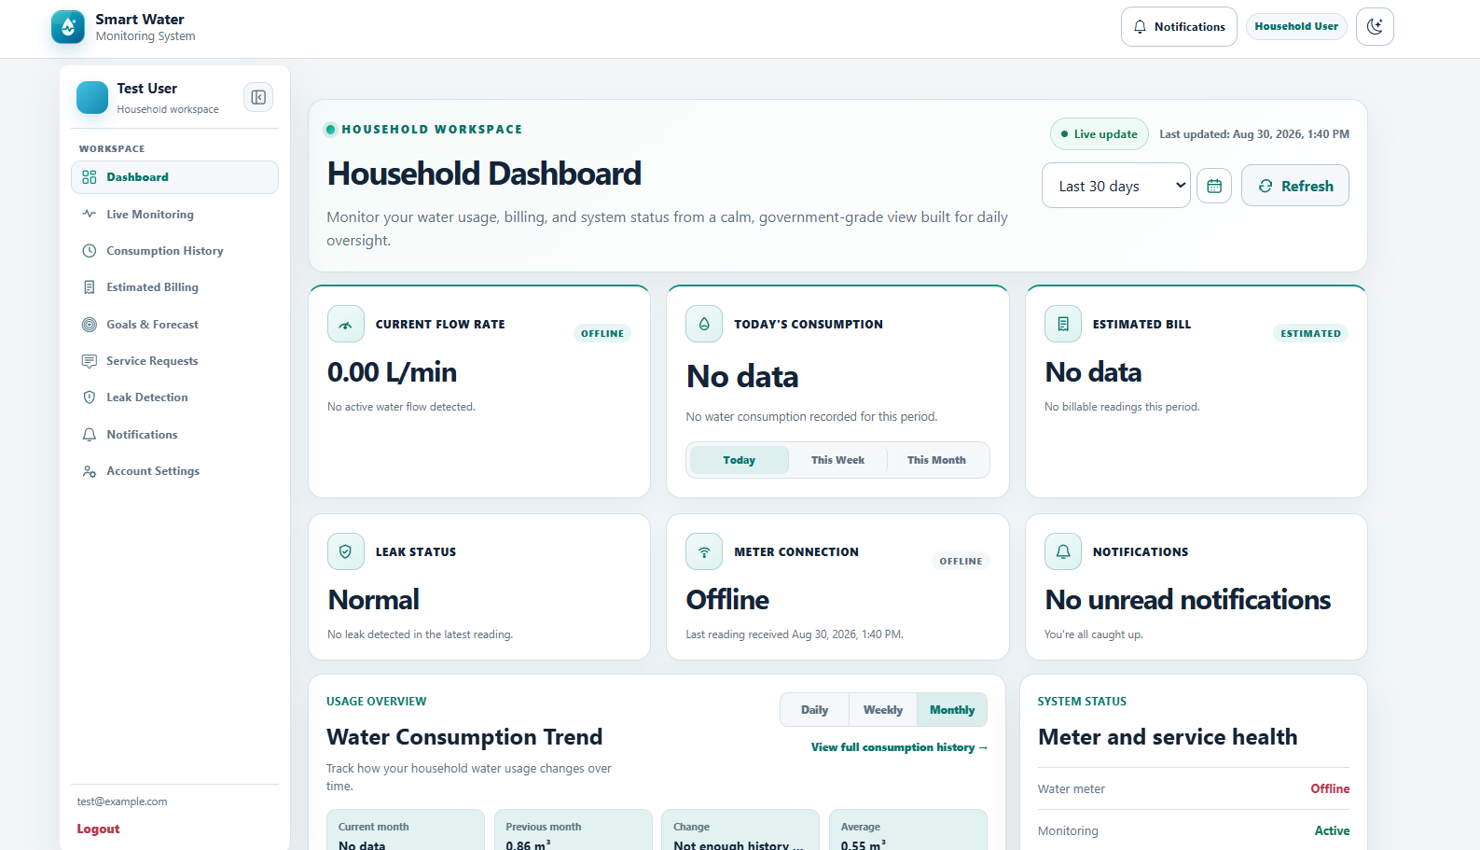

Figure 5.3 Household Dashboard Window
Figure 5.3 presents the household dashboard, which gives the authenticated household an immediate summary of water use, billing, meter condition, and recent activity.
1. Current Flow Rate shows the newest liters-per-minute value received from the assigned meter.
2. Estimated Bill summarizes the running charge when valid readings and an active water rate are available.
3. Leak Status, Meter Connection, and Notifications identify conditions requiring household attention.
4. Usage Comparison, Usage Snapshot, and Meter History summarize the selected period and its previous-period comparison.
5. Recent meter activity and alerts help the household determine whether readings are current.

Live Monitoring
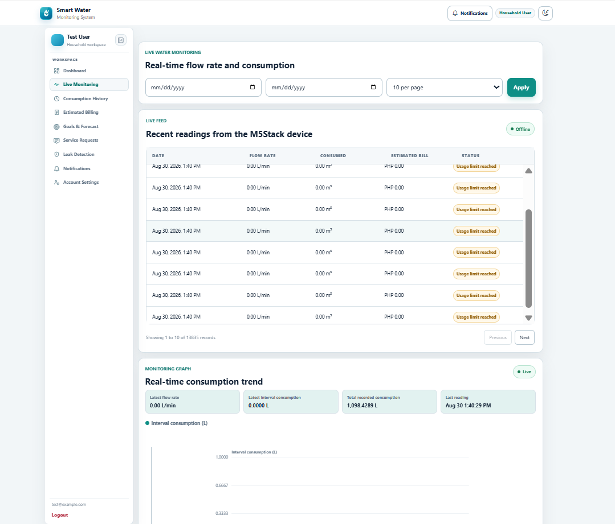

Figure 5.4 Household Live Monitoring Window

Figure 5.4 shows the live monitoring tab used to inspect the newest M5Stack CoreS3 telemetry and recent flow behavior.
1. The current reading presents the latest flow-rate and consumption values received from the assigned meter.
2. The live trend graph visualizes recent valid readings without inventing values for missing data.
3. The recent-readings list identifies when each M5Stack reading was recorded.
4. Date and rows-per-page controls limit the monitoring records shown on screen.
5. A connected meter may correctly show 0.00 L/min when no pulse is received during the present sampling interval.

Consumption History
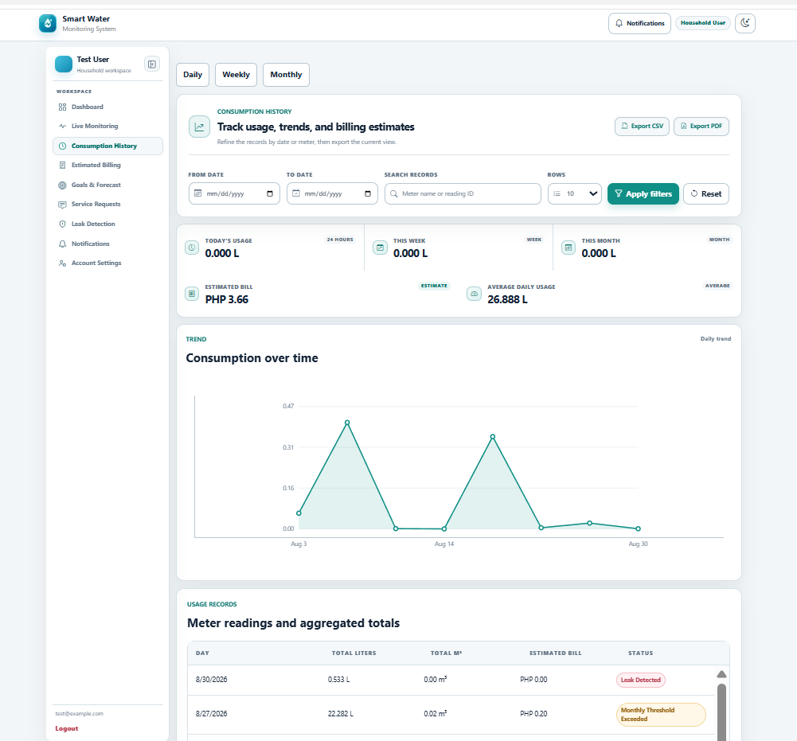

Figure 5.5 Household Consumption History Window

Figure 5.5 presents the historical-consumption tab, where the household can review detailed and aggregated use for selected reporting periods.
1. Daily, weekly, and monthly tabs change the aggregation used by the history view.
2. Date, meter, search, and page-size filters narrow the displayed records.
3. The trend chart presents recorded usage over the selected period.
4. Detailed meter readings and calculated totals support verification of household consumption.
5. CSV and PDF controls export the filtered history for further review or printing.

Estimated Billing
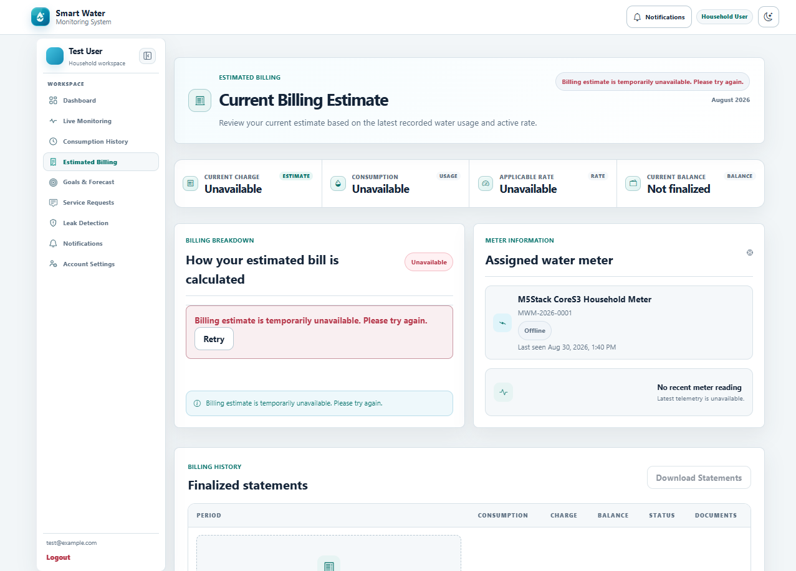

Figure 5.6 Household Estimated Billing Window
Figure 5.6 shows the estimated-billing tab, which converts recorded consumption into a transparent running estimate and provides access to finalized statements.
1. Current Billing Estimate calculates the running charge from valid consumption and the effective rate.
2. Billing Breakdown identifies the usage, water rate, fixed charge, and applicable adjustments.
3. Assigned-meter details and the latest reading show the source of the estimate.
4. Billing Statements list finalized records and their payment status.
5. Statement downloads are available when a finalized billing record has been generated.

Leak Detection
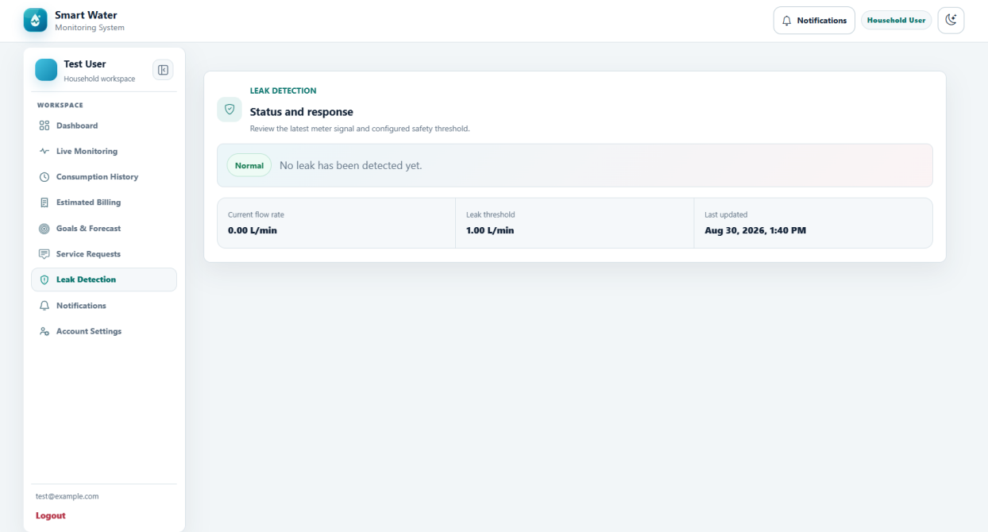

Figure 5.7 Household Leak Detection Window
Figure 5.7 presents the leak-detection tab used to communicate possible abnormal flow and the response expected from the household.
1. Leak Status distinguishes normal operation from a possible leak condition.
2. Current Flow Rate and the configured threshold provide the evidence used by the leak evaluation.
3. Last Updated identifies when the displayed condition was most recently assessed.
4. Alert history retains relevant notices instead of deleting the operational record.
5. When abnormal use persists, the household is advised to inspect the installation and notify the local waterworks for assurance.

Notifications
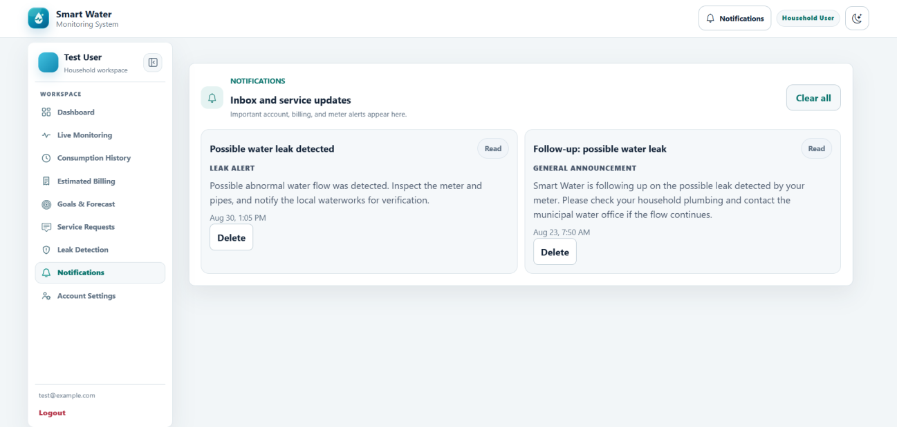

Figure 5.8 Household Notifications Window
Figure 5.8 shows the household inbox for account, meter, leak, billing, maintenance, and service information.
1. Unread indicators distinguish notices that still require household review.
2. Opening a notice displays the complete message and relevant context.
3. Service updates communicate interruptions, maintenance, and general announcements.
4. Meter and leak alerts connect important notices with the related monitoring event.
5. Clear All performs the permitted inbox-clearing action without changing unrelated operational records.

Account Settings
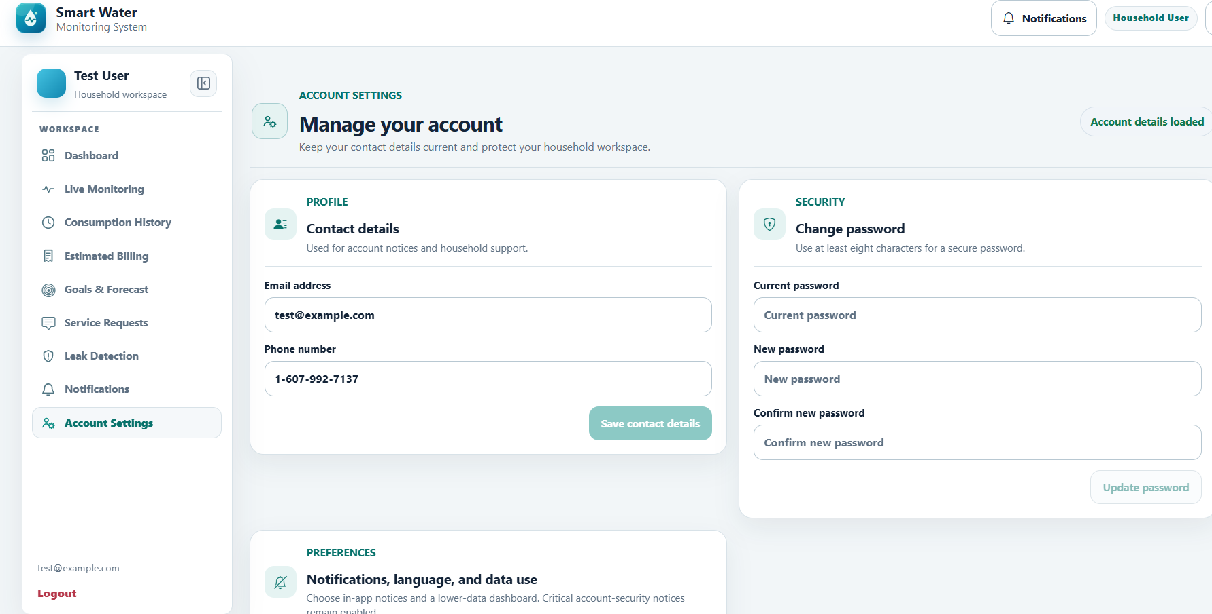

Figure 5.9 Household Account Settings Window
Figure 5.9 presents the account-settings tab used by a household to maintain permitted contact information and securely change its password.
1. The profile section identifies the authenticated household account.
2. Email address and phone number may be updated through validated contact fields.
3. Save Contact Details stores only the account information the household is permitted to change.
4. Change Password requires the current password, a new password, and confirmation.
5. Password validation and authenticated checks prevent an unrelated user from changing the account password.

Administrator User Guide

Overview
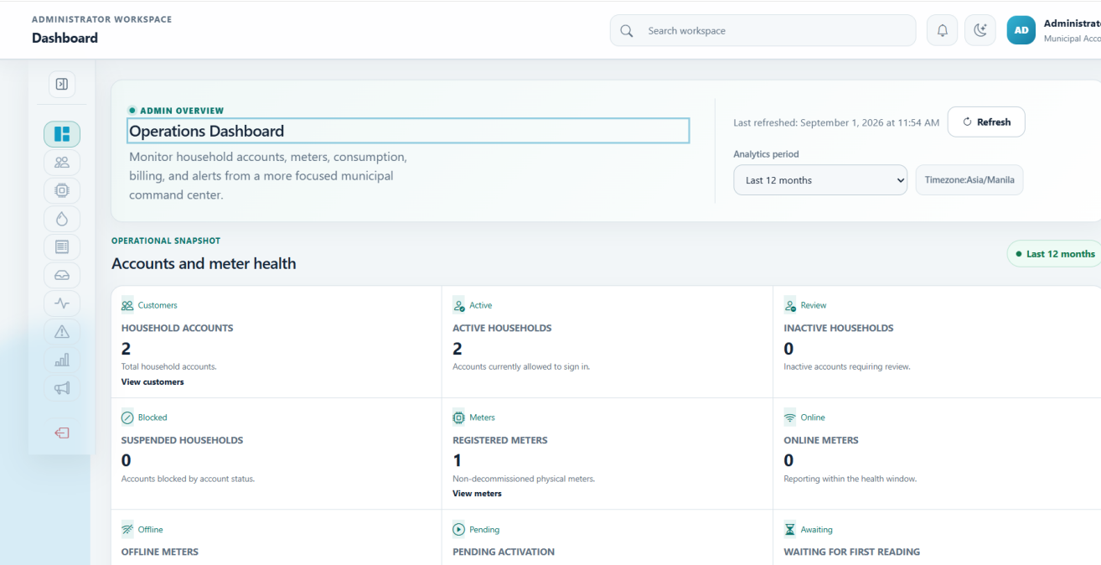

Figure 5.10 Administrator Overview Window
Figure 5.10 shows the administrator overview, which consolidates municipal operating status, trend information, and records requiring attention.
1. Operational Snapshot summarizes household accounts, meter health, leaks, and unread notices.
2. Analytics may be reviewed for 7 days, 30 days, 3 months, 12 months, or a custom period.
3. System Diagnostics separates application, device, and data-health conditions.
4. The 12-month consumption trend supports higher-level usage review.
5. Follow-up items and recent events direct the administrator to records that require action.

Customer Management
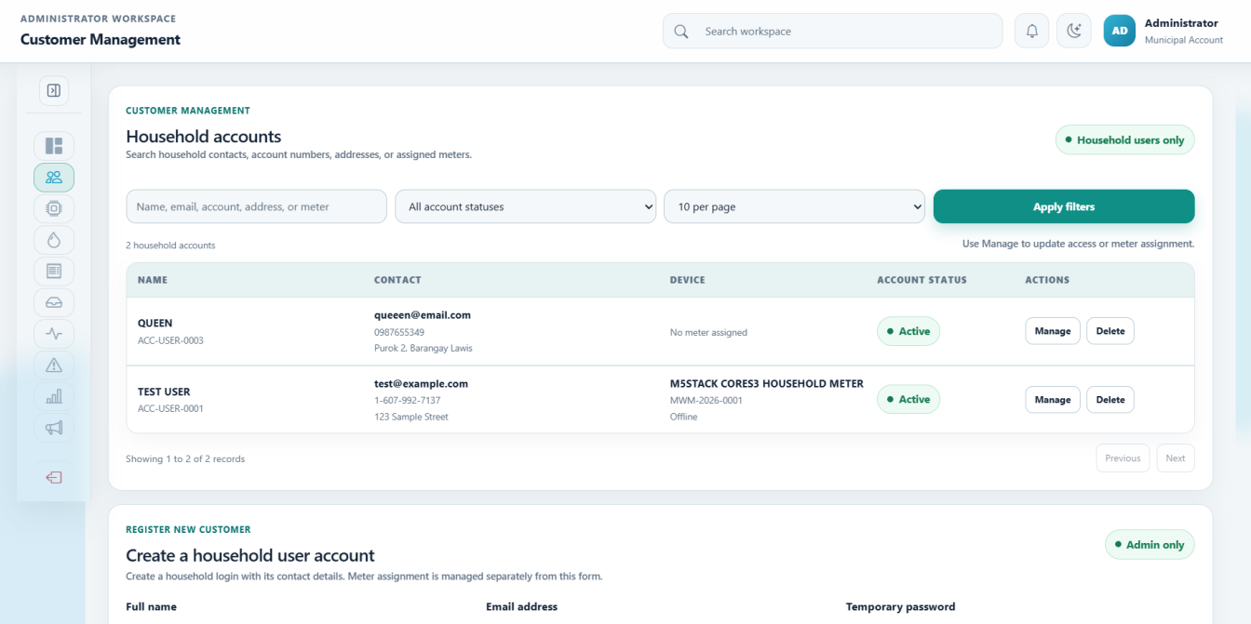

Figure 5.11 Administrator Customer Management Window
Figure 5.11 presents the customer-management tab used to create, locate, update, and control household accounts.
1. Household accounts may be filtered as active, inactive, suspended, or archived.
2. Create Household records the user's identity, barangay, and verified contact details.
3. Edit Account updates only permitted household and service information.
4. Meter Assignment links the household to the correct registered device.
5. Role restrictions and secure password handling protect administrator and household privileges.

Device Management
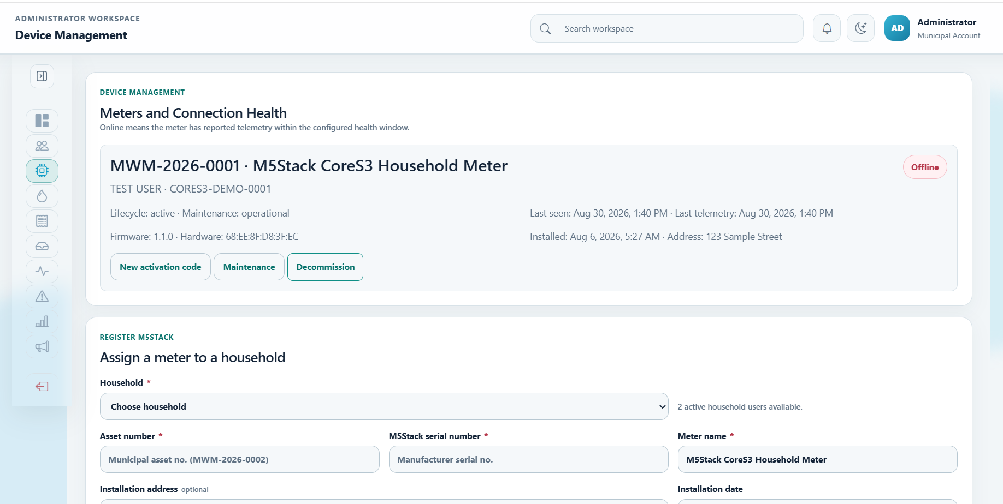

Figure 5.12 Administrator Device Management Window
Figure 5.12 shows the device-management tab for registering M5Stack meters, assigning them, and reviewing their communication health.
1. The meter registry lists device identity, assignment, and connection status.
2. Register M5Stack creates the controlled device record used by telemetry authentication.
3. Assign Household establishes the relationship between the meter and the owner of its readings.
4. Serial, asset, installation, and status details support device administration.
5. Activation codes provide limited credentials for commissioning the registered meter.

Water Rate Management
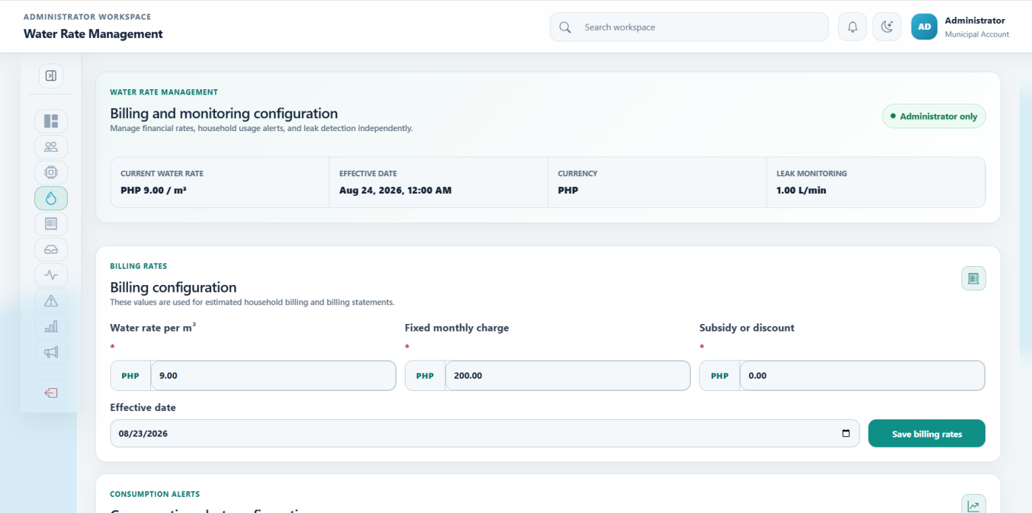

Figure 5.13 Administrator Water Rate Management Window
Figure 5.13 presents water-rate, billing, consumption-alert, and leak-monitoring configuration maintained by authorized administrators.
1. The active water rate includes rate per cubic meter, currency, and effective date.
2. Billing configuration maintains the fixed charge, subsidy or discount, and effective values.
3. Consumption alerts compare actual current month-to-date usage with the equivalent days of the previous month.
4. The relevant percentage, including a configured 100-percent increase or decrease, is evaluated only when a valid baseline exists.
5. Leak settings maintain flow threshold, duration, quiet hours, behavior, and notification audience.

Billing Management
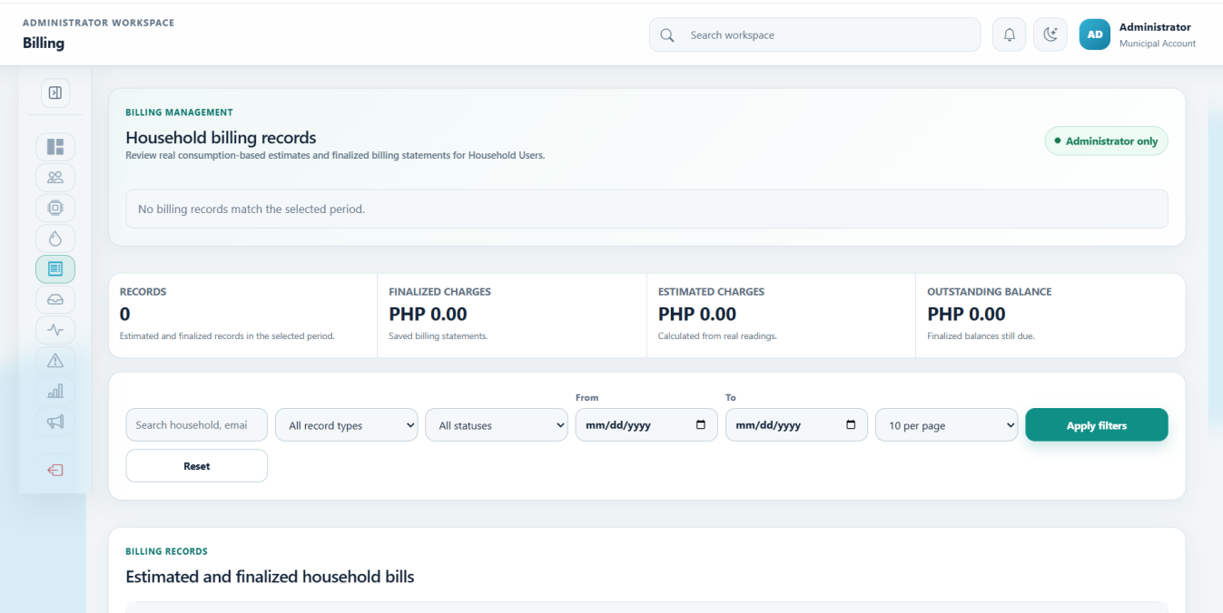

Figure 5.14 Administrator Billing Management Window
Figure 5.14 shows the billing-management tab used to review estimates, finalize eligible bills, and monitor payment status.
1. Billing records may be filtered by date, estimated or finalized state, and payment condition.
2. Payment status distinguishes estimated, unpaid, partially paid, and paid records.
3. Billing Details presents the consumption and rate basis of the charge.
4. Finalization creates a controlled billing statement from eligible recorded values.
5. Exports provide billing records for authorized reporting and review.

Consumption Monitoring
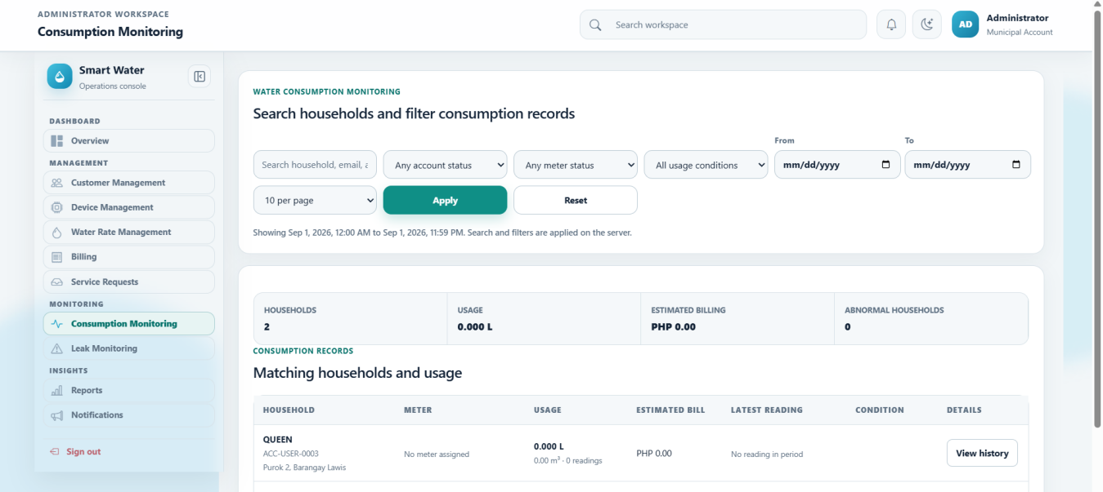

Figure 5.15 Administrator Consumption Monitoring Window
Figure 5.15 presents the administrator's detailed consumption view for searching households, reviewing meter conditions, and opening historical totals.
1. Search and filters locate households by account, meter, usage, leak, threshold, or no-reading condition.
2. The monitoring summary presents household count, usage, estimated billing, and abnormal cases.
3. Consumption records list detailed readings for the selected period.
4. Household History opens daily, weekly, and monthly totals for a selected account.
5. The effective water rate supplies the billing context displayed with consumption results.

Leak Monitoring
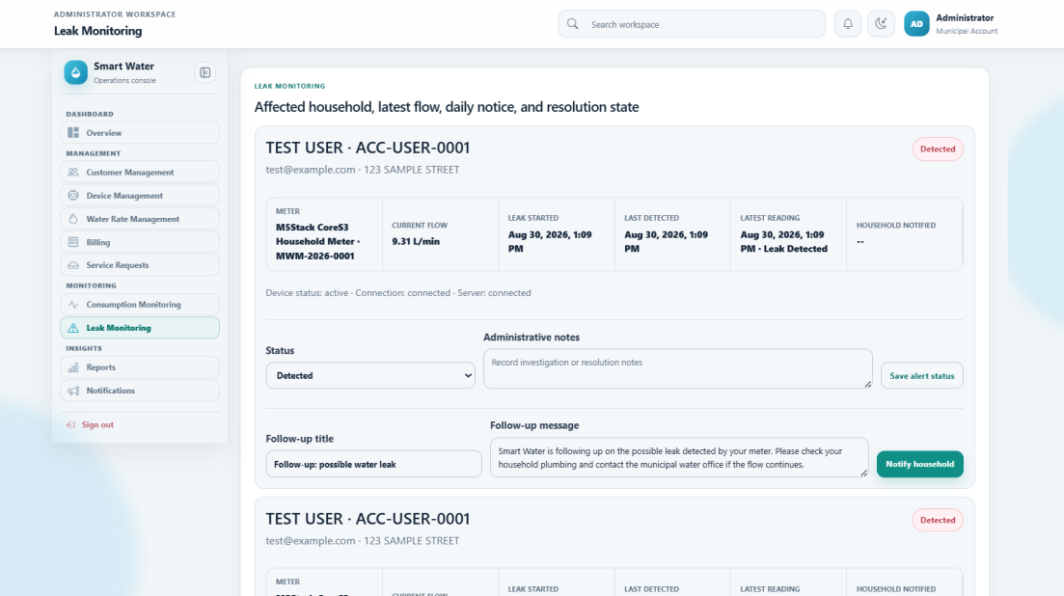

Figure 5.16 Administrator Leak Monitoring Window
Figure 5.16 shows the operational leak-monitoring tab used to investigate alerts and preserve the outcome of each case.
1. Each alert identifies the affected household, meter, latest flow evidence, and applicable threshold.
2. Follow-up notices document communication with the household or service personnel.
3. Resolve Alert closes an investigated condition while retaining its history.
4. False Positive records the reviewed classification without deleting audit evidence.
5. Reopen Case returns a closed alert to active review when new evidence is received.

Reports
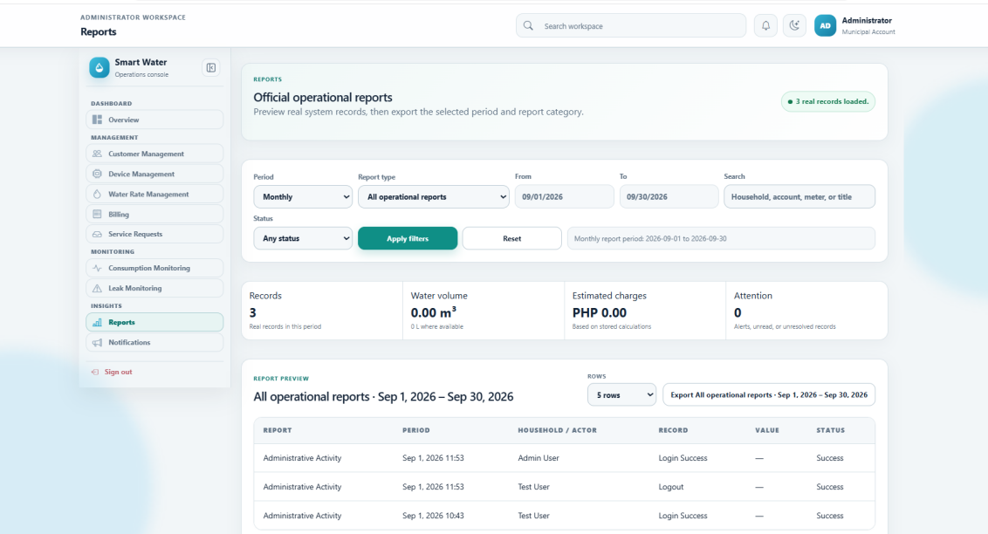

Figure 5.17 Administrator Reports Window
Figure 5.17 presents the reports tab used to prepare official operational summaries from SmartWater records.
1. Reporting periods include daily, weekly, monthly, and custom ranges.
2. Report types cover consumption, billing, notifications, leaks, devices, households, and audit events.
3. Search, date, status, and page-size controls refine the selected data set.
4. Summary values identify record count, consumption, charges, and items requiring attention.
5. Preview and Export support review before the official report is downloaded.

Notification Management
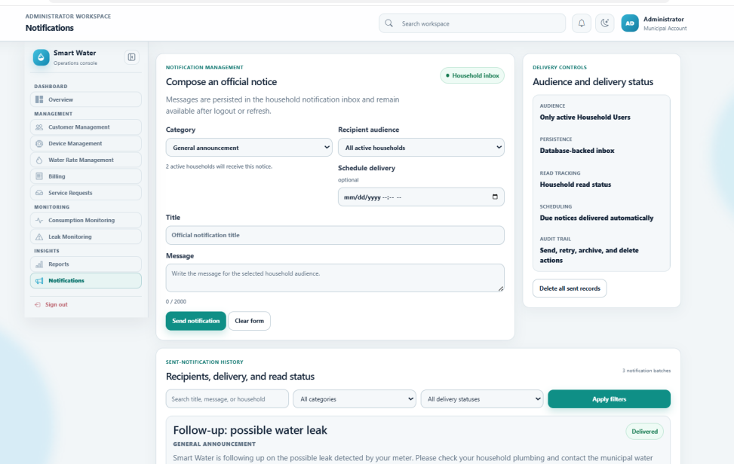

Figure 5.18 Administrator Notification Management Window
Figure 5.18 shows the notification-management tab used to compose, target, deliver, and audit household communications.
1. Notice categories include announcements, interruptions, maintenance, billing, leak or emergency, and device or system messages.
2. The audience may be all active households or one selected household.
3. Notices may be sent immediately or stored as scheduled communications.
4. Sent History records the category, audience, time, and delivery result.
5. Delivered, scheduled, partial, and failed states support retry, archive, and other permitted follow-up actions.

User Guide (IoT Device)

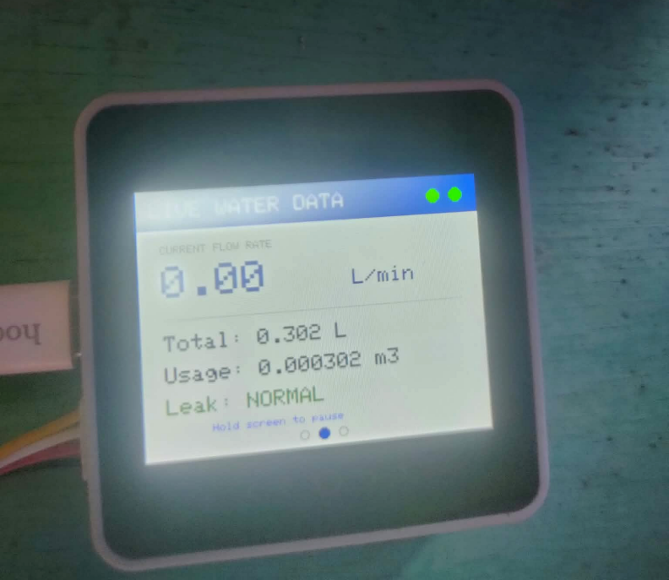
Figure 5.19 M5Stack CoreS3 Monitoring Window
Figure 5.19 shows the M5Stack CoreS3 device used with the YF-S201 water-flow sensor. The device converts sensor pulses into flow rate and accumulated water volume before sending the reading to the Laravel server.
1. The YF-S201 signal is read through GPIO2, while the sensor and CoreS3 share the required power and ground connections.
2. The firmware uses a calibration value of 450 pulses per liter and rejects very short duplicate edges as electrical noise.
3. The display shows Wi-Fi status, server status, current flow rate, total liters, cubic-meter usage, and leak condition.
4. A zero current flow rate means that no pulse was received in the present interval; it does not automatically mean that the device is offline.
5. Pending telemetry is retained when the server cannot be reached and is acknowledged only after a successful response.

References

Clemente, A. E., Samaniego, R. M. G., & Cruz, F. R. G. (2023). IoT based water consumption monitoring system for water management. 2023 15th International Conference on Computer and Automation Engineering, 114-119.
Rapelli, N., Myakal, A., Kota, V., & Rajarapollu, P. R. (2019). IoT based smart water management, monitoring and distribution system for an apartment. 2019 International Conference on Intelligent Computing and Control Systems, 440-443. https://doi.org/10.1109/ICCS45141.2019.9065369

Roslan, M. Y. H., Rahman, F. Y. A., Mohamad, R., & Shahbudin, S. (2025). Development and evaluation of an IoT-based home water usage monitoring system using LoRa and ESP32. 2025 IEEE 16th Control and System Graduate Research Colloquium, 111-114. https://ieeexplore.ieee.org/document/11159838
Varghese, L. J., Devanath, V., Kishore, V., Poornima, R., & Jacob, S. S. (2025). IoT based smart water meter for domestic utility. 2025 International Conference on Inventive Computation Technologies. https://doi.org/10.1109/ICICT64420.2025.11005058

CURRICULUM VITAE

Jea Marie Montuya Japay
Personal Details

Birthday: October 17, 2005
Address: Buacao, Clarin, Bohol
Email: jeangxxmarie@gmail.com
Height:
Weight:

EDUCATIONAL BACKGROUND

Elementary
Presentation of Mary School of Clarin Inc.
2011 - 2018
Secondary
Holy Cross Academy
2018-2021
Tertiary
Mater Dei College
Cabulijan, Tubigon, Bohol
2021-2024

Language: Tagalog, Cebuano, English

CURRICULUM VITAE

JOHN JOSHUA R. MASCARIÑAS
Personal Details

Birthday: November 21, 2004
Address: Ilijan Norte, Tubigon,Bohol
Email: johnjoshuamascarinas@gmail.com
Height: 165 cm
Weight: 123lbs

EDUCATIONAL BACKGROUND

Elementary
Avelino Chagas Elementary School Ilijan Norte, Tubigon, Bohol 2010-2017
Secondary
Tubigon West National High School Ilijan Norte, Tubigon, Bohol
2017-2021

Tertiary
Mater Dei College
Cabulijan, Tubigon, Bohol
2021-2024

Language: Filipino, Visayan, English

CURRICULUM VITAE

LYKAMAE A. MANGUILIMOTAN
Personal Details

Birthday: December 13, 2001
Address: Kinabag-an,Calape,Bohol
Email: lykamaemanguilimotan631@gmail.com
Height: 149 cm
Weight: 42kgs.

EDUCATIONAL BACKGROUND

Elementary
Pangangan Elementary School 2008-2014
Secondary
Pangangan National High School
2014-2020

Tertiary
Mater Dei College
Cabulijan, Tubigon, Bohol
2021-2024

Language: Filipino, Visayan, English

