CAPSTONE PROJECT

SMART WATER CONSUMPTION MONITORING SYSTEM
__________________________________________________

GROUP 4

MEMBERS
CENITA, ZEUS GYRO M.
JAPAY, JEA MARIE M.
MANGUILIMOTAN, LYKAMAE A.
MASCARIÑAS, JOHN JOSHUA R.

TABLE OF CONTENTS

Chapter Page
- Introduction 1
  - Project Context
  - Purpose and Description 1
  - Objectives 1
  - Scope and Limitations 2
- Review of Related Literature 3
- Technical Background 4
Architecture Design 4
3.1.1 Smart Water Consumption Monitoring
System Architecture Design 4
Details of Technology Used 4
Methodology 5
4.1 Requirements Analysis and Requirements
Documentation 5
4.2 System Design, Software, and Processes 21
4.3 Entity Relationship Diagram 24
4.4 Data Dictionary 26
4.5 Development and Testing 40
4.6 Implementations Plan 40
4.7 System Implementation Plan 41
Results and Discussion 42
References 64

I. Introduction

1.1 Project Context
Households often learn their water use only after an official bill is issued. This delay makes it difficult to connect daily consumption to cost, identify unusual flow early, or decide whether a possible plumbing concern requires attention. Connected water monitoring can provide a shorter feedback cycle by collecting flow information from a household pipeline and presenting it to households and authorized water-service personnel.
The Smart Water Consumption Monitoring System is a household-scale Internet of Things project for Calape, Bohol. It uses a YF-S201 flow sensor and an M5Stack CoreS3 to observe water flow. The CoreS3 samples the sensor pulse signal, estimates interval flow and volume, shows device status locally, and sends readings through Wi-Fi to a Laravel web application. The application stores accepted readings, derives the monthly consumption total, and provides household and municipal workspaces.
The updated system includes a municipal device registry and a controlled commissioning process. A device receives a one-time activation code, is bound to a hardware identity and household, and uses a scoped credential for telemetry. Each reading carries a stable identifier. If Wi-Fi or the server is temporarily unavailable, the device retains the pending interval and can resend it safely; the server recognizes a repeated identifier and prevents the same interval from being counted twice.

1.2 Purpose and Description
The purpose of the project is to provide an IoT-based Smart Water Consumption Monitoring System that gives households timely visibility of measured use and gives authorized municipal personnel a role-scoped way to review devices, household records, estimated billing information, notifications, reports, and follow-up activity. It is intended to support awareness and monitoring, not to replace an approved utility meter, an official municipal bill, or a physical inspection.
The device reads pulses from the YF-S201 on GPIO2 and uses a configurable calibration value to compute interval liters and flow rate. Firmware samples the signal once per second and attempts a telemetry upload approximately every three seconds. The Laravel application validates device identity and household assignment, stores accepted readings, calculates the server-authoritative monthly total, evaluates possible-leak conditions, and applies relevant billing settings. Households can view their own consumption, history, notifications, goals, statements, and service requests. Administrators can manage households, device lifecycle, billing settings, leak records, reports, offline payments, and audit logs.

1.3 Objectives
The general objective is to develop an IoT-based Smart Water Consumption Monitoring System that measures household water use, transmits reliable telemetry to a web application, and provides consumption, notification, and estimated-billing information appropriate to each user role.
• Measure water-flow pulses through a YF-S201 sensor and convert calibrated pulse counts into interval liters and flow rate using an M5Stack CoreS3.
• Provide local device status and upload readings through Wi-Fi using stable identifiers and retained pending intervals for safe retry.
• Commission physical meters through a municipal registry, one-time activation, hardware identity binding, and scoped device credentials.
• Provide households with live and historical consumption, notifications, goals, statements, billing documents, and service-request functions.
• Provide administrators with household, device, billing, leak, report, notification, payment-ledger, service-request, and audit functions.
• Identify possible leak conditions from server-configured flow rules and create alerts for investigation without claiming physical diagnosis or automatic water shutoff.
• Verify implemented software behavior through automated tests while keeping physical calibration and real-user field validation as separate requirements.

1.4 Scope and Limitations
The system covers household monitoring through a YF-S201 flow sensor connected to an M5Stack CoreS3. It includes local device display, Wi-Fi telemetry, retry-safe readings, role-scoped household and municipal web workspaces, consumption history, estimated and finalized statement support, configurable rates and subsidies or deductions, notifications, possible-leak records, reports, offline-payment records, service requests, and audit logging.
The initial firmware setting of 450 pulses per liter is a starting calibration value, not a verified accuracy claim. A measured-volume test is required for each installed sensor and plumbing arrangement. The system depends on power and usable Wi-Fi for timely data upload; an extended outage can delay the dashboard. Possible-leak alerts require inspection and do not close a valve. System estimates and statements must be reconciled with approved municipal rules before being treated as official bills. The project has automated software-test evidence, but sensor accuracy, installation quality, backup restoration, long-term reliability, and unassisted usability still require field validation.

II. Review of Related Literature
Andrić et al. (2022) describe an IoT approach to smart water use in which connected meters provide more transparent consumption information and support data analysis. The study is relevant to the present project because it treats water metering as a complete information path from physical measurement to understandable consumption data. The present system applies this principle at household scale through Wi-Fi telemetry and a web-based municipal workflow.
Tasong and Abao (2019) developed a water-monitoring application that combined Hall-effect flow sensing, cloud storage, browser access, and calibration trials. Their work is relevant because it demonstrates that pulse-derived volume must be calibrated rather than assumed. Accordingly, the present project treats its firmware factor as an initial configuration and does not claim field accuracy before a measured-volume calibration test has been completed.
Bragalli, Neri, and Toth (2019) examined smart-meter-based water-loss assessment in the presence of incomplete readings. This is relevant to the present project because communication problems can cause missing or repeated telemetry. The system responds by preserving unsent intervals locally, sending a stable reading identifier on retry, and applying server-side idempotency so a previously accepted reading is not counted again.
The project also adopts a controlled device lifecycle. Laravel Sanctum documents token-based API authentication concepts that inform the separation between browser-user access and commissioned device access. The implemented project extends that approach with municipal device registration, one-time activation, hardware binding, scoped credentials, suspension, rotation, and decommissioning. This prevents a generic shared upload key from being the sole identity of a physical meter.
The reviewed work supports the feasibility of connected water sensing, visual consumption information, calibration-aware measurement, and anomaly-oriented monitoring. The present project integrates those ideas with a local operational workflow: registered device identity, household association, retry-safe telemetry, server-authoritative consumption, configurable billing support, managed possible-leak follow-up, reports, and audit trails. It does not claim a new sensing principle or a fully validated utility replacement.

III. Technical Background

3.1 Architecture Design

3.1.1 Smart Water Consumption Monitoring System Architecture Design
The system has four connected layers. The measurement layer is the YF-S201 sensor installed in the household water path. The device layer is the M5Stack CoreS3, which receives the pulse signal through GPIO2, calculates interval values from its calibration setting, retains pending readings, and presents local device information. The application layer is a Laravel service with APIs, a relational database, business services, and audit logging. The user layer consists of household and administrator browser workspaces with records restricted by role and ownership.
Layer | Role in the System | Implemented Controls
Measurement | Produces a pulse signal representing water movement. | YF-S201 flow sensor; measured-volume calibration remains required.
Device | Samples pulses, calculates interval values, shows status, and uploads telemetry. | CoreS3; GPIO2; one-second sampling; three-second upload interval; pending-reading persistence.
Application | Validates, stores, derives, notifies, bills, reports, and audits. | Laravel API; server-side household assignment; stable reading IDs; server total and alert evaluation.
Household workspace | Shows only authenticated household records. | Live consumption, history, statements, notifications, goals, requests, and settings.
Municipal workspace | Manages records and operational follow-up. | Device lifecycle, billing configuration, leak records, reports, offline payments, service requests, and audit logs.

Water passing through the sensor produces pulses. The CoreS3 samples these pulses and uploads a unique interval reading when connectivity is available. The application verifies the commissioned device and its household assignment before storing the reading. It then derives the current-period total from accepted readings, evaluates the applicable billing and possible-leak rules, and makes the resulting state available to the device screen and appropriate web workspace. Household access is limited to the authenticated household; administrators can perform governed configuration and lifecycle actions recorded in audit logs.

3.2 Details of Technology Used
M5Stack CoreS3 ESP32 IoT Development Kit. The CoreS3 is the embedded processing and display device in the project. Its firmware samples the sensor once per second, uses Wi-Fi for telemetry, keeps pending readings for retry, and displays status without exposing credentials. The device does not decide municipal billing thresholds or authoritative monthly totals; these remain server-side decisions.
YF-S201 Water Flow Sensor. The sensor produces pulse signals as water passes through it. The CoreS3 converts counted pulses into volume and flow information using a configurable factor. The project's initial configuration is 450 pulses per liter. Since calibration depends on the installed sensor and plumbing conditions, measured-volume testing is required before field accuracy can be claimed.
Laravel Framework and Database Services. Laravel supplies the web application, API controllers, service logic, authentication, database migrations, report generation, and automated tests. WaterConsumptionService validates readings, prevents duplicate interval counting, derives monthly consumption, and creates notifications. BillingStatementService applies effective rates, fixed charges, subsidies or deductions, opening balance, and confirmed offline payments when generating statements.
Web Application. The browser interface provides household monitoring and municipal administration. Household users can access scoped consumption records, history, statements, notifications, goals, settings, and service requests. Administrators manage household records, physical device lifecycle, billing configuration, leak follow-up, reports, exports, offline-payment receipts, and audit trails. The website does not process online payments; authorized municipal staff record offline payment information.
Verification Tools. The project uses automated tests to verify device activation, credential checks, duplicate-reading idempotency, telemetry retries, monthly rollover, billing calculations, statements, offline payments, household data isolation, alerts, and selected security controls. The latest verification completed 181 automated tests with 1,178 assertions passing. This evidence supports the tested software behavior only and does not replace calibration, installation, recovery, backup, or real-user validation.
CHAPTER IV

Methodology

4.1 Requirements Analysis and Requirements Documentation
Requirements analysis revealed that there are three stakeholders involved: the city official, the end-user (a house family), and the smart meter. The first one controls all of the system activities, the second tracks the water usage, and the third device sends the readings to the server in an encrypted way.
Use Case Diagram
Manage household accounts

Manage devices and water rates

Finalize billing statements


Record payment and receipt
Review alerts and action center

Municipal Administrator

Manage service requests

Manage service requests

View live consumption
Review history and bills
Set goals and forecast
Household User
Account access and recovery
Use low-bandwidth website

Activate device

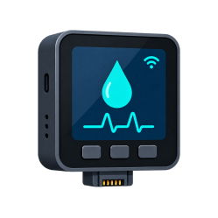
Upload water reading

Smart Meter
IoT Device

Report meter health

Figure 4.1. Use-case overview of the Smart Water Monitoring Consumption System.

Use Case Desciption
Use Case Name:  Manage Household Accounts | ID:1 | Important Level:  High
Primary Actor:  Municipal Administrator | Use Case Type: Essential, Detail
Scenario: The administrator wants to create, review, update, or change the operational status of a household account.
Brief Description: Maintains household identity, service address, contact information, account number, access status, and meter-assignment readiness
Trigger: The administrator selects Customer Management from the administrative workspace.
Normal Flow of Events:
- The administrator signs in and opens Customer Management.
- The system displays searchable and filterable household records.
- The administrator creates a new household or selects an existing record.
- The administrator enters or updates the permitted household information.
- The system validates required fields, unique account details, role, and status.
- The system saves the household record and logs the administrative activity.
Sub Flows:
Alternative/Exceptional Flows:
Table 4.1.1 Manage Household Accounts

Use Case Name:  Manage Devices and Water Rates | ID:2 | Important Level:  High
Primary Actor:  Municipal Administrator | Use Case Type: Essential, Detail
Scenario: The administrator wants to manage municipal smart meters and configure the water rates and monitoring rules applied to households.
Brief Description: Combines meter registration, assignment, maintenance, credential control, and effective-dated water-rate and alert configuration.
Trigger:The administrator opens Device Management or Water Rate Management.
Normal Flow of Events:

- The administrator opens the required meter or rate module.
- The system displays the current devices or active billing configurations.
- For a meter, the administrator registers, assigns, reassigns, suspends, rotates credentials, or decommissions the asset.
- For a rate, the administrator enters the water rate, fixed charge, subsidy, currency, effective date, and alert thresholds.
- The system validates identifiers, household eligibility, numeric ranges, and effective dates.
- The system saves the approved meter or rate configuration and records the activity.
Sub Flows:
Alternative/Exceptional Flows:
Table 4.1.2 Manage Devices and Water Rates

Use Case Name:  Generate and Finalize Billing Statements | ID:3 | Important Level:  High
Primary Actor:  Municipal Administrator | Use Case Type: Essential, Detail
Scenario:The administrator wants to generate a monthly billing statement for an eligible household.
Brief Description: Aggregates billable consumption, applies the applicable rate configuration, and preserves a historical charge snapshot.
Trigger: The administrator chooses Generate Statement in Billing Management.
Normal Flow of Events:
- The administrator opens Billing Management.
- The administrator selects the household and billing month.
- The system validates the period, household, billable readings, and applicable rate.
- The billing service totals liters and converts the result to cubic meters.
- The service applies the water rate, fixed charge, subsidy, and opening balance.
- The system stores the statement, charge breakdown, remaining balance, and payment status.
- The administrator reviews the generated billing record.
Sub Flows:
Alternative/Exceptional Flows:
Table 4.1.3 Generate and Finalize Billing Statements

Use Case Name:  Record Offline Payment and Receipt | ID:4 | Important Level:  High
Primary Actor:  Municipal Administrator | Use Case Type: Essential, Detail
Scenario:Authorized municipal staff want to record an offline payment and issue an official receipt
Brief Description: Records cash, bank-deposit, check, or other offline payments without processing money through the website.
Trigger: The administrator selects Record Payment for an unpaid or partially paid statement.
Normal Flow of Events:
1. The administrator opens the finalized statement.
2. The administrator enters the amount, method, reference, notes, and received date.
3. The system validates the remaining balance and payment details.
4. The payment is stored in the offline-payment ledger.
5. The statement amount paid, remaining balance, and status are recalculated.
6. The system generates a unique receipt number and PDF receipt.
7. The household can download the statement and related receipts.
Sub Flows:
Alternative/Exceptional Flows:
Table 4.1.4 Record Offline Payment and Receipt

Use Case Name:  Review Alerts Reports and Action Center | ID:5 | Important Level:  High
Primary Actor:  Municipal Administrator | Use Case Type: Essential, Detail
Scenario:The administrator wants to investigate alerts and prioritize municipal work requiring attention.
Brief Description: Combines leak follow-up, analytics, reports, exports, failed notices, overdue statements, and the prioritized action center.
Trigger: The administrator opens the Action Center, Leak Monitoring, Reports, Analytics, or Notifications.
Normal Flow of Events:
1. The system combines open requests, overdue statements, leak follow-ups, and failed notices.
2. The administrator selects an item, household, report category, period, or filter.
3. The system validates authorization and input parameters.
4. Related readings, alerts, billing data, notices, and summaries are retrieved.
5. The administrator reviews evidence and records the required follow-up.
6. The administrator resolves, marks false, reopens, retries, archives, or exports the supported record.
Sub Flows:
Alternative/Exceptional Flows:
Table 4.1.5 Review Alerts Reports and Action Center

Use Case Name:  Manage Service Requests | ID:6 | Important Level:  High
Primary Actor:  Household User; Municipal Administrator | Use Case Type: Essential, Detail
Scenario:A household wants to request municipal assistance and staff want to track the response through resolution.
Brief Description: Provides a referenced conversation for billing, leak, meter, account, interruption, and general service concerns.
Trigger: The household opens Service Requests or the administrator opens the municipal request queue.
Normal Flow of Events:
1. The household selects a category and enters the subject and description.
2. The system creates a unique request reference and an open status.
3. The household and authorized staff view the request conversation.
4. The administrator assigns priority, ownership, and status.
5. Either permitted participant adds a message; internal notes remain staff-only.
6. The administrator resolves or reopens the request as needed.
7. Updates are retained and may generate household notifications.
Sub Flows:
Alternative/Exceptional Flows:
Table 4.1.6 Manage Service Requests

Use Case Name:  View Live Consumption | ID:7 | Important Level:  High
Primary Actor:  Household User | Use Case Type: Essential, Detail
Scenario:The household user wants to view the latest water consumption and meter state.
Brief Description: Displays the latest owned reading, current flow, interval consumption, estimated billing state, leak state, and meter availability.
Trigger: The household user opens the Dashboard or Live Monitoring page.
Normal Flow of Events:
- The household user signs in.
- The user opens Dashboard or Live Monitoring.
- The browser requests the latest household-scoped readings.
- The server verifies ownership and retrieves the current meter and consumption state.
- The interface displays current flow, liters used, estimated bill, leak status, meter connection, and recent activity.
- The interface refreshes according to the configured near-real-time interval.
Sub Flows:
Alternative/Exceptional Flows:
Table 4.1.7 View Live Consumption

Use Case Name:  Review Consumption History and Bills | ID:8 | Important Level:  High
Primary Actor:  Household User | Use Case Type: Essential, Detail
Scenario:The household user wants to review past consumption and current or finalized billing information..
Brief Description: Combines daily, weekly, monthly, or custom consumption history with estimated billing details and monthly statements.
Trigger: The user opens Consumption History or Estimated Billing
Normal Flow of Events:
1. The user selects the history or billing page.
2. For history, the user selects a period or valid custom date range.
3. The server retrieves only the household's readings and computes totals and chart data.
4. For billing, the server selects the applicable rate and billable interval readings.
5. If the current month is empty, the latest metered month is clearly identified.
6. The interface displays estimates, finalized statements, balances, due dates, and receipts.
7. The user downloads an owned statement or receipt when required.
Sub Flows:
Alternative/Exceptional Flows:
Table 4.1.8 Review Consumption History and Bills

Use Case Name:  Set Consumption Goal and Forecast | ID:9 | Important Level:  High
Primary Actor:  Household User | Use Case Type: Essential, Detail
Scenario:The household wants to establish a monthly water-use goal and review projected end-of-month consumption.
Brief Description: Stores one household goal per month and compares actual usage, remaining allowance, progress, and forecast.
Trigger: The user opens Goals and Forecast and saves a target in liters.
Normal Flow of Events:
1. The system loads the household's current-month goal and consumption.
2. The user enters or updates a positive target volume.
3. The system validates and stores the household-scoped goal.
4. Current usage is compared with the target.
5. The service estimates end-of-month consumption from valid readings.
6. The interface displays progress, remaining allowance, and forecast status.
Sub Flows:
Alternative/Exceptional Flows:
Table 4.1.9 Set Consumption Goal and Forecast

Use Case Name:  Manage Notifications and Preferences | ID:10 | Important Level:  High
Primary Actor:  Household User | Use Case Type: Supporting, Detail
Scenario: The household wants to control eligible in-app notices, language, quiet hours, and data-use preferences.
Brief Description: Manages notification categories, read state, quiet hours, English or Filipino labels, and low-bandwidth behavior.
Trigger: The user opens Notifications or Account Settings.
Normal Flow of Events:
1. The system loads household-scoped notices and saved preferences.
2. The user reads, marks, or removes an eligible notice from the personal view.
3. The user selects notification categories and optional quiet hours.
4. The user selects English or Filipino and chooses low-bandwidth mode.
5. The system validates and stores the preferences.
6. The interface immediately applies supported language and data-use changes.
Sub Flows:
Alternative/Exceptional Flows:
Table 4.1.10 Manage Notifications and Preferences

Use Case Name:  Manage Account Access and Recovery | ID:11 | Important Level:  High
Primary Actor:  Household User | Use Case Type: Essential, Detail
Scenario: The household wants to update contact information, change a password, or recover access.
Brief Description: Protects household profile updates and password changes while preserving administrator-controlled account fields.
Trigger: The user opens Account Settings or selects Forgot Password on the login page.
Normal Flow of Events:
1. The authenticated user loads the household profile.
2. The user updates permitted contact details or submits the current and new password.
3. The system validates the request and protects role, status, and account number.
4. For recovery, the user requests a reset link for an eligible approved account.
5. The reset token and replacement password are validated.
6. The profile or password is updated and security activity is recorded.
Sub Flows:
Alternative/Exceptional Flows:
Table 4.1.11 Manage Account Access and Recovery

Use Case Name:  Use Low-Bandwidth and Installable Website | ID:12 | Important Level:  Medium
Primary Actor:  Household User | Use Case Type: Essential, Detail
Scenario: The household wants an installable interface that remains understandable during weak or interrupted connectivity.
Brief Description: Provides the web manifest, service worker, app-shell caching, user-scoped session snapshots, and accessible responsive controls.
Trigger: The user installs the website or revisits it with limited connectivity.
Normal Flow of Events:
1. The browser loads the web manifest and registers the service worker.
2. Static application-shell resources are cached for resilient loading.
3. Authenticated API responses are excluded from service-worker storage.
4. User-scoped dashboard snapshots may be retained only in session storage.
5. The interface reports offline or unavailable live state rather than showing stale data as current.
6. The user reconnects or refreshes to obtain authoritative meter information.
Sub Flows:
Alternative/Exceptional Flows:
Table 4.1.12 Use Low-Bandwidth and Installable Website

Use Case Name:  Activate Device | ID:13 | Important Level:  High
Primary Actor:  Smart Meter / IoT Device | Use Case Type: Essential
Scenario: A registered M5Stack smart meter wants to exchange its one-time code for a scoped device credential.
Brief Description: Binds the physical hardware to the municipal device record and activates authenticated telemetry access.
Trigger: The technician enters the administrator-issued activation code on the registered device.
Normal Flow of Events:
1. The administrator registers the meter and issues a short-lived activation code.
2. The device submits its UUID, activation code, hardware identity, and firmware version.
3. The server verifies that the code is valid, unused, and unexpired.
4. The server checks device status and hardware-binding rules.
5. The hardware identity is bound and the device is marked active.
6. The server issues a scoped credential.
7. The M5Stack stores the credential without printing the token to the serial console.
Sub Flows:
Alternative/Exceptional Flows:
Table 4.1.13 Activate Device

Use Case Name:  Upload Water Reading | ID:14 | Important Level:  High
Primary Actor:  Smart Meter / IoT Device | Use Case Type: Essential
Scenario: An activated smart meter wants to submit a measured water-consumption interval..
Brief Description: Authenticates the device, validates telemetry, stores the reading once, and returns authoritative totals and alert state.
Trigger: The firmware reaches the configured upload interval with a pending measurement.
Normal Flow of Events:
- The sensor counts valid flow pulses during the sampling interval.
- The firmware calculates flow rate and interval liters.
- The device creates a stable reading identifier and stores the pending state.
- The meter submits the reading with its scoped credential.
- The server derives the device and household from the authenticated identity.
- The server validates and stores the reading idempotently.
- The server evaluates thresholds and returns the authoritative total and leak state.
- After acknowledgement, the meter clears the pending interval and advances its sequence.
Sub Flows:
Alternative/Exceptional Flows:
Table 4.1.14 Upload Water Reading

Use Case Name:  Report Meter Health | ID:15 | Important Level:  Medium
Primary Actor:  Smart Meter / IoT Device | Use Case Type: Supporting
Scenario: The smart meter wants to report its connection, firmware, and operational health to the server.
Brief Description: Updates municipal visibility of device connectivity, last-seen activity, telemetry status, firmware version, and relevant diagnostics.
Trigger: The device activates, uploads telemetry, reconnects to the network, or reaches a health-reporting interval.
Normal Flow of Events:
- The M5Stack evaluates its Wi-Fi and server connection state.
- The device prepares its hardware identity, firmware version, monitoring state, signal strength, and health metadata.
- The device submits the health information using its scoped credential.
- The server validates the authenticated device identity.
- The server updates last-seen, last-telemetry, firmware, and operational health fields.
- The administrator workspace displays the latest device status.
Sub Flows:
Alternative/Exceptional Flows:
Table 4.1.15 Report Meter Health

4.2 System Design, Software, and Processes
The whole system is based on client-server architecture typical for the Internet of Things. The meter on the physical side takes measurements and does the data logging for a couple of hours. All the server-side Laravel code is responsible for maintaining and verifying user and data integrity, keeping track of usage history, billing cycles

Output and User Interface Design
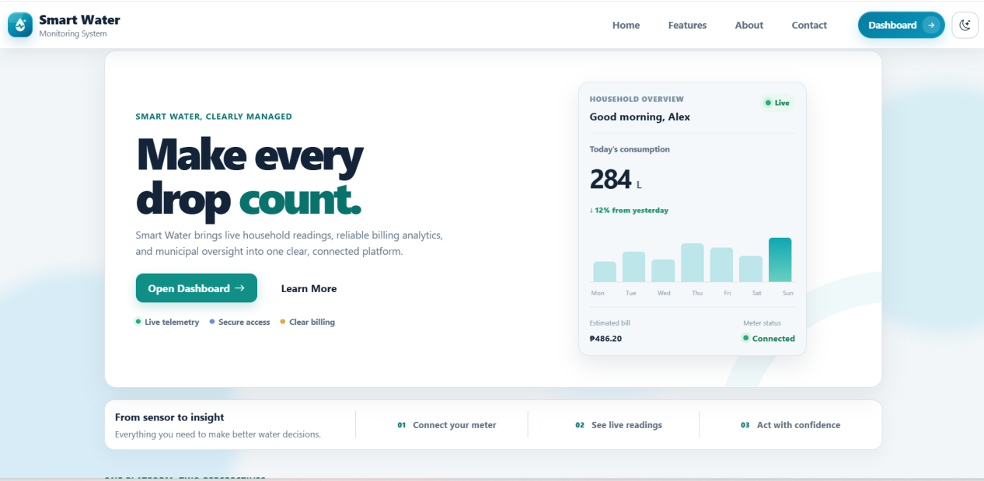
Figure 4.2.1 Home Interface
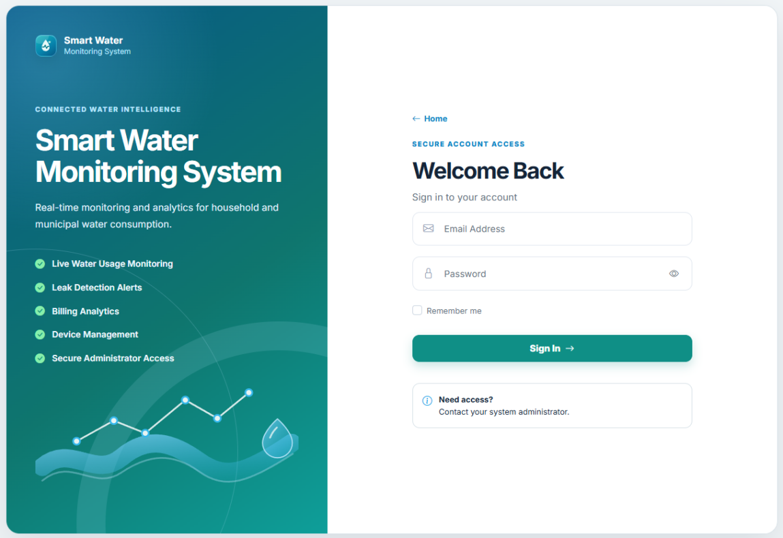

Figure 4.2.2 Log in Interface

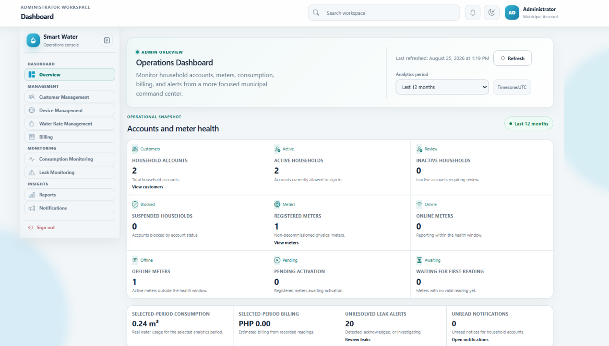
Figure 4.2.3 Admin (Dashboard) Interface

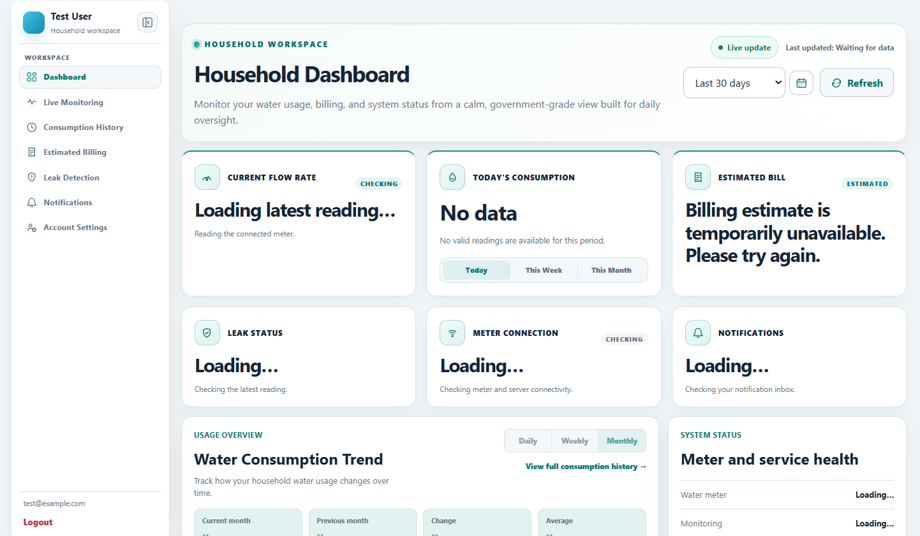
Figure 4.2.4 Household (Dashboard) Interface

4.3 Entity Relationship Diagram
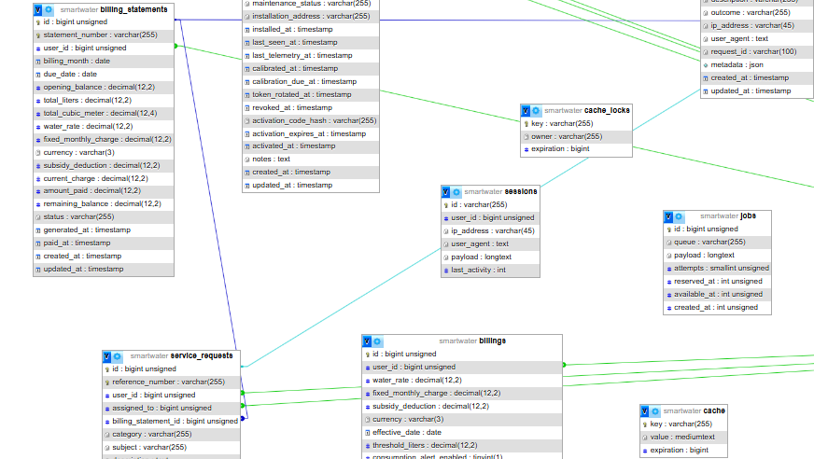
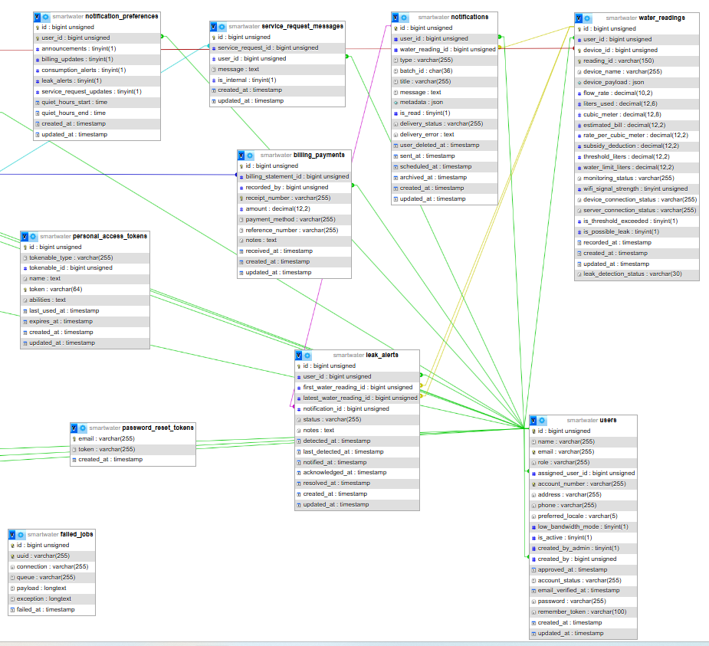

4.4 Data Dictionary
This data dictionary gives a brief overview of operational tables which participate directly in monitoring, billing, alerting, and administration activities. It should be noted that framework-support tables for cache, jobs, sessions, password resets, and personal access tokens will be a part of the implementation but have been excluded from the main discussion to keep things simple and clear.
Field Name | Data Type | Length | Description
id | BIGINT | 20 | Primary key.
name | VARCHAR | 255 | Display name.
email | VARCHAR | 255 | Account email address.
role | VARCHAR | 255 | Access role (administrator or household).
account_number | VARCHAR | 255 | Municipal household account number.
address | VARCHAR | 255 | Household service address.
phone | VARCHAR | 255 | Household contact number.
preferred_locale | VARCHAR | 5 | Selected interface language.
low_bandwidth_mode | BOOLEAN | 1 | Reduces polling and interface motion.
is_active | BOOLEAN | 1 | Whether the record is active.
email_verified_at | DATETIME | - | Email-verification timestamp.
password | VARCHAR | 255 | Hashed password.
remember_token | VARCHAR | 100 | Remember-me session token.
created_by_admin | BOOLEAN | 1 | Whether an administrator created the account.
assigned_user_id | BIGINT | 20 | Related account assignment.
created_by | BIGINT | 20 | Administrator that created the record.
approved_at | DATETIME | - | Approval timestamp.
account_status | VARCHAR | 255 | Current account status.
created_at | DATETIME | - | Record creation timestamp.
updated_at | DATETIME | - | Last update timestamp.
Table 4.4.1 Database Table of Users

Field Name | Data Type | Length | Description
id | BIGINT | 20 | Primary key.
uuid | VARCHAR | 255 | Public device identifier.
asset_number | VARCHAR | 255 | Municipal asset identifier.
serial_number | VARCHAR | 255 | Manufacturer or internal serial number.
name | VARCHAR | 255 | Display name.
household_id | BIGINT | 20 | Assigned household account.
auth_user_id | BIGINT | 20 | Account authorized to the device.
hardware_id | VARCHAR | 255 | Bound physical hardware identity.
firmware_version | VARCHAR | 255 | Reported firmware version.
status | VARCHAR | 255 | Current lifecycle or workflow status.
maintenance_status | VARCHAR | 255 | Maintenance state.
installation_address | VARCHAR | 255 | Meter installation location.
installed_at | DATETIME | - | Installation timestamp.
last_seen_at | DATETIME | - | Most recent device-contact time.
last_telemetry_at | DATETIME | - | Most recent telemetry time.
calibrated_at | DATETIME | - | Latest calibration time.
calibration_due_at | DATETIME | - | Next calibration due time.
token_rotated_at | DATETIME | - | Device-credential rotation time.
revoked_at | DATETIME | - | Credential revocation time.
activation_code_hash | VARCHAR | 255 | Hashed one-time activation code.
activation_expires_at | DATETIME | - | Activation-code expiry time.
activated_at | DATETIME | - | Successful activation time.
notes | TEXT | - | Operational notes.
created_at | DATETIME | - | Record creation timestamp.
updated_at | DATETIME | - | Last update timestamp.
Table 4.4.2 Database Table of Devices

Field Name | Data Type | Length | Description
id | BIGINT | 20 | Primary key.
user_id | BIGINT | 20 | Related household account.
device_id | BIGINT | 20 | Related registered meter.
reading_id | VARCHAR | 255 | Stable device reading identifier.
flow_rate | DECIMAL | 18,6 | Reported flow rate.
liters_used | DECIMAL | 18,6 | Consumption for the recorded interval.
cubic_meter | DECIMAL | 18,6 | Consumption in cubic metres.
estimated_bill | DECIMAL | 12,2 | Estimated charge at reading time.
rate_per_cubic_meter | DECIMAL | 12,4 | Applied rate per cubic metre.
subsidy_deduction | DECIMAL | 12,2 | Applied subsidy or deduction.
threshold_liters | DECIMAL | 18,6 | Configured consumption-alert threshold.
is_threshold_exceeded | BOOLEAN | 1 | Whether the threshold was exceeded.
is_possible_leak | BOOLEAN | 1 | Whether server rules flagged a possible leak.
leak_detection_status | VARCHAR | 255 | Possible-leak workflow status.
water_limit_liters | DECIMAL | 18,6 | Configured household consumption limit.
monitoring_status | VARCHAR | 255 | Current monitoring state.
wifi_signal_strength | INTEGER | 11 | Reported Wi-Fi signal strength.
device_connection_status | VARCHAR | 255 | Meter connection state.
server_connection_status | VARCHAR | 255 | Server connection state.
device_name | VARCHAR | 255 | Reported device label.
device_payload | JSON/TEXT | - | Sanitized telemetry payload.
recorded_at | DATETIME | - | Reading collection time.
created_at | DATETIME | - | Record creation timestamp.
updated_at | DATETIME | - | Last update timestamp.
Table 4.4.3 Database Table of Water Readings
Field Name | Data Type | Length
id | BIGINT | 20 | Primary key.
user_id | BIGINT | 20 | Related household account.
water_rate | DECIMAL | 12,4 | Water rate used for billing.
fixed_monthly_charge | DECIMAL | 12,2 | Fixed monthly charge.
subsidy_deduction | DECIMAL | 12,2 | Applied subsidy or deduction.
currency | VARCHAR | 3 | Billing currency code.
effective_date | DATE | - | Date configuration takes effect.
threshold_liters | DECIMAL | 18,6 | Configured consumption-alert threshold.
consumption_alert_enabled | BOOLEAN | 1 | Enables consumption alerts.
consumption_alert_unit | VARCHAR | 255 | Unit used for the consumption alert.
consumption_alert_behavior | VARCHAR | 255 | Configured consumption-alert action.
leak_alert_enabled | BOOLEAN | 1 | Enables possible-leak alerts.
leak_flow_rate_threshold | DECIMAL | 18,6 | Flow-rate threshold for possible leaks.
leak_continuous_duration_minutes | INTEGER | 11 | Required continuous duration for a possible leak.
leak_alert_behavior | VARCHAR | 255 | Configured possible-leak alert action.
quiet_hours_start | INTEGER | 2 | Notification quiet-hours start.
quiet_hours_end | INTEGER | 2 | Notification quiet-hours end.
is_active | BOOLEAN | 1 | Whether the record is active.
created_at | DATETIME | - | Record creation timestamp.
updated_at | DATETIME | - | Last update timestamp.
Table 4.4.4 Database Table of Billing Configurations

Field Name | Data Type | Length | Description
id | BIGINT | 20 | Primary key.
user_id | BIGINT | 20 | Related household account.
billing_month | DATE | - | Statement billing month.
opening_balance | DECIMAL | 12,2 | Balance carried into the statement.
total_liters | DECIMAL | 18,6 | Total billed consumption in litres.
total_cubic_meter | DECIMAL | 18,6 | Total billed consumption in cubic metres.
water_rate | DECIMAL | 12,4 | Water rate used for billing.
fixed_monthly_charge | DECIMAL | 12,2 | Fixed monthly charge.
subsidy_deduction | DECIMAL | 12,2 | Applied subsidy or deduction.
currency | VARCHAR | 3 | Billing currency code.
current_charge | DECIMAL | 12,2 | Current-period charge.
amount_paid | DECIMAL | 12,2 | Recorded offline payments.
remaining_balance | DECIMAL | 12,2 | Outstanding balance.
status | VARCHAR | 255 | Current lifecycle or workflow status.
generated_at | DATETIME | - | Statement generation time.
paid_at | DATETIME | - | Full-payment time.
created_at | DATETIME | - | Record creation timestamp.
updated_at | DATETIME | - | Last update timestamp.
Table 4.4.5 Database Table of Billing Statements

Field Name | Data Type | Length | Description
id | BIGINT | 20 | Primary key.
billing_statement_id | BIGINT | 20 | Related billing statement.
recorded_by | BIGINT | 20 | Administrator who recorded payment.
receipt_number | VARCHAR | 255 | Official receipt number.
amount | DECIMAL | 12,2 | Payment amount.
payment_method | VARCHAR | 255 | Offline payment method.
reference_number | VARCHAR | 255 | Payment or service-request reference.
notes | TEXT | - | Operational notes.
received_at | DATETIME | - | Payment receipt time.
created_at | DATETIME | - | Record creation timestamp.
updated_at | DATETIME | - | Last update timestamp.
Table 4.4.6 Database Table of Billing Payments

Field Name | Data Type | Length | Description
id | BIGINT | 20 | Primary key.
user_id | BIGINT | 20 | Related household account.
water_reading_id | BIGINT | 20 | Related telemetry reading.
type | VARCHAR | 255 | Notification category.
title | VARCHAR | 255 | Notification title.
message | TEXT | - | Message content.
metadata | JSON/TEXT | - | Supplementary structured metadata.
is_read | BOOLEAN | 1 | Whether the notification was read.
batch_id | VARCHAR | 255 | Notification delivery batch.
delivery_status | VARCHAR | 255 | Notification delivery state.
delivery_error | TEXT | - | Delivery error details, if any.
scheduled_at | DATETIME | - | Planned notification time.
sent_at | DATETIME | - | Notification send time.
archived_at | DATETIME | - | Archive time.
user_deleted_at | DATETIME | - | Household deletion time.
created_at | DATETIME | - | Record creation timestamp.
updated_at | DATETIME | - | Last update timestamp.
Table 4.4.7 Database Table of Notifications

Field Name | Data Type | Length | Description
id | BIGINT | 20 | Primary key.
user_id | BIGINT | 20 | Related household account.
announcements | BOOLEAN | 1 | Allows municipal announcements.
billing_updates | BOOLEAN | 1 | Allows billing updates.
consumption_alerts | BOOLEAN | 1 | Allows consumption alerts.
leak_alerts | BOOLEAN | 1 | Allows possible-leak alerts.
service_request_updates | BOOLEAN | 1 | Allows service-request updates.
quiet_hours_start | TIME | - | Notification quiet-hours start.
quiet_hours_end | TIME | - | Notification quiet-hours end.
created_at | DATETIME | - | Record creation timestamp.
updated_at | DATETIME | - | Last update timestamp.
Table 4.4.8 Database Table of Notifications Preferences
Field Name | Data Type | Length | Description
id | BIGINT | 20 | Primary key.
user_id | BIGINT | 20 | Related household account.
month | DATE | - | Goal month.
target_liters | DECIMAL | 12,2 | Household monthly consumption target.
created_at | DATETIME | - | Record creation timestamp.
updated_at | DATETIME | - | Last update timestamp.
Table 4.4.9 Database Table of Consumption Goals

Field Name | Data Type | Length | Description
id | BIGINT | 20 | Primary key.
reference_number | VARCHAR | 255 | Payment or service-request reference.
user_id | BIGINT | 20 | Related household account.
assigned_to | BIGINT | 20 | Assigned administrator.
billing_statement_id | BIGINT | 20 | Related billing statement.
category | VARCHAR | 255 | Service-request category.
subject | VARCHAR | 255 | Service-request subject.
description | TEXT | - | Detailed request or audit description.
priority | VARCHAR | 255 | Request priority.
status | VARCHAR | 255 | Current lifecycle or workflow status.
resolved_at | DATETIME | - | Resolution time.
created_at | DATETIME | - | Record creation timestamp.
updated_at | DATETIME | - | Last update timestamp.
Table 4.4.10 Database Table of Service Requests

Field Name | Data Type | Length | Description
id | BIGINT | 20 | Primary key.
service_request_id | BIGINT | 20 | Related service request.
user_id | BIGINT | 20 | Related household account.
message | TEXT | - | Message content.
is_internal | BOOLEAN | 1 | Visible only to administrators when true.
created_at | DATETIME | - | Record creation timestamp.
updated_at | DATETIME | - | Last update timestamp.
Table 4.4.11 Database Table of Service Request Messages

Field Name | Data Type | Length | Description
id | BIGINT | 20 | Primary key.
user_id | BIGINT | 20 | Related household account.
first_water_reading_id | BIGINT | 20 | First reading in the possible-leak event.
latest_water_reading_id | BIGINT | 20 | Latest reading in the possible-leak event.
notification_id | BIGINT | 20 | Related notification.
status | VARCHAR | 255 | Current lifecycle or workflow status.
notes | TEXT | - | Operational notes.
detected_at | DATETIME | - | Initial detection time.
last_detected_at | DATETIME | - | Most recent detection time.
notified_at | DATETIME | - | Notification time.
acknowledged_at | DATETIME | - | Administrator acknowledgement time.
resolved_at | DATETIME | - | Resolution time.
created_at | DATETIME | - | Record creation timestamp.
updated_at | DATETIME | - | Last update timestamp.
Table 4.4.7 Database Table of Leak Alerts

Field Name | Data Type | Length | Description
id | BIGINT | 20 | Primary key.
user_id | BIGINT | 20 | Related household account.
action | VARCHAR | 255 | Recorded administrative or security action.
auditable_type | VARCHAR | 255 | Type of affected record.
auditable_id | BIGINT | 20 | Identifier of affected record.
description | VARCHAR | 255 | Detailed request or audit description.
metadata | JSON/TEXT | - | Supplementary structured metadata.
outcome | VARCHAR | 255 | Result of the recorded action.
ip_address | VARCHAR | 45 | Request IP address.
user_agent | TEXT | - | Request user-agent value.
request_id | VARCHAR | 255 | Request correlation identifier.
created_at | DATETIME | - | Record creation timestamp.
updated_at | DATETIME | - | Last update timestamp.
Table 4.4.8 Database Table of Audit Logs

4.5 Development and Testing
The web application was developed iteratively and its implemented software behaviour was checked through automated tests.
The automated test suite covers application behaviour such as authentication, role-scoped access, telemetry validation, duplicate-reading protection, billing, notifications, service requests, and offline-payment records. Sensor calibration, installation quality, and field accuracy require separate measured-volume and deployment validation.
Observed software defects are addressed through regression testing before a release; hardware and field issues remain subject to installation and calibration checks.
4.6 Implementations Plan
The plan of action offers a step-by-step guide for the installation and maintenance of the system. It covers activities such as setting up the water-flow sensor and CoreS3, making Wi-Fi connectivity available, the Laravel server and database setup, registration of users and devices, and verifying that users and the administrator can both see the readings correctly displayed on their respective dashboards.
Implementation Issues and Challenges
Several challenges were encountered during the implementation such as incorrect connection of wires, sensor components that were defective, unstable pulse signals, network errors, telemetry responses that were duplicated or malformed, month-boundary billing behavior and possibility of presenting missing data as zero. The problem of hardware was handled by checking the component and wiring, calibration, pulse-noise filtering and repeated volume tests. The software part of the problem was tackled by having stable readings ids, doing matching acknowledgements, keeping retained pending intervals, defining server-based limits and connection status, aggregating current period data, reverting to using the metered-month if latest data is not available, setting up unavailable status, validation, audit logging and automated regression tests.
4.7 System Implementation Plan
The completed automated test run recorded 181 passing tests and 1,178 assertions. This is evidence for the tested software behaviour only. The M5Stack CoreS3 and YF-S201 sensor still require measured-volume calibration and field validation before any accuracy claim is made.

CHAPTER V
Results and Discussions
Chapter 5 describes the implemented interfaces, the operating methods of the system and the results of a check of the SmartWater Monitoring Consumption system's functionality. A detailed explanation of how the components at household, administrative, and IoT tiers cooperate to capture water-flow pulses will be provided, telemetry transmission, measurement database, consumption calculation, and reporting for monitoring, billing, alerting, and municipal administration.
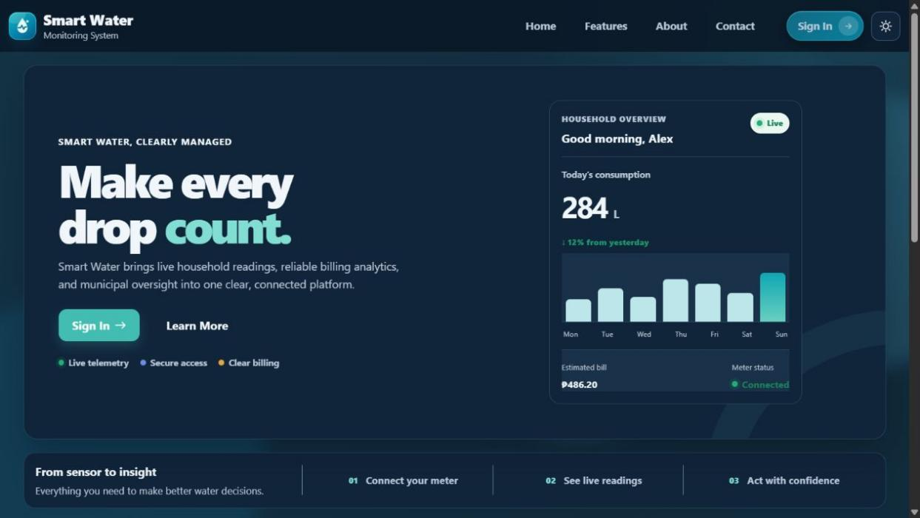
User Guide (Web Application)
Figure 5.1 Landing Page Window

Fig. 5.1 presents the publicly exposed part (home page) of SmartWater. It explains what the service is and leads the users who are entitled to the application to a secure page (application page).
1. The links allow you to go to Home, Features, About, and Contact sections.
2. On the Sign In button is the access after providing the user data (authentication) window.
3. A small switch is the theme control changing the display color mode of the interface between day and night.

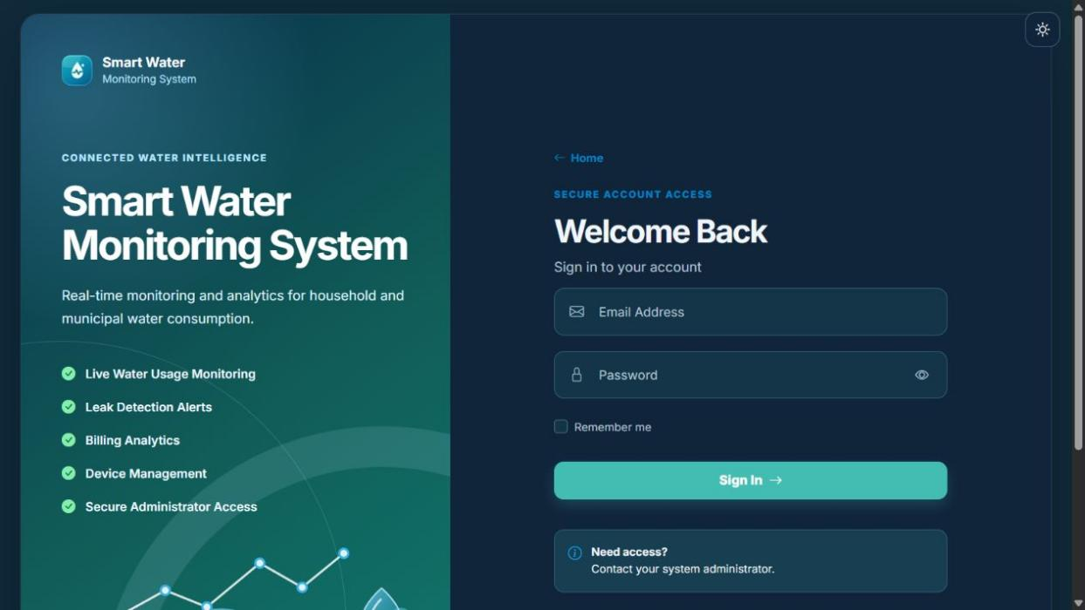
Authentication
Figure 5.2 Log In Page Window

Figure 5.2 displays the household and administrator accounts' login page. Since only authorized staff issue/maintain accounts, the option to sign up publicly is switched off.
1. The login is triggered upon input of the registered mail id with password.
2. The password visibility control helps the user verify the entered password without changing it.
3. Remember Me may retain the authenticated session on the same trusted device.
4. After successful authentication, the system opens the workspace assigned to the user's role.
5. Users who need access are instructed to contact the system administrator.
Household User Guide
Dashboard
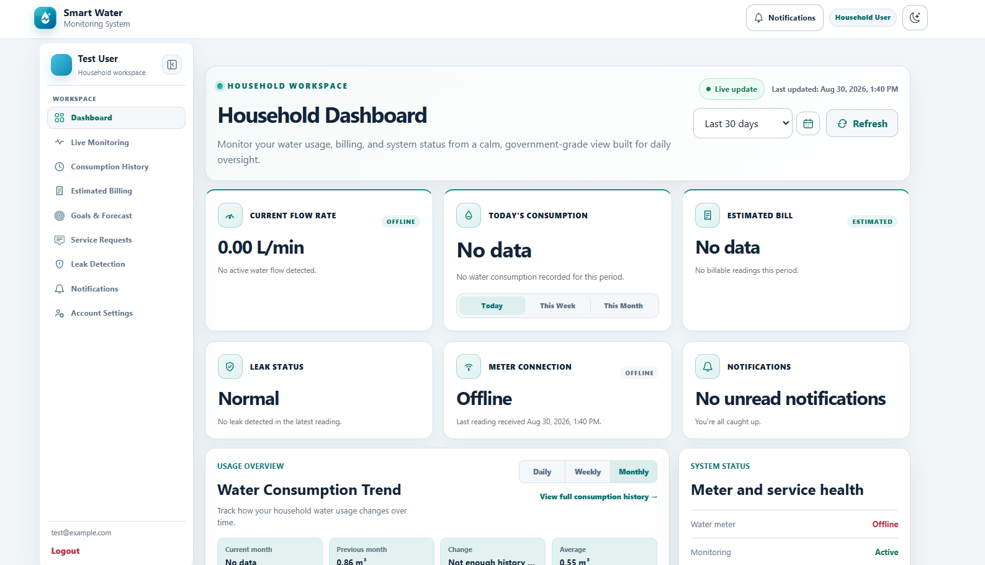

Figure 5.3 Household Dashboard Window
Figure 5.3 presents the household dashboard, which gives the authenticated household an immediate summary of water use, billing, meter condition, and recent activity.
1. Current Flow Rate shows the newest liters-per-minute value received from the assigned meter.
2. Estimated Bill summarizes the running charge when valid readings and an active water rate are available.
3. Leak Status, Meter Connection, and Notifications identify conditions requiring household attention.
4. Usage Comparison, Usage Snapshot, and Meter History summarize the selected period and its previous-period comparison.
5. Recent meter activity and alerts help the household determine whether readings are current.
Live Monitoring
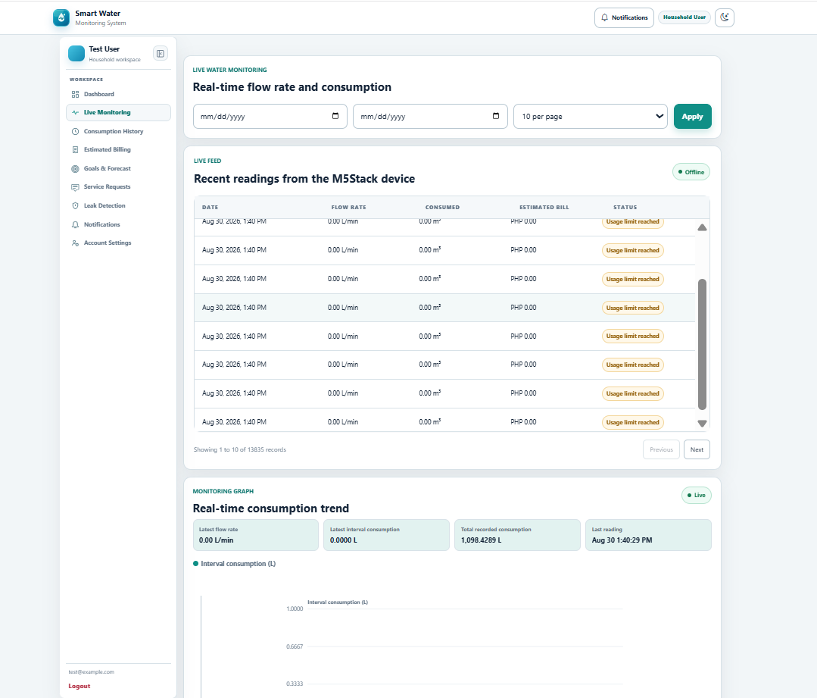

Figure 5.4 Household Live Monitoring Window

Figure 5.4 shows the live monitoring tab used to inspect the newest M5Stack CoreS3 telemetry and recent flow behavior.
1. The current reading presents the latest flow-rate and consumption values received from the assigned meter.
2. The live trend graph visualizes recent valid readings without inventing values for missing data.
3. The recent-readings list identifies when each M5Stack reading was recorded.
4. Date and rows-per-page controls limit the monitoring records shown on screen.
5. A connected meter may correctly show 0.00 L/min when no pulse is received during the present sampling interval.
Consumption History
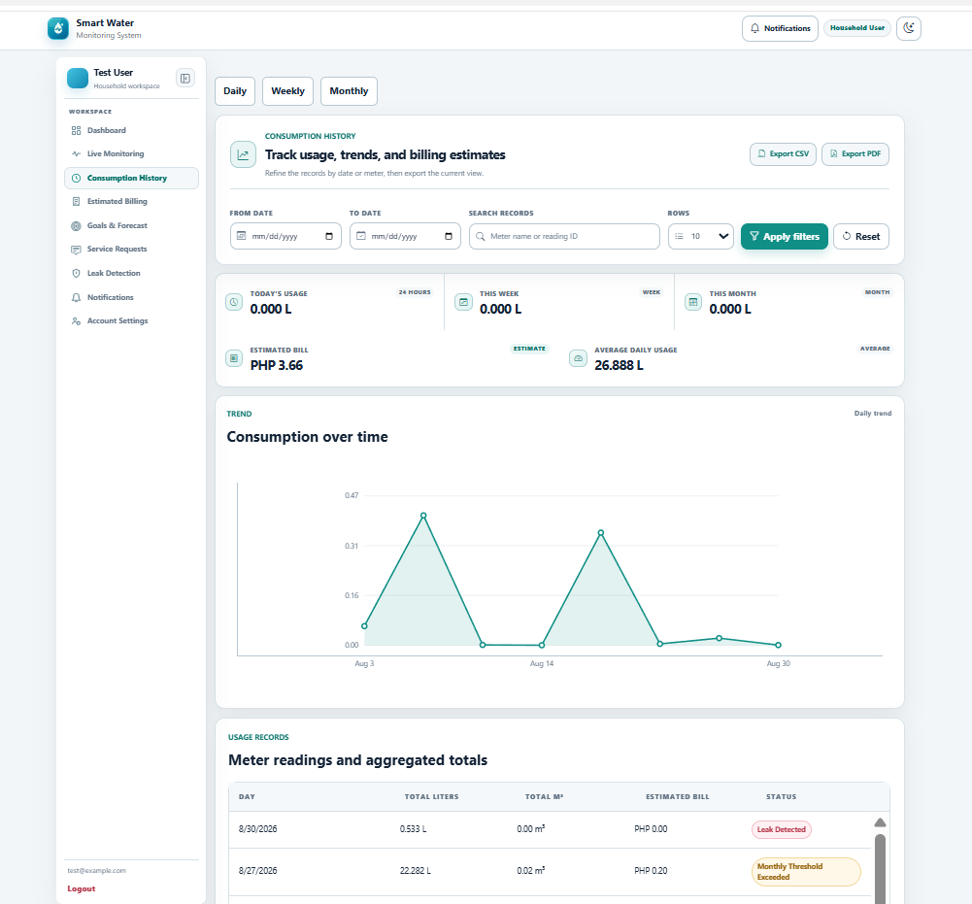

Figure 5.5 Household Consumption History Window

Figure 5.5 presents the historical-consumption tab, where the household can review detailed and aggregated use for selected reporting periods.
1. Daily, weekly, and monthly tabs change the aggregation used by the history view.
2. Date, meter, search, and page-size filters narrow the displayed records.
3. The trend chart presents recorded usage over the selected period.
4. Detailed meter readings and calculated totals support verification of household consumption.
5. CSV and PDF controls export the filtered history for further review or printing.
Estimated Billing
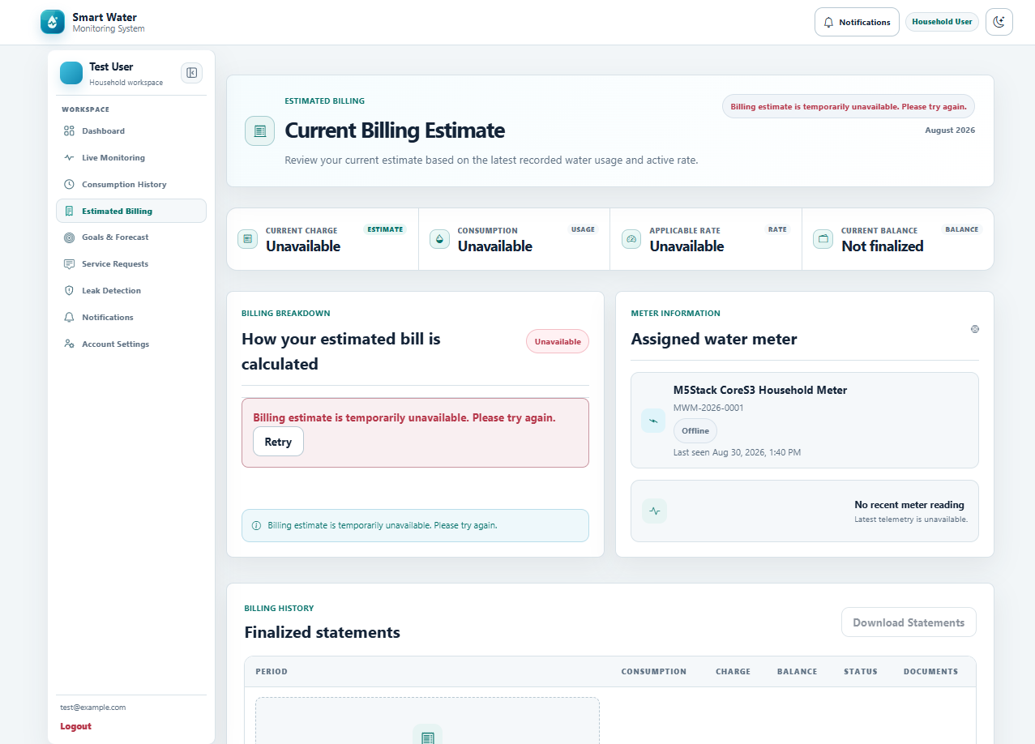

Figure 5.6 Household Estimated Billing Window
Figure 5.6 shows the estimated-billing tab, which converts recorded consumption into a transparent running estimate and provides access to finalized statements.
1. Current Billing Estimate calculates the running charge from valid consumption and the effective rate.
2. Billing Breakdown identifies the usage, water rate, fixed charge, and applicable adjustments.
3. Assigned-meter details and the latest reading show the source of the estimate.
4. Billing Statements list finalized records and their payment status.
5. Statement downloads are available when a finalized billing record has been generated.
Leak Detection
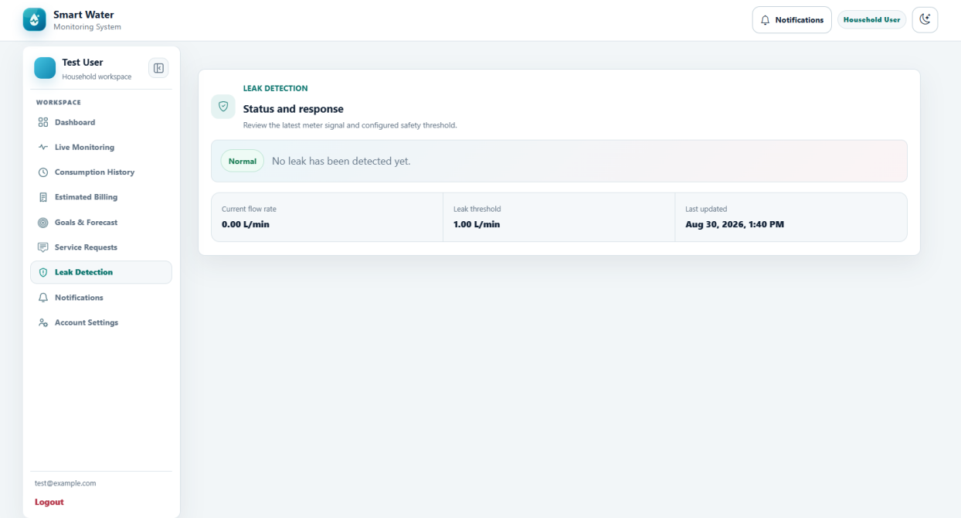

Figure 5.7 Household Leak Detection Window
Figure 5.7 presents the leak-detection tab used to communicate possible abnormal flow and the response expected from the household.
1. Leak Status distinguishes normal operation from a possible leak condition.
2. Current Flow Rate and the configured threshold provide the evidence used by the leak evaluation.
3. Last Updated identifies when the displayed condition was most recently assessed.
4. Alert history retains relevant notices instead of deleting the operational record.
5. When abnormal use persists, the household is advised to inspect the installation and notify the local waterworks for assurance.
Notifications
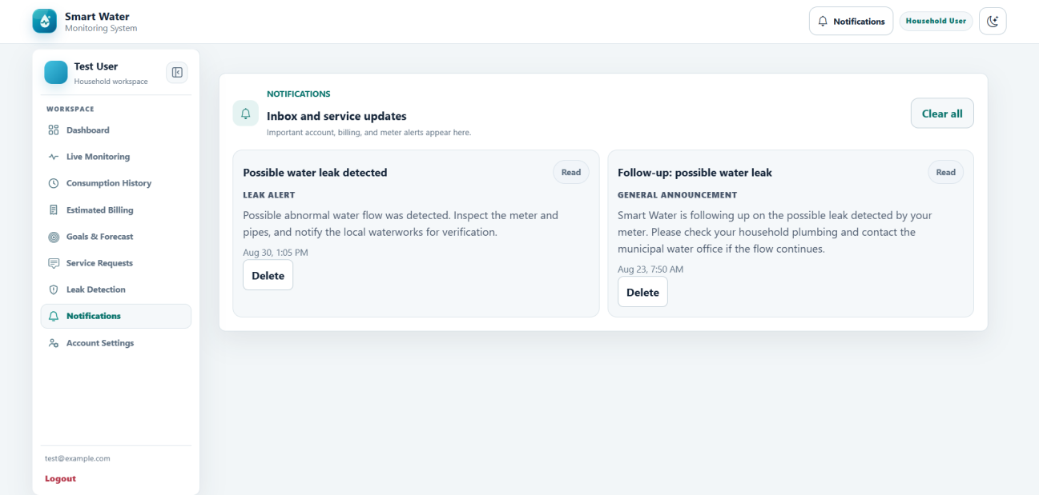

Figure 5.8 Household Notifications Window
Figure 5.8 shows the household inbox for account, meter, leak, billing, maintenance, and service information.
1. Unread indicators distinguish notices that still require household review.
2. Opening a notice displays the complete message and relevant context.
3. Service updates communicate interruptions, maintenance, and general announcements.
4. Meter and leak alerts connect important notices with the related monitoring event.
5. Clear All performs the permitted inbox-clearing action without changing unrelated operational records.
Account Settings
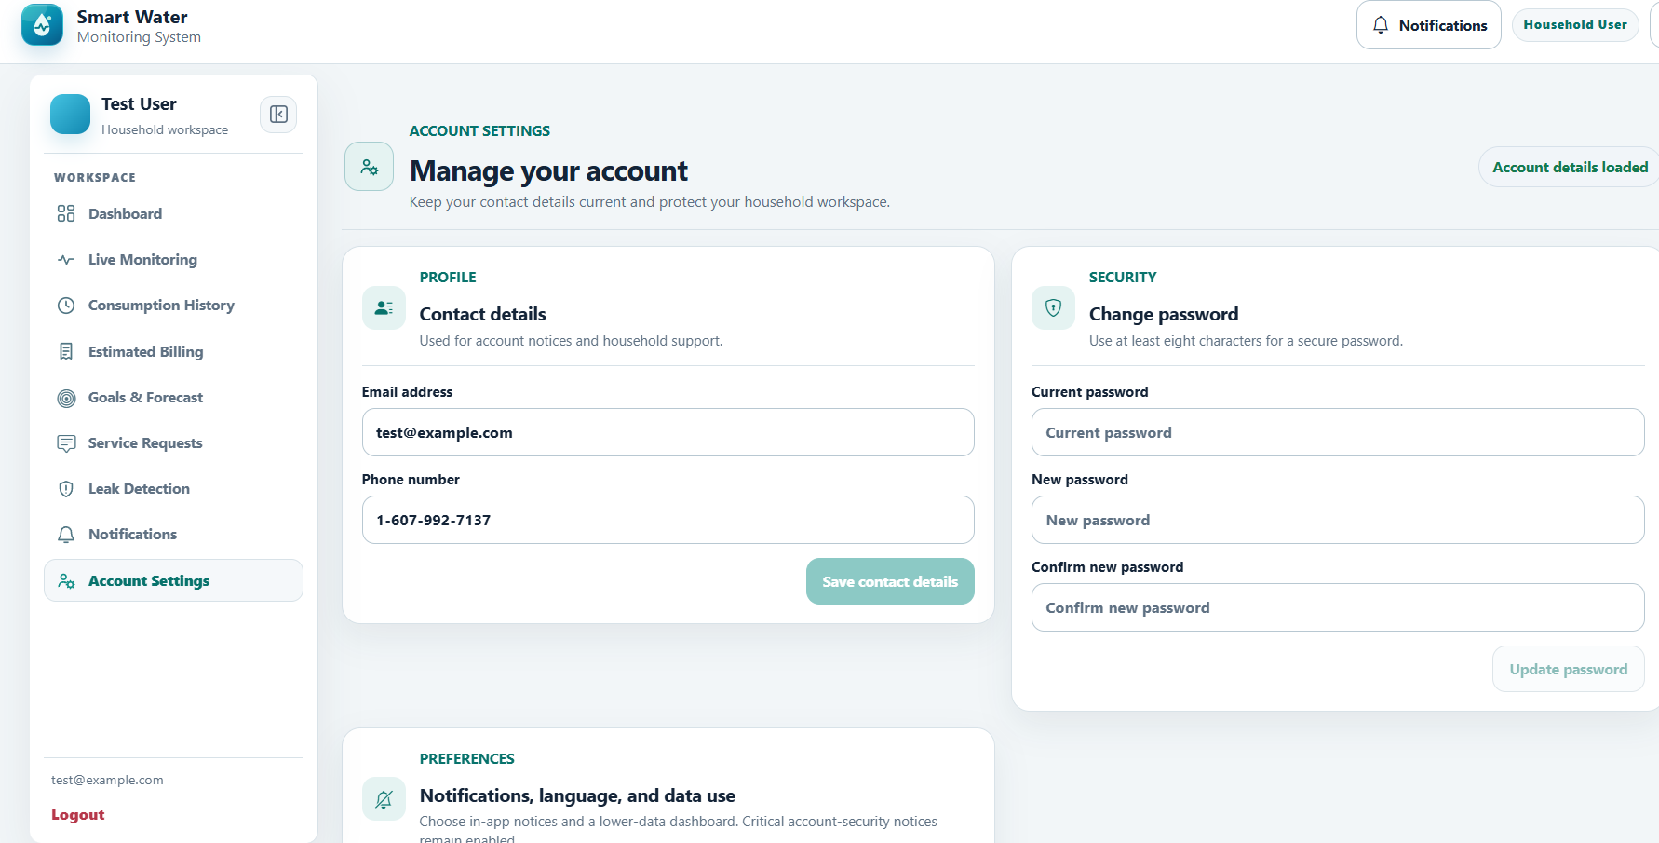

Figure 5.9 Household Account Settings Window
Figure 5.9 presents the account-settings tab used by a household to maintain permitted contact information and securely change its password.
1. The profile section identifies the authenticated household account.
2. Email address and phone number may be updated through validated contact fields.
3. Save Contact Details stores only the account information the household is permitted to change.
4. Change Password requires the current password, a new password, and confirmation.
5. Password validation and authenticated checks prevent an unrelated user from changing the account password.
Administrator User Guide
Overview
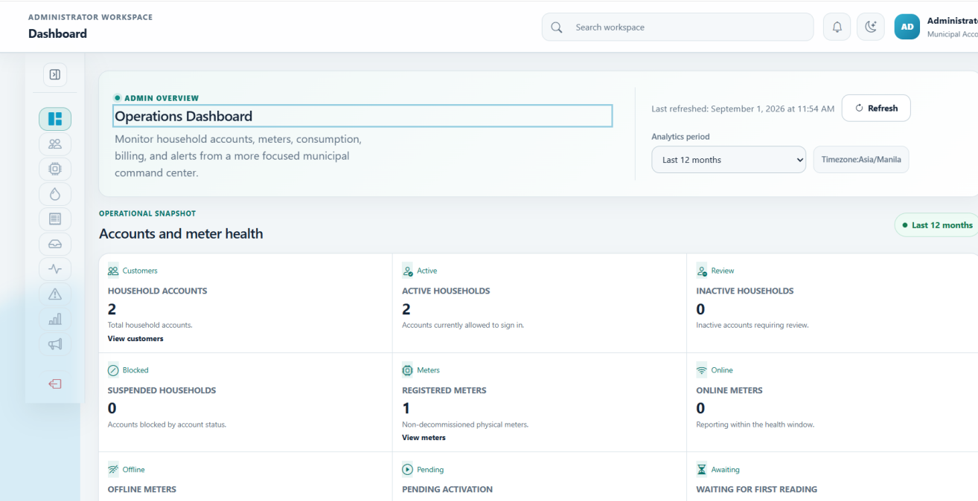

Figure 5.10 Administrator Overview Window
Figure 5.10 shows the administrator overview, which consolidates municipal operating status, trend information, and records requiring attention.
1. Operational Snapshot summarizes household accounts, meter health, leaks, and unread notices.
2. Analytics may be reviewed for 7 days, 30 days, 3 months, 12 months, or a custom period.
3. System Diagnostics separates application, device, and data-health conditions.
4. The 12-month consumption trend supports higher-level usage review.
5. Follow-up items and recent events direct the administrator to records that require action.
Customer Management
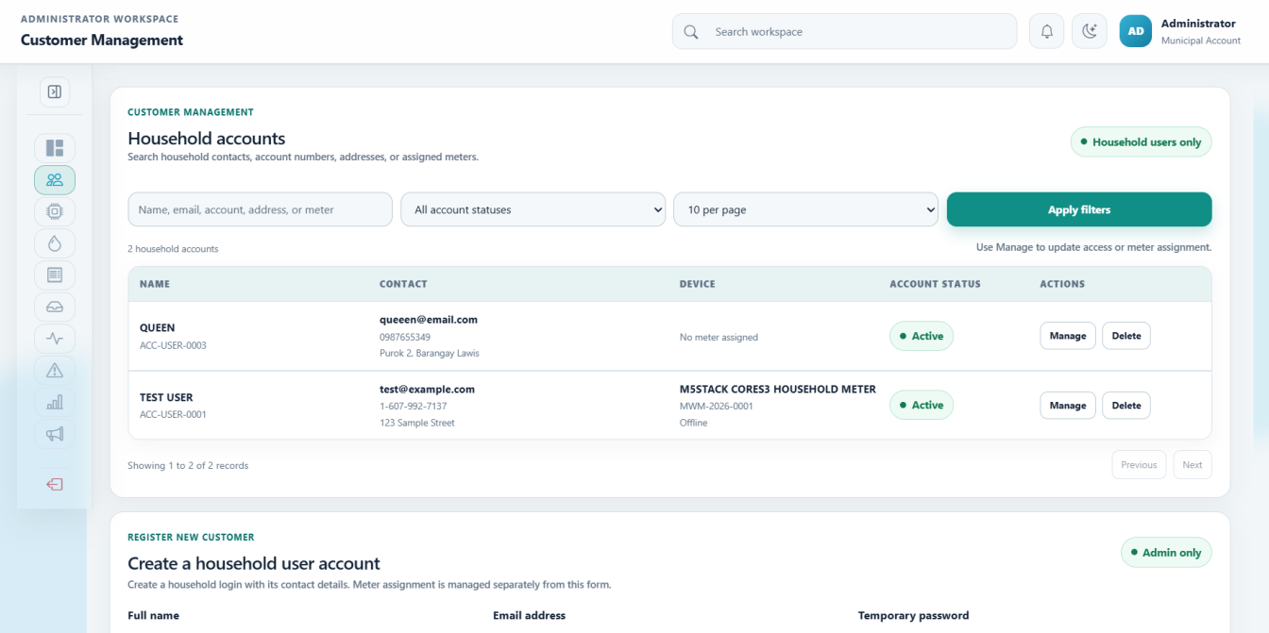

Figure 5.11 Administrator Customer Management Window
Figure 5.11 presents the customer-management tab used to create, locate, update, and control household accounts.
1. Household accounts may be filtered as active, inactive, suspended, or archived.
2. Create Household records the user's identity, barangay, and verified contact details.
3. Edit Account updates only permitted household and service information.
4. Meter Assignment links the household to the correct registered device.
5. Role restrictions and secure password handling protect administrator and household privileges.
Device Management
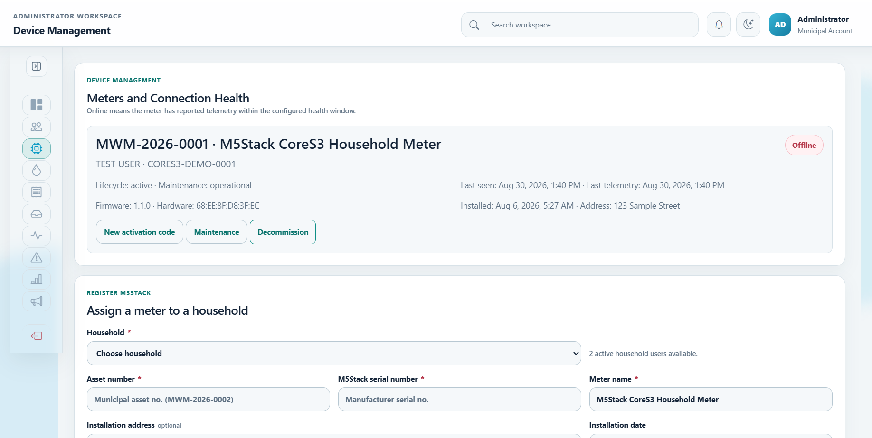

Figure 5.12 Administrator Device Management Window
Figure 5.12 shows the device-management tab for registering M5Stack meters, assigning them, and reviewing their communication health.
1. The meter registry lists device identity, assignment, and connection status.
2. Register M5Stack creates the controlled device record used by telemetry authentication.
3. Assign Household establishes the relationship between the meter and the owner of its readings.
4. Serial, asset, installation, and status details support device administration.
5. Activation codes provide limited credentials for commissioning the registered meter.
Water Rate Management
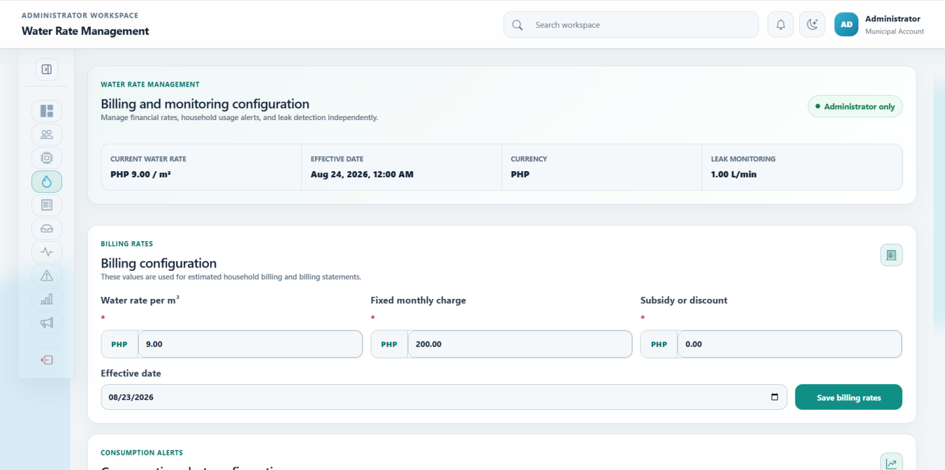

Figure 5.13 Administrator Water Rate Management Window
Figure 5.13 presents water-rate, billing, consumption-alert, and leak-monitoring configuration maintained by authorized administrators.
1. The active water rate includes rate per cubic meter, currency, and effective date.
2. Billing configuration maintains the fixed charge, subsidy or discount, and effective values.
3. Consumption alerts compare actual current month-to-date usage with the equivalent days of the previous month.
4. The relevant percentage, including a configured 100-percent increase or decrease, is evaluated only when a valid baseline exists.
5. Leak settings maintain flow threshold, duration, quiet hours, behavior, and notification audience.
Billing Management
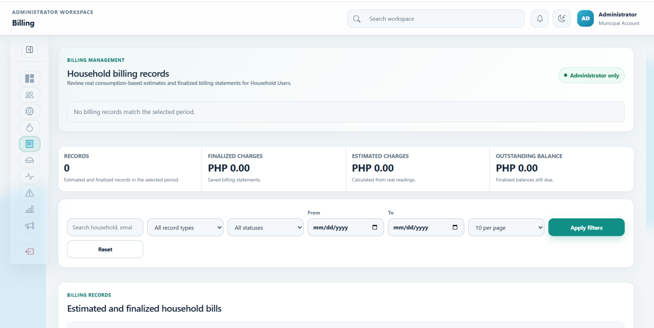

Figure 5.14 Administrator Billing Management Window
Figure 5.14 shows the billing-management tab used to review estimates, finalize eligible bills, and monitor payment status.
1. Billing records may be filtered by date, estimated or finalized state, and payment condition.
2. Payment status distinguishes estimated, unpaid, partially paid, and paid records.
3. Billing Details presents the consumption and rate basis of the charge.
4. Finalization creates a controlled billing statement from eligible recorded values.
5. Exports provide billing records for authorized reporting and review.
Consumption Monitoring
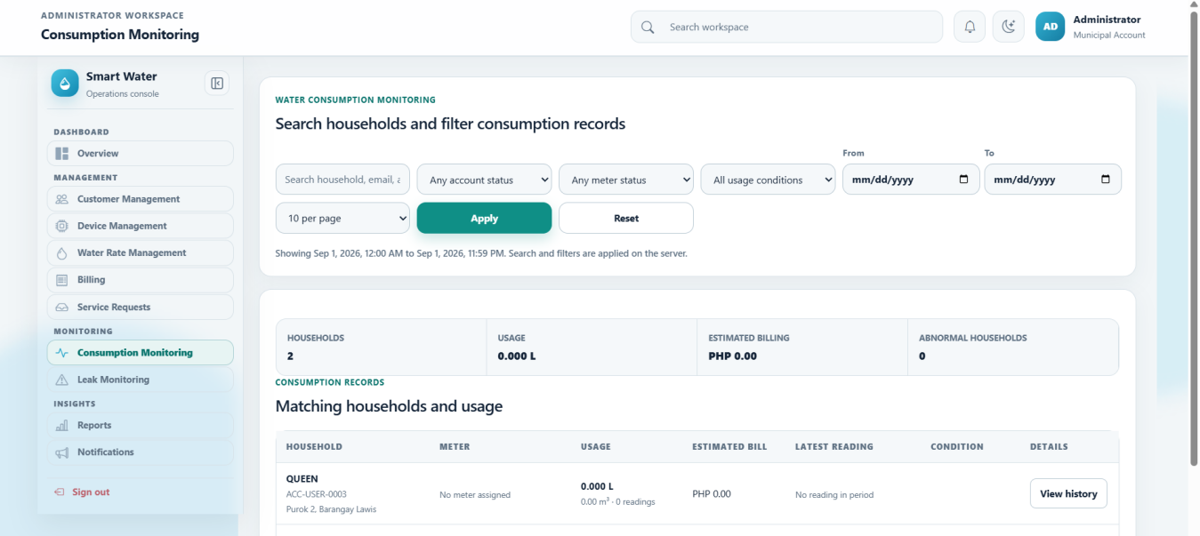

Figure 5.15 Administrator Consumption Monitoring Window
Figure 5.15 presents the administrator's detailed consumption view for searching households, reviewing meter conditions, and opening historical totals.
1. Search and filters locate households by account, meter, usage, leak, threshold, or no-reading condition.
2. The monitoring summary presents household count, usage, estimated billing, and abnormal cases.
3. Consumption records list detailed readings for the selected period.
4. Household History opens daily, weekly, and monthly totals for a selected account.
5. The effective water rate supplies the billing context displayed with consumption results.
Leak Monitoring
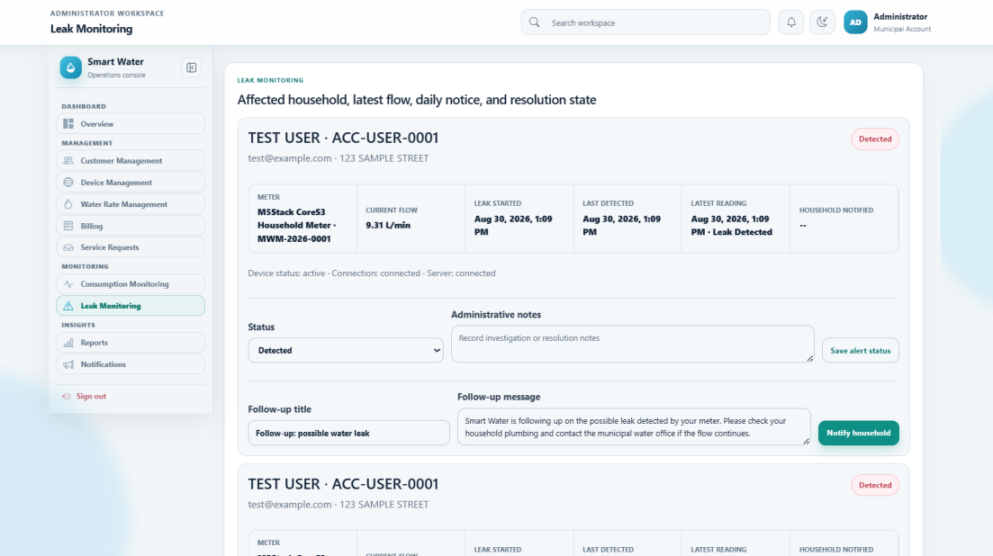

Figure 5.16 Administrator Leak Monitoring Window
Figure 5.16 shows the operational leak-monitoring tab used to investigate alerts and preserve the outcome of each case.
1. Each alert identifies the affected household, meter, latest flow evidence, and applicable threshold.
2. Follow-up notices document communication with the household or service personnel.
3. Resolve Alert closes an investigated condition while retaining its history.
4. False Positive records the reviewed classification without deleting audit evidence.
5. Reopen Case returns a closed alert to active review when new evidence is received.
Reports
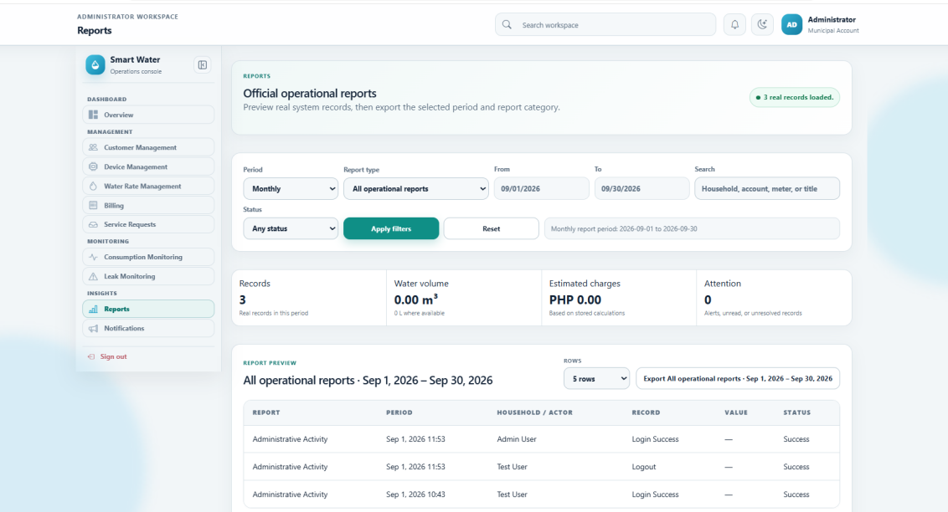

Figure 5.17 Administrator Reports Window
Figure 5.17 presents the reports tab used to prepare official operational summaries from SmartWater records.
1. Reporting periods include daily, weekly, monthly, and custom ranges.
2. Report types cover consumption, billing, notifications, leaks, devices, households, and audit events.
3. Search, date, status, and page-size controls refine the selected data set.
4. Summary values identify record count, consumption, charges, and items requiring attention.
5. Preview and Export support review before the official report is downloaded.
Notification Management
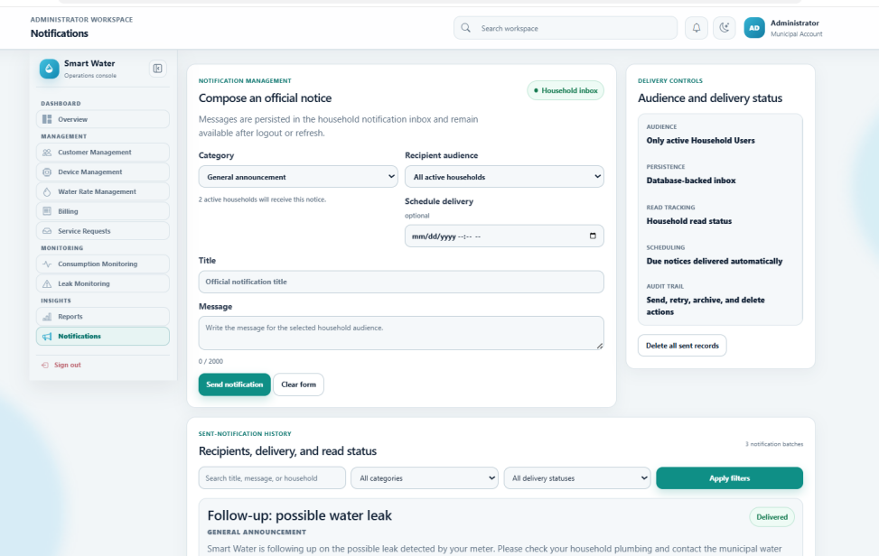

Figure 5.18 Administrator Notification Management Window
Figure 5.18 shows the notification-management tab used to compose, target, deliver, and audit household communications.
1. Notice categories include announcements, interruptions, maintenance, billing, leak or emergency, and device or system messages.
2. The audience may be all active households or one selected household.
3. Notices may be sent immediately or stored as scheduled communications.
4. Sent History records the category, audience, time, and delivery result.
5. Delivered, scheduled, partial, and failed states support retry, archive, and other permitted follow-up actions.
User Guide (IoT Device)

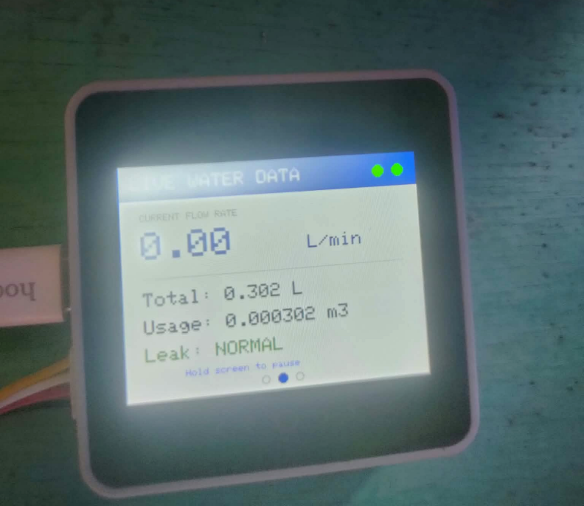
Figure 5.19 M5Stack CoreS3 Monitoring Window
Figure 5.19 shows the M5Stack CoreS3 device used with the YF-S201 water-flow sensor. The device converts sensor pulses into flow rate and accumulated water volume before sending the reading to the Laravel server.
1. The YF-S201 signal is read through GPIO2, while the sensor and CoreS3 share the required power and ground connections.
2. The firmware uses a calibration value of 450 pulses per liter and rejects very short duplicate edges as electrical noise.
3. The display shows Wi-Fi status, server status, current flow rate, total liters, cubic-meter usage, and leak condition.
4. A zero current flow rate means that no pulse was received in the present interval; it does not automatically mean that the device is offline.
5. Pending telemetry is retained when the server cannot be reached and is acknowledged only after a successful response.

References

Navin Rapelli, Ashish Myakal, Vyankatesh Kota, & Prachi R. Rajarapollu. (2019). IoT based smart water management, monitoring and distribution system for an apartment. In 2019 International Conference on Communication and Signal Processing Technologies. IEEE.
https://colab.ws/articles/10.1109%2FICCS45141.2019.9065369

AE. Clemente, R. M. G. Samaniego, & F. R. G. Cruz. (2023). IoT based water consumption monitoring system for water management. In 2023 15th International Conference on Computer and Automation Engineering. IEEE.
IoT Based Water Consumption Monitoring System for Water Management | IEEE Conference Publication | IEEE Xplore

Lijo Jacob Varghese, Devanath V., Kishore V., Poornima R., & Suma Sira Jacob. (2025). IoT based smart water meter for domestic utility. In 2025 International Conference on Inventive Computation Technologies (ICICT). IEEE.
https://ieeexplore.ieee.org/abstract/document/11005058

Mohamed Yusuf Hassan Roslan, Farah Yasmin Abdul Rahman, Roslina Mohamad, & Shahrani Shahbudin. (2025). Development and evaluation of an IoT-based home water usage monitoring system using LoRa and ESP32. In 2025 IEEE 16th Control and System Graduate Research Colloquium (ICSGRC). IEEE.
https://ieeexplore.ieee.org/abstract/document/11159838

CURRICULUM VITAE

Jea Marie Montuya Japay
Personal Details

Birthday: October 17, 2005
Address: Buacao, Clarin, Bohol
Email: jeangxxmarie@gmail.com
Height:
Weight:

EDUCATIONAL BACKGROUND

Elementary
Presentation of Mary School of Clarin Inc.
2011 - 2018
Secondary
Holy Cross Academy
2018-2021
Tertiary
Mater Dei College
Cabulijan, Tubigon, Bohol
2021-2024

Language: Tagalog, Cebuano, English

CURRICULUM VITAE

JOHN JOSHUA R. MASCARIÑAS
Personal Details

Birthday: November 21, 2004
Address: Ilijan Norte, Tubigon,Bohol
Email: johnjoshuamascarinas@gmail.com
Height: 165 cm
Weight: 123lbs

EDUCATIONAL BACKGROUND

Elementary
Avelino Chagas Elementary School Ilijan Norte, Tubigon, Bohol 2010-2017
Secondary
Tubigon West National High School Ilijan Norte, Tubigon, Bohol
2017-2021

Tertiary
Mater Dei College
Cabulijan, Tubigon, Bohol
2021-2024

Language: Filipino, Visayan, English

CURRICULUM VITAE

LYKAMAE A. MANGUILIMOTAN
Personal Details

Birthday: December 13, 2001
Address: Kinabag-an,Calape,Bohol
Email: lykamaemanguilimotan631@gmail.com
Height: 149 cm
Weight: 42kgs.

EDUCATIONAL BACKGROUND

Elementary
Pangangan Elementary School 2008-2014
Secondary
Pangangan National High School
2014-2020

Tertiary
Mater Dei College
Cabulijan, Tubigon, Bohol
2021-2024

Language: Filipino, Visayan, English

