## Goal

The goal of this assignment was to implement the Dequeue ADT using a doubly linked list with proper testing.

## Testing

For this project I started with unit testing for all the methods in the Dequeue. I ensured that each method was tested and any possibility of exception or called combination of methods returned the expected results. I was able to achieve 100% code coverage for the EbadiradDequeue class. Testing involved creating a new EbadiradDequeue object and then depending on the situation I would populate the dequeue with uniquely identifiable data. I did not test the node class as that class was only a getter and setter methods that were trivial to the point if they failed the language would have failed. The second part of testing was writing out a small console application similar to the provided testing material that would demonstrate the hard-coded expected results with what happened in the application. I wrote this application in a separate class called EbadiradDequeueMain.

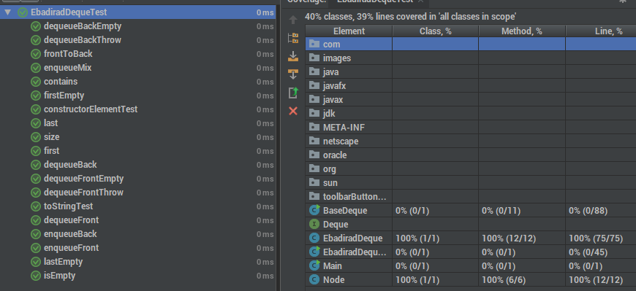Here is a screenshot of the unit test results and the code coverage results.

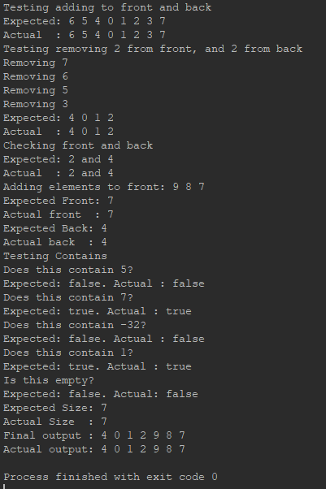Below is the console application output: