# Goal

The goal of this assignment was to build a random maze generator using the recursive division method.

# Testing

## Unit testing

For this project I used less unit testing than in previous projects. I was able to unit test my supporting methods, randBetween and validSubArea. These two methods passed all my testing and has 100% code coverage. Since these methods were simple there was not much to test. Below is the unit test output and the code coverage output. 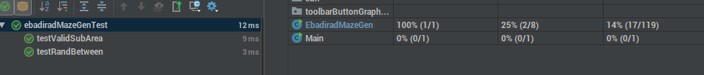

## Input testing

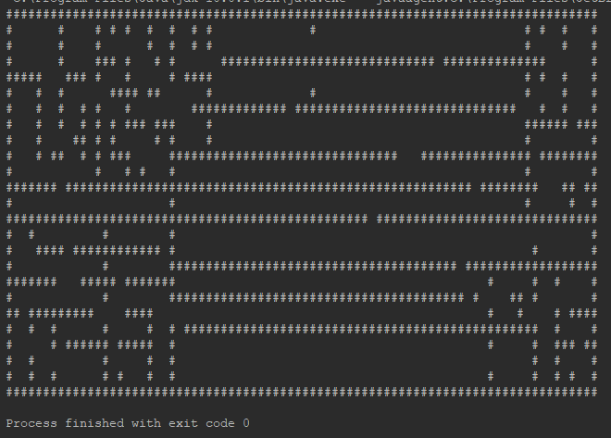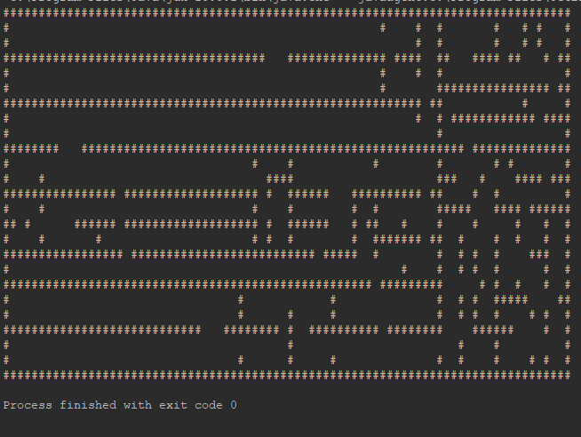 The main testing I did with this project was input output testing using the console. Since this application was very random and we did not know what to expect as our output I decided to compare the generated maze with the sample maze. I needed to ensure I could walk through the maze and that the walls were not doubled up. Below is the console output for three runs of the application. I have ran this application many times and walked through each maze to ensure all the rooms connect making each maze solvable from any room. Although I have done all this testing I am still not 100% confident that this maze is random enough, during my development and testing I found that the randomness felt like a pattern was being built. I decided to use the java.util.Random package that was imported at the beginning of the package, but in the future I think I will use java.util.concurrent.ThreadLocalRandom to generate my random numbers as well as making the calls to the recursive statements execute in a more random manner.

