# Goal

The goal of this project was to implement quicksort using a middle value, and to implement merge sort using arrays as parameters only.

# Testing

## Unit testing

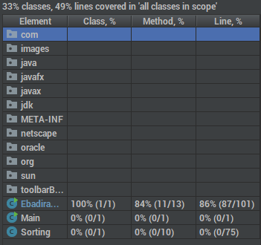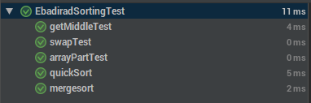 For this project I mainly focused on unit testing my supporting methods. I was able to test all my methods with 100% code coverage. I tested my main methods by creating a loop that ran 30 times, that would create an Integer array of random length, and then populate that array with random numbers, then sorting that array and running the provided isSorted method. There were 2 other methods that I was unable to include in my code coverage and they were for the “main” method and a show method that was provided. Below is the output for the code coverage and unit tests.

## Input testing

After my supporting methods behaved as intended, I used the provided input/output testing to verify that I was able to sort a simple array correctly. Once I had that array sorted, I went back to the unit testing and ran random integer arrays to verify that I was able to sort any array that came at me. Below is the output of the provided input output tests.

