USA-Electric Vehicle Population Data
- Project Overview and Objective
This dataset, titled "Electric Vehicle Population Data," provides a comprehensive record of registered electric vehicles (EVs), likely within a specific geographic area (such as Washington state, based on the snippet information).
The data includes detailed attributes for each vehicle, such as:
- Geographic Location: County, City, State, Postal Code, Vehicle Location Coordinates, and 2020 Census Tract.
- Vehicle Specifications: Model Year, Make, Model, and a partial Vehicle Identification Number (VIN).
- Electric Details: Electric Vehicle Type (e.g., Battery Electric Vehicle (BEV) or Plug-in Hybrid Electric Vehicle (PHEV)), Electric Range, and Clean Alternative Fuel Vehicle (CAFV) Eligibility status.
- Infrastructure/Policy: Electric Utility provider and Legislative District.
Objective:
The primary objective of this dataset is to track, analyse, and monitor the adoption and distribution of electric vehicles to inform infrastructure planning, policy development, and market analysis.
Key applications and secondary objectives include:
- Infrastructure Planning: To identify where EVs are most concentrated (distribution) to strategically plan and deploy charging station infrastructure.
- Market Analysis: To understand consumer preferences by analysing the most popular Makes, Models, and Model Years of EVs being registered.
- Policy Development: To track the progress of clean vehicle initiatives by monitoring the Electric Range and CAFV Eligibility status of the vehicle population.
- Resource Management: To assist Electric Utilities in planning for increased electricity demand due to EV charging across different geographic areas (Census Tracts).
- Data Sources
  - Source Description and Timeline:
The data source for the Electric Vehicle Population Data is the Washington State Department of Licensing (DOL).
The dataset, which tracks registered Battery Electric Vehicles (BEVs) and Plug-in Hybrid Electric Vehicles (PHEVs), is officially published on the State of Washington's open data portal at https://catalog.data.gov/dataset/electric-vehicle-population-data
  - Domain:
Transport industry
- Problem Statement
"How can the state and its utility providers effectively manage and accelerate the transition to electric vehicles (EVs) while ensuring that the necessary charging infrastructure and electric grid capacity are adequately planned for, equitably distributed, and proactively scaled to meet the rapidly increasing demand across diverse geographic regions?"

- Attribute (column/ Features) Details:
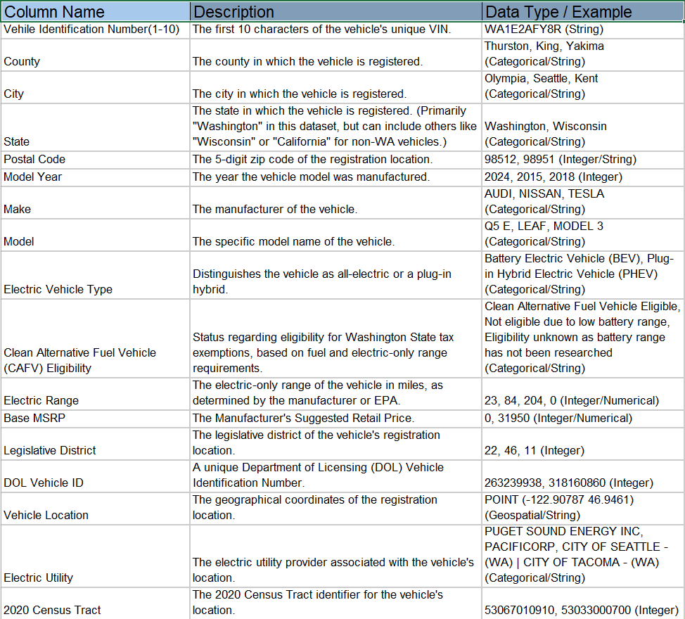

- Tools and Technologies. (Excel)
A) Data Import and Transformation
These features are used to load the CSV file and make the data ready for structured analysis:
- CSV Import/Data Connection: Excel's capability to open the .csv file directly. For advanced cleaning, analysts might use Power Query (part of the Data tab) to:
  - Set Data Types: Ensure columns like Model Year, Electric Range, and Base MSRP are correctly recognized as numbers.
  - Filter/Clean: Remove blank rows or known errors during the import process.
- Text to Columns: This is essential for splitting composite data fields. For this dataset, an analyst would use it to:
  - Split Vehicle Location: Separate the geographical coordinates from the string, extracting Latitude and Longitude into their own columns.
  - Split Electric Utility: If necessary, to separate the utility provider names (e.g., separating PUGET SOUND ENERGY INC from CITY OF TACOMA - (WA) if both are listed).
- Find and Replace: Used to standardize entries, such as correcting minor spelling errors in Make or Model names, or simplifying long category names in Electric Vehicle Type.
B) Data Cleaning and Preparation Functions
These are core Excel functionalities used for quality assurance and structure:
- Remove Duplicates: Used to ensure the dataset is unique, often based on the DOL Vehicle ID or the 10-character VIN.
- Sorting and Filtering: Fundamental tools for quickly isolating specific subsets of the data (e.g., showing only vehicles in "King" county, or sorting by Model Year).
- Data Validation: Used to restrict input or flag errors if an analyst manually enters data, ensuring consistency for columns like Model Year (e.g., must be a 4-digit number
C) Analysis and Reporting
These are the primary tools for generating insights from the prepared data:
- Pivot Tables: The most powerful analytical tool in Excel. It is used to quickly aggregate, summarize, and cross-tabulate the data to answer questions like:
  - "What is the total count of EVs by County?"
  - "How many BEVs versus PHEVs are registered for each Make?"
  - "What is the average Electric Range by Model and Model Year?"
- VLOOKUP / XLOOKUP: Used to merge or cross-reference this dataset with other external data sources (e.g., an external table of charging station locations based on the Postal Code).
- Conditional Formatting: Applied to highlight trends and outliers, such as highlighting all vehicles with an Electric Range over a certain threshold.
- Aggregate Formulas: Basic formulas like SUMIF, COUNTIF, and AVERAGEIF are used for simple, targeted aggregations without needing a full Pivot Table.
Tools and Technologies. (Power BI)

A) Power Query (Data Preparation)
This is the Extract, Transform, Load (ETL) component within Power BI, used to prepare the data before analysis.
- M Language: The programming language behind Power Query. It's used for advanced data cleaning scripts like:
  - Unpivoting/Pivoting: Restructuring the data model.
  - Splitting Columns: Separating the Vehicle Location coordinates (POINT (-122.90787 46.9461)) into distinct Latitude and Longitude columns for mapping.
  - Conditional Columns: Creating new categorical columns (e.g., classifying counties into "Urban," "Suburban," or "Rural" based on EV density).
- Data Source Connection: Connecting to the original CSV file or, in a professional setting, connecting directly to the open data portal via web connector.
B) Power Pivot (Data Modelling)
This engine handles the relationships and calculations on the data model.
- Data Modelling: Organizing the raw data into tables and defining relationships. For this dataset, an analyst might create:
  - A 'Vehicles' fact table (the main dataset).
  - A 'Time' dimension table (linked to Model Year).
  - A 'Geography' dimension table (with unique County or Electric Utility entries).
- DAX (Data Analysis expressions): This is the formula language used to create complex calculations, measures, and calculated columns for advanced insights:
  - Measures: Calculating the % Share of BEVs by county (e.g., DIVIDE (COUNTROWS (FILTER ('EV Data', 'EV Data'[Electric Vehicle Type] = "BEV")), COUNTROWS ('EV Data'))).
  - Calculated Columns: Creating a column that categorizes the Electric Range into bins (e.g., "Short Range," "Medium Range," "Long Range").
C) Power View (Visualization & Reporting)
This is the front-end tool for creating interactive reports and dashboards.
- Visualizations: Using built-in and custom visuals to present findings:
  - Maps (ArcGIS/Shape Map): Visualizing the spatial distribution of EVs by County or plotting individual Vehicle Location points (Latitude/Longitude).
  - Slicers: Interactive filters that allow users to drill down by Model Year, Make, or Electric Utility.
  - Key Performance Indicators (KPIs): Displaying metrics like the total EV count or the average Electric Range.
- Data Pre-processing (Excel / Power Query)
Microsoft Excel (Manual & Formula-Based Cleaning)
These steps focus on quick fixes, standardization, and essential cleanups that an analyst would perform directly in the spreadsheet:
A) Standardize Column Names
- Action: Rename the column Vehicle Identification Number(1-10) to a simpler, non-formula-breaking name, such as VIN Prefix.
B) Clean/Fill Base MSRP
- Action: Use a filter or a IF formula to identify records where Base MSRP is $0$ or null. While many true MSRPs are not recorded, these values would skew an average calculation. Depending on the objective, these records should be filtered out for financial analysis or categorized as "MSRP Unknown."
C) Handle Missing Geographical Data
- Action: Identify and inspect rows where County, City, or Postal Code are blank. Decide whether to delete these rows (if few) or categorize them as "Unknown Location" (if many).
D) Check Electric Range Values
- Action: Sort the Electric Range column and inspect values. The column can contain $0$ for newer vehicles where the EPA range hasn't been finalized or older vehicles where data is missing.
Power Query (Advanced ETL & Automation)
Power Query is used for more complex, automated, and repeatable transformations, especially for preparing the geospatial data.
A) Data Type Conversion
- Action: Use the "Change Type" step to enforce correct data types:
  - Model Year, Postal Code, Legislative District, DOL Vehicle ID, 2020 Census Tract $\right arrow$ Whole Number (Integer) or Text (if leading zeros are important, like for Postal Code).
  - Electric Range, Base MSRP $\right arrow$ Whole Number (Integer) or Decimal Number.
B) Geospatial Data Splitting (Crucial Step)
- Action: Use the "Split Column by Delimiter" function on the Vehicle Location column to extract Latitude and Longitude.
  - Split by the space and opening parenthesis: POINT (to isolate the coordinates.
  - Split the resulting column by the comma and space: , to separate the Latitude and Longitude.
  - Clean up the closing parenthesis) from the Latitude/Longitude columns.
  - Change the new columns, Latitude and Longitude, to Decimal Number.
C) Clean Up Electric Utility Text
- Action: Use the "Replace Values" function to simplify utility provider names that contain multiple entries (e.g., replace CITY OF SEATTLE - (WA)|CITY OF TACOMA - (WA) with the primary provider or a standardized name like Seattle/Tacoma City Light).
D) Conditional Grouping
- Action: Use the "Conditional Column" feature to create a new feature based on the Electric Range and Electric Vehicle Type:
  - If Electric Vehicle Type is PHEV, create Fuel_Type_Range as "PHEV."
  - If Electric Vehicle Type is BEV and Electric Range $\geq 200$, set Fuel_Type_Range to "Long-Range BEV."
  - Otherwise, set it to "Short-Range BEV."
- Analysis and Visualizations (Power BI)

- Count Vehicles by Model Year
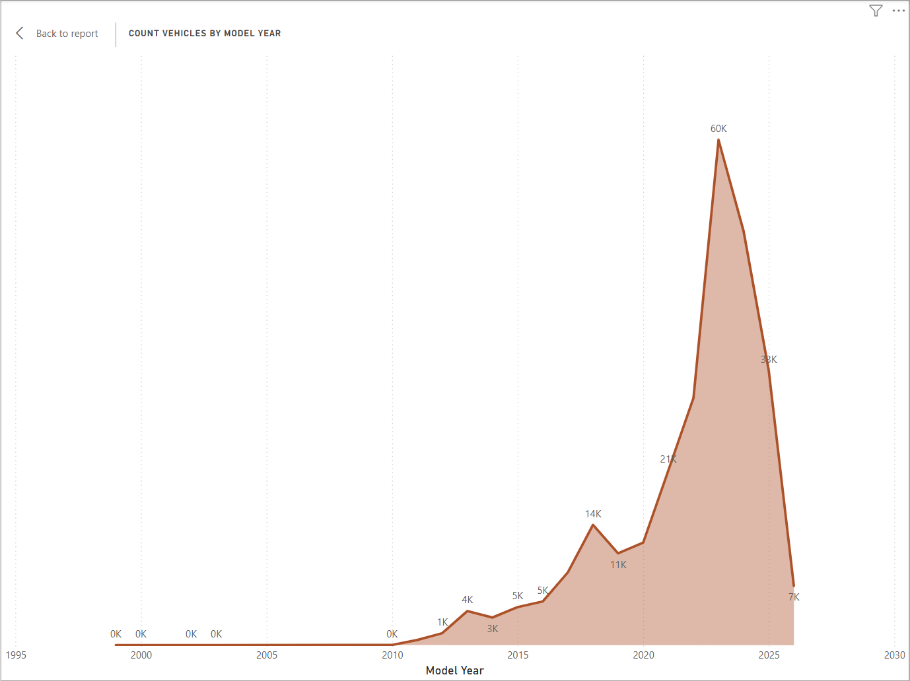
- State and DOL Vehicle ID
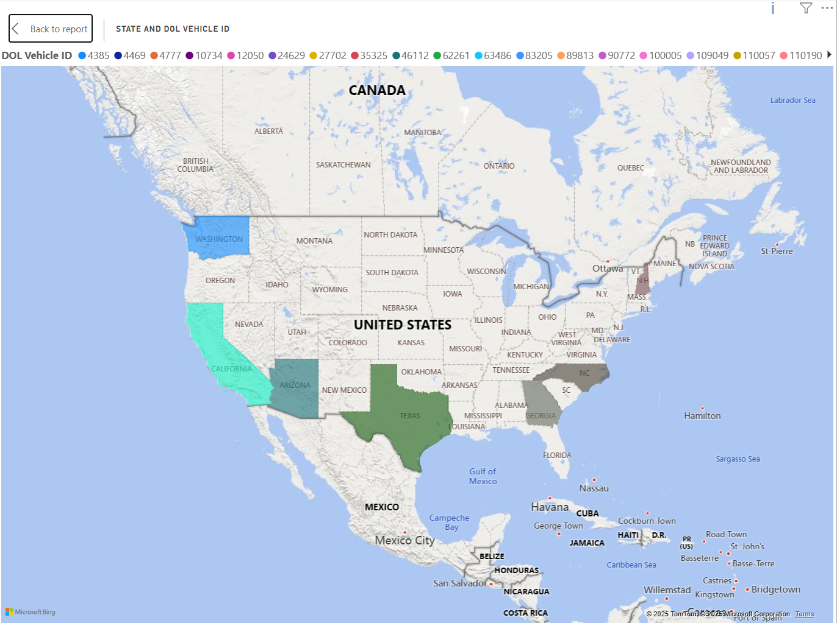
- Vehicle Count by City
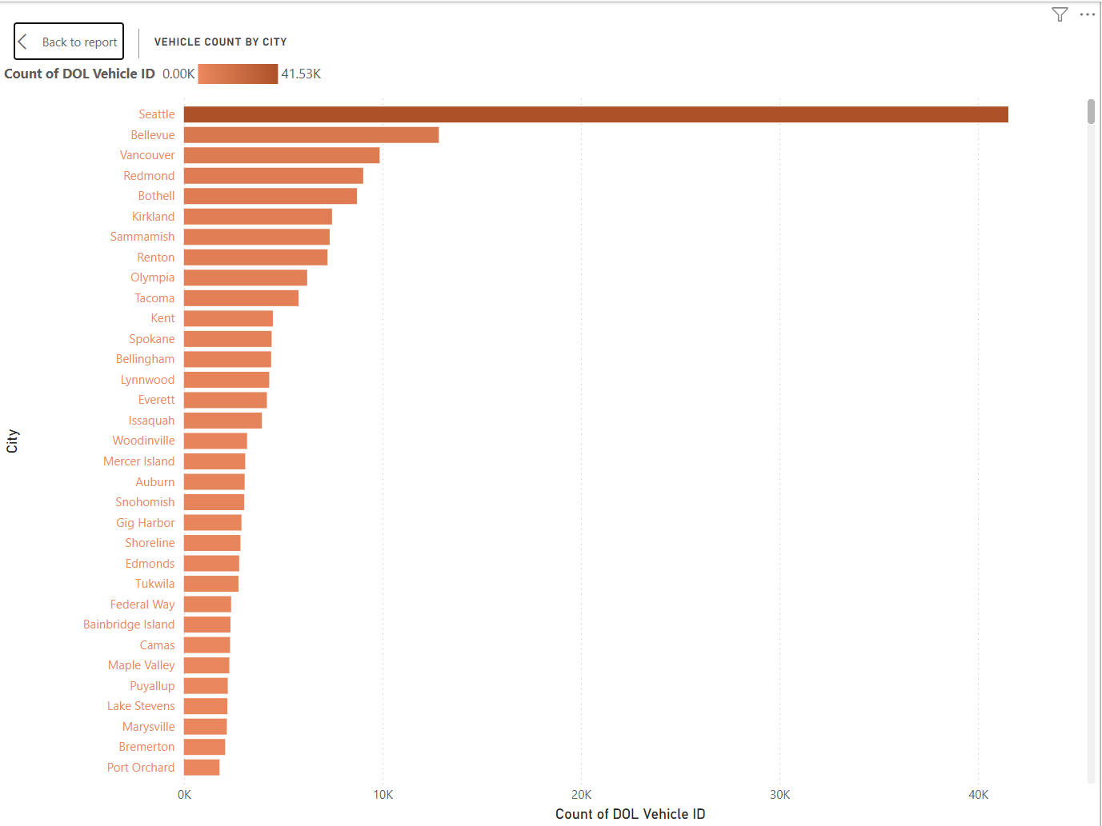
D)Vehicle count by (CAFV ) eligibility
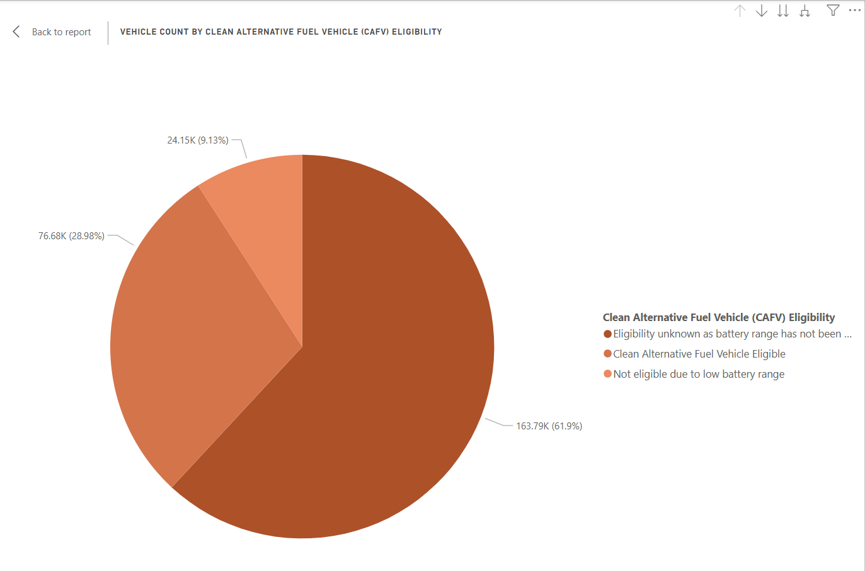

- Count of vehicle by electric Range (BINS)
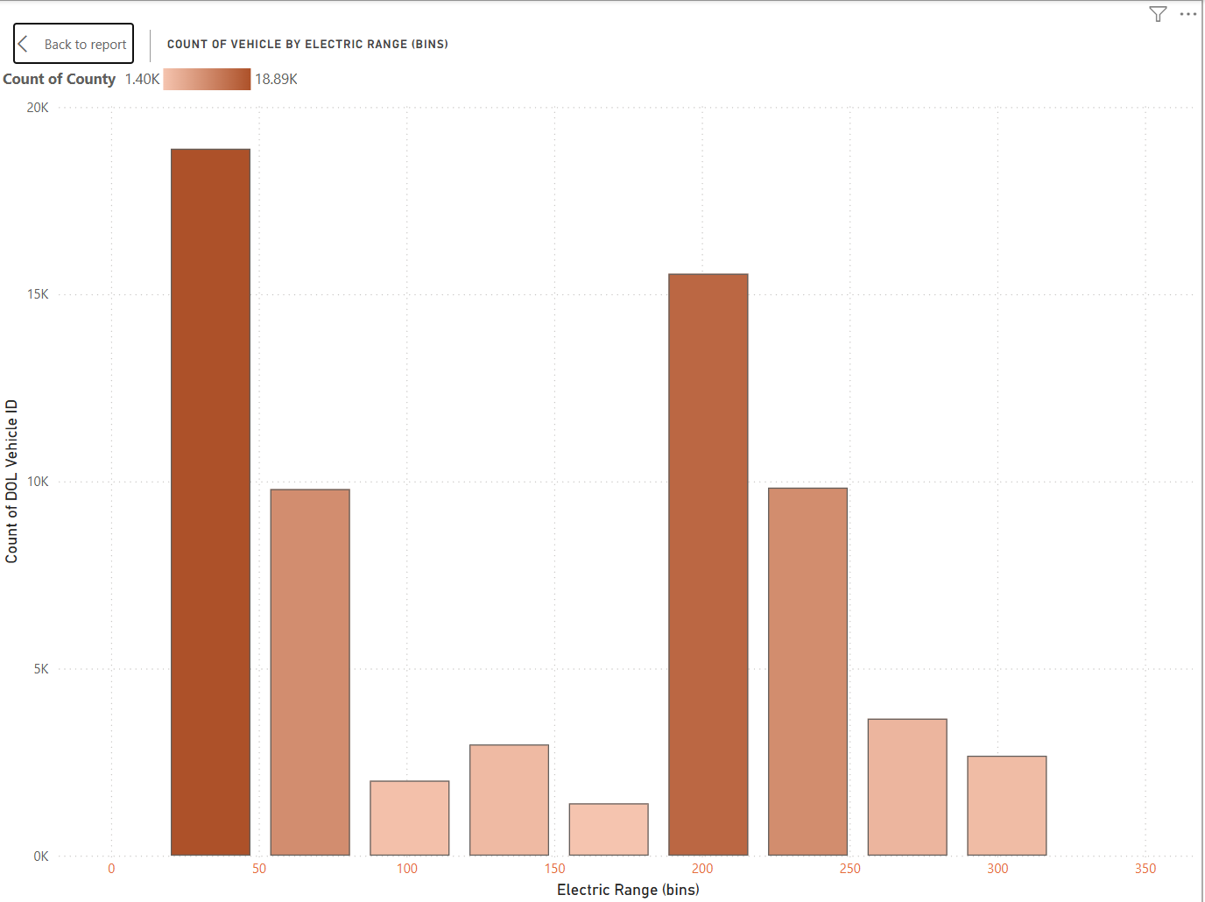
F) Count of DOL Vehicle ID
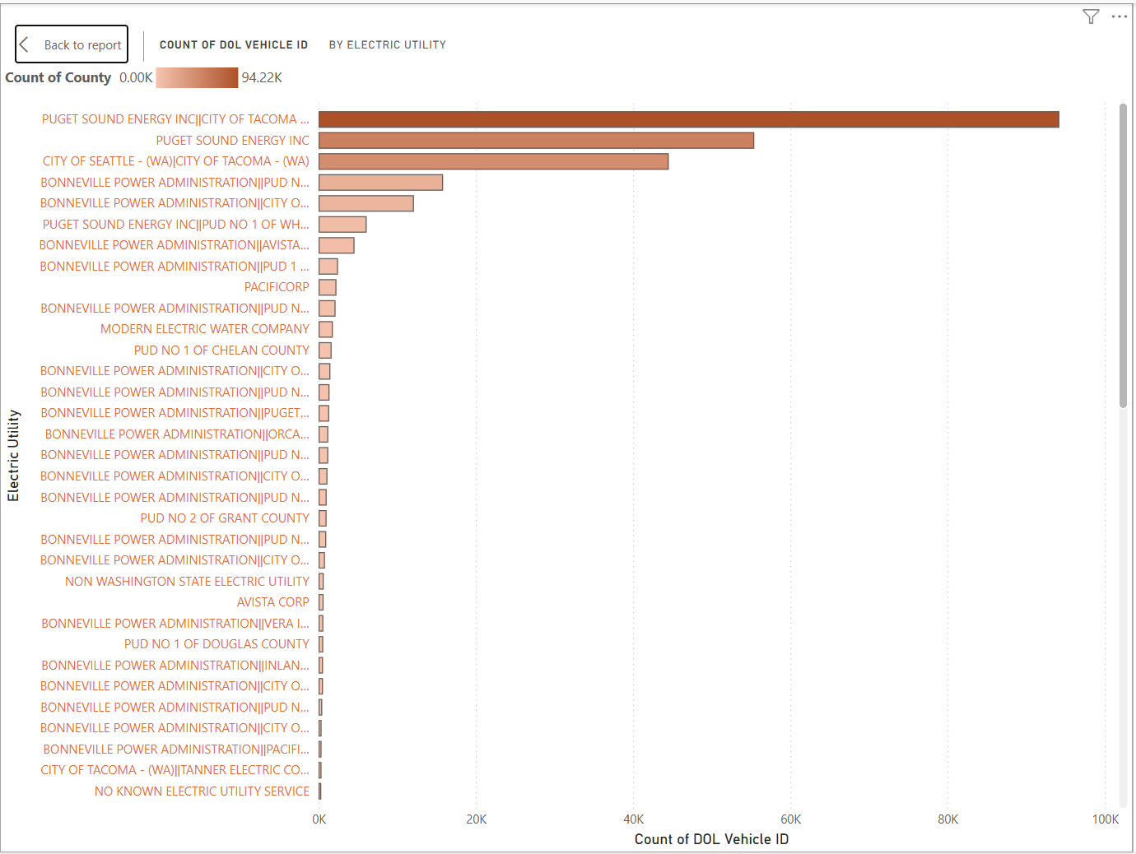

- VECHILE COUNT BY ELECTRIC VECHILE TYPE
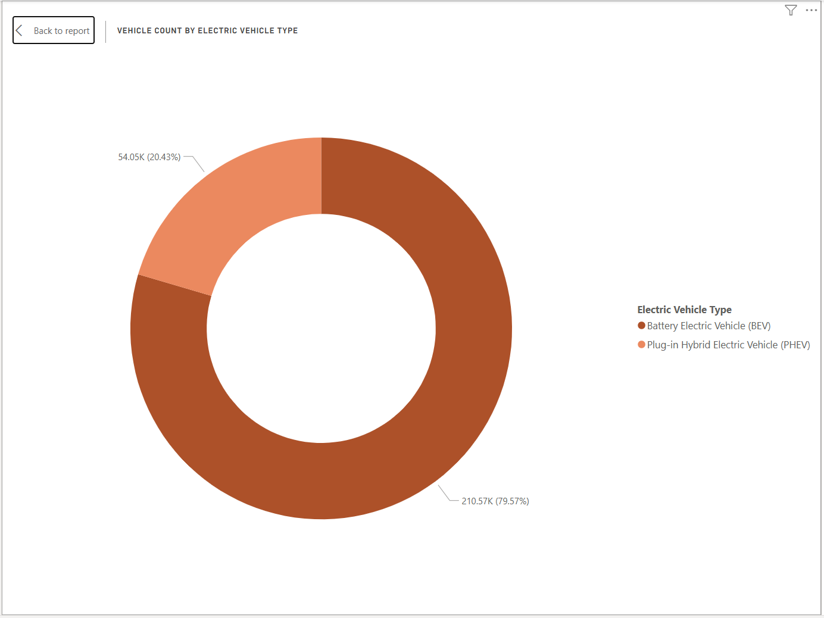
- Vehicle count by clean alternative fuel vehicle eligibility
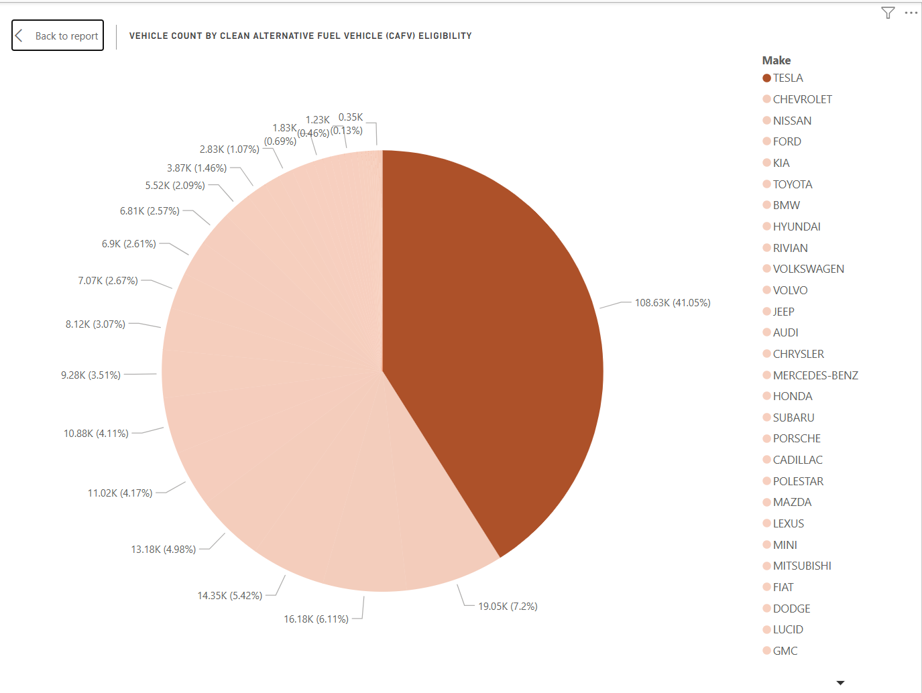
- Count of DOL Vehicle ID
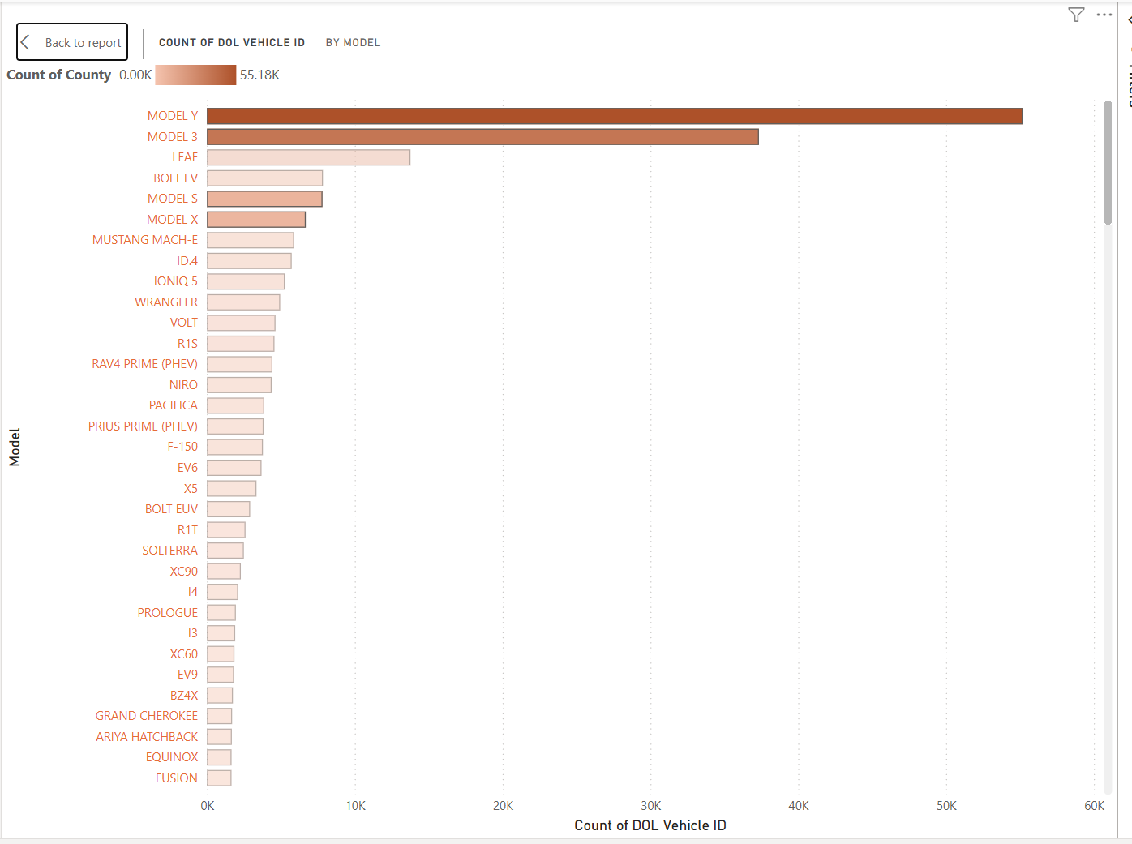
- Country, city, state, CAFV, Make, Model Year.
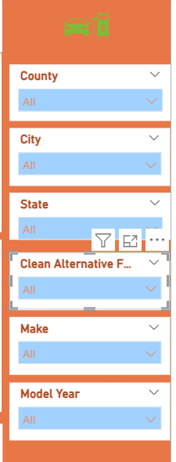

Final DASHBOARD / REPORT
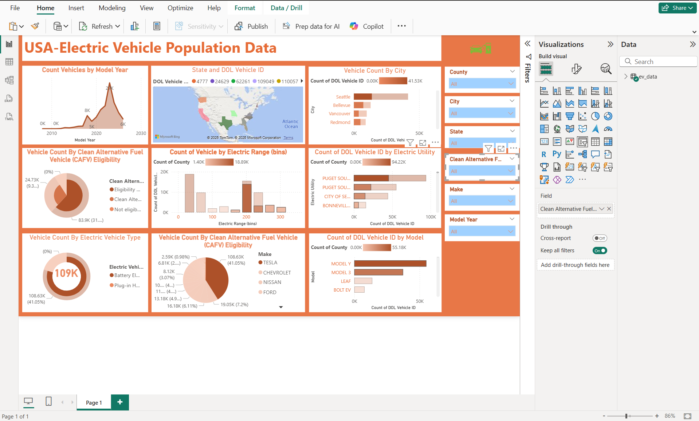
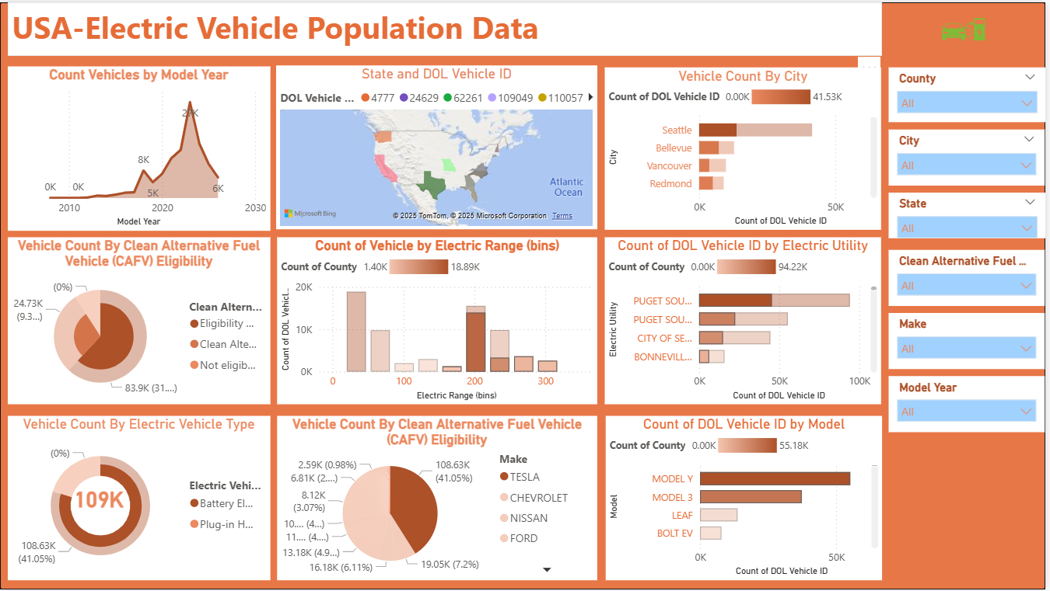

- Conclusions
A) Power Query (Data Preparation): Was essential for cleaning and transforming raw data, most critically by extracting the usable Latitude and Longitude coordinates from the complex string format. This step unlocked the entire geospatial analysis needed for infrastructure planning.
B) Power BI (Analysis & Reporting): The platform established a Star Schema for high performance and used DAX Measures to create reliable, strategic metrics (e.g., % BEV Share, Avg Electric Range). This provided state and utility planners with the data needed for:
  - Infrastructure Prioritization: Identifying areas of high EV concentration.
  - Grid Planning: Pinpointing utility service areas facing potential load increases.
  - Policy Evaluation: Assessing the success of state incentives like CAFV Eligibility.
.

