
A SKILL BASED EVALUATION REPORT
SUBMITTED BY
JEBARSON CALEB D (URK24CS1038)
TALARI S VAMSHI KRISHNA (URK24CS1025)
JASPER FREDDY PAUL R S (URK24CS1118)
PAVIN MUTHU G (URK24CS1017)
COURSE CODE
23CS2048
COURSE NAME
WEB TECHNOLOGY
OCTOBER 2026

DIVISION OF COMPUTER SCIENCE AND ENGINEERING
SCHOOL OF COMPUTER SCIENCE AND TECHNOLOGY

HIRESENSE: AI-ASSISTED RESUME ANALYSIS AND JOB MATCHING PORTAL
A REAL TIME APPLICATION REPORT
Submitted by
JEBARSON CALEB D (URK24CS1038)
TALARI S VAMSHI KRISHNA (URK24CS1025)
JASPER FREDDY PAUL R S (URK24CS1118)
PAVIN MUTHU G (URK24CS1017)
DIVISION OF COMPUTER SCIENCE AND ENGINEERING
KARUNYA INSTITUTE OF TECHNOLOGY AND SCIENCES
(Declared as Deemed-to-be-under Sec-3 of the UGC Act,
1956) Karunya Nagar, Coimbatore - 641 114. INDIA
OCTOBER 2026

ABSTRACT
Recruitment today is dominated by two manual, slow activities: job seekers guess whether their resume will pass an Applicant Tracking System (ATS), and recruiters read hundreds of resumes to find a handful of suitable candidates. HireSense is a full-stack web application that automates both sides of this loop with an AI-assisted resume analysis and job matching engine.
The application supports three roles. A job seeker uploads a resume (PDF, DOCX or TXT); the server extracts its text and asks a large language model (Groq-hosted openai/gpt-oss-120b, or a local llama3.2 model through Ollama) for a structured report containing an ATS score, detected skills, years of experience, strengths, weaknesses, concrete improvement suggestions and suitable job roles. Every open job is then ranked for the seeker using a fast hybrid score (required-skill overlap plus TF-IDF cosine similarity), and an on-demand AI fit check explains the decisive matches and gaps. A recruiter posts jobs, sees applicants ranked by match score, discovers suitable candidates who have not applied, updates application status and downloads original resumes. An administrator monitors platform statistics through charts and manages users and job posts. If the AI provider is unreachable or returns malformed output, a rule-based engine (a 220-skill dictionary with aliases and heuristic ATS checks) takes over, so the portal always responds.
The front end is a React 18 single-page application built with Vite, React Router, Axios and Chart.js, with a responsive light/dark theme and client-side form validation. The back end is a Node.js and Express 5 REST API secured with JSON Web Tokens, bcrypt password hashing, role-based route guards, Helmet and CORS, with server-side validation through express-validator and Multer for size- and type-restricted uploads. Data is persisted in MongoDB through Mongoose schemas for four collections (users, resumes, jobs and applications), including the original resume file, the embedded AI analysis and a per-application score breakdown. The system follows a three-tier client–server architecture and is deployed on Vercel (static front end plus a serverless API) with MongoDB Atlas.
Functional testing of 23 API scenarios (validation, authentication, authorisation, upload limits and AI analysis) produced the expected result in every case, and the interface was verified on desktop and mobile viewports in both themes.
Keywords: MERN stack, React, Node.js, Express, MongoDB, REST API, JWT, large language model, ATS score, resume parsing, TF-IDF, job matching.
TABLE OF CONTENTS
CONTENTS PAGE NO.
CHAPTER 1: INTRODUCTION 1
1.1 Background of the Project 1
1.2 Problem Statement 1
1.3 Objectives 1
1.4 Scope of the Project 2
CHAPTER 2: LITERATURE SURVEY 3
2.1 Review of Existing Websites / Web Applications 3
2.2 Summary of Existing Approaches 4
2.3 Research Gap or Limitations of Existing Systems 4
CHAPTER 3: METHODOLOGY AND SYSTEM DESIGN 5
3.1 Proposed Methodology 5
3.2 System Architecture 6
3.3 Website Structure and Navigation Flow 6
3.4 UML Diagram – Use Case Diagram 7
3.5 Database Design 8
3.6 Tools and Technologies Used 9
3.7 Module Description 10
3.7.1 Authentication and User Management Module 10
3.7.2 Resume Upload and AI Analysis Module 10
3.7.3 Job Management Module 10
3.7.4 Matching and Application Module 11
3.7.5 Administration Module 11
3.7.6 AI Provider and Fallback Module 11
CHAPTER 4: IMPLEMENTATION AND RESULTS 12
4.1 Implementation Details 12
4.1.1 Front-End Development 12
4.1.2 Back-End Development 13
4.1.3 Database Connectivity 14
4.2 Screenshots of the Web Application 16
4.3 Sample Inputs and Outputs 24
4.4 Testing and Results 26
4.4.1 Unit Testing 26
4.4.2 Cross-Browser and Responsiveness Testing 26
4.4.3 Form Validation and Functional Testing 27
CHAPTER 5: CONCLUSION AND FUTURE ENHANCEMENT 28
5.1 Summary of the Work 28
5.2 Conclusion 28
5.3 Future Enhancements 28
REFERENCES 30
SAMPLE OUTPUT SCREENSHOT 32
ANNEXURE: HACKNEX 2026 PARTICIPATION CERTIFICATES 38

LIST OF FIGURES
Figure 3.1: Resume analysis and job matching pipeline 5
Figure 3.2: Three-tier system architecture of HireSense 6
Figure 3.3: Sitemap and navigation flow 7
Figure 3.4: Use case diagram 8
Figure 3.5: Entity–relationship diagram of the MongoDB collections 9
Figure 4.1: users collection – passwords stored only as bcrypt hashes 14
Figure 4.2: jobs collection – a job post created by a recruiter 15
Figure 4.3: applications collection – match score and embedded score breakdown 15
Figure 4.4: Landing page 16
Figure 4.5: Login page 17
Figure 4.6: Job seeker dashboard with top job matches and resume snapshot 18
Figure 4.7: AI resume analysis report – ATS score, skills, issues and suggested fixes 19
Figure 4.8: Job matches ranked by match score 20
Figure 4.9: Recruiter dashboard – job posts with applicant statistics 21
Figure 4.10: Applicants for a job ranked by AI match score 22
Figure 4.11: Admin platform overview with charts 23
Figure 4.12: Responsive layout on a mobile viewport (390 px wide) 24
Figure 4.13: Post a job form showing a client-side validation message 25
Figure 4.14: Registration form showing a server-side validation error (duplicate e-mail) 26
Figure S.1: Sample UI – login page (light theme) 32
Figure S.2: Sample UI – seeker’s applications with match scores and status 32
Figure S.3: MongoDB database resume_portal – collections and document counts 33
Figure S.4: Stored resume document with AI analysis (resumes collection) 33

LIST OF TABLES
Table 2.1: Comparison of existing systems with HireSense 3
Table 3.1: MongoDB collections 9
Table 3.2: Tools and technologies 9
Table 4.1: Main REST API endpoints (all prefixed with /api) 13
Table 4.2: Sample inputs and outputs 24
Table 4.3: Cross-browser and responsiveness checks 26
Table 4.4: Functional and validation test results 27

CHAPTER 1: INTRODUCTION

1.1 Background of the Project
Online recruitment has become the default channel through which students and professionals find employment. Large portals list thousands of openings, and employers increasingly rely on Applicant Tracking Systems (ATS) that parse resumes and filter them by keywords before a human ever reads them. As a result, a well-qualified candidate can be rejected simply because the resume uses different terminology, lacks quantified achievements, or is formatted in a way the parser cannot read.
At the same time, recent large language models (LLMs) can read unstructured text and produce structured, explainable judgements. Combined with classical information-retrieval techniques such as TF-IDF similarity, they make it possible to give job seekers recruiter-quality feedback within seconds and to give recruiters a ranked, explained shortlist instead of a pile of PDFs.
HireSense was developed as the Web Technology (23CS2048) project to apply the full web stack — HTML5, CSS3, JavaScript, React, Node.js, Express and MongoDB — to this real-world problem, and to integrate an AI service in a way that remains reliable when that service is slow or unavailable.

1.2 Problem Statement
Job seekers do not know how an ATS or a recruiter will judge their resume, which of their skills are being recognised, or which open jobs genuinely fit their profile. Recruiters, on the other hand, spend most of their screening time reading resumes that do not meet the basic requirements, and existing portals rarely explain why a candidate matches a job. Paid AI resume checkers exist, but they are separate from the job board, so feedback and matching are not connected. There is a need for a single, secure web portal in which resumes are analysed automatically, jobs and candidates are ranked by an explainable match score, and every role (seeker, recruiter and administrator) works on the same live data.

1.3 Objectives
- To design and develop a responsive, role-based web portal for job seekers, recruiters and administrators using React on the client and Node.js/Express on the server.
- To extract text from uploaded PDF, DOCX and TXT resumes and generate a structured AI analysis: ATS score, skills, experience, education, strengths, weaknesses, suggestions and suitable roles.
- To rank every open job for a seeker, and every applicant for a recruiter, using a hybrid score that combines required-skill overlap, TF-IDF text similarity and an LLM fit judgement with reasoning.
- To store users, resumes (including the original file), jobs and applications in MongoDB with validated Mongoose schemas and appropriate indexes.
- To secure the application with JWT authentication, bcrypt password hashing, role-based authorisation, and both client-side and server-side input validation.
- To guarantee availability through a rule-based fallback engine whenever the AI provider fails, and to deploy the system to the cloud.

1.4 Scope of the Project
The scope covers the complete hiring loop inside one portal: registration and login, resume upload and analysis, job posting and editing, AI-ranked job matches, applications with cover notes, applicant ranking, candidate discovery, application status tracking (applied, shortlisted, rejected, hired), and administrative moderation with dashboard statistics. Resumes are limited to text-based PDF, DOCX and TXT files of up to 4 MB; scanned image-only resumes, video interviews, payment features and e-mail notifications are outside the current scope. The AI provider is configurable: the hosted Groq API is used by default, and a fully local Ollama model can be selected when resume data must not leave the machine.

CHAPTER 2: LITERATURE SURVEY

2.1 Review of Existing Websites / Web Applications
LinkedIn Jobs. LinkedIn combines a professional profile with a job board. Candidates apply with their profile or an uploaded resume, and the platform shows how a member’s listed skills compare with a posting. Matching is driven by the profile fields the user maintains rather than by an analysis of the resume document itself, and detailed insights are part of paid plans.
Naukri.com. Naukri is one of the largest Indian job portals. Recruiters search a large resume database with keyword and filter queries, and job seekers receive job recommendations based on their profile. Resume quality feedback is offered mainly as a separate paid resume-writing service.
Indeed. Indeed aggregates postings from many sources and lets employers screen applicants with questions and filters. Its strength is reach and search; it does not give candidates an explanation of how well their resume fits a specific job.
Jobscan and similar ATS resume checkers (e.g. Resume Worded). These tools let a user paste a resume and a job description to receive a keyword “match rate” and formatting tips. They provide useful feedback, but they are standalone utilities: the user must copy each job description manually, and recruiters do not see the results.
Commercial ATS products (e.g. Workday, Greenhouse). Enterprise ATS platforms parse resumes into structured fields and let recruiters filter applicants. They are designed for employers, are expensive, and largely rely on keyword rules that are opaque to candidates.
Research foundations. Classical information retrieval represents documents as TF-IDF weighted term vectors and compares them with cosine similarity [9], [10]. Transformer-based language models [11], [12] and open-weight models such as gpt-oss [13] can now return structured JSON judgements from free text, enabling explainable scoring that pure keyword matching cannot provide.
Table 2.1: Comparison of existing systems with HireSense
System | Resume analysis | Job/candidate ranking | Explanation of match | Recruiter + seeker in one place
LinkedIn Jobs | Profile-based | Yes | Partial (premium) | Yes
Naukri.com | Paid service | Keyword search | No | Yes
Indeed | No | Search / filters | No | Yes
Jobscan / Resume Worded | Yes (keywords) | One job at a time | Keyword list | No (seeker only)
Enterprise ATS | Parsing only | Rule-based filters | No | No (recruiter only)
HireSense | LLM + rules | All jobs / all candidates | AI reasoning + missing skills | Yes, plus admin

2.2 Summary of Existing Approaches
- Keyword and filter search: recruiters query a resume database by keywords, location and experience. Fast, but brittle with synonyms (e.g. “Node” vs “Node.js”) and gives no ranking explanation.
- Profile-field matching: platforms compare structured profile fields with job fields. Accurate only when users keep profiles complete and current.
- ATS parsing with rules: resumes are parsed into sections and scored with fixed rules, which reward formatting and exact keywords over real suitability.
- Standalone AI resume checkers: provide document feedback against one pasted job description, disconnected from live job listings and from recruiters.

2.3 Research Gap or Limitations of Existing Systems
- Resume feedback and job matching are separate products; a candidate cannot see, in one place, how their resume is judged and which live jobs it fits.
- Match scores are rarely explained. Candidates do not learn which required skills are missing, and recruiters cannot see why a candidate ranks highly.
- Pure keyword systems fail on synonyms and context, while pure LLM systems are slow, can return malformed output and become unavailable when the provider is down.
- Recruiters only see candidates who applied; suitable candidates already on the platform are not surfaced.
- Most AI features require paid plans, which limits access for students and freshers.
HireSense addresses these gaps by combining a deterministic, instant hybrid score with an on-demand LLM judgement, exposing the matched and missing skills and the AI reasoning to both sides, adding a “Discover candidates” view for recruiters, and falling back to rules whenever the AI cannot answer.

CHAPTER 3: METHODOLOGY AND SYSTEM DESIGN

3.1 Proposed Methodology
The project followed an iterative, incremental model. Requirements were first captured as user stories for the three roles; the database schema and REST API were then designed, followed by the AI pipeline, the React interface and finally deployment and testing. Each iteration delivered a working vertical slice (for example, “upload a resume and see its analysis”) that was tested end to end before the next feature was started. Work was tracked in a shared GitHub repository.
The core of the methodology is the resume-processing and matching pipeline shown in Figure 3.1. The uploaded file is converted to plain text, analysed by the LLM in JSON mode, validated and blended with rule-based signals, and stored. Matching uses two levels: a fast deterministic score computed for every open job on each request, and a slower AI fit score requested only when the user applies, checks fit or re-scores.
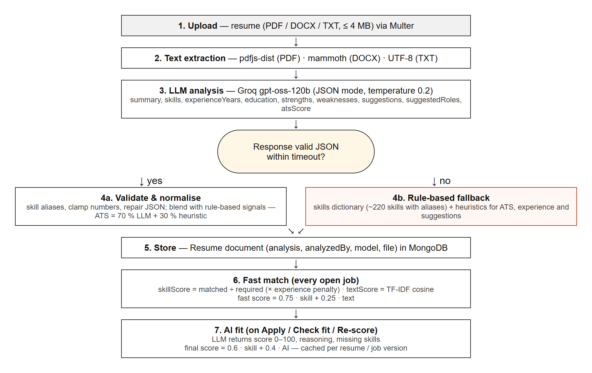
Figure 3.1: Resume analysis and job matching pipeline
The scoring formulas are: skillScore = matched required skills ÷ required skills × 100 (reduced proportionally when the candidate has less than the minimum experience); textScore = TF-IDF cosine similarity between the resume and the job text, scaled to 0–100; fast score = 0.75 × skillScore + 0.25 × textScore; and, once the LLM has judged the fit, final score = 0.6 × skillScore + 0.4 × AI score.

3.2 System Architecture
HireSense uses a three-tier client–server architecture (Figure 3.2). The presentation tier is a React single-page application that runs in the browser and communicates only through HTTPS JSON requests. The application tier is an Express 5 REST API that applies security middleware, authentication, role checks and validation before calling controllers and services; the services layer contains the text extractor, the resume analyser, the matcher, the LLM client and the rule-based fallback. The data tier is MongoDB, accessed through Mongoose. The external AI provider (Groq or Ollama) is called only by the application tier, so API keys never reach the browser.
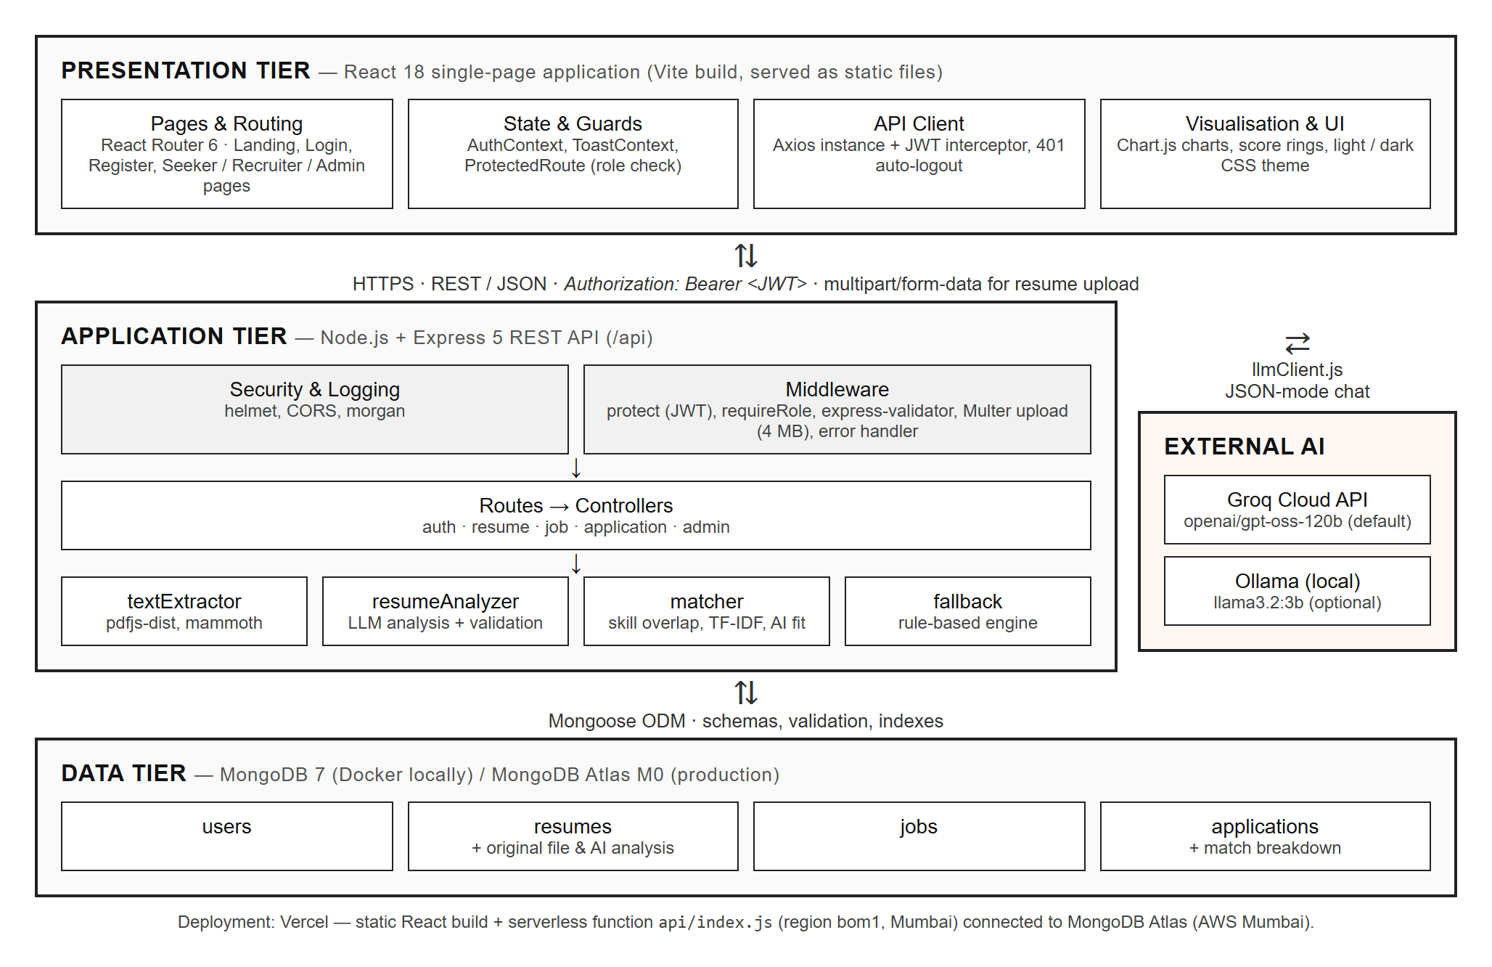
Figure 3.2: Three-tier system architecture of HireSense

3.3 Website Structure and Navigation Flow
Figure 3.3 shows the sitemap. Public visitors see the landing, login and registration pages. After authentication the server returns a JWT, the AuthContext stores the session, and the ProtectedRoute component sends each user to the home page of their role. Every signed-in page shares a navigation bar with a role-specific menu, an AI status badge (AI online / Model missing / AI fallback), a theme toggle and a log-out action.
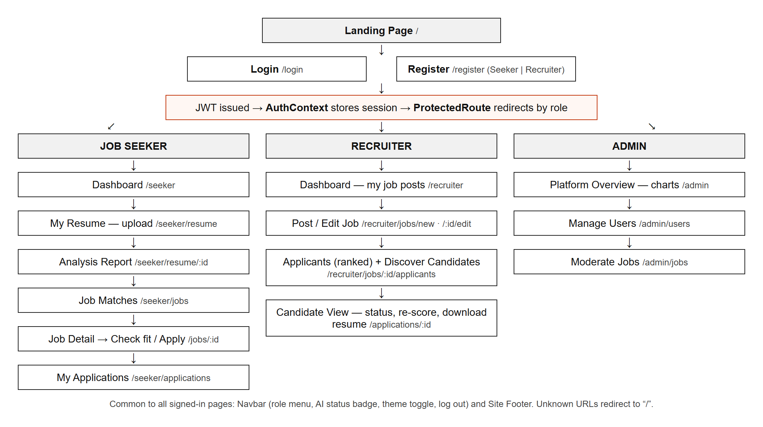
Figure 3.3: Sitemap and navigation flow

3.4 UML Diagram – Use Case Diagram
The use case diagram (Figure 3.4) identifies three actors. The Job Seeker uploads and analyses resumes, views the ATS report, browses ranked job matches, checks AI fit, applies and tracks applications. The Recruiter manages job posts, views ranked applicants, discovers matching candidates, changes application status, re-scores applicants and downloads resumes. The Admin views platform statistics and manages users and job posts. All actors authenticate through the shared Register / Log in use case; use cases marked «AI» are served by the LLM with the rule-based fallback.
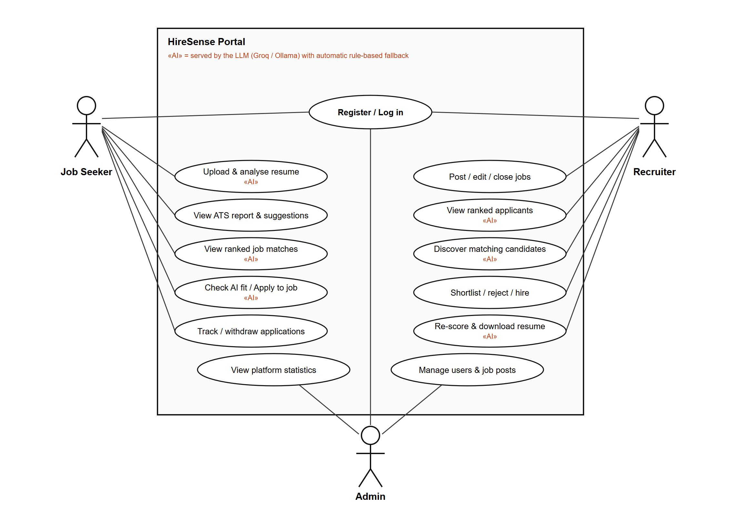
Figure 3.4: Use case diagram

3.5 Database Design
MongoDB was chosen because resume analyses and match breakdowns are naturally nested documents whose fields can evolve, while the main entities still relate to each other through references. Four collections are used; their relationships are shown in the ER diagram in Figure 3.5 and summarised in Table 3.1.
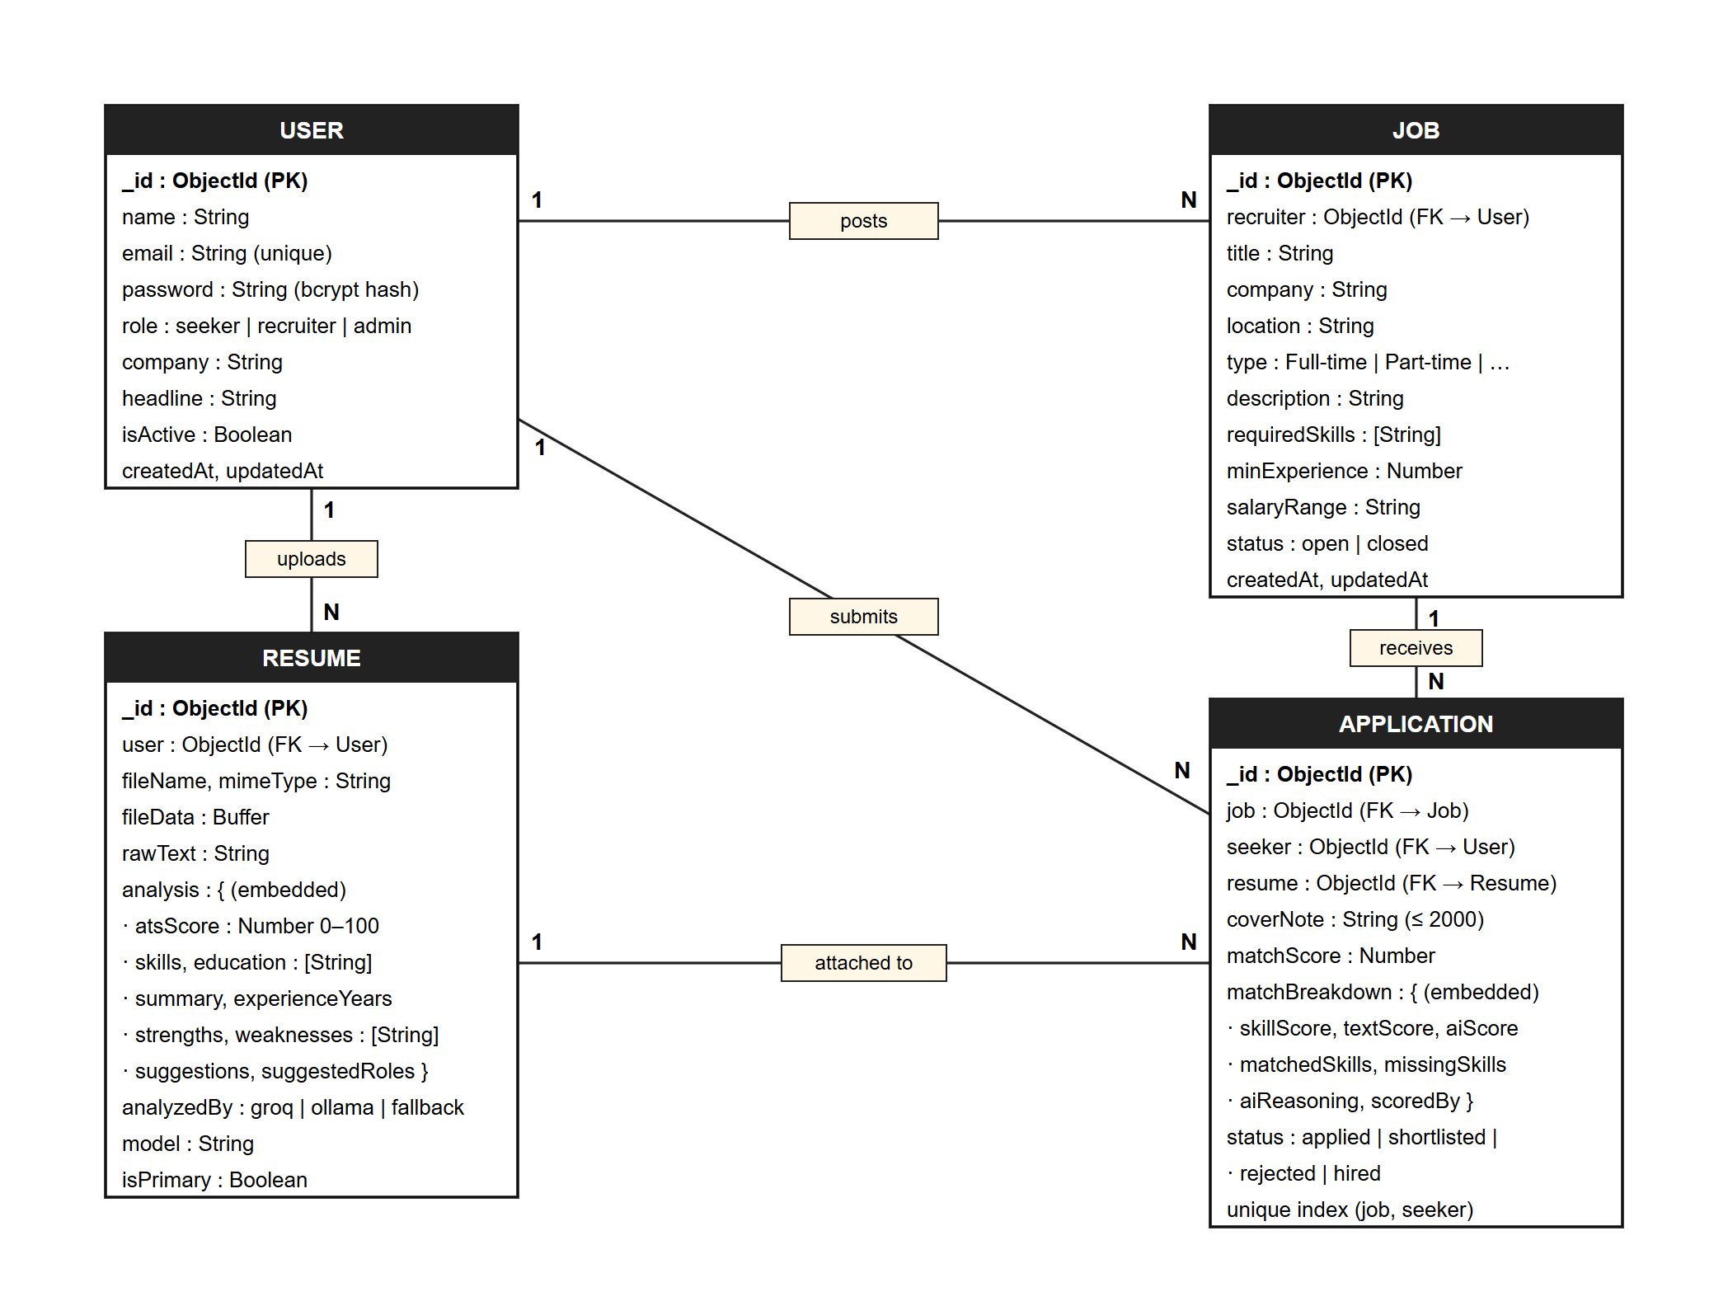
Figure 3.5: Entity–relationship diagram of the MongoDB collections
Table 3.1: MongoDB collections
Collection | Purpose | Key fields / constraints
users | Seekers, recruiters and admins | email unique and lower-cased; password bcrypt-hashed and excluded from queries; role enum; isActive flag
resumes | Uploaded resumes and AI analysis | user reference; original file stored as Buffer (≤ 4 MB); rawText; embedded analysis sub-document; analyzedBy (groq / ollama / fallback); isPrimary
jobs | Job posts created by recruiters | recruiter reference; requiredSkills array; minExperience ≥ 0; type and status enums; text index on title, description and company
applications | A seeker’s application to a job | job, seeker and resume references; matchScore; embedded matchBreakdown; status enum; unique compound index (job, seeker) prevents duplicate applications

3.6 Tools and Technologies Used
Table 3.2: Tools and technologies
Layer | Technology | Use in the project
Front end | HTML5, CSS3, JavaScript (ES2022) | Semantic markup, custom responsive CSS with light/dark themes, client logic
Front end | React 18, React Router 6, Vite 6 | Component-based SPA, client-side routing with role guards, fast build and dev server
Front end | Axios, Chart.js (react-chartjs-2) | HTTP client with JWT interceptor; admin dashboard charts
Back end | Node.js 20+, Express 5 | REST API server, routing and middleware
Back end | jsonwebtoken, bcryptjs, helmet, cors, morgan | Authentication, password hashing, security headers, CORS policy, request logging
Back end | express-validator, Multer | Server-side input validation; multipart upload with type and size limits
Back end | pdfjs-dist, mammoth | Text extraction from PDF and DOCX resumes
AI | Groq API (openai/gpt-oss-120b), Ollama (llama3.2:3b) | Resume analysis and job-fit judgement in JSON mode
Database | MongoDB 7, Mongoose 8 | Document storage, schemas, validation and indexes
Other tools | VS Code, Git / GitHub, Docker, Postman, Chrome DevTools | Development, version control, local MongoDB container, API testing, debugging
Deployment | Vercel, MongoDB Atlas | Static hosting + serverless API (Mumbai region); managed cloud database

3.7 Module Description

3.7.1 Authentication and User Management Module
Handles registration (as seeker or recruiter; recruiters must give a company name), login, profile update and session restore. Passwords are hashed with bcrypt in a Mongoose pre-save hook; a signed JWT carrying the user id and role is returned on login and verified by the protect middleware on every protected route. The requireRole middleware restricts routes to specific roles, and deactivated accounts are rejected.

3.7.2 Resume Upload and AI Analysis Module
Accepts PDF, DOCX or TXT files up to 4 MB through Multer, extracts the text, and produces the analysis described in Section 3.1. Seekers can keep several resumes, mark one as primary for matching, re-run the analysis, and delete resumes that are not attached to applications. The analysis report page shows the ATS score ring, skills, experience, education, AI-flagged issues with suggested fixes, strengths and suggested roles.

3.7.3 Job Management Module
Recruiters create, edit, close and delete job posts with title, company, location, type, salary range, minimum experience, description and required skills (entered with an auto-complete skill input). All signed-in users can search open jobs by keyword, location, type and skills.

3.7.4 Matching and Application Module
Ranks all open jobs for a seeker’s primary resume, provides the AI “Check my fit” explanation, and records applications with a cover note and a stored score breakdown. Recruiters see applicants ranked by score, can filter by status, change status, re-score with the AI, open a full candidate view and download the original resume. The “Discover candidates” tab ranks every seeker on the platform against a job.

3.7.5 Administration Module
Gives administrators an overview dashboard (users by role, jobs, applications, analysed resumes, sign-ups over the last 14 days, applications by status, top candidate skills and most demanded skills) and pages to activate/deactivate users, change roles, delete users, and close or delete job posts.

3.7.6 AI Provider and Fallback Module
llmClient.js wraps the Groq chat-completions API and the Ollama chat API behind one chatJSON function with timeouts, one retry on rate-limit, and tolerant JSON parsing. A cached health check powers the AI status badge. When the provider is not ready or the output is invalid, fallback.js produces the analysis with the skills dictionary and heuristic ATS checks, and the result is labelled “fallback” so users know which engine produced it.

CHAPTER 4: IMPLEMENTATION AND RESULTS

4.1 Implementation Details
The repository is organised as a monorepo with a client folder (React application), a server folder (Express API) and an api/index.js entry point that runs the same Express app as a Vercel serverless function. During development npm run dev starts both the API (port 5000) and the Vite dev server (port 5173), and MongoDB runs in a Docker container defined in docker-compose.yml. A seed script creates demo users, 20 jobs, 5 analysed resumes and 13 applications.

4.1.1 Front-End Development
UI design. The interface follows a “blueprint paper” visual language: a warm paper background with a hairline grid, large uppercase headlines, monospace section labels such as [01], square cards without rounded corners, and a single orange accent. All colours are CSS custom properties, which allows a light and a dark theme that follows the operating-system preference or the user’s toggle.
Components and routing. Pages are composed from reusable components — Navbar, JobCard, ScoreRing, MatchBreakdown, SkillInput, Charts, ApplyModal and ProtectedRoute. React Router defines public routes and role-guarded route groups; unknown URLs redirect to the home page. Global state is limited to two React contexts: AuthContext (current user and token) and ToastContext (notifications).
Responsive layout. Layouts use CSS Grid and Flexbox with media queries; at phone widths the navigation collapses into a menu button and multi-column grids stack into a single column (see Figure 4.12).
Form validation. Forms use HTML5 constraints (required, type="email", minLength) for immediate feedback, plus JavaScript checks before submission — for example, a job cannot be published without at least one required skill. Errors returned by the server are displayed in a form-level error banner.
// client/src/api/client.js – every request carries the JWT; an expired session logs the user out
api.interceptors.request.use((config) => {
const token = localStorage.getItem('token');
if (token) config.headers.Authorization = `Bearer ${token}`;
return config;
});

4.1.2 Back-End Development
The Express application applies Helmet, CORS (restricted to the client URL), JSON body parsing and Morgan logging, then mounts all routes under /api. Each route is a chain of middleware: authentication (protect), authorisation (requireRole), validation rules, and finally the controller. A central error handler converts validation errors, Multer errors, Mongoose cast/validation errors and duplicate-key errors into consistent JSON responses with the correct HTTP status code. Table 4.1 lists the main endpoints.
// server/src/routes/index.js – registration with server-side validation
router.post('/auth/register',
body('name').trim().notEmpty().withMessage('Name is required'),
body('email').isEmail().withMessage('A valid email is required'),
body('password').isLength({ min: 6 }).withMessage('Password must be at least 6 characters'),
validate, auth.register);

// role guard reused across route groups
const recruiter = [protect, requireRole('recruiter', 'admin')];
router.post('/jobs', ...recruiter, ...jobValidators, jobs.createJob);
Table 4.1: Main REST API endpoints (all prefixed with /api)
Method | Endpoint | Access | Description
POST | /auth/register, /auth/login | Public | Create account / log in and receive a JWT
GET | /auth/me | Any user | Current user profile
GET | /ai/health | Public | AI provider status for the navbar badge
POST | /resumes | Seeker | Upload (multipart) and analyse a resume
POST | /resumes/:id/reanalyze | Seeker | Run the analysis again
GET | /jobs, /jobs/:id | Any user | Search open jobs / job detail
GET | /jobs/matches | Seeker | Open jobs ranked for the primary resume
GET | /jobs/:id/fit | Seeker | AI fit check with reasoning
POST/PUT/DELETE | /jobs, /jobs/:id | Recruiter | Create, update, delete job posts
GET | /jobs/:id/candidates | Recruiter | Rank all seekers for a job
POST | /applications | Seeker | Apply to a job (computes AI match score)
GET | /applications/job/:jobId | Recruiter | Applicants ranked by score
PATCH | /applications/:id/status | Recruiter | Shortlist / reject / hire
POST | /applications/:id/rescore | Recruiter | Re-run AI scoring
GET | /admin/stats | Admin | Dashboard statistics
GET/PATCH/DELETE | /admin/users, /admin/jobs | Admin | Manage users and moderate jobs

The AI integration sends a strict system prompt that asks for a JSON object with fixed keys and an explicit ATS rubric (section headings, contact information, keywords, quantified achievements, date consistency, action verbs and education). The response is validated, numbers are clamped, skill names are normalised through an alias dictionary, and the ATS score is blended with the rule-based score so that it is stable between runs.

4.1.3 Database Connectivity
The server connects to MongoDB with Mongoose using the MONGO_URI environment variable (a Docker container locally and MongoDB Atlas in production). Because serverless functions start and stop frequently, ensureDB() creates the connection once, reuses it across invocations, and retries on the next request if a connection attempt fails; the serverless entry point returns HTTP 503 with a JSON message instead of crashing when the database is unreachable.
// server/src/config/db.js – connect once and reuse across serverless invocations
export async function ensureDB() {
if (mongoose.connection.readyState === 1) return;
connecting ??= connectDB().catch((err) => { connecting = undefined; throw err; });
await connecting;
}
Schemas enforce data integrity at the database layer: required fields, enums for roles, job types and statuses, numeric ranges, a unique e-mail index, a text index for job search and a unique compound index that prevents a seeker from applying twice to the same job. Sensitive fields (password, fileData, rawText) use select: false so they are never returned unless explicitly requested. Figures 4.1–4.3 show documents stored by the application, queried with mongosh.
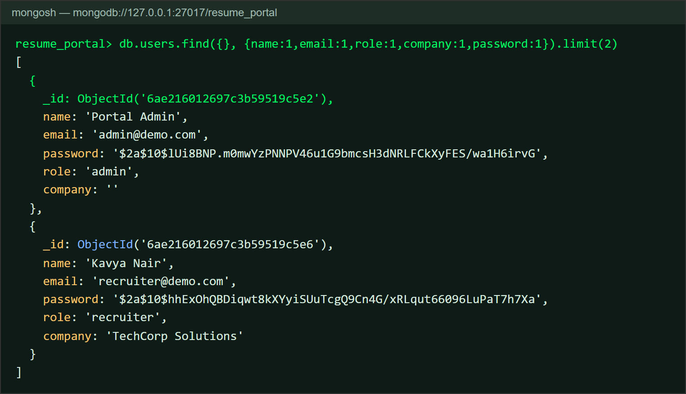
Figure 4.1: users collection – passwords stored only as bcrypt hashes
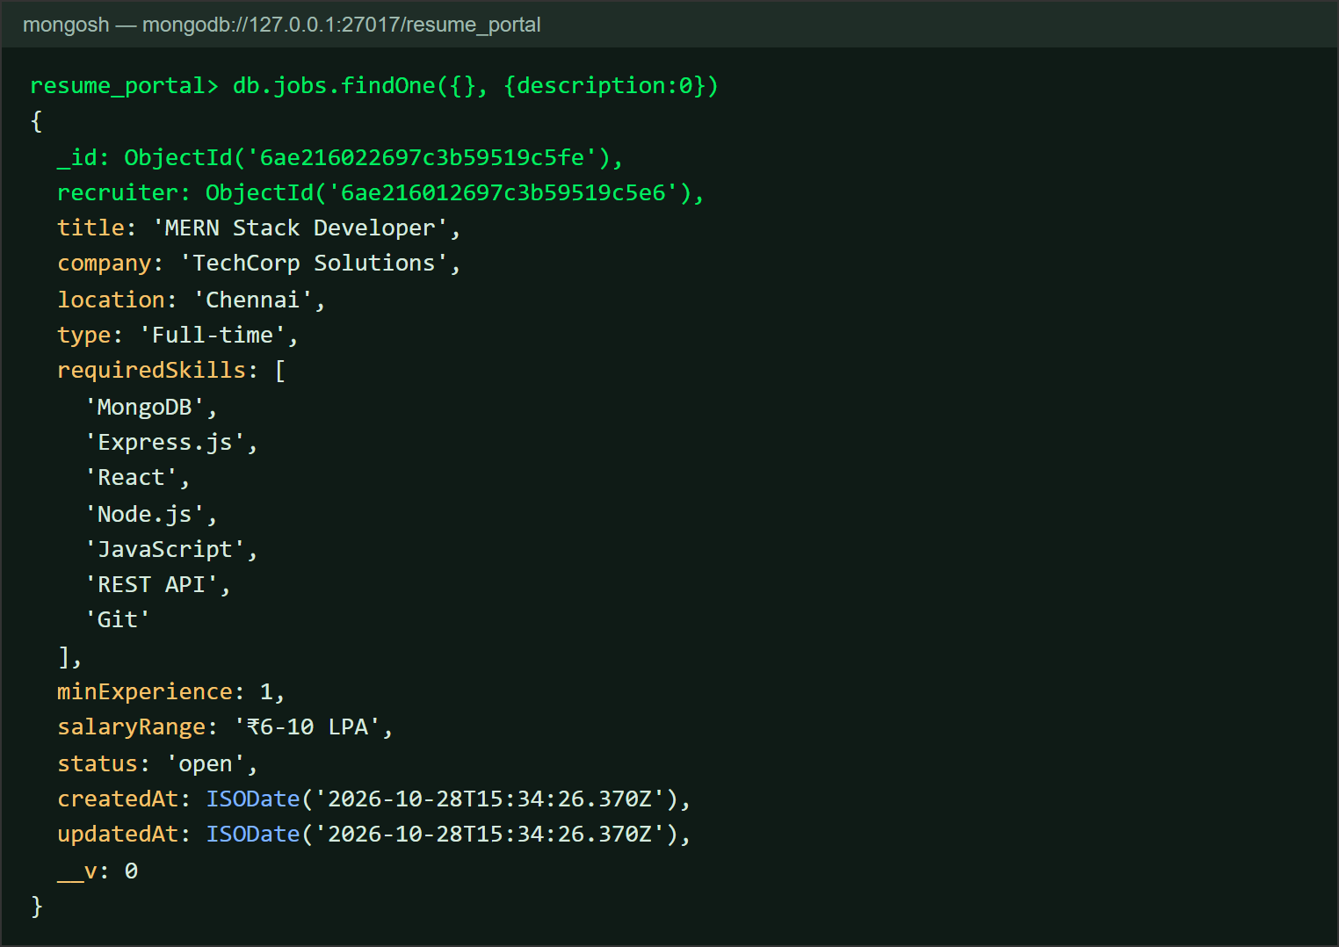
Figure 4.2: jobs collection – a job post created by a recruiter
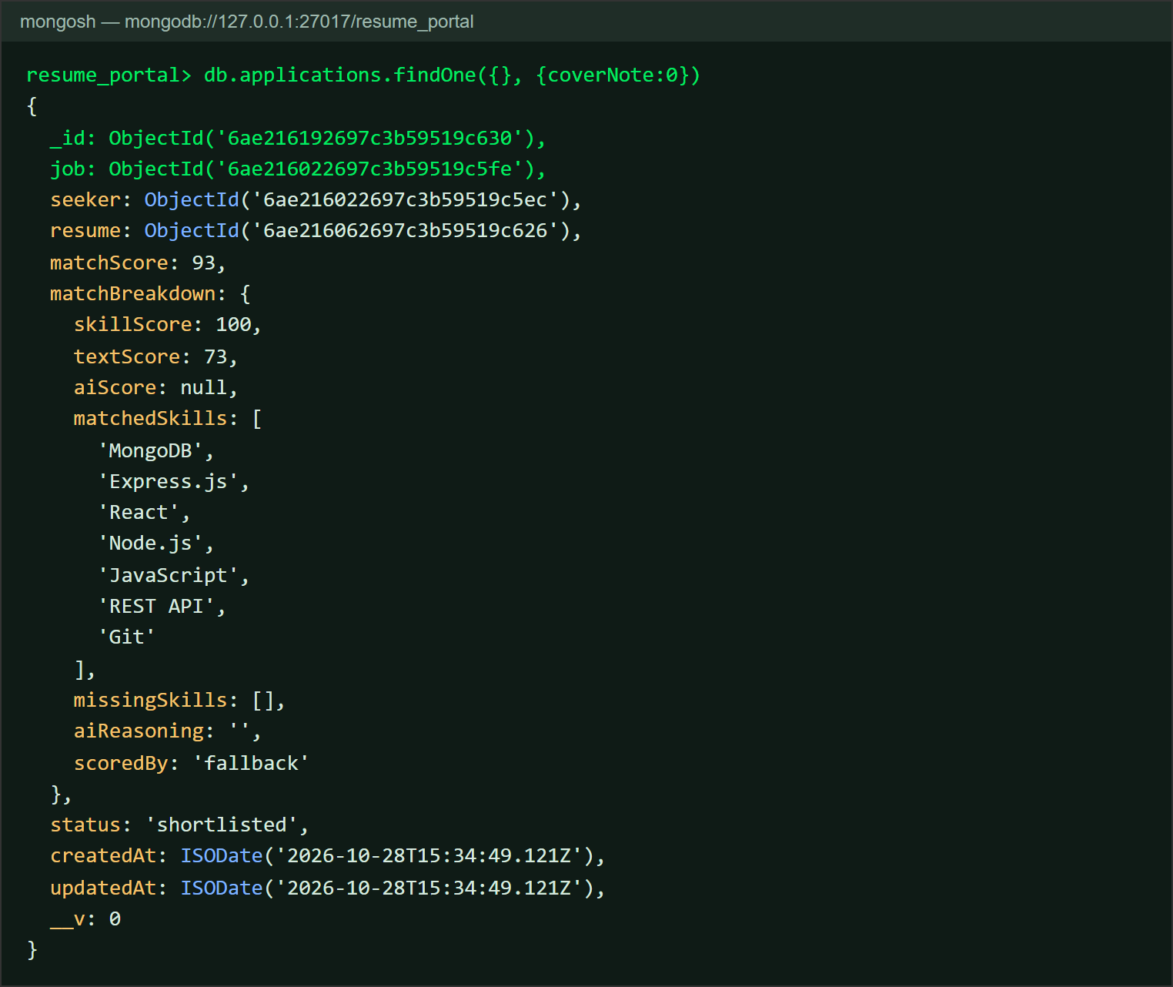
Figure 4.3: applications collection – match score and embedded score breakdown

4.2 Screenshots of the Web Application
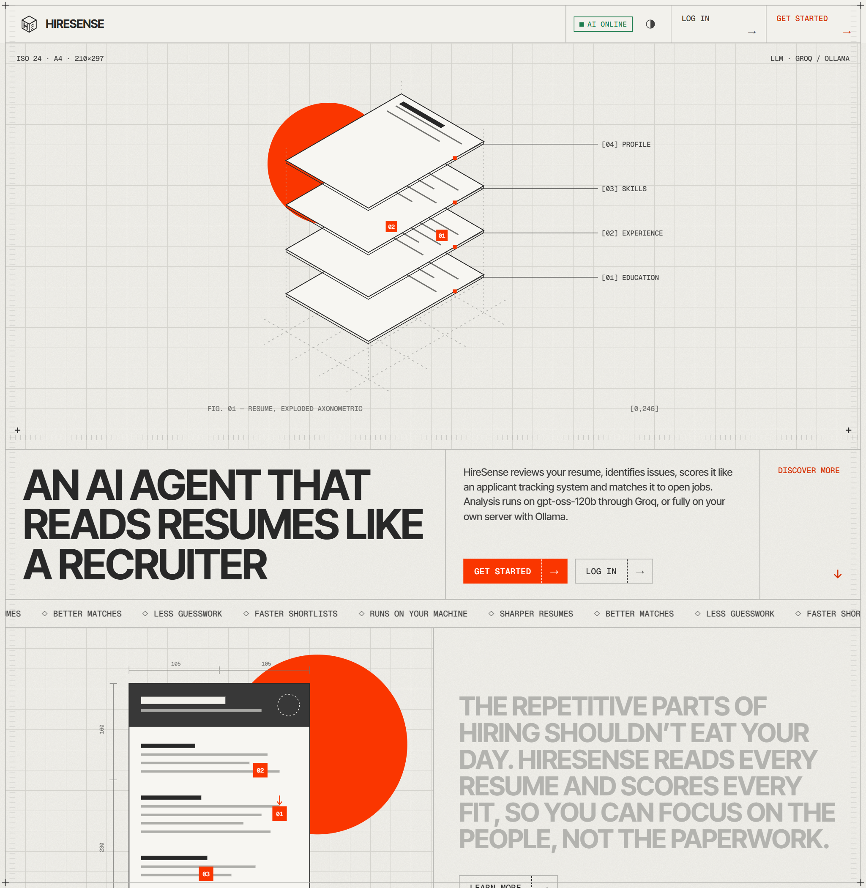
Figure 4.4: Landing page
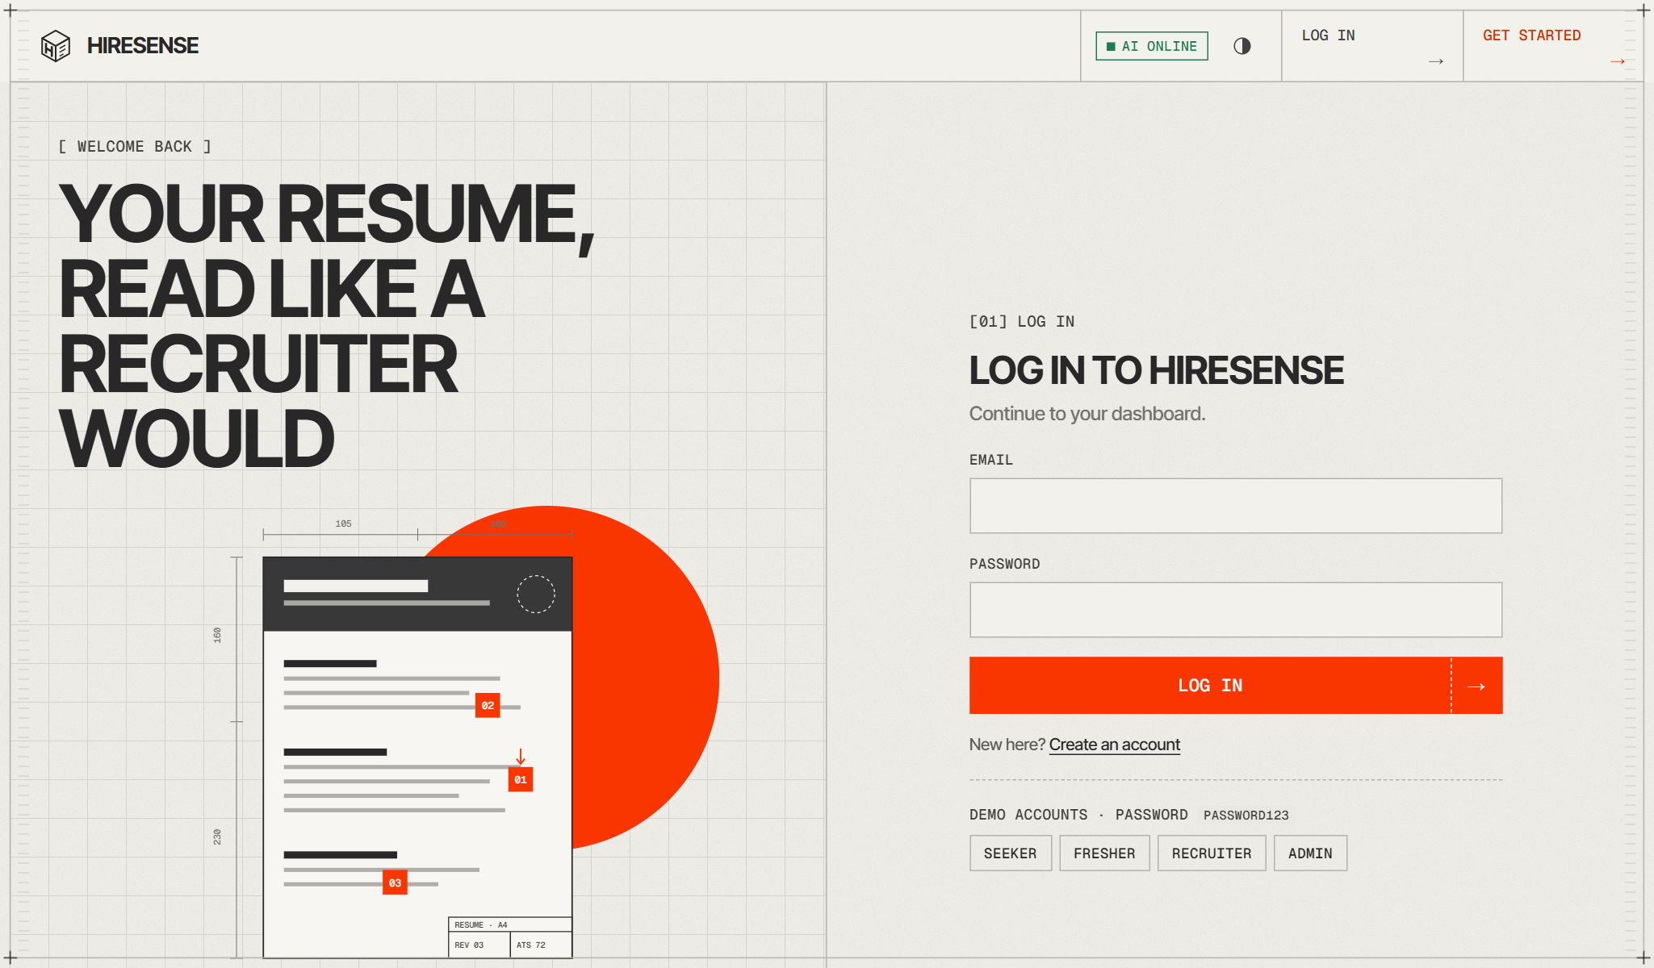
Figure 4.5: Login page
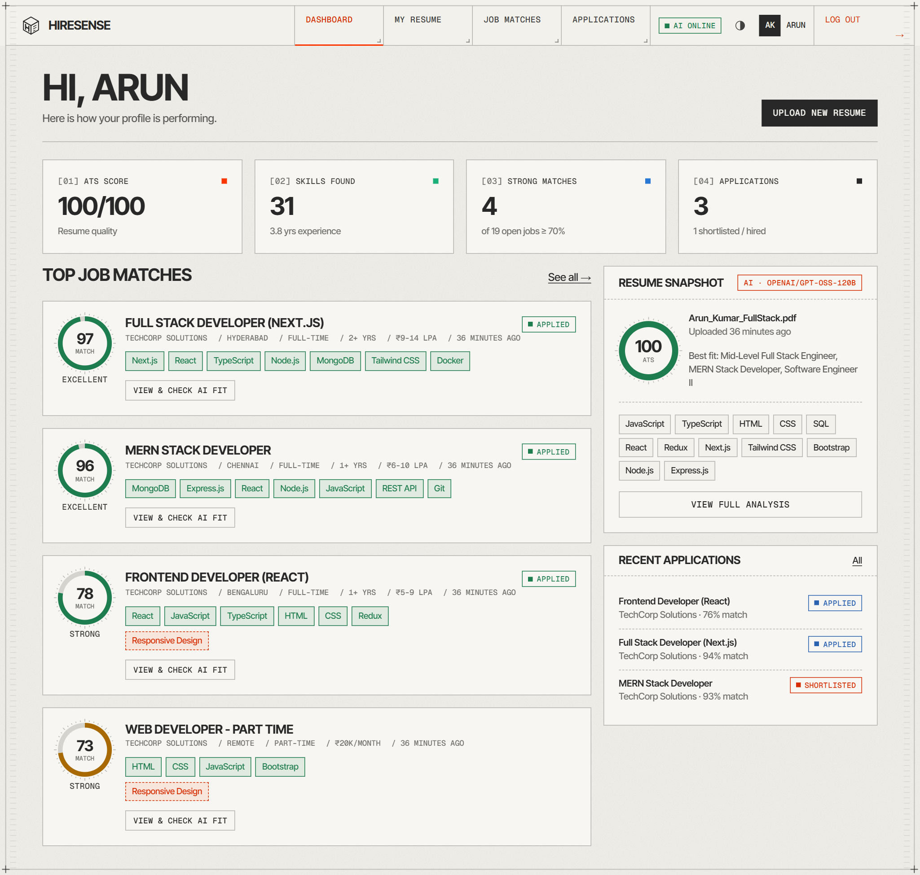
Figure 4.6: Job seeker dashboard with top job matches and resume snapshot
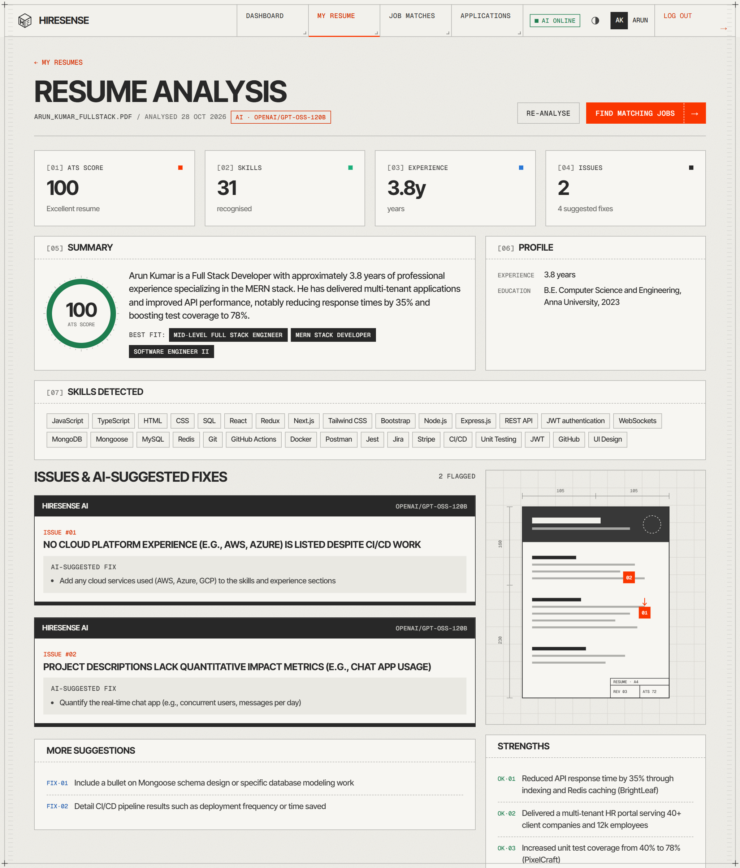
Figure 4.7: AI resume analysis report – ATS score, skills, issues and suggested fixes
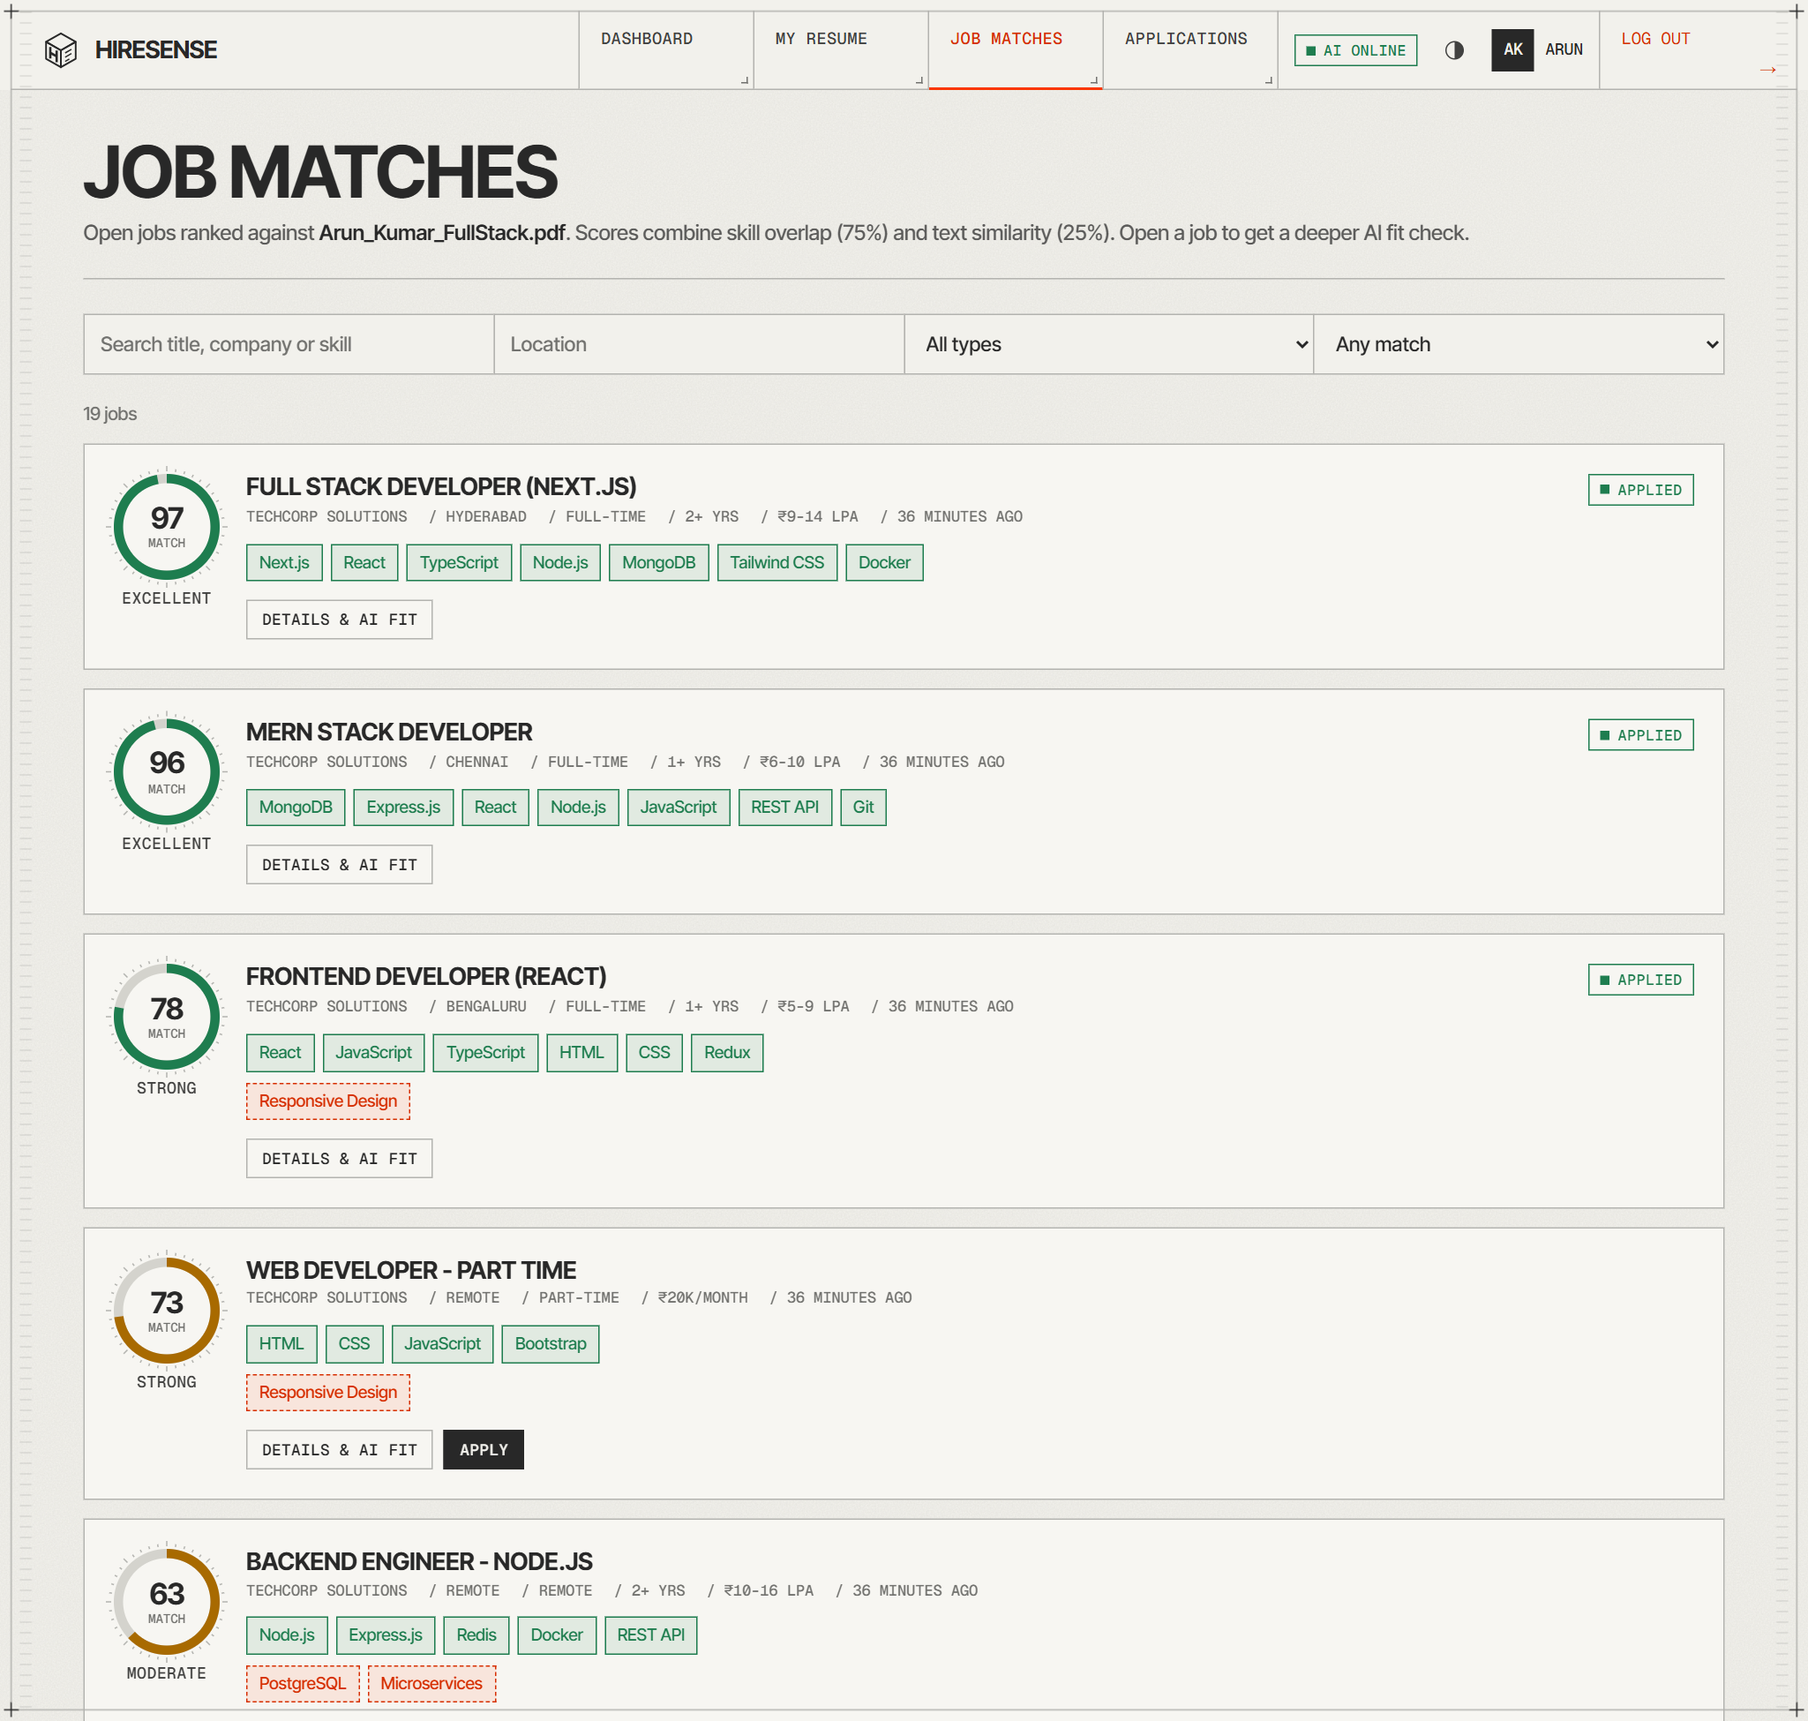
Figure 4.8: Job matches ranked by match score
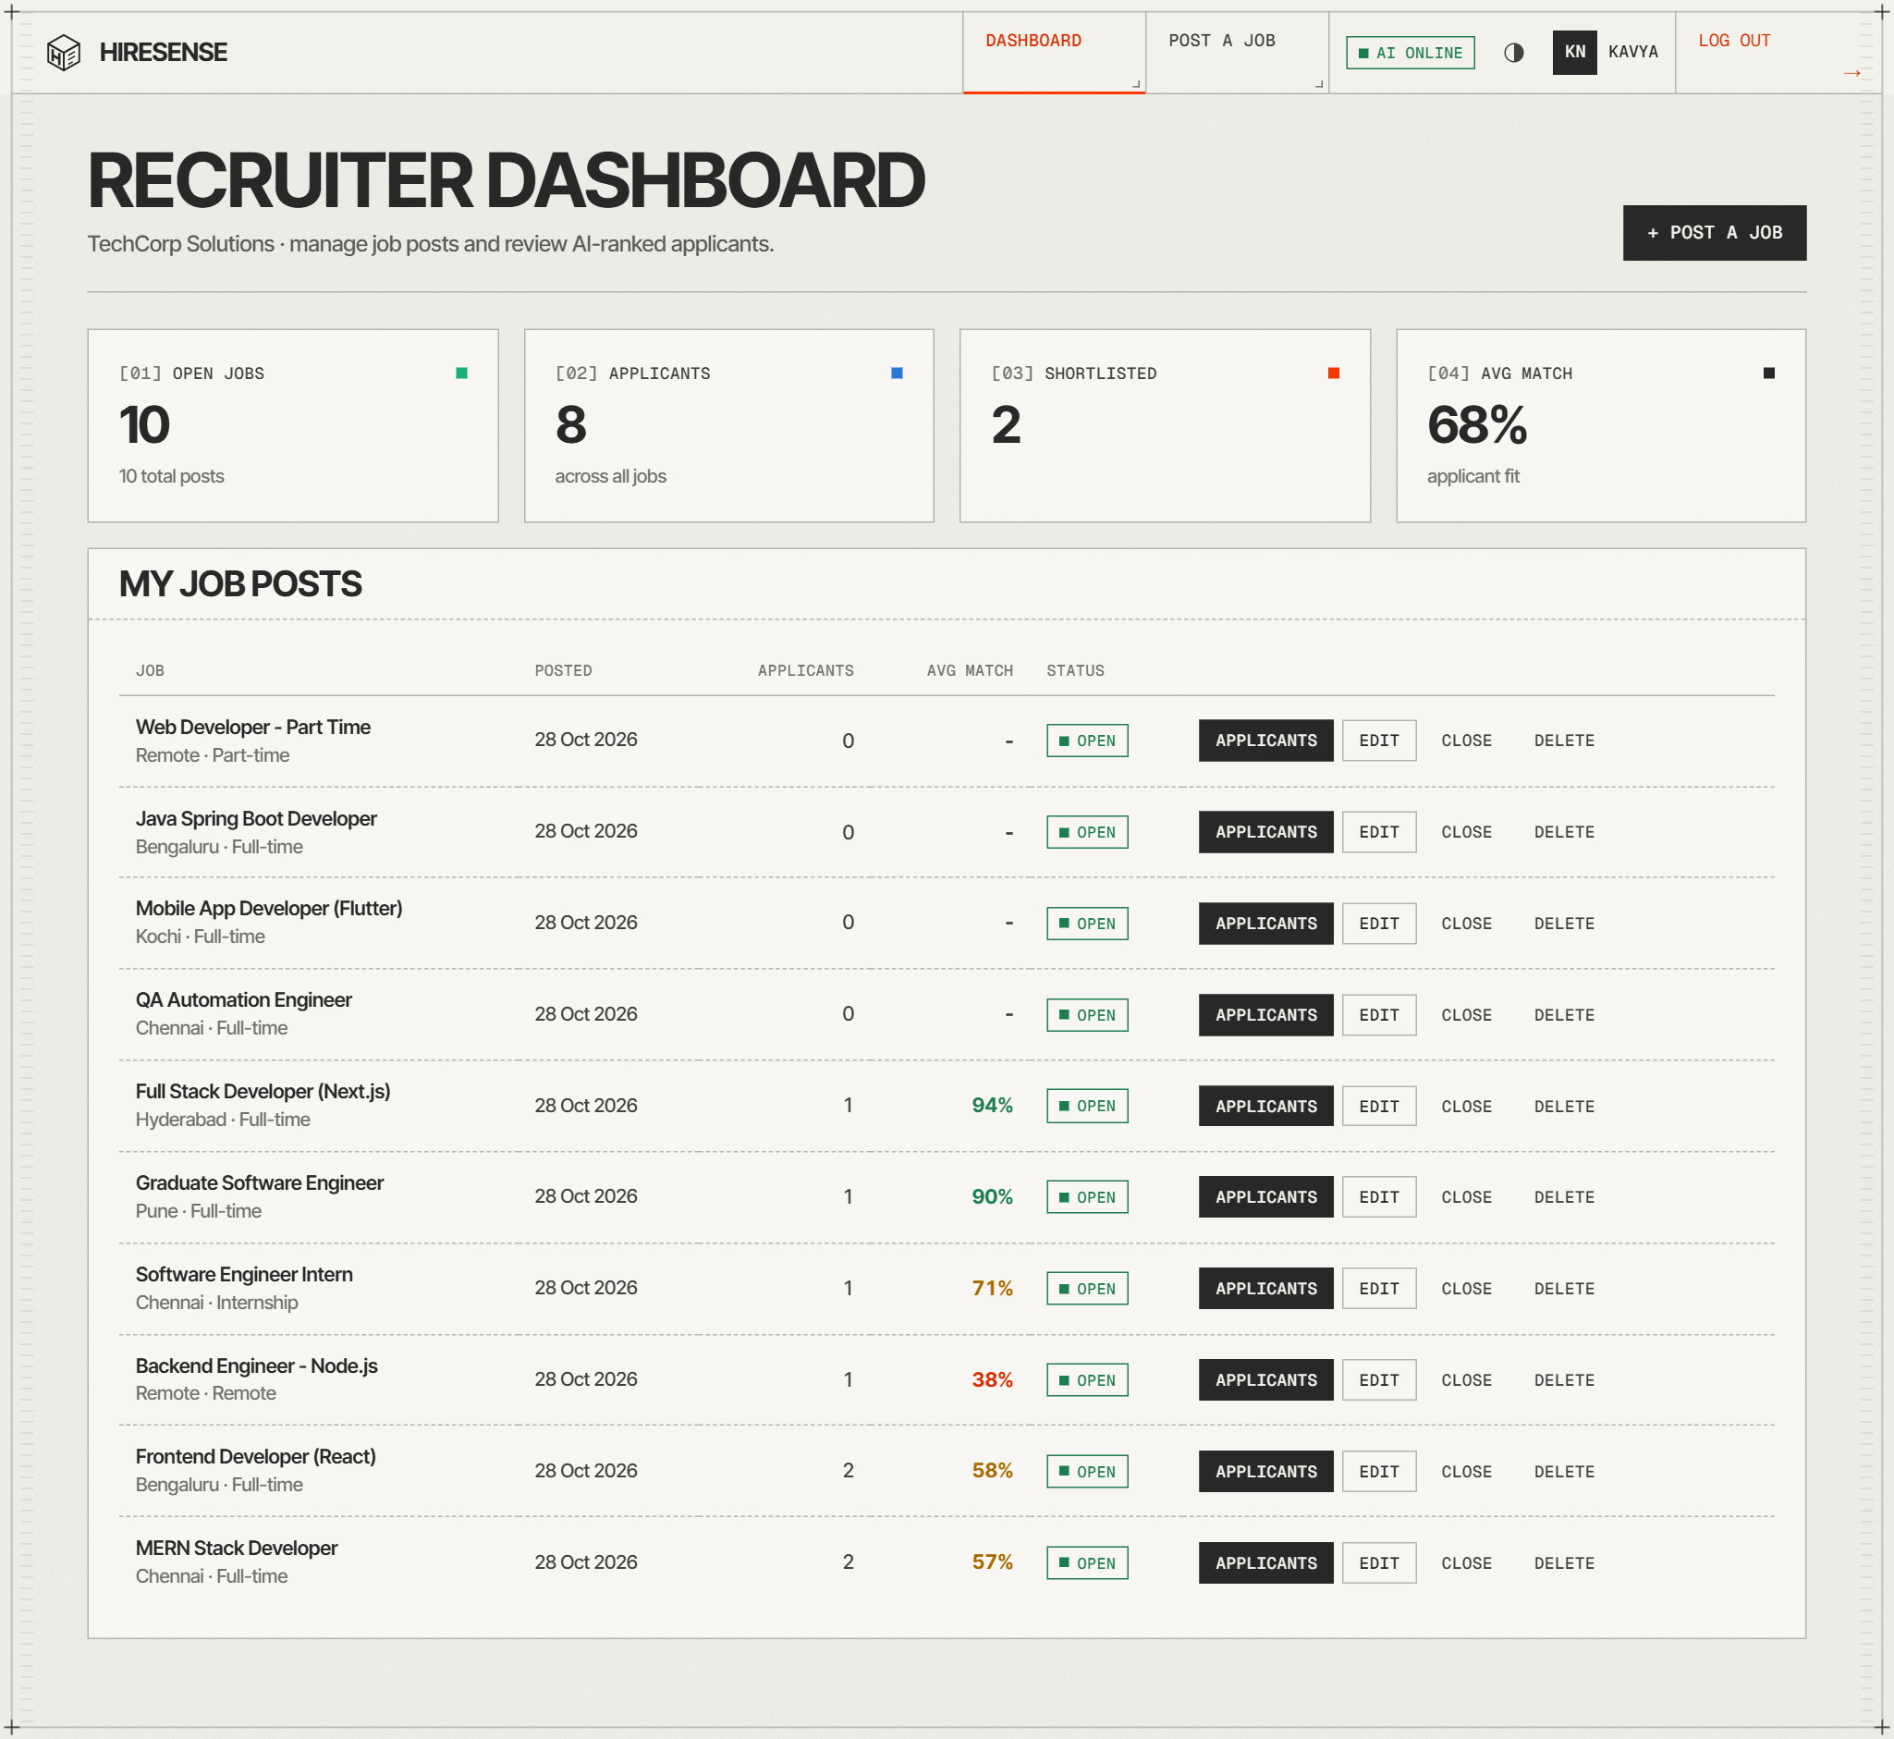
Figure 4.9: Recruiter dashboard – job posts with applicant statistics
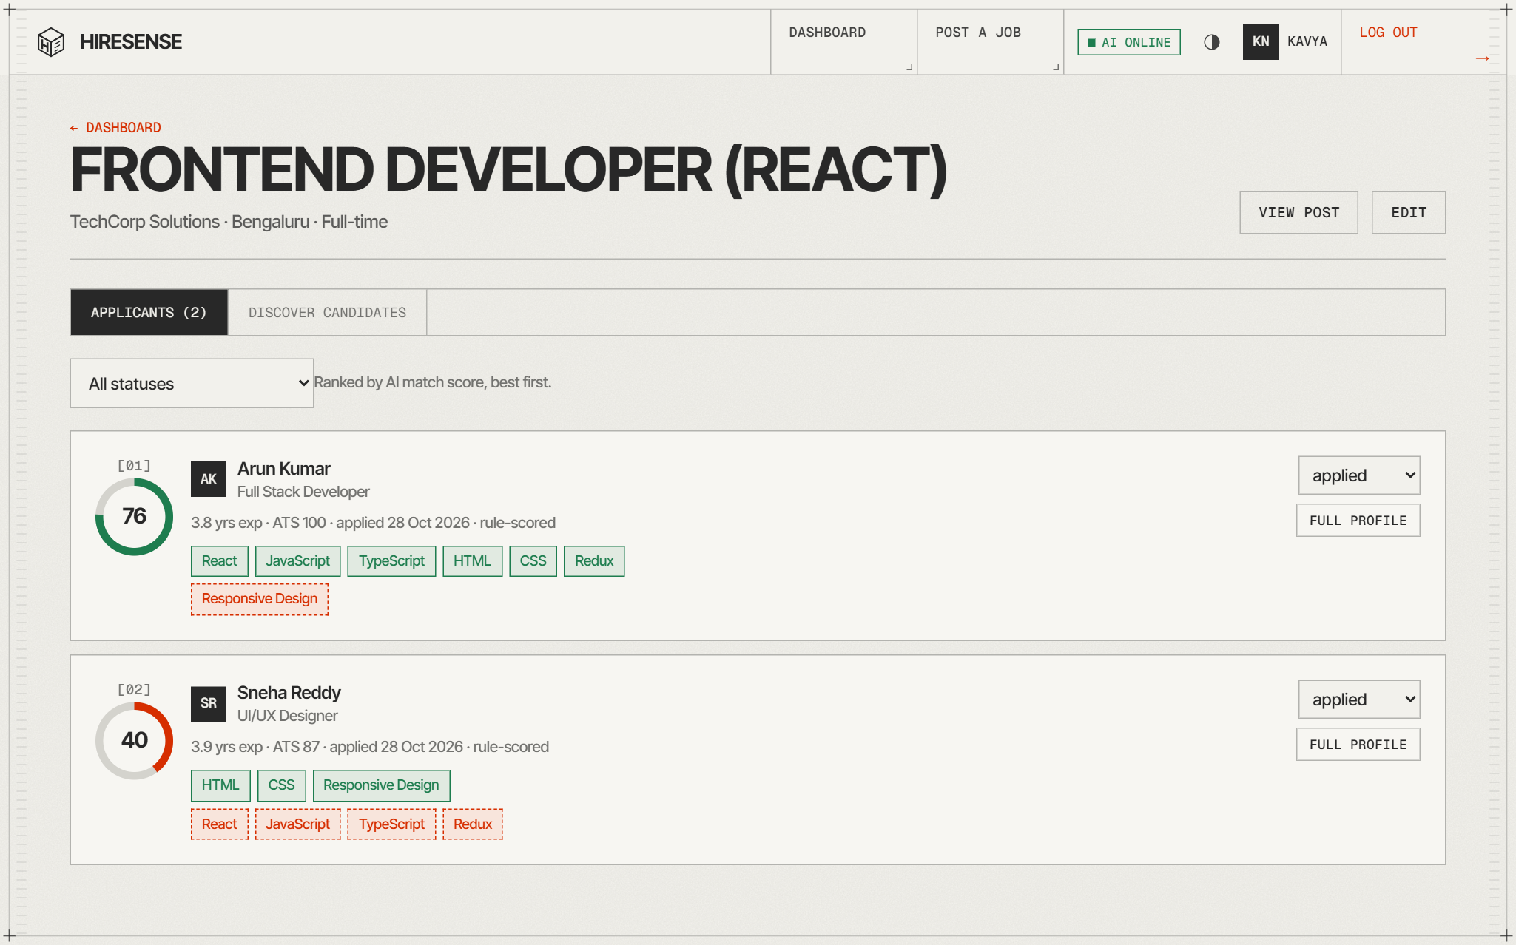
Figure 4.10: Applicants for a job ranked by AI match score
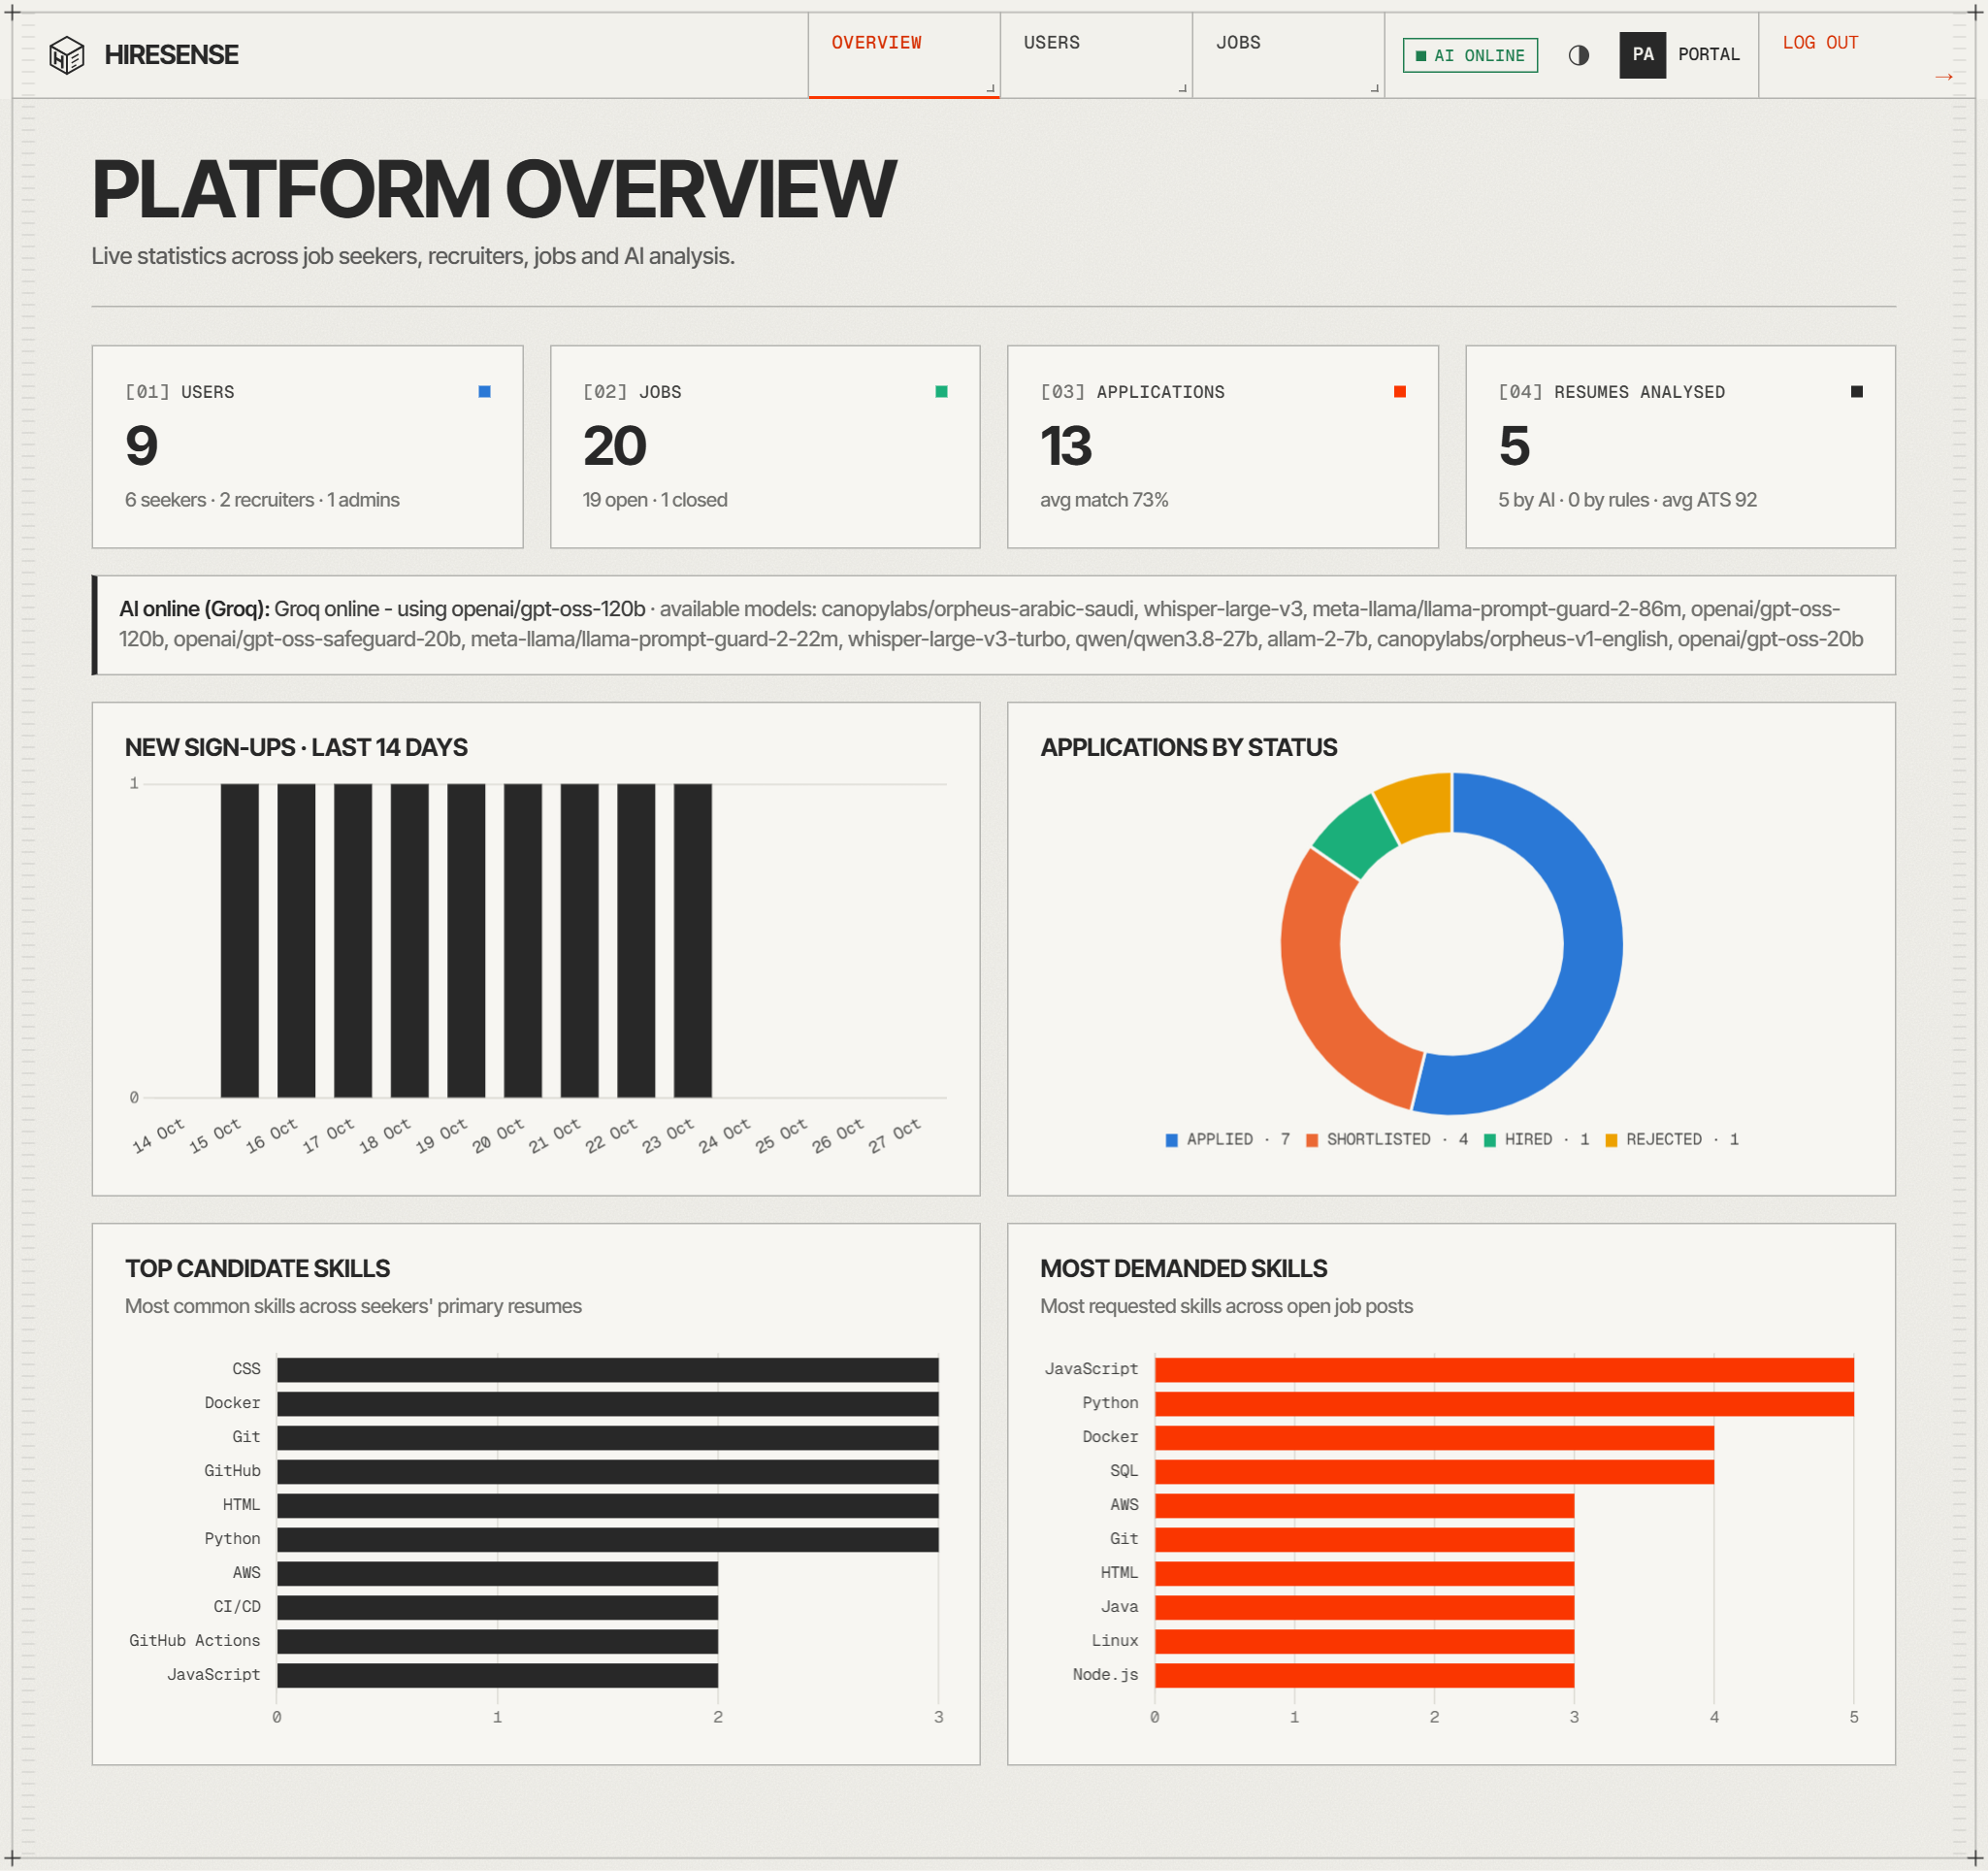
Figure 4.11: Admin platform overview with charts
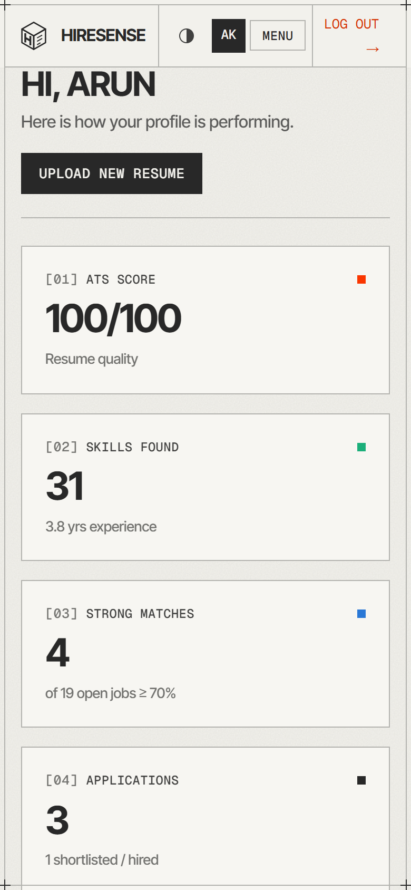
Figure 4.12: Responsive layout on a mobile viewport (390 px wide)

4.3 Sample Inputs and Outputs
Table 4.2: Sample inputs and outputs
Input | Output produced by the system
Seeker uploads Arun_Kumar_FullStack.pdf (full-stack developer resume) | ATS score 100/100, 31 skills recognised (JavaScript, TypeScript, React, Node.js, MongoDB, Docker …), 3.8 years of experience, suggested roles “Mid-level Full Stack Engineer, MERN Stack Developer, Software Engineer II”, 2 AI-flagged issues with fixes (Figure 4.7)
Fresher uploads Rahul_Verma_Fresher.pdf | Analysed by Groq in ≈3.6 s: ATS score 85, 15 skills detected; 19 open jobs ranked for the resume
Arun applies to “MERN Stack Developer” (TechCorp) | Application stored with matchScore 93: skillScore 100 (7/7 required skills matched), textScore 73, status later set to “shortlisted” (Figure 4.3)
Recruiter opens applicants for “Frontend Developer (React)” | Two applicants listed in descending order of match score with matched and missing skills (Figure 4.10)
Recruiter tries to publish a job without required skills | Form blocked with “Add at least one required skill – it is the main signal for AI matching.”
User registers with an e-mail that already exists | HTTP 409 and the banner “An account with this email already exists”

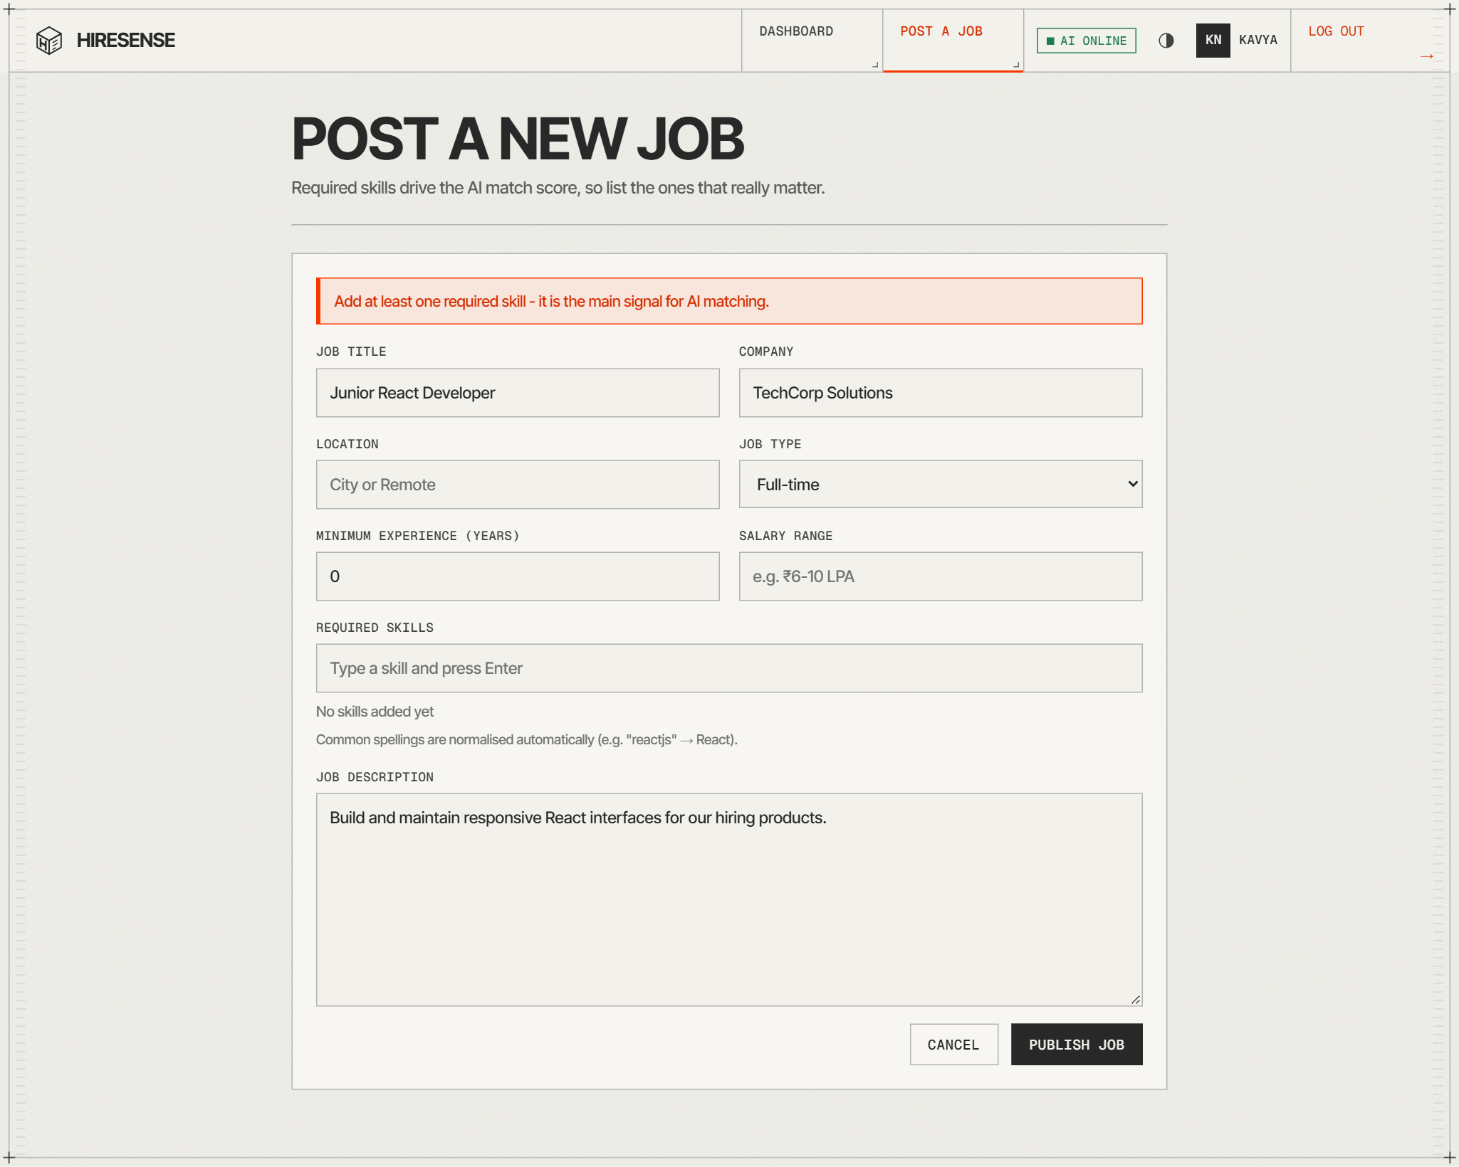
Figure 4.13: Post a job form showing a client-side validation message
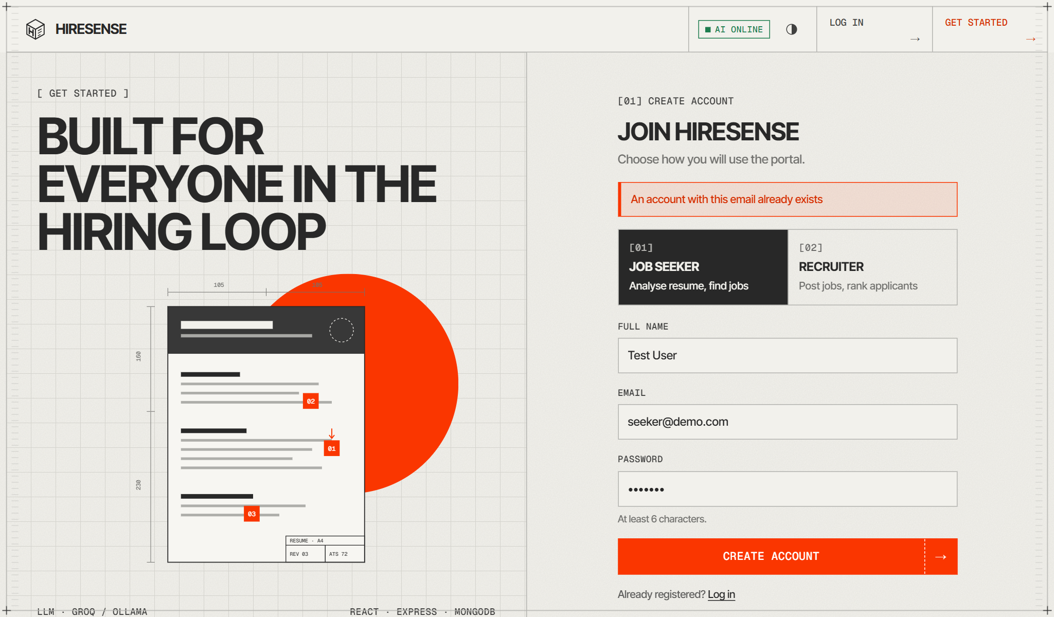
Figure 4.14: Registration form showing a server-side validation error (duplicate e-mail)

4.4 Testing and Results

4.4.1 Unit Testing
Each service function was tested in isolation during development with sample data: extractText with PDF, DOCX and TXT resumes from the samples folder; analyzeWithRules with resumes of different profiles (full-stack, data science, DevOps, UI/UX and fresher); fastMatch with jobs whose required skills were fully, partly and not matched, and with candidates below the minimum experience; and parseJsonLoose with model responses wrapped in markdown fences or containing trailing commas. The rule-based fallback was tested by stopping the AI provider and confirming that uploads still produced an analysis labelled “fallback”.

4.4.2 Cross-Browser and Responsiveness Testing
Table 4.3: Cross-browser and responsiveness checks
Environment | Viewport | Checks | Result
Google Chrome (desktop) | 1366 × 800 | All pages for the three roles, light and dark themes, charts, file upload | Pass
Chrome mobile emulation (Android) | 390 × 844 | Collapsed navigation menu, stacked cards and forms, no horizontal scroll | Pass
Tablet emulation | 768 × 1024 | Two-column grids, tables scroll inside their container | Pass
Production build on Vercel | Desktop and mobile | Routing of deep links (SPA rewrite), API calls to the serverless function | Pass

4.4.3 Form Validation and Functional Testing
A scripted functional test exercised the running API with valid and invalid requests. Table 4.4 lists every case with the expected and the observed HTTP status; all 23 cases produced the expected result. The valid resume upload, which calls the Groq LLM, completed in about 3.6 seconds, while all other requests completed within 65 ms on the local server.
Table 4.4: Functional and validation test results
# | Test case | Expected | Observed status / message | Result
1 | Register – invalid email | 400 + message | 400 – A valid email is required | Pass
2 | Register – short password | 400 + message | 400 – Password must be at least 6 characters | Pass
3 | Register – empty name | 400 + message | 400 – Name is required | Pass
4 | Register – duplicate email | 409 Conflict | 409 – An account with this email already exists | Pass
5 | Login – wrong password | 401 | 401 – Invalid email or password | Pass
6 | Protected route without token | 401 | 401 – Not authenticated | Pass
7 | Tampered JWT | 401 | 401 – Session expired, please log in again | Pass
8 | Login seeker@demo.com | 200 + token | 200 | Pass
9 | Login recruiter@demo.com | 200 + token | 200 | Pass
10 | Login fresher@demo.com | 200 + token | 200 | Pass
11 | Seeker calls admin API | 403 | 403 – This action requires role: admin | Pass
12 | Seeker posts a job | 403 | 403 – This action requires role: recruiter or admin | Pass
13 | Job – description < 30 chars | 400 | 400 – Description should be at least 30 characters | Pass
14 | Job – experience out of range | 400 | 400 – Experience must be 0-40 years | Pass
15 | Apply – missing jobId | 400 | 400 – jobId is required | Pass
16 | Apply – duplicate application | 409 | 409 – You have already applied to this job | Pass
17 | Invalid ObjectId | 400 | 400 – Invalid _id | Pass
18 | Upload – .exe file | 400 | 400 – Only PDF, DOCX or TXT resumes are allowed | Pass
19 | Upload – 5 MB file | 400 | 400 – File is too large (max 4 MB) | Pass
20 | Upload – valid PDF resume | 201 + analysis | 201 – ATS 85, 15 skills, analysedBy=groq | Pass
21 | Ranked job matches | 200 + ranked list | 200 – 19 jobs ranked | Pass
22 | Delete test resume | 200 | 200 – Resume deleted | Pass
23 | Unknown route | 404 | 404 – Route not found: GET /api/nope | Pass

CHAPTER 5: CONCLUSION AND FUTURE ENHANCEMENT

5.1 Summary of the Work
HireSense was designed and implemented as a complete MERN-stack web application with three roles. The work included the database design for four MongoDB collections, a secured REST API of more than thirty endpoints, an AI pipeline that analyses resumes and scores job fit with an LLM, a rule-based fallback engine, and a responsive React interface with dashboards and charts. The system was tested functionally and on multiple viewports, and deployed to Vercel with MongoDB Atlas.

5.2 Conclusion
The project shows that a hybrid approach — instant deterministic scoring for every job combined with on-demand LLM judgement — gives users both speed and explanation. Job seekers receive specific, actionable feedback on their resume and a ranked list of jobs with the skills they are missing, and recruiters receive a ranked, explained shortlist and can discover candidates who have not applied. Layered validation (HTML5 constraints, JavaScript checks, express-validator and Mongoose schemas), JWT-based role authorisation and the automatic fallback make the application secure and dependable. The project applied the core Web Technology concepts of the course — client-side scripting, component-based UI, HTTP and REST, server-side programming, middleware, and database integration — to a real recruitment problem.

5.3 Future Enhancements
- OCR support (for example Tesseract) so that scanned, image-only resumes can be analysed.
- E-mail and in-app notifications when an application status changes or a new matching job is posted.
- Semantic embeddings stored in a vector index (such as MongoDB Atlas Vector Search) to complement TF-IDF similarity.
- Interview scheduling with calendar integration and AI-generated interview questions based on the missing skills.
- Resume builder that applies the AI suggestions directly and exports an ATS-friendly PDF.
- Automated test suites (Jest / Supertest for the API and Playwright for the UI) running in a CI pipeline on every commit.
- Bias and fairness auditing of AI scores, and an option for recruiters to hide personal details during screening.

REFERENCES
[1] MDN Web Docs, “HTML, CSS and JavaScript reference,” Mozilla. [Online]. Available: https://developer.mozilla.org
[2] W3Schools, “Web development tutorials – HTML, CSS, JavaScript, Node.js, React.” [Online]. Available: https://www.w3schools.com
[3] React Team, “React documentation.” [Online]. Available: https://react.dev
[4] OpenJS Foundation, “Express – Node.js web application framework, API reference.” [Online]. Available: https://expressjs.com
[5] MongoDB Inc., “MongoDB Manual” and “Mongoose ODM documentation.” [Online]. Available: https://www.mongodb.com/docs/manual and https://mongoosejs.com/docs
[6] M. Jones, J. Bradley and N. Sakimura, “JSON Web Token (JWT),” RFC 7519, IETF, May 2015.
[7] R. T. Fielding, “Architectural Styles and the Design of Network-based Software Architectures,” Ph.D. dissertation, University of California, Irvine, 2000.
[8] OWASP Foundation, “OWASP Top 10 – 2021.” [Online]. Available: https://owasp.org/Top10
[9] G. Salton and C. Buckley, “Term-weighting approaches in automatic text retrieval,” Information Processing & Management, vol. 24, no. 5, pp. 513–523, 1988.
[10] C. D. Manning, P. Raghavan and H. Schütze, Introduction to Information Retrieval. Cambridge University Press, 2008.
[11] A. Vaswani et al., “Attention is all you need,” in Advances in Neural Information Processing Systems 30 (NeurIPS), 2017.
[12] T. Brown et al., “Language models are few-shot learners,” in Advances in Neural Information Processing Systems 33 (NeurIPS), 2020.
[13] OpenAI, “gpt-oss-120b & gpt-oss-20b model card,” Aug. 2025.
[14] Groq Inc., “GroqCloud API documentation – chat completions and JSON mode.” [Online]. Available: https://console.groq.com/docs
[15] Ollama, “Ollama documentation and API.” [Online]. Available: https://github.com/ollama/ollama
[16] Mozilla, “PDF.js.” [Online]. Available: https://mozilla.github.io/pdf.js
[17] Chart.js contributors, “Chart.js documentation.” [Online]. Available: https://www.chartjs.org/docs
[18] Vercel Inc., “Vercel documentation – Functions and deployments.” [Online]. Available: https://vercel.com/docs
[19] Project source code: HireSense repository. [Online]. Available: https://github.com/jebarson-caleb/hiresense

SAMPLE OUTPUT SCREENSHOT
A. UI Design
Figure S.1: Sample UI – login page (light theme)
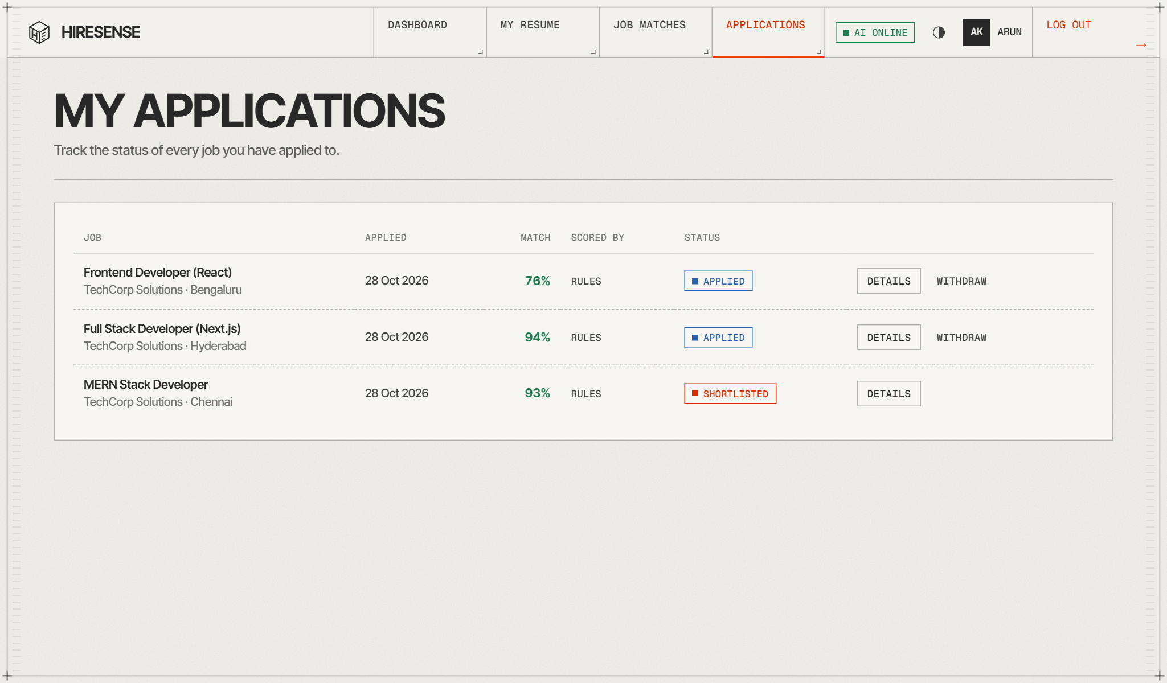
Figure S.2: Sample UI – seeker’s applications with match scores and status
B. MongoDB Database Storage
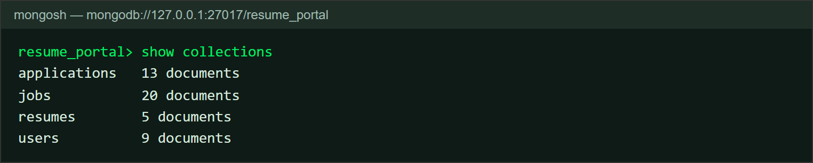
Figure S.3: MongoDB database resume_portal – collections and document counts
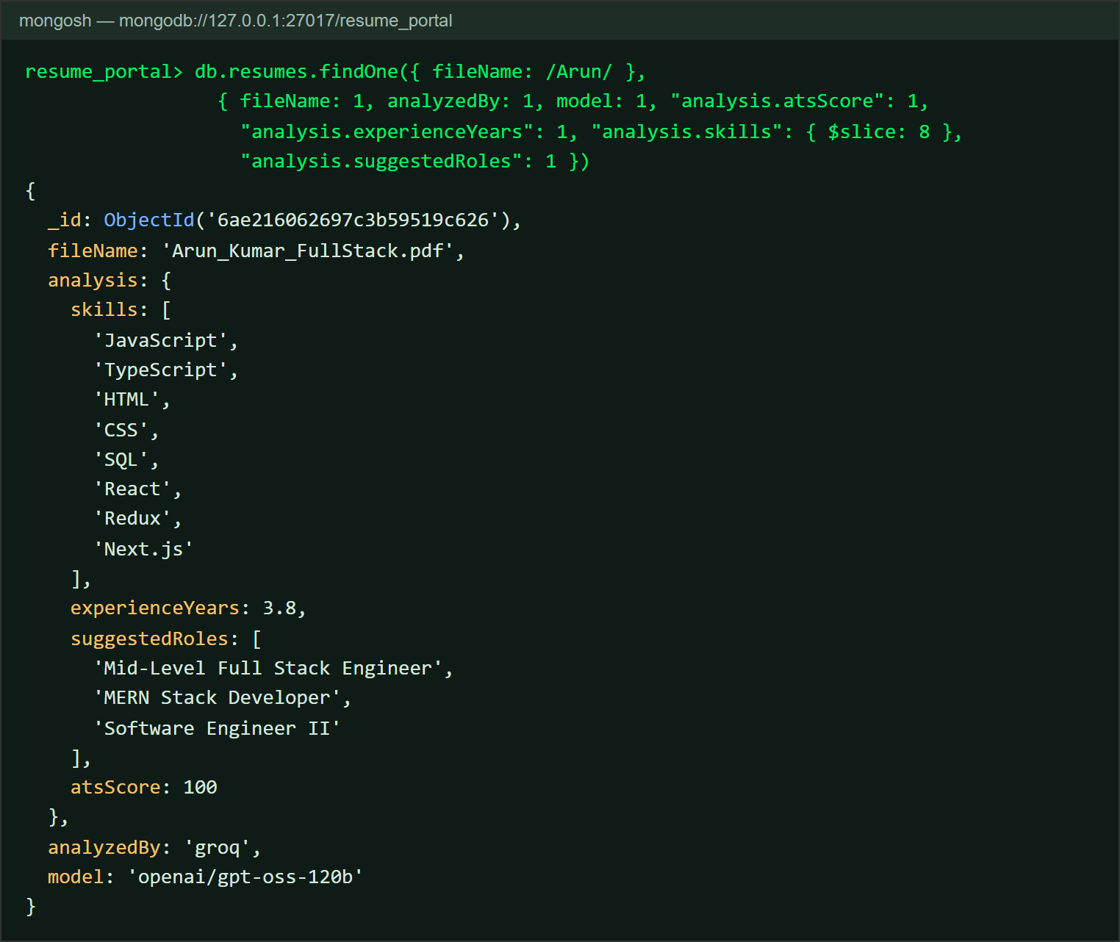
Figure S.4: Stored resume document with AI analysis (resumes collection)

EVALUATION SHEET
Reg.No : URK24CS1038
Name : JEBARSON CALEB D
Course code: 23CS2048
Course Name: Web Technology
S.No | Rubrics | Maximum  Marks | Marks  Obtained
1 | Hackathon | 20
2 | Project – Case Study | 20
Total |  | 40

Rubrics | Excellent (4) | Good (3) | Average (2) | Below Average  (1)
Design of
Website
(4 Marks)
Input Validation
(4 Marks)
Integration of
Frontend and
Backend
(4 Marks)
Presentation
and Viva
(4 Marks)
GitHub
Repository
(4 Marks)
Signature of the Faculty-in-charge
EVALUATION SHEET
Reg.No : URK24CS1025
Name : TALARI S VAMSHI KRISHNA
Course code: 23CS2048
Course Name: Web Technology
S.No | Rubrics | Maximum  Marks | Marks  Obtained
1 | Hackathon | 20
2 | Project – Case Study | 20
Total |  | 40

Rubrics | Excellent (4) | Good (3) | Average (2) | Below Average  (1)
Design of
Website
(4 Marks)
Input Validation
(4 Marks)
Integration of
Frontend and
Backend
(4 Marks)
Presentation
and Viva
(4 Marks)
GitHub
Repository
(4 Marks)
Signature of the Faculty-in-charge
EVALUATION SHEET
Reg.No : URK24CS1118
Name : JASPER FREDDY PAUL R S
Course code: 23CS2048
Course Name: Web Technology
S.No | Rubrics | Maximum  Marks | Marks  Obtained
1 | Hackathon | 20
2 | Project – Case Study | 20
Total |  | 40

Rubrics | Excellent (4) | Good (3) | Average (2) | Below Average  (1)
Design of
Website
(4 Marks)
Input Validation
(4 Marks)
Integration of
Frontend and
Backend
(4 Marks)
Presentation
and Viva
(4 Marks)
GitHub
Repository
(4 Marks)
Signature of the Faculty-in-charge
EVALUATION SHEET
Reg.No : URK24CS1017
Name : PAVIN MUTHU G
Course code: 23CS2048
Course Name: Web Technology
S.No | Rubrics | Maximum  Marks | Marks  Obtained
1 | Hackathon | 20
2 | Project – Case Study | 20
Total |  | 40

Rubrics | Excellent (4) | Good (3) | Average (2) | Below Average  (1)
Design of
Website
(4 Marks)
Input Validation
(4 Marks)
Integration of
Frontend and
Backend
(4 Marks)
Presentation
and Viva
(4 Marks)
GitHub
Repository
(4 Marks)
Signature of the Faculty-in-charge

ANNEXURE: HACKNEX 2026 PARTICIPATION CERTIFICATES
24-Hour National Hackathon organised by the Division of CSE, Karunya Institute of Technology and Sciences
1. JEBARSON CALEB D (URK24CS1038)
2. TALARI S VAMSHI KRISHNA (URK24CS1025)
3. JASPER FREDDY PAUL R S (URK24CS1118)
4. PAVIN MUTHU G (URK24CS1017)

