1.Creating the table:

Source table schema:

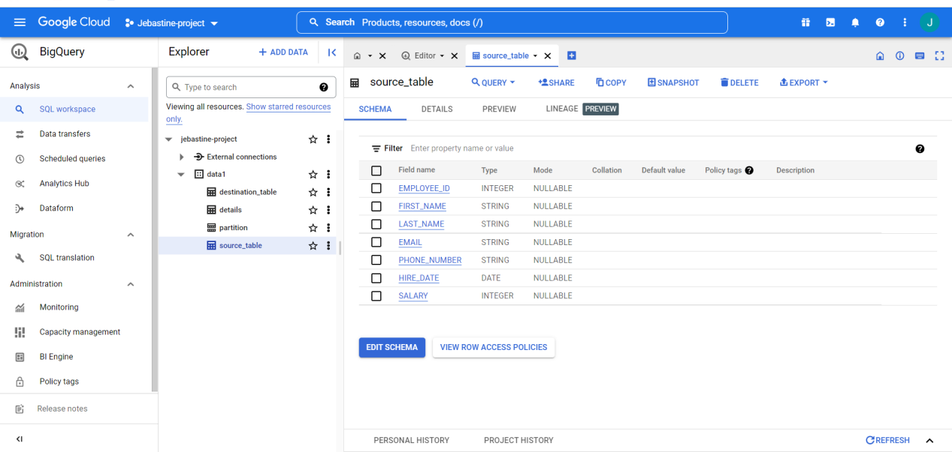

Source table preview

100 records:

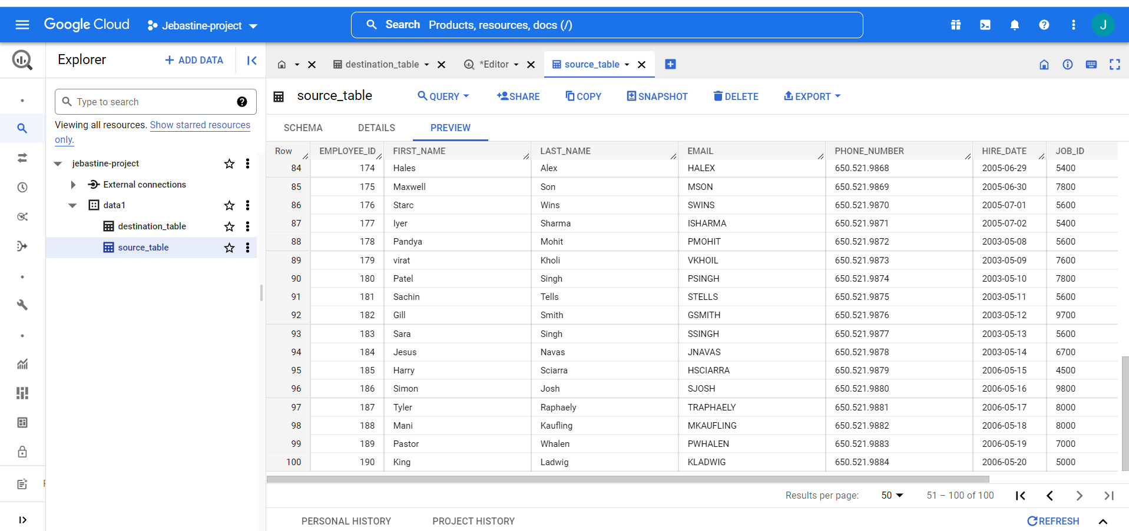

Destination table schema:

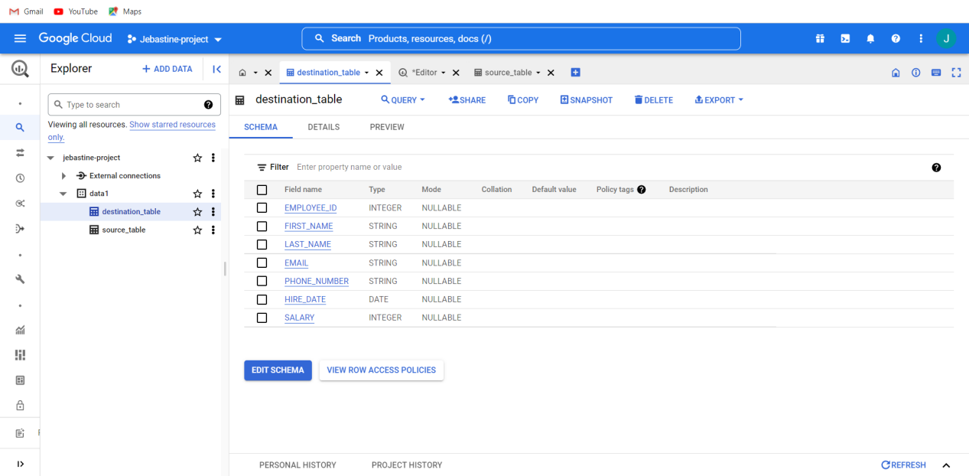

Destination table preview

Where there are only 50 records:

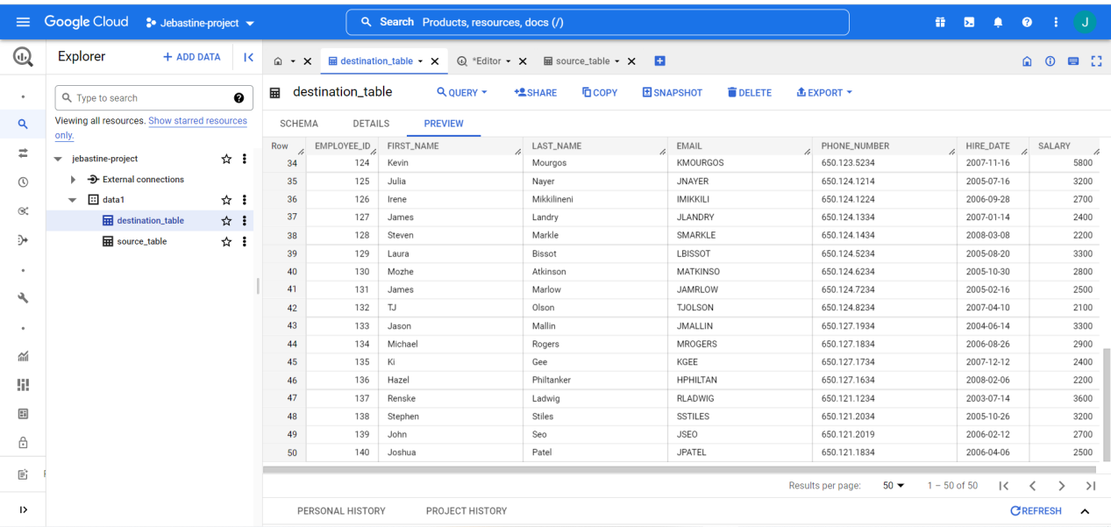

Create merge statement to load the source table data into destination table using upsert scenario:

Query:

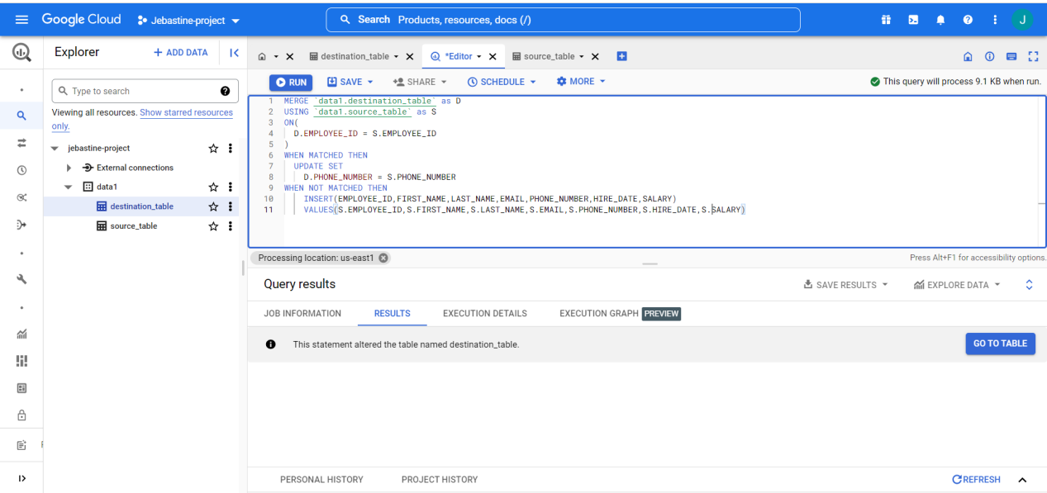

Destination table is affected:

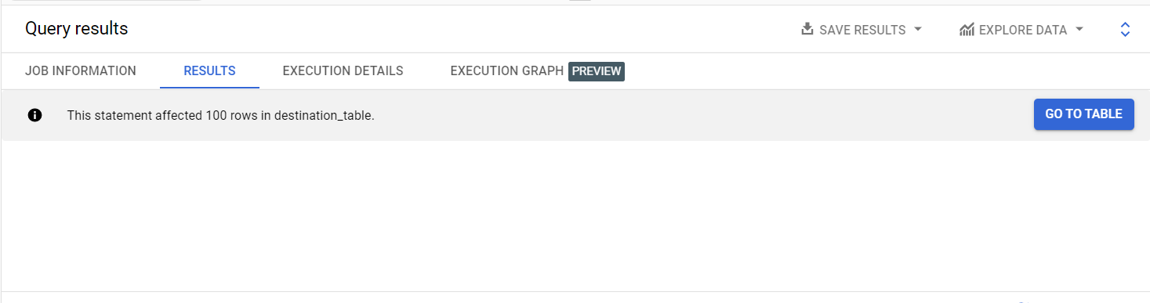

Merge and upsert done:

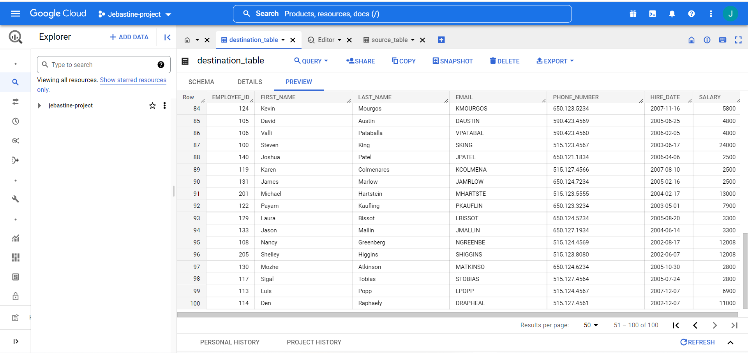

2.Create an airflow dag which will load the data from GCS bucket to Bigquery table.

Using composer creating airflow in gcp:

Dag folder:

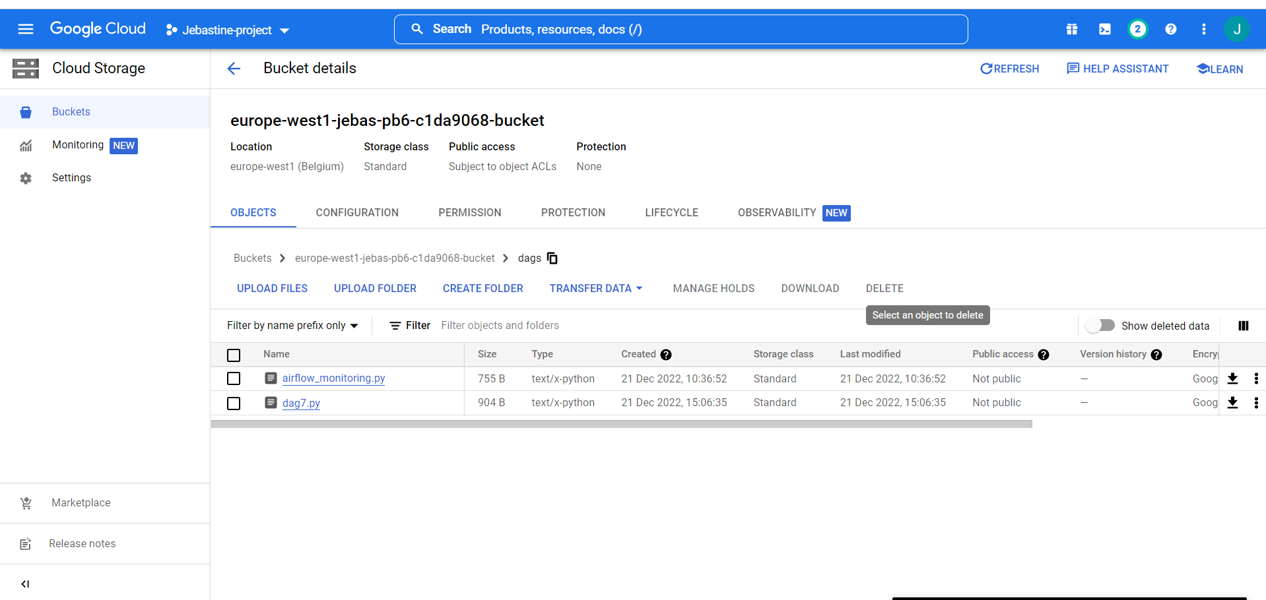

Csv folder stored in the bucket:

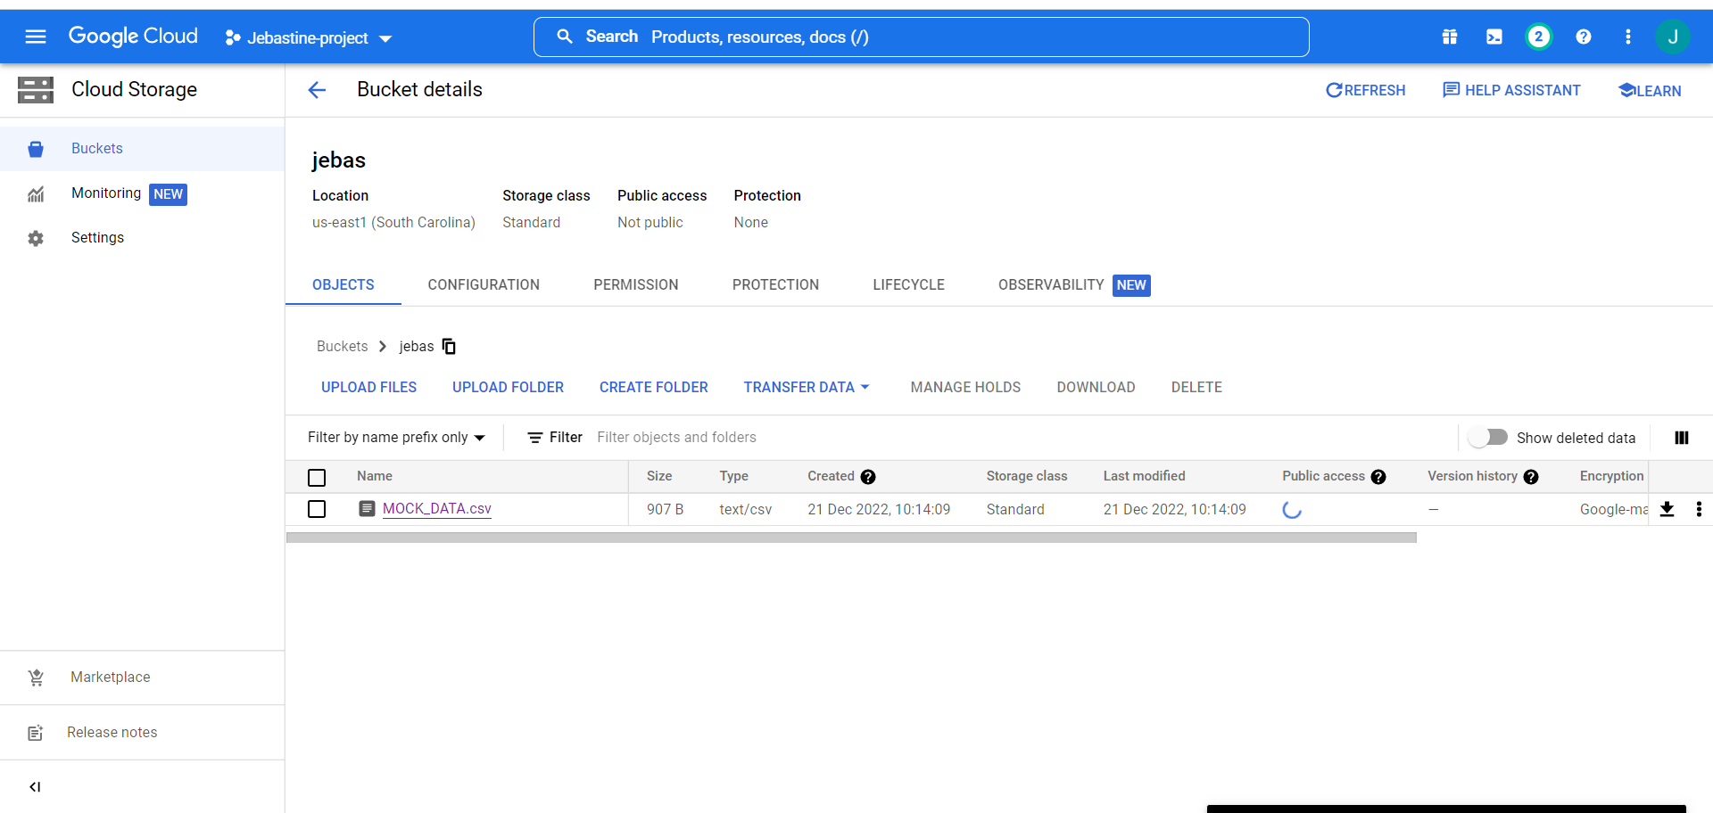

Dag is success:

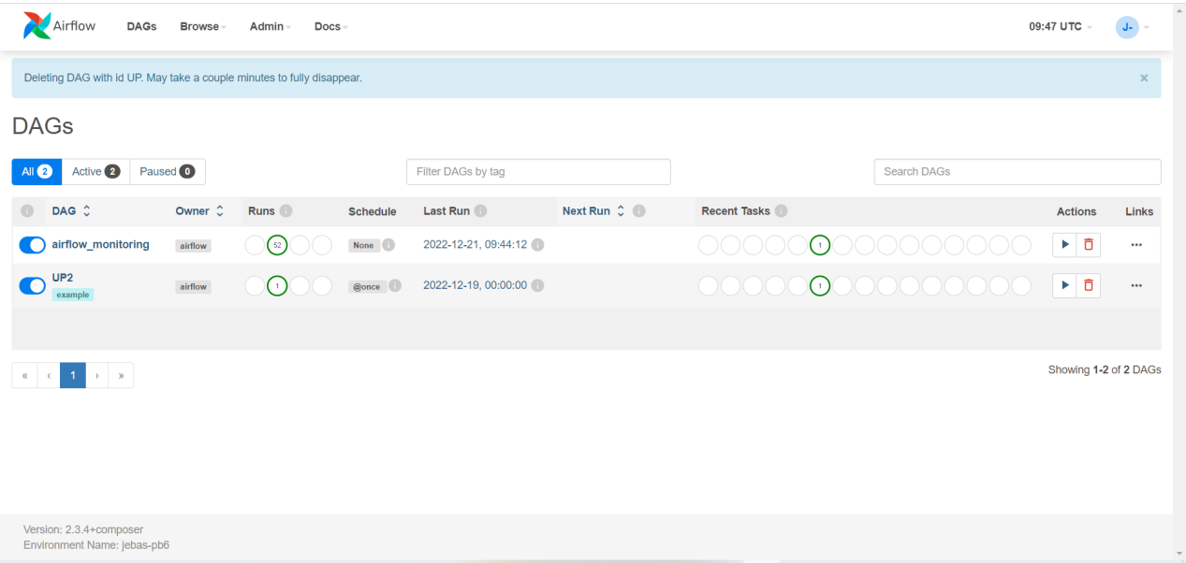

Code:

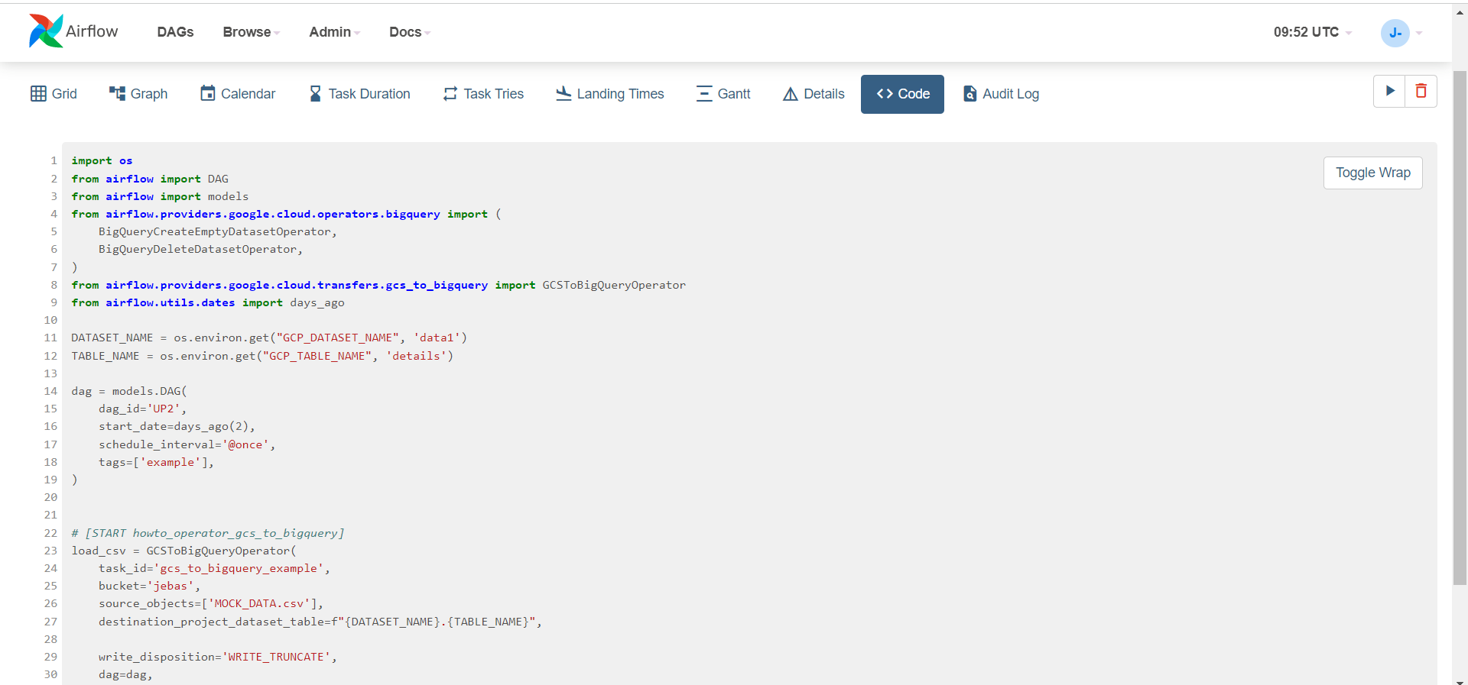

Successfully loaded:

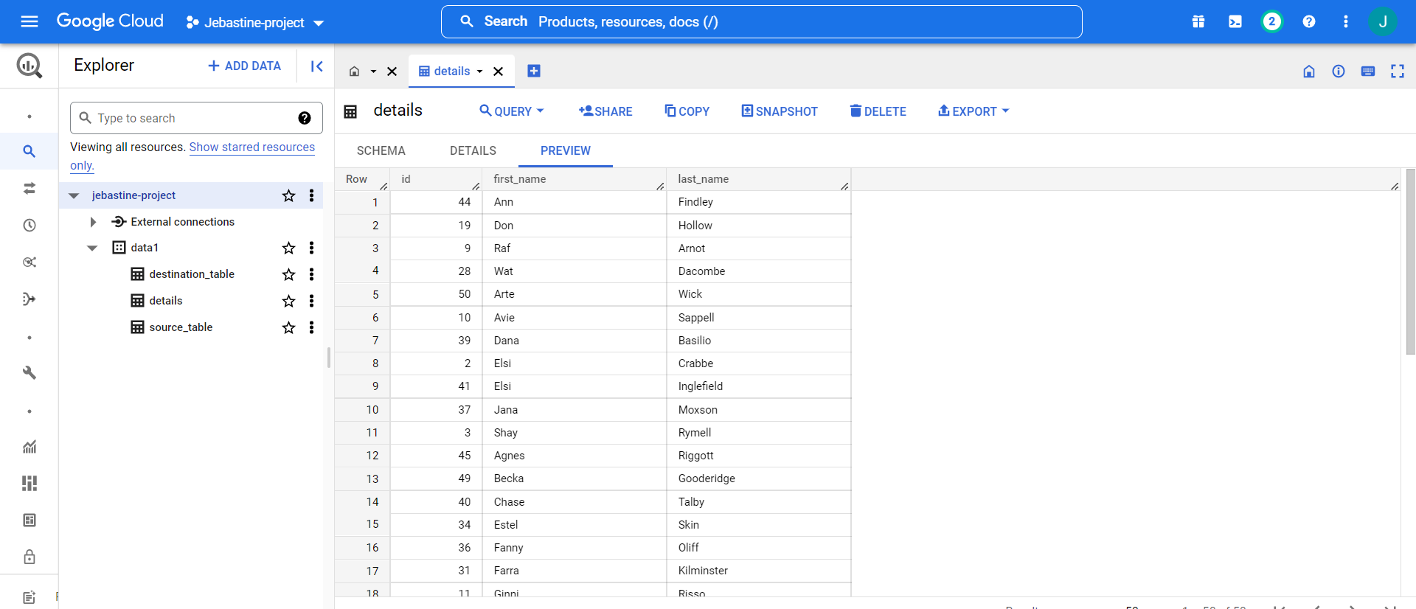

3.Upload high volume of data in big query and try to optimise it's read performance by using appropriate partitioning and clustering.

Data for partitioning by day:

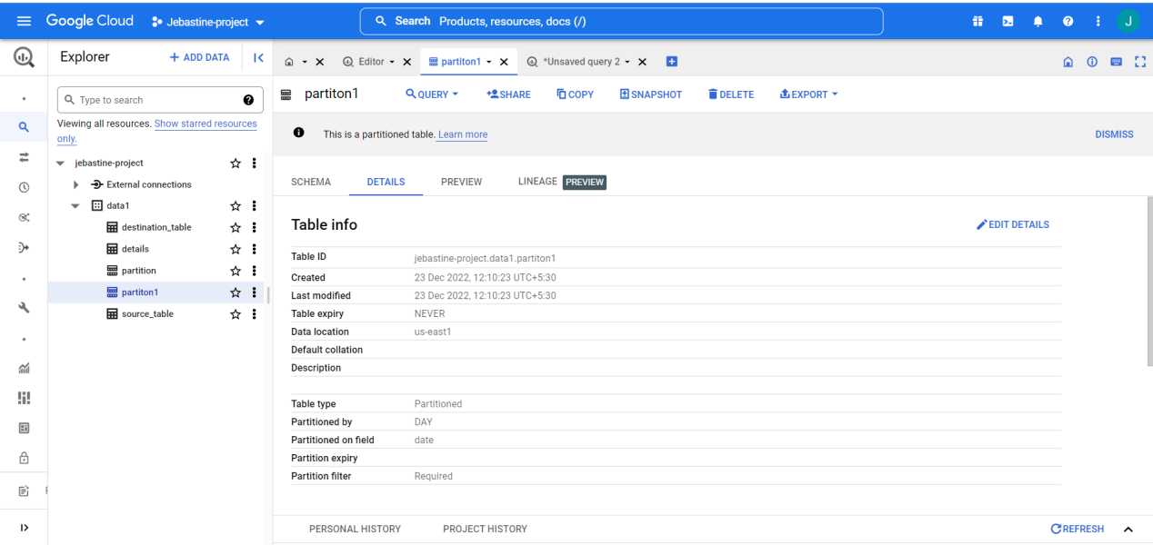

Volume of data:

56,734 rows:

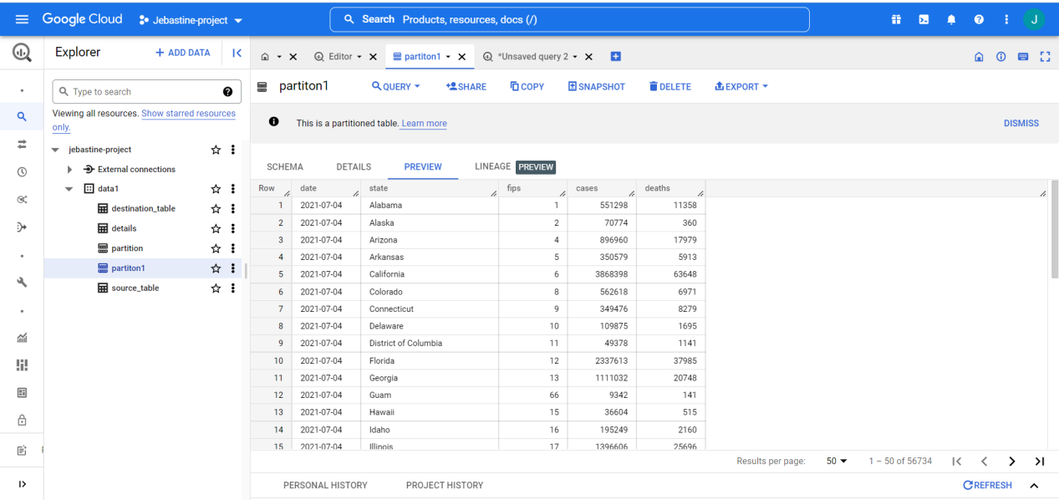

Partitioning based on date:

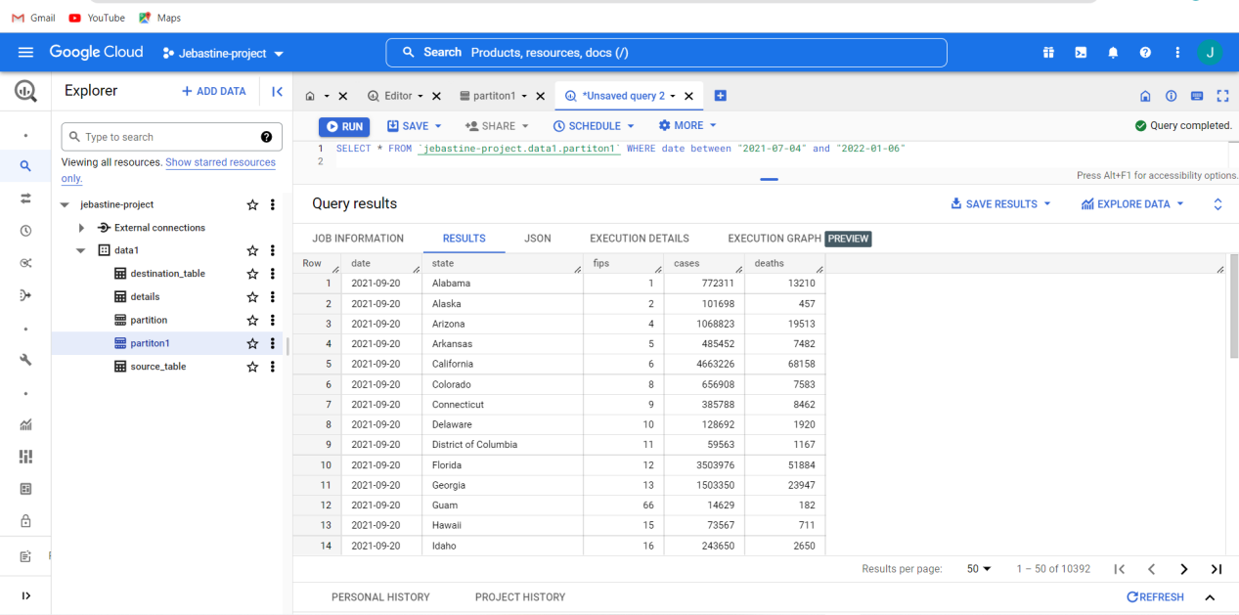

Clustering based on state:

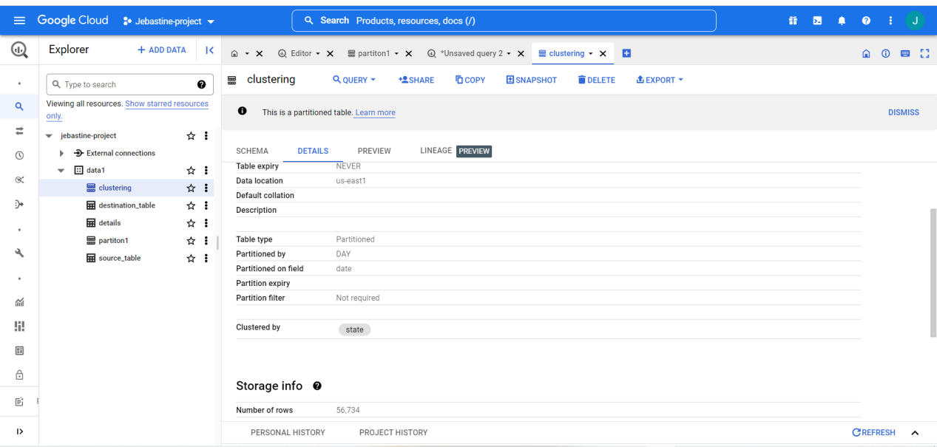

Query :

Successful:

