**CURRICULUM VITAE**

**PERSONAL DATA**

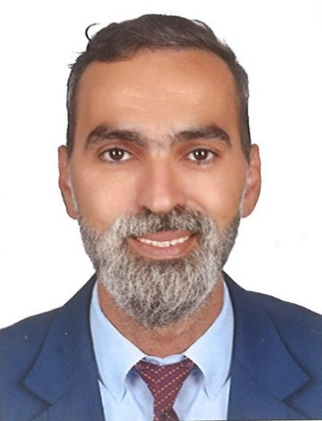 **Ammar Ramadan AL Ali**

* **Nationality: : Syrian**
* **Marital Status : Single**
* **Date of Birth : 10/02/1981**
* **Address : Abu Dhabi-UAE**
* **Mobile : 00971558223993**
* **E-Mail :** [**ammar.lau82@gmail.com**](mailto:ammar.lau82@gmail.com)

**OBJECTIVE**

Work in a challenging environment in order to contribute to improving efficiency and performance of any work environment.

**EDUCATION & CERTIFICATES**

**High School Diploma**

**Computer skills:** Microsoft Word, Excel, and Power Point, Photoshop Designer

**WORK EXPERIENCE**

**Call center representative: Al Salama medical center**

**2013- to 2022**

* Fulfils requests by clarifying desired information; completing transactions; forwarding requests.
* Manage large amounts of inbound and outbound calls in a timely manner
* Maintains Call Center database by entering information.
* Keeps equipment operational by following established procedures; reporting malfunctions.
* Updates job knowledge by participating in educational opportunities.
* Enhances organization reputation by accepting ownership for accomplishing new and different requests; exploring opportunities to add value to job accomplishments.
* Meet personal/team qualitative and quantitative targets
* Keep records of all conversations in our call center database in a comprehensible way

**Branch Manager: Sweets palace**

**2011 to 2013**

* Management of service, activities, delivery, and safety.
* Taking care of order & the quality
* Costumers care and communicating
* Fix the issue of any customer complaint and send report to the head office

**Call Center: Romano’s Macaroni Grill (Doha-Qatar)**

**2007 to 2008**

* Taking care of customer.
* Able to work under pressure.
* Food hygiene and safety
* Serve the food.
* Excellent communication.

**Shamyat Restaurant**

**Call Center: 2005 To 2006**

* Maintains Call Center database by entering information.
* Meet personal/team qualitative and quantitative targets
* Obtains patient information by answering telephone calls; interviewing clients;
* Determines requirements by working with customers.
* Keep records of all conversations in our call centre database in a comprehensible way

**LANGUAGES**

* Arabic.
* English (very good).
* Also have vailed driving license

**More details about me I have vailed residential visa in dubai**

