1. Singleton Pattern

Logger.java

package singleton_pattern;

public class Logger {

    private static Logger instance;

    private Logger(){

        System.out.println("Logger initialized");

    }

    public static Logger getInstance(){

        if(instance==null){

            instance=new Logger();

        }

        return instance;

    }

    public void log(String message){

        System.out.println("[LOG]: "+message);

    }

}

Main.java

package singleton_pattern;

public class Main {

    public static void main(String[] args) {

        Logger logger1=Logger.getInstance();

        logger1.log("This is the first log message");

        Logger logger2=Logger.getInstance();

        logger2.log("This is the second log message");

        if(logger1==logger2){

            System.out.println("Singleton works");

        }

        else{

            System.out.println("Singleton does not work");

        }

    }

}

Output:

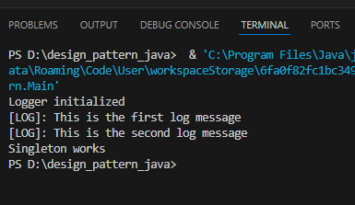

2. Factory pattern

documentFactory.java

package factory_pattern;

public abstract class documentFactory {

    public abstract documents createDocuments();

}

Documents.java

package factory_pattern;

public interface documents{

    void open();

}

excelDocument.java

package factory_pattern;

public class excelDocument implements documents{

    public void open(){

      System.out.println("Opening an excel document");

    }

}

excelFactory.java

package factory_pattern;

public class excelFactory extends documentFactory{

    public documents createDocuments(){

        return new excelDocument();

    }

}

Pdfdocument.java

package factory_pattern;

public class pdfDocument implements documents {

    public void open(){

        System.out.println("Opening a PDF document");

    }

}

pdfFactory.java

package factory_pattern;

public class pdfFactory extends documentFactory {

    public documents createDocuments(){

        return new pdfDocument();

    }

}

wordDocument.java

package factory_pattern;

public class wordDocument implements documents {

    public void open(){

        System.out.println("Opening a word document");

    }

}

wordFactory.java

package factory_pattern;

public class wordFactory extends documentFactory {

    public documents createDocuments(){

        return new wordDocument();

    }

}

Main.java

package factory_pattern;

public class Main {

    public static void main(String[] args) {

        documentFactory wordFac=new wordFactory();

        documents wordDoc=wordFac.createDocuments();

        wordDoc.open();

        documentFactory pdfFac=new pdfFactory();

        documents pdfDoc=pdfFac.createDocuments();

        pdfDoc.open();

        documentFactory excelFac=new excelFactory();

        documents excelDoc=excelFac.createDocuments();

        excelDoc.open();

    }

}

Output:

