**Exercise 1: Setting Up JUnit**

**AppTest.java**

import org.junit.Test;

import static org.junit.Assert.*;

public class AppTest {

@Test

public void testAddition() {

int result = 2 + 3;

assertEquals(5, result);

}

}

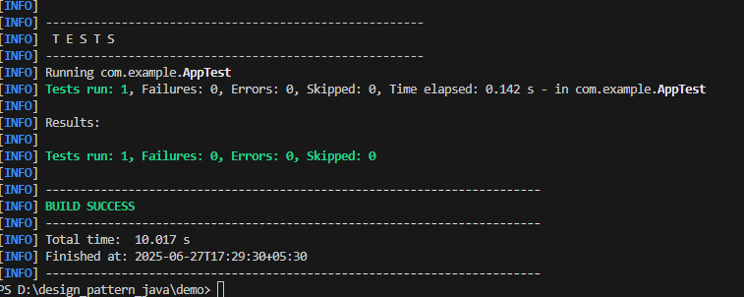

**Exercise 3: Assertions in JUnit**

**AssertionTest.java**

import org.junit.Test;

import static org.junit.Assert.*;

public class AssertionTest {

@Test

public void testAssertions() {

assertEquals(5, 2 + 3);

assertTrue(5 > 3);

assertFalse(5 < 3);

assertNull(null);

assertNotNull(new Object());

}

}

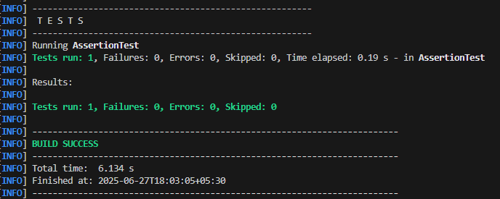

**Exercise 4: Arrange-Act-Assert (AAA) Pattern, Test Fixtures, Setup and Teardown Methods in JUnit**

**Calculator.java**

package com.example;

public class Calculator {

public int add(int a, int b) {

return a + b;

}

public int multiply(int a, int b) {

return a * b;

}

}

**CalculatorTest.java**

package com.example;

import org.junit.Before;

import org.junit.After;

import org.junit.Test;

import static org.junit.Assert.*;

public class CalculatorTest {

private Calculator calculator;

@Before

public void setUp() {

calculator = new Calculator();

System.out.println("Setup complete.");

}

@After

public void tearDown() {

System.out.println("Test finished.");

}

@Test

public void testAddition() {

int a = 5;

int b = 3;

int result = calculator.add(a, b);

assertEquals(8, result);

}

@Test

public void testMultiplication() {

int a = 4;

int b = 6;

int result = calculator.multiply(a, b);

assertEquals(24, result);

}

}

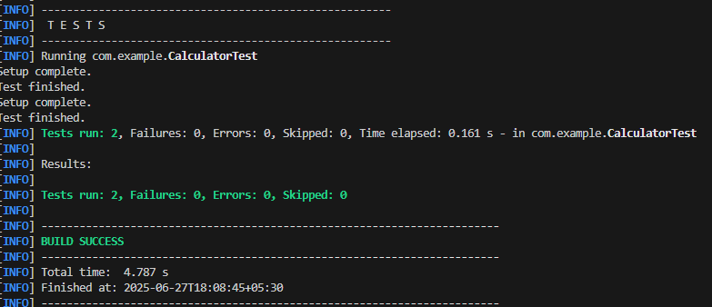

**Exercise 1: Mocking and Stubbing**

**ExternalApi.java**

package com.example;

public interface ExternalApi {

String getData();

}

**MyService.java**

package com.example;

public class MyService {

private final ExternalApi api;

public MyService(ExternalApi api) {

this.api = api;

}

public String fetchData() {

return api.getData();

}

}

**MyServiceTest.java**

package com.example;

import static org.mockito.Mockito.*;

import static org.junit.jupiter.api.Assertions.*;

import org.junit.jupiter.api.Test;

public class MyServiceTest {

@Test

public void testExternalApi() {

ExternalApi mockApi = mock(ExternalApi.class);

when(mockApi.getData()).thenReturn("Mock Data");

MyService service = new MyService(mockApi);

String result = service.fetchData();

assertEquals("Mock Data", result);

}

}

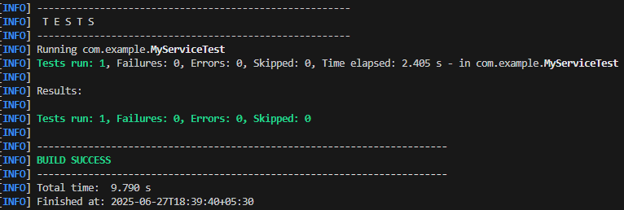

**Exercise 2: Verifying Interactions**

**MyServiceTest.java**

package com.example;

import static org.mockito.Mockito.*;

import org.junit.jupiter.api.Test;

import org.mockito.Mockito;

public class MyServiceTest {

@Test

public void testVerifyInteraction() {

ExternalApi mockApi = mock(ExternalApi.class);

MyService service = new MyService(mockApi);

service.fetchData();

verify(mockApi).getData();

}

}

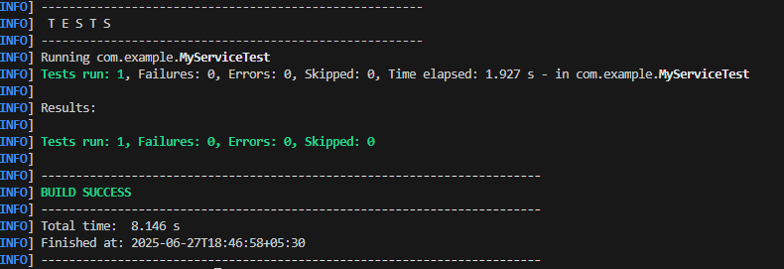

**Exercise 1: Logging Error Messages and Warning Levels**

**LoggingExample.java**

package com.example;

import org.slf4j.Logger;

import org.slf4j.LoggerFactory;

public class LoggingExample {

private static final Logger logger = LoggerFactory.getLogger(LoggingExample.class);

public static void main(String[] args) {

logger.error("This is an error message");

logger.warn("This is a warning message");

}

}

