1 - Module-Title: Database Design & Normalization

2 - Objective :
Purpose of this module:
This SQL module focuses on performing retail data analysis on a cleaned and normalized retail database. It helps retrieve, filter, combine, and summarize sales, invoice, and product information to understand customer behavior, product performance, country-wise sales, revenue trends, peak order times, high-value invoices, and best-selling products. Overall, the purpose of these queries is to convert raw retail transaction data into meaningful insights that can support business decision-making.
The analysis was done to find useful insights such as which products sell the most, which customers purchase frequently, which countries generate more revenue, what time or month has higher order activity, and which invoices or products contribute the most to sales. By using SQL queries like filtering, grouping, sorting, joins, and advanced calculations, the module helps convert transaction data into business information that can support decisions related to sales strategy, inventory management, customer analysis, and market performance.

3 – Tools And Technologies Used:
- Python
- Pandas
- SQLite
- SQL
- VS Code
- Excel

4 – Tasks Performed :
SQL Module:
- Imported the cleaned retail dataset into SQLite
- Created a retail database for analysis
- Split the retail data into three normalized tables: Sales_Retaildb, Invoices_Retaildb, and Products_Retaildb
- Checked table structure, data types, and total row counts
- Retrieved sample records from sales, invoice, and product tables
- Used WHERE conditions to filter products, customers, countries, quantities, prices, and invoice details
- Used ORDER BY and LIMIT to find top products, latest orders, highest quantities, and sorted records
- Used aggregate functions like SUM, AVG, MIN, MAX, and COUNT
- Performed GROUP BY analysis to summarize revenue, quantity sold, orders, customers, countries, and time-based trends
- Used HAVING to identify high-revenue products, high-volume items, repeat customers, high-value invoices, and low-performing products
- Created INNER JOIN queries to combine sales, invoice, and product information
- Analyzed country-wise sales, customer spending, product performance, hourly revenue, daily revenue, and monthly revenue
- Identified best-selling products, top customers, active markets, and seasonal shopping patterns
- Used advanced SQL concepts such as subqueries, window functions, CASE statements, and CTEs
- Generated business insights from the retail transaction data for better decision-making.

5 – Methodology / Process :
- Collected and used the cleaned retail dataset for analysis.
- Imported the cleaned dataset into SQLite.
- Created the retail database for storing transaction data.
- Normalized the dataset by splitting it into three tables: Sales_Retaildb, Invoices_Retaildb, and Products_Retaildb.
- Checked the table structure, data types, and total number of records in each table.
- Retrieved sample data from each table to understand the contents.
- Used basic SQL filtering with WHERE, LIKE, and IN to find specific products, countries, customers, prices, and quantities.
- Used sorting and limiting with ORDER BY and LIMIT to identify top records, latest orders, expensive products, and high-quantity transactions.
- Applied aggregate functions such as SUM, AVG, COUNT, MIN, and MAX to calculate sales and product metrics.
- Used GROUP BY and HAVING to summarize data and identify high-revenue products, high-volume items, repeat customers, and important markets.
- Used INNER JOIN to combine sales, invoice, and product tables for complete transaction-level analysis.
- Performed country-wise, customer-wise, product-wise, hourly, daily, and monthly sales analysis.
- Applied advanced SQL concepts such as subqueries, window functions, CASE statements, and CTEs for deeper analysis.
- Generated business insights from the final query results to understand retail performance and support decision-making.

6 – Screenshots with Queries and outputs
--1. Display 15 rows of the sales table
SELECT * FROM Sales_Retaildb LIMIT 300;

--2.Display 15 rows of the Invoices table
SELECT * FROM Invoices_Retaildb LIMIT 300;

--3.Display 15 rows of the products table
SELECT * FROM Products_Retaildb LIMIT 300; 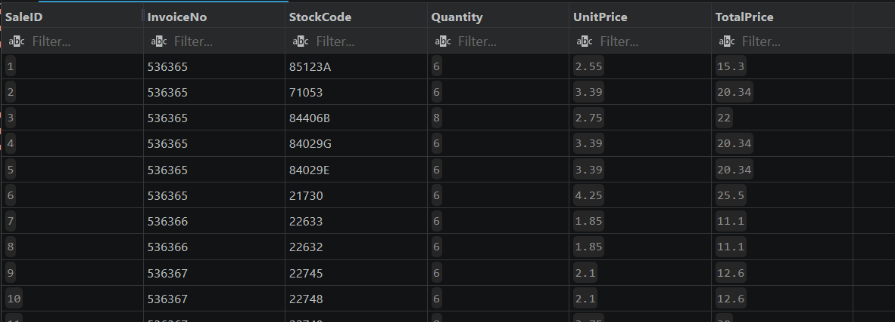
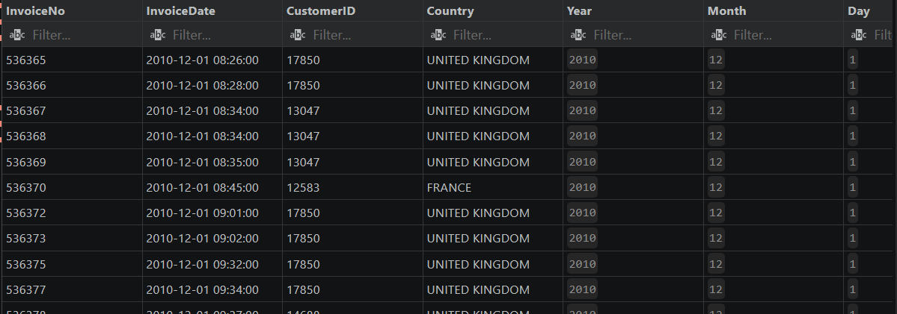
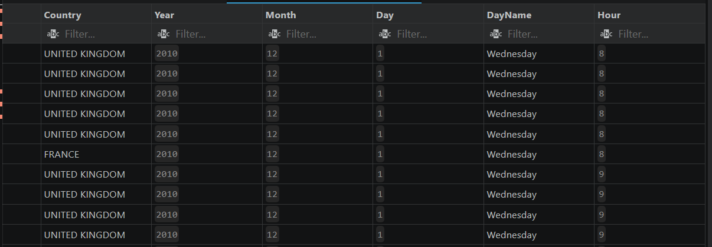
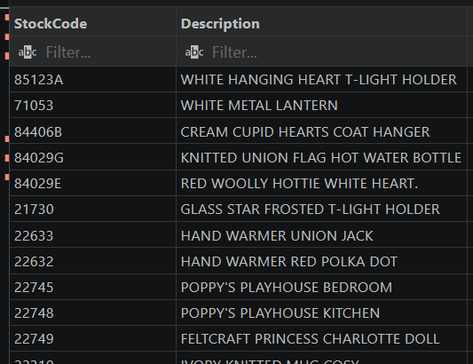
--4.Data types of Sales_Retaildb table
PRAGMA table_info(Sales_Retaildb);
--5.Data types of Invoices_Retaildb table
PRAGMA table_info(Invoices_Retaildb);
--6.Data types of Products_Retaildb table
PRAGMA table_info(Products_Retaildb);
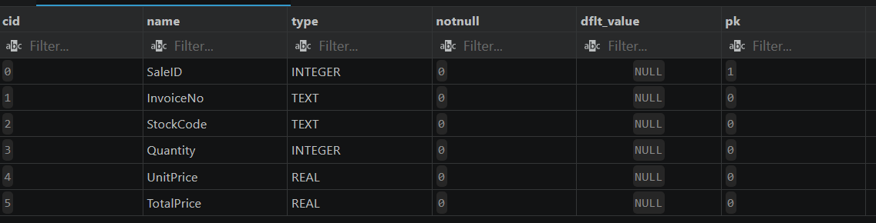
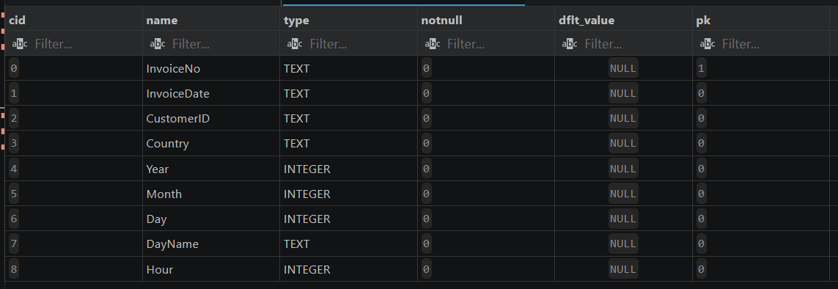
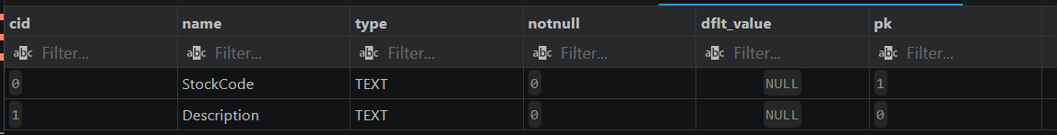
--7. Selecting the product with that stock code
SELECT * FROM Products_Retaildb WHERE StockCode='85123A';
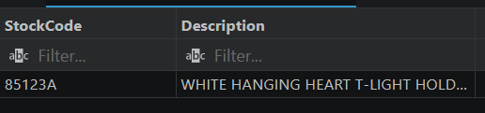
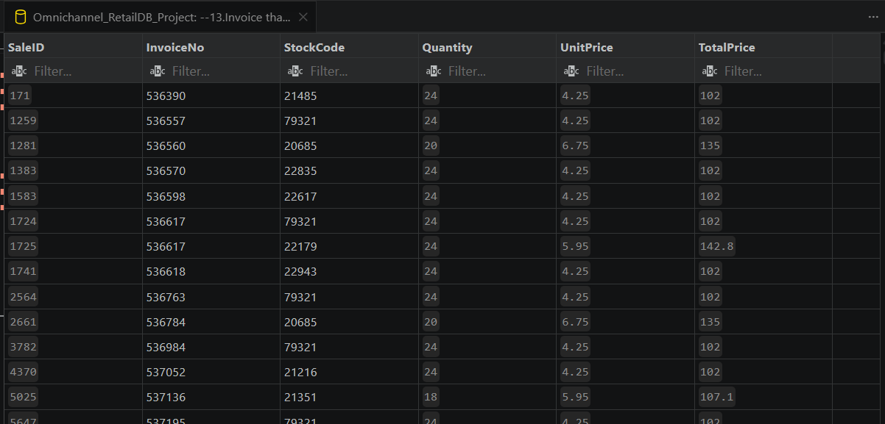
--13.Invoice that bought total price greater than 100
SELECT * FROM Sales_Retaildb WHERE TotalPrice > 100;

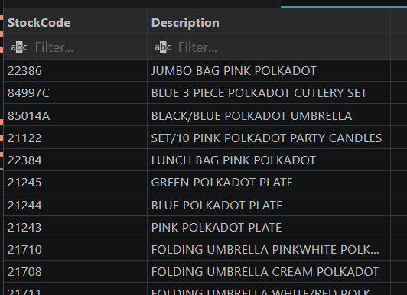
--8. Searching for the product containing a specfic keyword
SELECT * FROM Products_Retaildb WHERE Description LIKE '%POLKADOT%';

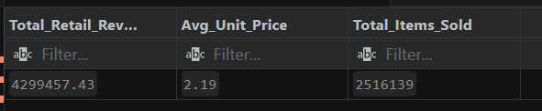
--15.Calculate total revenue and average unit price
SELECT ROUND(SUM(TotalPrice),2) AS Total_Retail_Revenue,ROUND(AVG(UnitPrice),2) AS Avg_Unit_Price,SUM(Quantity) AS Total_Items_Sold FROM Sales_Retaildb;

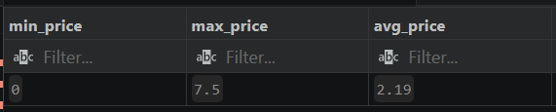
-- Check actual price distribution
SELECT ROUND(MIN(UnitPrice), 2) AS min_price,ROUND(MAX(UnitPrice), 2) AS max_price,ROUND(AVG(UnitPrice), 2) AS avg_price FROM Sales_Retaildb;
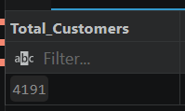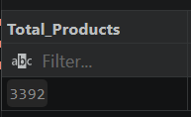
-- Count the total number of unique customers in the invoices table
SELECT COUNT(DISTINCT CustomerID) AS Total_Customers FROM Invoices_Retaildb;

-- Count the total number of unique products sold in the sales table
SELECT COUNT(DISTINCT StockCode) AS Total_Products FROM Sales_Retaildb;

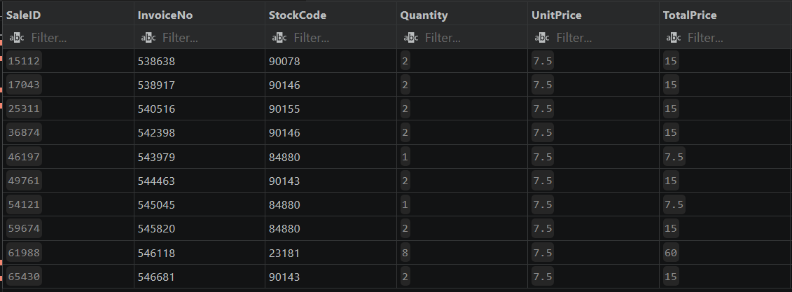
-- 16.Most Expensive Products
SELECT * FROM Sales_Retaildb ORDER BY UnitPrice DESC LIMIT 10;

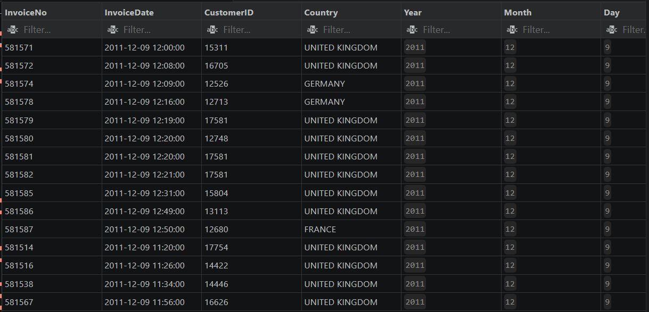
--17.Find 15 most orders to check the latest transactional timeline
SELECT * FROM Invoices_Retaildb ORDER BY Year DESC,Month DESC,Day DESC,Hour DESC LIMIT 15;

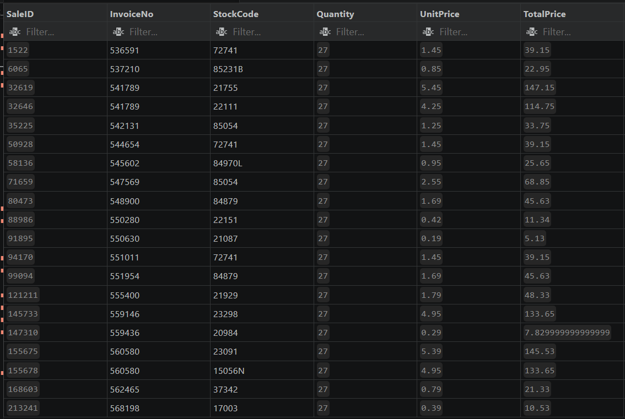
--19.Top 20 single line transactions with the highest quantity
SELECT * FROM Sales_Retaildb ORDER BY Quantity DESC LIMIT 20;

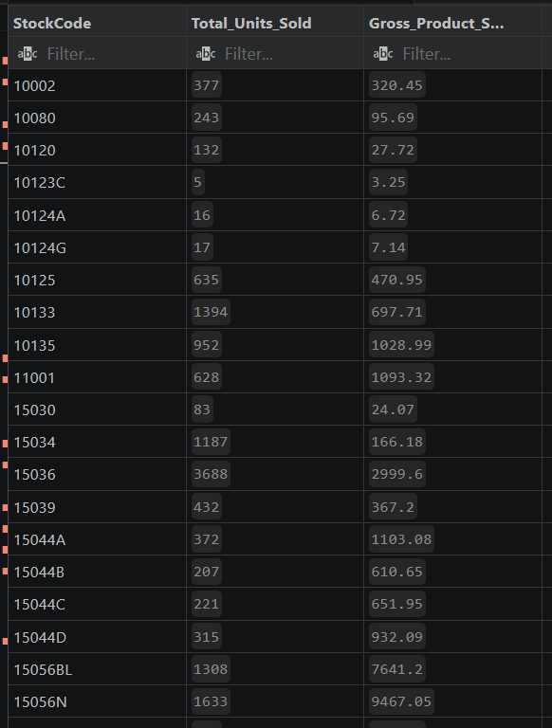
--21. Total Quantity sold and revenue generated per unique product code
SELECT StockCode,SUM(Quantity) AS Total_Units_Sold,Round(SUM(TotalPrice),2) AS Gross_Product_Sales FROM Sales_Retaildb GROUP BY StockCode;

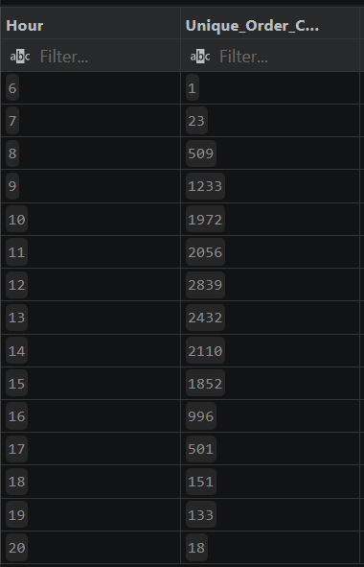
--23. Hourly order distribution:Count unique hours to identify peak operational times
SELECT Hour,COUNT(InvoiceNo) AS Unique_Order_Count FROM Invoices_Retaildb GROUP BY Hour;

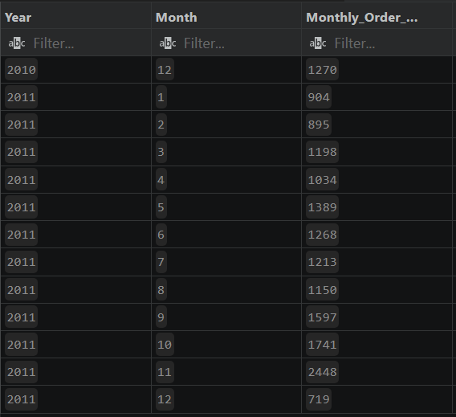
--25. Seasonal Demand : Group by year and Month to track how to order volume changes monthly
SELECT Year,Month,Count(InvoiceNo) AS Monthly_Order_Volume FROM Invoices_Retaildb GROUP BY Year,Month;

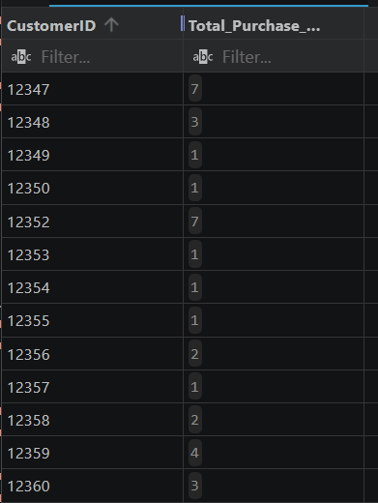
--27.Customer Purchase Frequency : Track how many Seprate checkout sessions each CustomerID completed
SELECT CustomerID,COUNT(InvoiceNo) AS Total_Purchase_Sessions FROM Invoices_Retaildb WHERE CustomerID IS NOT NULL GROUP BY CustomerID;

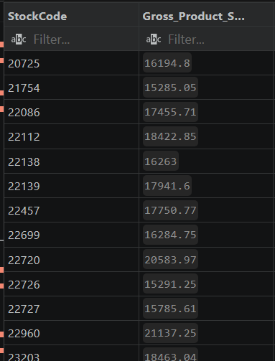
--28.High revenue Product codes : Finding Product codes that have bought in more than $15,000 in gross sales
SELECT StockCode,ROUND(SUM(TotalPrice),2) AS Gross_Product_Sales FROM Sales_Retaildb GROUP BY StockCode HAVING Gross_Product_Sales > 15000;

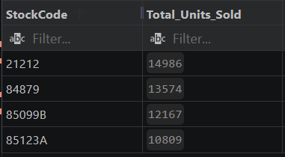
--29. Heavy Volume Items : Find Product codes where greater than 10,000 units have been sold
SELECT StockCode,SUM(Quantity) AS Total_Units_Sold FROM Sales_Retaildb GROUP BY StockCode HAVING Total_Units_Sold > 10000;
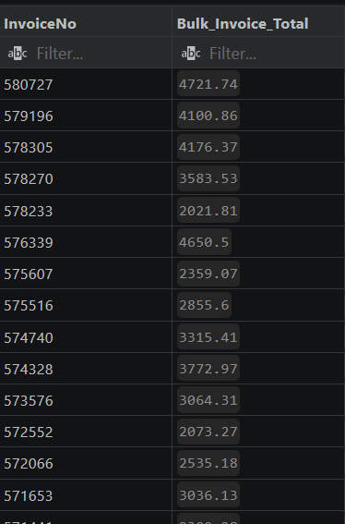
--33. High values Invoices : Find specfic order numbers Where the total single bill is greater than 2000
SELECT InvoiceNo,ROUND(SUM(TotalPrice),2) AS Bulk_Invoice_Total FROM Sales_Retaildb GROUP BY InvoiceNo HAVING Bulk_Invoice_Total > 2000.00 ORDER BY InvoiceNo DESC;

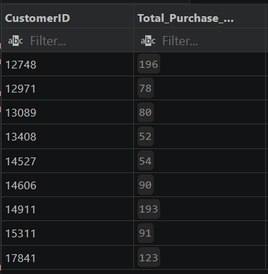
--34.Elite Repeat Shoppers: Identify individual customer IDs who have completed more than 50 separate checkout sessions
SELECT CustomerID,COUNT(InvoiceNo) AS Total_Purchase_Sessions FROM Invoices_Retaildb WHERE CustomerID IS NOT NULL GROUP BY CustomerID HAVING Total_Purchase_Sessions > 50 ORDER BY CustomerID ASC;

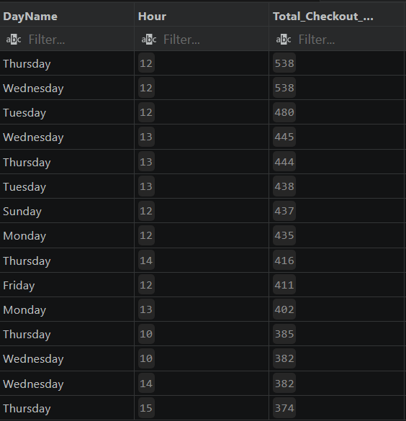
--35. Granular Peak Operations: Find the absolute busiest Day and Hour combinations
SELECT DayName, Hour, COUNT(InvoiceNo) AS Total_Checkout_Sessions FROM Invoices_Retaildb GROUP BY DayName, Hour ORDER BY Total_Checkout_Sessions DESC LIMIT 15;

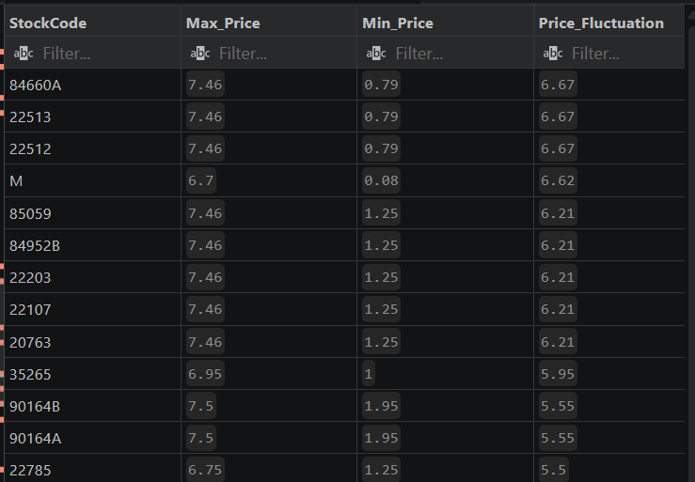
--38. Product Pricing Consistency Audit: Monitor item unit price fluctuations across orders
SELECT StockCode, ROUND(MAX(UnitPrice), 2) AS Max_Price, ROUND(MIN(UnitPrice), 2) AS Min_Price, ROUND(MAX(UnitPrice) - MIN(UnitPrice), 2) AS Price_Fluctuation FROM Sales_Retaildb GROUP BY StockCode HAVING Price_Fluctuation > 0.00 ORDER BY Price_Fluctuation DESC LIMIT 15;

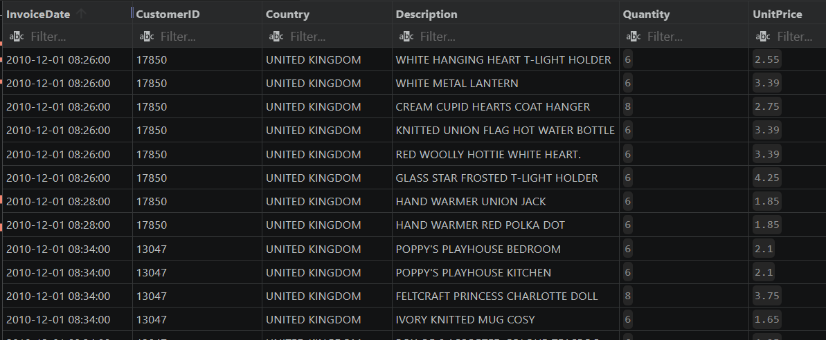
-- 47.Complete retail transaction view using all 3 tables
SELECT I.InvoiceDate,I.CustomerID, I.Country,P.Description,S.Quantity,S.UnitPrice, S.TotalPrice FROM Sales_Retaildb S INNER JOIN Invoices_Retaildb I ON S.InvoiceNo = I.InvoiceNo INNER JOIN Products_Retaildb P ON S.StockCode = P.StockCode
LIMIT 100;
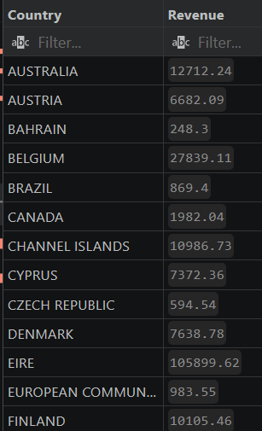
-- 57.Calculate total revenue contribution grouped by country
SELECT I.Country,ROUND(SUM(S.TotalPrice),2) AS Revenue FROM Sales_Retaildb S INNER JOIN Invoices_Retaildb i ON S.InvoiceNo=I.InvoiceNo GROUP BY I.Country;

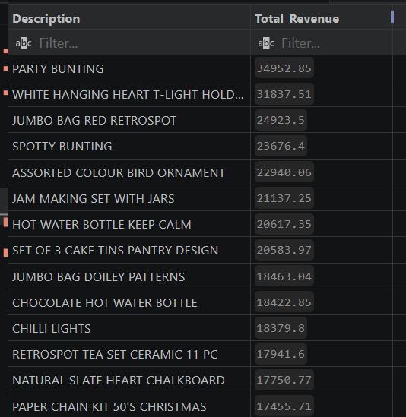
-- 61.Rank the top 30 product descriptions based on total revenue generated descending
SELECT P.Description,ROUND(SUM(S.TotalPrice),2) AS Total_Revenue FROM Products_Retaildb P INNER JOIN Sales_Retaildb S ON P.StockCode=S.StockCode GROUP BY P.Description ORDER BY Total_Revenue DESC LIMIT 30;
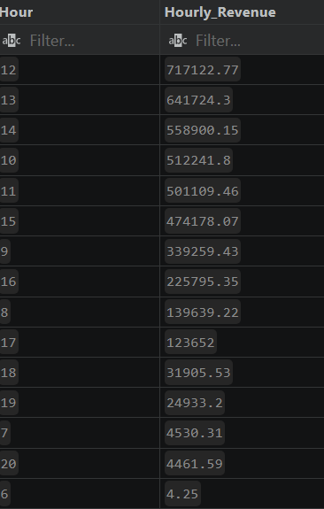
-- 64.Calculate total revenue tracking metrics grouped and ordered by hour descending
SELECT I.Hour,ROUND(SUM(TotalPrice),2) AS Hourly_Revenue FROM Sales_Retaildb S INNER JOIN Invoices_Retaildb I ON S.InvoiceNo=I.InvoiceNo GROUP BY I.Hour ORDER BY Hourly_Revenue DESC;

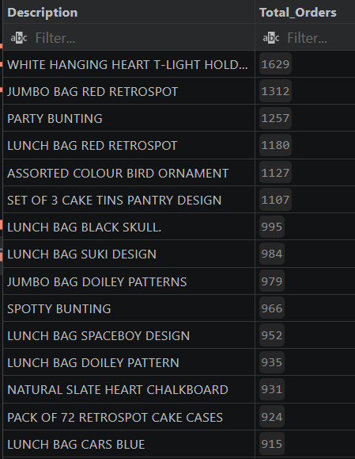
--65. Rank the top 20 most popular product descriptions by unique order counts descending
SELECT P.Description,COUNT(DISTINCT S.InvoiceNo) AS Total_Orders FROM Sales_Retaildb S INNER JOIN Products_Retaildb P ON S.StockCode=P.StockCode GROUP BY P.Description ORDER BY Total_Orders DESC LIMIT 20;

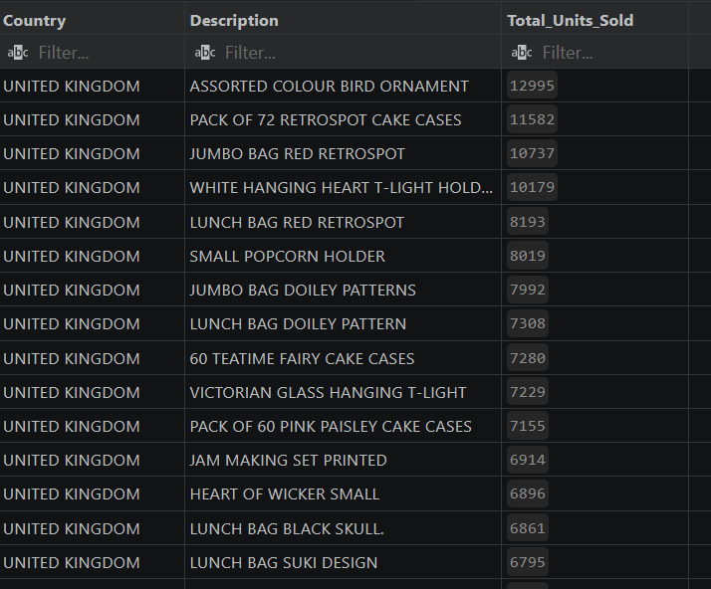
--66. Calculate total physical units sold grouped by country and product description ordered by quantity descending
SELECT I.Country,P.Description,SUM(S.Quantity) AS Total_Units_Sold FROM Sales_Retaildb S INNER JOIN Invoices_Retaildb I ON S.InvoiceNo=I.InvoiceNo INNER JOIN Products_Retaildb P ON S.StockCode=P.StockCode GROUP BY I.Country,P.Description ORDER BY Total_Units_Sold DESC;

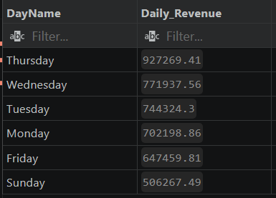
--67. Calculate total revenue trends grouped and ordered by day of the week descending
SELECT I.DayName,ROUND(SUM(S.TotalPrice),2) AS Daily_Revenue FROM Sales_Retaildb S INNER JOIN Invoices_Retaildb I ON S.InvoiceNo=I.InvoiceNo GROUP BY I.DayName ORDER BY Daily_Revenue DESC;

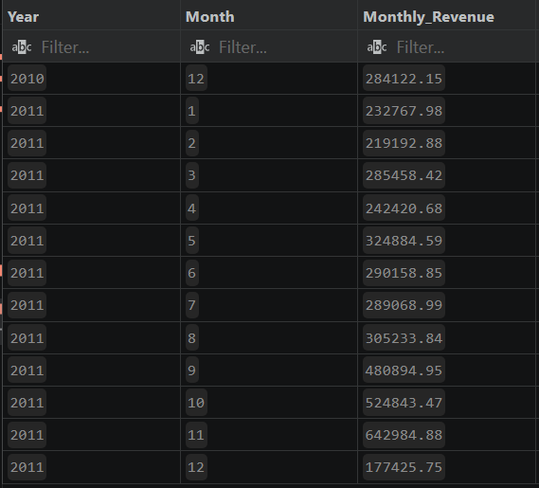
--68. Track revenue fluctuations over a timeline grouped and ordered by year and month
SELECT I.Year,I.Month,ROUND(SUM(S.TotalPrice),2) AS Monthly_Revenue FROM Sales_Retaildb S INNER JOIN Invoices_Retaildb I ON S.InvoiceNo = I.InvoiceNo GROUP BY I.Year, I.Month ORDER BY I.Year, I.Month;

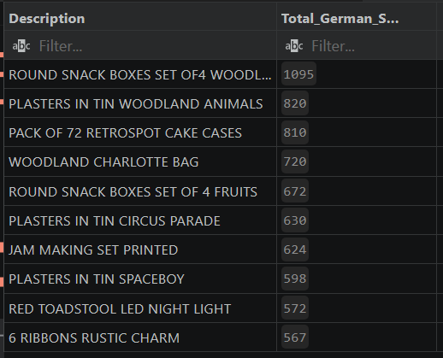
-- 72. Identify the top 10 best-selling product descriptions specifically for customers in Germany
SELECT P.Description, SUM(S.Quantity) AS Total_German_Sales FROM Sales_Retaildb S INNER JOIN Invoices_Retaildb I ON S.InvoiceNo = I.InvoiceNo INNER JOIN Products_Retaildb P ON S.StockCode = P.StockCode WHERE I.Country = 'GERMANY' GROUP BY P.Description ORDER BY Total_German_Sales DESC LIMIT 10;

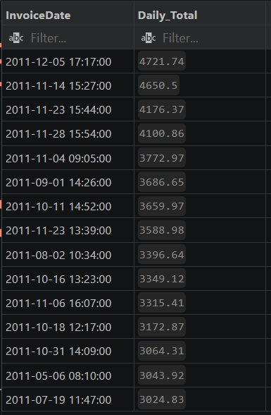
-- 85. Use a Common Table Expression (CTE) to calculate daily sales totals and identify high revenue days
WITH DailySales AS (SELECT I.InvoiceDate,SUM(S.TotalPrice) AS Daily_Total FROM Sales_Retaildb S INNER JOIN Invoices_Retaildb I ON S.InvoiceNo = I.InvoiceNo GROUP BY I.InvoiceDate) SELECT InvoiceDate,ROUND(Daily_Total, 2) AS Daily_Total FROM DailySales WHERE Daily_Total > 3000 ORDER BY Daily_Total DESC;

7. Results / Achievements
- Retail database was successfully created in SQLite.
- Cleaned retail dataset was imported into the database.
- Dataset was normalized into three tables: Sales_Retaildb, Invoices_Retaildb, and Products_Retaildb.
- Table structures, data types, and row counts were verified.
- Basic SQL queries were executed to filter products, customers, countries, prices, quantities, and invoices.
- Aggregate analysis was completed using SUM, AVG, COUNT, MIN, and MAX.
- Product-wise, customer-wise, country-wise, hourly, daily, and monthly analysis was performed.
- JOIN queries were created to combine sales, invoice, and product data.
- High-revenue products, top customers, repeat buyers, high-value invoices, and low-performing products were identified.
- Advanced SQL concepts such as subqueries, window functions, CASE statements, and CTEs were applied.
- Business insights were generated from retail transaction data.

8. Challenges Faced
- The original dataset contained a large amount of retail transaction data, and also found it hard to find a proper initial setup for the database ,tables and all to execute the queries and all.
- The data needed to be split into separate tables to reduce repetition and make the database more organized.
- While creating normalized tables, correct relationships between invoice numbers, stock codes, customers, and products had to be maintained.
- Some customer records contained missing or null customer IDs, so filtering conditions like WHERE CustomerID IS NOT NULL were used during customer analysis.
- JOIN queries required matching the correct keys such as InvoiceNo and StockCode to combine data accurately.
- Aggregation queries needed proper use of GROUP BY and HAVING to avoid incorrect summaries.
- Large query outputs were managed using LIMIT, sorting, and filtering to make the results easier to understand.
- Found it challenging to write advanced queries.
9. Conclusion
In this module, the cleaned retail dataset was imported into SQLite, normalized into three structured tables, and analyzed using SQL. Different queries were performed to understand sales, products, customers, countries, revenue, order timing, and business trends. By using filtering, grouping, joins, aggregate functions, and advanced SQL techniques, the module successfully converted raw retail transaction data into meaningful business insights.

