ONLINE RETAIL DATA CLEANING AND PREPROCESSING PROJECT REPORT

1. Introduction
This project focuses on cleaning and preprocessing an Online Retail dataset using Python and Pandas in Google Colab. The objective of the project was to improve data quality by handling missing values, removing duplicate and invalid records, standardizing text data, detecting outliers, and creating useful features for further analysis.
The cleaned dataset can be used for:
- Data Analysis
- Business Insights
- Data Visualization
- Statistical Analysis
- Machine Learning Applications

2. Tools and Technologies Used
The following tools and technologies were used throughout the project:
- Python
- Google Colab
- Pandas
- NumPy
- Scikit-learn
- Git
- GitHub

3. Dataset Exploration
The dataset was initially explored to understand its structure and quality. The following checks were performed:
- Number of rows and columns
- Column names
- Data types
- Missing values
- Duplicate records
- Statistical summary

Code Used
import pandas as pd

df = pd.read_csv('/content/OnlineRetail.csv', encoding='ISO-8859-1')

print(df.shape)
print(df.columns)
print(df.info())
print(df.describe())

[Insert Existing Dataset Exploration Screenshots Here]

4. Handling Missing Values
Missing values were identified in important columns such as Description and CustomerID. These values were handled to improve data quality and maintain consistency.

Code Used
print(df.isnull().sum())

df['Description'] = df['Description'].fillna('Unknown')
df['CustomerID'] = df['CustomerID'].fillna(0)

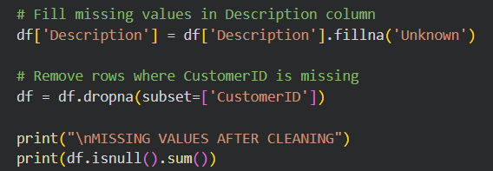

5. Removing Duplicate Records
Duplicate transactions can affect analysis results. Duplicate rows were identified and removed.

Code Used
print("Duplicate Rows:", df.duplicated().sum())

df = df.drop_duplicates()

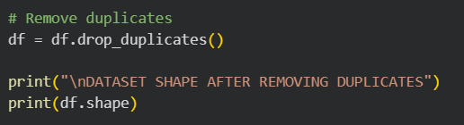

6. Data Type Conversion
Data types were converted into appropriate formats to support accurate calculations and analysis.

Code Used
df['InvoiceDate'] = pd.to_datetime(df['InvoiceDate'])
df['CustomerID'] = df['CustomerID'].astype(int)

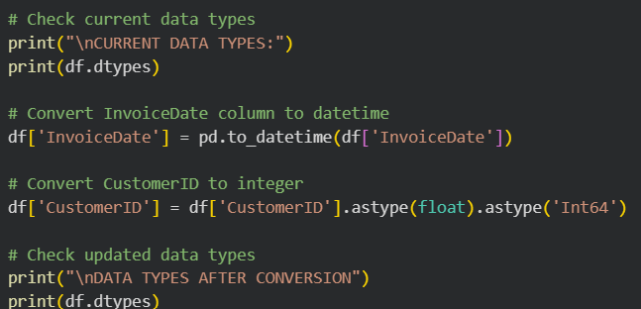

7. Removing Cancelled Orders
Cancelled transactions were identified using invoice numbers beginning with the letter "C" and were removed.

Code Used
cancelled_orders = df['InvoiceNo'].astype(str).str.startswith('C')

df = df[~cancelled_orders]

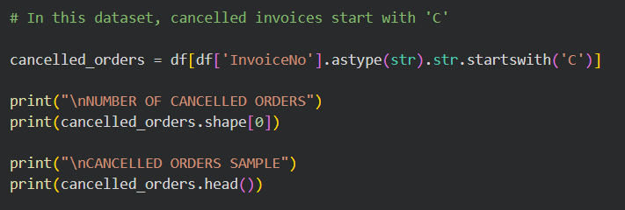

8. Removing Invalid Quantities
Rows containing invalid quantity values (less than or equal to zero) were removed.

Code Used
df = df[df['Quantity'] > 0]

9. Removing Invalid Prices
Rows containing invalid UnitPrice values (less than or equal to zero) were removed.

Code Used
df = df[df['UnitPrice'] > 0]

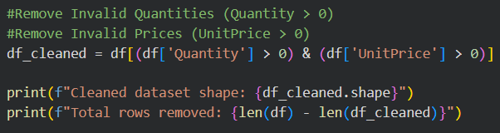

10. Detecting and Removing Outliers
Outliers in Quantity and UnitPrice were detected using the Interquartile Range (IQR) method and removed.

Code Used
Q1 = df['Quantity'].quantile(0.25)
Q3 = df['Quantity'].quantile(0.75)

IQR = Q3 - Q1

lower_bound = Q1 - 1.5 * IQR
upper_bound = Q3 + 1.5 * IQR

df = df[
(df['Quantity'] >= lower_bound) &
(df['Quantity'] <= upper_bound)
]

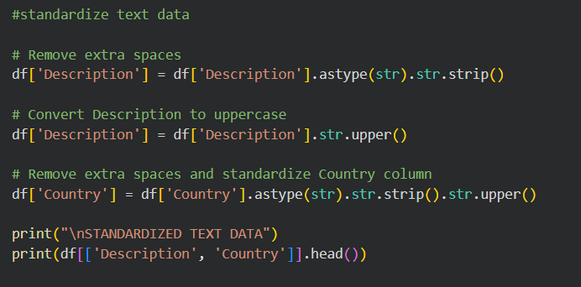

11. Standardizing Text Data
Text data was standardized by:
- Removing extra spaces
- Converting text into uppercase
- Maintaining a consistent format

Code Used
df['Description'] = (
df['Description']
.astype(str)
.str.strip()
.str.upper()
)

df['Country'] = (
df['Country']
.astype(str)
.str.strip()
.str.upper()
)

[Insert Existing Text Standardization Screenshots Here]

12. Removing Special Characters
Special characters and unwanted symbols were removed from text columns to improve consistency.

Code Used
import re

df['Description'] = df['Description'].apply(
lambda x: re.sub(r'[^A-Za-z0-9 ]', '', str(x))
)

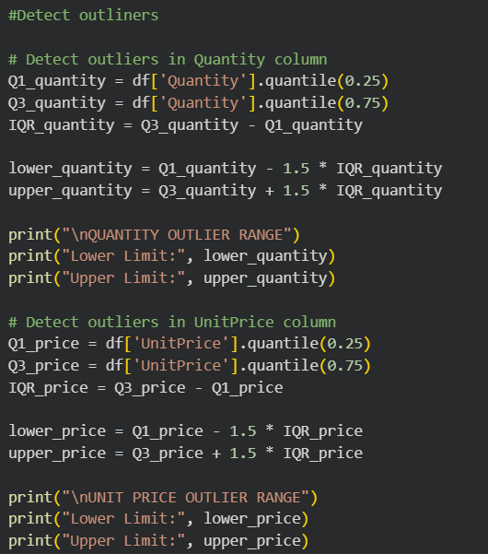
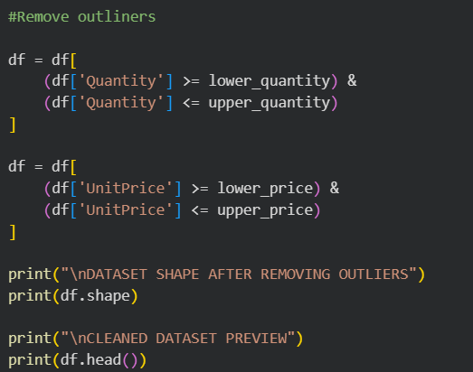

13. Renaming Columns
Column names were standardized to improve readability and consistency.

Code Used
df.columns = df.columns.str.strip()

df.columns = (
df.columns
.str.lower()
.str.replace(' ', '_')
)

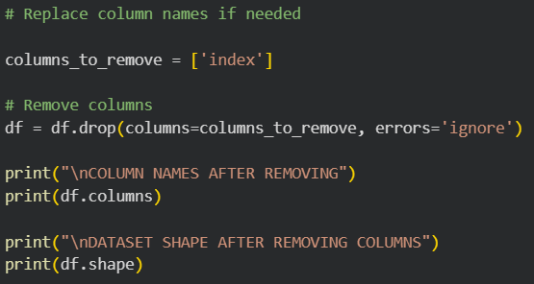

14. Removing Extra Spaces
Extra spaces in column names and text fields were removed.

Code Used
df.columns = df.columns.str.strip()

df['Description'] = df['Description'].astype(str).str.strip()

df['Country'] = df['Country'].astype(str).str.strip()

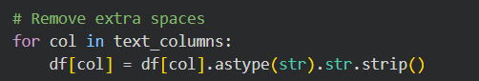

15. Validating TotalPrice Consistency
The TotalPrice column was validated using the formula:

Formula
TotalPrice = Quantity × UnitPrice

Code Used
df['Calculated_TotalPrice'] = (
df['Quantity'] * df['UnitPrice']
)

invalid_records = df[
df['TotalPrice'] != df['Calculated_TotalPrice']
]

print("Invalid Records:", len(invalid_records))

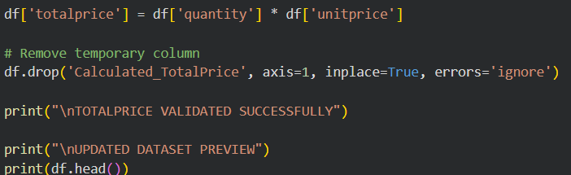

16. Creating New Useful Columns
New columns were created to improve analysis and reporting.

Created Columns
- TotalPrice
- Year
- Month
- Day
- DayName
- Hour

Code Used
df['TotalPrice'] = df['Quantity'] * df['UnitPrice']

df['Year'] = df['InvoiceDate'].dt.year
df['Month'] = df['InvoiceDate'].dt.month
df['Day'] = df['InvoiceDate'].dt.day
df['DayName'] = df['InvoiceDate'].dt.day_name()
df['Hour'] = df['InvoiceDate'].dt.hour

17. Creating Categories/Bins
Numerical values were grouped into categories to simplify analysis.

Code Used
df['Sales_Category'] = pd.cut(
df['TotalPrice'],
bins=[0, 50, 200, df['TotalPrice'].max()],
labels=['Low', 'Medium', 'High']
)

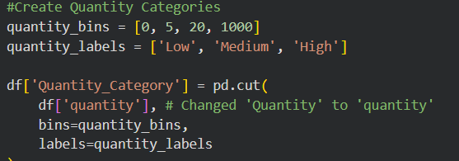

18. Scaling Numerical Columns
Feature scaling was applied to bring numerical variables into a common range.

Code Used
from sklearn.preprocessing import StandardScaler

scaler = StandardScaler()

df[['Quantity', 'UnitPrice', 'TotalPrice']] = (
scaler.fit_transform(
df[['Quantity', 'UnitPrice', 'TotalPrice']]
)
)

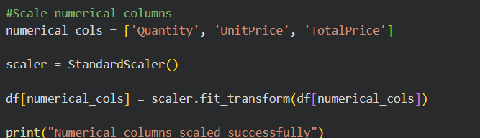

19. Encoding Categorical Columns
Categorical variables were converted into numerical representations suitable for machine learning.

Code Used
df_encoded = pd.get_dummies(
df,
columns=['Country'],
drop_first=True
)

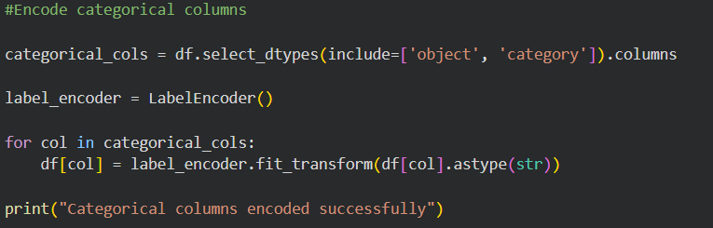

20. Removing Unnecessary Columns
Unwanted columns were removed from the dataset to improve efficiency.

Code Used
df = df.drop(
columns=['Unnamed: 0'],
errors='ignore'
)

21. Final Dataset Summary
A final summary was generated to verify the cleaned dataset.

Code Used
print(df.info())
print(df.describe())
print(df.isnull().sum())
print("Duplicate Rows:", df.duplicated().sum())

22. Saving the Final Cleaned Dataset
The final cleaned dataset was saved for future analysis.

Code Used
df.to_csv(
'Final_Cleaned_Retail_Dataset.csv',
index=False
)

23. Git and Version Control
Git and GitHub were used for version control and project tracking.

Common Commands Used
git add .
git commit -m "Completed data cleaning tasks"
git push origin main

24. Conclusion
The Online Retail dataset was successfully cleaned and preprocessed using Python and Pandas. Multiple data cleaning and preprocessing techniques were applied, including handling missing values, removing duplicates, eliminating invalid records, standardizing text data, removing special characters, validating calculations, detecting outliers, creating useful features, scaling numerical columns, and encoding categorical variables.
As a result, the dataset became cleaner, more consistent, and suitable for advanced analytics.
The final dataset is now ready for:
- Exploratory Data Analysis (EDA)
- Business Reporting
- Data Visualization
- Statistical Analysis
- Machine Learning Applications
This project demonstrates a complete data cleaning and preprocessing workflow that improves data quality and prepares raw retail data for meaningful analysis and predictive modeling.

