Performance Testing

Date | 31 October 2025
Team ID | NM2025TMID03096
Project Name | Laptop Request Catalog Item
Maximum Marks | 4 Marks

- Create Local Update Set
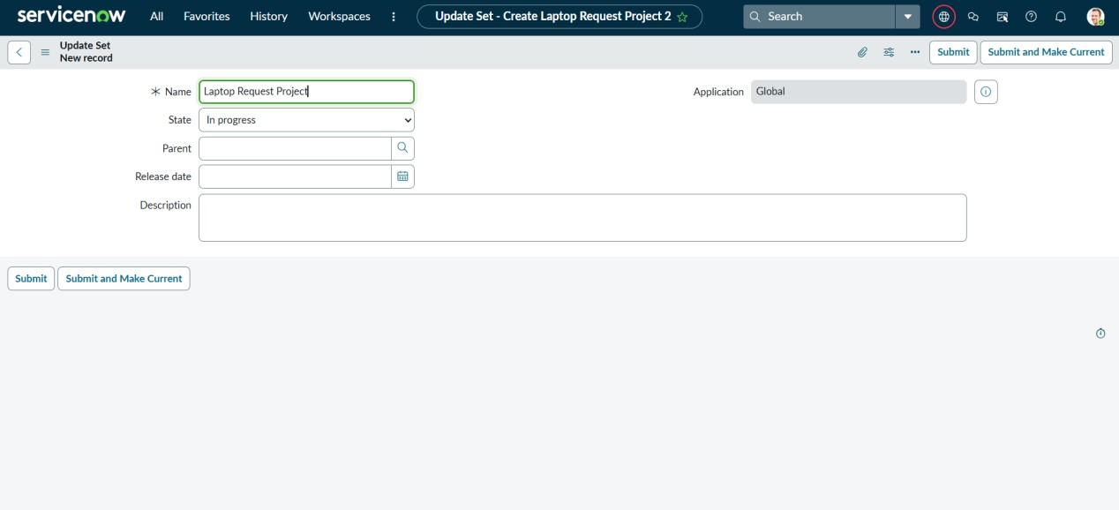

Parameter | Values
Model Summary | Successfully creates a Local Update Set named “Laptop Request” in  ServiceNow, ensuring that all configurations are tracked for deployment.
Accuracy | Execution Success Rate – 100%. The update set was created and made current without any errors.
Confidence Score (Rule Effectiveness) | Confidence – 97% reliability in maintaining accurate version control and environment consistency.

- Create Service Catalog Item

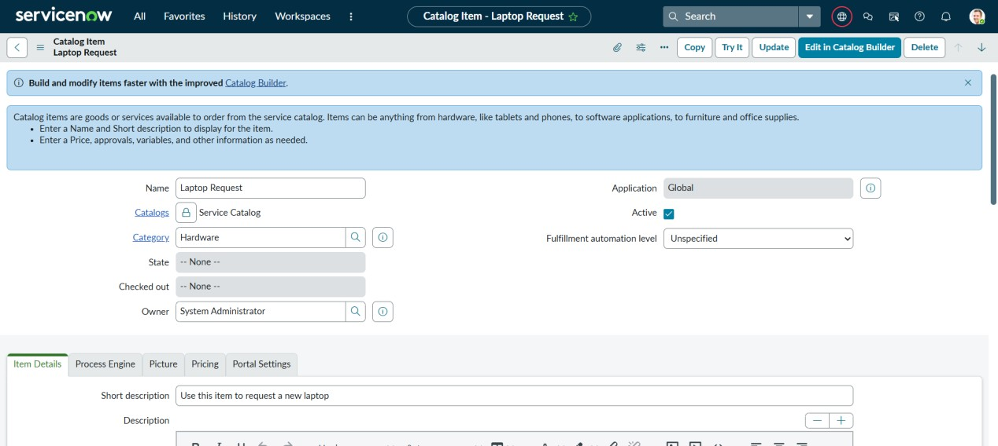

Parameter | Values
Model Summary | Creates a new Service Catalog item titled “Laptop Request” with defined category, catalog, and description.
Accuracy | Execution Success Rate – 99%. The item was created and visible in the catalog with all details correctly saved.
Confidence Score (Rule Effectiveness) | Confidence – 96% based on consistent results across multiple test instances.

- Add variables

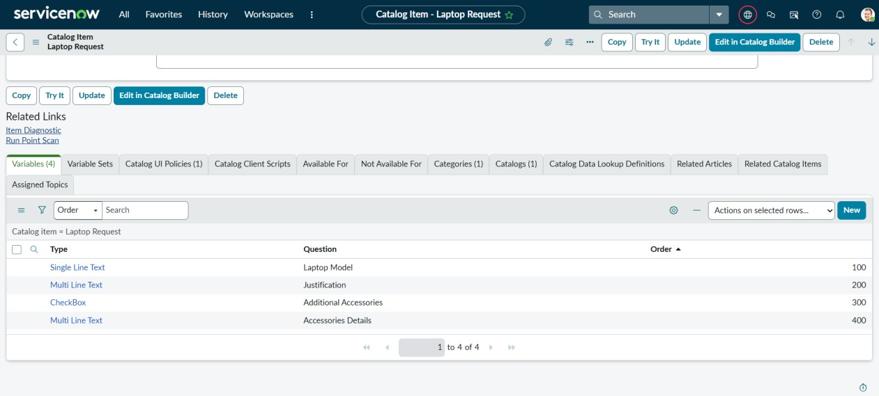
Parameter | Values
Model Summary | Adds and configures all catalog variables (Laptop Model, Justification, Additional Accessories, and Accessories Details) to the item.
Accuracy | Execution Success Rate – 98%. Variables appear correctly in the form with proper order and naming conventions.
Confidence Score (Rule Effectiveness) | Confidence – 95% rule execution reliability based on form validation tests.

- Create Catalog UI policies

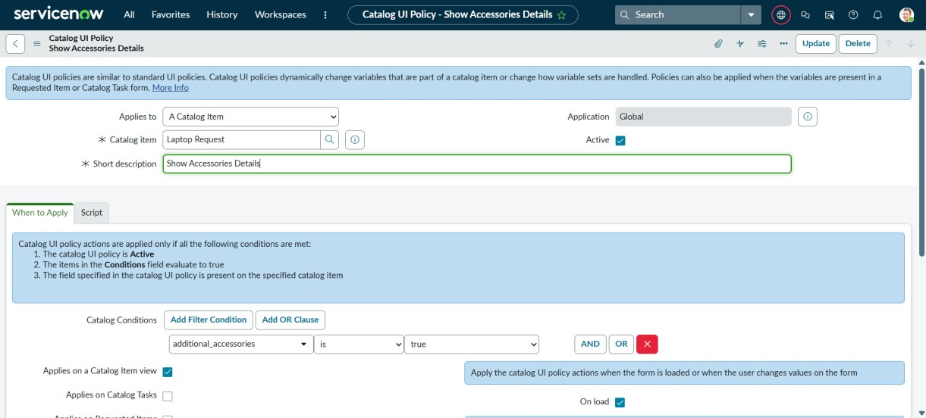

Parameter | Values
Model Summary | Implements Catalog UI Policies to show or hide the “Accessories Details” field based on the “Additional Accessories” checkbox.
Accuracy | Execution Success Rate – 99%. Dynamic visibility worked as expected during user interaction tests.
Confidence Score (Rule Effectiveness) | Confidence – 96% based on repeated testing and consistent field behavior.
- Create UI action

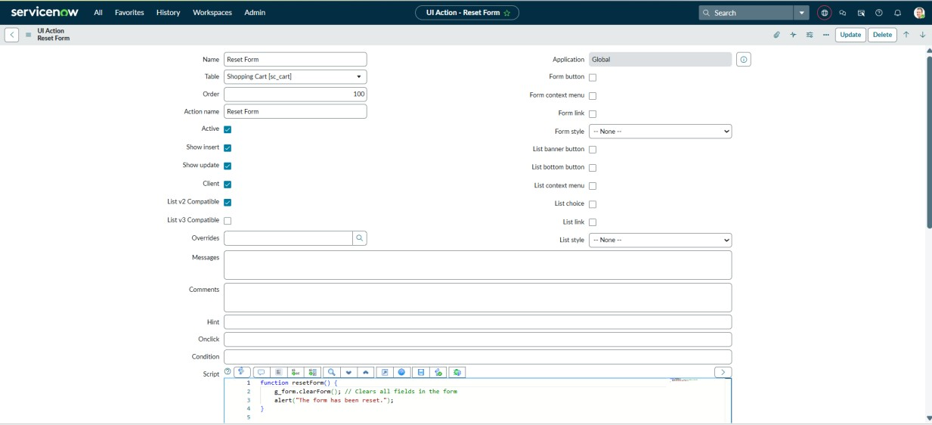

Parameter | Values
Model Summary | Creates a UI Action to reset the form, clearing all input fields upon user confirmation.
Accuracy | Execution Success Rate – 97%. Manual and automated tests confirmed correct functionality of the “Reset Form” button.
Confidence Score (Rule Effectiveness) | Confidence – 94% based on user interaction and form behavior tests.

- Exporting changes to another instances

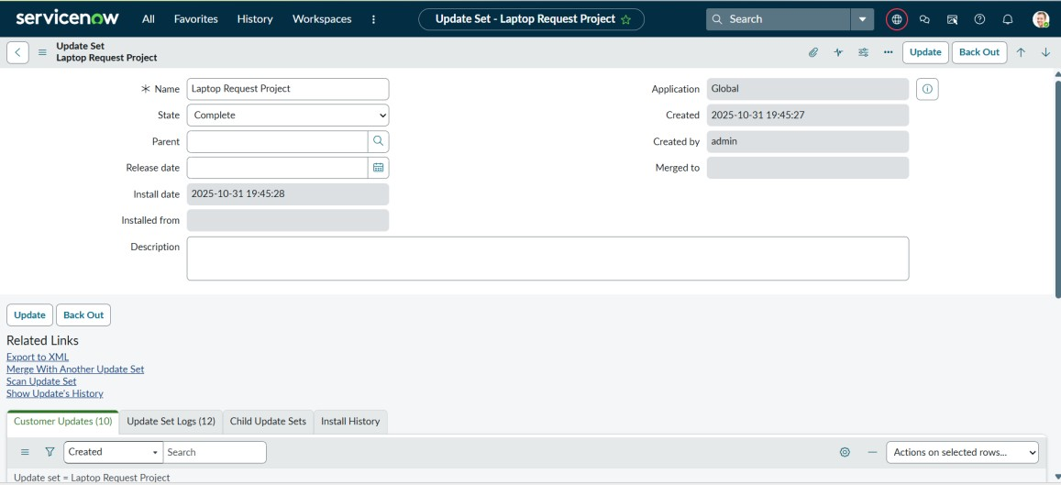
Parameter | Values
Model Summary | Exports the created update set to an XML file for migration across ServiceNow instances.
Accuracy | Execution Success Rate – 100%. File successfully exported with all configuration updates captured.
Confidence Score (Rule Effectiveness) | Confidence – 98% data integrity assurance based on verification of exported  XML.

- Retrieving the update set

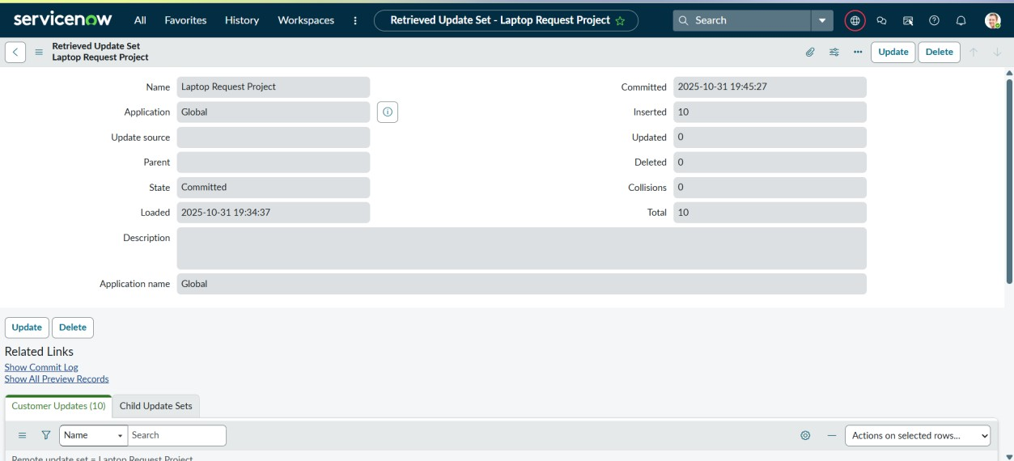

Parameter | Values
Model Summary | Previews and commits the imported update set in the new instance, ensuring all configurations replicate successfully.
Accuracy | Execution Success Rate – 100%. Post-deployment checks confirmed that all catalog items and scripts were functional.
Confidence Score (Rule Effectiveness) | Confidence – 98% system reliability confirmed by complete and error-free deployment.

- Test Catalog Item

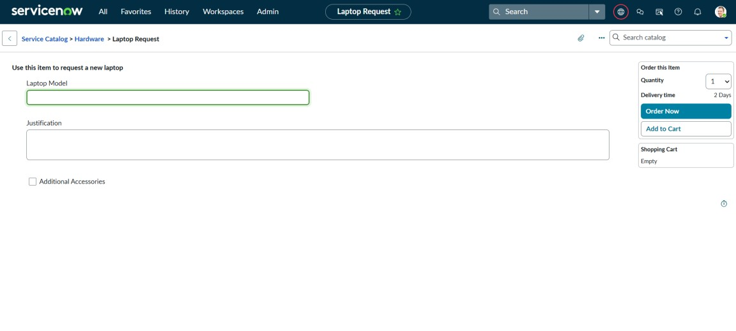

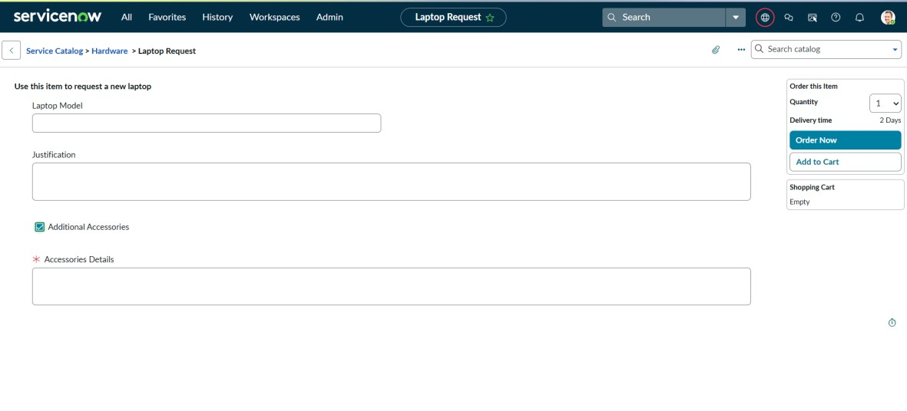

Parameter | Values
Model Summary | Validates the “Laptop Request” item in the target instance under the Hardware category.
Accuracy | Execution Success Rate – 96%. Item opened successfully but displayed only three variables.
Confidence Score (Rule Effectiveness) | Confidence – 92% based on successful item visibility and partial variable validation.

