Technical

Database

Schema
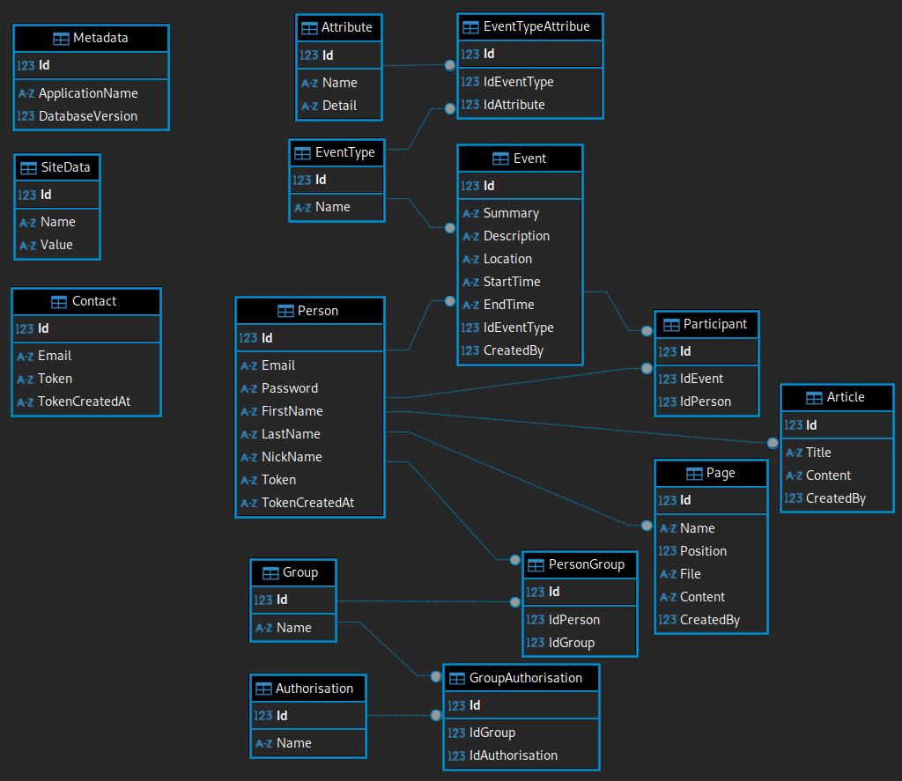

Tables

Initial data

Not up datable
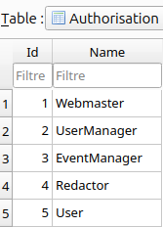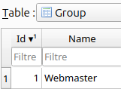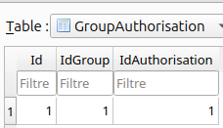

Data created during installation
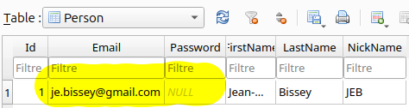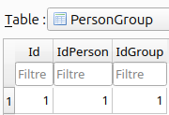

Grant

Site’s folders structure

MyClub
The web application.

images
Images files used.

includes
Pieces of page files.

js
JavaScript files.

lib
All PHP classes used. Some included folders for actions with many classes like “Database”.

Other folders

SignIn
All files used for a specific action.

Data
All data created by users ares stored here.
The “MyClub.sqlite” file stores all data except images.
The “LogMyClub.sqlite” file stores the logs of the web application.

Images
The folder Images stores all the images added by users. Sub folders are automatically created when new images are added. There are one sub folder by year and inside one sub folder by month.

Backup
Save buttons exist in Webmaster, Redactor, EventManager and PersonManager pages. When the button is clicked, a new copy of “MyClub.sqlite” is created.
The GFS schema is used.

Sub folders

Year
If a file doesn’t exist for the current year, backup is stored here. Else month sub-folders are tested.
There will be one file per year in this folder.

Month
There are sub-folders “01, 02 … 12”. If a file doesn’t exist for the current year and the current month, the backup is stored here. Else week day sub-folders are tested.
If a file exists for another year, it is deleted. So there is only one file per sub-folder.

Week day
There are sub-folders “Mon, Tue … Sun”. If a file already exists, it is deleted. So there is only one file per folder.

The web application

Install
Upload the folder “MyClub” and its content to the destination site.

Update
Remove the folder “MyClub” and its content already present in the destination site. Then upload the new version.

How it works
When pages access to the database classes, checks are made :
- Is there a file “MyClub.sqlite” in “Data” folder? If not, the template is copied.
- Check if the “Data/MyClub.sqlite” is a database for the web application. If not, the application stop.
- How is the version of “Data/MyClub.sqlite”?
  - Same as awaited, nothing to do.
  - Older as awaited, incremental updates are made.
  - Later as awaited, the application stop.

Tools
Visual studio code with some PHP extensions
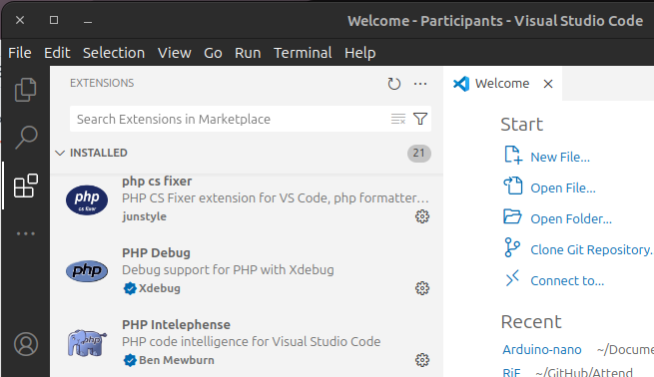

Creating an Application

Links
https://phpdelusions.net/pdo
https://www.w3schools.com/php/default.asp

Install

Install Composer
https://getcomposer.org/download/
php -r "copy('https://getcomposer.org/installer', 'composer-setup.php');"
php -r "if (hash_file('sha384', 'composer-setup.php') === 'dac665fdc30fdd8ec78b38b9800061b4150413ff2e3b6f88543c636f7cd84f6db9189d43a81e5503cda447da73c7e5b6') { echo 'Installer verified'; } else { echo 'Installer corrupt'; unlink('composer-setup.php'); } echo PHP_EOL;"
php composer-setup.php
php -r "unlink('composer-setup.php');"
sudo mv composer.phar /usr/local/bin/composer
→
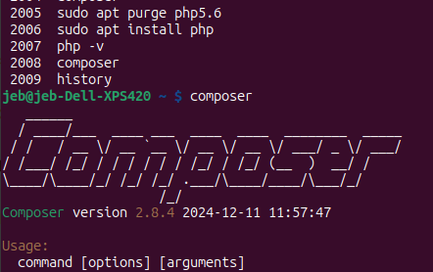

Install PHPMailer
composer require phpmailer/phpmailer
