Technical

Tools

Linux
Visual studio code with some PHP extensions
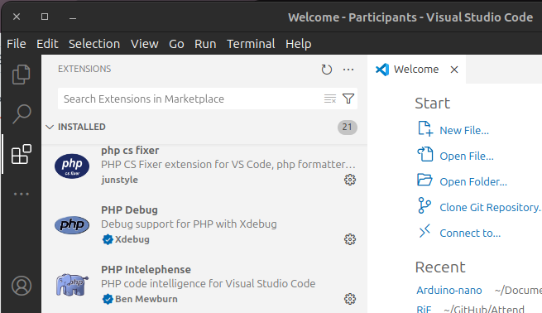

Install Laravel
https://laravel.com/docs/11.x
/bin/bash -c "$(curl -fsSL https://php.new/install/linux/5.6)"
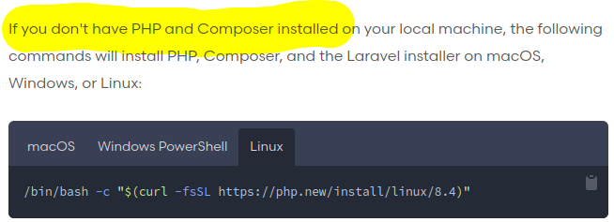
→ version PHP 5.6 (the version of free.fr)

Install mysql server
sudo apt install mysql-server
sudo service mysql status
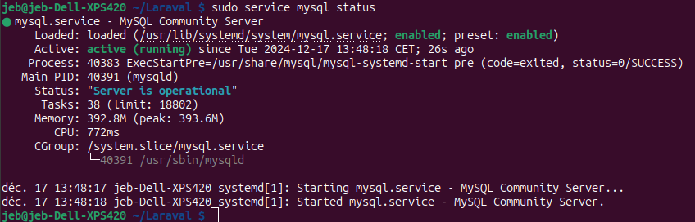

Windows
https://herd.laravel.com/docs/windows/1/getting-started/installation
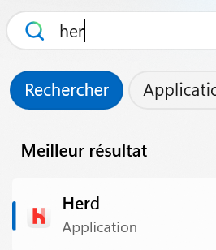
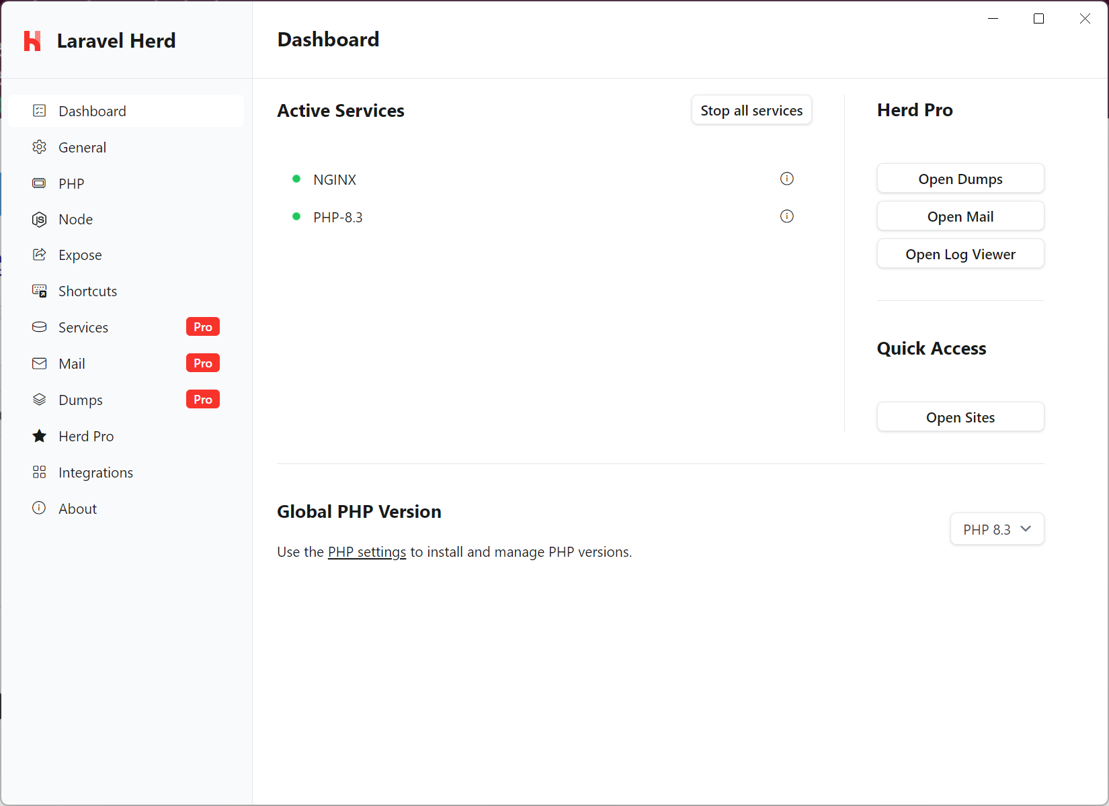

Creating an Application
https://herd.laravel.com/docs/windows/1/getting-started/sites

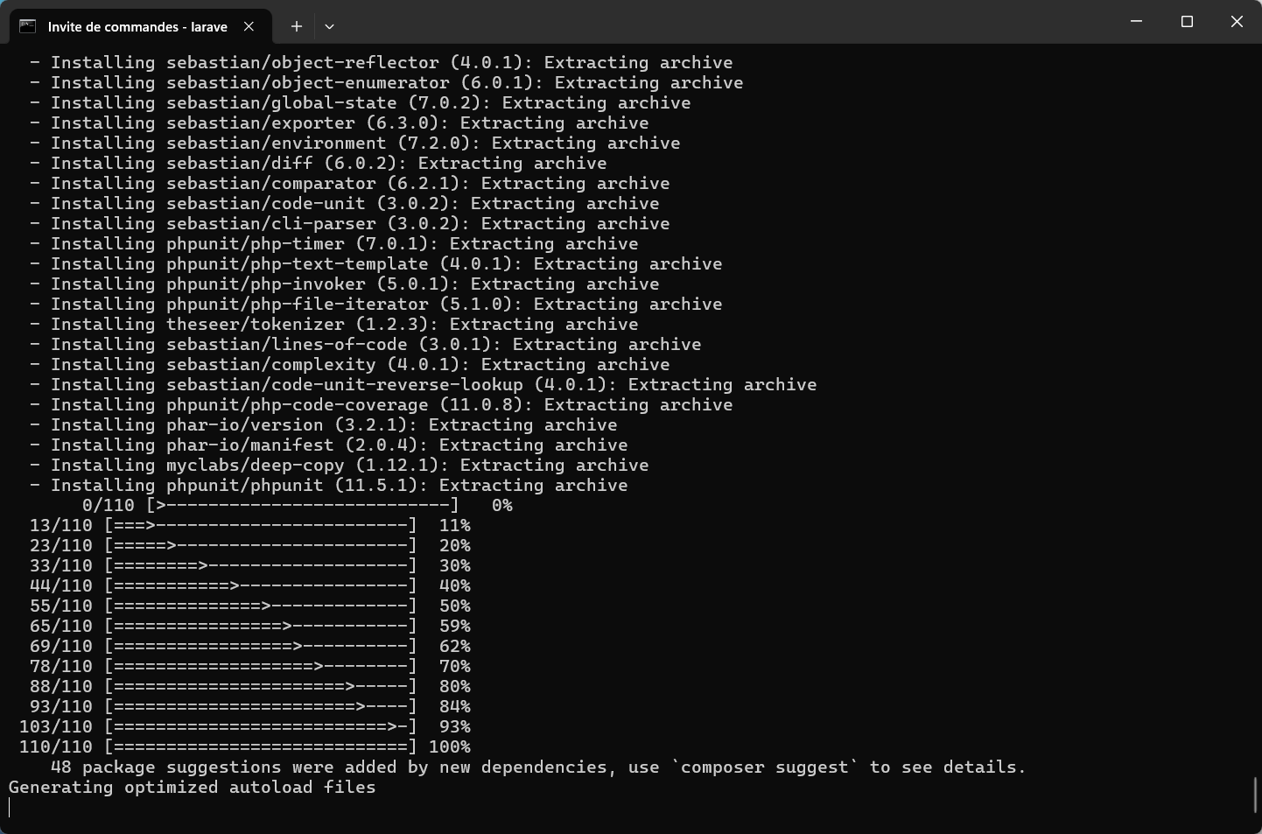
→ freeze?

