**Project: Measure Energy Consumption**

# **Phase 4: Development Part 2**

## **Introduction to Energy Consumption Measurement and Prediction:**

## Energy consumption measurement and prediction is a critical aspect of modern resource management and sustainability efforts. The ability to accurately measure and forecast energy consumption patterns is essential for various sectors, including residential, commercial, and industrial, as it enables organizations and individuals to make informed decisions about energy use and optimize their operations. This project aims to leverage innovative techniques to improve the precision and robustness of energy consumption measurement and prediction.

## **Project Plan:**

In this project, we emphasize the application of innovative techniques to enhance the accuracy and reliability of energy consumption measurement and prediction. These innovative techniques include:

**Machine Learning Models:** Traditional machine learning models, such as Random Forests, Support Vector Machines (SVMs), and Gradient Boosting, provide a strong foundation for predicting energy consumption. These models can be employed in conjunction with the other techniques to achieve robust and reliable predictions.

## **Data Collection:**

* Begin by downloading the dataset from the Kaggle dataset link [(https://www.kaggle.com/datasets/robikscube/hourly-energy-consumption).](https://www.kaggle.com/datasets/robikscube/hourly-energy-consumption) Ensure that the dataset is in a format that can be readily used for analysis.

# **Program:**

LINK FOR KAGGLE NOTEBOOK:

<https://www.kaggle.com/code/jeblinaldod/ai-phase4>

**Code :**

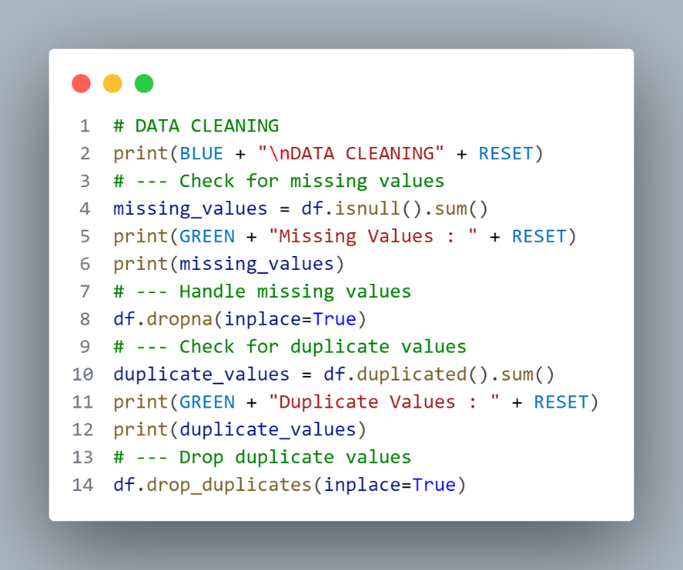

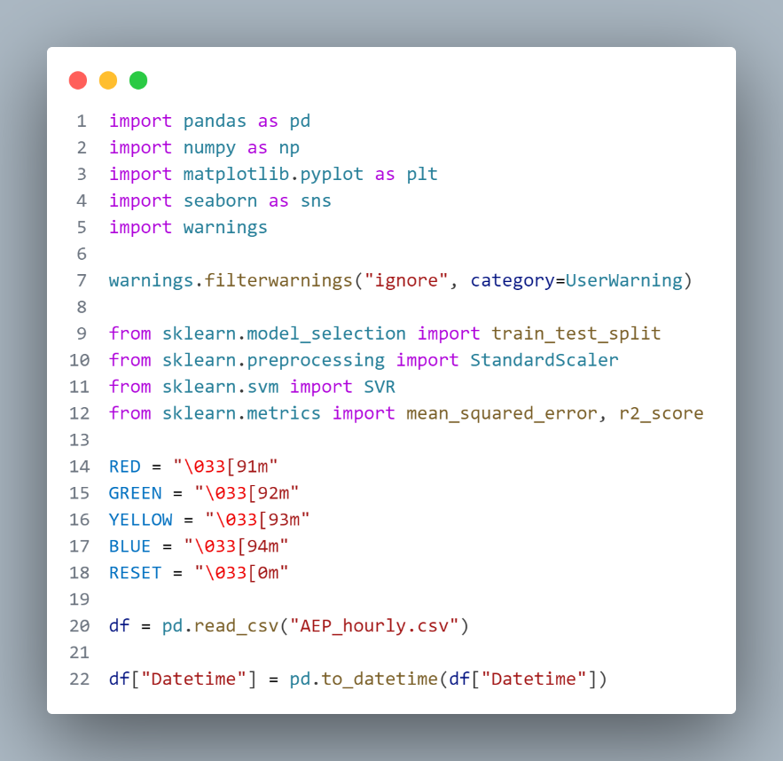

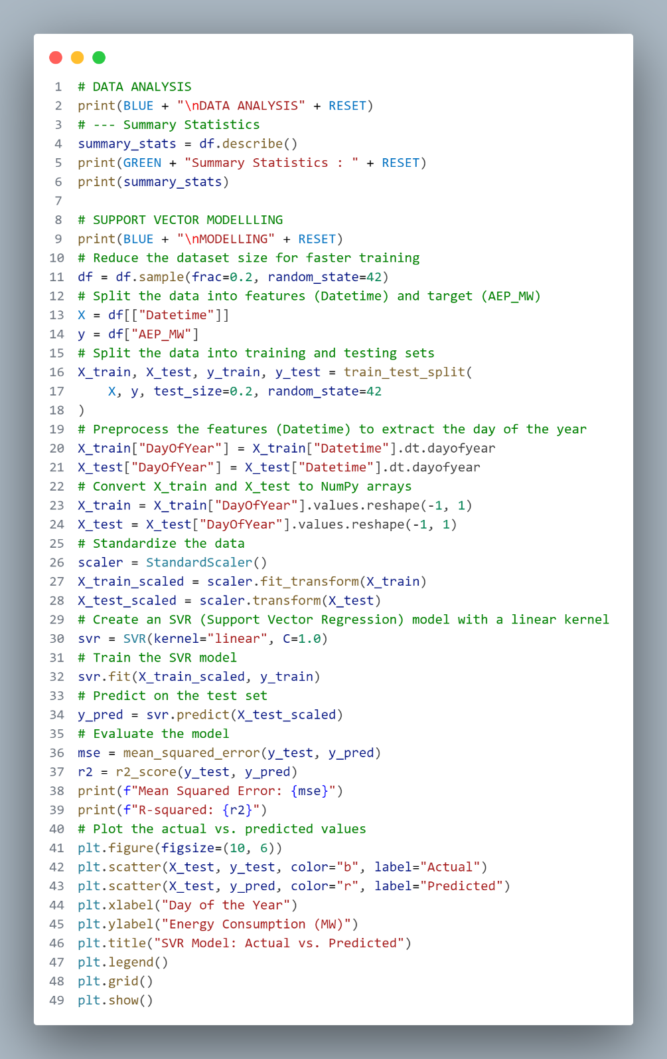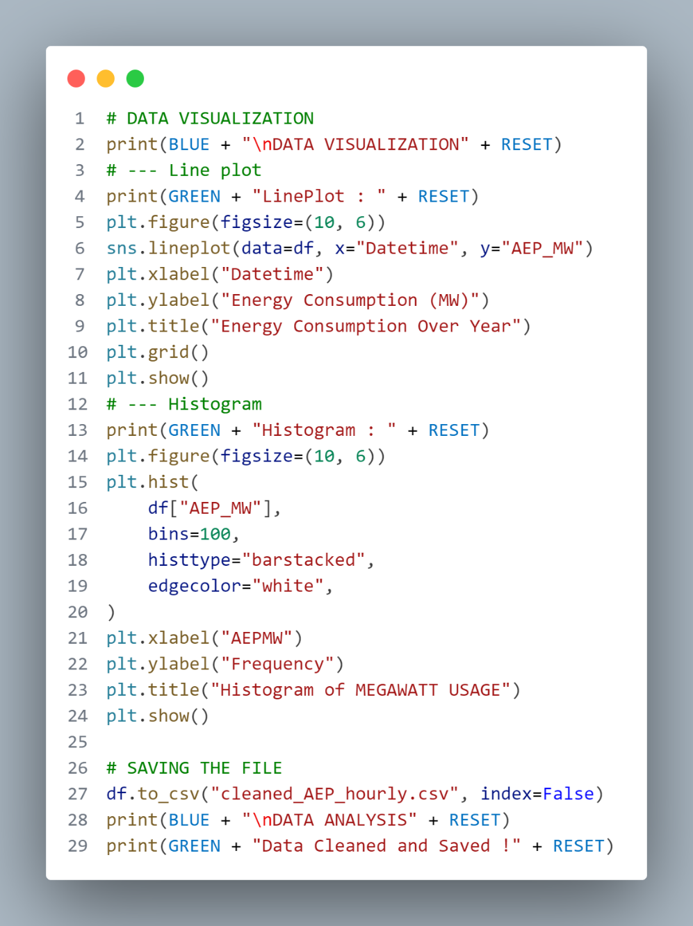

# **Output:**

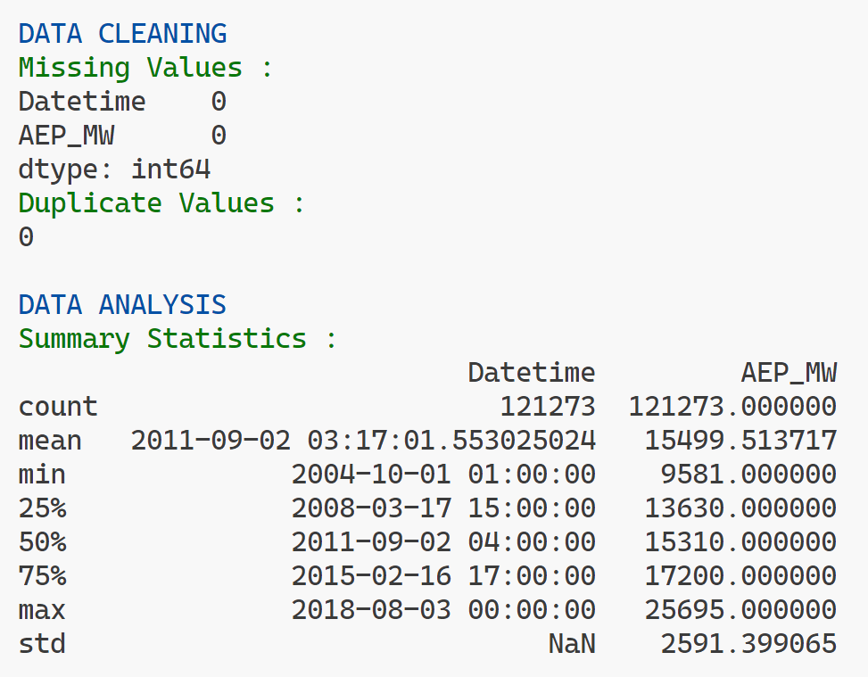

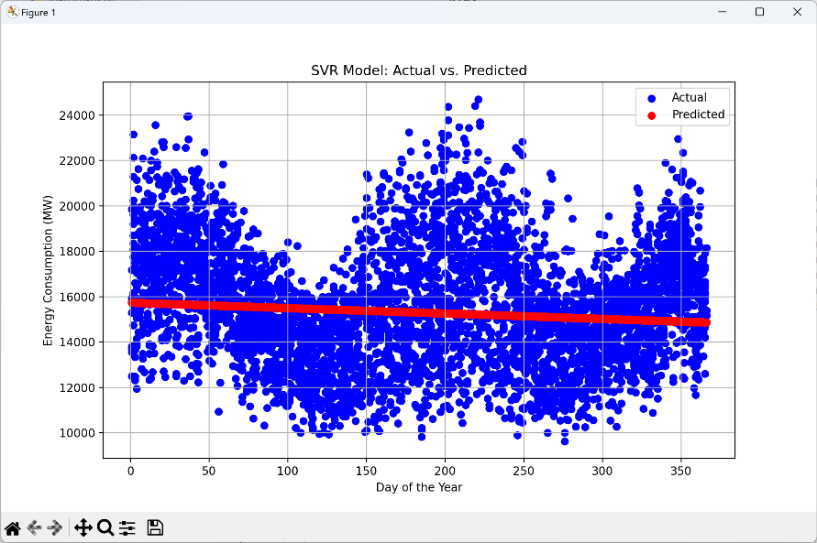

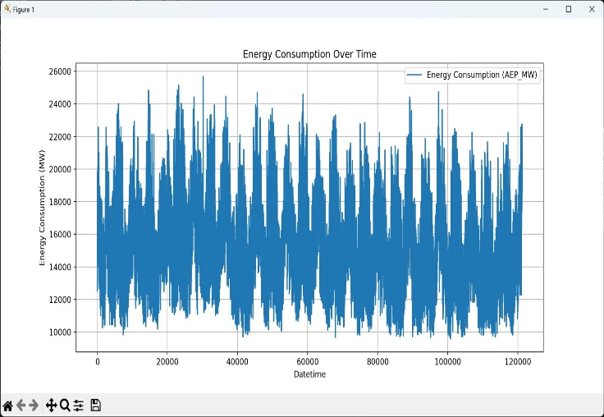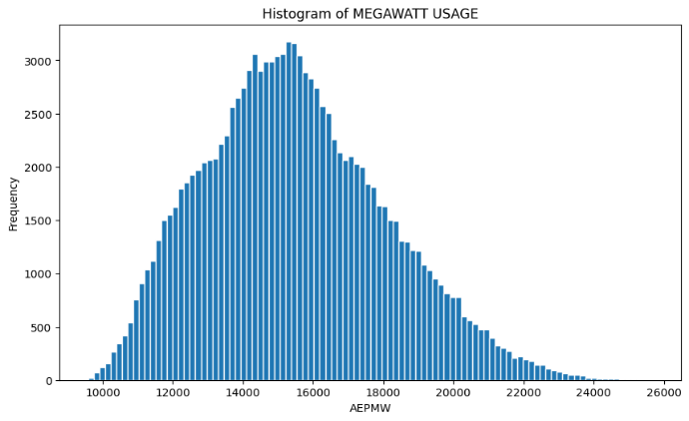

## **Support Vector Modelling:**

## Support vector modelling is a machine learning technique for classification or regression.

## It finds a hyperplane that separates the data into classes or predicts the output.

## In Python, you can use Scikit-Learn to implement it.

## to use it one must know how to validate and evaluate the performance of support vector models.

##### 

##### **Conclusion & Future work:**

⦁ The development of measuring energy consumption begins with the data cleaning and analysis.

⦁ Data cleaning encompasses the treatment of missing values and the removal of duplicate entries, ensuring a complete and unique dataset.

⦁ The subsequent data analysis unveils valuable insights by computing summary statistics and examining class distribution.

⦁ The data visualization gives a visual output in terms of plots which are very human understandable and comparable with other data.

⦁ The subsequent Support vector modelling and training enables you to model and train your machine for the particular dataset and provide a reliable prediction system.