CPE301 – SPRING 2019

Design Assignment X

Student Name: Jeb Marinas

Student #:5003376451

Student Email: marinj4@unlv.nevada.edu

Primary Github address:github.com/jebmarinas

Directory:

Submit the following for all Labs:

1. In the document, for each task submit the modified or included code (only) with highlights and justifications of the modifications. Also, include the comments.
2. Use the previously create a Github repository with a random name (no CPE/301, Lastname, Firstname). Place all labs under the root folder ESD301/DA, sub-folder named LABXX, with one document and one video link file for each lab, place modified asm/c files named as LabXX-TYY.asm/c.
3. If multiple asm/c files or other libraries are used, create a folder LabXX-TYY and place these files inside the folder.
4. The folder should have a) Word document (see template), b) source code file(s) and other include files, c) text file with youtube video links (see template).

1. **COMPONENTS LIST AND CONNECTION BLOCK DIAGRAM w/ PINS**

Atmega328pb

FTDI chip

LM34

1. **INITIAL/MODIFIED/DEVELOPED CODE OF TASK 1/A**
2. #define *F_CPU* 16000000UL
3. #define BAUD 9600
4. #include <avr/io.h>
5. #include <util/delay.h>
6. #include <avr/interrupt.h>
7. #include <util/setbaud.h>
8. #include <stdio.h>
9. volatile *uint8_t* of;
10. volatile float adc_temp;
11. void usart_init(void)
12. {
13. UBRR0H = *UBRRH_VALUE*; // loads the ubrrh value into high
14. UBRR0L = *UBRRL_VALUE*;// loads the ubrr0l value into low
15. UCSR0C = _BV(UCSZ01) | _BV(UCSZ00); // 8-bit data
16. UCSR0B = _BV(RXEN0) | _BV(TXEN0);// enable RX and TX
17. }
18. void set()
19. {
20. TCCR0A = 0; // normal mode is initiated
21. TCCR0B = 0x05;// the prescaler is set to 1024
22. TCNT0 = 0x00;// initiates the counter to 0
23. TIMSK0 = (1<<TOIE0); // enable interrupt
24. sei(); // enable global interrupt
25. }
26. void usart_tx_string(char * info)
27. {
28. while((*info != '\0'))
29. {
30. while( !(UCSR0A & (1 << UDRE0)));
31. UDR0 = *info;
32. info++;
33. }
34. }
35. ISR(TIMER0_OVF_vect)
36. {
37. of++; // this will increment the overflow
38. }
39. void adc_init(void)
40. {
41. ADMUX = (0<<REFS1)| // reference selection bit
42. (1<<REFS0)| //AVCC EXTERNAL CAP AT REF
43. (0<<ADLAR)| //ADC LEFT ADJUST RESULT
44. (1<<MUX2)| //ANALOG CHANNEL SELECTION BITS
45. (0<<MUX1)| //ADC
46. (0<<MUX0);
47. ADCSRA = (1<<ADEN)| // ADC ENABLE
48. (0<<ADSC)| // ADC START CONVERSION
49. (0<<ADATE)| // ADC AUTO TRIGGER ENABLE
50. (0<<ADIF)| // ADC INTERRUPT ENABLE
51. (0<<ADIE)|// ADC PRESCALER SELECT BIT
52. (1<<ADPS2)|
53. (1<<ADPS1)|
54. (1<<ADPS0); // SELECT CHANNEL
55. }
56. void read_adc(void)
57. {
58. unsigned char i = 4;
59. adc_temp = 0;
60. while(i--)
61. {
62. ADCSRA |=(1<<ADSC);
63. while(ADCSRA & (1<<ADSC));
64. adc_temp += ADC;
65. *_delay_ms*(50);
66. }
67. adc_temp = (adc_temp/4);
68. }
69. int main(void)
70. {
71. usart_init();
72. set();
73. adc_init();
75. char c[20];
76. while(1)
77. {
78. while(of < 61);
79. read_adc();
80. *snprintf*(c,sizeof(c), "%f\r\n", adc_temp);
81. usart_tx_string(c);
82. usart_tx_string("\n");
83. of = 0;
84. }
85. }

**SCHEMATICS**

1. **SCREENSHOTS OF EACH TASK OUTPUT (ATMEL STUDIO OUTPUT)**

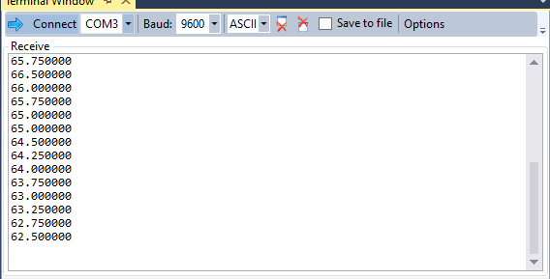

1. **SCREENSHOT OF EACH DEMO (BOARD SETUP)**

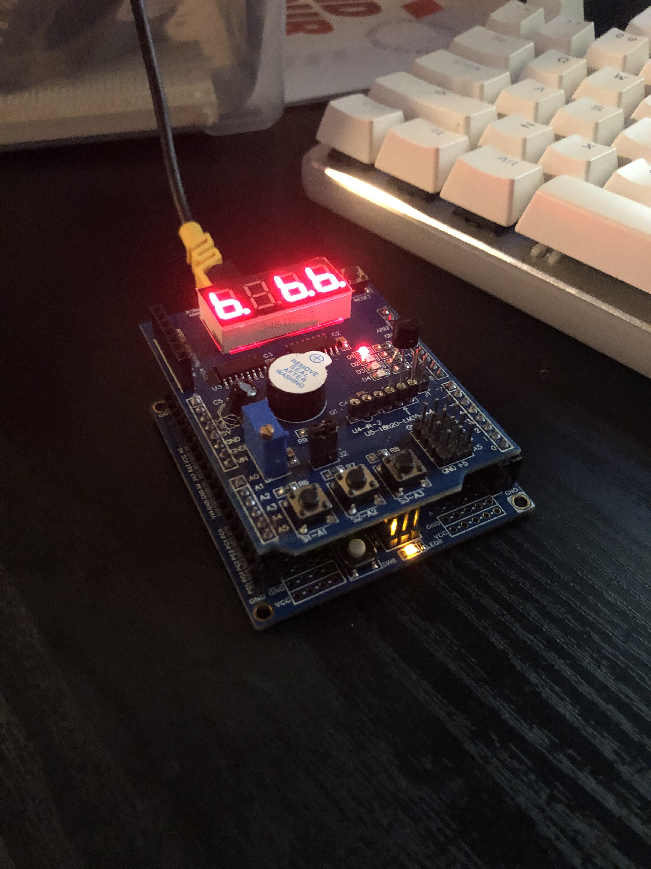

1. **VIDEO LINKS OF EACH DEMO**

<https://www.youtube.com/watch?v=O5QHUHwZO6E>

1. **GITHUB LINK OF THIS DA**

<https://github.com/jebmarinas/cpe301/tree/master/hw3b>

**Student Academic Misconduct Policy**

<http://studentconduct.unlv.edu/misconduct/policy.html>

“This assignment submission is my own, original work”.

NAME OF THE STUDENT