CPE403 – Advanced Embedded Systems

# Design Assignment # 1

DO NOT REMOVE THIS PAGE DURING SUBMISSION:

Name: Jeb Marinas

Email:marinj4@unlv.nevada.edu

Github Repository link (root): https://github.com/jebmarinas/Micro_projects

Youtube Playlist link (root): https://youtube.com/channel/UC4UYhdLZJwQUP_ce9kvbNMg

**Follow the submission guideline to be awarded points for this Assignment.**

Submit the following for all Assignments:

1. In the document, for each task submit the modified or included code (from the base code) with highlights and justifications of the modifications. Also include the comments. If no base code is provided, submit the base code for the first task only.
2. Create a private Github repository with a random name (no CPE/403, Lastname, Firstname). Place all labs under the root folder TIVAC, sub-folder named Assignment1, with one document and one video link file for each lab, place modified c files named as asng_taskxx.c.
3. If multiple c files or other libraries are used, create a folder asng1_t01 and place these files inside the folder.
4. The folder should have a) Word document (see template), b) source code file(s) with startup_ccs.c and other include files, c) text file with youtube video links (see template).
5. Submit the doc file in canvas before the due date. The root folder of the github assignment directory should have the documentation and the text file with youtube video links.
6. Organize your youtube videos as playlist under the name “cpe403”. The playlist should have the video sequence arranged as submission or due dates.
7. Only submit pdf documents. Do not forget to upload this document in the github repository and in the canvas submission portal.
8. Code for Tasks. for each task submit the modified or included code (from the base code) with highlights and justifications of the modifications. Also include the comments. If no base code is provided, submit the base code for the first task only. Use separate page for each task.

Task1:

1. /*
2. * TIVAC Assignment 1 - Task 1
3. * 1) Display device temperature every 0.5s
4. * 2) Toggle RGB LEDs using PF0
5. */
6. **#include** <stdint.h>
7. **#include** <stdbool.h>
8. **#include** "inc/hw_memmap.h"
9. **#include** "inc/hw_types.h"
10. //#include "inc/hw_ints.h"
11. **#include** "inc/tm4c123gh6pm.h"
12. **#include** "driverlib/gpio.h"
13. **#include** "driverlib/pin_map.h"
14. **#include** "driverlib/sysctl.h"
15. **#include** "driverlib/uart.h"
16. **#include** "driverlib/interrupt.h"
17. **#include** "driverlib/timer.h"
18. **#include** "driverlib/debug.h"
19. **#include** "driverlib/adc.h"
20. **#include** "driverlib/sysctl.h"
21. **#include** "utils/uartstdio.h"
22. **#include** <string.h>
23. **#ifdef** DEBUG
24. void__error__(**char** *pcFilename, uint32_t ui32Line)
25. {
26. }
27. **#endif**
28. // Globals
29. uint32_t ui32Period;
30. **char** buffer[4];
31. uint32_t ui32ADC0Value[4];
32. **volatile** uint32_t ui32TempAvg;
33. **volatile** uint32_t ui32TempValueC;
34. **volatile** uint32_t ui32TempValueF;
35. **void** **ConfigurePORT**(**void**);
36. // Timer 1 ISR
37. **void** **Timer1IntHandler**(**void**)
38. {
39. // Clear the timer interrupt
40. **TimerIntClear**(TIMER1_BASE, TIMER_TIMA_TIMEOUT);
41. **ADCIntClear**(ADC0_BASE, 2);
42. **ADCProcessorTrigger**(ADC0_BASE, 2);
43. **ADCSequenceDataGet**(ADC0_BASE, 2, ui32ADC0Value);
44. ui32TempAvg = (ui32ADC0Value[0] + ui32ADC0Value[1] + ui32ADC0Value[2] + ui32ADC0Value[3] + 2)/4;
45. ui32TempValueC = (1475 - ((2475 * ui32TempAvg)) / 4096)/10;
46. ui32TempValueF = ((ui32TempValueC * 9) + 160) / 5;
47. **UARTprintf**("C %3d\t",ui32TempValueC );
48. **UARTprintf**("F %3d\t",ui32TempValueF );
49. **UARTprintf**("\n");
50. }
51. **int** **main**(**void**) {
52. // Configure Clock
53. **SysCtlClockSet**(SYSCTL_SYSDIV_4 | SYSCTL_USE_PLL | SYSCTL_OSC_MAIN | SYSCTL_XTAL_16MHZ);
54. // Configure peripherals
55. **SysCtlPeripheralEnable**(SYSCTL_PERIPH_UART0);
56. **SysCtlPeripheralEnable**(SYSCTL_PERIPH_GPIOA);
57. **SysCtlPeripheralEnable**(SYSCTL_PERIPH_TIMER1); // Enabling Timer 1
58. ConfigurePORT();
59. // Configure ADC
60. **SysCtlPeripheralEnable**(SYSCTL_PERIPH_ADC0);
61. **ADCHardwareOversampleConfigure**(ADC0_BASE, 32);
62. **ADCSequenceConfigure**(ADC0_BASE, 2, ADC_TRIGGER_PROCESSOR, 0); // Changed to sequencer #2
63. **ADCSequenceStepConfigure**(ADC0_BASE, 2, 0, ADC_CTL_TS);
64. **ADCSequenceStepConfigure**(ADC0_BASE, 2, 1, ADC_CTL_TS);
65. **ADCSequenceStepConfigure**(ADC0_BASE, 2, 2, ADC_CTL_TS);
66. **ADCSequenceStepConfigure**(ADC0_BASE, 2, 3, ADC_CTL_TS|ADC_CTL_IE|ADC_CTL_END);
67. **ADCSequenceEnable**(ADC0_BASE, 2);
68. //register the interrupt handler for PF0
69. // GPIOIntRegister(GPIO_PORTF_BASE, GPIOF0IntHandler);
70. //SW2 goes low when pressed
71. **GPIOIntTypeSet**(GPIO_PORTF_BASE, GPIO_PIN_0, GPIO_FALLING_EDGE);
72. // Configure Timer 1 module
73. **TimerConfigure**(TIMER1_BASE, TIMER_CFG_PERIODIC);
74. ui32Period = **SysCtlClockGet**()/2; // Period of 0.5s 2Hz
75. **TimerLoadSet**(TIMER1_BASE, TIMER_A, ui32Period -1);
76. **IntEnable**(INT_TIMER1A);
77. **TimerIntEnable**(TIMER1_BASE, TIMER_TIMA_TIMEOUT);
78. // Configure pins for UART
79. //GPIOPinConfigure(GPIO_PA0_U0RX);
80. **GPIOPinConfigure**(GPIO_PA1_U0TX);
81. **GPIOPinTypeUART**(GPIO_PORTA_BASE, GPIO_PIN_0 | GPIO_PIN_1);
82. **UARTClockSourceSet**(UART0_BASE, UART_CLOCK_PIOSC);
83. **UARTStdioConfig**(0, 115200, 16000000);
84. // Enable interrupts
85. **IntMasterEnable**();
86. **GPIOIntEnable**(GPIO_PORTF_BASE, GPIO_PIN_0);
87. **TimerEnable**(TIMER1_BASE, TIMER_A);
88. **ADCSequenceEnable**(ADC0_BASE, 2);
89. // Initial message to terminal display
90. **UARTprintf**("Temperature:\n");
91. **while** (1){};
92. }
93. **void** **ConfigurePORT**(**void**)
94. {
95. //Port configuration (LEDS)
96. //Enable GPIOF port
97. **SysCtlPeripheralEnable**(SYSCTL_PERIPH_GPIOF);
98. //set LEDS connected to pins as outputs
99. **GPIOPinTypeGPIOOutput**(GPIO_PORTF_BASE, GPIO_PIN_1|GPIO_PIN_2|GPIO_PIN_3);
100. //Unlock Pin F0 to use an interrupt on SW2
101. SYSCTL_RCGC2_R |= 0x00000020; // activate clock for Port F
102. GPIO_PORTF_LOCK_R = 0x4C4F434B; // unlock GPIO Port F
103. GPIO_PORTF_CR_R = 0x1F; // allow changes to PF4-0
104. // only PF0 needs to be unlocked, other bits can't be locked
105. GPIO_PORTF_AMSEL_R = 0x00; // disable analog on PF
106. GPIO_PORTF_PCTL_R = 0x00000000; // PCTL GPIO on PF4-0
107. GPIO_PORTF_DIR_R = 0x0E; // PF4,PF0 in, PF3-1 out
108. GPIO_PORTF_AFSEL_R = 0x00; // disable alt funct on PF7-0
109. GPIO_PORTF_PUR_R = 0x11; // enable pull-up on PF0 and PF4
110. GPIO_PORTF_DEN_R = 0x1F; // enable digital I/O on PF4-0
111. }

**Task 2:**

**#include** <stdint.h>

**#include** <stdbool.h>

**#include** "inc/hw_types.h"

**#include** "inc/hw_memmap.h"

**#include** "inc/tm4c123gh6pm.h"

**#include** "driverlib/sysctl.h"

**#include** "driverlib/gpio.h"

**#include** "driverlib/pin_map.h"

**#include** "driverlib/timer.h"

**#include** "driverlib/uart.h"

**#include** "driverlib/adc.h"

**#include** "utils/uartstdio.h"

**#include** "driverlib/interrupt.h"

//********************

**typedef** **struct**{

uint32_t adcBuffer[4];

uint32_t AVG;

uint32_t C;

uint32_t F;

}Temp_t;

**typedef** **enum**{

*WAIT*,

*RED*, *BLUE*, *GREEN*,

*red*, *blue*, *green*,

*TEMP*,

*temp*,

*STAT*

}State_enum;

**typedef** **struct**{

**unsigned** **char** input;

}UART_t;

**void** **check_status**(uint32_t status, **const** **char**\* string);

**void** **send_status**(**const** **char**\* string, **bool** status);

**void** **calculate_avg_temperature**(Temp_t *temp_t);

//*******************

**#define** GREEN_LED GPIO_PIN_3

**#define** BLUE_LED GPIO_PIN_2

**#define** RED_LED GPIO_PIN_1

//*******************

**int** **main**(**void**)

{

//Config System Clock

**SysCtlClockSet**(SYSCTL_SYSDIV_5 | SYSCTL_XTAL_16MHZ | SYSCTL_USE_PLL | SYSCTL_OSC_MAIN );

Temp_t temp_t;

**volatile** **unsigned** **char** status_of_leds;

**volatile** State_enum state, nextState = *WAIT*;

**volatile** UART_t uart_t;

**volatile** uint32_t period;

//Config UART

**SysCtlPeripheralEnable**(SYSCTL_PERIPH_GPIOA);

**SysCtlPeripheralEnable**(SYSCTL_PERIPH_UART0);

**GPIOPinConfigure**(GPIO_PA0_U0RX);

**GPIOPinConfigure**(GPIO_PA1_U0TX);

**GPIOPinTypeUART**(GPIO_PORTA_BASE, GPIO_PIN_0 | GPIO_PIN_1);

**UARTStdioConfig**(0, 115200, **SysCtlClockGet**());

//

//Config ADC

**SysCtlPeripheralEnable**(SYSCTL_PERIPH_ADC0);

**ADCSequenceConfigure**(ADC0_BASE, 1, ADC_TRIGGER_PROCESSOR, 0);

**ADCSequenceStepConfigure**(ADC0_BASE, 1, 0, ADC_CTL_TS);

**ADCSequenceStepConfigure**(ADC0_BASE, 1, 1, ADC_CTL_TS);

**ADCSequenceStepConfigure**(ADC0_BASE, 1, 2, ADC_CTL_TS);

**ADCSequenceStepConfigure**(ADC0_BASE, 1, 3, ADC_CTL_TS | ADC_CTL_END | ADC_CTL_IE);

**ADCSequenceEnable**(ADC0_BASE, 1);

//Config LEDs

**SysCtlPeripheralEnable**(SYSCTL_PERIPH_GPIOF);

**GPIOPinTypeGPIOOutput**(GPIO_PORTF_BASE, GPIO_PIN_1 | GPIO_PIN_2 | GPIO_PIN_3);

**GPIOPadConfigSet**(GPIO_PORTF_BASE, GPIO_PIN_1 | GPIO_PIN_2 | GPIO_PIN_3, GPIO_STRENGTH_2MA, GPIO_PIN_TYPE_STD_WPU);

//Next State for UI

**while**(1)

{

**if**(state == *WAIT*)

{

**while**(!**UARTCharsAvail**(UART0_BASE)){};

uart_t.input = **UARTCharGet**(UART0_BASE);

**if**(uart_t.input == 'R') state = *RED*;

**else** **if**(uart_t.input == 'B') state = *BLUE*;

**else** **if**(uart_t.input == 'G') state = *GREEN*;

**else** **if**(uart_t.input == 'r') state = *red*;

**else** **if**(uart_t.input == 'b') state = *blue*;

**else** **if**(uart_t.input == 'g') state = *green*;

**else** **if**(uart_t.input == 'T') state = *TEMP*;

**else** **if**(uart_t.input == 't') state = *temp*;

**else** **if**(uart_t.input == 'S') state = *STAT*;

}

**else** **if**(state == *RED*){

**GPIOPinWrite**(GPIO_PORTF_BASE, RED_LED, RED_LED);

}

**else** **if**(state == *red*){

**GPIOPinWrite**(GPIO_PORTF_BASE, RED_LED, RED_LED);

}

**else** **if**(state == *BLUE*){

**GPIOPinWrite**(GPIO_PORTF_BASE, RED_LED, 0);

}

**else** **if**(state == *blue*){

**GPIOPinWrite**(GPIO_PORTF_BASE, BLUE_LED, BLUE_LED);

}

**else** **if**(state == *GREEN*){

**GPIOPinWrite**(GPIO_PORTF_BASE, BLUE_LED, 0);

}

**else** **if**(state == *green*){

**GPIOPinWrite**(GPIO_PORTF_BASE,GREEN_LED, GREEN_LED);

}

**else** **if**(state == *TEMP*){

calculate_avg_temperature(&temp_t);

**UARTprintf**("C %3d\t", temp_t.C);

**UARTprintf**("\n");

}

**else** **if**(state == *temp*){

calculate_avg_temperature(&temp_t);

**UARTprintf**("C %3d\t", temp_t.F);

**UARTprintf**("\n");

}

**else** **if**(state == *STAT*){

status_of_leds = **GPIOPinRead**(GPIO_PORTF_BASE, RED_LED | BLUE_LED | GREEN_LED);

check_status((status_of_leds&RED_LED) >> 1, "Red: ");

check_status((status_of_leds&BLUE_LED) >> 2, "Blue: ");

check_status((status_of_leds&GREEN_LED) >> 3, "Green: ");

}

state = *WAIT*;

}

}

**void** **check_status**(uint32_t status, **const** **char**\* string){

**if**(status)

send_status(string, 1);

**else**

send_status(string, 0);

}

**void** **send_status** (**const** **char**\* string, **bool** status){

**UARTprintf**(string);

**if**(status)

**UARTprintf**("ON");

**else**

**UARTprintf**("OFF");

**UARTprintf**("\n");

}

//Calculate the average

**void** **calculate_avg_temperature**(Temp_t *temp_t){

//Trigger ADC and wait for interrupt

**ADCProcessorTrigger**(ADC0_BASE, 1);

**while**(!**ADCIntStatus**(ADC0_BASE, 1, **false**)){};

**ADCIntClear**(ADC0_BASE, 1);

**ADCSequenceDataGet**(ADC0_BASE, 1, temp_t->adcBuffer);

//Calculate Average

temp_t->AVG = (temp_t->adcBuffer[0] + temp_t->adcBuffer[1] + temp_t->adcBuffer[2] + temp_t->adcBuffer[3])/4;

temp_t->C = (1475 - ((2475 * temp_t->AVG)) / 4096)/10;

temp_t->F = ((temp_t->C * 9) + 160) / 5;

}

**Task 3:**

**#include** "inc/tm4c123gh6pm.h"

**#include** <stdbool.h>

**#include** <stdint.h>

**#include** "inc/hw_ints.h"

**#include** "inc/hw_memmap.h"

**#include** "inc/hw_adc.h"

**#include** "inc/hw_types.h"

**#include** "inc/hw_udma.h"

**#include** "driverlib/adc.h"

**#include** "driverlib/debug.h"

**#include** "driverlib/gpio.h"

**#include** "driverlib/interrupt.h"

**#include** "driverlib/pin_map.h"

**#include** "driverlib/rom.h"

**#include** "driverlib/rom_map.h"

**#include** "driverlib/sysctl.h"

**#include** "driverlib/systick.h"

**#include** "driverlib/timer.h"

**#include** "driverlib/uart.h"

**#include** "driverlib/udma.h"

**#include** "utils/uartstdio.h"

**#define** ADC_SAMPLE_BUF_SIZE 1

**#if** defined(ewarm)

**#pragma** data_alignment=1024

uint8_t pui8ControlTable[1024];

**#elif** defined(ccs)

**#pragma** DATA_ALIGN(pui8ControlTable, 1024)

uint8_t pui8ControlTable[1024];

**#else**

uint8_t pui8ControlTable[1024] **__attribute__** ((aligned(1024)));

**#endif**

//Structs

**enum** BUFFER_STATUS

{

*EMPTY*,

*FULL*

};

**typedef** **struct**{

uint16_t adcBuffer[ADC_SAMPLE_BUF_SIZE];

uint32_t AVG;

uint32_t C;

uint32_t F;

}Temp_t;

**typedef** **enum**{

*WAIT*,

*RED*, *BLUE*, *GREEN*,

*red*, *blue*, *green*,

*TEMP*,

*temp*,

*STAT*

}State_enum;

**typedef** **struct**{

**unsigned** **char** input;

}UART_t;

///////////////////////////////////////////

//Variables

**volatile** **static** **enum** BUFFER_STATUS BufferStatus;

**volatile** Temp_t temp_t;

**volatile** uint32_t Count;

///////////////////////////////////////////

//Prototype

**void** **CalculateTemperatureAvg**(**void**);

**void** **ConfigureUART**(**void**);

**void** **ConfigureADC**(**void**);

**void** **ConfigureUDMA**(**void**);

**void** **check_status**(uint32_t status, **const** **char**\* string);

**void** **send_status**(**const** **char**\* string, **bool** status);

///////////////////////////////////////////

**#define** GREEN_LED GPIO_PIN_3

**#define** BLUE_LED GPIO_PIN_2

**#define** RED_LED GPIO_PIN_1

///////////////////////////////////////////

**int** **main**(**void**){

**SysCtlClockSet**(SYSCTL_SYSDIV_2_5 | SYSCTL_USE_PLL | SYSCTL_OSC_INT | SYSCTL_XTAL_16MHZ);

**volatile** **unsigned** **char** status_of_leds;

**volatile** State_enum state, nextState = *WAIT*;

**volatile** UART_t uart_t;

BufferStatus = *EMPTY*;

**SysCtlPeripheralEnable**(SYSCTL_PERIPH_ADC0);

**SysCtlPeripheralEnable**(SYSCTL_PERIPH_UDMA);

//Config LEDs

**SysCtlPeripheralEnable**(SYSCTL_PERIPH_GPIOF);

**GPIOPinTypeGPIOOutput**(GPIO_PORTF_BASE, GPIO_PIN_1 | GPIO_PIN_2 | GPIO_PIN_3);

**GPIOPadConfigSet**(GPIO_PORTF_BASE, GPIO_PIN_1 | GPIO_PIN_2 | GPIO_PIN_3, GPIO_STRENGTH_2MA, GPIO_PIN_TYPE_STD_WPU);

ConfigureUART();

ConfigureUDMA();

ConfigureADC();

**IntMasterEnable**();

**while**(1)

{

**if**(state == *WAIT*)

{

**while**(!**UARTCharsAvail**(UART0_BASE)){};

uart_t.input = **UARTCharGet**(UART0_BASE);

**if**(uart_t.input == 'R') state = *RED*;

**else** **if**(uart_t.input == 'B') state = *BLUE*;

**else** **if**(uart_t.input == 'G') state = *GREEN*;

**else** **if**(uart_t.input == 'r') state = *red*;

**else** **if**(uart_t.input == 'b') state = *blue*;

**else** **if**(uart_t.input == 'g') state = *green*;

**else** **if**(uart_t.input == 'T') state = *TEMP*;

**else** **if**(uart_t.input == 't') state = *temp*;

**else** **if**(uart_t.input == 'S') state = *STAT*;

}

**else** **if**(state == *RED*){

**GPIOPinWrite**(GPIO_PORTF_BASE, RED_LED, RED_LED);

}

**else** **if**(state == *red*){

**GPIOPinWrite**(GPIO_PORTF_BASE, RED_LED, RED_LED);

}

**else** **if**(state == *BLUE*){

**GPIOPinWrite**(GPIO_PORTF_BASE, RED_LED, 0);

}

**else** **if**(state == *blue*){

**GPIOPinWrite**(GPIO_PORTF_BASE, BLUE_LED, BLUE_LED);

}

**else** **if**(state == *GREEN*){

**GPIOPinWrite**(GPIO_PORTF_BASE, BLUE_LED, 0);

}

**else** **if**(state == *green*){

**GPIOPinWrite**(GPIO_PORTF_BASE,GREEN_LED, GREEN_LED);

}

**else** **if**(state == *TEMP*){

calculate_avg_temperature(&temp_t);

**UARTprintf**("C %3d\t", temp_t.C);

**UARTprintf**("\n");

}

**else** **if**(state == *temp*){

calculate_avg_temperature(&temp_t);

**UARTprintf**("C %3d\t", temp_t.F);

**UARTprintf**("\n");

}

**else** **if**(state == *STAT*){

status_of_leds = **GPIOPinRead**(GPIO_PORTF_BASE, RED_LED | BLUE_LED | GREEN_LED);

check_status((status_of_leds&RED_LED) >> 1, "Red: ");

check_status((status_of_leds&BLUE_LED) >> 2, "Blue: ");

check_status((status_of_leds&GREEN_LED) >> 3, "Green: ");

}

state = *WAIT*;

}

}

}

**void** **check_status**(uint32_t status, **const** **char**\* string){

**if**(status)

send_status(string, 1);

**else**

send_status(string, 0);

}

**void** **send_status** (**const** **char**\* string, **bool** status){

**UARTprintf**(string);

**if**(status)

**UARTprintf**("ON");

**else**

**UARTprintf**("OFF");

**UARTprintf**("\n");

}

**void** **CalculateTemperatureAvg**(**void**){

**ADCProcessorTrigger**(ADC0_BASE, 0);

**while**(BufferStatus == *EMPTY*){};

temp_t.AVG = 0;

**for**(Count = 0; Count < ADC_SAMPLE_BUF_SIZE; Count++)

{

temp_t.AVG += temp_t.adcBuffer[Count];

temp_t.adcBuffer[Count] = 0;

}

BufferStatus = *EMPTY*;

uDMAChannelTransferSet(UDMA_CHANNEL_ADC0 | UDMA_PRI_SELECT,

UDMA_MODE_BASIC,

(**void** *)(ADC0_BASE + ADC_O_SSFIFO0),

&temp_t.adcBuffer, ADC_SAMPLE_BUF_SIZE);

**uDMAChannelEnable**(UDMA_CHANNEL_ADC0 | UDMA_PRI_SELECT);

temp_t.AVG = ((temp_t.AVG +

(ADC_SAMPLE_BUF_SIZE / 2)) /

ADC_SAMPLE_BUF_SIZE);

temp_t.C = (1475 - ((2475 * temp_t.AVG)) / 4096)/10;

temp_t.F = ((temp_t.C * 9) + 160) / 5;

}

**void** **ConfigureUART**(**void**){

**SysCtlPeripheralEnable**(SYSCTL_PERIPH_GPIOA);

**SysCtlPeripheralEnable**(SYSCTL_PERIPH_UART0);

**GPIOPinConfigure**(GPIO_PA0_U0RX);

**GPIOPinConfigure**(GPIO_PA1_U0TX);

**GPIOPinTypeUART**(GPIO_PORTA_BASE, GPIO_PIN_0 | GPIO_PIN_1);

**UARTStdioConfig**(0, 115200, **SysCtlClockGet**());

}

**void** **ConfigureADC**(**void**){

**IntDisable**(INT_ADC0SS0);

**ADCIntDisable**(ADC0_BASE, 0);

**ADCSequenceDisable**(ADC0_BASE, 0);

**ADCSequenceConfigure**(ADC0_BASE, 0, ADC_TRIGGER_PROCESSOR, 0);

**ADCSequenceStepConfigure**(ADC0_BASE, 0, 0, ADC_CTL_TS | ADC_CTL_END |

ADC_CTL_IE);

**ADCSequenceEnable**(ADC0_BASE, 0);

**ADCIntClear**(ADC0_BASE, 0);

**ADCSequenceDMAEnable**(ADC0_BASE, 0);

**ADCIntEnable**(ADC0_BASE, 0);

**IntEnable**(INT_ADC0SS0);

}

**void** **ConfigureUDMA**(**void**){

**uDMAEnable**();

**uDMAControlBaseSet**(pui8ControlTable);

**uDMAChannelAttributeDisable**(UDMA_CHANNEL_ADC0,

UDMA_ATTR_ALTSELECT | UDMA_ATTR_HIGH_PRIORITY |

UDMA_ATTR_REQMASK);

**uDMAChannelControlSet**(UDMA_CHANNEL_ADC0 | UDMA_PRI_SELECT, UDMA_SIZE_16 |

UDMA_SRC_INC_NONE | UDMA_DST_INC_16 | UDMA_ARB_64);

uDMAChannelTransferSet(UDMA_CHANNEL_ADC0 | UDMA_PRI_SELECT,

UDMA_MODE_BASIC,

(**void** *)(ADC0_BASE + ADC_O_SSFIFO0),

&temp_t.adcBuffer, ADC_SAMPLE_BUF_SIZE);

**uDMAChannelAttributeEnable**(UDMA_CHANNEL_ADC0, UDMA_ATTR_USEBURST);

**uDMAChannelEnable**(UDMA_CHANNEL_ADC0);

}

**void** **ADCSeq0Handler**(**void**){

**ADCIntClear**(ADC0_BASE, 0);

**if** ((**uDMAChannelModeGet**(UDMA_CHANNEL_ADC0 | UDMA_PRI_SELECT) == UDMA_MODE_STOP))

{

BufferStatus = *FULL*;

}

}

Block diagram and/or Schematics showing the components, pins used, and interface.

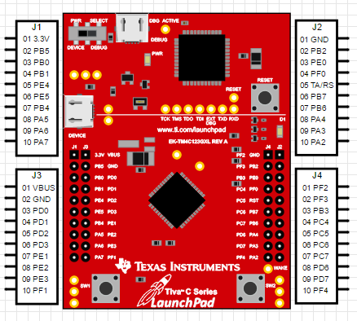

Set_up:

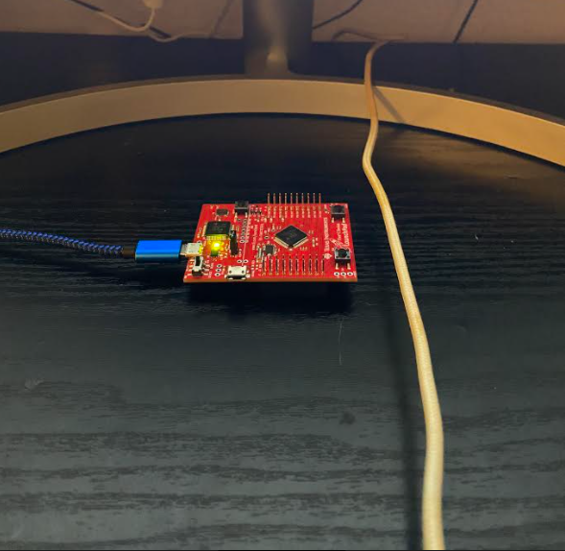

Screenshots of the IDE, physical setup, debugging process - Provide screenshot of successful compilation, screenshots of registers, variables, graphs, etc.

**Task1 compilation:**

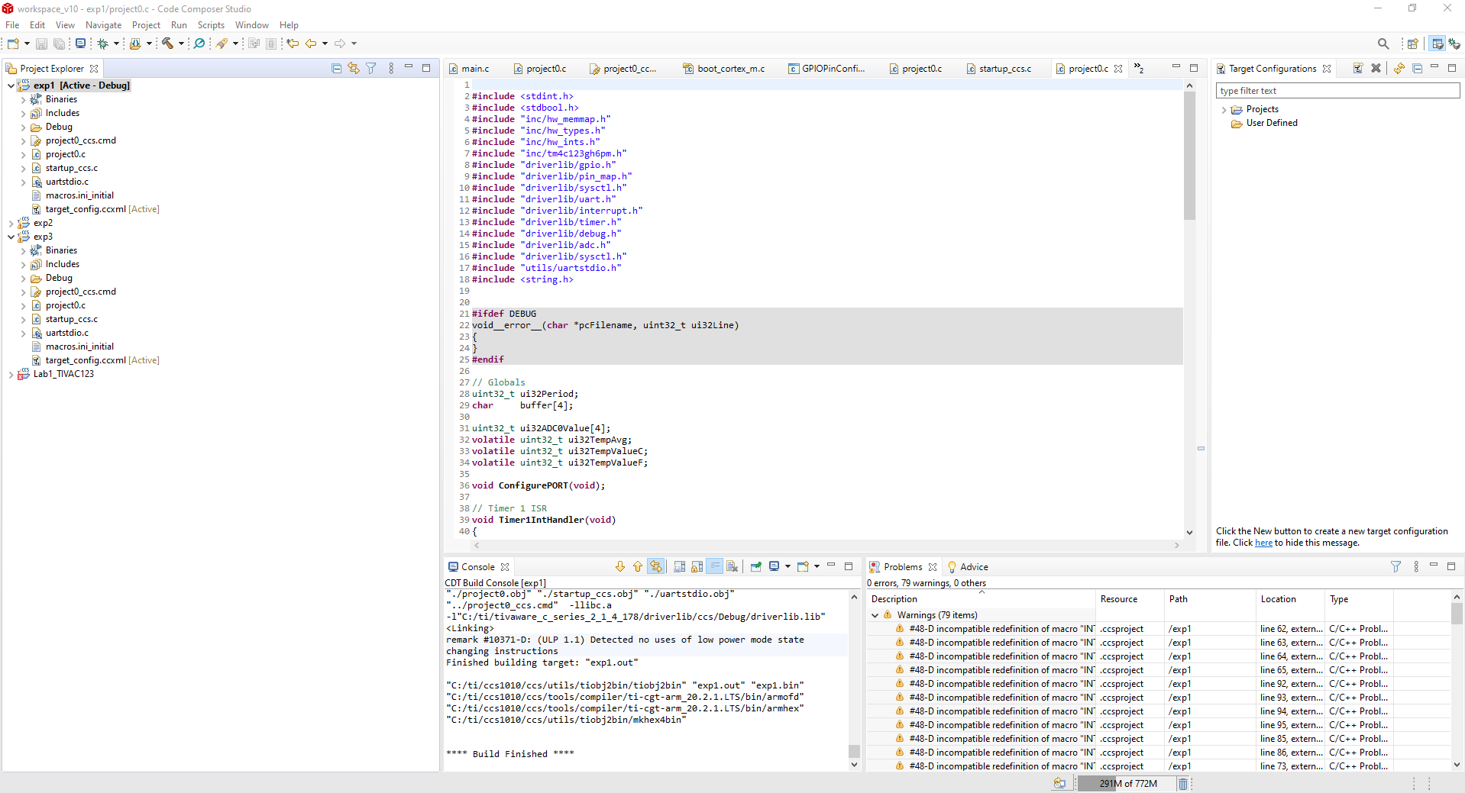

**Task2 compilation:**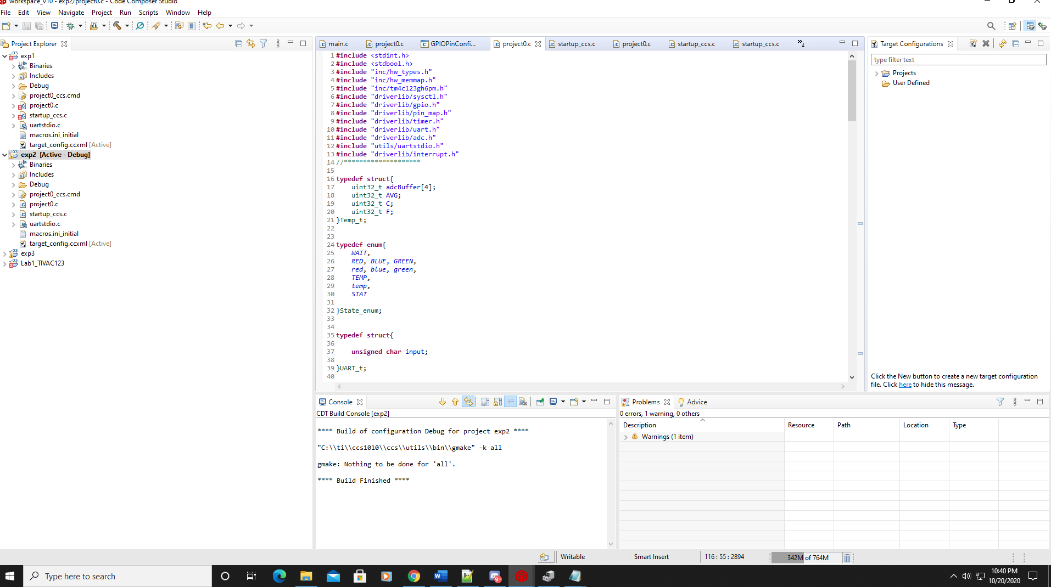

**Task3 compilation:**

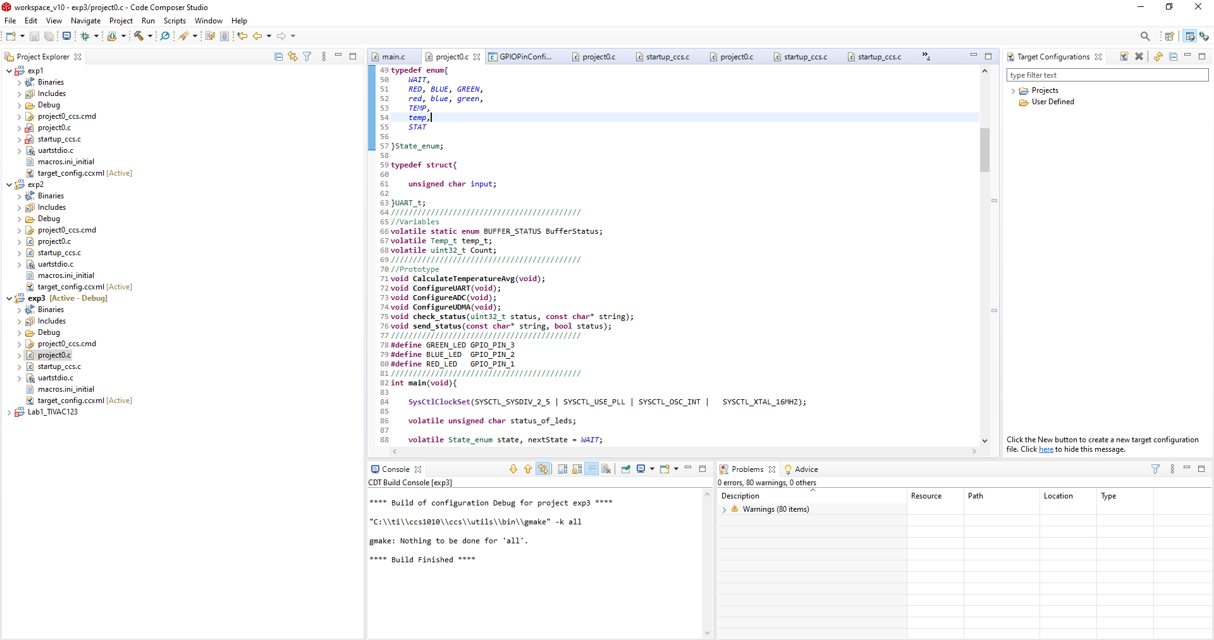

1. Declaration

I understand the Student Academic Misconduct Policy - http://studentconduct.unlv.edu/misconduct/policy.html

“This assignment submission is my own, original work”.

Name of the Student

Jeb Marinas