170822

Bleedthrough from Alexa 633 to Alexa 555

Key

**Blue cells = Alexa 488 nm → B channel**

**UV2 cells = Alexa 555 nm → Red channel**

**UV1 cells = Alexa 633 nm → Green channel**

**The problem**

We can have bleed-through in sections stained with **Alexa 633** and **Alexa 555**. This is because selecting the long-pass over the band-pass setting on the confocal microscope sets a lower threshold for what counts as signal in the long-wavelength range (the net is too big). The result? The **green channel** (stained with **Alexa 633**) infringes on areas which should only be stained in the **red channel** (stained with **Alexa 555** ). Adding to the issue, **Alexa 633** is a very efficient dye with a broad excitation range – it isn’t very picky about what counts as a true positive.

On the bright side, **Alexa 488** and **Alexa 555** have good separation. Sections stained with these dyes should produce easily distinguishable patterns of opsin expression.

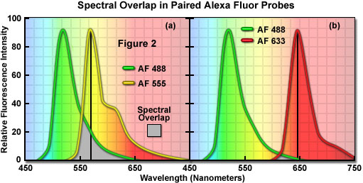

**The solution**

Use Image Math in FIJI to counter the effect of an overly grabby **Alexa 633.** Subtracting the **green channel** (**Alexa 633**) from the **red channel (Alexa 555)** reveals the true **red channel** (**Alexa 555**).

Split the image:

**Image > Color > Split channels**

Subtract the green channel from the red channel:

**Process >Image calculator** (Red on top, green on bottom)

(Another option: You can fine tune the selection. David says if R-G is too aggressive, you can do something like R-0.5*G. To tell whether R-G subtracted too liberally, he looked at the background with a false color to see if any of it was blown out by the subtraction process.)

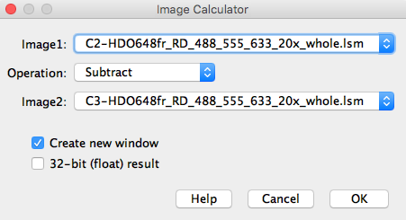

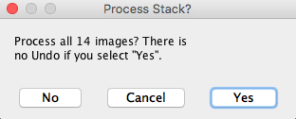

Merge the image (melds R, G, B channels into composite image):

**Image > Color > Merge channels >** Given a pop-up menu > Select image in first 3 channels and select composite

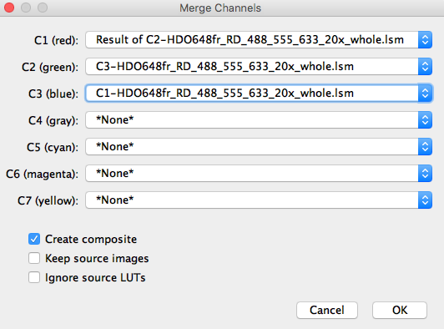

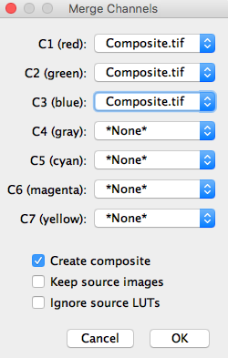

Option: To split the image into 3 separate channels (RGB) (e.g. to selectively modify one channel), use:

**Image > Colors > Split channels**

**170822 Cell count check:**

Recount ommatidia based on the new images Adriana and David processed in FIJI today.

* Copy/paste my previous count boxes so they overlap the new section. Do the cell designations line up
* Co-expression is still a possibility, but the expectation is that it will be dramatically reduced.

Specimens to use:

**HDO648fr_RD (UV1-UV2-B)**

**HDO706bf_RA (UV1-B-LW)**