**Food Web Structure as a Driver of Multiple Ecosystem Functions in New England Salt Marsh Ecosystems**

Jarrett E. K. Byrnes

University of Massachusetts Boston

**Introduction**

Salt marshes provide a number of key services to society (Zedler and Kercher 2005, Koch et al. 2009). How this provision of services will change as species are lost due to different drivers of global change is currently not well understood. As rates of extinction accelerate to match the magnitudes of geological mass extinction events (Barnosky et al. 2011), ecologists have come to understand that reductions in diversity will affect a wide variety of ecosystem functions and services in nature (Balvanera et al. 2006, Cardinale et al. 2012). Most of the work examining the consequences diversity loss has been based on the diversity of terrestrial primary producers (Cardinale et al. 2011). Moreover, work understanding the consequences of diversity loss typically functions on how losing species diversity will affect the provision of a single function or service.

In marine ecosystems such as coastal salt marshes (1) we are more likely to lose consumer species – predatory fishes, crabs, birds, etc. (Byrnes et al. 2007) and (2) we are often concerned with far more than the loss of any single function. Rather, we often want to know how the loss of species throughout an entire food web will affect an entire suite of ecosystem functions and services. **Here I propose to conduct a series of observational and manipulative experiments to examine how loss of consumer and herbivore species in salt marsh food webs alters multiple ecosystem functions.**

**Relevance to MIT Sea Grant Strategic Plan**

The health and functioning of coastal ecosystems cannot be assessed via any single function alone. A highly productive ecosystem does not guarantee that populations of commercial species are robust. A system subjected to overgrazing may still have active belowground processes leading to high carbon storage. To fully assess the effects of human change on coastal ecosystem, we need to be able to understand how drivers of change affect the simultaneous performance of multiple ecosystem functions – i.e., ecosystem multifunctionality *sensu* Byrnes et al. (In Review). Yet, the assessment of multiple ecosystem functions simultaneously into a single clear measure of ecosystem function is not straightforward (Byrnes et al. In Review).

**I propose to examine how the loss of species diversity can alter the multifunctionality – and hence the health – of coastal salt marshes in New England.** Bottom-up forcing (Valiela and Teal 1979, Fox et al. 2012) and the balance of competition and facilitation (Bertness and Hacker 1994, Bertness and Ewanchuk 2002) are strong influences in New England salt marshes. However, we have seen that the function of these ecosystems can be strongly affected by changing the abundances of both terrestrial and marine consumers (Silliman and Bertness 2002a, Holdredge et al. 2009). Rather than examine changes in abundance in any single taxa, I will investigate the consequences of extinction – i.e., reductions in diversity - across a wide range of taxa in salt marsh food webs. I will attack this problem using analytic frameworks I have developed (Byrnes et al. 2013) for the field of biodiversity and ecosystem multifunctionality research (Hector and Bagchi 2007, Zavaleta et al. 2010, Isbell et al. 2011, Gamfeldt et al. 2012).

In New England salt marshes, diversity loss might alter a wide variety of crucial ecosystem functions relating to shoreline protection, nursery habitat, runoff filtration, food for commercially important nearshore species, carbon storage and potentially others (Assessment 2005). Each of these functions is necessary for a vital and healthy salt marsh ecosystem. And yet, we do not understand how changes in the dynamic community of plants, herbivores, and predators around them can simultaneously impact all of the functions, and thus ecosystem health, together. Furthermore, across all systems, we have no studies that have examined how the loss of species at higher trophic levels impact ecosystem multifunctionality.

Additionally, the field of biodiversity and ecosystem function (Tilman et al. 1997, Hooper et al. 2005) has largely focused on how the loss of primary producers alters ecosystem function (Cardinale et al. 2011) with a far smaller number focusing on the loss of consumer diversity. The earth, however, is not composed solely of plants and algae. In particular, most marine species lost are at higher trophic levels (Byrnes et al. 2007). Salt marsh ecosystems in New England are a dynamic ecosystem, with many functions linked to the presence or absence of species at these higher trophic levels (Silliman and Bertness 2002a, Finke and Denno 2004, Bertness et al. 2008, Holdredge et al. 2009). The loss of predatory and herbivorous crabs, snails, fish, birds, spiders, flies, and other species at higher levels in salt marsh food webs could have large effects on salt marsh ecosystem function. However, attempting to understand how salt marsh ecosystem functions are altered by the simultaneous loss of species from both marine and terrestrial (Pennings et al. 2009, Lewis and Denno 2009) portions of the food web represents a novel approach to the study of this coupled ecosystem.

*The research in this proposal directly addresses the MIT Sea Grant focus area on Healthy Coastal Ecosystems. It explores* ***HCE Goal 1****: Ecosystem services are improved by enhanced health, diversity and abundance of fish, wildlife and plants. Second, its results further* ***HCE Goal 2****: Ecosystem‐based approaches are used to manage land, water and living resources. Its results will allow us to use food webs as a heuristic tool to further understand the results of management decisions. We will be able to ask how will decisions affect the shape of local food webs, and what will that mean for salt marsh ecosystem function? Last, both the databases created and the outreach activities described below contribute to MIT Sea Grant’s focus on promoting environmental literacy and education. We are committed to a robust outreach strategy that will allow more New Englanders to learn about local habitats and actively engage with the science going on in their communities.*

**Additional Scientific Rationale**

**When considering the consequences of consumer diversity loss, the field of biodiversity-ecosystem function research has to date largely failed to find general conclusions for many functions measured.** Both theoretical (Thebault and Loreau 2006) and experimental (Finke and Denno 2004, Dang et al. 2005, Byrnes et al. 2006) explorations of changes to animal diversity – be it herbivore, predator, or otherwise – have yielded wildly different predictions even for simple phenomena such as trophic cascades. At first glance this discrepancy seem to result from idiosyncrasies of manipulated species. On further examination, we have begun to discern that certain properties of food webs – the balance of generalists and specialists, the frequency of intraguild predation and omnivory, the number of trophic levels – appear to have predictable effects on the probability that extinction of animals will have cascading effects on ecosystem function (Roopnarine and Angielczyk 2011). Food web network topology, long the domain of food web network theory (Dunne 2006), appears to determine the consequences of extinction. Thus, with this work I will broaden the field of *biodiversity-ecosystem function research* to incorporate ideas from *food web network theory*, merging both into a larger synthesis.

**Research Questions & Approach**

*Q1) Who eats whom in New England salt marshes?*

As a first step in this work, we will compile a database of who eats whom in New England marshes (both marine and terrestrial). Although there has been great deal of work done to characterize isolated trophic pieces of these food webs (Pennings and Bertness 2001, Silliman and Bertness 2002b, Finke and Denno 2004, Holdredge et al. 2009, Altieri et al. 2012), no where has there been a unified collection of this information to create an ecosystem-wide food web topology. Similarly, there have been few integrated attempts to unify our understanding of how the terrestrial and marine portions of the food web are coupled. We do not have a complete picture of what New England salt marsh food webs look like in their totality nor how they may compare to other ecosystems on earth. This hinders our ability to use information from other ecosystems when making decisions about management efforts in salt marshes.

I will build a food web for New England and beyond from the literature (e.g., Bertness 1998), consulting additional experts where necessary to create a full picture of the network structure of the entire food web. Working with a graduate student, we will perform a search of the literature to determine species interactions. We will start with species lists from the Wells NERR, Plum Island LTER, and Waquoit Bay NERR. For each species we will search ISI Web of Science, Google Scholar, Avano, and Aquatic Commons. We will search each species name with the additional keywords of “diet*”, “predator”, “prey”, “gut content*”, and “feeding” (asterisks used to expand search terms). In addition, we will search these five keywords in thesis and grey literature databases at the WHOI/MBL Library and NERR and LTER thesis databases. Only feeding observations from studies that showed direct consumption (e.g., either a feeding observation in the field, gut contents, or lab preference study) or provided strong evidence of a direct feeding relationship between two taxa were used. From the academic literature, we will report feeding links from field observations, gut contents analyses, laboratory experiments (i.e., it was assumed that researchers were creating treatments from *a priori* knowledge of the natural history of organisms), or summaries of natural history information. Only field and laboratory observations with quantitative data will be used from PhD dissertations, Masters theses, and agency reports. The quality of data will likely vary by taxon and author. In many cases, diet information may taxonomically vague (e.g., “Gastropods”). We will therefore categorize the information by the level of taxonomic resolution provided in our database.

Information will be input into an online publicly available food web database that I have been creating with a team of computer science undergraduate students (<http://databaseui.herokuapp.com/>) as part of their coursework. Food Web Builder (Figure 1) allows for detailed natural history information to be input as well as verified feeding links. The system allows for observations of feeding behavior to be geospatially tagged. The database will be publically accessible once complete. Additionally, I will be working over the next year with undergraduates to create dynamic tools for visualization of these food web networks as part of their coursework, including filtering by species ranges, habitat types, and more. Once built, I will create trophic group structures *de novo* based on my results (Allesina and Pascual 2009) for use later in experiments.

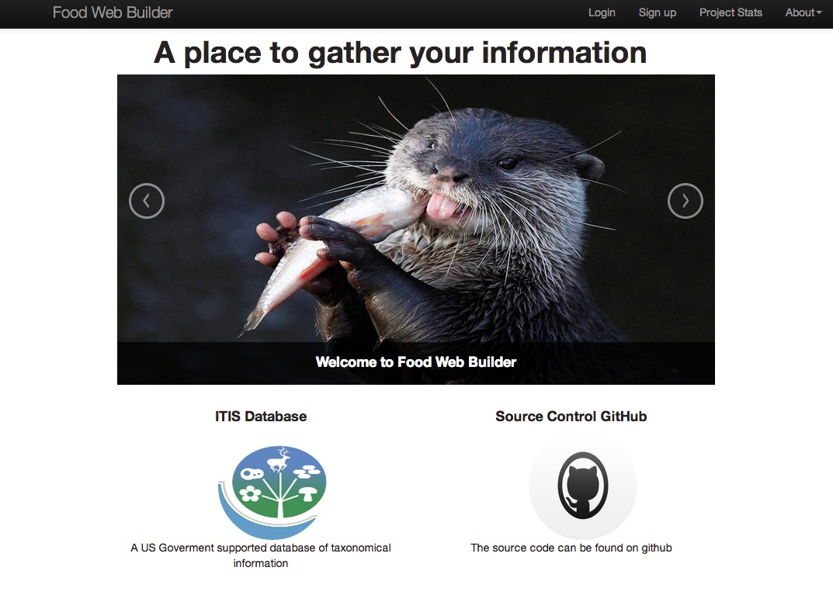*Additional Relevance to Management & Education:*All of this information will all be made publically available to anyone working in or simply interested by coastal salt marsh ecosystems via the Food Web Builder database. Managers, students, and the general public will be able to view and interact with the structure of salt marsh food webs. They will be able to look at each species and see who its predators and prey are in a single simple interface. This will enable a more complete understanding of the indirect effects of changes to any species in the system at a glance. This catalog of this underappreciated aspect of the biodiversity of New England salt marshes will fill a basic gap in our knowledge of these systems.

Figure 1: The login screen from the alpha version of food web builder. http://databaseui.herokuapp.com

Furthermore, the Food Web Builder system is being constructed so that it can be used for any system. It will be made publically available to anyone who wishes to construct a food web from the literature – from the rocky intertidal to George’s Bank to the Sahara.

*Q2) Does food web structure modify multifunctionality in tidal marsh ecosystems?*

To determine relationships between tidal marsh food web structure and multifunctionality, I will first conduct an observational study to understand the links between the two. I recognize that there are many other factors that can shape both food web structure and ecosystem function. I will therefore use a statistical modeling technique, Structure Equation Modeling (Grace et al. 2012), to cleanly separate the signal of the environment from any signal of food web structure. In addition, SEM will allow me to evaluate the direct and indirect impact of different aspects of food web structure on ecosystem multifunctionality.

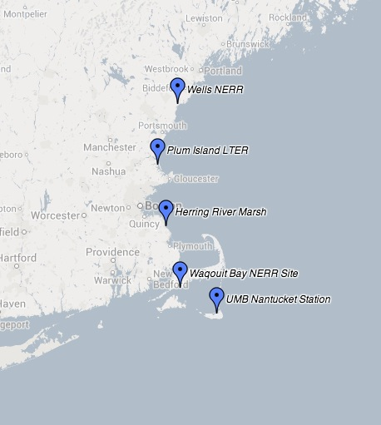Data used to parameterize models will come from surveys (Figure 2) in the Wells National Estuarine Research Reserve (NERR) in Maine, the Waquoit Bay NERR in Massachusetts, the Herring River marsh, and the UMass Boston Nantucket Field Station. This data will be supplemented by data from the two control sites in an ongoing experiment (Deegan et al. 2007, 2012) at the Plum Island Long-Term Ecological Research Site (PIE LTER). I will use multiple sites in order to sample across a wide array of abiotic conditions and food web structures.

Figure 2: Field sites for marsh survey work.

Sampling within a single site alone would not give me the relevant levels of variation to understand general salt marsh processes. Rather, the variation in abiotic conditions and food web structure will allow me to create a more robust model of how food web structure affects ecosystem function with higher statistical power to detect biologically meaningful effects. SEM functions similarly to Linear Regression when, if only a small amount of variation in variables is present, the signal of processes – even strong ones – cannot be detected due to insufficient power (Gerrodette 1987). Sites have been selected due to their geographic distance and the very different conditions – ranging from coastal embayment to offshore island – which should allow for a large amount of variation in observed variables. This will increase the power of analyses.

*Survey Design*

The goal of this survey is to characterize food web structure at a local scale – transects within a marsh – and relate those numbers to functions at the same scale. At each site I monitor, I will sample three transects over the two years (n=3 per marsh per year, total n=36 including PIE LTER sampled twice). Following the NERR vegetation sampling protocol, in each area I will place three transects running from a creek edge and end before crossing into the upland. At NERR sites, vegetation sampling is conducted on evenly spaced 1m2 quadrats along the transect line leading to 15 - 20 quadrats per area (SAV-Emergent Biomonitoring Committee 2009). I will adapt this sampling scheme to non-NERR marshes, ensuring that each transect has 9 placed in a stratified random sampling design using low, mid, and high marsh as strata. Transect lines will be placed 10m apart plus an additional 1-10m chosen randomly. Functions will be sampled in the low marsh area of each transect adjacent to creeks except where noted. By sampling in them I will not conflate elevation with distance from creek edge (i.e., depending on marsh morphology, the tall *Spartina* zone may end within one to tens of meters from a creek edge).

*Sampling Methods*

1) Vegetation – In all 1m2 quadrats I will conduct stem density counts of vascular plants, and quantify percent cover of all visible algal species.

2) Macroinvertebrates – Macroinvertebrates (primarily snails) will be visually censused in all plots. I will also enumerate invertebrates in an additional 1m2 quadrat in the creek bed at the end of each transect.

3) Highly mobile macroinvertebrates – To sample crabs and other macroinvertebrates, I will place 2 baited 24”x18”x18” Promar crab traps on each transect at the creek edge. I will empty and count the traps after each tide high tide for three tide cycles to evaluate average crab abundance.

4) Insect communities – To sample insects (Robinson et al. 2011) I will place five sticky traps and pit traps evenly spaced along each transect during a single low tide. Pit (cylindrical 11cm traps in the sediment) and sticky traps (Tanglefoot on 20cm x 10cm pieces of plastic) will be left out for three hours. I will suction sample five 0.25m2 plots adjacent to sampled plots along each transect using a D-vac suction sampler. All Insects and spiders will be frozen and enumerated in the lab.

5) Fish communities – Fish are highly mobile and move easily from transect to transect. Trapping at each transect will therefore produce highly non-independent measures. Thus, I will sample fish and use those data to all three transects. To sample fish, I propose to use visual estimation of fish coming into an area at low tide. I will place two Go Pro cameras in the bottom of the creek channel 5m in front of the transect closest to the marsh inlet. Cameras will be facing upwards and buried so that lenses are just above the substrate. As the tide rolls in, cameras will record continuously. While visibility is likely to be less than one meter, many of the fish entering the marsh area should pass by the camera at this point. Fish will be identified to lowest taxonomic level possible from video back in the lab.

6) Infauna – At the base of each transect, I will take three 7 cm diameter and 10 cm deep cores at the creek bank. Cores will be put through a 0.5-mm mesh sieve and preserved in 10% formalin. Infauna will be enumerated in the lab.

7) Birds – During the three days before and after transect sampling, I will conduct observational bird counts from the shore. I will sample area from dawn to dusk. Sampled area will include 10m before and after the first and last transect and will be marked with PVC poles. Again, like fish, values of birds will be common to all three transects.

*Functional Assays*

I will the perform assays for the following ecosystem functions that describe the dynamics of energy and nutrient flux within the ecosystem: predation rates on snails, crabs, and beetles, grazing on algal detritus and live cordgrass, decomposition of *Spartina*, fall migratory bird diversity, fall migratory bird abundance, soil respiration at low tide, and surface microbial production (Bowen et al. 2009). For predation assays, I will place 6 tethered individual large grazing Littorine snails and green crabs in the low marsh during a tidal cycle and record predation. Two individuals will be placed out per high tide cycle. Each focal individual will have a Go Pro camera anchored to the substrate next to it to observe the identity of the predator and rate of predation. Beetles will be tethered and observed during a low tide cycle in the same manner. For grazing assays, six standardized pieces of live algae and *Spartina alterniflora* will be placed in the low marsh for three tidal cycles and noted for change in mass (algae) or number of grazing scars (*Spartina*). I will measure decomposition by looking at change in mass of dried dead *S. alterniflora* left in litter bags in the low marsh for two weeks. I will measure soil respiration at low tide with a LICOR 6400 using the closed chamber method (Norman et al. 1992, 1997). For microbial production, I will take five cores (15mm dia, 10mm deep) at each transect and use leucine incorporation to measure production (Buesing and Gessner 2003, Bowen et al. 2009). I will calculate the multifunctionality of a plot as the number of functions performing at or above some threshold of the highest 5 observed values for that function in the dataset (Zavaleta et al. 2010, Byrnes et al. 2013).

*Food Web Structure*

To quantify food web structure, I will take the aggregated transect level data and use the feeding links within the food web database to create transect level food webs. I will create both qualitative food webs from presence/absence data (Dunne et al. 2002) as well as use differences in average biomass of different species to create quantitative food webs (Bascompte et al. 2005). Data for fish and birds will be used for all three transects in an area in creating these local webs. From each web, I will calculate the species richness (S), number of links (L) connectance (L/S2 for qualitative webs), and trophic height of the webs. I will calculate the same metrics for quantitative webs (Bersier et al. 2002).

*Statistical Methods*

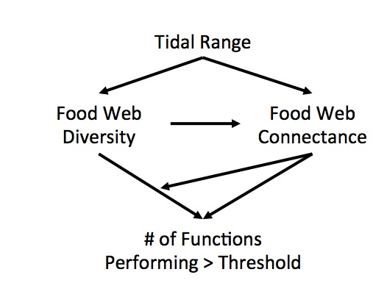With these data, I will use Structural Equation Models (Grace et al. 2012) to compare three alternate models (Figure 3) relating food web structure to ecosystem multifunctionality – the number of functions performing at some fraction of their maximum (Zavaleta et al. 2010). I will compare the explanatory power of models (Figure 1) that look at a) whole web topology, b) look at marine or terrestrial topologies separately and then compare parameter estimates, c) look at additional toplogical features such as trophic height and omnivory, both grouped and ungrouped by system. All SEMs will be fit using standard covariance based techniques, unless the data is replete with nonlinearities or indicates highly non-normal error distributions. If the data is not amenable to covariance based techniques, I will use equation-level estimation with tests of D-Separation to test the causal assumptions of each model (Shipley 2000).

Figure 3: Path diagrams of general models to be fit in Structural Equation Modeling analysis. Models will be run for all species, marine species only, terrestrial species only, and with other topological properties besides connectance such as trophic height.

To ensure that model results are robust to a wide variety of assumptions I will 1) use values both from qualitative and quantitative webs. This comparison of the use of metrics from the two web building techniques in a statistical analysis has not been previously conducted in the literature. 2) I will use five different threshold choices for calculations of multifunctionality for to both test the robustness of my results and see whether certain aspects of food web structure affect different levels of multifunctionality (Byrnes et al. In Review). I will use 10%, 25%, 50%, 75%, and 95% of the maximum values, as defined above.

*Additional Products for Management & Education:* All data collected in this study will be made immediately publically available after quality control. Quality controlled data and metadata will be made available via our lab’s website, and will be deposited at the Knowledge Network for Biocomplexity (<https://knb.ecoinformatics.org/>). This data can be used by any interested party for management or for illustrative teaching purposes. The study will also produce maps of how food web structure varies within and between study sites. We will create and release software to use the data in combination with our database to produce local food webs. This will allow for rapid visualization and assessment of food web structure as well as its variability over space and time.

*Q3) How does food web structure alter the impact of predator diversity loss on multifunctionality?*

While the above observational study will give crucial data on the biodiversity and ecosystem function of local salt marshes, the modeling methods cannot mechanistically demonstrate how food web structure is related to salt marsh multifunctionality. Therefore, in year two, I will use manipulative experiments to explore how food web structure can alter the consequences of predator extinctions for multifunctionality in tidal marshes.

This experiment will evaluate the interaction between changing diversity and food web structure. I will manipulate both the marine and terrestrial portions of lower marsh food webs consisting of predatory crabs, spiders, beetles, herbivorous crabs, snails, and insects, and a base of algae and tidal marsh plants (e.g., Figure 4, a sample potential web for manipulation). **Manipulating both marine and terrestrial food webs gives me the ability to create a wide variety of food web structures that are simply not possible to create in other systems. It also demonstrates the relative importance of marine versus terrestrial components of marsh food webs for the maintenance of salt marsh ecosystem function.**

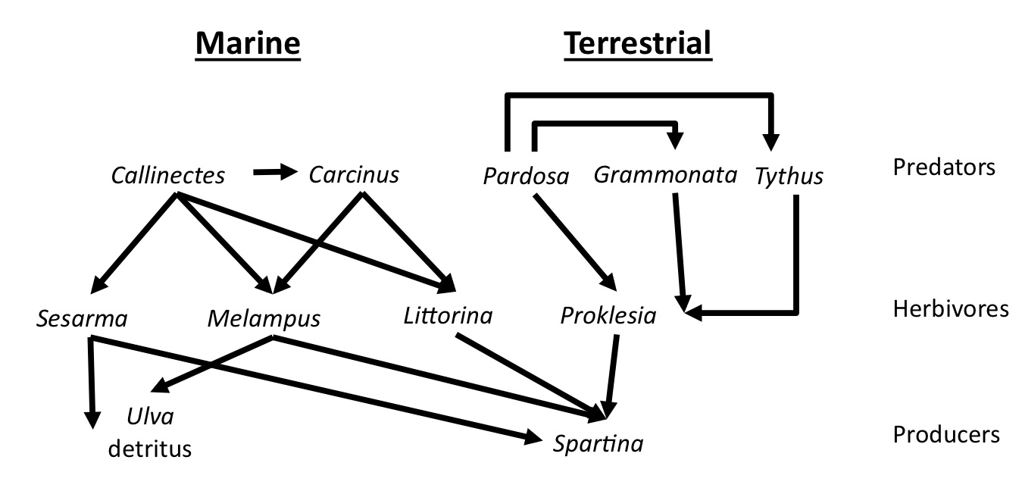In these food web manipulations, I will assemble multiple community types and evaluate how food web structure alters the impacts of species loss by comparing specific pairs of community types. I will perform this experiment at the site with the most diverse food web based on initial samples. The exact species being manipulated will depend on the baseline data collected from surveys at that site, thus leading to a wide variety of food web configurations across all experiments. The goal is to evaluate the effects of changing structure due to predator loss *per se*, although the experiment will also allow for the examination of compositional tests.

**Figure 4:** Example partial Massachusetts tidal marsh food web for manipulation in experiments based on literature reports. Species are listed by genus name. Solid lines indicate an observed or potential feeding relationship to be verified by this study. Actual food webs used for manipulations will depend on data cleaned in Q1 and results from surveys of experimental sites with only 4 species manipulated per site.

*Experimental Design*

Experiments will be initiated in late June. All communities will be assembled in 1x0.5m cages in the low marsh *Spartina* zone with four small plastic tubs to retain water during low tide. After all animals are cleared, cages will be stocked with green algae from the genus *Ulva*, all herbivores in the system at average densities from all field surveys.

I will then add one of the following predator treatments using a replacement design (i.e., total abundance of predators is held constant): 4 predator species, both marine predators only, both terrestrial predators only, all combinations of one marine and one terrestrial predator, monocultures of each predator, and a no predator control (Figure 5 for an example). Each site will have n=3 per treatment (36 cages total at each site). Treatments will be randomly assigned to cages across the marsh. Note, while replication of any one treatment type in any one marsh is low, the central focus of the experiment is *not* on composition *per se*, but rather on the effects of shifts in topology and species richness. That said, given that many species will be shared across sites, and that I am employing a replicated regression design (Cottingham et al. 2005), I should be able to determine the relative importance of individual species, and potentially of some key species pairs for ecosystem function and multifunction.

Figure 5: Four potential food web structures in the experiment - A) All species, B) only marine species, C) one marine and one terrestrial species, D) one species monoculture.

*Ulva* will be replaced monthly and consumption scored. Predators will be replaced monthly in the cases of escape or mortality.

At the end of the experiment (2 months), I will evaluate multifunctionality in cages using the assays described in the survey section above except migratory bird counts. I will add an additional measure – bird use – by observing bird use of formerly caged areas during the day after cages are removed. I will recording total standing stock of all species in cages, and also use these in assessments of function.

*Analysis*

At the core of this experiment I want to ask whether food web topology interacts with loss of species richness to affect both each single function as well as net multifunctionality. To answer this, I will statistically model the data with the appropriate generalized linear models with richness, initial food web connectance (i.e., calculated at all 4 species present), and their interaction as predictors of each single function and multifunctionality. If food web topology does matter, then more highly connected food webs will likely witness very different effects of diversity than less highly connected food webs. As higher connectance in the case of webs here likely indicates high intraguild predation and omnivory, I hypothesize that the effects of diversity loss will decrease in more highly connected webs. I will repeat this analysis also looking at food web omnivory, and within-predator-guild connectance as additional predictors to determine what aspects of food web structure may affect the consequences of diversity loss the most.

To evaluate the relative impact of losing marine, terrestrial, or a combination of species, I will perform *a priori* comparisons between the 4-species treatment and each 2-species treatment. These comparisons will allow me to test whether function is lost more quickly when extinctions are balanced across the terrestrial and marine webs or when losing an entire compartment of the food web. By comparing each 2-species treatment to its component monocultures, I can further evaluate how initial food web structure modifies the relative impacts of extinction. Here again I can look at whether losing a species from within versus across terrestrial and marine compartments causes a greater shift in function. I will also evaluate the relative importance of each species to individual functions and ecosystem multifunctionality by comparing monoculture treatments to both the full polyculture (e.g., to evaluate overyielding) and to the no-predator control (Loreau 1998) and composition effects using the framework of Kirwan et al. (2009).

**Timeline**

Food web assembly will in the fall of 2013. Year 1 of the grant will focus on field surveys in the Herring River marsh, the Waqouit NERR and the PIE LTER, development of sampling techniques, and preliminary experiments. In year 2, I will run the field experiment. I will repeat the surveys at the PIE LTER and sample the UMB field station and the Wells NERR sites. I will attempt to maintain the surveys of species in the future to create a rich publically available data set for my lab and others. PIE LTER monitoring is ongoing. Outreach activities listed below will commence in the fall of 2013 and expand as we begin generating data and results.

**Products, Outreach and Beneficiaries**

Our project focuses on five types of products: research papers from the above projects, open data from our work, building new tools for science, public outreach, and academic training. **With respect to new tools, I hope that the food web database will become a new standard format in ecology.** Access to results from Food Web Builder will be freely available to the scientific community. Additionally, future members of Prof. Ethan Bolker’s software design courses are planning on refining the visualizations and data export from the system to make the information more readily accessible to a generalist audience. One advantage I have noticed in collaborating with undergraduate Computer Science majors is that they are not biologists, but are fascinated by the information we collect. Many of the most insightful comments on organizing, visualizing, and representing the information thus far have not come from experienced scientists looking at the project, but from the ever curious undergrads themselves.

With respect to papers, **all manuscripts will be submitted to open access journals**. Before publication, manuscripts will be posted to PeerJ preprints so that work can be immediately publically available. Data and code will be made publically available via our lab’s website, and post-publication deposited to Dryad (URL) where it will be searchable via Data One (http://dataone.org).

**I have a four-point plan for outreach.** *First, my lab will maintain and promote a project blog* intended for public outreach. Every week we will post one or more of three types of items: photos from the sites with accompanying natural history notes, stories from the field, or a discussion of environmental issues in tidal marshes. I will actively promote this blog through online social media, where I have been active since 2005 (see synergistic activities). *Second, I will maintain an active voice in the online discussion of science via Twitter* (e.g., see <http://twitter.com/jebyrnes>) as will all members of my lab. Information tweeted by scientists influences both the public scientific discussion - 43% of marine scientists’ followers are non-scientists (Darling et al. 2013) - and the development of science itself, with tweeted papers increasing their citation rates (Eysenbach 2011). *Third, members of my lab will speak at local science cafes* around Boston about the natural history and novel ecological aspects of the work. *Fourth, members of my lab will conduct public online discussions with salt marsh scientists* using Google Hangouts as a platform. This has been tremendously successful in generating interest and citizen engagement for astronomy and astrophysics (e.g., http://blog.galaxyzoo.org/tag/hangout/), and we will import this approach to our project. We plan to talk with both prominent senior scientists as well as graduate and undergraduate students working in these systems to get a diverse set of perspectives on how people think about salt marsh ecology and natural history.

Moreover, we can quantify impact of these activities via blog pageviews, retweets of information in twitter, audience sizes at science cafes, and number of viewers for online discussions. If one of our outreach activities is not achieving high viewership, we can adjust the frequency and scope of what information we distribute via those channels.

**This project presents several opportunities for training.** The project will fund a PhD student in PI Byrnes’s lab (Marc Hensel, current NERR Fellow at Sapelo Island, Georgia) who will lead the field work. The project will hire and train undergraduate research technicians to work in the field and in laboratory processing. I also plan to offer a short summer course in Structural Equation Modeling at UMB available to the general Boston area marine science community.

**References Cited**

Allesina, S., and M. Pascual. 2009. Food web models: a plea for groups. Ecology letters 12:652–662.

Altieri, A. H., M. D. Bertness, T. C. Coverdale, N. C. Herrmann, and C. Angelini. 2012. A trophic cascade triggers collapse of a salt-marsh ecosystem with intensive recreational fishing. Ecology 93:1402–1410.

Assessment, M. E. 2005. Ecosystems and human well-being: wetlands and water. World Resources Institute, Washington, DC.

Balvanera, P., A. B. Pfisterer, N. Buchmann, J.-S. He, T. Nakashizuka, D. Raffaelli, and B. Schmid. 2006. Quantifying the evidence for biodiversity effects on ecosystem functioning and services. Ecology letters 9:1146–1156.

Barnosky, A. D., N. Matzke, S. Tomiya, G. O. U. Wogan, B. Swartz, T. B. Quental, C. Marshall, J. L. McGuire, E. L. Lindsey, K. C. Maguire, Ben Mersey, and E. A. Ferrer. 2011. Has the Earth's sixth mass extinction already arrived? Nature 471:51–57.

Bascompte, J., C. J. Melián, and E. Sala. 2005. Interaction strength combinations and the overfishing of a marine food web. Proceedings of the National Academy of Sciences of the United States of America 102:5443–5447.

Bersier, L.-F., C. Banašek-Richter, and M.-F. Cattin. 2002. Quantitative descriptors of food-web matrices. Ecology 83:2394–2407.

Bertness, M. D. 1998. The Ecology of Atlantic Shorelines. Sinauer Associates Inc.

Bertness, M. D., and P. J. Ewanchuk. 2002. Latitudinal and climate-driven variation in the strength and nature of biological interactions in New England salt marshes. Oecologia 132:392–401.

Bertness, M. D., and S. D. Hacker. 1994. Physical stress and positive associations among marsh plants. American Naturalist 144:363–372.

Bertness, M. D., C. Crain, C. Holdredge, and N. Sala. 2008. Eutrophication and consumer control of New England salt marsh primary productivity. Conservation Biology 22:131–139.

Bowen, J. L., B. C. Crump, L. A. Deegan, and J. E. Hobbie. 2009. Increased supply of ambient nitrogen has minimal effect on salt marsh bacterial production. Limnology and Oceanography 54:713–722.

Buesing, N., and M. O. Gessner. 2003. Incorporation of Radiolabeled Leucine into Protein to Estimate Bacterial Production in Plant Litter, Sediment, Epiphytic Biofilms, and Water Samples. Microbial Ecology 45:291–301.

Byrnes, J. E., J. J. Stachowicz, K. M. Hultgren, A. R. Hughes, S. V. Olyarnik, and C. S. Thornber. 2006. Predator diversity strengthens trophic cascades in kelp forests by modifying herbivore behavior. Ecology letters 9:61–71.

Byrnes, J. E., P. L. Reynolds, and J. J. Stachowicz. 2007. Invasions and extinctions reshape coastal marine food webs. PloS one 2:e295.

Byrnes, J. E., L. Gamfeldt, F. Isbell, J. Griffin, J. S. Lefcheck, D. Hooper, B. Cardinale, and J.E. Duffy. In Review. Investigating the relationship between biodiversity and ecosystem multifunctionality: Challenges and solutions.

Cardinale, B. J., J. E. Duffy, A. Gonzalez, D. U. Hooper, C. Perrings, P. Venail, A. Narwani, G. M. Mace, D. Tilman, D. A. Wardle, A. P. Kinzig, G. C. Daily, M. Loreau, J. B. Grace, A. Larigauderie, D. S. Srivastava, and S. Naeem. 2012. Biodiversity loss and its impact on humanity. Nature 486:59–67.

Cardinale, B. J., K. L. Matulich, D. U. Hooper, J. E. Byrnes, E. Duffy, L. Gamfeldt, P. Balvanera, M. I. O'Connor, and A. Gonzalez. 2011. The functional role of producer diversity in ecosystems. American journal of botany 98:572–592.

Cottingham, K. L., J. T. Lennon, and B. L. Brown. 2005. Knowing when to draw the line: designing more informative ecoloigcal experiments. Frontiers in Ecology and the Environment 3:145–152.

Dang, C. K., E. Chauvet, and M. O. Gessner. 2005. Magnitude and variability of process rates in fungal diversity-litter decomposition relationships. Ecology letters 8:1129–1137.

Darling, E. S., D. Shiffman, I. M. Côté, and J. A. Drew. 2013. The role of Twitter in the life cycle of a scientific publication. PeerJ PrePrints.

Dunne, J. A. 2006. The network structure of food webs. Pages 27–86 *in* M. Pascual and J. A. Dunne, editors. Ecological Networks: Linking Structure to Dynamics in Food Webs. Oxford University Press.

Dunne, J. A., R. J. Williams, and N. D. Martinez. 2002. Food-Web Structure and Network Theory: The Role of Connectance and Size. Proceedings of the National Academy of Sciences of the United States of America 99:12917–12922.

Finke, D. L., and R. F. Denno. 2004. Predator diversity dampens trophic cascades. Nature 429:407–410.

Fox, S. E., M. Teichberg, I. Valiela, and L. Heffner. 2012. The Relative Role of Nutrients, Grazing, and Predation as Controls on Macroalgal Growth in the Waquoit Bay Estuarine System. Estuaries and Coasts 35:1193–1204.

Gamfeldt, L., T. Snäll, R. Bagchi, M. Jonsson, L. Gustafsson, P. Kjellander, M. Ruiz-Jaen, M. Fröberg, J. Stendahl, C. D. Philipson, G. Mikusiński, E. Andersson, B. Westerlund, H. Andrén, F. Moberg, J. Moen, and J. Bengtsson. 2012. Higher levels of multiple ecosystem services are found in forests with more tree species. Nature Communications.

Gerrodette, T. 1987. A power analysis for detecting trends. Ecology:1364–1372.

Grace, J. B., D. R. Schoolmaster Jr., G. R. Guntenspergen, A. M. Little, B. R. Mitchell, K. M. Miller, and E. W. Schweiger. 2012. Guidelines for a graph-theoretic implementation of structural equation modeling. Ecosphere 3:art73.

Hector, A., and R. Bagchi. 2007. Biodiversity and ecosystem multifunctionality. Nature 448:188–190.

Holdredge, C., M. D. Bertness, and A. H. Altieri. 2009. Role of Crab Herbivory in Die-Off of New England Salt Marshes. Conservation Biology 23:672–679.

Hooper, D. U., F. S. I. Chapin, J. J. Ewel, A. Hector, P. Inchausti, S. Lavorel, J. H. Lawton, D. M. Lodge, M. Loreau, S. Naeem, B. Schmid, H. Setälä, A. J. Symstad, J. Vandermeer, and D. A. Wardle. 2005. Effects of biodiversity on ecosystem functioning: a consensus of current knowledge. Ecological Monographs 75:3–35.

Isbell, F., V. Calcagno, A. Hector, J. Connolly, W. S. Harpole, P. B. Reich, M. Scherer-Lorenzen, B. Schmid, D. Tilman, J. van Ruijven, A. Weigelt, B. J. Wilsey, E. S. Zavaleta, and M. Loreau. 2011. High plant diversity is needed to maintain ecosystem services. Nature 477:199–202.

Kirwan, L., J. Connolly, J. A. Finn, C. Brophy, A. Lüscher, D. Nyfeler, and M. T. Sebasti. 2009. Diversity-interaction modeling: estimating contributions of species identities and interactions to ecosystem function. Ecology 90:2032–2038.

Koch, E. W., E. B. Barbier, B. R. Silliman, D. J. Reed, G. M. Perillo, S. D. Hacker, E. F. Granek, J. H. Primavera, N. Muthiga, and S. Polasky. 2009. Non-linearity in ecosystem services: temporal and spatial variability in coastal protection. Frontiers in Ecology and the Environment 7:29–37.

Lewis, D., and R. F. Denno. 2009. A seasonal shift in habitat suitability enhances an annual predator subsidy. Journal of Animal Ecology 78:752–760.

Loreau, M. 1998. Separating sampling and other effects in biodiversity experiments. Oikos 82:600–602.

Norman, J. M., C. J. Kucharik, S. T. Gower, D. D. Baldocchi, P. M. Crill, M. Rayment, K. Savage, and R. G. Striegl. 1997. A comparison of six methods for measuring soil-surface carbon dioxide fluxes. Journal of Geophysical Research 102:28771–28–777.

Norman, J. M., R. Garcia, and S. B. Verma. 1992. Soil surface CO2 fluxes and the carbon budget of a grassland. Journal of Geophysical Research: Atmospheres (1984–2012) 97:18845–18853.

Pennings, S. C., and M. D. Bertness. 2001. Salt marsh communities. Marine community ecology:289–316.

Pennings, S. C., C.-K. Ho, C. S. Salgado, K. Wieski, N. Dave, A. E. Kunza, and E. L. Wason. 2009. Latitudinal variation in herbivore pressure in Atlantic Coast salt marshes. Ecology 90:183–195.

Robinson, A., A. N. Cohen, B. Lindsey, and L. Grenier. 2011. Distribution of Macroinvertebrates Across a Tidal Gradient, Marin County, California. San Francisco Estuary and Watershed Science 9:1–14.

Roopnarine, P. D., and K. D. Angielczyk. 2011. The evolutionary palaeoecology of species and the tragedy of the commons. Biology Letters.

SAV-Emergent Biomonitoring Committee. 2009. NERRS SWMP Bio-Monitoring Protocol: Long-term Monitoring of Estuarine Submersed and Emergent Vegetation Communities. Page 14 National Estuarine Research Reserve System Technical Report. National Estuarine Research Reserve System.

Shipley, B. 2000. A New Inferential Test for Path Models Based on Directed Acyclic Graphs. Structural Equation Modeling: A Multidisciplinary Journal 7:206–218.

Silliman, B. R., and M. D. Bertness. 2002a. A trophic cascade regulates salt marsh primary production. Proceedings of the National Academy of Sciences of the United States of America 99:10500–10505.

Silliman, B. R., and M. D. Bertness. 2002b. A trophic cascade regulates salt marsh primary production. Proceedings of the National Academy of Sciences of the United States of America 99:10500–10505.

Thebault, E., and M. Loreau. 2006. The relationship between biodiversity and ecosystem functioning in food webs. Ecological Research 21:17–25.

Tilman, D., C. L. Lehman, and K. T. Thomson. 1997. Plant diversity and ecosystem productivity: theoretical considerations. PNAS 94:1857–1861.

Valiela, I., and J. M. Teal. 1979. The nitrogen budget of a salt marsh ecosystem. Nature 280:652–656.

Zavaleta, E. S., J. R. Pasari, K. B. Hulvey, and G. D. Tilman. 2010. Sustaining multiple ecosystem functions in grassland communities requires higher biodiversity. Proceedings of the National Academy of Sciences 107:1443–1446.

Zedler, J. B., and S. Kercher. 2005. Wetland resources: status, trends, ecosystem services, and restorability. Annual Review of Environment and Resources 30:39–74.