**Can Kelps Buffer Massachusetts Coastlines from the Effects of Ocean Acidification?**

Jarrett Byrnes, University of Massachusetts Boston

*Definition of Problem*

Unless major actions are taken at a global scale, the effects of climate change are likely to increase well into the future (IPCC AR5, 2013). As cessation is likely not an option, we must turn towards adaptation and mitigation. In particular, processes that can mitigate increases in ocean CO2 content, and hence mitigate the potential impact of ocean acidification, may prove key in the future. Mitigation at a macro-scale is difficult to achieve and may require large-scale technological solutions. However, a myriad of biological processes regulate ocean pCO2 at local spatial scales, and may provide opportunities for local mitigation in habitats that are critical for ecosystem health and commercially harvested species. **Here I propose to test how kelp bed ecosystems in New England might alter ocean pH at local scales at hence the effects of ocean acidification.**

Kelps are emerging as an exciting source of climate change mitigation. Kelps like the dominant *Saccharina* species are suggested to slow shorelines erosion and change local flow conditions (Asano et al., 1992; Mork, 1996; Løvås and Tørum, 2001). Kelps are beginning to be explored as a potential source of blue carbon storage (Chung et al., 2010; Wilmers et al., 2012) due to their ability to soak up carbon as a part of photosynthesis and then deposit it for later burial as detritus. While their early reproductive stages of some kelps might be affected by changes in pH (Gaitán-Espitia et al., 2014), their increased growth from increases in future CO2 for at least some species appears to more than make up for it (Roleda et al., 2011), implying that they will continue to be a major habitat in the future. Whether kelps serve as a good blue carbon store is unclear, however, as much of the detritus is used for respiration by other organisms in the environment. How much kelp detritus is actually buried is not certain, and models currently depend on back-of-the-envelope calculations that have yet to be verified. Where kelp uptake of carbon might have more immediate application is in regulation of local seawater pH.

There are many reasons that kelp forests as a whole might or might not affect local seawater pH (Fig. 1). First, kelps deplete local seawater CO2 during the daytime via photosynthesis. This may create some local buffering, depending on water flow rates. Second, kelps may act to slow local flow, amplifying any effects of local depletion from slowing flow (Asano et al., 1992). There are reasons kelp beds might increase local pH as well. Kelps are incredibly productive, generating an enormous amount of biomass. This high productivity and concomitant respiration during the day and night could outweigh any diurnal effect (Hofmann et al., 2011). Second, as kelps shade out other algae (Hawkins and Harkin, 1985; Hruby, 1976) and facilitate many respiring animals (Bologna and Steneck, 1993; Efird and Konar, 2013), the might actually create a net CO2 source, leading to locally lowered pH.

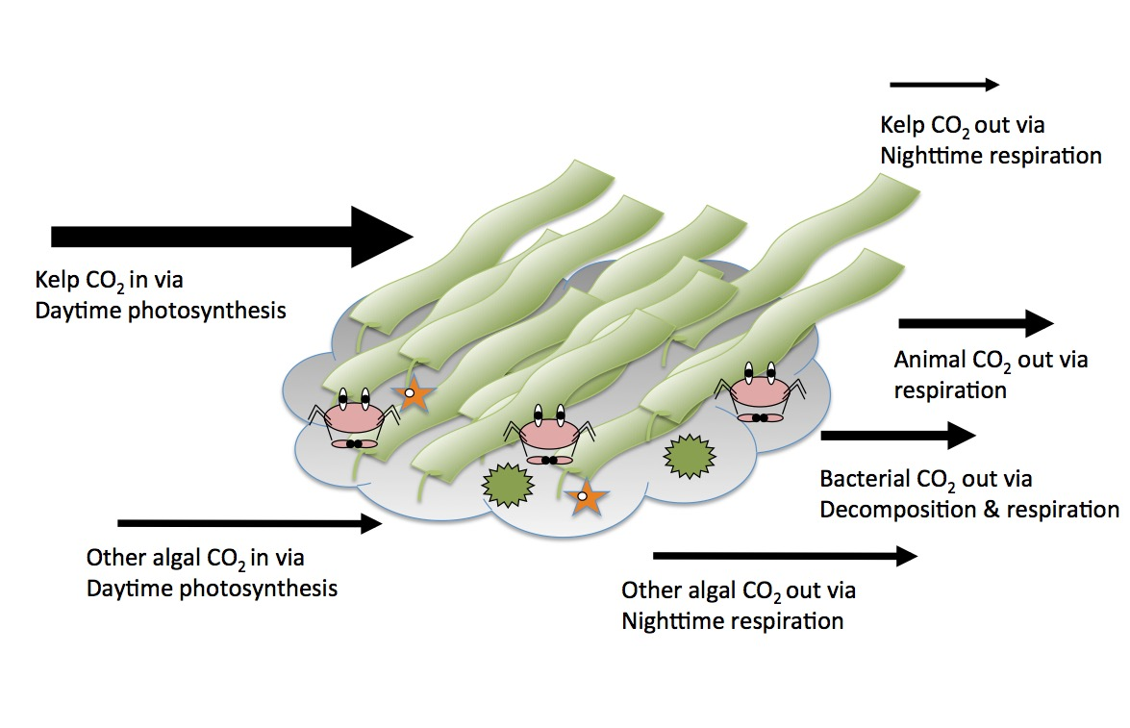

Figure 1 Pathways for CO2 to enter and exit a kelp forest ecosystem. The net balance at any point in time will affect local ocean pH.

If kelp beds can change pH at a local spatial scale – even if pH in the surrounding waters remains the same - the impacts are likely to be tremendous. Kelps host a wide variety of marine organisms, many of whom are calcifiers, such as sea urchins (Miller and Mann, 1973). Some live in the kelp beds themselves, such as lobsters (Bologna and Steneck, 1993). Others live directly on kelp blades themselves or within complex kelp holdfasts (Norderhaug et al., 2002). By shading macroalgae, kelps also facilitate curstose corraline algae (Melville and Connell, 2008). Therefore, how whole kelp bed communities alter localized pH could have a tremendous effect on a wide variety of biological processes and species – some of commercial importance – within temperate rocky reefs.

**General Approach**

*Sites and General Sampling of Ocean pH* **-** In the following objectives, I propose to sample pH in different areas of temperate rocky reefs around Massachusetts. To sample pH *in situ* I propose to use a SeaFET autonomous pH sensor in combination with a CTD logger needed to calculate pH (Gaitán-Espitia et al., 2014; Hofmann et al., 2011; Martz et al., 2010). According to Martz *et al.* (2010) these sensors units and exhibit stability over weeks to months of ±0.005 pH. Salinity, temperature, and voltage from the suite of sensors can then be used to calculate pCO2 using standard methods (Robbins et al., 2010). Note, when referring to the ‘sensor’ below, I mean the sensor suite of the SeaFET and CTD. All measurements below, unless stated otherwise, will take place around Baker Island, Misery Island, and the Gooseberries in Salem Sound, where my lab has been working for the past three years. All sampling will take place from July to October.

*Objective 1) Determine the impact of kelp beds in altering local-scale pH –* To assess whether kelp beds are altering local-scale pH, I will perform two separate experiments. First, at three sites, I will create paired cleared and uncleared plots in kelp beds. To ensure that the center of these areas are not influenced by local kelp beds, I will clear a large area (8m in radius). In each area, I will assess kelp abundance and the abundance of all other major macroalgae using 1m2 quadrats in the central 4m2 of plots. I will then place a pH sensor sampling every 10 minutes in the center of each plot for 72 hours. I will compare the pH timeseries of sites using standard mixed model time series analysis using treatment, time of day, and an interaction as predictors of pH with a random effect of site.

Second, to evaluate both whether the clearance was adequate and the extent of the effect in the water column, I will conduct an 8 hour assay in each plot with one sensor placed in the plot and the second moved from 1-8m above the plot, moving up 1m per hour. I will evaluate the difference in average hourly pH between the plot and above the plot with treatment, depth, and a random effect of site as predictors. In both assays, if kelp is buffering against pH, it should be consistently lower inside of or closer to the control plot. The first assay will also show to what extent any daytime mitigation might be overwhelmed by nighttime community respiration.

*Objective 2) Determine the scale at which kelp beds begin to alter OA –* While in objective 1, I will determine whether kelp bed ecosystems as a whole decrease, increase, or do not modify ocean pH, how localized this effect is on the seabed will be unclear due to the use of a large clearing only. I will therefore perform a removal experiment at a single site (Baker Island) with pairs of plots having either no kelp removed or kelp removed in a 1, 2, 4, or 6m radius from where a sensor will be placed. For each plot (0-6m kelp removed), I will place one sensor inside the plot and a second sensor in a randomly chosen non-cleared area nearby for 72 hours sampling once every 10 minutes. I will analyze the data using a time series with clearance size, time of day, and an interaction as predictors. As before, I will assess whether any increases in the ability of kelp beds to buffer from pH during the day (if they exist) exceed the effects of nighttime changes.

*Objective 3) Compare pH levels in different macroalgal habitats to ambient surroundings –* While I might find that kelp bed habitats have some net localized effect on ocean pH, 1) many subtidal habitats are *not* composed of kelp. The Gulf of Maine has seen numerous invasive algae (REFS) colonize reefs. Other habitats are dominated by mussels, urchins, or other invertebrates depending on prevailing conditions. What is difference in pH within any of these habitats relative to surrounding waters versus in a kelp forest habitat? To answer this question, I will survey 8 randomly selected reefs at 10m depth in the outer Boston Harbor Islands and 8 in outer islands of Salem Sound. At each site, I will deploy a sensor at depth and one 4m under the surface for 8 hours sampling every ten minutes. I will survey the site to assess the abundance of all macroalgae, fish, sessile, and mobile invertebrates along a 40m transect using a combination of quadrat, band transect, and point count techniques. I will then model the difference in pH between the benthic and open water sensors as a function of kelp abundance, percent cover of other algae, summed density of macroinvertebrates, and summed density of fish.

**Broader Impacts**

In addition to student training and open access publications, any results from this project will be featured on the blog for the Floating Forests project (<http://blog.floatingforests.org>) about kelp forest ecology. This blog focuses on kelp forest ecology, and currently has 300-500 views monthly.

**Relevance to MIT SeaGrant Goals**

This proposal directly addressed the MIT SeaGrant call for Ocean Acidification by bringing in new data, models, and analysis relating to how our coastlines might cope with changes in ocean pH. It addresses *HCE Goal 2: Ecosystem‐based approaches to manage land, water and living resources* – by evaluating whether kelp beds provide an ecosystem service with respect to mitigating climate change. If beds are found to buffer local environments, data count contribute to *SFA Goal 1: A safe, secure and sustainable supply of seafood to meet public demand* – as these beds also host a wide variety of commercially fished species that might better tolerate future OA conditions living within kelp beds. Last, it addresses *RCE Goal 3: Improvements in coastal water resources sustain human health and ecosystem services* by directly assessing whether kelp beds in New England provide an as yet unidentified ecosystem service.

**Contribution to Basic Science**

This proposal contributes to the basic science of understanding the role of kelp beds in regulating large-scale ecosystem functions. One opportunity that studies of OA *in situ* provide for scientists is to look at whole-ecosystem processes. While we can estimate respiration and photosynthetic rates at a small scale using experimental chambers, scaling these measurements up *in situ* to the landscape is highly problematic. Looking at how pH and pCO2 differ across a landscape allows scientists to begin to develop an understanding of how whole communities shape ecosystem function, providing a bridge between disciplines.

**Timeline**

Objective 1 & half of Objective 3 will be carried out in May-November of 2016. Objective 2 and the remaining samples for objective 3 will be carried out in May-November of year 2. Winter of 2017 data for objective 1 will be presented at the Benthic Ecology Meetings. Fall/Winter of 2018, data will be presented at BEM and manuscripts will be prepared for submission.

**References**

Asano, T., Deguchi, H., Kobayashi, N., 1992. Interaction between water waves and vegetation. Coastal Engineering Proceedings 1(23). doi:10.9753/icce.v23.

Bologna, P.A.X., Steneck, R., 1993. Kelp beds as habitat for American lobster Homarus americanus. Marine Ecology Progress Series 100, 127.

Chung, I.K., Beardall, J., Mehta, S., Sahoo, D., Stojkovic, S., 2010. Using marine macroalgae for carbon sequestration: a critical appraisal. J. Appl. Phycol. 23, 877–886. doi:10.1007/s10811-010-9604-9

Efird, T.P., Konar, B., 2013. Habitat characteristics can influence fish assemblages in high latitude kelp forests. Environ. Biol. Fishes 97, 1253–1263. doi:10.1007/s10641-013-0211-x

Gaitán-Espitia, J.D., Hancock, J.R., Padilla-Gamiño, J.L., Rivest, E.B., Blanchette, C.A., Reed, D.C., Hofmann, G.E., 2014. Interactive effects of elevated temperature and pCO 2 on early-life-history stages of the giant kelp *Macrocystis pyrifera*. J. Exp. Mar. Biol. Ecol. 457, 51–58.

Hawkins, S.J., Harkin, E., 1985. Preliminary canopy removal experiments in algal dominated communities low on the shore and in the shallow subtidal on the Isle of Man. Bot. Mar. 28, 223–230.

Hofmann, G.E., Smith, J.E., Johnson, K.S., Send, U., Levin, L.A., Micheli, F., Paytan, A., Price, N.N., Peterson, B., Takeshita, Y., Matson, P.G., Crook, E.D., Kroeker, K.J., Gambi, M.C., Rivest, E.B., Frieder, C.A., Yu, P.C., Martz, T.R., 2011. High-Frequency Dynamics of Ocean pH: A Multi-Ecosystem Comparison. PLoS ONE 6, e28983. doi:10.1371/journal.pone.0028983

Hruby, T., 1976. Observations of algal zonation resulting from competition. Estuarine and Coastal Marine Science 4, 231–233. doi:10.1016/0302-3524(76)90045-1

IPCC AR5, 2013. Chapter 12: Long-term Climate Change: Projections, Commitments and Irreversibility - Final Draft Underlying Scientific-Technical Assessment, in: IPCC Fifth Assessment Report (AR5), Climate Change 2013: the Physical Science Basis. pp. 1–177.

Løvås, S.M., Tørum, A., 2001. Effect of the kelp *Laminaria hyperborea* upon sand dune erosion and water particle velocities. Coastal Engineering 44, 37–63.

Martz, T.R., Connery, J.G., Johnson, K.S., 2010. Testing the Honeywell Durafet for seawater pH applications. Limnol. Oceangr. Methods 8, 172–184. doi:10.4319/lom.2010.8.172

Melville, A.J., Connell, S.D., 2008. Experimental effects of kelp canopies on subtidal coralline algae. Austral. Ecol. 26, 102–108. doi:10.1111/j.1442-9993.2001.01089.pp.x

Miller, R.J., Mann, K.H., 1973. Ecological energetics of the seaweed zone in a marine bay on the Atlantic coast of Canada. III. Energy transformations by sea urchins. Mar. Biol. 18, 99–114. doi:10.1007/BF00348685

Mork, M., 1996. The effect of kelp in wave damping. Sarsia 80, 323–327.

Norderhaug, K.M., Christie, H., Rinde, E., 2002. Colonisation of kelp imitations by epiphyte and holdfast fauna; a study of mobility patterns. Mar. Biol. (Berl.) 141, 965–973.

Robbins, L.L., Hansen, M.E., Kleypas, J.A., Meylan, S.C., 2010. CO2calc—a user-friendly seawater carbon calculator for Windows, Mac OS X, and iOS (iPhone). Open-file Report 2010− 1280. US Geological Survey, Reston, VA.

Roleda, M.Y., Morris, J.N., McGraw, C.M., Hurd, C.L., 2011. Ocean acidification and seaweed reproduction: increased CO2 ameliorates the negative effect of lowered pH on meiospore germination in the giant kelp *Macrocystis pyrifera* (Laminariales, Phaeophyceae). Glob Change Biol 18, 854–864. doi:10.1111/j.1365-2486.2011.02594.x

Wilmers, C.C., Estes, J.A., Edwards, M., Laidre, K.L., Konar, B., 2012. Do trophic cascades affect the storage and flux of atmospheric carbon? An analysis of sea otters and kelp forests. Frontiers in Ecology and the Environment 10, 409–415. doi:10.1890/110176