**Kelp in the city: Urbanization and climate change jointly drive decreases in Giant Kelp forests across large spatial scales**

Isaac S. Rosenthal1,2, Tom W. Bell3, Kyle C. Cavanaugh4, Jarrett E. K. Byrnes5*

1 – School for the Environment, University of Massachusetts Boston, Boston, Massachusetts

2 – Amherst College, Amherst, Massachusetts

3 – Applied Ocean Physics and Engineering, Woods Hole Oceanographic Institution, Woods Hole, Massachusetts

4 – Department of Geography, University of California Los Angeles, Los Angeles, California

5 – Department of Biology, University of Massachusetts Boston, Boston, Massachusetts

* - Corresponding author, jarrett.byrnes@umb.edu

**Abstract**

Giant kelp (*Macrocystis pyrifera*) forests are critical marine habitats with great economic (Costanza et al., 2014; Cuba et al., 2022) and environmental value (Foster et al., 1985; Steneck & Erlandson, 2002). These forests are primarily found in temperate coastal waters and are sensitive to climate change (Cavanaugh et al., 2011; Tegner et al., 1996). This is not the only stressor that they experience; their distribution frequently overlaps with human population centers (Graham et al., 2007, see Appendix 1 for a brief overview). Kelp is vulnerable to environmental disturbances associated with urbanization, especially water quality degradation as a result of sedimentation and/or eutrophication (Todd et al., 2019). It is possible that the impacts of temperature and urbanization are synergistic, but the potential synergies between these parameters have not been quantified. Here we show that coverage of impervious surface and temperature are both important predictors of kelp biomass, and that they may have nonlinear synergies. We used three decades of remote sensing data to causally model the relationship between kelp biomass and cover, sea surface temperature, and impervious surface coverage. We found that at medium (0.2) levels of impervious surface coverage, the expected correlation between temperature and kelp biomass breaks down, resulting in low biomass regardless of temperature. These results suggest that kelp forest

responses to ocean warming are complex and attempts to forecast their response to climate change induced warming should include consideration of local anthropogenic impacts.

**Introduction**

Giant kelp (*Macrocystis pyrifera*) forests are an exceptionally valuable natural resource along many temperate coastlines of the world (Graham et al., 2007; Raffaelli & Hawkins, 1996; Steneck & Erlandson, 2002). The provide key services such as wave dampening, nutrient cycling, fish and invertebrate habitat, tourism attraction, and goods supplied by direct harvest (Duggins et al., 1990; Elsmore et al., 2023; Gutierrez et al., 2006; Peteiro, 2018; Peters et al., 2019). Giant kelp in North America provides an estimated $35 billion/year in services alone (Eger et al., 2023). These services rely on healthy kelp forests to realize their full potential (Smale et al., 2019). Kelp forests line the temperate coastlines of the world, where roughly 10% of humans live with a projected increase in human coastal population of up to 50% over the next 30 years (Neumann et al., 2015). As such, they are directly exposed to impacts of human coastal development. Urbanization in particular threatens to degrade water quality and the capacity for future provision of kelp-derived ecosystem services (Dwight et al., 2011; Gorman & Connell, 2009). Increasing coastal urbanization’s impact would occur against a backdrop of increasing climate change, which is already weakening the resilience of the world’s kelp forests (Smale, 2020; Steneck & Erlandson, 2002). Here we explore the joint consequences of coastal urbanization and climate change for giant kelp forests using 37 years of satellite-derived data from ~750km of California’s central and southern coast using Econometric causal modeling techniques to show how the two jointly act to reduce these vital ecosystems.

California’s coastal watersheds have experienced increases in urbanization of up to 30% over the last 70 years, with concomitant increases in runoff that could impact kelps (Beighley et al., 2003). Kelps require high light levels in cold nutrient rich water alongside low overgrowth by epiphytes or competition from encroaching fast-growing turf algae (Dayton, 1985; Schiel & Foster, 2015). Sediment and nutrient deposition due to elevated terrestrial runoff in urban environments with high impervious surface area stand to harm kelp forests on both of those fronts (Morris et al., 2020). Mechanistic studies of urbanization on subsurface kelp forests of *Ecklonia radiata* in South Australia show that urban runoff is a strong driver of kelp declines and replacement by turf algae (Gorman et al., 2009). In *Macrocystis,* high sediment load can negatively impact recruitment - early *Macrocystis* developmental stages are vulnerable to light limitation and sand-scour (Dayton, 1985; Tait, 2019). In extreme cases, sedimentation can lead to habitat loss as kelp cannot survive in areas without suitable amounts of hard substrata (Stephens et al., 2006). Nutrient runoff can similarly decrease kelp in natural populations. Increased turbidity can decrease light available for recruitment and growth of kelps and can favor algal turfs with low light requirements, shifting the balance of competition for space from kelp to turfs (Foster & Schiel, 2010; F. E. Moy & Christie, 2012a). In addition, this turf-dominance effect is enhanced by increased sediment loads as a result of these turf’s morphologic capacity to trap sediments, allowing them to persist even under heavy sedimentation regimes (Airoldi, 1998; Filbee-Dexter & Wernberg, 2018). Thus, urbanization could potentially shift a kelp forest system to an alternate stable state due to its impacts on light and sediments.

Changes in light and sedimentation from accelerating coastal urbanization have not occurred in isolation. Climate change has led to a series of impacts that negatively affect kelp

forests. These impacts include elevated temperatures, more frequent heat waves, changes in weather and ocean current patterns, alterations to predator/grazer dynamics, and warming- driven changes in competitive interactions with epiphytes and other algal species (Bennett et al., 2015; Filbee-Dexter & Scheibling, 2014; Frölicher & Laufkötter, 2018; Hayward, 1997; Provost et al., 2017; Scheibling & Gagnon, 2009; Smale, 2020; Vergés et al., 2014). Kelp loss in response to ocean warming and concomitant decreases in nutrients is a well- documented trend in marine ecosystems across the world (Beas-Luna et al., 2020; Dayton et al., 1998; Edyvane, 2003; Ling et al., 2009; McPherson et al., 2021; Pessarrodona et al., 2018). Urbanization and temperature could act as synergistic stressors in two ways. First, the strength of one could depend on the other – i.e., the per capita effect of sedimentation could be stronger under a warmer, low nutrient regime. Alternatively, one stressor could change the baseline on which the other acts. This change in baseline could make the impact of the second appear small merely due to there not being much kelp left to begin with – i.e. a 20% reduction of 20% of a forest is much smaller than a 20% reduction of 100% of a forest).

Mechanistically, these synergies could be due to climate change reducing the resilience of *Macrocystis* via more frequent thermal stress and nutrient limitation (Cavanaugh et al., 2011).Urbanization alters the coastal hydrology by increasing terrestrial runoff, harming *Macrocystis* forest resilience to warming directly by depressing recruitment and growth (Tait, 2019). Hydrologic alterations associated with urbanization could also interact with climate change driven increases in storm frequency and intensity such that developed areas can experience higher levels of runoff-related pollution than pristine areas (Kaushal et al., 2008). These synergistic effects may be further amplified by the ecological consequences of environmental change related to these drivers; for example, the competitive dominance of

turf-forming algae is enhanced under high nutrient/sediment conditions, and hysteresis may restrict the capacity for degraded kelp forests to recover (Filbee-Dexter et al., 2016; Filbee- Dexter & Wernberg, 2018).

In order to understand these possible joint influences of urbanization and ocean temperature change on kelp forests, we used data from multiple remote sensing sources to model the interaction between sea surface temperature (SST) and urban development on peak annual giant kelp biomass and cover in California. We included 11 sites in central and southern California, spanning from Point Reyes to the Mexican border. We modeled peak annual kelp biomass and aerial canopy cover from 1985-2021 as a function of several drivers: 1) spring SST, 2) summer SST, 3) percent cover of urban area, and 4) spring peak kelp biomass. By modeling both biomass per unit area and areal cover, we were able to tease apart how urbanization and climate change drive both the distribution and total amount of kelp in different areas along the West Coast of the US. We utilized causal modeling techniques drawn from the Econometrics literature (Antonakis et al., 2021; Butsic et al., 2017; Dudney et al., 2021; Mundlak, 1978; Pearl et al., 2016; Wooldridge, 2010) to control for confounding variables and show that, at large spatial scales, urbanization and warming work together to decrease kelp forest biomass and areal cover. Finally, our models used log of kelp biomass per unit area and a logistic curve of area covered (i.e., % of maximum forest area) to accommodate the nonlinear nature of the data, more cleanly evaluate synergies between drivers, and account for the possibility of nonlinear threshold effects.

**Methods**

*Study Sites and Data Sources*

The study sites used in our analysis consist of a series of segments along the California coast, spanning from Point Reyes to the Mexican border (Figure 1) We focused on this region in order to utilize the Landsat-derived Multiple Endmember Spectral Mixture Analysis (MESMA) database of kelp biomass and canopy cover (Bell et al., 2020, 2023; Hamilton et al., 2020). The data consists of quarterly measurements of kelp biomass derived from Landsat 5 Thematic Mapper (TM), Landsat 7 Enhanced Thematic Mapper Plus (ETM+), Landsat 8 Operational Land Imager (OLI), and Landsat 9 Operational Land Imager 2 (OLI-2) satellite imagery. USGS Level-2 Surface Reflectance images are first classified on a pixel-by-pixel basis into one of four categories (land, seawater, clouds/NA, and kelp) with a binary decision tree. The ratio of kelp to water for each “kelp” pixel is then modeled using multiple endmember spectral mixture analysis and converted to biomass by comparison to in situ diver surveys. See Bell et al. (2020) for thorough explanation and validation of this protocol. This dataset is curated and made available by the Santa Barbara Long Term Ecological Research site (SBC LTER), as well as being publicly available at [http://kelpwatch.org](http://kelpwatch.org/). The data spans from 1984-the present, although we restricted our

analysis to the years of 1985 to 2021 based on availability of ancillary data. For each site, we created a polygon area of interest (AOI), and for every quarter calculated an average biomass per pixel in order to correct for different sizes of available habitat at each site. For analyses of cover, we calculated quarterly percent cover as the fraction of pixels within a site’s area of interest that contained kelp in that given quarter divided by the number of pixels that have ever contained kelp at that site’s AOI.

We quantified urbanization using the USGS Land Change Monitoring, Assessment, and Protection (LCMAP) Collection 1.3 dataset (USGS, 2022). This data is derived via the application of a Continuous Change Detection and Classification (CCDC) algorithm to Landsat Analysis Ready Data (ARD) (Brown et al., 2020; Zhu & Woodcock, 2014). It provides an annual time series (1985-2021) of land cover classification at a 30-meter spatial resolution. This data was accessed via the USGS LCMAP viewer and downloaded as a series of georeferenced .tiff files. We calculated an “urbanization value” by quantifying the fraction of pixels in each of our sites’ AOIs that are classified as “Developed”. This approach to quantifying urban cover has been previously implemented in analyses of urbanization’s impact on freshwater ecosystems (Dietz & Clausen, 2008).

Temperature data was derived from NOAA’s Optimum Interpolation Sea Surface Temperature (OISST) ¼° dataset. OISST is a daily, continuously updated gridded temperature product with global coverage, beginning in 1981 (Huang et al., 2021). This data is derived from a variety of sources (primarily satellites, ships, and buoys). Satellite data is adjusted for bias based on in situ data (ships and buoys), and then missing grid cells are filled in using optimum interpolation. We accessed this data using R version 4.3.0 and the *rerddap* package (Chamberlain, 2023), which allows for direct, free data access given a user-provided bounding box, as well as start and end dates. We obtained data for each of our sites, calculated quarterly mean temperatures, and used both spring and summer average temperatures in our models.

*Causal Modeling Approach*

All statistical analyses were performed in R version 4.3.0 (R Core Team, 2023).

Models were fit using the *glmmTMB* package (Brooks et al., 2023). Our data is structured longitudinally as repeated measurements of the same pixels over time. Each individual measurement of kelp biomass is one pixel from a site *s* in a year *t.* To test for the impacts on biomass (“biomass model”), we used a generalized linear mixed model with a log-link to account for nonlinear change in our response variable. To test for impacts on cover (“cover model”), we used a beta regression with a logit-link, as the cover data is bounded between 0 and 1 (0-100% cover).

In order to estimate the causal relationship between kelp biomass and our predictors we utilized a Mundlak device model design from Econometrics (Mundlak, 1978). This approach is based on the assumption that there are confounding variables which influence our response that we did not measure or directly include as model parameters. These confounders are assumed to correlate with our parameters of interest at the site level. We account for them by calculating group means (i.e., site-mean terms in our analysis) and including them as parameters in our models. Because we implemented them in concert with a random effect of site, we can interpret our model results such that our predictors of interest describe the causal influence of those parameters on the response variable, with the influence of our confounders being captured by the group-mean coefficients - also called the contextual effect (Antonakis et al., 2021). The random effect of site then captures all remaining variation between sites that is not due to either our parameters of interest or confounders associated with them. In our case, the majority of these contextual effects were significantly different from 0 (Tables 1 & 2), implying that these confounders do have measurable impacts on our

response and therefore controlling for them via the group mean approach was appropriate. To see how our model structure corresponds to a causal Directed Acyclic Graph of influences for which we do and do not have measurements, see Appendix 2. To evaluate the robustness of our model to causal assumptions, we refit it with site as a fixed effect and no group level predictors (see Appendix 3) and found no differences in coefficient estimates. For more on these designs in an ecological context, see the appendix of Dee et al. (2023) for a thorough explanation.

In addition to the site mean terms to control for confounders, our models included the following fixed effects: year as a categorical variable, spring mean biomass (or cover, for the cover model), summer mean water temperature, spring mean water temperature, and urbanization value (i.e., fraction of Landsat pixels classified as “developed”. In keeping with the group mean covariate approach, we included site-level means for spring and summer SST, spring kelp biomass (or cover), and urban percent cover as additional parameters in our model.

We also accounted for potential temporal heterogeneities in temperature’s impact on *Macrocystis* by including an interaction term between temperature and year; this is based on the assumption that although temperature is an important environmental parameter for *Macrocystis*, its impact will be modified by other oceanographic conditions that vary on an annual scale, such as winter storms (M. J. Tegner & Dayton, 1987).

We also included an interaction term between mean site-level urbanization values and mean site-level spring temperatures. This interaction term controls for possible interactions

between unobserved confounding variables. In other words, the contextual effects of urbanization can depend on the contextual effect of temperature at that site, and this interaction term captures this possible relationship.

We assessed model assumptions with the *DHARMa* package (Hartig, 2023). The biomass model contains some potentially problematic intermediate residual values, but a visual inspection of a plot of observed vs simulated residuals confirmed the suitability of this model. The cover model fit well, with no issues. We used the *visreg* (Breheny & Burchett, 2023) and *ggeffects* (Lüdecke, 2023) packages to generate conditional predictions using our fitted models. Unless otherwise stated, these predictions were conditioned on the median values of our predictors.

**Results and Discussion**

Kelp at our sites spanned a range of biomass per unit area from 0.12 kg/m2 to 3892 kg/m2 (Ventura-Santa Barbara and Monterey, respectively). Overall, kelps have decreased by 76% in biomass and 11% in cover during the timeseries, although there is substantial interannual variability (Figure 2). Similarly, our sites span a range of thermal variation and human pressure over space and time. Urbanization values from nearly 0% to roughly 50% urban landcover (Figure 2), with San Nicolas Island (0.1%) and Los Angeles (54%) serving as the “pristine” and “heavily urbanized” ends of our urbanization spectrum. Suburbs and towns ranged from 1-20%. Over the course of the timeseries, the urbanization values at pristine sites were fairly stable: pristine sites were stable, changing by less than 0.5% (i.e., San Nicolas Island, Santa Barbara Island, Catalina Island, and Big Sur). However, more

urbanized sites increased by as much as 5% across the time series (Los Angeles and San Diego). Ocean temperatures along the California coast are spatially variable, with oceanographic drivers such as coastal upwelling and the California Current System influencing local temperature regimes (Hickey, 1979; Huyer, 1983). The temperature at all sites increased over time ranging from 0.5 to 2 degrees celsius (Point Conception and Malibu, respectively, Figure 2). While there is substantial interannual variability that we attributed to a host of oceanographic factors (e.g., El Niño, The Blob), the long-term positive trend is attributed primarily to climate change (Mendelssohn et al., 2004).

Broadly, we find that urbanization reduces the biomass of kelp forests. It acts in synergy with rising ocean temperature, which similarly reduces the biomass of kelp forests, but also acts to shrink the area covered by kelp forests. Our model for biomass per unit area explained 71% of the variability in summer kelp biomass ( Conditional R2: 0.713, Marginal R2: 0.697). Urbanization (β = -35.56, SE= 12.71, Chisq = 8.8295, Df = 1, p = 0.003, Fig. 2)

has a negative impact on peak summer kelp biomass per unit area. This model result indicates that an area with an urban land cover of 100% (for reference, L.A. is 50%) would lack kelp. The impact of urbanization on kelp biomass becomes apparent quickly, with both our model and our data showing severe declines in areas with as low as 20% urban land cover (Fig. 2 showing predictions at median values of temperature in the data, 15.70º C).

This means that urban areas have already lowered kelp biomass before experiencing thermal stress.

Spring temperature similarly had a negative relationship with summer kelp biomass but only as an interaction with year (Chisq = 58.3082, df = 36, p = 0.010733), indicating temporal heterogeneity in kelp’s response to temperature due to other drivers that vary by

year (e.g., storm disturbances, disease outbreaks, etc. ) (Dayton et al., 1999; Dayton & Tegner, 1984; Tegner et al., 1997.; Vásquez et al., 2008; Wei et al., 2021). Despite this interannual heterogeneity, the overall impact of warming temperatures on kelp biomass is, like urbanization, negative (Figure 4). On average, warmer springs led to significantly reduced peak summer-kelp biomass than colder springs (Average β = -4.3, average SE = 4.04). Curiously, there was no interaction between temperature and urbanization (Chisq = 1965, Df = 1, p = 0.66). This is due to the nonlinear nature of the model - a decrease in kelp from urbanization means that temperature’s effects will occur on an already diminished kelp forest. Thus the effects of multiple stressors are cumulative, but the magnitude of one does not change due to the effects of the other.

We controlled for several factors in our model to derive a causal estimate of the effects of urbanization and temperature. More kelp in the springtime was associated with more summer kelp biomass (β = 9.80E-04, SE = 5.99E-01, Chisq = 35.797, Df = 1, p = 2.19E-09). This was expected given that kelp recruits typically settle in late winter to early spring and begin to grow rapidly throughout the spring (Reed et al., 1988). We controlled for drivers confounded with temperature (both spring and summer) and urbanization by including parameters in our model that represent the mean temperature and urbanization values at each site, across the whole time series. These site means control for the influence of unmeasured variables that are correlated with temperature or urbanization and would otherwise confound our results. We found that there were significant confounders related to both spring (β = -2.238. SE= 0.599, Chisq = 13.93, Df = 1, p = 0.0001) and summer (β = - 1.780, SE= 0.458, Chisq = 15.2225, Df = 1, p = 9.56E-05) site means. In addition, the site mean parameter for urbanization was significant (β =14.23. SE= 16.55, Chisq = 7.5193, Df =

1, p = 0.006). Finally, we included an interaction effect between site man spring temperatures and site mean urbanization to account for the possibility that these unmeasured variables can interact with each other and cause potentially nonlinear biases, although this parameter was not different from 0 (Chisq = 1.732, Df = 1, p = 0.19) These results suggest that there are indeed confounding variables that influence summer kelp biomass, but they do not interact with each other. Had we failed to account for them with our model, these omitted variables would bias our results and reduce our capacity for causal inference.

While urbanization and temperature decrease the biomass per unit area of kelp forests, we found that in contrast only temperature - and summer temperature at that - controls the total area of giant kelp forests. Mean summer temperatures influenced percent of area occupied by kelp (β = -0.3067, SE = 0.05738, Chisq = 28.5657, Df = 1, p = 9.06E-08, Fig. 4). Summer water temperature can have a strong effect on where kelp can survive - an increase of 1 degree Celsius is associated with a 26% decrease in kelp canopy area (Figure 5). Additionally, this effect manifests as a nonlinear decline. Kelp persists across the entire range of summer temperature values we observed (14-22 degrees C), but at temperatures above 18 degrees C we see notable reductions in area, and near-total loss occurs far more frequently (Fig. 5). This result suggests that summer temperatures (and by proxy nutrient availability) are the most important determinant of kelp forest distribution, with the impacts of urbanization and spring temperature acting as “sub-lethal” effects in the context of patch persistence.

We implemented the same measures of control as with the biomass model to allow for causal inference by including site mean terms. Spring kelp coverage was again positively related to summer kelp coverage (β = 3.07870, SE = 0.253758, Chisq = 147.1955, Df =1, p =

< 2.2e-16), an unsurprising result. Again, there were significant influences of confounders related to spring (β = 2.224946, SE = 0.586630, Chisq = 16.76, Df = 1, p = 4.23E-05) and summer (β = -1.636121, SE = 0.450943, Chisq = 13.164 , Df =1, p = 0.00029) site mean temperatures. The site mean of urbanization was unimportant in isolation (Chisq = 3623, Df

= 1, p = 0.54), but the interaction between site mean urbanization and spring temperature was (β = 1.334874, SE = 0.658748, Chisq = 4.1062, Df =1, p = 0.042726), indicating the

presence of interactive effects between unmeasured variables. As with the biomass model above, the inclusion of these site mean parameters and interactions enable us to account for these effects when interpreting our results, thus we can use them to infer causality.

Putting the results of both analyses together, we show that physical factors such as summer temperature establish the ceiling for total *Macrocystis* biomass within an area by driving distribution via availability of suitable habitat. Within this established distribution, kelp biomass per unit area is determined by both urbanization as well as spring temperatures. Our results indicate that urbanized kelp forests can be persistent but are likely to be sparse and characterized by smaller individuals with less canopy. However, the long-term persistence of these forests is not guaranteed in the face of warming ocean temperatures as a result of climate change.

Pulling back to consider the impact of global change on kelp forests, our results show that kelp forests are regulated by different drivers that set thresholds determining both forest distribution and biomass. While patches can be persistent (in terms of canopy coverage) across a range of summer temperatures from roughly 14 to 18 degrees C, above 18 degrees these patches see dramatic reductions in size (Fig. 5). Thus, temperature sets an upper bound for regional biomass. Simultaneously, kelp biomass per unit area is negatively influenced by

both spring temperature and urbanization. The influence of spring temperature is variable based on annual conditions, but it is consistently negative. The influence of urbanization on summer kelp biomass is dramatic and indicates the presence of a sharp threshold of around 20% urbanization, at which point predicted biomass drops to near zero. Both act additively on a log-scale, thus one driver sets the upper bound of kelp biomass for the influence of the other. While this might look like an interaction, or synergy, on a linear scale (temperature does little at high levels of urbanization), this is an additive interaction on a log-scale. This is a subtle distinction from the perspective of management, however. Simply put, each driver can be viewed as resetting the threshold of maximum biomass for the other (Appendix 4).

While we focused on central and southern California, canopy forming kelps are critical ecosystem engineers across the globe and are threatened by environmental degradation across their entire distribution (Coleman et al., 2022; Connell, 2007; Dayton et al., 1998; Layton et al., 2020; Pfister et al., 2018). These effects are not limited to a specific canopy forming species. For example, bull kelp (*Nereocystis luetkeana*) is a canopy forming species that occurs in the northeast Pacific ocean and has seen massive losses over the last 150 years. Its extent has decreased by as much as 63%, with some areas experiencing almost complete loss, primarily attributed to changes in environmental conditions such as ocean temperature and water quality degradation (Berry et al., 2021; Hollarsmith et al., 2022).

Likewise, urbanization has been implicated in the decline of kelp in other regions as well; the metropolitan coast of Adeleide has lost up to 70% of its canopy forming kelps (Connell et al., 2008). Much of this loss is attributed to conversion from kelp forests to algal turfs, a process that is exacerbated by water quality degradation as a result of both urbanization as well as warming (Wernberg, 2021). Non-canopy forming kelps are also vulnerable to the combined

impacts of urbanization and warming, sugar kelp (*Saccharina latissima*) in southern Norway has experienced significant loss and widespread conversion to algal turfs (F. E. Moy & Christie, 2012b). This loss is attributed to both increases in temperature as well as high levels of sedimentation and eutrophication, driven by runoff(Cossellu & Nordberg, 2010). Sites in this region have experienced conversion from rocky bottom to silt by as much as 35%, which has catastrophic implications for macroalgal recruitment (F. Moy et al., 2008). Despite these bleak examples, kelp populations have not exhibited a uniform global trend (Krumhansl et al., 2016), as of 2012 only 1/3 of ecoregions are dominated by declining kelp forests. These examples underscore the need to understand how kelps will respond to future environmental change such that management efforts can be effectively implemented, both in areas in need of remediation as well as areas that have not yet experienced loss.

Overall, giant kelp forests near urban areas are more vulnerable to the negative impacts of climate change. Conversely, urbanization’s impact on kelp forests will only grow stronger in a warming ocean. Both of these findings are especially relevant to areas where kelp is already approaching its upper limit of thermal tolerance in the summer. Our results highlight the importance of considering thresholds of human impacts in kelp forest ecology and the ways in which human activities may synergize across multiple scales to threaten these key marine habitats. If we are to preserve kelp forest service provision, managers must account for synergy driven thresholds that could induce rapid ecosystem degradation (Hamilton et al., 2022). Understanding the nuances of how global and local drivers may interact to affect kelp distribution and health is a key part of this successful management as intensifying anthropogenic activity continues to challenge the resilience of these important ecosystems.

**Acknowledgments**

The authors would like to thank Dr. David Siegel for their work to develop and tune the kelp classification modeling. We would also like to thank the members of the Byrnes lab, specifically Breck McCollum and Meredith McPherson for their time and expertise in creating our causal model structures.

**Tables and Figures**

|  |  |  |  |  |  |
| --- | --- | --- | --- | --- | --- |
| **Parameter** | **Estimate** | **Std. Error** | **Chisq** | **Df** | **Pr(>Chisq)** |
| Urban Pixel Fraction | -3.56E+01 | 3.66E+00 | 8.8295 | 1 | 0.0029639 |
| Site Mean Urban Pixel Fraction | 1.42E+01 | 1.27E+01 | 7.5193 | 1 | 0.006104 |
| Mean Summer SST | -2.59E-01 | 1.66E+01 | 1.9263 | 1 | 0.1651659 |
| Site Mean Summer SST | -1.79E+00 | 1.87E-01 | 15.2225 | 1 | 9.56E-05 |
| Mean Spring SST | -5.95E-01 | 4.58E-01 | 0.97 | 1 | 0.3246749 |
| Site Mean Spring SST | 2.24E+00 | 3.60E-01 | 13.9348 | 1 | 0.0001893 |
| Mean Spring Kelp Biomass | 9.80E-04 | 5.99E-01 | 35.797 | 1 | 2.19E-09 |
| Site Mean Spring Kelp Biomass | 5.07E-04 | 1.64E-04 | 0.2826 | 1 | 0.5950214 |
| Year | -4.31E+00 | 4.04E+00 | 247.4188 | 36 | <2.2E-16 |
| Mean Spring SST*Year | 4.22E-01 | 2.89E-01 | 58.3082 | 36 | 0.010733 |
| Urban Pixel Fraction*Mean Spring SST | 2.01E-01 | 4.54E-01 | 0.1965 | 1 | 0.6575251 |
| Site Mean Urban Pixel Fraction*Site Mean Spring SST | 1.02E+00 | 7.73E-01 | 1.732 | 1 | 0.1881566 |

Table 1: Biomass model results. p-values represent the output of Type II Wald chisquare tests, implemented via the Anova() function in the car package for R version XXX. Coefficient estimates and standard errors for year and year*spring interaction term presented as mean values for clarity, as these categorical variables have 37 levels each.

|  |  |  |  |  |  |
| --- | --- | --- | --- | --- | --- |
| **Parameter** | **Estimate** | **Std. Error** | **Chisq** | **Df** | **Pr(>Chisq)** |
| Urban Pixel Fraction | -5.136441 | 9.181929 | 0.6608 1 | 1 | 0.4162818 |
| Site Mean Urban Pixel Fraction | - 17.571096 | 12.973908 | 0.3623 | 1 | 0.5472069 |
| Mean Summer SST | -0.306694 | 0.057383 | 28.5657 | 1 | 9.06E-08 |
| Site Mean Summer SST | -1.636121 | 0.450943 | 13.164 | 1 | 0.0002854 |
| Mean Spring SST | -4.847213 | 3.853077 | 1.8303 | 1 | 0.1760877 |
| Site Mean Spring SST | 2.224946 | 0.58663 | 16.7639 | 1 | 4.23E-05 |
| Mean Spring Kelp Percent Cover | 3.078701 | 0.253758 | 147.1955 | 1 | < 2.2e-16 |
| Site Mean Spring Kelp Percent Cover | 3.705473 | 1.847168 | 4.0242 | 1 | 0.0448531 |
| Year | -0.016062 | 0.029101 | 24.3438 | 36 | 8.06E-07 |
| Mean Spring SST*Year | 0.002377 | 0.001926 | 1.5232 | 36 | 0.2171363 |
| Urban Pixel Fraction*Mean Spring SST | -0.041713 | 0.365793 | 0.013 | 1 | 0.9092098 |
| Site Mean Urban Pixel Fraction*Site Mean Spring SST | 1.334874 | 0.658748 | 4.1062 | 1 | 0.042726 |

Table 2: Cover model results. p-values represent the output of Type II Wald chisquare tests, implemented via the Anova() function in the *car* package (Fox et al., 2023) for R version

4.3.0 (R Core Team, 2023). Coefficient estimates and standard errors for year and year*spring interaction term presented as mean values for clarity, as these categorical variables have 37 levels each.

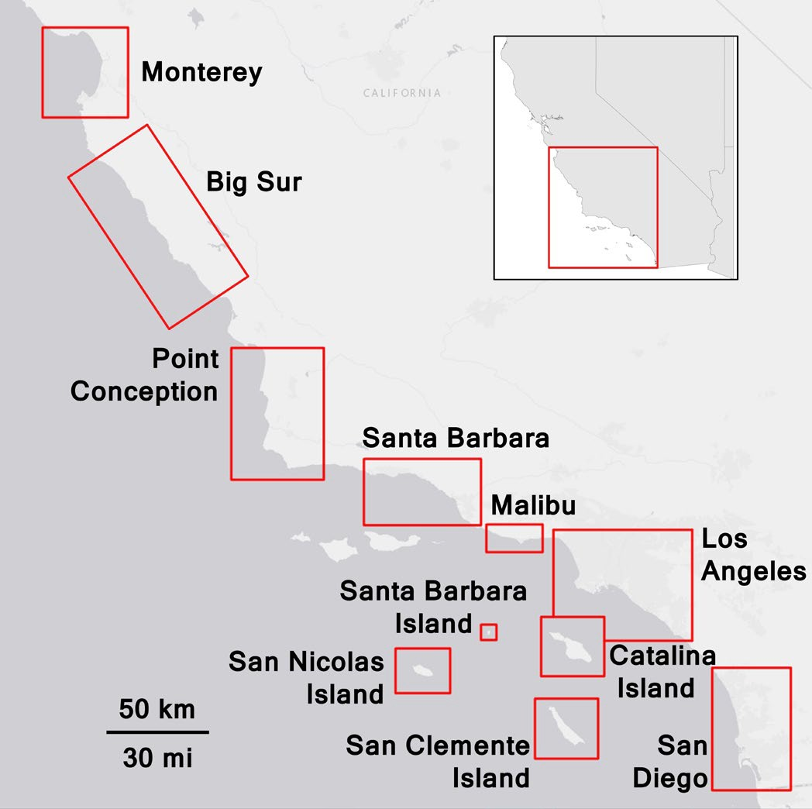

**Figure 1.** Map of sites used in our analysis. AOIs delineated in red. Inset depicts study region location relative to California’s coast. Basemap data sources: Esri, DeLorme, NAVTEQ

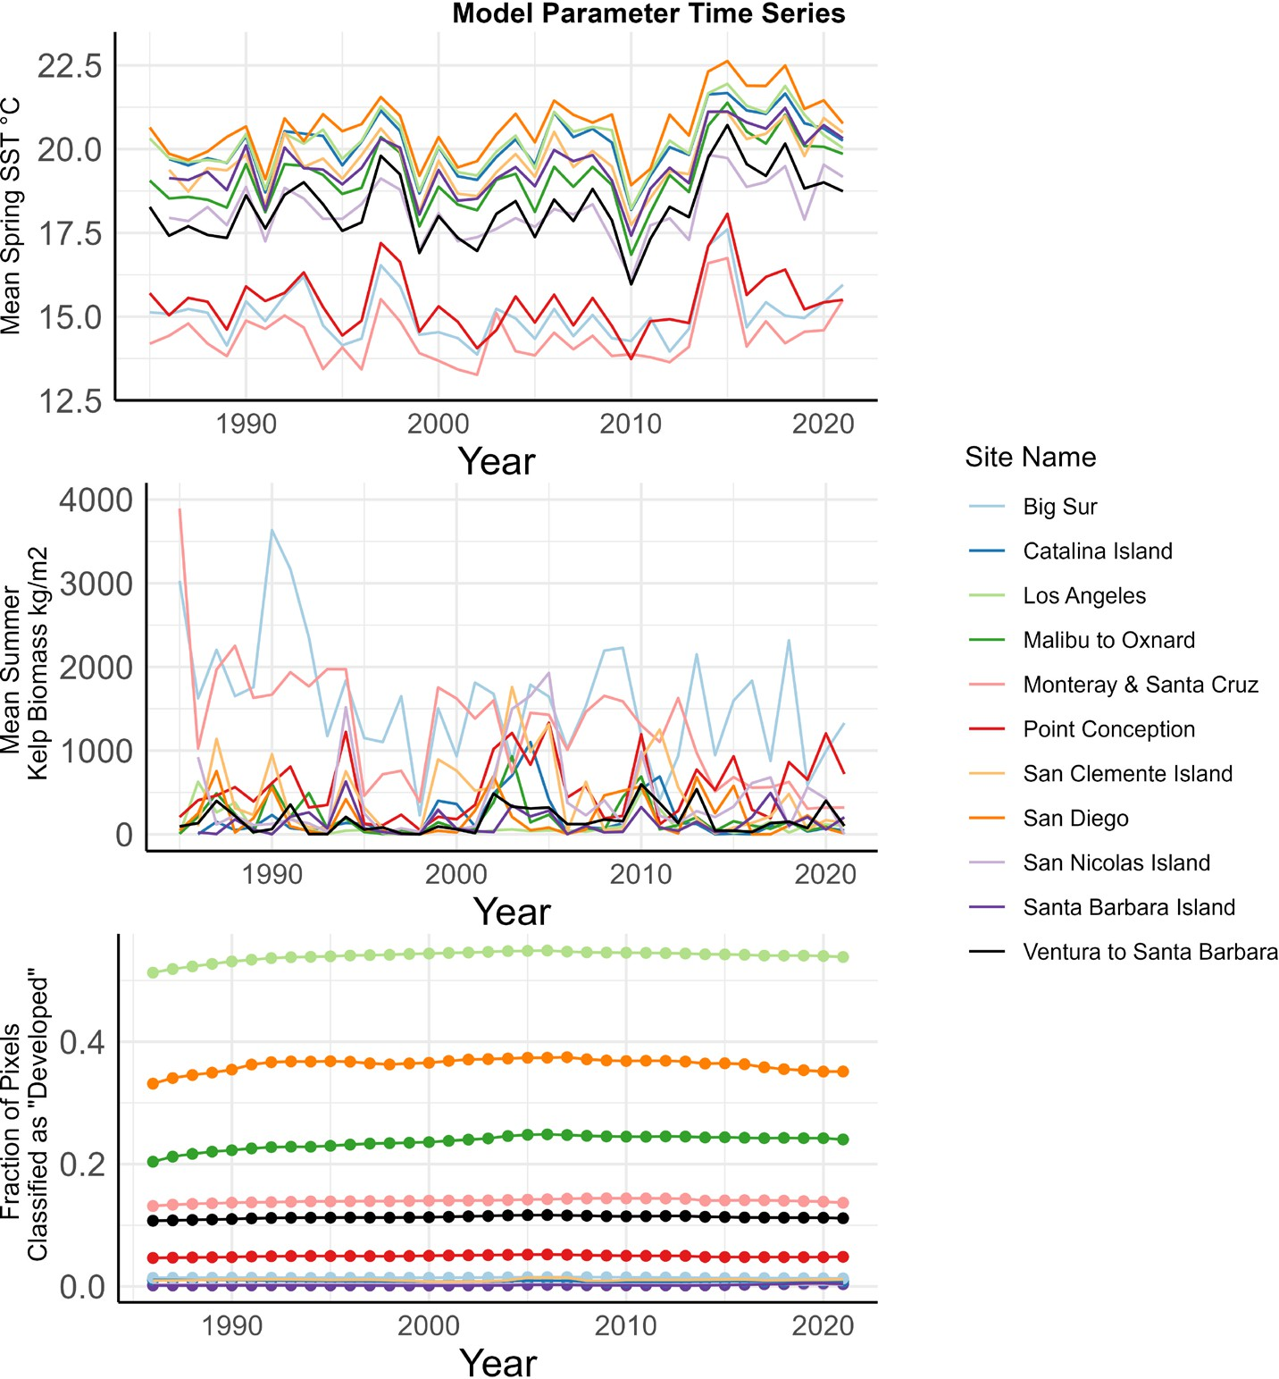

**Figure 2.** Time series of model parameters. A) Average summer kelp biomass over time in kg of wet kelp/meter2. B) Spring SST data for each site. C) Urban cover (fraction of pixels classified as “developed”) for each site.

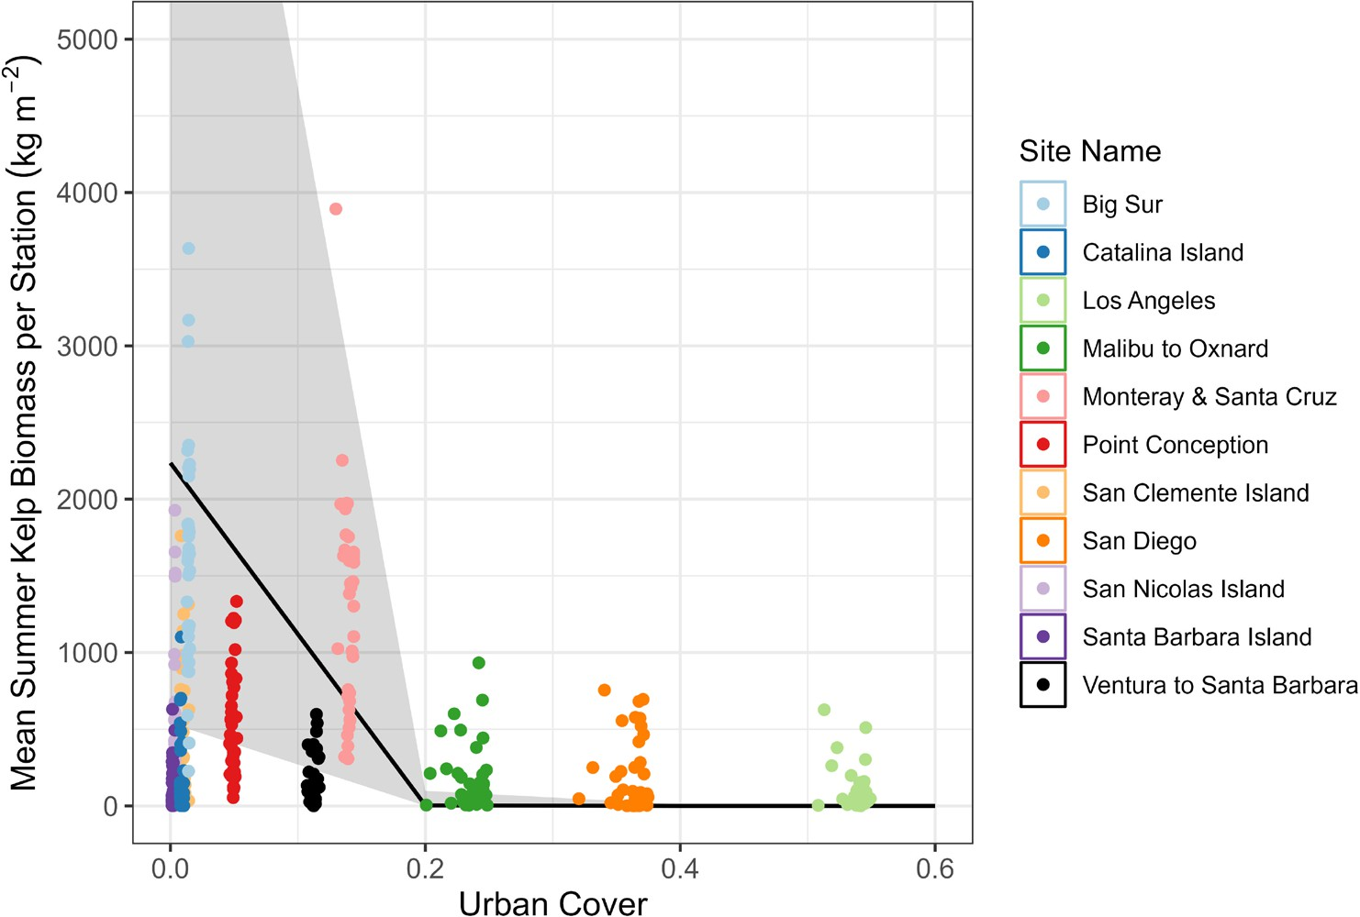

**Figure 3:** Model predicted values (black line) of mean summer biomass with 95% confidence intervals, conditional on median predictor values. Urban cover represents the fraction of pixels in a site that are classified as developed. Raw data (points) plotted for reference.

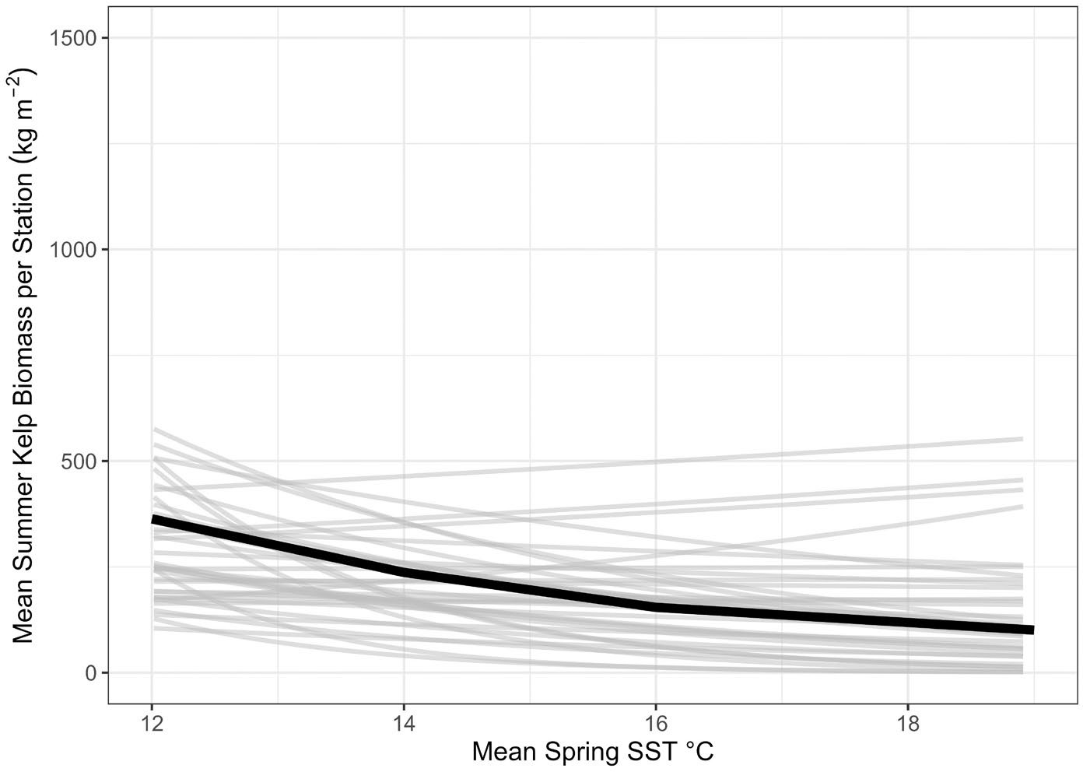

**Figure 4.** Interaction between mean spring SST and year. Lines display the effect of spring SST on summer kelp biomass for each year, conditional on the median values of all other predictors. Grey lines depict model output for each year, black line depicts average trend.

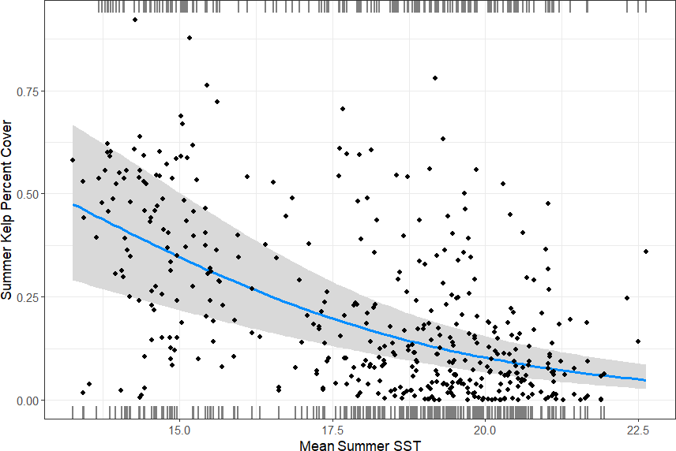

**Figure 5.** Model predicted values (blue line) of summer kelp percent cover, with 95% confidence intervals (grey), conditional on median predictor values. Raw data (points) plotted for reference.

**References**

Airoldi, L. (1998). Roles of disturbance, sediment stress, and substratum retention on spatial dominance in algal turf. *Ecology*, *79*(8), 2759–2770.

Airoldi, L. (2003). The effects of sedimentation on rocky coast assemblages. Oceanography and Marine Biology, 41, 161–236. https://doi.org/10.1201/9780203180570

Antonakis, J., Bastardoz, N., & Rönkkö, M. (2021). On Ignoring the Random Effects Assumption in Multilevel Models: Review, Critique, and Recommendations.

*Organizational Research Methods*, *24*(2), 443–483. https://doi.org/10.1177/1094428119877457

Beas-Luna, R., Micheli, F., Woodson, C. B., Carr, M., Malone, D., Torre, J., Boch, C., Caselle, J. E., Edwards, M., Freiwald, J., Hamilton, S. L., Hernandez, A., Konar, B., Kroeker, K. J., Lorda, J., Montaño-Moctezuma, G., & Torres-Moye, G. (2020).

Geographic variation in responses of kelp forest communities of the California Current to recent climatic changes. *Global Change Biology*, *26*(11), 6457–6473. https://doi.org/10.1111/gcb.15273

Beighley, R. E., Melack, J. M., & Dunne, T. (2003). Impacts of California’s Climatic Regimes and Coastal Land Use Change on Streamflow Characteristics. *JAWRA Journal of the American Water Resources Association*, *39*(6), 1419–1433.

Bell, T. W., Allen, J. G., Cavanaugh, K. C., & Siegel, D. A. (2020). Three decades of variability in California’s giant kelp forests from the Landsat satellites. *Remote Sensing of Environment*, *238*. https://doi.org/10.1016/j.rse.2018.06.039

Bell, T. W., Cavanaugh, K. C., & Siegel, D. A. (2023). *SBC LTER: Time Series of Quarterly NetCDF Files of Kelp Biomass in the Canopy from Landsat 5, 7 and 8, Since 1984 (Ongoing) Ver. 21.* Environmental Data Initiative.

Bennett, S., Wernberg, T., Harvey, E. S., Santana‐Garcon, J., & Saunders, B. J. (2015).

Tropical herbivores provide resilience to a climate‐mediated phase shift on temperate reefs. *Ecology Letters*, *18*(7), 714–723. Berberian, L. A., Lopez, A. M., Avouris, D. M., Lee, C. M., Hestir, E. L., & Cavanaugh, K. C. (2023). Applications for Aquatic Remote Sensing and Swat Modeling: Tracking the Wildfire Response of California’s Giant Kelp Forests. IGARSS 2023-2023 IEEE International Geoscience and Remote Sensing Symposium, 4006–4009.

Berry, H. D., Mumford, T. F., Christiaen, B., Dowty, P., Calloway, M., Ferrier, L., Grossman,

E. E., & VanArendonk, N. R. (2021). Long-term changes in kelp forests in an inner basin of the Salish Sea. *PLoS ONE*, *16*(2 February). https://doi.org/10.1371/journal.pone.0229703

Breheny, P., & Burchett, W. (2023). *visreg: Visualization of Regression Models*. <http://pbreheny.github.io/visreg>

Brooks, M. E., Kristensen, K., van Benthem, K. J., Magnusson, A., Berg, C. W., Nielsen, A., Skaug, H. J., Maechler, M., & Bolker, B. M. (2023). glmmTMB Balances Speed and Flexibility Among Packages for Zero-inflate d Generalized Linear Mixed Modeling. In *The R Journal* (Issue 2). https://doi.org/10.32614/RJ-2017-066

Brown, J. F., Tollerud, H. J., Barber, C. P., Zhou, Q., Dwyer, J. L., Vogelmann, J. E.,

Loveland, T. R., Woodcock, C. E., Stehman, S. V., Zhu, Z., Pengra, B. W., Smith, K.,

Horton, J. A., Xian, G., Auch, R. F., Sohl, T. L., Sayler, K. L., Gallant, A. L., Zelenak, D., … Rover, J. (2020). Lessons learned implementing an operational continuous United States national land change monitoring capability: The Land Change Monitoring, Assessment, and Projection (LCMAP) approach. *Remote Sensing of Environment*, *238*. https://doi.org/10.1016/j.rse.2019.111356

Butsic, V., Lewis, D. J., Radeloff, V. C., Baumann, M., & Kuemmerle, T. (2017). Quasi- experimental methods enable stronger inferences from observational data in ecology. In *Basic and Applied Ecology* (Vol. 19, pp. 1–10). Elsevier GmbH. <https://doi.org/10.1016/j.baae.2017.01.005>

Byrnes, J., Stachowicz, J. J., Hultgren, K. M., Randall Hughes, A., Olyarnik, S. V, & Thornber, C. S. (2006). Predator diversity strengthens trophic cascades in kelp forests by modifying herbivore behaviour. Ecology Letters, 9(1), 61–71.

Cavanaugh, K. C., Siegel, D. A., Reed, D. C., & Dennison, P. E. (2011). Environmental controls of giant-kelp biomass in the Santa Barbara Channel, California. *Marine Ecology Progress Series*, *429*, 1–17. https://doi.org/10.3354/meps09141

Chamberlain, S. (2023). *rerddap: General Purpose Client for ERDDAP Servers*. https://CRAN.R-project.org/package=rerddap

Coleman, M. A., Reddy, M., Nimbs, M. J., Marshell, A., Al-Ghassani, S. A., Bolton, J. J., Jupp, B. P., De Clerck, O., Leliaert, F., Champion, C., Pearson, G. A., Serrão, E. A., Madeira, P., & Wernberg, T. (2022). Loss of a globally unique kelp forest from Oman. *Scientific Reports*, *12*(1). https://doi.org/10.1038/s41598-022-08264-3

Connell, S. D. (2007). Water Quality and the Loss of Coral Reefs and Kelp Forests: Alternative States and the Influence of Fishing. In S. D. Connell & B. M. Gillanders (Eds.), *Marine Ecology* (pp. 556–568).

Connell, S. D., Russell, B. D., Turner, D. J., Shepherd, S. A., Kildea, T., Miller, D., Airoldi, L., & Cheshire, A. (2008). Recovering a lost baseline: Missing kelp forests from a metropolitan coast. *Marine Ecology Progress Series*, *360*, 63–72. https://doi.org/10.3354/meps07526

Cossellu, M., & Nordberg, K. (2010). Recent environmental changes and filamentous algal mats in shallow bays on the Swedish west coast — A result of climate change? *Journal of Sea Research*, *63*, 202–212. https://doi.org/10.1016/j.seares.2010.01.004

Costanza, R., de Groot, R., Sutton, P., van der Ploeg, S., Anderson, S. J., Kubiszewski, I., Farber, S., & Turner, R. K. (2014). Changes in the global value of ecosystem services. *Global Environmental Change*, *26*(1), 152–158. https://doi.org/10.1016/j.gloenvcha.2014.04.002

Cuba, D., Guardia-Luzon, K., Cevallos, B., Ramos-Larico, S., Neira, E., Pons, A., & Avila- Peltroche, J. (2022). Ecosystem Services Provided by Kelp Forests of the Humboldt Current System: A Comprehensive Review. *Coasts*, *2*(4), 259–277. https://doi.org/10.3390/coasts2040013

Dayton, P. K. (1985). *Ecology of Kelp Communities*. *16*(1985), 215–245.

Dayton, P. K., & Tegner, M. J. (1984). Catastrophic storms, El Niño, and patch stability in a southern California kelp community. *Science*, *224*(4646), 283–285.

Dayton, P. K., Tegner, M. J., Edwards, P. B., & Riser, K. L. (1998). Sliding Baselines, Ghosts, and Reduced Expectations in Kelp Forest Communities. *Ecological Applications*, *8*(2), 309–322.

Dayton, P. K., Tegner, M. J., Edwards, P. B., & Riser, K. L. (1999). Temporal and spatial scales of kelp demography: The role of oceanographic climate. *Ecological Monographs*, *69*(2), 219–250. https://doi.org/10.1890/0012-9615(1999)069[0219:TASSOK]2.0.CO;2

Dee, L. E., Ferraro, P. J., Severen, C. N., Kimmel, K. A., Borer, E. T., Byrnes, J. E. K., Clark,

A. T., Hautier, Y., Hector, A., Raynaud, X., Reich, P. B., Wright, A. J., Arnillas, C. A.,

Davies, K. F., MacDougall, A., Mori, A. S., Smith, M. D., Adler, P. B., Bakker, J. D., … Loreau, M. (2023). Clarifying the effect of biodiversity on productivity in natural ecosystems with longitudinal data and methods for causal inference. *Nature Communications*, *14*(1). https://doi.org/10.1038/s41467-023-37194-5

Dietz, M. E., & Clausen, J. C. (2008). Stormwater runoff and export changes with development in a traditional and low impact subdivision. *Journal of Environmental Management*, *87*(4), 560–566.

Dudney, J., Willing, C. E., Das, A. J., Latimer, A. M., Nesmith, J. C. B., & Battles, J. J. (2021). Nonlinear shifts in infectious rust disease due to climate change. *Nature Communications*, *12*(1). https://doi.org/10.1038/s41467-021-25182-6

Duggins, D. O., Eckman, J. E., & Sewell, A. T. (1990). Ecology of understory kelp environments. II. Effects of kelps on recruitment of benthic invertebrates. *Journal of Experimental Marine Biology and Ecology*, *143*(1), 27–45. https://doi.org/https://doi.org/10.1016/0022-0981(90)90109-P

Dwight, R. H., Caplan, J. S., Brinks, M. V., Catlin, S. N., Buescher, G., & Semenza, J. C. (2011). Influence of Variable Precipitation on Coastal Water Quality in Southern California. *Water Environment Research*, *83*(12), 2121–2130. https://doi.org/10.2175/106143011x12928814444574

Edyvane, K. (2003). Conservation Monitoring and Recovery of Threatened Giant Kelp ( Macrocystis pyrifera ) Beds in Tasmania – Final Report part 1. *Department of Primary Industries, Water & Environment, Hobart*, *November*, 106–177.

Eger, A. M., Marzinelli, E. M., Beas-Luna, R., Blain, C. O., Blamey, L. K., Byrnes, J. E. K.,

Carnell, P. E., Choi, C. G., Hessing-Lewis, M., Kim, K. Y., Kumagai, N. H., Lorda, J., Moore, P., Nakamura, Y., Pérez-Matus, A., Pontier, O., Smale, D., Steinberg, P. D., & Vergés, A. (2023). The value of ecosystem services in global marine kelp forests. *Nature Communications*, *14*(1). https://doi.org/10.1038/s41467-023-37385-0

Elsmore, K., Nickols, K. J., Miller, L. P., Ford, T., Denny, M. W., & Gaylord, B. (2023).

Wave damping by giant kelp, Macrocystis pyrifera. *Annals of Botany*, mcad094.

Eppley, R. W., Carlucci, A. F., Holm-Hansen, O., Kiefer, D., McCarthy, J. J., & Williams, P.

M. (1972). Evidence for eutrophication in the sea near Southern California coastal sewage outfalls, July, 1970. Calif. Mar. Res. Comm., CalCOFI Rept, 16, 74–83.

Fernández, P. A., Roleda, M. Y., & Hurd, C. L. (2015). Effects of ocean acidification on the photosynthetic performance, carbonic anhydrase activity and growth of the giant kelp Macrocystis pyrifera. Photosynthesis Research, 124, 293–304.

Filbee-Dexter, K., Feehan, C. J., & Scheibling, R. E. (2016). Large-scale degradation of a kelp ecosystem in an ocean warming hotspot. *Marine Ecology Progress Series*, *543*, 141–152. https://doi.org/10.3354/meps11554

Filbee-Dexter, K., & Scheibling, R. E. (2014). Sea urchin barrens as alternative stable states of collapsed kelp ecosystems. In *Marine Ecology Progress Series* (Vol. 495, pp. 1–25). https://doi.org/10.3354/meps10573

Filbee-Dexter, K., & Wernberg, T. (2018). Rise of Turfs: A New Battlefront for Globally Declining Kelp Forests. In *BioScience* (Vol. 68, Issue 2, pp. 64–76). Oxford University Press. <https://doi.org/10.1093/biosci/bix147>

Foster, M., Neushul, M., & Zingmark, R. (1971). The Santa Barbara oil spill Part 2: Initial effects on intertidal and kelp bed organisms. Environmental Pollution (1970), 2(2), 115– 134.

Foster, M. S., & Schiel, D. R. (2010). Loss of predators and the collapse of southern California kelp forests (?): Alternatives, explanations and generalizations. *Journal of Experimental Marine Biology and Ecology*, *393*(1–2), 59–70.

Foster, M. S., Schiel, D. R., & (U.S.), N. C. E. T. (1985). *The Ecology of Giant Kelp Forests in California: A Community Profile*. U.S. Fish and Wildlife Service. https://books.google.com/books?id=7t0UzwEACAAJ

Fox, J., Weisberg, S., & Price, B. (2023). *car: Companion to Applied Regression*. https://CRAN.R-project.org/package=car

Frölicher, T. L., & Laufkötter, C. (2018). Emerging risks from marine heat waves. In *Nature Communications* (Vol. 9, Issue 1). Nature Publishing Group. https://doi.org/10.1038/s41467-018-03163-6

Gorman, D., & Connell, S. D. (2009). Recovering subtidal forests in human-dominated landscapes. *Journal of Applied Ecology*, *46*(6), 1258–1265. https://doi.org/10.1111/j.1365-2664.2009.01711.x

Gorman, D., Russell, B. D., & Connell, S. D. (2009). Land-to-sea connectivity: linking human-derived terrestrial subsidies to subtidal habitat change on open rocky coasts. *Ecological Applications*, *19*(5), 1114–1126.

Grahm, M. H., Harrold, C., Lisin, S., Light, K., Watanabe, J. M., & Foster, M. S. (1997).

Population dynamics of giant kelp Macrocystis pyrifera along a wave exposure gradient. Marine Ecology Progress Series, 148, 269–279.

Graham, M. H., Vásquez, J. A., & Buschmann, A. H. (2007). Global Ecology of the Giant Kelp Macrocystis: From Ecotypes to Ecosystems. *Oceanography and Marine Biology: An Annual Review*, *45*, 39–88.

Gutierrez, A., Correa, T., Muñoz, V., Santibañez, A., Marcos, R., Cáceres, C., & Buschmann,

A. H. (2006). Farming of the giant kelp macrocystis pyrifera in southern Chile for development of novel food products. *Journal of Applied Phycology*, *18*(3–5), 259–267. https://doi.org/10.1007/s10811-006-9025-y

Hamilton, S. L., Bell, T. W., Watson, J. R., Grorud‐Colvert, K. A., & Menge, B. A. (2020).

Remote sensing: generation of long‐term kelp bed data sets for evaluation of impacts of climatic variation. *Ecology*, *101*(7), e03031.

Hamilton, S. L., Gleason, M. G., Godoy, N., Eddy, N., & Grorud-Colvert, K. (2022). Ecosystem-based management for kelp forest ecosystems. *Marine Policy*, *136*. https://doi.org/10.1016/j.marpol.2021.104919

Hartig, F. (2023). *DHARMa: Residual Diagnostics for Hierarchical (Multi-Level / Mixed) Re gression Models*. <http://florianhartig.github.io/DHARMa/>

Hayward, T. L. (1997). Pacific Ocean climate change: atmospheric forcing, ocean circulation and ecosystem response. *Trends in Ecology & Evolution*, *12*(4), 150–154. https://doi.org/https://doi.org/10.1016/S0169-5347(97)01002-1

Hepburn, C. D., Holborow, J. D., Wing, S. R., Frew, R. D., & Hurd, C. L. (2007). Exposure to waves enhances the growth rate and nitrogen status of the giant kelp Macrocystis pyrifera. Marine Ecology Progress Series, 339, 99–108. https://www.int- res.com/abstracts/meps/v339/p99-108/

Hickey, B. M. (1979). The California current system—hypotheses and facts. *Progress in Oceanography*, *8*(4), 191–279.

Hollarsmith, J. A., Andrews, K., Naar, N., Starko, S., Calloway, M., Obaza, A., Buckner, E., Tonnes, D., Selleck, J., & Therriault, T. W. (2022). Toward a conceptual framework for managing and conserving marine habitats: A case study of kelp forests in the Salish Sea. *Ecology and Evolution*, *12*(1). https://doi.org/10.1002/ece3.8510

Huang, B., Liu, C., Banzon, V., Freeman, E., Graham, G., Hankins, B., Smith, T., & Zhang, H.-M. (2021). Improvements of the Daily Optimum Interpolation Sea Surface Temperature (DOISST) Version 2.1. *Journal of Climate*, *34*(8), 2923–2939. https://doi.org/10.1175/JCLI-D-20

Huyer, A. (1983). Coastal upwelling in the California current system. In *Progress in Oceanography* (Vol. 12, Issue 3, pp. 259–284). https://doi.org/10.1016/0079-

6611(83)90010-1

Kaushal, S. S., Groffman, P. M., Band, L. E., Shields, C. A., Morgan, R. P., Palmer, M. A., Belt, K. T., Swan, C. M., Findlay, S. E. G., & Fisher, G. T. (2008). Interaction between Urbanization and Climate Variability Amplifies Watershed Nitrate Export in Maryland. *Environmental Science & Technology*, *42*(16), 5872–5878. https://doi.org/10.1021/es800264f

Krumhansl, K. A., Okamoto, D. K., Rassweiler, A., Novak, M., Bolton, J. J., Cavanaugh, K. C., Connell, S. D., Johnson, C. R., Konar, B., Ling, S. D., Micheli, F., Norderhaug, K.

M., Pérez-Matus, A., Sousa-Pinto, I., Reed, D. C., Salomon, A. K., Shears, N. T., Wernberg, T., Anderson, R. J., … Byrnes, J. E. K. (2016). Global patterns of kelp forest change over the past half-century. *Proceedings of the National Academy of Sciences*, *113*(48), 13785–13790. https://doi.org/10.1073/pnas.1606102113

Layton, C., Coleman, M. A., Marzinelli, E. M., Steinberg, P. D., Swearer, S. E., Vergés, A., Wernberg, T., & Johnson, C. R. (2020). Kelp Forest Restoration in Australia. In *Frontiers in Marine Science* (Vol. 7). Frontiers Media S.A. <https://doi.org/10.3389/fmars.2020.00074>

Leal, P. P., Hurd, C. L., Sander, S. G., Armstrong, E., Fernández, P. A., Suhrhoff, T. J., & Roleda, M. Y. (2018). Copper pollution exacerbates the effects of ocean acidification and warming on kelp microscopic early life stages. Scientific Reports, 8(1), 14763.

Ling, S. D., Johnson, C. R., Frusher, S. D., & Ridgway, K. R. (2009). Overfishing reduces resilience of kelp beds to climate-driven catastrophic phase shift. *Proceedings of the National Academy of Sciences of the United States of America*, *106*(52), 22341–22345. <https://doi.org/10.1073/pnas.0907529106>

Leighton, D. L., Jones, L. G., & North, W. J. (1966). Ecological relationships between giant kelp and sea urchins in southern California. Proceedings of the Fifth International Seaweed Symposium, Halifax, August 25–28, 1965, 141–153.

Lüdecke, D. (2023). *ggeffects: Create Tidy Data Frames of Marginal Effects for ggplot from Model Outputs*. https://strengejacke.github.io/ggeffects/

McPherson, M. L., Finger, D. J. I., Houskeeper, H. F., Bell, T. W., Carr, M. H., Rogers- Bennett, L., & Kudela, R. M. (2021). Large-scale shift in the structure of a kelp forest ecosystem co-occurs with an epizootic and marine heatwave. *Communications Biology*,

*4*(1). https://doi.org/10.1038/s42003-021-01827-6

Mendelssohn, R., Schwing, F. B., & Bograd, S. J. (2004). Nonstationary seasonality of upper ocean temperature in the California Current. *Journal of Geophysical Research: Oceans*,

*109*(10). https://doi.org/10.1029/2004JC002330

Morris, R. L., Hale, R., Strain, E. M. A., Reeves, S. E., Vergés, A., Marzinelli, E. M., Layton, C., Shelamoff, V., Graham, T. D. J., Chevalier, M., & Swearer, S. E. (2020). Key Principles for Managing Recovery of Kelp Forests through Restoration. *BioScience*, *70*(8), 688–698. https://doi.org/10.1093/biosci/biaa058

Moy, F., Christie, H., Steen, H., Stålnacke, P., Aksnes, D., Alve, E., Aure, J., Bekkby, T., Fredriksen, S., & Gitmark, J. (2008). *Final report from the Sugar Kelp Project 2005- 2008. SFT-rapport 1043/2008*. TA-2467/2008. NIVA reportn.

Moy, F. E., & Christie, H. (2012a). Large-scale shift from sugar kelp (Saccharina latissima) to ephemeral algae along the south and west coast of Norway. *Marine Biology Research*, *8*(4), 309–321. https://doi.org/10.1080/17451000.2011.637561

Moy, F. E., & Christie, H. (2012b). Large-scale shift from sugar kelp (Saccharina latissima) to ephemeral algae along the south and west coast of Norway. *Marine Biology Research*, *8*(4), 309–321.

Mundlak, Y. (1978). On the pooling of time series and cross section data. *Econometrica: Journal of the Econometric Society*, 69–85.

Neumann, B., Vafeidis, A. T., Zimmermann, J., & Nicholls, R. J. (2015). Future coastal population growth and exposure to sea-level rise and coastal flooding - A global assessment. *PLoS ONE*, *10*(3). <https://doi.org/10.1371/journal.pone.0118571>

North, W. J., Jackson, G. A., & Manley, S. L. (1986). *Macrocystis* and its environment, knowns and unknowns. Aquatic Botany, 26, 9–26. https://doi.org/https://doi.org/10.1016/0304-3770(86)90003-3

Pearl, J., Glymour, M., & Jewell, N. P. (2016). *Causal inference in statistics: A primer*. John Wiley & Sons.

Pessarrodona, A., Moore, P. J., Sayer, M. D. J., & Smale, D. A. (2018). Carbon assimilation and transfer through kelp forests in the NE Atlantic is diminished under a warmer ocean climate. *Global Change Biology*, *24*(9), 4386–4398. https://doi.org/10.1111/gcb.14303

Peteiro, C. (2018). *Alginate Production from Marine Macroalgae, with Emphasis on Kelp Farming* (pp. 27–66). https://doi.org/10.1007/978-981-10-6910-9_2

Peters, J. R., Reed, D. C., & Burkepile, D. E. (2019). Climate and fishing drive regime shifts in consumer-mediated nutrient cycling in kelp forests. *Global Change Biology*, *25*(9), 3179–3192. https://doi.org/10.1111/gcb.14706

Pfister, C. A., Berry, H. D., & Mumford, T. (2018). The dynamics of Kelp Forests in the Northeast Pacific Ocean and the relationship with environmental drivers. *Journal of Ecology*, *106*(4), 1520–1533. https://doi.org/10.1111/1365-2745.12908

Provost, E. J., Kelaher, B. P., Dworjanyn, S. A., Russell, B. D., Connell, S. D., Ghedini, G., Gillanders, B. M., Figueira, W. I., & Coleman, M. A. (2017). Climate-driven disparities among ecological interactions threaten kelp forest persistence. *Global Change Biology*, *23*(1), 353–361. https://doi.org/10.1111/gcb.13414

R Core Team. (2023). *R: A Language and Environment for Statistical Computing*. R Foundation for Statistical Computing. https:[//www.R-project.org/](http://www.R-project.org/)

Raffaelli, D., & Hawkins, S. J. (1996). *Intertidal ecology*. Springer Science & Business Media.

Reed, D. C., Laur, D. R., & Ebeling, A. W. (1988). Variation in algal dispersal and recruitment: the importance of episodic events. *Ecological Monographs*, *58*(4), 321– 335.

Scheibling, R. E., & Gagnon, P. (2009). Temperature-mediated outbreak dynamics of the invasive bryozoan Membranipora membranacea in Nova Scotian kelp beds. *Marine Ecology Progress Series*, *390*, 1–13. https://doi.org/10.3354/meps08207

Schiel, D. R., & Foster, M. S. (2015). The biology and ecology of giant kelp forests. In *The Biology and Ecology of Giant Kelp Forests*. <https://doi.org/10.2216/5501br01>

Schmid, M., Fernández, P. A., Gaitán-Espitia, J. D., Virtue, P., Leal, P. P., Revill, A. T., Nichols, P. D., & Hurd, C. L. (2020). Stress due to low nitrate availability reduces the biochemical acclimation potential of the giant kelp Macrocystis pyrifera to high temperature. Algal Research, 47, 101895. https://doi.org/https://doi.org/10.1016/j.algal.2020.101895

Seymour, R. J., Tegner, M. J., Dayton, P. K., & Parnell, P. E. (1989). Storm wave induced mortality of giant kelp, Macrocystis pyrifera, in Southern California. Estuarine, Coastal and Shelf Science, 28(3), 277–292. https://doi.org/https://doi.org/10.1016/0272-

7714(89)90018-8

Smale, D. A. (2020). Impacts of ocean warming on kelp forest ecosystems. In *New Phytologist* (Vol. 225, Issue 4, pp. 1447–1454). Blackwell Publishing Ltd. https://doi.org/10.1111/nph.16107

Smale, D. A., Wernberg, T., Oliver, E. C. J., Thomsen, M., Harvey, B. P., Straub, S. C., Burrows, M. T., Alexander, L. V., Benthuysen, J. A., Donat, M. G., Feng, M., Hobday, A. J., Holbrook, N. J., Perkins-Kirkpatrick, S. E., Scannell, H. A., Sen Gupta, A., Payne, B. L., & Moore, P. J. (2019). Marine heatwaves threaten global biodiversity and the provision of ecosystem services. In *Nature Climate Change* (Vol. 9, Issue 4, pp. 306– 312). Nature Publishing Group. https://doi.org/10.1038/s41558-019-0412-1

Steneck, R., & Erlandson, J. M. (2002). *Kelp Forest Ecosystems : Biodiversity , Stability , Resilience and Future*.

Stephens, J. S., Larson, R. J., & Pondella, D. J. (2006). Rocky reefs and kelp beds. In *The Ecology of Marine Fishes: California and Adjacent Waters* (pp. 227–252). University of California Press. https://doi.org/10.1525/california/9780520246539.003.0009

Tait, L. W. (2019). Giant kelp forests at critical light thresholds show compromised ecological resilience to environmental and biological drivers. *Estuarine, Coastal and Shelf Science*, *219*, 231–241. https://doi.org/10.1016/j.ecss.2019.02.026

Tegner, M., Dayton, P., Eedwards, P., & Riser, K. (1996). Is there evidence for long-term climatic change in Southern California kelp forests? *California Cooperative Oceanic Fisheries Investigations Reports*, *37*.

Tegner, M. J., & Dayton, P. K. (1987). El Niño Effects on Southern California Kelp Forest Communities. *Advances in Ecological Research*, *17*(C), 243–279. <https://doi.org/10.1016/S0065-2504(08)60247-0>

Tegner, M. J., & Dayton, P. K. (1991). Sea urchins, El Ninos, and the long term stability of Southern California kelp forest communities. Marine Ecology Progress Series.

Oldendorf, 77(1), 49–63.

Tegner, M. J., Dayton, P. K., Edwards, P. B., & Riser, K. L. (1997.). *Large-scale, low- frequency oceanographic effects on kelp forest succession: a tale of two cohorts* (Vol. 146).

Todd, P. A., Heery, E. C., Loke, L. H. L., Thurstan, R. H., Kotze, D. J., & Swan, C. (2019). Towards an urban marine ecology: characterizing the drivers, patterns and processes of marine ecosystems in coastal cities. *Oikos*, *128*(9), 1215–1242. https://doi.org/10.1111/oik.05946

U.S. Geological Survey (USGS). (2022). Land Change Monitoring, Assessment, and Projection (LCMAP) Collection 1.3 Science Products for the Conterminous United States. In *USGS data release*.

Vásquez, J. A., Vega, J. M. A., & Buschmann, A. H. (2008). Long term variability in the structure of kelp communities in northern Chile and the 1997–98 ENSO. In *Eighteenth International Seaweed Symposium* (pp. 279–293). Springer Netherlands. https://doi.org/10.1007/978-1-4020-5670-3_35

Vergés, A., Steinberg, P. D., Hay, M. E., Poore, A. G. B., Campbell, A. H., Ballesteros, E.,

Heck, K. L., Booth, D. J., Coleman, M. A., Feary, D. A., Figueira, W., Langlois, T., Marzinelli, E. M., Mizerek, T., Mumby, P. J., Nakamura, Y., Roughan, M., van Sebille, E., Gupta, A. Sen, … Wilson, S. K. (2014). The tropicalization of temperate marine ecosystems: Climate-mediated changes in herbivory and community phase shifts.

*Proceedings of the Royal Society B: Biological Sciences*, *281*(1789). https://doi.org/10.1098/rspb.2014.0846

Wei, X., Li, K. Y., Kilpatrick, T., Wang, M., & Xie, S. P. (2021). Large-Scale Conditions for the Record-Setting Southern California Marine Heatwave of August 2018. *Geophysical Research Letters*, *48*(7). https://doi.org/10.1029/2020GL091803

Wernberg, T. (2021). Marine heatwave drives collapse of kelp forests in Western Australia. In

*Ecosystem collapse and climate change* (pp. 325–343). Springer.

Wooldridge, J. M. (2010). *Econometric analysis of cross section and panel data*. MIT press. Zhu, Z., & Woodcock, C. E. (2014). Continuous change detection and classification of land cover using all available Landsat data. *Remote Sensing of Environment*, *144*, 152–171.

<https://doi.org/10.1016/j.rse.2014.01.011>

Zimmerman, R., & Kremer, J. (1986). In situ growth and chemical composition of the giant kelp, Macrocystis pyrifera: response to temporal changes in ambient nutrient availability

. Marine Ecology Progress Series, 27(Diekmann 1980), 277–285. https://doi.org/10.3354/meps027277

**Appendix 1**

Summary table of kelp-relevant environmental drivers.

|  |  |  |
| --- | --- | --- |
| **Driver** | **Significance** | **References** |
| Wave Exposure | While *Macrocystis* can persist under a range of wave exposure regimes, kelp in medium to high exposure sites tend to exhibit more recruitment and higher growth rates than kelp found in protected sites. However, wave-induced mortality poses a risk to mature kelps and may synergize with the projected  increases in storm severity as a result of climate change. | Grahm et al., 1997; Hepburn et al., 2007; Seymour et al., 1989 |
| Water Temperature | Warm waters negatively impact kelp forest health and resilience. While seasonal and oceanographic cycles naturally expose kelps to a variety of oceanographic conditions, climate change threatens to increase temperatures more rapidly than kelps can adapt. In extreme cases, marine heatwaves can cause severe loss of kelp forests. In addition to these direct impacts, temperature often synergizes  with other drivers such, as acidification or nutrient limitation. | Beas-Luna et al., 2020; Dayton et al., 1998; McPherson et  al., 2021 |
| Ocean Acidification | Little evidence suggests ocean acidification will be directly impactful to kelp but increases in pH can synergize with other environmental degradation (e.g., warming, nutrient availability, presence of competitor species) such that  *Macrocystis* is negatively affected. | Fernández et al., 2015) |
| Nutrient Availability | Kelp requires nutrients such as nitrogen and phosphorous and is sensitive to changes in environmental concentrations of these key resources. Nutrient deficiencies can synergize with other drivers and are often driven by elevated water temperatures, such as those experienced during marine heatwaves and El  Nino events. | Cavanaugh et al., 2011; Schmid et al., 2020; Zimmerman &  Kremer, 1986 |
| Sedimentation | Elevated turbidity due to sedimentation is problematic for kelps as they require high light levels to sustain growth. In addition, extreme sedimentation can reduce habitat availability by covering hard bottom, and in some cases can even  smother kelp recruits. | Airoldi, 2003; Dayton, 1985; Morris et al., 2020; Stephens et al.,  2006; Tait, 2019 |
| Eutrophication | Nutrient runoff can stimulate phytoplankton blooms, reducing water clarity and  decreasing light availability for growing *Macrocystis.* | Eppley et al., 1972;  North et al., 1986 |
| Pollution | Although not particularly sensitive to chemical pollutants, they can still pose a threat to *Macrocystis* forests. Oil spills are not known to directly impact Macrocystis health but can harm key organisms in the community. Copper runoff can substantially decrease viability of *Macrocystis* meiospores.  Disturbances such as wildfires threaten the health of kelp forests by releasing toxins into the environment, while simultaneously depositing large quantities of  ash into the water column. | Berberian et al., 2023; Foster et al., 1971; Leal et al., 2018 |
| Predation | In some kelp forest communities, herbivore populations are controlled by marine predators. Loss of these predators due to anthropogenic activities (e.g., fishing, hunting, habitat loss) can have significant, long-lasting impacts on kelp forest community structure. In extreme cases, this can lead to total loss of kelp  cover due to overwhelming grazing pressure. | Byrnes et al., 2006;  M. S. Foster & Schiel, 2010; Steneck &  Erlandson, 2002 |
| Herbivory | Many marine herbivores directly consume kelp. In extreme cases, typically caused by shifts in predator populations or grazer behavior, this leads to the formation of barrens which are devoid of kelp. | Filbee-Dexter & Scheibling, 2014; Leighton et al., 1966; Tegner & Dayton,  1991 |
| Competition | Kelp competes with other macroalgal species for substrate and light. Environmental degradation can alter these relationships in favor of kelp's competitors, exacerbating the direct negative effects of reductions in water  quality. | (Airoldi, 1998; Filbee- Dexter & Wernberg, 2018) |

**Appendix 2**

In order to assist with determining the structure of our causal model, we represented our variables of interest as a directed acyclic graph. For ease of interpretation, we did not graphically depict interaction effects, although they are assumed to be present and we structured our models as such. Variables in boxes denote measured variables, variables in ovals denote random effects. Arrows denote causal linkages between variables.

Supplementary Figure 1 represents what our model structure would be if we fit only fixed effects and a random effect of site. Solid lines display the system assumed by fitting a mixed model with a random effect of site. However site is correlated with temperature, urbanization, and spring biomass (indicated with dotted lines, supplementary figure 1). These site level correlations represent the drivers that are associated with our measured variables (temp, spring biomass, and urbanization), but that vary on a site level – aka, the contextual effect of these parameters (Antonakis et al., 2021). In other words, these are ways in which site confounds our response variable by way of unmeasured variables that are related to our predictors, and would prevent us from making causal inferences with this model structure.

In order to account for these unmeasured effects, we include site-level group means to account for these confounding effects and allow us to draw causal inference about how our predictors affect our response. Once calculated, these variables are treated as any other model parameter. With these site-mean predictors, the random effect of site is no longer associated with any of our other predictors and thus satisfies the assumption that it is independent of our other variables (Supplementary figure 2).

In order to illustrate how this model structure accounts for unmeasured variables, consider an additional parameter such as terrestrial wildfires. These events have the potential

to release vast amounts of ash, particulate material, and toxic chemicals into the marine environment and can certainly have a negative impact on kelp (Berberian et al., 2023). Our model is structured such that the existence of an unmeasured variable, (e.g., terrestrial fires) does not impact our interpretation of the results regarding temperature or urbanization. By including the site mean terms, we are accounting for long-term site-specific characteristics (e.g., the legacy effects of wildfires that are in some way related to urbanization or temperature) separately from the within-site differences from year to year (captured by the non-site level parameters). In this example, leftover impacts of wildfire unrelated to urbanization or temperature are contained within our random effect of site. Note that this model does not allow us to make any predictions about the effects of wildfires, rather it allows us to make predictions about urbanization and temperature while accounting for the unmeasured effects of wildfires. If we wanted to specifically make predictions about wildfires, they would need to be included in the model as a direct effect.

**Figures**

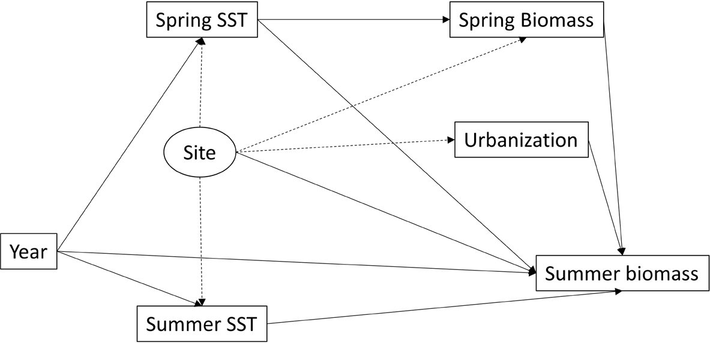

**Supplementary figure 1:** Directed Acyclic Graph denoting the model structure assumed when using a random effect. Measured variables are indicated by boxes, random effects are indicated by ovals. Solid arrows indicate associations codified in the model, dotted lines denote the actual relationships between variables. Interactions between variables not shown.

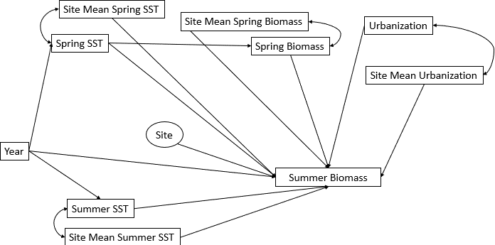

**Supplementary figure 2:** Directed Acyclic Graph denoting our model structure. Measured variables are indicated by boxes, random effects are indicated by ovals. Arrows indicate causal linkages. Interactions between variables not shown.

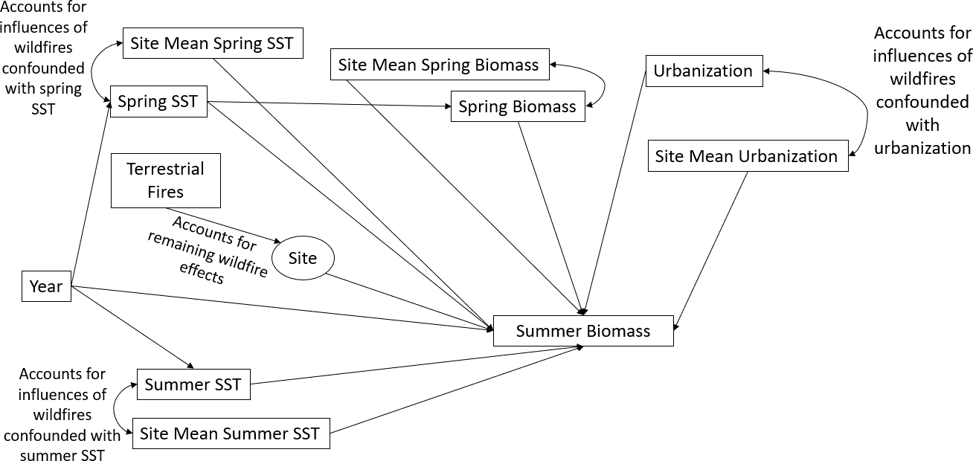

**Supplementary figure 3:** Directed Acyclic Graph of a theoretical model that includes terrestrial fires. In this case, long term differences between sites as a result of fires are accounted for by the site mean parameters, while any leftover variability driven by fires is captured by the random effect. Arrows indicate causal linkages. Interactions between variables not shown.

**Appendix 3**

In order to evaluate the robustness of our model results to casual assumptions, we also fit a model that does not contain group level predictors, and includes site as a fixed effect. This model was fit using the *glmmTMB* package (Brooks et al., 2023) for R version

4.3.0 (R Core Team, 2023), and otherwise utilizes the same generalized linear mixed model framework as our group-mean biomass and cover models. Model parameters included urban cover, spring and summer mean temps, spring biomass, site, year, and two interaction terms: spring mean temperature* urban cover (to investigate the possibility of linear interaction terms) and spring mean temperature *year (to account for temporal heterogeneity in the effect of temperature). The results of this model corroborate the conclusions drawn from our group-means model. Urban pixel fraction (beta = -36.9, SE = 11.6, p < 0.05), the interaction between mean spring SST and year (average beta = 43.4, average SE = 3.83, p < 0.05), and spring biomass (beta =1.000e-03, SE = 1.498e-04, p < 0.05) are all significant predictors of summer kelp biomass (Supplementary table 1). This result supports the implementation of the group-mean approach to refine this analysis and enable causal inference.

**Tables**

|  |  |  |  |  |  |
| --- | --- | --- | --- | --- | --- |
| **Parameter** | **Estimate** | **Std. Error** | **Chisq** | **Df** | **Pr(>Chisq)** |
| Mean Summer SST | -2.38E-01 | 1.80E-01 | 1.622 | 1 | 0.202776 |
| Mean Spring SST | -6.34E-01 | 3.32E-01 | 1.142 | 1 | 0.28517 |
| Mean Spring Kelp Biomass | 1.00E-03 | 1.50E-04 | 37.123 | 1 | 1.11E-09 |
| Urban Pixel Fraction | -3.69E+01 | 1.16E+01 | 9.424 | 1 | 0.002142 |
| Site | 3.90E+00 | 1.83E+00 | 85.585 | 10 | 4.00E-14 |
| Year | -4.43E+00 | 3.83E+00 | 176.19  9 | 36 | <2.2E-16 |
| Mean Spring SST*Urban Pixel Fraction | 2.14E-01 | 4.02E-01 | 0.226 | 1 | 0.634545 |
| Mean Spring SST*Year | 4.34E-01 | 2.64E-01 | 58.807 | 36 | 0.00958 |

**Supplementary table 1:**

Fixed Effects model results. p-values represent the output of Type II Wald chisquare tests, implemented via the Anova() function in the car package (Fox et al., 2023) for R version

4.3.0 (R Core Team, 2023) . Coefficient estimates and standard errors for site, year and year*spring interaction term presented as mean values for clarity, as these categorical variables have 11 levels (site) and 37 (year terms).

**Appendix 4**

To aid with understanding nonlinear synergies, consider the following conceptual example.

In this example, we are interested in how two stressors (e.g., temperature and urbanization) affect an environmental response (e.g., kelp biomass). In isolation, kelp biomass exhibits nonlinear responses to each of our environmental stressors independently (Supplementary figure 3). Points A1 and B1 represent kelp biomass under low values of these stressors (low stressed), and points A2 and B2 represent kelp biomass under elevated conditions (high stress). In the absence of a synergy, if one were interested in how kelp will respond to these stressors, one could simply use the model fit to estimate kelp biomass by using A2 or B2 to generate predictions of kelp biomass.

However, if both occur in concert, one stressor can set the baseline for kelp biomass – the absolute maximum kelp that is possible under those conditions. This in turn influences the maximum impact that the other stressor can have on kelp biomass (Supplementary figure 4). The impacts of stressors A and B occurring together can drive kelp loss beyond what would normally occur under these conditions in a vacuum. Note that in reality these stressors are likely to be continuous variables, we have simply illustrated four possible combinations for simplicity. In addition, it may not always be clear which stressor sets the baseline. In general both natural history and relevant mechanisms in the ecosystem in question should be considered when applying this framework.

**Figures**

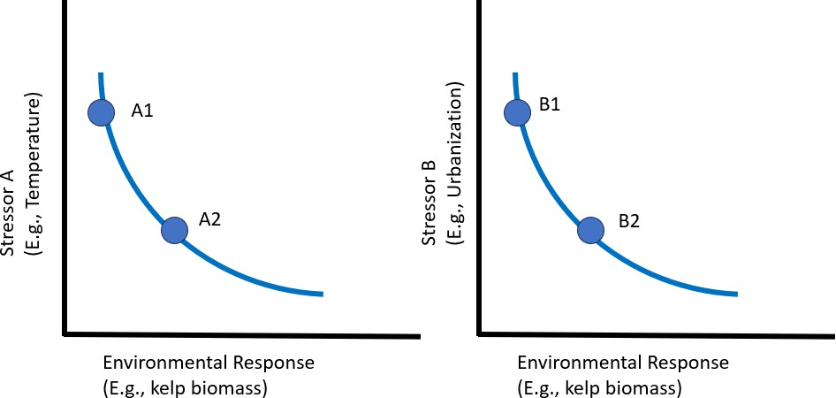

**Supplementary figure 4:** Conceptual diagram of non-linear kelp response to two non- synergistic stressors. Points A1 and B1 represent kelp biomass under low stress conditions, points A2 and B2 represent kelp biomass under high stress conditions.

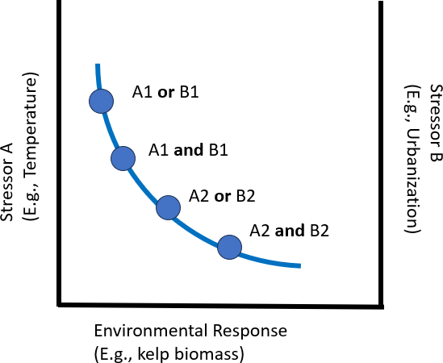

**Supplementary figure 5:** Conceptual diagram of non-linear kelp response to two synergistic stressors. Kelp biomass is reduced even in the low stress conditions, when both drivers are considered simultaneously. Under conditions of synergistic high stress, biomass is reduced beyond what either stressor is capable of in isolation.

CHAPTER 4

A CITIZEN SCIENCE APPROACH TO TEACHING CLIMATE CHANGE IN INTRODUCTORY-LEVEL UNDERGRADUATE GENERAL SCIENCE COURSES

* 1. **Abstract:**

Hundreds of thousands of undergraduates enroll in general education science courses to fulfill university core requirements, however many of these lecture-based courses fail to foster high-level data literacy skills. This work details the design, implementation, and analysis of a new climate change-based classroom activity for college students that pairs data interpretation with participation in an online citizen science project called Floating Forests ([http://floatingforests.org](http://floatingforests.org/)). We pilot tested our activity in introductory geoscience and

biology courses at six universities (~1,500 students) during the 2020-2021 academic year. Additionally, we developed and validated a survey to assess how engagement with our activity impacted students’ self-reported changes across four factors: 1) perceptions of the impacts of climate change, 2) data literacy self-efficacy, 3) beliefs about the value of citizen science, and 4) beliefs about science engagement. In a pre- to post-test comparison, students who utilized our activity in their courses showed statistically significant increases (*p* < 0.05) across all four factors. These results highlight the potential benefit of implementing data- driven, citizen science-based activities in introductory-level undergraduate courses.

* 1. **Purpose and Learning Goals**

Nearly all institutions of higher education in the United States require students to enroll in an introductory science course to fulfill their institution’s liberal arts requirement. Non-science majors enrolled in these introductory courses make up a large fraction of the student population more broadly. Unfortunately, many do not recognize the importance of science to their future careers (Glynn et al., 2007). Post-graduation, these students enter the workforce in a range of occupations in which they may not explicitly need deep content knowledge of any particular scientific discipline. Nevertheless, they can still benefit from having an enhanced scientific understanding, an ability to think critically, and ability to make evidence-based conclusions when presented with data (Lyons, 2011). For many of these undergraduate non-science majors, these courses will be their last formal exposure to science. Thus, a focus on epistemology in general education science courses will pave the way for a more scientifically and data literate society (National Research Council, 1996).

In this work, we applied a curriculum model developed by Simon et al. (2022) for astronomy education to create and evaluate a citizen science-based activity for undergraduate, introductory level geoscience and biology courses. This activity uses data and materials from the Floating Forests citizen science project ([www.FloatingForests.org](http://www.floatingforests.org/)), and is

hereafter referred to as the Floating Forests Activity. It takes a multi-faceted, data-driven approach to improve students’ 1) perceptions of the impacts of climate change, 2) data literacy self-efficacy, 3) beliefs about the value of citizen science, and 4) beliefs about science engagement. We developed and validated a four-factor, Likert-scale survey to evaluate the impact of the activity across these aforementioned objectives. The remainder of this paper describes our curriculum and assessment design, details the results of our survey

and analysis, and demonstrates the potential value of data-rich, citizen science-based classroom investigations more broadly.

* 1. **Literature Context**

Data literacy is *“the ability to understand and use data effectively to inform decisions”* and means an individual can identify, collect, organize, summarize, and prioritize data (Koltay, 2015; Mandinach & Gummer, 2013, p. 30). Although improving undergraduate students’ science literacy has been a priority of general education science courses for decades (National Research Council, 1996, 2009, 2010), the development and implementation of instructional materials aimed at improving students’ proficiency with data continues to lag behind. Prior research has shown that undergraduate students struggle to distinguish between data and evidence (Lyons, 2011) and with making predictions, observations, or explanations when presented with real data (e.g., Kastens et al., 2009; Mattox et al., 2006; Tien et al., 2007). The COVID-19 pandemic further highlighted the need for the public to be able to reason critically when presented with data. These skills are often overlooked in general education science courses where the predominant style of lecturing prioritizes content over epistemology (Gray et al., 2012). Because the traditional, lecture-based approach may remain the primary mode of instruction for many courses due to logistical constraints, we believe lectures must be supplemented with activities that enhance data literacy and promote critical thinking.

Wolff et al., (2016) present the construct of data literacy as a skill that can be sharpened with practice and experience. Furthermore, additional studies suggest that the inclusion of real-world data in the classroom is ideal for enhancing students’ data literacy

skills (Gould et al., 2014; Kjelvik & Schultheis, 2019). They also point out the importance of extending these real-world data experiences to large, complex data sets. As we enter the era of big data, integrating curriculum into the general education classroom that involves interaction with large datasets would provide non-science majors with skills that will serve them in the rest of their undergraduate tenures, in the workforce, and in their everyday lives.

* + 1. *Citizen Science as a Tool to Bring Big Data to the College Classroom*

Inquiry-based learning is an effective pedagogical strategy for improving data literacy skills (Erwin, 2015; Vahey et al., 2012). With its strong focus on metacognition, students develop areas such as critical thinking, problem solving, and project management skills.

Students develop these skills by working with actual data and real-world applications (Apedoe et al., 2006).

Despite the demonstrated effectiveness of inquiry-based learning, there is a major barrier to wider adoption: the burden often falls on instructors to identify appropriate data sets and scientific questions for investigation (Mueller et al., 2011). One solution is to use existing citizen science projects. These projects often have scientific questions with large datasets that are approachable to students. The incorporation of citizen science projects into the undergraduate, general education curriculum can engage students in analyzing and interpreting data, making observations, and making predictions with real data (Slater et al., 2008; Tien et al., 2007).

One form of citizen science involves crowdsourcing aspects of the data analysis process, enabling research teams to solve problems involving large quantities of data more efficiently while taking advantage of humans’ innate ability to recognize patterns and detect

anomalies in the data (e.g., Trouille et al., 2019 and the references therein). Studies across a variety of educational disciplines have seen significant gains in terms of student engagement and achievement with the inclusion of citizen science in their curricula (Coleman & Mitchell, 2014; Vitone et al., 2016). Students gain practical experience and learn to apply it directly, which also promotes critical thinking and problem solving in ways that traditional lectures cannot (Shah & Martinez, 2016).

Despite these aforementioned benefits, there remains relatively little work in the education research literature on the use of citizen science as the focal point of inquiry-based learning activities in undergraduate courses. In a survey of citizen science publications, classroom education was the primary focus of only 7% of papers published between 1997 and 2014 (Follett & Strezov, 2015). Most of these papers focused on citizen science projects that were conducted on school grounds directly (e.g. monitoring butterfly populations; Kelemen-Finan et al., 2013). Citizen science-based experiences for undergraduate, non- science majors have been conducted almost exclusively in biology (e.g., Hitchcock et al., 2021; Trautmann, 2013) and astronomy courses (e.g., Slater et al., 2008, 2011; Trouille et al., 2019). Considering the limited number of publications that highlight the use of citizen science in undergraduate classrooms, it is not surprising that there are even fewer published studies on the use of citizen science as a tool to improve students’ data literacy in the undergraduate classroom.

* 1. **Curriculum Development Model Overview**

The curriculum development model we used as the blueprint for our climate change-based activity is described in detail in Simon et al., 2022) and summarized below. The model was created with the goal of improving general education students’ self-reported ability to

interpret and analyze data representations (e.g., tables, graphs, and figures), while simultaneously introducing them to citizen science as a tool that would empower them to make meaningful contributions to science. With these goals in mind, the curriculum development model consists of three distinct parts:

1. A lecture-tutorial-based introductory activity that provides students with the opportunity to develop representational competence and essential background knowledge of the discipline.
2. A citizen science investigation that empowers learners to explore real data from the forefront of active research in Science, Technology, Engineering, and Mathematics (STEM) and allows them to make contributions to the science community.
3. A data analysis activity that encourages students to engage in critical reasoning, while guiding them to make evidence-based conclusions in pursuit of answers to contemporary scientific questions.

The curriculum model places a strong emphasis on real-world applications and is intended to elicit deep student engagement with scientific topics and data via the “variation approach to learning” (Linder & Fraser, 2006). This is accomplished by presenting a diverse set of data representations in tandem with a series of questions, tasks, and thought experiments (e.g., student debates) that are intended to link concepts and provide students with both increased representational competence, data literacy, and disciplinary discernment.

The first and third components of the curriculum model were developed to provide students with the proper context and support needed to understand the value of citizen science and students’ ability to contribute. Typically, citizen science projects attract a

population of free-choice learners who are already intrinsically motivated to contribute to scientific research (Raddick et al., 2013). Undergraduate students enrolled in a required introductory science course, however, may not have that same intrinsic motivation or general interest in the disciplinary topic the citizen science project highlights. As such, the lecture- tutorial component of the curriculum development model provides students with the opportunity to delve more deeply into the disciplinary topic emphasized in the citizen science project while the data analysis portion of the model uses data derived directly from the citizen science project to help students more readily discern the value of the project in the context of answering relevant scientific questions.

Student survey results from classroom testing of an astronomy-based activity developed utilizing this model suggest that the activity was effective at improving general education astronomy students’ data literacy self-efficacy. Furthermore, students indicated improved positive beliefs surrounding their ability to make meaningful contributions to science via participation in citizen science. The astronomy-based activity was developed prior to the Floating Forests Activity, but both activities were deployed for classroom use during the same academic year. Data from the astronomy-based activity was analyzed first, and it was not until the success of the curriculum model was demonstrated in astronomy that we endeavored to determine if the results were comparable in a non-astronomy field, at different institutions of higher education, and with different students.

* 1. **Overview of Floating Forests Citizen Science Project**

To fulfill Part 2 of the curriculum development model’s required components, we built the climate change activity around the citizen science project Floating Forests

([www.floatingforests.org](http://www.floatingforests.org/)). Floating Forests is an online citizen science project using the

Zooniverse platform, a suite of sophisticated tools and infrastructure supporting over 80 active projects and 2.5 million participants worldwide ([www.Zooniverse.org](http://www.zooniverse.org/); Lintott et al., 2008). The objective of the Floating Forests project is to generate a time series of giant kelp *(Macrocystis pyrifera)* populations at a global scale. Giant kelp is a species of brown algae with a worldwide distribution and great value, both as an economic and an ecological resource (Bulleri & Chapman, 2010; Ghedini et al., 2013; Schiel & Foster, 2015). In addition to its importance, it giant kelp is also threatened by human activities, hence the need for global mapping and monitoring efforts. Floating Forests utilizes consensus classifications to detect giant kelp in satellite images and produces data of comparable accuracy to expert classifications (Houskeeper et al., 2022). Floating Forests is an ideal candidate for formal undergraduate curriculum development because there is almost no barrier to entry for participants. It is free and platform agnostic - all that is required is a device with an internet connection. All necessary training and instruction is included in the experience, and participants are able to contact the research team through the project web page if they have additional questions.

In addition to its ease of use, Floating Forest’s focus on climate change impacts make it a strong candidate for classroom integration. Climate change is an ideal topic to integrate into science courses because it encompasses a range of scientific disciplines broadly including geoscience, ecology, biology, chemistry, and physics. Additionally, it is a very timely topic that is distinguished by an extensive public dialogue that is riddled with misinformation (Cook, 2022; Treen et al., 2020). Real-world applications are important for sparking student interest in science. For example, an initiative to incorporate climate change

into an introductory level college level geology course improved student learning outcomes and was overall positively received by the students (McNeal et al., 2014).

* 1. **Study Population and Setting**

Students enrolled in general education geoscience and biology courses at six institutions of higher education utilized the Floating Forests Activity during the 2020 - 2021 academic year (Table 1). Two institutions were located in the Western United States, two in the Midwest, one in the South and one in the Northeast. The students enrolled in these general education science courses were typically in the first two years of their undergraduate degree program. Depending on the institution type, these courses enroll 20 - 200 students. All courses had a full-time faculty member as the instructor of record, and several of the courses also included 1-10 graduate-level teaching assistants. 52.5% of students in the data set identified as female, 44.5% identified as male, and 3% either declined to indicate their gender preference or self-described. 59% of students identified as White, 11% identified as Black, 15% identified as Asian, and 7% declined to answer or preferred to self-describe.

Additionally, 14% of students identified as Hispanic/Latino. Note that these groups do not necessarily add up to 100%, as students were allowed to select multiple options. To conduct research with human subjects, the research team gained approval from the institutional review board (IRB) of all universities where data were analyzed.

* 1. **Materials and Implementation**
     1. *Activity Implementation*

The Floating Forests Activity was designed to take one 75-90 minute class or lab period to complete. Due to the COVID-19 pandemic, the participating courses implemented the activity either synchronously online via Zoom or in a fully asynchronous online course format with students working individually. Instructors were not required to provide substantive background information prior to administration of the activity as it is intended to serve as an introduction to the topic of climate change. Instructors were asked to provide students with a brief introduction to crowdsourcing, assuring students that any potential errors in classification on their part would have little impact on the data quality. Following this brief introduction, students were given access to the Floating Forests Activity and worked through it at their own pace.

* + 1. *Curriculum in Context: How the Model Informed our Content*

The curriculum development model we utilized (described above) has three parts, corresponding to the three parts of the Floating Forests Activity. The complete activity can be found in appendix 2 or at [www.classrooms.zooniverse.org](http://www.classrooms.zooniverse.org/).

The first component of the curriculum development model was to leverage an active learning technique to improve students' representational competence while building relevant disciplinary knowledge. Accordingly, Part 1 of the Floating Forests Activity utilizes a lecture- tutorial approach to establish baseline climate change content knowledge that is foundational to the rest of the activity. Lecture-tutorials are activities that pair carefully sequenced tasks with corresponding representations to help students build the mental models required to

overcome common conceptual misconceptions (Prather et al., 2004). Lecture-tutorials have been used in many introductory science courses, including geoscience and astronomy, with much success (e.g., Kortz et al., 2008; Prather et al., 2009). The lecture-tutorial section of the Floating Forests Activity covers greenhouse gases and the carbon cycle, with a strong emphasis on interpreting graphs and historical data. For example, we presented long term records of atmospheric carbon dioxide at a scale that illustrates both annual cycles as well as long term trends. Students were tasked with interpreting the data at both scales so that the difference between the “natural” carbon cycle and the effects of direct anthropogenic input can be compared.

The relevancy of scale is reiterated in Part 1 of the Floating Forests Activity in the context of the magnitude of climate change impacts. Students are introduced to the concept of statistical modeling with a qualitative example in which the modeled impacts of natural and anthropogenic drivers of climate change are visually compared. The activity spotlights data and model outputs from Haustein et al.’s (2017) report. This report clearly shows a sharp increase in the impacts of anthropogenic activities as compared with natural factors over time, which provides a strong case study in which the importance of scales and rates are discussed. Upon completion of this section, students summarize the links between human activity, atmospheric carbon dioxide, and global temperature. Furthermore, they understand the importance of temporal scale and rate in the context of climate change.

The second component of the curriculum model emphasized the importance of giving students an opportunity to explore real data while directly contributing to research. We accomplished this goal by focusing Part 2 of our activity on the Floating Forests online citizen science project, described in the previous section.

We created a separate practice version of Floating Forests exclusively for this activity.

This consists of 15 curated satellite images which were selected because they provide exemplary representation of the most common phenomena present in the actual Floating Forests dataset. Specifically, they include several good examples of kelp, as well as some examples of confounding features such as benthic mudflats, clouds, waves, image noise, and various other artifacts. Students thoroughly study these images in order to develop confidence in their ability to identify kelp before visiting the primary Floating Forests project website and contributing to the active project. At this point in the activity, students are working with actual data and making real contributions to the project. Upon completion of this section, students gain confidence classifying images on Floating Forests. Specifically, they should be able to differentiate between kelp, waves, clouds, and mudflats, and should develop a better understanding that authentic data is rarely (if ever) clean.

The final component of the curriculum model concerns the importance of data informed activities that guide students towards making evidence-based conclusions. To this end, Part 3 of the Floating Forests Activity ties the climate change concepts introduced in Part 1 together with kelp forest ecology introduced in Part 2. Students are presented with data representations such as seasonal maps of kelp forests generated via citizen science classifications on Floating Forests (Fig. 1), graphs of kelp population trajectories, and temperature data (both regional and global in scale). This consideration of both seasonal and long-term trends reinforces the concepts introduced in Part 1 by presenting them in an ecological context. Part 3 concludes with a thought experiment regarding climate change “hot spots” and how ecological lessons learned in a rapidly changing region such as Tasmania can be generalized to create predictions about future changes in other places. Upon

completion of this section, students should be able to synthesize data from multiple sources and relate it to their growing knowledge of the global climate system in order to make evidence-based conclusions about the potential future ecological effects of climate change.

As mentioned previously, student survey results from classroom testing of an astronomy-based activity utilizing the same curriculum model were promising (Simon et al., 2022). As such, our evaluation of the Floating Forests Activity placed specific emphasis on demonstrating the efficacy of the aforementioned curriculum model across disciplines, to see if its application to an activity that includes geoscience and biology topics would reproduce analogous student self-efficacy improvements to those observed in astronomy.

* 1. **Evaluation**
     1. *Survey Design*

Our assessment of the Floating Forests Activity was designed to measure students’ self-reported change across four different learning objectives: climate change perception (students’ perception of the drivers and impacts of climate change), data literacy self-efficacy (students’ self-reported proficiency using data/representations to make evidence-based conclusions), value of citizen science (students’ beliefs about the value of citizen science to the scientific community), and science engagement (students’ beliefs about contributing to and engaging with to science in a meaningful way). The final survey consisted of 21 Likert- style items loosely inspired by (Estrada et al., 2011), and more closely based upon the survey utilized in Simon et al., (2022). Each of the survey items were rated on a scale of 1 (Strongly Disagree) to 7 (Strongly Agree). Of the 21 overall items, 14 were included on both the pre and post-tests. In addition to these core items, the pre-test included three baseline items

regarding students’ general beliefs about science, and the post-test included four items in which students more directly reflected on the activity’s impacts. A complete list of survey items is included in appendix 1.

* + 1. *Data Collection*

Our survey was administered online via Qualtrics ([https://www.qualtrics.com](https://www.qualtrics.com/)). The

survey was administered in a pre/post-test fashion in both the Fall of 2020 and Spring of 2021, with students taking the pre-test as an at-home assignment in the first week of their course, and the post-test within one week of the activity’s completion. The timing of activity and evaluation administration was not standardized between institutions, as each instructor incorporated it into their syllabus independently. Per IRB protocol, instructors informed their students that their course had been selected to participate in a research study that involved two surveys and an activity. Students were notified that if they chose not to participate, there would be no penalty.

* + 1. *Data Cleaning and Data Analysis*

Raw student survey data was initially cleaned by removing all incomplete responses, as well as all responses that were completed in under 30 seconds, as we were concerned that these were low-effort responses and would yield poor quality data. In the case of duplicate responses (likely caused by unintentional resubmissions), students’ most recently completed response was retained. Students’ pre- and post-test responses were matched using unique, confidential identifiers. The final number of student survey responses after data cleaning and matching is shown in Table 2. We attribute the high level of attrition to a combination of

factors including students dropping the course after completing the pre-test, students not attending class on the day the Floating Forests Activity was implemented, lack of academic incentive for students to complete surveys (e.g. little to no impact on students’ course grade), and the added stress of the COVID-19 pandemic. In addition, some students incorrectly entered their anonymous identifiers, leading to completed post-tests that could not be matched with a corresponding pre-test.

We used the matched dataset for the remainder of our data analysis because it is the only subset of our data where we could guarantee that students completed the pre-test, Floating Forests Activity, and the post-test. Before proceeding, however, we compared the matched and unmatched datasets using an unpaired Wilcoxon Ranked Sum test. This nonparametric test was selected given the ordinal, non-normal nature of the dataset and was performed to ensure that the subset of matched responses were representative of the larger unmatched dataset, which would enable the implementation of paired analyses on the matched dataset. Each respondent’s individual item responses were averaged to create an overall respondent score for the pre and post-test separately. We then compared the overall score for respondents with and without matches for the pre-tests and found no significant difference (Meanmatched = 5.90, Meanunmatched = 5.99, Nmatched = 388, Nunmatched = 875, *Z* = - 1.56, *p* = 0.12). We repeated the process on the post-test responses, again finding no significant difference between the matched and unmatched datasets (Meanmatched = 6.24, Meanunmatched = 6.18, Nmatched = 388, Nunmatched = 142, *Z* = -1.41, *p* = 0.16). These results allowed us to implement pairwise analyses on the matched dataset exclusively.

To assess potential change between students’ pre- and post-test responses, we calculated the average of each student’s pre and post-test responses and performed a

Wilcoxon Signed Rank test. Individual item response averages were compared for each of the four learning objectives, as well as an overall average of all items on both the pre- and post-tests. Wilcoxon effect sizes were calculated using the formula *r* = *Z*/√N, where *Z* is the standardized test statistic and N is the number of response pairs. The threshold for statistical significance in these analyses was set at 95% confidence (α = 0.05).

* + 1. *Reliability & Validity*

In order to interpret our survey results at the category level, survey items were grouped into the four learning objectives, hereafter referred to as factors: climate change perception, data literacy self-efficacy, value of citizen science, and science engagement. We assessed the validity of these factors with both an exploratory factor analysis (EFA) and a confirmatory factor analysis (CFA). We used the following indices and thresholds to assess the degree of model fit: RMSEA ≤ 0.06, SRMR ≤ 0.08, CFI ≥ 0.95, and TLI ≥ 0.95 (Brown, 2015; Hu & Bentler, 1999).

The matched pre- and post-test dataset (N = 388) was randomly split in half to create separate data sets to perform exploratory and confirmatory factor analyses for instrument validation, leaving 194 responses for each test. The EFA indicated that a 4-factor model was appropriate, and CFA testing of this 4-factor model showed acceptable fit (RMSEA =0.047, SRMR = 0.063, CFI =0.97, and TLI =0.95). For more details regarding these analyses, refer to Appendix 2. Given the adequate fit of this 4-factor CFA, items were grouped by factor for the remaining statistical analyses.

We used Cronbach’s alpha to assess internal reliability, with a critical threshold of 0.7 (Cronbach, 1951; Hair et al., 2019). Each factor met this threshold for alpha, indicating

adequate reliability (climate change perception = 0.91, data literacy self-efficacy = 0.81, value of citizen science = 0.85, science engagement = 0.82).

* 1. **Results**

We first quantified the change in students’ total survey scores (i.e., the sum of all four factor scores) as a measure of overall change to better understand the impact of the Floating Forests Activity more generally. The mean of the 14 items that appeared on both the pre- and post-tests was calculated at the individual student level to generate overall test scores. These pre and post-test means were compared using a Wilcoxon Signed Rank test. We found a statistically significant difference between the pre-t and post-test overall scores in the matched data, indicating that the Floating Forests Activity broadly increased students’ beliefs across our four learning objectives (Meanpre= 5.99, Meanpost = 6.23, *Z* = -8.21, *p* < 0.01, *r* = 0.23).

To quantify the impact the Floating Forests Activity had on each of the factors more specifically, we performed an identical analysis of students’ pre and post-test scores on each factor individually. The results of this analysis are found in Table 3 and Figure 2.

* + 1. *Perception of Climate Change Impacts*

Student responses to the “Perception of Climate Change Impacts” factor showed a small but significant increase (i.e., higher levels of agreement that climate change is a serious issue after completion of the activity) (Meanpre= 6.18, Meanpost = 6.48, *Z* = -8.95, *p* < 0.01, *r*

= 0.18). Several of our survey items can be treated as content knowledge indicators. For example, our item “*Small changes in Earth’s average temperature over time seriously impact*

*the environment*” is an objectively true statement, and it was a key concept emphasized in the Floating Forests Activity. Student responses to this item showed overall increases in agreement, which indicates that to some degree this information was internalized. Student responses shifted from an average of 6.21 in the pre-test to 6.53 in the post-test (Z = -5.08, *p*

< 0.01, *r* = 0.18).

Another important concept covered by the activity is the degree to which human activity has contributed to climate change. Students were presented with the visual output from a statistical model that compared the importance of anthropogenic and natural drivers of climate change, which showed that anthropogenic factors are substantially more important than natural ones. In order to determine the efficacy of this approach, we asked students two separate survey items:

* + - 1. *Human activities play the most significant role in contributing to climate change.*
      2. *Human activities play a significant role in contributing to climate change.*

We saw no significant difference between pre and post-test scores for the second item, likely due to a high pre-test average of 6.5 indicating that students were already aware that humans are a major driver of climate change. However, the first item’s post-test scores were significantly higher than pre-test scores (Meanpre= 6.08, Meanpost = 6.38, *Z* = -3.63, *p* < 0.01, *r* = 0.14). This indicates that students showed positive change in their understanding of the degree to which human activities drive climate change, that is more students understood that anthropogenic activities are *the most* significant driver of climate change. Had our activity failed to communicate this information, we would expect student responses to be more similar across these items, indicating that they did not internalize the difference between these statements.

* + 1. *Data Literacy Self-Efficacy*

One of the primary goals of the Floating Forests Activity was to improve students’ beliefs about their data literacy skills, and we saw significant improvement at the factor level (Meanpre= 5.96, Meanpost = 6.16, *Z* = -6.27, *p* < 0.01, *r* = 0.14). One survey item within our data literacy factor was specifically intended to evaluate success in this area: *I am confident in my ability to interpret representations of data (graphs, tables, and charts) when seeking out answers to questions.* This item showed significant improvement from pre- to post-test results and had the highest effect size of any item in the data literacy factor (Meanpre= 5.77, Meanpost = 6.10, *Z* = -4.78, *p* < 0.01, *r* = 0.16). This suggests that our activity improves student self-efficacy specifically in interpreting data.

* + 1. *Beliefs about the Value of Citizen Science and Science Engagement*

Both the “Value of Citizen Science” (Meanpre= 5.74 , Meanpost = 6.07 , *Z* = -7.74, *p* < 0.01, *r* = 0.22) and the “Science Engagement” (Meanpre= 5.57 , Meanpost = 5.91 , *Z* = -6.99, *p*

< 0.01, *r* = 0.17) factors showed significant positive changes in student response scores between the pre-tests to post-tests (Table 3, Fig.2). These results indicate that participation in the Floating Forests Activity leads to an increase in positive student beliefs about the value of citizen science and about engagement with science more generally.

* + 1. *Post-Test Items*

Our survey included four additional post-test items that specifically targeted students’ attitudes toward citizen science and the data literacy components of the Floating Forests

Activity. Although a full mechanistic investigation of how citizen science inclusion may impact student learning was beyond the scope of our evaluation, we did ask students to quantify their interest in further contributing to citizen science projects. Eighty percent of students responded that they would be interested in continuing to contribute to the Floating Forests project, with slightly more (83%) indicating that they were interested in generally participating in other citizen science projects (Fig 3, panels C and D). Additionally, 85% of students indicated that they would be receptive to further citizen science-based course curricula (Fig 3, panel A).

Furthermore, we asked students if the Floating Forests Activity improved their data literacy skills, with an overwhelming 94% responding positively (Fig. 3, panel B). This cluster of post-test only follow-up items further supported the notion that overall, participation in the Floating Forests Activity may lead to direct improvements in students’ self-reported data literacy skills, as well as increased interest in participation in citizen science (i.e., authentic scientific research).

* 1. **Interpretations**

In this work, we present the development and testing of an inquiry-based, citizen science activity on the topic of climate change for non-STEM majors. We also evaluated the efficacy of the activity as it relates to our 4 factors: climate change perception, data literacy self-efficacy, value of citizen science, and science engagement. This evaluation was carried out via a Likert style pre/post survey, and nonparametric analysis of the responses indicated significant positive change across all four factors. Students were more aware of the importance of climate change, reported higher levels of confidence in their data-literacy

skills, were more positive about their ability to contribute to science, and reported increased belief in the value of citizen science after completion of the Floating Forests Activity in their undergraduate course. In addition, post-test-only data indicated that students enjoyed the activity and were interested in making further contributions to citizen science projects.

These results were generally consistent with those reported in Simon et al. 2022 for an astronomy activity developed using the same curriculum model described previously. In both this study and the Simon et al. study, there were statistically significant increases across the three factors consistent between both studies: data literacy self-efficacy, students’ beliefs about the value of citizen science, and beliefs about science engagement. Another consistency between both this study and the Simon et al. study was the inflated pre-test scores for nearly every item on the assessment. These inflated pre-test scores likely created a ceiling effect which contributed to generally low effect-sizes across each of the factors.

Although the effect sizes were low, the statistically significant increases for each of the factors both in this study and the Simon et al. suggest that both the Floating Forests Activity and the astronomy activity were successful at improving students’ beliefs and perceptions across a variety of factors, rather than leaving students with feelings of inadequacy post- activity (James et al., 2022).

There was little negative feedback provided by students in terms of potential improvements to be made to the Floating Forests Activity based on survey responses. Most notably, student respondents noted that several of the activity’s questions were worded too vaguely. We addressed these concerns between the first and second semester of data collection by rephrasing these questions to be more focused, and in some cases added additional supporting materials. For example, the first iteration of the first part of the activity

asked students to “explain short term changes in atmospheric CO2 over time”. Several students felt that “short term changes” was too vague, and we updated this question to specify “the seasonal pattern we observe in atmospheric CO2 over the course of one year”. This question was paired with a figure that depicts atmospheric CO2 concentrations over time and to further clarify the intention of the question, we added an inset that highlighted change on an annual, seasonal scale.

# Limitations

* + 1. *COVID-19*

One limitation of this study was the timing of the COVID-19 pandemic. At the inception of the activity’s development, it was intended for collaborative use in in-person classes. As the pandemic developed and most academic institutions moved to online formats, we adapted the curriculum to prioritize flexibility by making it available via Google Docs to allow instructors to easily implement the activity at no additional cost. While this flexibility was critical given the rapid and often chaotic shift to virtual learning, it also meant that we had no way to standardize implementation between instructors. While all pilot instructors administered the activity virtually, two out of the ten pilot instructors reported administering the activity asynchronously.

In addition, this reduced capacity to standardize implementation affected the timing of pre- and post-test administration. Ideally, students would have completed the pre- and post-tests immediately before and after completing the activity, but this was simply not possible for many instructors to accommodate. Therefore, it is likely that differences in pre-

and post-test responses were influenced by both the Floating Forests Activity as well as by students’ other learning experiences in their courses. To help account for this, we included an item on the post-test that directly asked students if participation in the Floating Forests Activity improved their data literacy self-efficacy, to which 94% of students reported that it did (Fig. 3, panel B). While obviously not as conclusive as more tightly coordinated pre-

/post-test administration, this direct self-reflection lends credence to our activity specifically impacting students’ data literacy self-efficacy. The other three factors (climate change perception, beliefs about the value of citizen science, and beliefs about science engagement,) were more specific to our particular activity, and unless students were exposed to the topic of climate change or engaged in other citizen science-based classroom experiences concurrently, we can attribute at least a majority of the observed positive changes in students’ beliefs to our activity.

* + 1. *Self-Reported Data*

One limitation of our evaluation is that we relied on self-reported student data to assess the impact of the Floating Forests Activity. Self-reported data has been shown to poorly reflect objectively measured knowledge gains in college students (Bowman, 2010; Pike, 1999; Price & Randall, 2008). However, we developed our activity with a focus on general beliefs rather than specific content knowledge. While not directly equivalent to objective knowledge gains, perceived developmental changes are linked to student satisfaction, enthusiasm, and general attitudes towards science (Gray & DiLoreto, 2016; Pike, 1993; Terenzini et al., 1982).

As we continue to develop and evaluate curricula with an emphasis on data analysis, it is imperative that we work to evaluate changes in data literacy directly (rather than via self- reported measures alone). This serves as motivation to create and validate an appropriate instrument with which to assess data literacy directly (e.g., via a task-based assessment), which would provide an additional layer of quantitative evaluation of student learning to supplement the self-reported data used in this study.

# Implications

Despite the aforementioned limitations, the results of our study indicate the curriculum model developed in Simon et al., (2022) for astronomy is effective in other disciplinary contexts (i.e., geoscience and biology). This has several implications that may be helpful to those interested in developing or implementing similar activities.

Specifically, we have shown that the Floating Forests Activity is suitable for use in undergraduate general science courses. It can be used as a standalone introduction to climate change with no necessary prerequisites and can measurably affect student understanding of climate change drivers and impacts. The Floating Forests Activity can be effectively implemented as an in-class assignment that students complete either independently or in small groups, or it can be completed outside the classroom (or in online class) as a take home activity or homework assignment. If inclined, instructors could adapt the Floating Forests Activity for in-class implementation by using the figures presented in the activity in lecture slides, and the accompanying questions and student debates to facilitate small group or entire class discussions (depending on class size). Although the Floating Forests Activity contains

three distinct parts intended to flow together, each part could be used independently if an instructor prefers breaking the activity into shorter components between lecture segments.

The success of the Floating Forests Activity furthers the assertions made in Simon et al., (2022) that citizen science is an invaluable tool for bringing big data to undergraduate, general education, science courses in an accessible way. Inquiry-based, data-forward instructional activities centered around an active citizen science investigation can successfully improve students' self-reported data literacy skills. One key aspect of the Floating Forests Activity is that students did not simply participate in the Floating Forests Zooniverse project, but that they also interacted with project data that was generated by the contributions of other volunteers in the form of maps and graphs. This experience allowed students to hone their data literacy skills and improve their self-confidence, improving their ability to understand the value of scientific research as a result. Students often report that their classroom experiences with science lack relevance to their lives, and this work affirms that positive exposure to citizen science is a strong way to shift this perspective (Jenkins, 2011; Mitchell et al., 2017; Ruiz et al., 2016). The curriculum model developed by Simon et al., (2022) and implemented here can be used as a blueprint for the development of classroom activities across a myriad of disciplines. This is an exciting prospect, as there are currently over 80 citizen science projects across ten disciplines active on the Zooniverse platform alone.

# Acknowledgments

We wish to thank Dr. Ed Prather and Dr. Travis Rector for their guidance throughout the curriculum development process. We would also like to express our

appreciation for Dr. Chris Mead, Dr. Sanlyn Buxner, and the Umass Boston Advanced Statistical Collective for their help with the statistical analysis and interpretation. Finally, our sincere gratitude to all the pilot instructors who let us administer our survey and activity in their classrooms; without them this work would not have been possible.

# Tables and Figures

|  |  |  |  |
| --- | --- | --- | --- |
| **Institution** | **Institution Type** | **Participant N** | **Course Subject** |
| Institution 1 | Public University, Very High Research Activity (R1) | 222 | Geoscience |
| Institution 2 | Public Community College | 34 | Biology |
| Institution 3 | Public University, High Research Activity (R2) | 415 | Biology |
| Institution 4 | Public University, Very High Research Activity (R1) | 135 | Geoscience |
| Institution 5 | Public University, Very High Research Activity (R1) | 530 | Geoscience |
| Institution 6 | Private Liberal Arts College, Historically Black College or University (HBCU) | 48 | Geoscience |
| No Attribution |  | 21 |  |
| **Total** |  | 1405 |  |

Table 1: Institution types, numbers of student participants, and course subjects. Institution names redacted for anonymity. “No Attribution” refers to students who did not report an identifiable institution affiliation.

|  |  |  |
| --- | --- | --- |
| **Administration** | **Number of Students (N)** | **Percentage of Total (N/N Total)** |
| Pre-test | 1263 | 89.9 |
| Post-test | 530 | 37.7 |
| Matched pairs | 388 | 27.6 |

Table 2: Self-efficacy survey student response rate after cleaning the data.

|  |  |  |  |  |  |  |
| --- | --- | --- | --- | --- | --- | --- |
| **Factor/Category** | **Item Numbers** | **Pre-test Mean ± SD** | **Post-test Mean ± SD** | ***z-***  **score** | ***p*- value** | **Effect Size** |
| Climate Change Perception | 4-10 | 6.18 ± 1.04 | 6.40 ± 0.87 | -8.95 | <0.01 | 0.18 (small) |
| Data Literacy | 11-13 | 5.96 ± 0.93 | 6.16 ± 0.86 | -6.27 | <0.01 | 0.14 (small) |
| Value of Citizen Science | 14, 15 | 5.74 ± 0.88 | 6.07 ± 0.88 | -7.74 | <0.01 | 0.22 (small) |
| Contribution Capacity | 16, 17 | 5.57 ± 1.21 | 5.91 ± 1.07 | -6.99 | <0.01 | 0.17 (small) |

Table 3: Results from factor-level Wilcoxon signed-rank tests using the matched pairs data (N = 388). Pre- and post-test means and standard deviation (SD), *z*-scores, statistical significance (*p* < 0.05), and Wilcoxon effect sizes are reported for the four learning factors. The mean and standard deviations were on a scale from 1 (strongly disagree) to 7 (strongly agree).

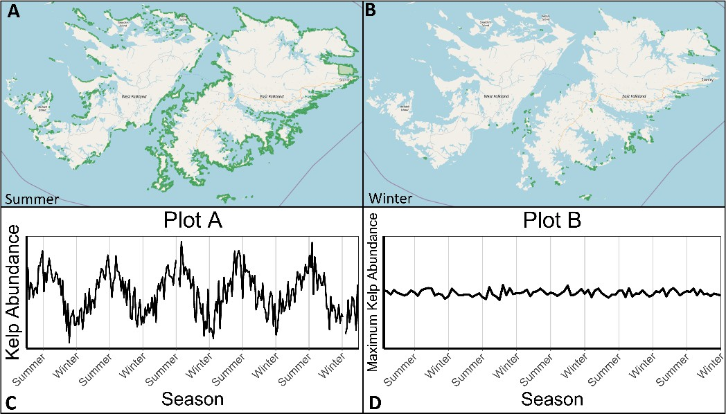

Figure 1. Representation used in part 3 of the activity. Students are provided with an interactive map that allows kelp coverage to be toggled on and off by season. Panels A and B display summer and winter kelp coverage, generated by citizen scientists and the Floating Forests project. Students are tasked with interpreting seasonal dynamics and selecting the plot (options found in panels C and D) which best represents the observed patterns.

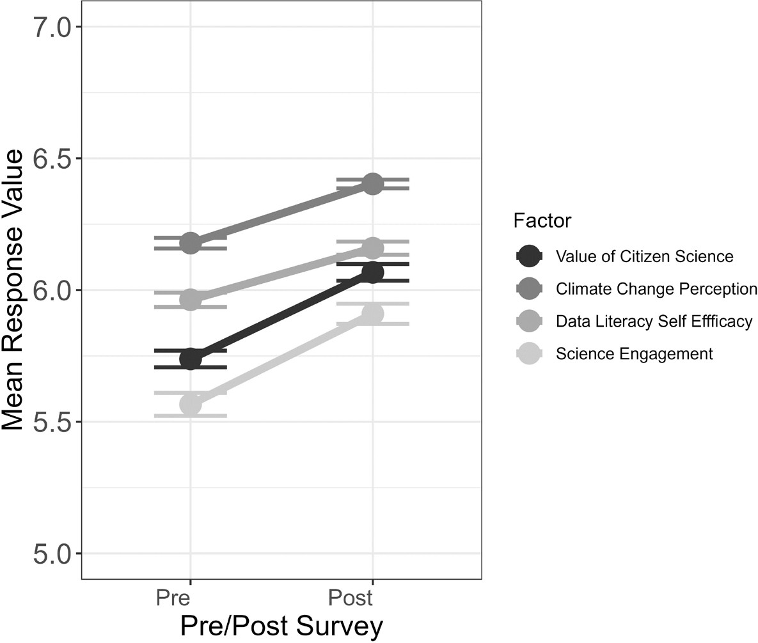

Figure 2: Comparison of matched pre- and post-test factor scores (N = 388). Factor scores are the average score of all items within a factor, on a scale from 1 (Strongly Disagree) to 7 (Strongly Agree). Each factor corresponds to one of the Floating Forest Activity learning goals.

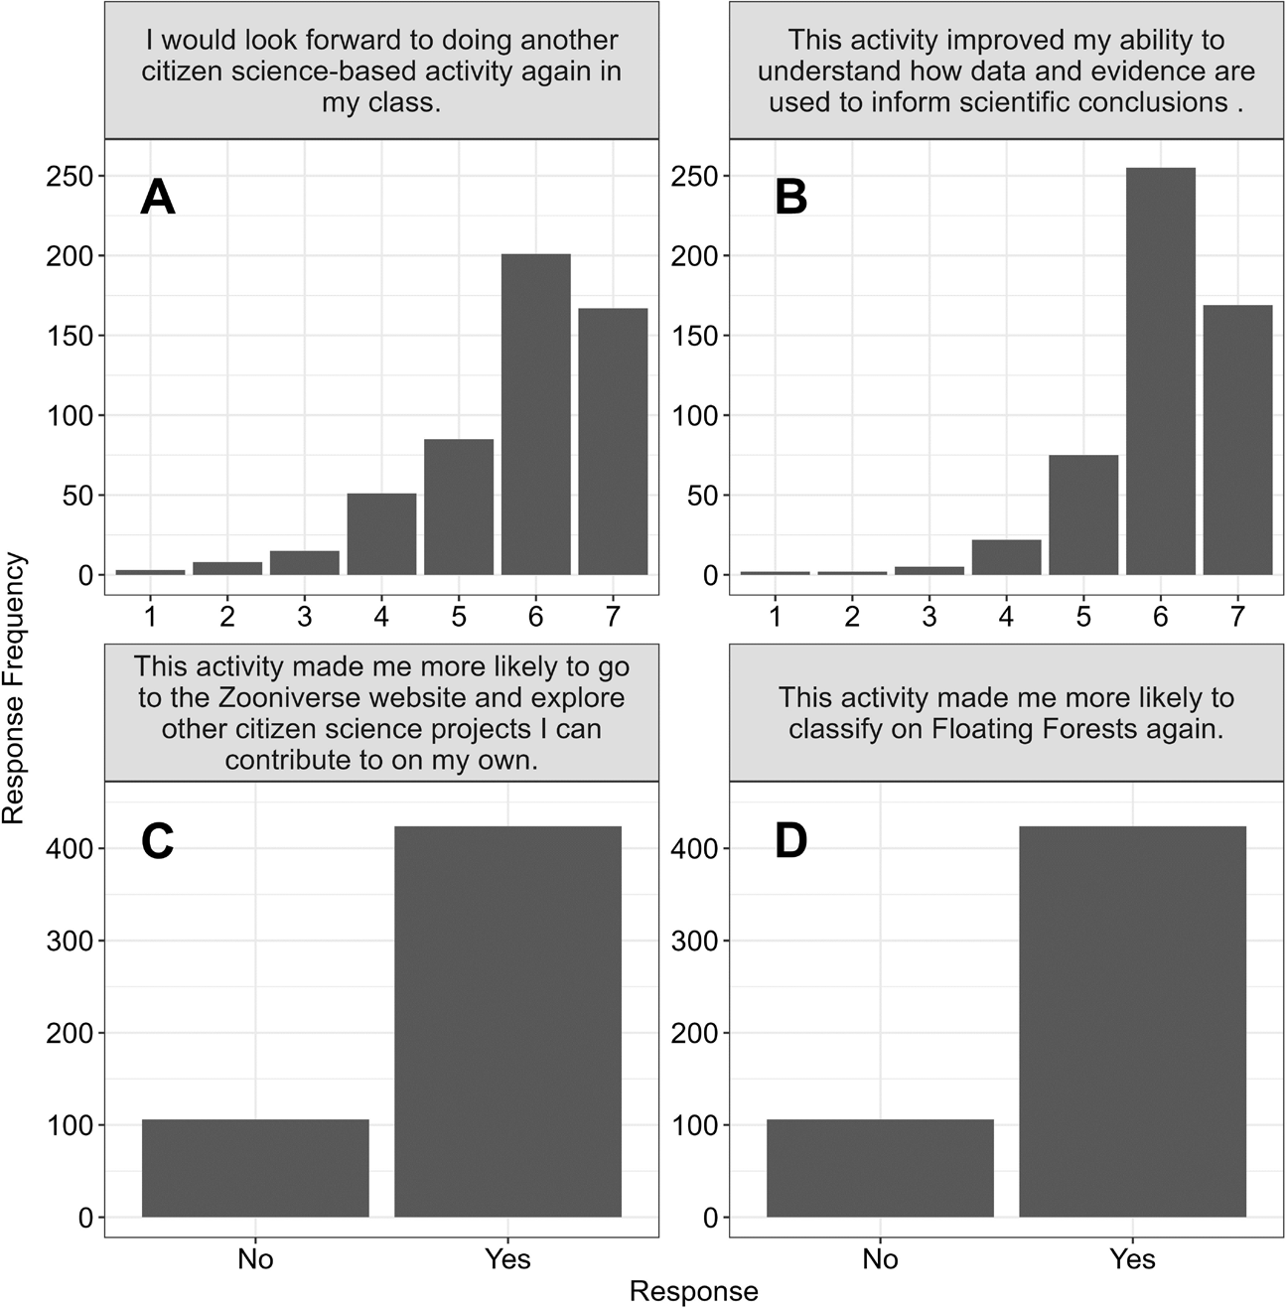

Figure 3: Bar chart of matched student responses (N = 388) to the four post-test-only items. The x-axis of panels A and B can be interpreted as 1 = Strongly Disagree, 2 = Disagree, 3 = Somewhat Disagree, 4 = Neither Agree nor Disagree, 5 = Somewhat Agree, 6 = Agree, 7 = Strongly Agree.

# References

Apedoe, X. S., Walker, S. E., & Reeves, T. C. (2006). Integrating Inquiry-based Learning into Undergraduate Geology. *Journal of Geoscience Education*, *54*(3), 414–421. https://doi.org/10.5408/1089-9995-54.3.414

Bowman, N. A. (2010). Can 1st-year college students accurately report their learning and development? *American Educational Research Journal*, *47*(2), 466–496.

Brown, T. A. (2015). Confirmatory factor analysis for applied research, 2nd ed. In

*Confirmatory factor analysis for applied research, 2nd ed.* The Guilford Press.

Bulleri, F., & Chapman, M. G. (2010). The introduction of coastal infrastructure as a driver of change in marine environments. *Journal of Applied Ecology*, *47*(1), 26–35. https://doi.org/10.1111/j.1365-2664.2009.01751.x

Coleman, J., & Mitchell, M. (2014). Active Learning in the Atmospheric Science Classroom and Beyond Through High-Altitude Ballooning. *Journal of College Science Teaching*, *044*(02), 1–6. https://doi.org/10.2505/4/jcst14_044_02_26

Cook, J. (2022). Understanding and countering misinformation about climate change.

*Research Anthology on Environmental and Societal Impacts of Climate Change*, 1633– 1658.

Cronbach, L. J. (1951). Coefficient alpha and the internal structure of tests. *Psychometrika*, *16*(3), 297–334. https://doi.org/10.1007/BF02310555

Erwin, R. W. (2015). Data Literacy: Real-World Learning Through Problem-Solving With Data Sets. *American Secondary Education*, *43*(2), 18–26. https://search.ebscohost.com/login.aspx?direct=true&db=eue&AN=103298736&site=eh ost-live

Estrada, M., Woodcock, A., Hernandez, P. R., & Schultz, P. W. (2011). Toward a Model of Social Influence that Explains Minority Student Integration into the Scientific Community. *Journal of Educational Psychology*, *103*(1), 206–222. https://doi.org/10.1037/a0020743

Follett, R., & Strezov, V. (2015). An analysis of citizen science based research: Usage and publication patterns. *PLoS ONE*, *10*(11), 1–14. https://doi.org/10.1371/journal.pone.0143687

Ghedini, G., Russell, B. D., & Connell, S. D. (2013). Managing local coastal stressors to reduce the ecological effects of ocean acidification and warming. *Water (Switzerland)*, *5*(4), 1653–1661. https://doi.org/10.3390/w5041653

Glynn, S. M., Taasoobshirazi, G., & Brickman, P. (2007). Nonscience majors learning science: A theoretical model of motivation. *Journal of Research in Science Teaching*, *44*(8), 1088–1107. https://doi.org/10.1002/tea.20181

Gould, R., Sunbury, S., & Dussault, M. (2014). In Praise of Messy Data: Lessons from the Search for Alien Worlds. *The Science Teacher*, *November*, 31–36.

Gray, J. A., & DiLoreto, M. (2016). The effects of student engagement, student satisfaction, and perceived learning in online learning environments. *International Journal of Educational Leadership Preparation*, *11*(1).

Gray, S. A., Nicosia, K., & Jordan, R. C. (2012). *Lessons Learned from Citizen Science in the Classroom*. [http://democracyeducationjournal.org/home/vol20/iss1/2/.](http://democracyeducationjournal.org/home/vol20/iss1/2/)

Hair, J., Black, W., Babin, B., & Anderson, R. (2019). Multivariate data analysis. Prentice Hall. In *London* (8th ed.).

Haustein, K., Allen, M. R., Forster, P. M., Otto, F. E. L., Mitchell, D. M., Matthews, H. D., & Frame, D. J. (2017). A real-time Global Warming Index. *Scientific Reports*, *7*(1), 1–6. https://doi.org/10.1038/s41598-017-14828-5

Hitchcock, C., Vance-Chalcraft, H., & Aristeidou, M. (2021). Citizen Science in Higher Education. *Citizen Science: Theory and Practice*, *6*(1), 1–4. https://doi.org/10.5334/CSTP.467

Houskeeper, H. F., Rosenthal, I. S., Cavanaugh, K. C., Pawlak, C., Trouille, L., Byrnes, J. E. K., Bell, T. W., & Cavanaugh, K. C. (2022). Automated satellite remote sensing of giant kelp at the Falkland Islands (Islas Malvinas). *PLoS ONE*, *17*(1 January), 1–20. https://doi.org/10.1371/journal.pone.0257933

Hu, L. T., & Bentler, P. M. (1999). Cutoff criteria for fit indexes in covariance structure analysis: Conventional criteria versus new alternatives. *Structural Equation Modeling*, *6*(1), 1–55. https://doi.org/10.1080/10705519909540118

James, N. M., Kreager, B. Z., & LaDue, N. D. (2022). Predict-observe-explain activities preserve introductory geology students’ self-efficacy. *Journal of Geoscience Education*, *70*(2), 238–249.

Jenkins, L. L. (2011). Using citizen science beyond teaching science content: A strategy for making science relevant to students’ lives. *Cultural Studies of Science Education*, *6*, 501–508.

Kastens, K. A., Agrawal, S., & Liben, L. (2009). How students and field geologists reason in integrating spatial observations from outcrops to visualize a 3-D geological structure.

*International Journal of Science Education*, *31*(3), 365–393. https://doi.org/10.1080/09500690802595797

Kelemen-Finan, J., Knoll, C., & Pröbstl-Haider, U. (2013). Citizen science - Really cool or just stupid? Lay monitoring as contribution to the environmental education of young people. *Naturschutz Und Landschaftsplanung*, *45*, 171–176.

Kjelvik, M. K., & Schultheis, E. H. (2019). Getting messy with authentic data: Exploring the potential of using data from scientific research to support student data literacy. *CBE Life Sciences Education*, *18*(2), 1–8. https://doi.org/10.1187/cbe.18-02-0023

Koltay, T. (2015). Data literacy: In search of a name and identity. *Journal of Documentation*, *71*(2), 401–415. https://doi.org/10.1108/JD-02-2014-0026

Kortz, K. M., Smay, J. J., & Murray, D. P. (2008). Increasing learning in introductory geoscience courses using lecture tutorials. *Journal of Geoscience Education*, *56*(3), 280– 290.

Linder, C., & Fraser, D. (2006). Using a Variation Approach To Enhance Physics Learning in a College Classroom. *The Physics Teacher*, *44*(9), 589–592. https://doi.org/10.1119/1.2396777

Lintott, C. J., Schawinski, K., Slosar, A., Land, K., Bamford, S., Thomas, D., Raddick, M. J., Nichol, R. C., Szalay, A., Andreescu, D., Murray, P., & Vandenberg, J. (2008). Galaxy Zoo: Morphologies derived from visual inspection of galaxies from the Sloan Digital Sky Survey. *Monthly Notices of the Royal Astronomical Society*, *389*(3), 1179–1189. https://doi.org/10.1111/j.1365-2966.2008.13689.x

Lyons, D. (2011). Impact of backwards faded scaffolding approach to inquiry-based astronomy laboratory experiences on undergraduate non-science majors’ views of scientific inquiry. Ph.D. Dissertation: University of Wyoming.

Mandinach, E. B., & Gummer, E. S. (2013). A Systemic View of Implementing Data Literacy in Educator Preparation. *Educational Researcher*, *42*(1), 30–37. https://doi.org/10.3102/0013189X12459803

Mattox, A. C., Reisner, B. A., & Rickey, D. (2006). What Happens When Chemical Compounds Are Added to Water ? An Introduction to the Model–Observe–Reflect– Explain (MORE) Thinking Frame. *Journal of Chemical Education*, *83*(4), 622–624.

McNeal, K. S., Libarkin, J. C., Ledley, T. S., Bardar, E., Haddad, N., Ellins, K., & Dutta, S. (2014). The role of research in online curriculum development: The case of EarthLabs climate change and Earth system modules. *Journal of Geoscience Education*, *62*(4), 560–577.

Mitchell, N., Triska, M., Liberatore, A., Ashcroft, L., Weatherill, R., & Longnecker, N. (2017). Benefits and challenges of incorporating citizen science into university education. *PLoS One*, *12*(11), e0186285.

Mueller, M., Tippins, D., & Bryan, L. (2011). The Future of Citizen Science. In *democracy & education* (Vol. 20, Issue 1). http://democracyeducationjournal.org/home/vol20/iss1/[6http://democracyeducationjourn](http://democracyeducationjourn/) al.org/home/vol20/iss1/1[2http://democracyeducationjournal.org/home/vol20/iss1/13http:](http://democracyeducationjournal.org/home/vol20/iss1/13http)

//democracyeducationjournal.org/home/vol20/iss2/14

National Research Council (NRC). (1996). *National Science Education Standards*. National Research Council (NRC). (2009). *National Science Education Standards*. National Research Council (NRC). (2010). *National Science Education Standards*.

Pike, G. R. (1993). The relationship between perceived learning and satisfaction with college: An alternative view. *Research in Higher Education*, *34*, 23–40.

Pike, G. R. (1999). The constant error of the halo in educational outcomes research. *Research in Higher Education*, *40*(1), 61–86.

Prather, E. E., Rudolph, A. L., Brissenden, G., & Schlingman, W. M. (2009). A national study assessing the teaching and learning of introductory astronomy. Part I. The effect of interactive instruction. *American Journal of Physics*, *77*(4), 320–330. https://doi.org/10.1119/1.3065023

Prather, E. E., Slater, T. F., Adams, J. P., Bailey, J. M., Jones, L. V., & Dostal, J. A. (2004).

Research on a Lecture-Tutorial Approach to Teaching Introductory Astronomy for Non– Science Majors. *Astronomy Education Review*, *3*(2), 122–136. https://doi.org/10.3847/aer2004019

Price, B. A., & Randall, C. H. (2008). Assessing learning outcomes in quantitative courses: Using embedded questions for direct assessment. *Journal of Education for Business*, *83*(5), 288–294.

Raddick, M., Bracey, G., Gay, P. L., Lintott, C. J., Cardamone, C., Murray, P., Schawinski, K., Szalay, A. S., & Vandenberg, J. (2013). Galaxy zoo: Motivations of citizen scientists. *Astronomy Education Review*, *12*(1). https://doi.org/10.3847/AER2011021

Ruiz-Mallén, I., Riboli-Sasco, L., Ribrault, C., Heras, M., Laguna, D., & Perié, L. (2016). Citizen science: Toward transformative learning. *Science Communication*, *38*(4), 523– 534.

Schiel, D. R., & Foster, M. S. (2015). The biology and ecology of giant kelp forests. In *The Biology and Ecology of Giant Kelp Forests*. https://doi.org/10.2216/5501br01

Shah, H. R., & Martinez, L. R. (2016). Current Approaches in Implementing Citizen Science in the Classroom. *Journal of Microbiology & Biology Education*, *17*(1), 17–22. https://doi.org/10.1128/jmbe.v17i1.1032

Simon, M. N., Prather, E. E., & Rosenthal, I. S. (2022). A New Curriculum Development Model for Improving Undergraduate Students ’ Data Literacy and Self-Efficacy in Online Astronomy Classrooms. *Astronomy Education Journal*, *2*(1).

Slater, S. J., Slater, T. F., & Lyons, D. J. (2011). Teaching Scientific Inquiry with Galaxy Zoo.

*The Physics Teacher*, *49*(2), 94–96. https://doi.org/10.1119/1.3543583

Slater, S. J., Slater, T. F., & Shaner, A. (2008). Impact of backwards faded scaffolding in an astronomy course for pre-service elementary teachers based on inquiry. *Journal of Geoscience Education*, *56*(5), 408–416. https://doi.org/10.5408/jge_nov2008_slater_408

Terenzini, P. T., Pascarella, E. T., & Lorang, W. G. (1982). An assessment of the academic and social influences on freshman year educational outcomes. *The Review of Higher Education*, *5*(2), 86–110.

Tien, L. T., Teichert, M. A., & Rickey, D. (2007). Effectiveness of a MORE laboratory module in prompting students to revise their molecular-level ideas about solutions. *Journal of Chemical Education*, *84*(1), 175–181. https://doi.org/10.1021/ed084p175

Trautmann, N. M. (2013). *Citizen science : 15 lessons that bring biology to life, 6-12*.

Treen, K. M. d’I, Williams, H. T. P., & O’Neill, S. J. (2020). Online misinformation about climate change. *Wiley Interdisciplinary Reviews: Climate Change*, *11*(5), e665.

Trouille, L., Nelson, T., & Feldt, J. (2019). Astronomy Education, Volume 1. In C. Impey &

S. Buxner (Eds.), *Evidence-based instruction for introductory courses*. IOP Publishing. https://doi.org/10.1088/2514-3433/ab2b42

Vahey, P., Rafanan, K., Patton, C., Swan, K., van ’t Hooft, M., Kratcoski, A., & Stanford, T. (2012). A cross-disciplinary approach to teaching data literacy and proportionality.

*Educational Studies in Mathematics*, *81*(2), 179–205. <http://www.jstor.org/stable/23254237>

Vitone, T., Stofer, K. A., Steininger, M. S., Hulcr, J., Dunn, R., & Lucky, A. (2016). School of ants goes to college: Integrating citizen science into the general education classroom increases engagement with science. *Journal of Science Communication*, *15*(1), 1–24. https://doi.org/10.22323/2.15010203

Wolff, A., Gooch, D., Cavero Montaner, J. J., Rashid, U., & Kortuem, G. (2016). Creating an Understanding of Data Literacy for a Data-driven Society. *The Journal of Community Informatics*, *12*(3), 9–26. https://doi.org/10.15353/joci.v12i3.3275

# Appendix 1

List of Survey Items

|  |  |  |
| --- | --- | --- |
| **Item** | **Survey Item Text** | **Category/Factor** |
| 1 | I usually understand concepts taught to me in my science classes. | Pre-test only |
| 2 | Science plays an important role in our society. | Pre-test only |
| 3 | I trust the results that come from scientific research. | Pre-test only |
| 4 | The impacts of climate change on our world are already serious. | Climate Change Perception |
| 5 | I am concerned about the effects of climate change on human society. | Climate Change Perception |
| 6 | I am concerned about the effects of climate change on non-human nature (e.g. plants and animals). | Climate Change Perception |
| 7 | Scientists are accurately depicting the severity of climate change. | Climate Change Perception |
| 8 | Small changes in Earth’s average temperature over time seriously impacts the environment. | Climate Change Perception |
| 9 | Human activities play a significant role in contributing to climate change. | Climate Change Perception |
| 10 | Human activities play the most significant role in contributing to climate change. | Climate Change Perception |
| 11 | I understand how data and evidence can be used to inform scientific conclusions. | Data Literacy Self-Efficacy |
| 12 | I am comfortable using data and evidence to inform my own scientific conclusions. | Data Literacy Self-Efficacy |
| 13 | I am confident in my ability to interpret representations of data (graphs, tables, and charts) when seeking out answers to questions. | Data Literacy Self-Efficacy |
| 14 | Participation in citizen science would allow me to make meaningful contributions to the scientific community. | Value of Citizen Science |
| 15 | Citizen science projects can make valuable contributions to scientific research. | Value of Citizen Science |
| 16 | I want to make contributions to science that I find meaningful. | Science Engagement |
| 17 | I can make contributions to science that I find meaningful. | Science Engagement |
| 18 | This activity made me more likely to classify on Floating Forests again. | Post-test Only |
| 19 | This activity made me more likely to go to the Zooniverse website and explore other citizen science projects I can contribute to on my own. | Post-test Only |
| 20 | This activity improved my ability to understand how data and evidence are used to inform scientific conclusions . | Post-test Only |
| 21 | I would look forward to doing another citizen science-based activity again in my class. | Post-test Only |

Supplemental Table 1: A complete list of items from the student self-efficacy survey. Items 4- 17 appeared on both the pre- and post-tests, and are grouped into their respective factors.

Items 1-3 only appeared on the pre-test, and items 18-21 only appeared on the post-test.

# Appendix 2

This appendix contains a copy of the Floating Forests Activity. This activity is hosted by the Zooniverse at the following URL: [https://classroom.zooniverse.org/#/activities-for-](https://classroom.zooniverse.org/%23/activities-for-undergraduates) [undergraduates](https://classroom.zooniverse.org/%23/activities-for-undergraduates).

**A Citizen Science-Based Approach to Learning About Climate Change and Ocean Ecosystems**

**Part I: Climate Change Overview**

We are changing the planet. Human activities such as the burning of fossil fuels, deforestation, and factory farming, have altered the composition of Earth’s atmosphere by releasing gas byproducts. This group of gasses are called greenhouse gasses due to their effect on the environment: they act like the glass of a greenhouse, absorbing heat and changing Earth’s climate. This group contains a handful of gasses, including carbon dioxide (CO2), methane (CH4), and nitrous oxide (N2O). Each of these gasses has the ability to affect the environment, but the most widely studied greenhouse gas is CO2. CO2 can remain in the atmosphere for hundreds of years. This longevity makes it imperative to understand, and is one of the reasons we need to do our part to address human CO2 emissions. (For more information about climate change, check out [this NASA article](https://climate.nasa.gov/causes/) for a brief introduction or [Intergovernmental Panel on Climate Change (IPCC) executive summary](https://www.ipcc.ch/site/assets/uploads/2018/02/ipcc_wg3_ar5_summary-for-policymakers.pdf) for a more detailed overview).

In order to study the effects of CO2 on the Earth, we need to know how much is present in the atmosphere. In 1957, a scientist named Charles Keeling began monitoring atmospheric CO2 at the Mauna Loa observatory in Hawaii. This project has endured throughout the years and is now the longest continuous record of CO2 on Earth. The graph below is referred to as the ‘Keeling Curve’ in honor of Charles Keeling’s contributions to science.

**Figure 1:** Carbon dioxide concentration over time at Mauna Loa Observatory. Data courtesy of Scripps Institution of Oceanography (SIO), Inset Dr. Pieter Tans, NOAA/ESRL.

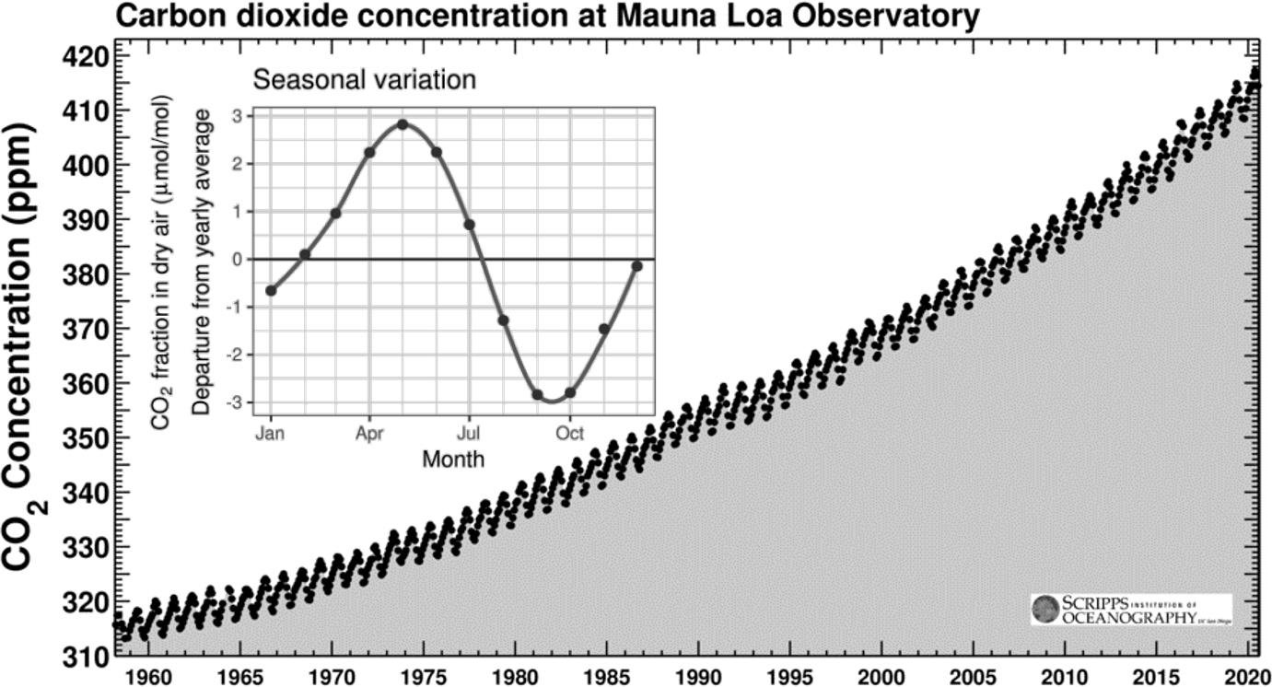

1. How does CO2 concentration change over the course of approximately one year?
2. How has CO2 concentration changed over the last 60 years?

It’s important to remember that CO2 enters the atmosphere through a variety of mechanisms, some naturally occurring, some human-driven. The balance and flow of carbon between land, ocean, and atmosphere is known as the carbon cycle and is a key component of what makes Earth habitable.

On land, CO2 is removed from the atmosphere via photosynthesis by plants. Some of this carbon is returned to the atmosphere via respiration or decomposition. Some of this CO2 is used by trees to fuel the production of biomass - forests are often referred to as “carbon sinks” because they take CO2 out of the atmosphere and store it long term in the form of trees and roots. Forests may store up to 20% of the world’s carbon, keeping it out of circulation for as long as the forest remains undisturbed.

The oceanic components of the carbon cycle are slightly different. Due to CO2’s ability to dissolve in water, the ocean itself absorbs a large amount of CO2. Within the seawater, a cycle of photosynthesis/respiration occurs much as it would on land. Some CO2 is released back into the water or air via decomposition, some is “lost” as it sinks into the deep sea. Many marine organisms use carbon (derived from CO2) to form their shells, making them vulnerable to changes in ocean chemistry. While marine absorption of CO2 has helped manage atmospheric levels, the ocean’s water chemistry has suffered as a result, leaving many of these shell-formers vulnerable.

Human activities have upset the carbon cycle’s natural balance by releasing additional amounts of CO2 into the atmosphere. Much of this CO2 is released as a result of the combustion of fossil fuels, factory farming, and deforestation practices. Through these practices, humans are injecting massive amounts of CO2 directly back into the carbon cycle at a pace that far exceeds natural rates.

1. Based on what you have learned about the carbon cycle, how would you explain the seasonal pattern we observe in atmospheric CO2 over the course of one year (refer back to Figure 1)?

**Figure 2:** Change in Earth’s global temperature and atmospheric CO2 levels over the last ~140 years. Global temperature change is depicted in red and CO2 concentration is overlaid in yellow. *Image adapted from* [*climatecentral.org*](https://www.climatecentral.org/gallery/graphics/co2-and-rising-global-temperatures)

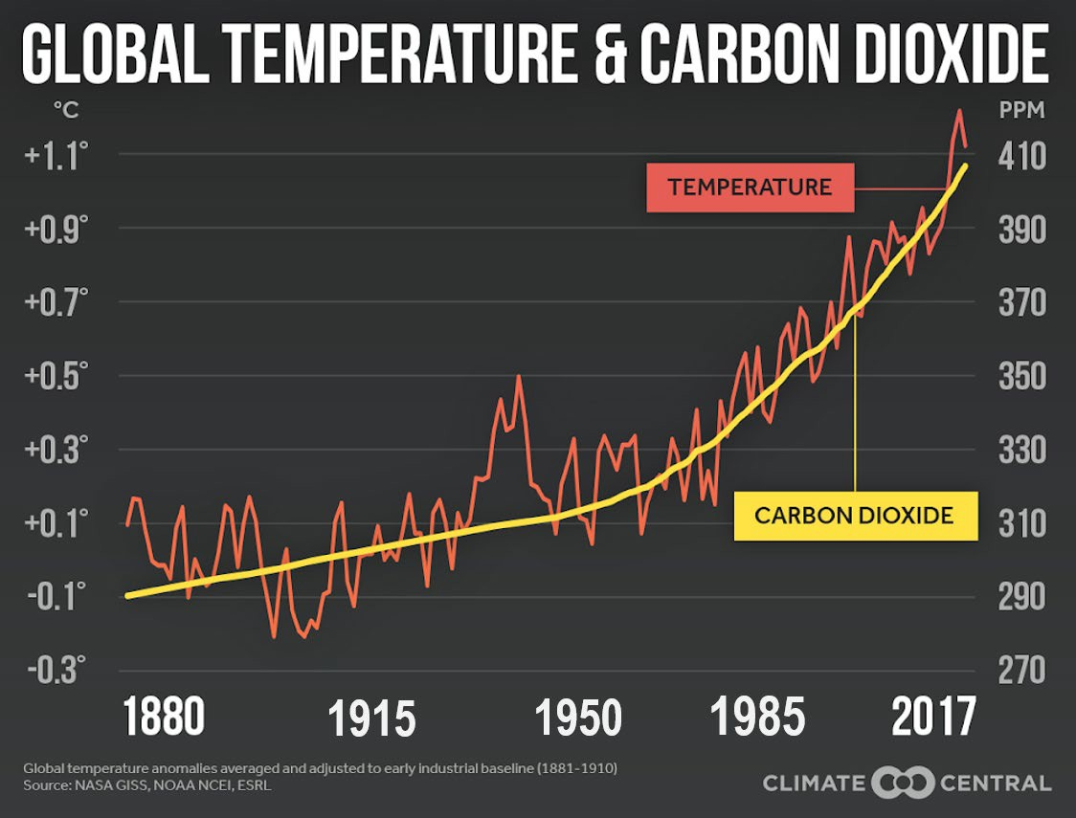

1. What relationship between CO2 concentration and temperature do you observe in Figure 2?
2. Based on your answer to Question 4, if CO2 concentration continues to increase, what implications will this have for Earth’s temperature?
3. The **slope** (steepness) of the yellow line in Figure 2 tells us about how atmospheric CO2 concentration changes over time (rate). The steeper the slope, the greater the change. Is the *rate* of CO2 concentration the same over the last 140 years? If not, does it increase or decrease over time?
4. What implications does your answer to Question 6 have for the Earth’s temperature?

The carbon cycle exemplifies that both humans and nature play distinct roles when it comes to Earth’s changing temperature. The extent to which both humans and nature impact climate change extends beyond just CO2 and is beyond the scope of this activity. What we can determine, however, is whether human processes (like deforestation and burning of fossil fuels) or natural processes (like volcanic eruptions and solar activity) dominate when it comes to Earth’s changing climate. For example, deforestation contributes to climate change through the release of carbon that had been previously stored in trees, and is responsible for up to 10% of all human-caused CO2 emissions (*Check out* [*this Climate Council article*](https://www.climatecouncil.org.au/deforestation/) *for more information about how deforestation is linked to climate change)*.

**Figure 3:** A model of how human and natural activities have affected the earth's temperature (in degrees Celsius) over time. Gray points depict observed data, lines depict the fit of a statistical model that predicts relative

contribution to climate change from both human and natural factors. *Data and model source: Haustein et al. 2017 (Scientific Reports).*

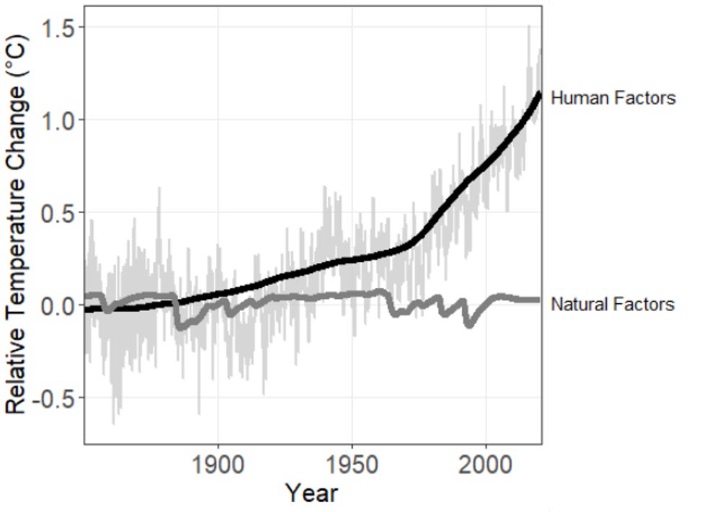

1. How well does the natural factors line (dark grey) match the data (light grey)?
2. How well does the human factors line (black) match the data (light grey)?
3. Between the years 1850-1900, did natural or human factors contribute more significantly to climate change?
4. Between the years 1900-1950, did natural or human factors contribute more significantly to climate change?
5. Between the years 1950-2000, did natural or human factors contribute more significantly to climate change?
6. Based on your answers to Questions 9-11, have human factors always contributed more significantly to climate change? If not, what do you think caused the shift? (HINT: think about industrialization)
7. By how many degrees Celcius has the Earth warmed over the last approximately 170 years? Do you think this number is large enough to make an impact on Earth’s climate and ecosystems? Explain your reasoning.
8. Two students are debating their answers to Question 13.

Student 1: I don’t really think it matters that the Earth has warmed by around 1 degree Celsius. Think about how much the temperature changes in some places on a daily basis! 1 degree would never make a difference. I think we can keep living our lives as is.

Student 2: I’m not sure I agree with you. 1 degree is just an average, so some places on Earth have already warmed by more than 1 degree. Think about the human body. If our temperature goes up by 1 degree, we probably have a fever. If our temperature goes up by 2-3 degrees, we are feeling really sick. I think in some situations, 1 degree can make a big difference.

Which student do you agree with? Explain your reasoning.

It can be difficult to visualize the impacts of a seemingly small change like one degree, but it is important to remember that the global climate impacts our planet in a variety of ways. A rigorous exploration of the many impacts of climate change on our world is beyond the scope of this activity, but [check out this NASA article](https://climate.nasa.gov/news/2865/a-degree-of-concern-why-global-temperatures-matter/) for some more information.

**Part II: An Ocean Ecosystem Impacted by Climate Change**

Climate change does not only impact humans, it also threatens ecosystems across the world, from the arctic tundra to the Great Barrier Reef. The plants and animals that live in these habitats are adapted to live in a certain set of environmental conditions. As these conditions change, organisms may be unable to adapt quickly enough which could lead to the collapse of an ecosystem. Scientists often focus on the most sensitive species in order to better understand how climate change may affect the environment. In this part of the activity, we will explore how one such ecosystem is affected by these environmental changes.

**Kelp from space!**

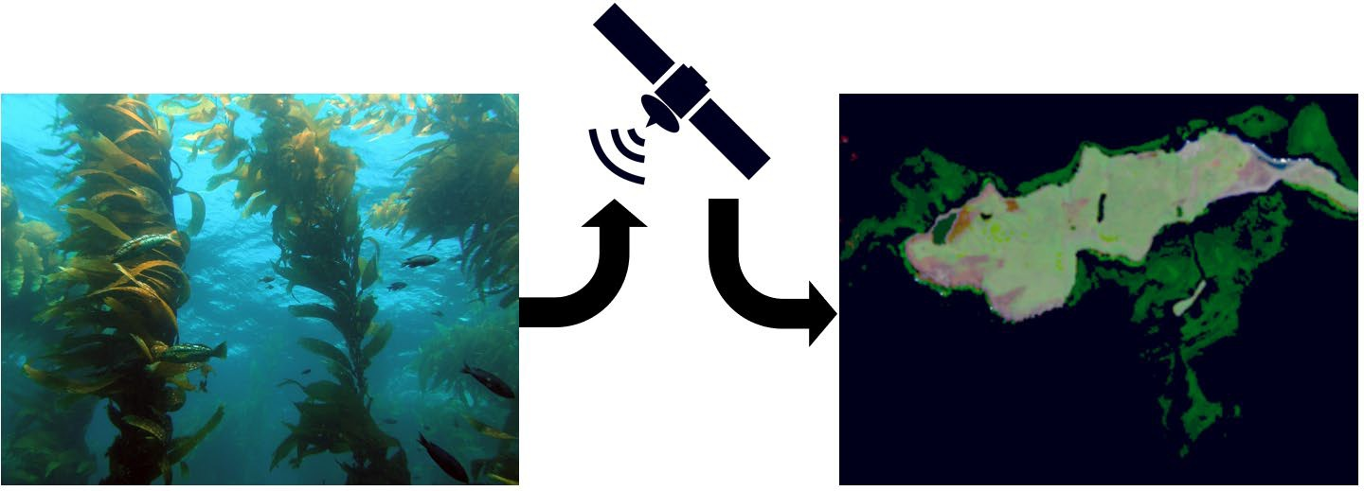

*Macrocystis pyrifera*, or giant kelp, is a massive species of brown algae that is considered an “ecosystem engineer”. Much like trees form the foundation of a terrestrial forest, *Macrocystis* forms the foundation of a kelp forest! Like their land-locked cousins, kelp forests are hotspots of biodiversity and are home to countless species of animals and algae. Kelps, along with many associated fish and shellfish are commercially harvested. The most widespread use for giant kelp itself is as a source of algin, a chemical thickener used in many food and household products. Next time you’re shopping for ice cream, check out the ingredient list and look for algin or carrageenan. Both come from kelp!

These kelp forests are found across the globe and share a common set of environmental requirements. Mature kelp fronds can weigh hundreds of pounds, and as such require a hard substrate as an anchorpoint. They attach to bedrock and boulders with their holdfast, composed of a collection of haptera which superficially resemble roots. They prefer cool and clear water and are unable to tolerate temperatures much higher than 20 degrees celsius. Giant kelp can grow to 100 feet tall or more, reaching growth rates of 1-2 feet per day under ideal conditions! Because it reaches the surface and forms a visible canopy, it can be seen in overhead photographs. Traditionally, scientists have studied kelp either through the use of SCUBA gear or aerial photographs acquired from airplanes. While these methods work well, they can be slow and expensive and are not suited to work at a global scale. The advent of freely available satellite images have opened new doors for researchers to collect data at a scale that was previously impossible.

By coupling the global reach of satellite images with a globally distributed organism like giant kelp, we can learn how climate change will affect this important ocean ecosystem.

**Familiarizing Yourself with Floating Forests**

Scientists have long been interested in how giant kelp has been affected by climate change, but have been unable to collect enough data to tackle this question at a global scale. In order to capture enough data, researchers teamed up with [The Zooniverse](https://www.zooniverse.org/about) to develop Floating Forests, a citizen science project in which volunteers identify giant kelp in satellite photographs. With the help of volunteers like you, scientists have been able to map millions of kelp patches all over the world.

Now it’s your turn to contribute to real research by helping the Floating Forests team locate kelp!

**Instructions**

* 1. To begin, head to [https://www.zooniverse.org](https://www.zooniverse.org/) and click Register in the top right-hand corner to make an account. If you already have an account, sign in.
  2. Once you’re signed in, go to [this website](https://www.zooniverse.org/projects/mollysimon/floating-forests-a-deeper-dive) to visit the Floating Forests practice module. Click on Get Started to begin. If an instruction tutorial doesn’t automatically pop up, click the Tutorial button and follow the instructions provided.
  3. For each image, you will record your answer both on Zooniverse and in the table on the next page. Each image has a number. Record what you see in each image next to its corresponding number in the table. There are a total of 15 images. Once you finish each image, click the Done button to move on to the next image.
  4. If you want to view your current image in google maps there is a map link in the metadata tab. Click the metadata button to access it.

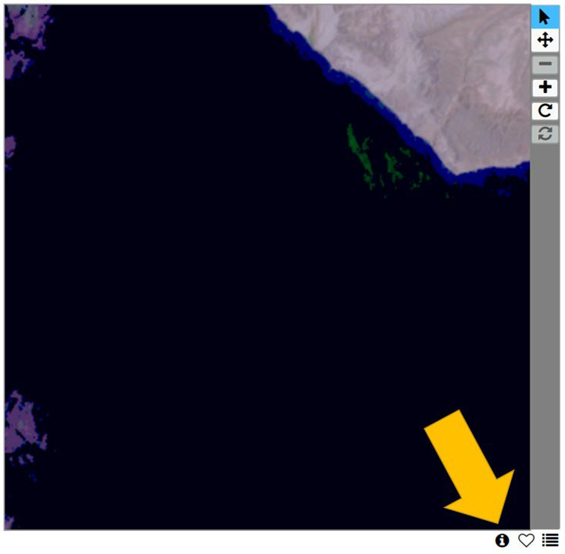

* 1. If you get stuck at any point you can click on NEED SOME HELP WITH THIS TASK right below your answer choices, or click the Field Guide tab on the right-hand side of the screen to see some examples of each feature.

**Table 1:** Record what you see in each image next to its corresponding number in the table below.

|  |  |  |  |
| --- | --- | --- | --- |
| **Image #** | **Features** | **Image #** | **Features** |
| 1 |  | 9 |  |
| 2 |  | 10 |  |
| 3 |  | 11 |  |
| 4 |  | 12 |  |
| 5 |  | 13 |  |
| 6 |  | 14 |  |
| 7 |  | 15 |  |
| 8 |  |  |  |

* 1. Want to know how you did? Compare your classifications to a kelp marine expert by checking out [this](https://docs.google.com/spreadsheets/d/1O-p-iAkJJF62UlpFBCq9Ipzd4S3R-fReHiUFqyqnnkw/edit?usp=sharing) [sheet.](https://docs.google.com/spreadsheets/d/1O-p-iAkJJF62UlpFBCq9Ipzd4S3R-fReHiUFqyqnnkw/edit?usp=sharing)
  2. Don’t worry if you still need some practice! Read over the kelp expert’s answer sheet a few times until you understand what distinguishes kelp from other features that might appear in satellite images. Once you’re feeling a bit more confident, you’re ready to classify on the actual Floating Forests project!
     1. **It’s important to note that you shouldn’t feel any pressure when you’re contributing to real research by classifying on the Floating Forests project. At least 15 people look at each image, so even if you aren’t exactly correct, the power of the crowd will help you out!**
  3. You’re ready to become an official citizen scientist! Go to the full [Floating Forests](https://www.zooniverse.org/projects/zooniverse/floating-forests/classify) webpage, and follow the tutorial to get started classifying for real!
  4. Spend about ten minutes classifying on Floating Forests before moving on to the next section of the activity.

**Debrief**

1. Were any of the Floating Forests images particularly tricky to classify? What about them made them more confusing?
2. In your experience, how did the images in the practice module compare to the images in the actual Floating Forests project?

**Part III: Using Floating Forests Data to Learn about Climate Change**

In Part II of this activity, you helped the Floating Forests science team by identifying previously unknown kelp patches. You’re officially part of a team of over 9,000 volunteers making an environmental impact by helping to create a map of global kelp distribution!

Diving into a new dataset can be a little intimidating, especially if you aren’t already familiar with how kelp data looks over time. Ecological data is almost always variable and can be difficult to interpret at first look. Instead of providing you with raw data, you’ll be given plots/figures to help you uncover whether or not kelp forests are affected by climate change.

***Will you be able to see direct evidence that climate change impacts our ocean ecosystems? Let’s look at the data, and then you decide!***

Floating Forests has been used to study kelp in places that have historically received little attention from scientists. Follow [this link](https://irosenthal.github.io/falklands_course.html?fbclid=IwAR2sroycxPojte7xKbVdlwloo5RfOxeZNtv_iTTVvVAy09KaSH0W3sNMEes) to view an interactive map of the Falkland Islands. You can control which season you are viewing by clicking the button in the upper right-hand corner of the map.

1. Which season(s) has the most amount of kelp coverage?
2. Which season(s) has the least amount of kelp coverage?
3. How does kelp coverage fluctuate over the course of one year (seasonal cycle)?

**Figure 1:** Plots A and B show hypothetical kelp abundance over the course of the seasons.

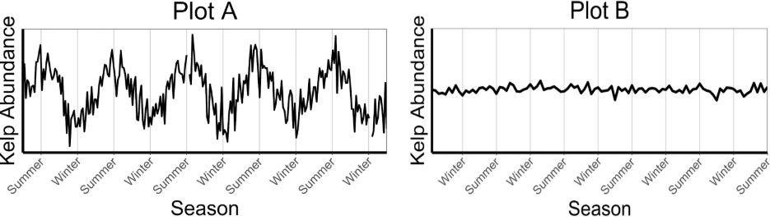

1. Which of the plots in Figure 1 best represents your answer to Question 3? Explain your reasoning.

The cyclical nature of kelp forests can make it tricky to tell the difference between natural variation and long term effects of something like climate change. In order to get a more direct understanding of year to year change, scientists often look for ways to account for seasonal patterns in their analysis. One straightforward way to do this is to compare the maximum amount of kelp (which occurs during the summer) from year to year. This gives us a snapshot of kelp at its peak, and we can compare this value over time to get an idea of how kelp forests are affected by environmental factors without being confounded by natural seasonal patterns.

1. If scientists were to compare the maximum amount of kelp in a specific region over the course of several years, would you expect the data to look relatively constant or cyclical? Explain your reasoning.

**Figure 2:** Plots A and B show hypothetical kelp abundance over the course of several years..

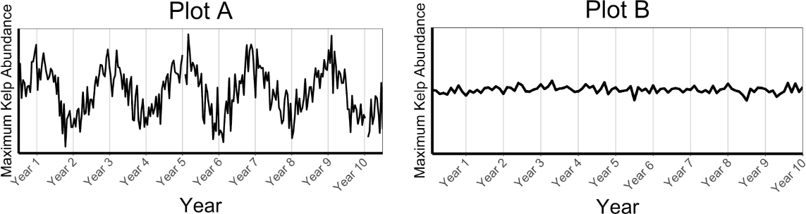

1. Which of the plots in Figure 2 best represents your answer to Question 5? Explain your reasoning.

Now you will look at the amount of kelp Floating Forests volunteers have been able to identify in the Australian island-state of Tasmania.

**Figure 3:** Maximum summer kelp abundance in Tasmania, Australia from 1991-2014. Raw data is presented in gray, with the average trend over time overlaid as a black line.

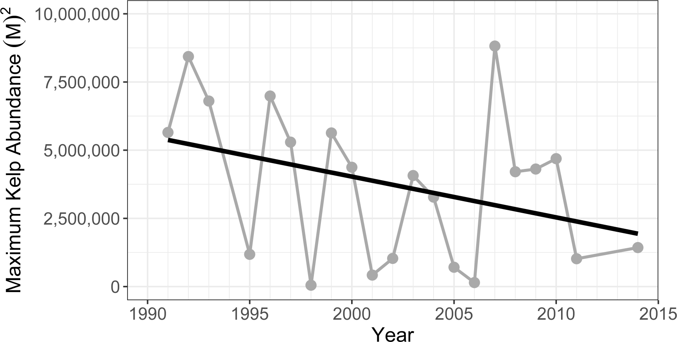

1. Based on Figure 3, how has the maximum amount of kelp in Tasmania changed over time? By how much (e.g. 30%, 70%)?

**Figure 4:** Summer ocean temperature at Hobart, Tasmania from 1870 - 2019. Raw data is presented in grey, with the average trend over time overlaid as a black line (*Data source: Met Office Hadley Centre, HadISST)*

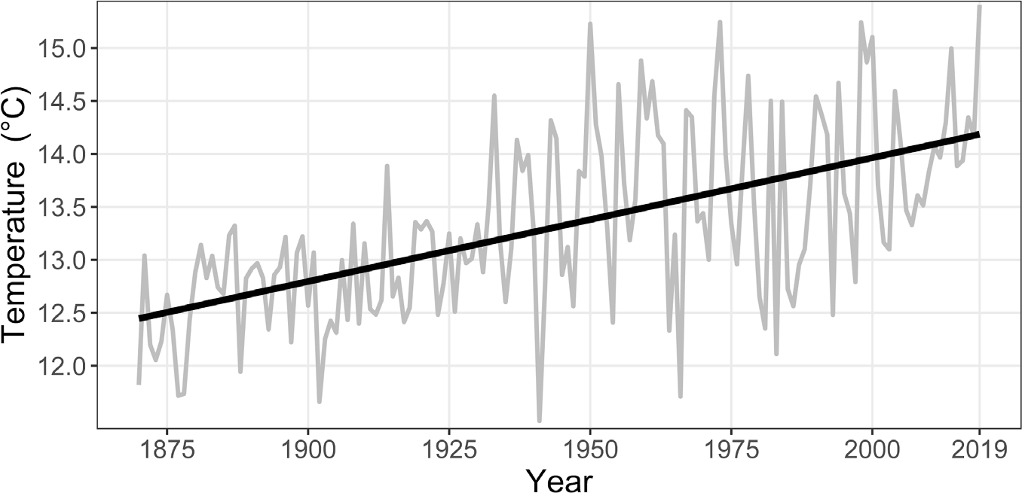

1. Based on Figure 4, how is ocean temperature around Tasmania changing over time?
2. By approximately how many degrees has ocean temperature changed in this region?
3. What relationship between ocean temperature and kelp can you deduce based on the provided data from Tasmania (maximum kelp abundance and ocean temperature)?

**Figure 5**: Ocean temperature from 1870-2019. Panel A depicts global trends and panel B depicts the trend for Hobart, Tasmania. Raw data is presented in grey, with the average trend over time overlaid as a black line (*Data source: Met Office Hadley Centre, HadISST)*

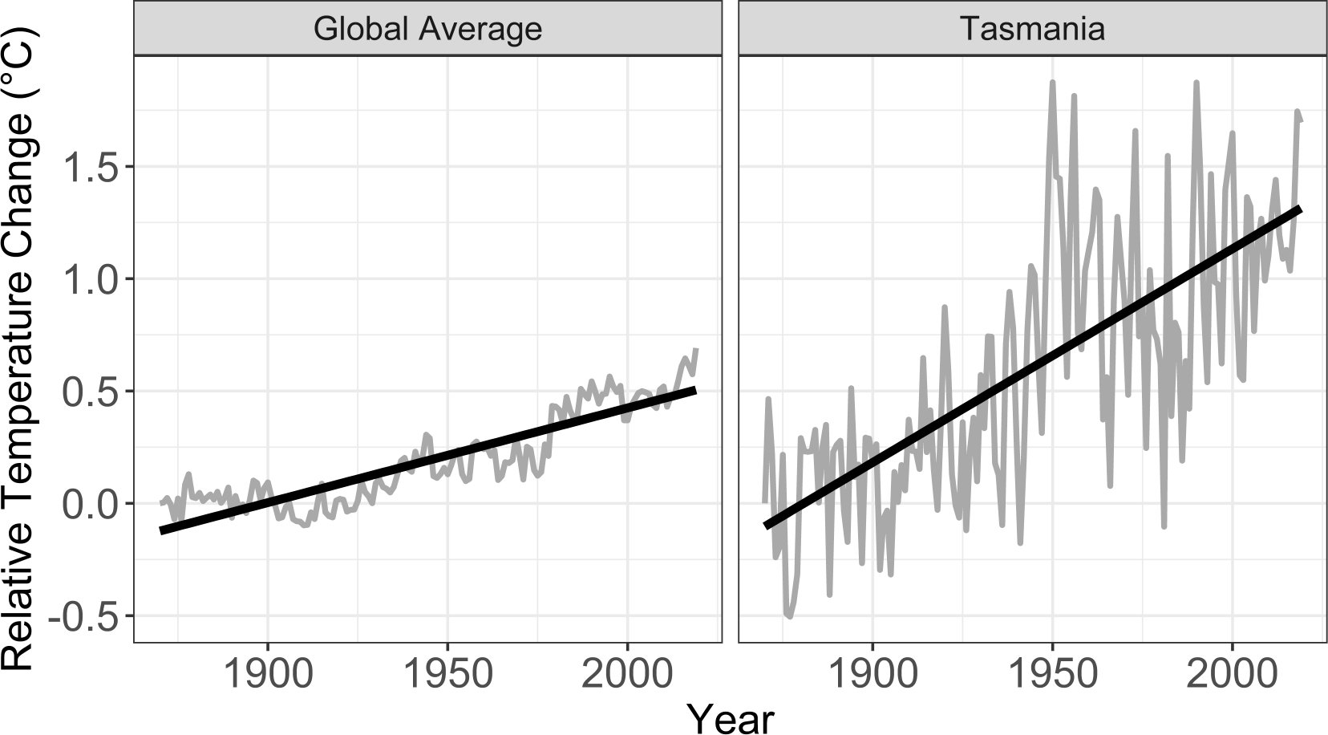

1. Using the data presented in Figure 5, how does ocean temperature change in Tasmania compare to the rest of the world?

Although the entire Earth is warming, some parts of the world are considered climate change “hot-spots” due to a faster rate of warming than the global average. Hot spots are excellent places to study the effects of climate change, because they give scientists a glimpse into the future of what the rest of the Earth will look like if the temperature continues to increase. Tasmania is one such hot-spot that scientists study. In Tasmania, warming waters have disrupted major ocean currents and shifted the East Australian Current (EAC) to the south, flooding the Tasman Sea with warm water. This has brought many rapid environmental changes to the region and is the

major driver in the localized loss of kelp. This change has been so dramatic that in 2012 the Australian government listed giant kelp as an endangered species.

1. Based on what you’ve learned in this activity, are small increases in the ocean’s temperature (~1.5 degrees celsius) significant enough to impact ocean ecosystems? Explain your reasoning.

Despite the warnings we present here, most ecosystems are resilient and can recover if given a chance - it is not too late! Local case studies can provide insight as to how kelp forests can recover from stress. In this case, we will use the example of the Point Loma kelp forests in California.

Between 1940 and 1960, a newly installed shallow water sewage outfall pumped huge amounts of polluted wastewater into the region’s kelp forests. By 1960, these kelp forests had almost entirely disappeared. In response, many scientists worked together with the goal of understanding what happened to the kelp and how to restore it. Their research led to the relocation of the sewage outfall to be further offshore, which in turn led to the recovery of local kelp forests! Similarly, if we reduce environmental stress by decreasing CO2 emissions, it is likely that many threatened kelp forests will recover.

By helping map kelp on Floating Forests, you are helping scientists better understand where kelp is most vulnerable. In turn, the data you contribute could be used to inform better environmental policy and regulation and focused kelp recovery efforts!

**References:**

Haustein, K., M. R. Allen, P. M. Forster, F. E. L. Otto, D. M. Mitchell, H. D. Matthews, and D. J. Frame. 2017.

A real-time Global Warming Index. Scientific Reports 7:1–6.

IPCC. 2014. Summary for Policy Makers. Page Climate Change 2014: Mitigation of Climate Change.

Contribution of Working Group III to the Fifth Assessment Report of the Intergovernmental Panel on Climate Change. United Kingdom and New York.

Rayner, N. A., D. E. Parker, E. B. Horton, C. K. Folland, L. V. Alexander, D. P. Rowell, E. C. Kent, and A. Kaplan. 2003. Global analyses of sea surface temperature, sea ice, and night marine air temperature since the late nineteenth century. Journal of Geophysical Research D: Atmospheres 108

CHAPTER 5 CONCLUSIONS AND FUTURE WORK

# Summary of Conclusions

Kelp forests are influenced by many environmental drivers related to anthropogenic activity, which play out as a complex system of environmental conditions and ecological interactions. Human activities such as conversion of natural landscape to impervious surface can alter surficial flow dynamics, leading to degradation in water quality. These alterations can further exacerbate the impacts of pulse disturbances. For example, wildfires release huge amounts of particulate matter into the air which can settle and cause substantial harm to marine and aquatic ecosystems, with high levels of impervious surface potentially increasing the speed and severity of this discharge as a result of increased surface flow (Paul et al., 2022). Climate change can further interact with such disturbances, and along with urbanization can jointly test the resilience of these critical ecosystems. Our models suggest that these drivers behave synergistically, leading to degradation and kelp loss on multiple axes. However, models of these impacts are very data-hungry and consequently we are restricted to performing regional analyses and then generalizing our conclusions to other locations. Citizen science provides a method with which we can scale up the data collection, but also serves as a platform for education and outreach that can allow complex topics such as climate change to be presented in a way that allows students to engage critically and form conclusions based on their own interpretations of data.

Causal models reveal that both urbanization and temperature cause declines in kelp forests in California. Kelp biomass is casually influenced by the degree to which its neighboring coastline has been urbanized, with the potential for severe, nonlinear loss to occur with as little as 20% impervious surface coverage. Additionally, warm spring ocean temperatures are associated with nonlinear declines. This effect is variable from year to year, but constantly causes kelp declines with a critical threshold in the range of 16-18 degrees C at which point kelp biomass is substantially reduced. Interestingly, kelp cover is not influenced by onshore urbanization, but *is* driven nonlinearly by summer ocean temperatures with temperatures above roughly 18 degrees C frequently leading to severe declines or loss of canopy coverage. These results suggest that distribution and density are driven by subtly different mechanisms, with water quality having a strong effect on biomass but not directly affecting coverage.

Despite the power of this modelling approach, it requires substantial amounts of data to be implemented. While some ancillary datasets are available on a global scale (such as temperature), historical kelp biomass/distribution data is critical for tuning these models in other locations and in many cases, we simply do not have historical records. However, citizen science allows us to engage with non-experts to crowd source the classification of Landsat images, unlocking a rich time series with global coverage. Data generated by these citizen scientists is accurate when compared to expert classifications: at a consensus threshold of 6, accuracy is roughly 85%. Additionally, these classifications are not biased towards over or underestimation of kelp coverage, an important consideration if this data is to be used for causal inference. Additionally, with the launch of Landsat 9, the Landsat record is poised to continue to provide a stream of useful data (Masek et al., 2020). Beyond Landsat 9, a number

of other satellite missions (both present and planned) could be integrated into this citizen science pipeline. Imagery from Sentinel-2 has been used to map kelp with high accuracy (Mora-Soto et al., 2020). Future missions such as the Surface Biology and Geology (SBG) mission (launching 2027) and Landsat Next (launching 2030) herald major improvements to our capacity to image aquatic habitats and promise to deliver high quality data for years to come (Cawse-Nicholson et al., 2021, Wu et al., 2019).

Citizen science is far more than simply a way to crowdsource data generation, and thus I sought to explore ways in which we could “give back” to our citizen scientists. A citizen science-based activity focused on the relationship between climate change, kelp, and humans was effective when implemented in undergraduate coursework. Not only did students learn about climate change, but they were substantially more confident in their ability to interpret data and contribute to scientific dialogues after completing this experience. In addition, they reported increased trust in the results obtained through scientific research, which is extremely important given the current politicized landscape of science.

# Considerations for Future Studies

While the results and conclusions I present here are certainly exciting and inspire confidence for the future of environmental monitoring, there are still many questions left unanswered. Our causal models were successful at accounting for confounding factors, but it would be even better if we could more directly model mechanistic influences. For example, instead of relying on impervious surface as our only indicator of urbanization, it would be ideal to include actual measures of water turbidity/ocean color or locations of sewage outflows. While this data may be difficult to obtain and almost assuredly not available globally, even models based on smaller scales that include these parameters could be

extremely insightful as to the specific mechanisms that govern the complex responses that kelp forests exhibited to environmental degradation. Additionally, I would like to test this model on more sites. The MESMA dataset extends into Baja California, and by reaching out to the rich network of kelp mappers, I should be able to acquire kelp data for the rest of the Pacific Northwest, ideally even into Canada.

Likewise, while the accuracy of citizen science classifications was suitable, the pace at which they were completed was still somewhat problematic. While this could potentially be improved with measures such as more effective image preprocessing to filter out more images without kelp, this pace is unlikely to change categorically. However, this does not mean that it is dead-end. The rise of machine learning (especially convolutional neural nets) seems to herald a paradigm shift in which data processing at massive scales can be enabled with fairly small sets of annotated training data. Citizen science image classification presents one possible approach to generating these training datasets as the infrastructure required for our approach to image classification is almost identical to that needed for labeling training images. This is an exciting prospect, as machine learning (aka “AI”) is another instance of a complex topic that people interact with on a daily basis. By introducing people to it in a guided manner with a focused application (such as image classification for environmental monitoring), we may be able to improve people’s understanding and dispel misconceptions even if that is not the primary goal of the project.

Finally, the use of citizen science in formal education is a continuously developing area of research. We presented our activity as a template for others to use as a starting point, but unfortunately due to the timing of the COVID-19 pandemic we were unable to fully investigate the efficacy of our approach in a “typical” classroom setting. Future efforts to

harmonize citizen science with classroom education should be cognizant of the differences between virtual and in-person learning and many of the approaches we took would likely benefit from iteration with in-person learning in mind.

Ultimately, kelp forests have proven to be an unbelievably rich source of data, insight, and inspiration. Although they are vulnerable to loss, their importance makes them compelling and as such, they serve as a highly valuable tool for both ecological research as well as scientific education.

# References

Cawse-Nicholson, K., Townsend, P. A., Schimel, D., Assiri, A. M., Blake, P. L., Buongiorno,

M. F., Campbell, P., Carmon, N., Casey, K. A., Correa-Pabón, R. E., Dahlin, K. M., Dashti, H., Dennison, P. E., Dierssen, H., Erickson, A., Fisher, J. B., Frouin, R., Gatebe,

C. K., Gholizadeh, H., … Zhang, Q. (2021). NASA’s surface biology and geology designated observable: A perspective on surface imaging algorithms. *Remote Sensing of Environment*, *257*, 112349. https://doi.org/https://doi.org/10.1016/j.rse.2021.112349

Masek, J. G., Wulder, M. A., Markham, B., McCorkel, J., Crawford, C. J., Storey, J., & Jenstrom, D. T. (2020). Landsat 9: Empowering open science and applications through continuity. *Remote Sensing of Environment*, *248*, 111968.

Mora-Soto, A., Palacios, M., Macaya, E. C., Gómez, I., Huovinen, P., Pérez-Matus, A., Young, M., Golding, N., Toro, M., & Yaqub, M. (2020). A high-resolution global map of giant kelp (Macrocystis pyrifera) forests and intertidal green algae (Ulvophyceae) with Sentinel-2 imagery. *Remote Sensing*, *12*(4), 694.

Paul, M. J., LeDuc, S. D., Lassiter, M. G., Moorhead, L. C., Noyes, P. D., & Leibowitz, S. G. (2022). Wildfire Induces Changes in Receiving Waters: A Review With Considerations for Water Quality Management. *Water Resources Research*, *58*(9), e2021WR030699. https://doi.org/https://doi.org/10.1029/2021WR030699

Wu, Z., Snyder, G., Vadnais, C., Arora, R., Babcock, M., Stensaas, G., Doucette, P., & Newman, T. (2019). User needs for future Landsat missions. Remote Sensing of Environment, 231, 111214. https://doi.org/https://doi.org/10.1016/j.rse.2019.111214