Assignment:
1) Create the readme.md to understand the flow ,impacted file and APIs for ingestion
2) Explore embedding model
Cohere
Voyage
Jina
Login and create the API
API collection and test in postman

1. Created a readme.md file by providing a prompt in copilot
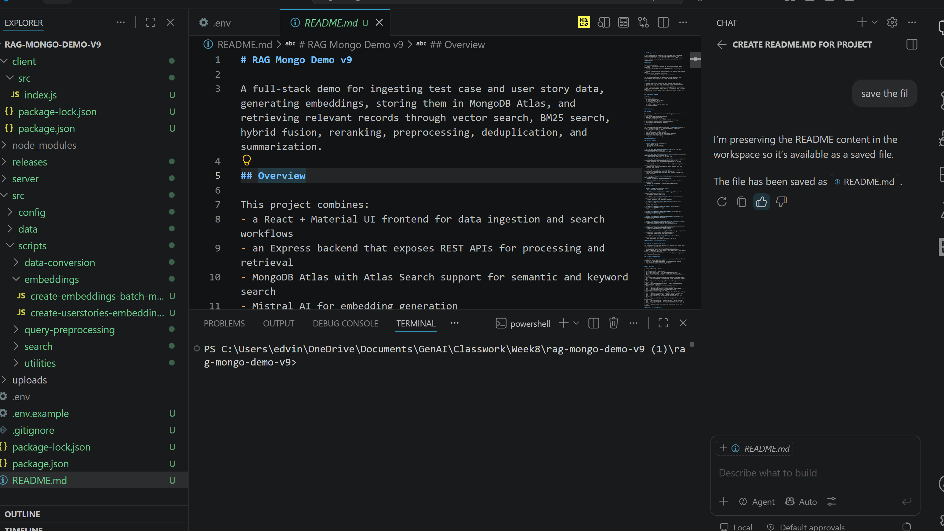

Logged in cohere and created API keys:
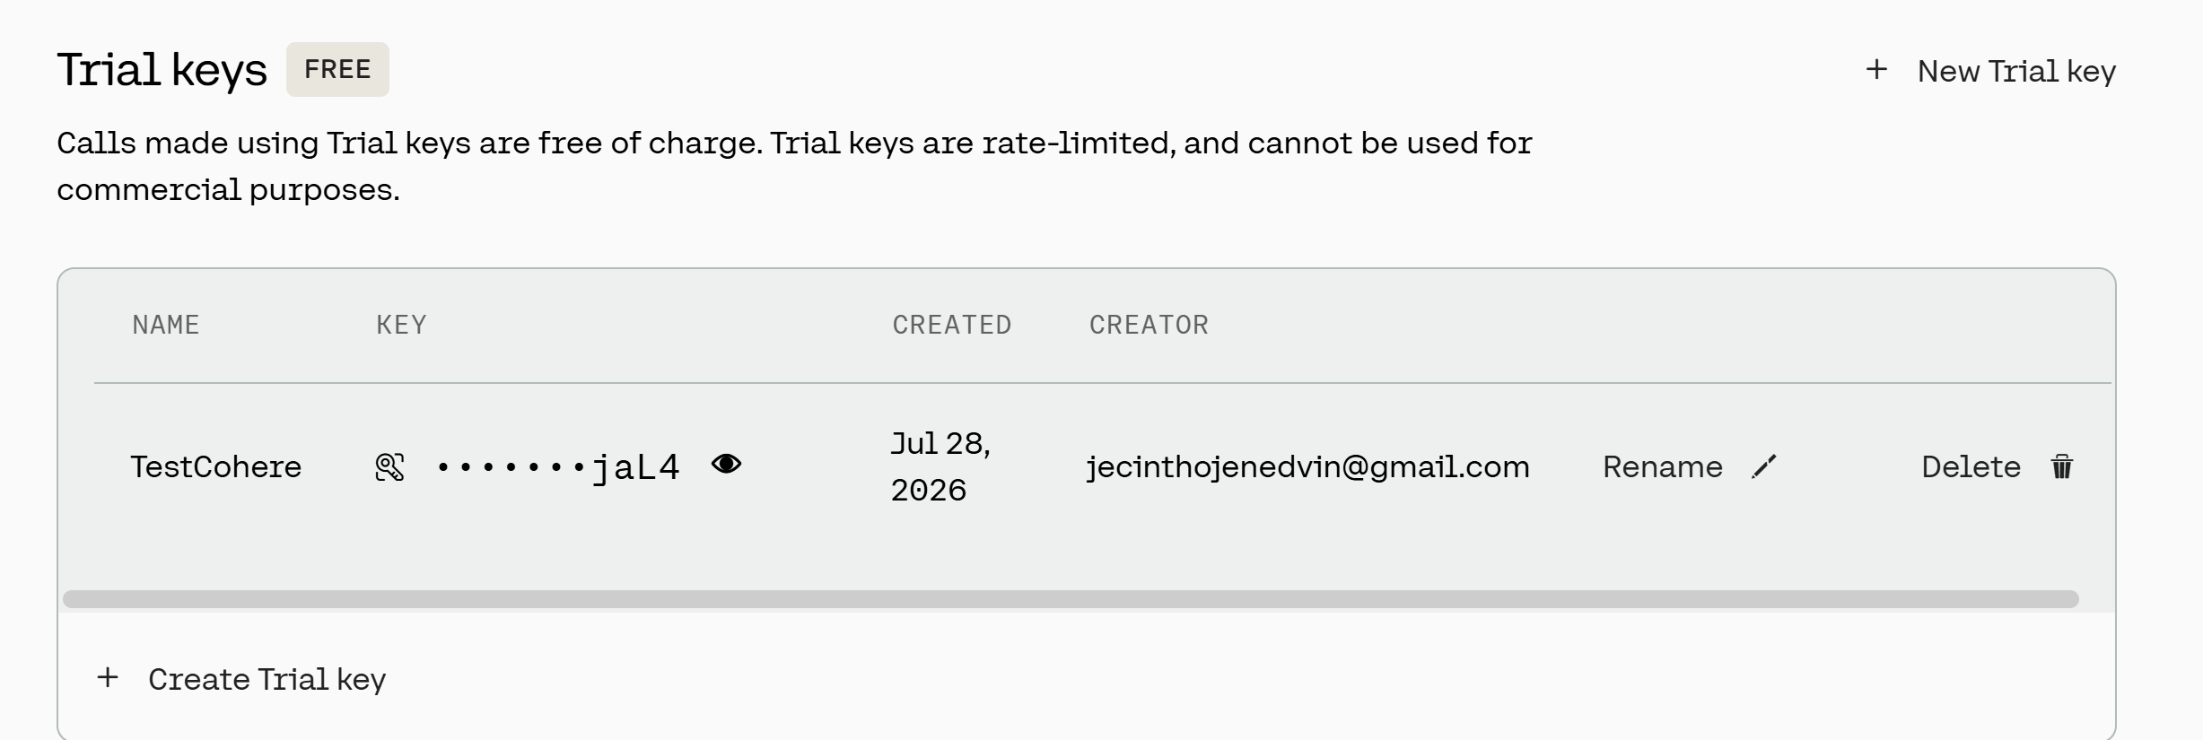

Generated the cohere postman collection by providing prompt in Chatgpt

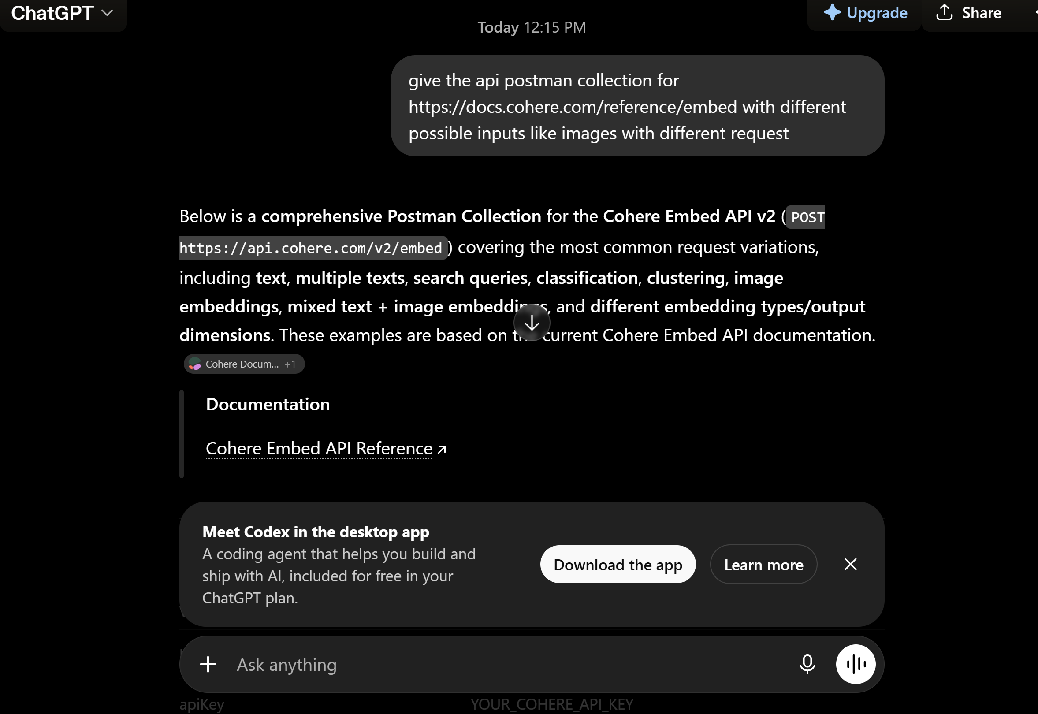
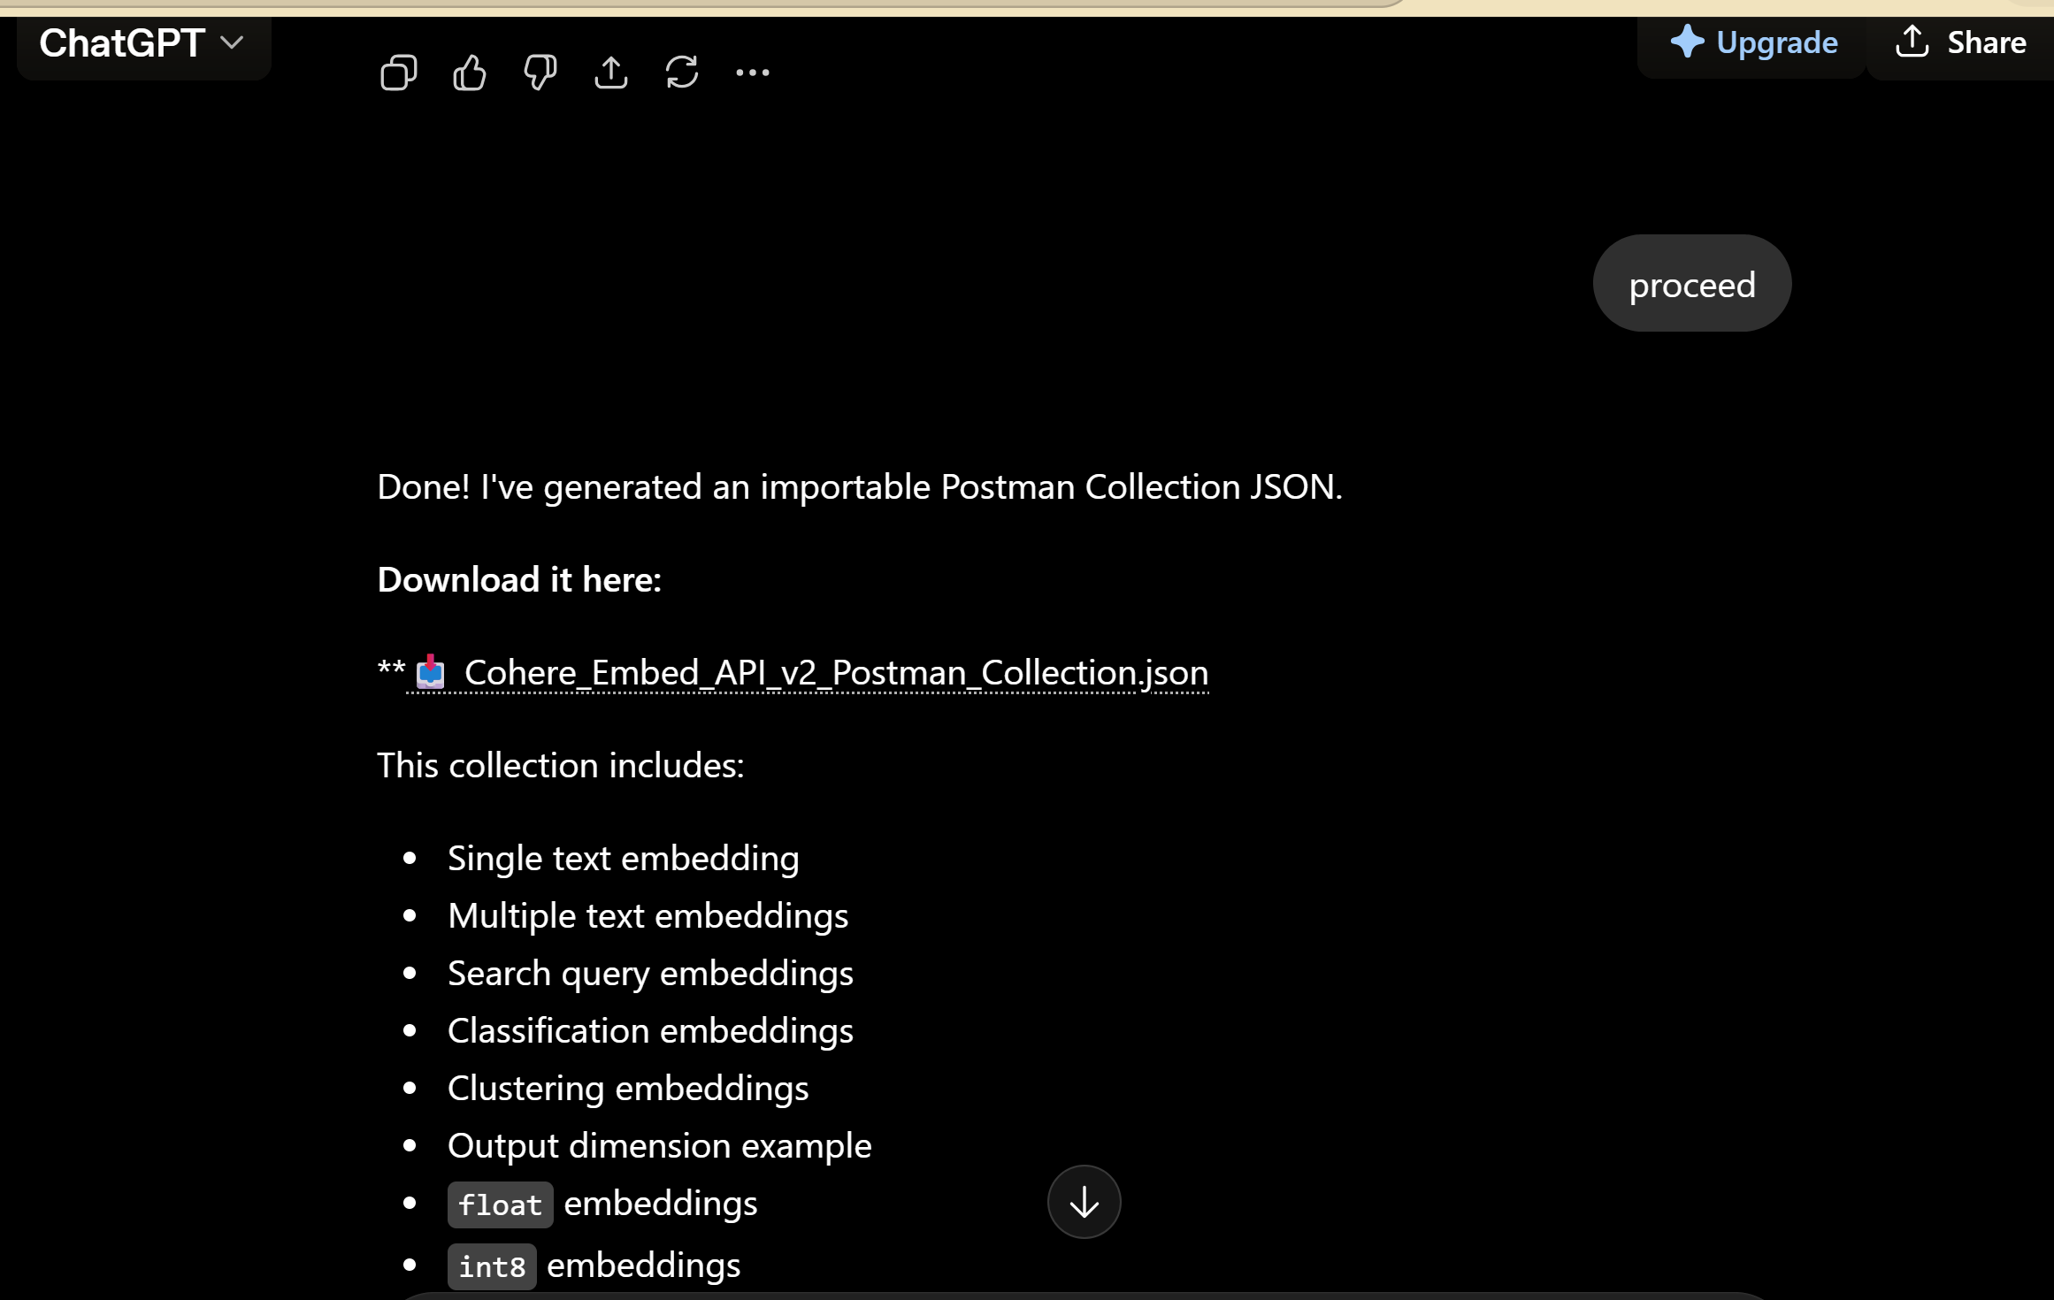
Imported the collection in postman and updated the API keys. Posted through postman successfully.
