**JERICK P. LABASAN**

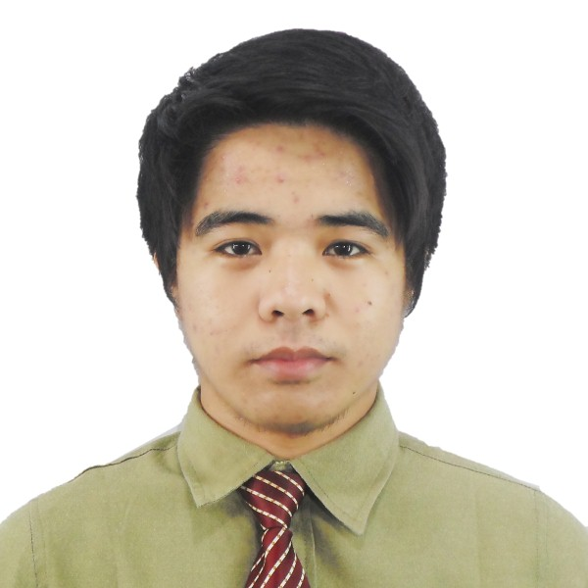

#284 Zamora Street

San Mateo, Isabela 3318

09352849363/09754669607

jeck.labasan@yahoo.com

**OBJECTIVE**

To obtain a web developer position and seeking experience from a well-established company to be able to apply my knowledge, proficiency and to further develop my skills to contribute to the company’s growth.

**EDUCATIONAL BACKGROUND**

**Tertiary** Central Luzon State University

Science City of Muñoz, Nueva Ecija

Bachelor of Science in Information Technology

2011– 2016

**TECHNICAL SKILLS**

* CSS framework (Bootstrap) PHP/HTML
* Framework (Code Igniter HMVC, Slim)
* Web API
* JSON, JQuery, JavaScript libraries (localStorage JS, Offline JS, Mustache JS, Path JS)
* Java and Visual Basic
* Computer Literate (MS Word, Excel, Power point,)
* Ability to work under minimal supervision

**PERSONAL PROFILE**

Name: Jerick P. Labasan

Gender: Male

Date of Birth: May 8, 1995

Age: 21

Civil Status: Single

Height: 5 feet 3 inches

Weight: 55 kg

Citizenship: Filipino

Religion: Iglesia Ni Cristo

Father: Erick M. Labasan

Mother: Jenalyn P. Labasan

Language/Dialects Spoken: English, Filipino

**SEMINARS ATTENDED**

“**12th Youth Congress on Information Technology**”

Held at SMX Convention Center, Pasay City

September 12 2014

**Microsoft Imagine Camp**

Held at University Auditorium, CLSU

**WORK EXPERIENCE**

February 9 – April 8, 2016

Web Developer (Back-end Developer)

On-the-Job Training at Avasia Information Systems

September 2016 – present

IT – Staff (Web Developer)

Service Resources Inc.

**CHARACTER REFERENCES**

**NEMENCIO MACABALE**

Chairman, Department of Information Systems Institute

College of Engineering

Central Luzon State University, Science City of Muñoz, Nueva Ecija

**FRANCIS A. CANARE**

Web Development Lecture Instructor

Central Luzon State University, Science City of Muñoz, Nueva Ecija

09057024767

**Maria Isabel Milagroso**

Web Development Laboratory Instructor

Central Luzon State University, Science City of Muñoz, Nueva Ecija

isabelmilagroso@gmail.com

I hereby certify that the above information is true and correct to the best of my knowledge.

JERICK P. LABASAN

Applicant